Supplementary Figure S1. Internal Validation of the Anthropometric Prediction Equation against Dual-Energy X-ray Absorptiometry (DXA) Measurements in the NHANES Cohort
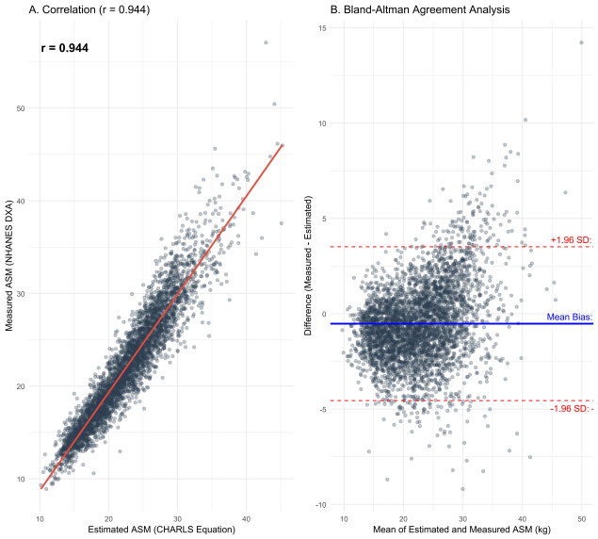

(A) Scatter plot illustrating the correlation between appendicular skeletal muscle mass (ASM) estimated using the anthropometric equation (Wen et al., 2011) and ASM measured by DXA. The Pearson correlation coefficient (r = 0.944) indicates a strong positive linear relationship. The red line represents the linear regression fit. (B) Bland-Altman plot assessing the agreement between the estimated and measured ASM. The blue solid line represents the mean bias (-0.X kg), and the red dashed lines indicate the 95% limits of agreement (±1.96 SD). Abbreviation: ASM, appendicular skeletal muscle mass; DXA, dual-energy X-ray absorptiometry; SD, standard deviation.

Supplementary Table 1. Fine-Gray Competing Risk Regression for Incident CVD Events.
Phenotype | SHR (95% CI) | P Value
Normal | 1.00 (Ref) | -
Obesity Only | 1.51 (1.31–1.74) | <0.001
Sarcopenia Only | 1.23 (1.04–1.46) | 0.016
Sarcopenic Obesity | 2.09 (1.77–2.46) | <0.001

