Table 1. General knowledge regarding anti-resorptive medication and MRONJ
(% of Yes answers)
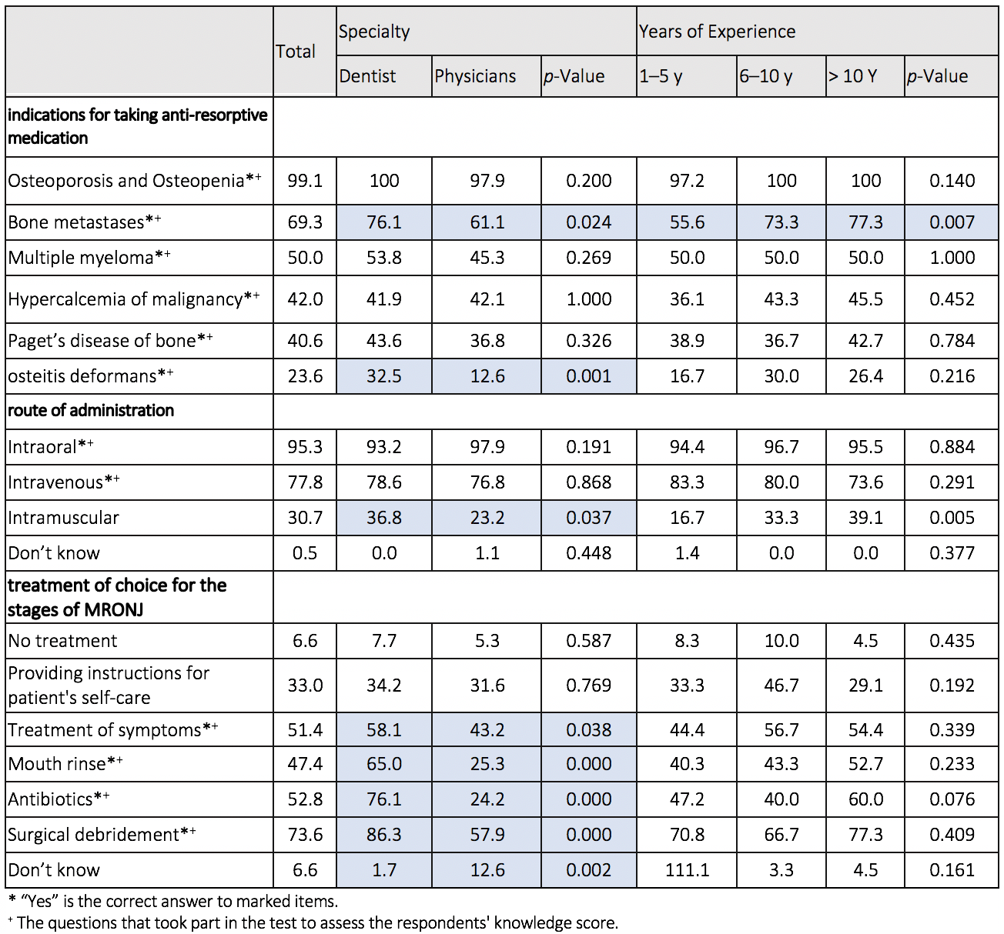

Table 2. Knowledge regarding risk factors and clinical features of MRONJ
(% of correct answers)
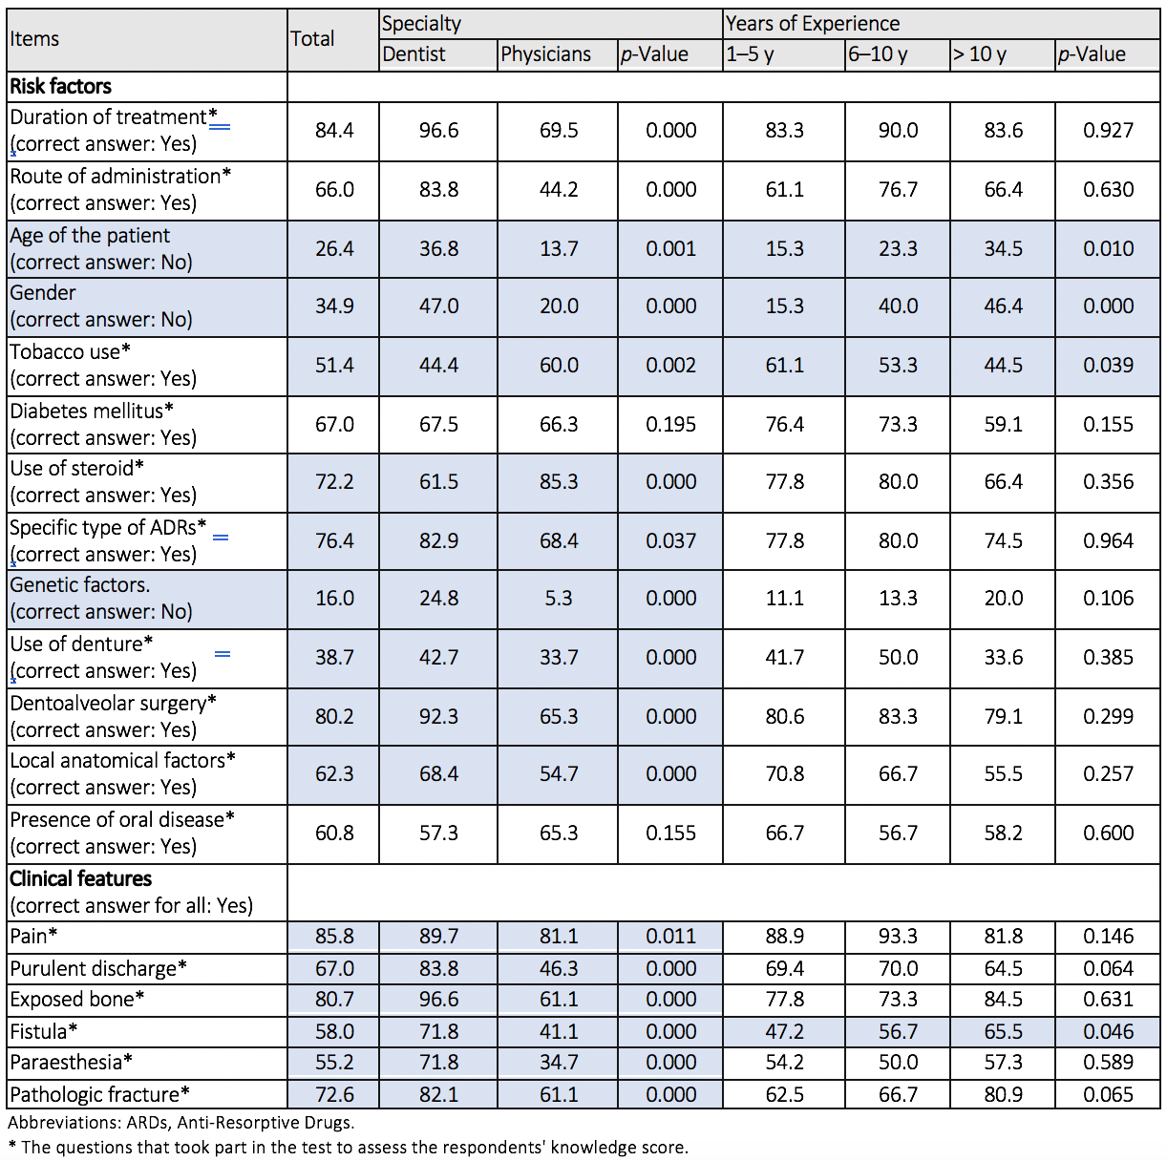

Table 3. Data of the preferences of sources of information regarding MRONJ (% of Yes answers)
