Figure S2. Interactions of TeAP1/FUL proteins with class B, C, D and, E proteins of marigold by yeast two-hybrid assays.
Fig. S1a. Assession of Self-activation and autoaction of AD and BD constructs.
Fig. S2b. Interactions of TeAP1/FUL proteins with class B, C, D, and E proteins of marigold by yeast two-hybrid assays. Ten-fold serial dilutions from 10-1 to 10-5 of each culture were spotted on the selected SD -Leu/-Trp/-His/-Ade plates with X-α-gal.
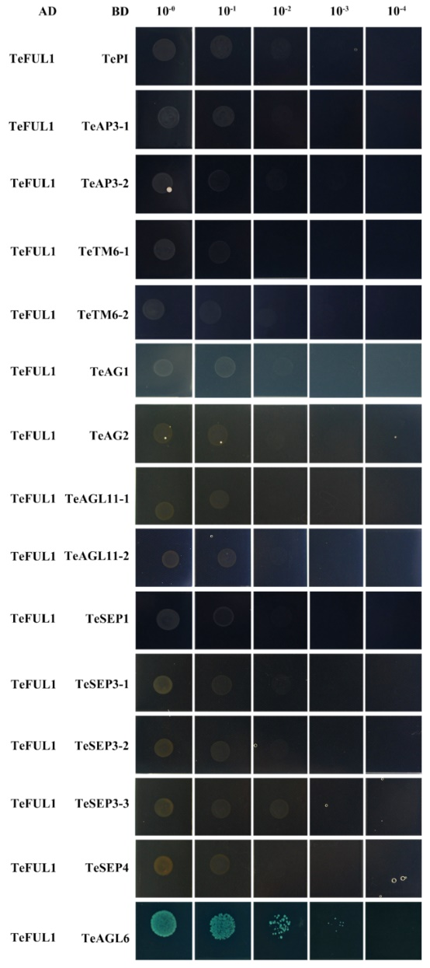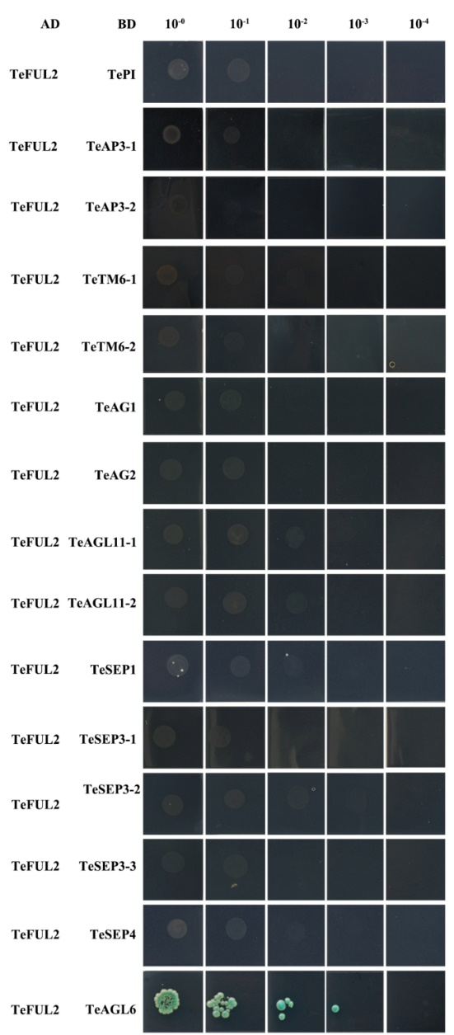
Fig. S1c. Interactions of TeAP1/FUL with class A, B, C, D, and E proteins of marigold by yeast two-hybrid assays. Ten-fold serial dilutions from 10⁻¹ to 10⁻⁵ of each culture were spotted on the selected SD -Leu/-Trp/-His/-Ade plates with X-α-gal. Class B proteins: TeAP3-1, TeAP3-2, TePI, TeTM6-1, TeTM6-2. Class C proteins: TeAG1 and TeAG2 proteins; Class D proteins: TeAGL11-1 and TeAGL11-2; Class E proteins: TeSEP1, TeSEP3-1, TeSEP3-2, TeSEP3-3, TeSEP4 and TeAGL6 proteins.
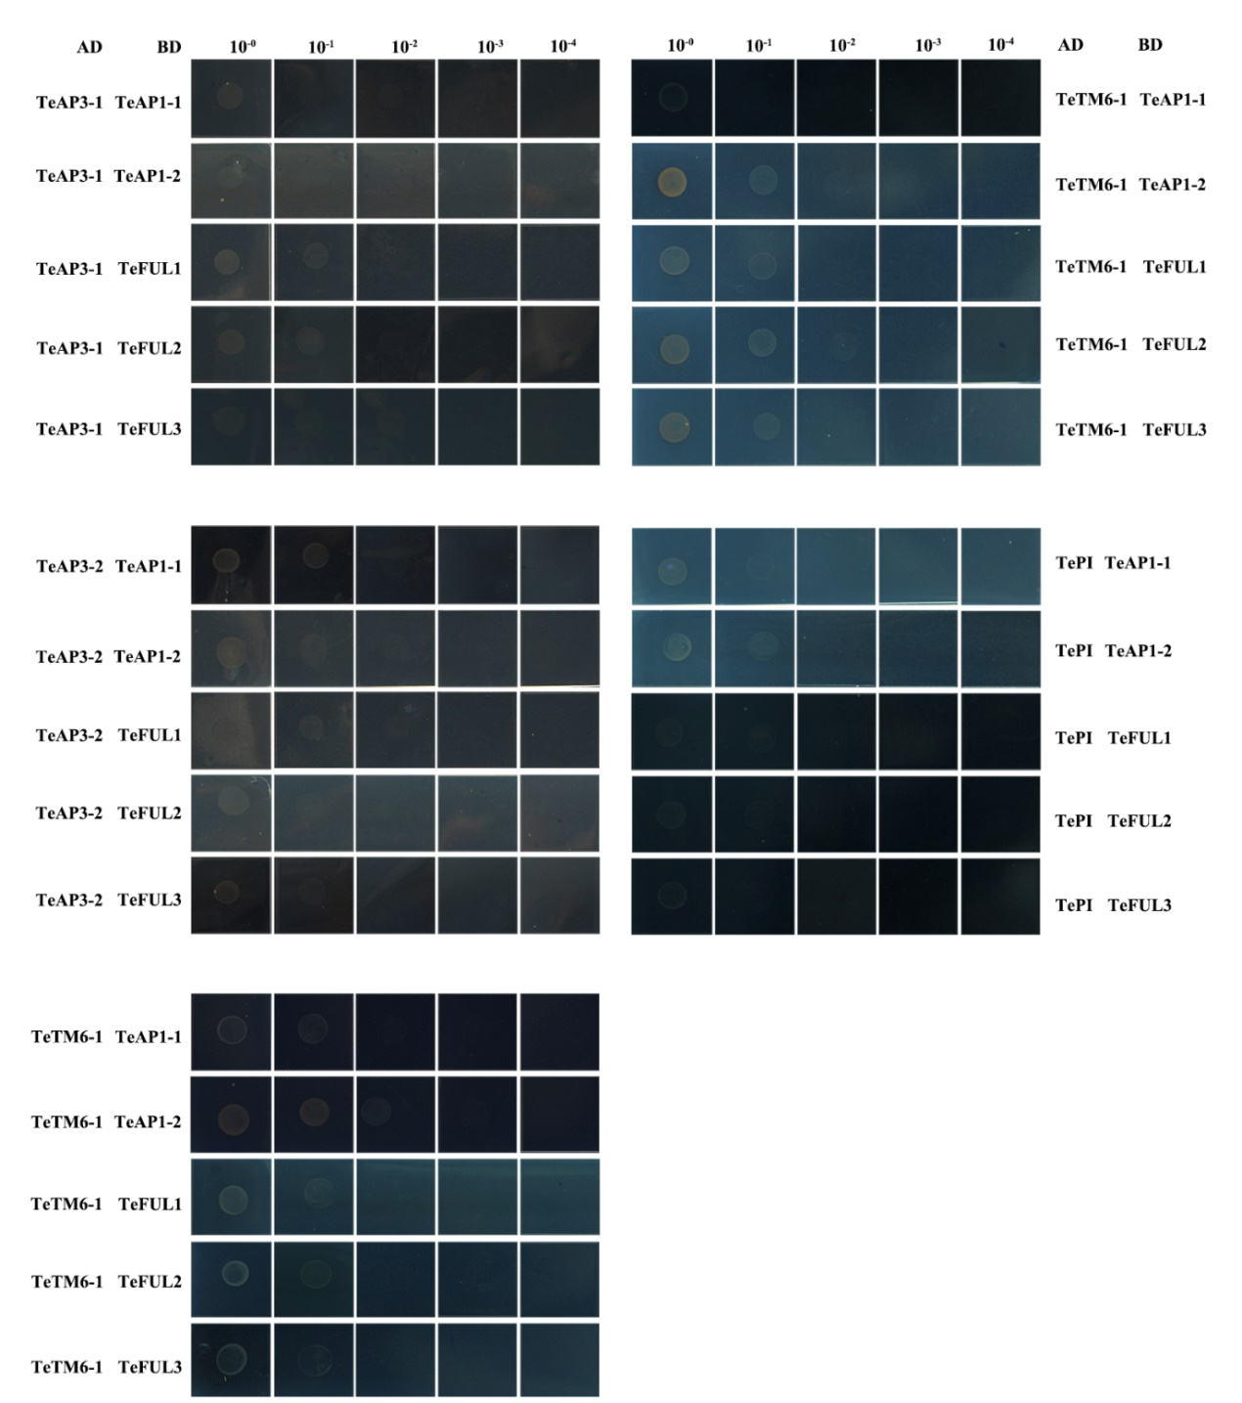
Fig. S1d. Interactions of class B proteins and TeAP1/FUL proteins of marigold by yeast two-hybrid assays. Ten-fold serial dilutions from 10⁻¹ to 10⁻⁵ of each culture were spotted on the selected SD -Leu/-Trp/-His/-Ade plates with X-α-gal. Class B proteins: TeAP3-1, TeAP3-2, TePI, TeTM6-1, TeTM6-2.
Fig. S2e. Interactions of class C and D proteins with TeAP1/FUL proteins of marigold by yeast two-hybrid assays. Ten-fold serial dilutions from 10⁻¹ to 10⁻⁵ of each culture were spotted on the selected SD -Leu/-Trp/-His/-Ade plates with X-α-gal. Class C proteins: TeAG1 and TeAG2 proteins; Class D proteins: TeAGL11-1 and TeAGL11-2.

Fig. S2f. Interactions of class E proteins and TeAP1/FUL proteins of marigold by yeast two-hybrid assays. Ten-fold serial dilutions from 10⁻¹ to 10⁻⁵ of each culture were spotted on the selected SD -Leu/-Trp/-His/-Ade plates with X-α-gal. Class D proteins: Class E proteins: TeSEP1, TeSEP3-1, TeSEP3-2, TeSEP3-3, TeSEP4 and TeAGL6 proteins.

