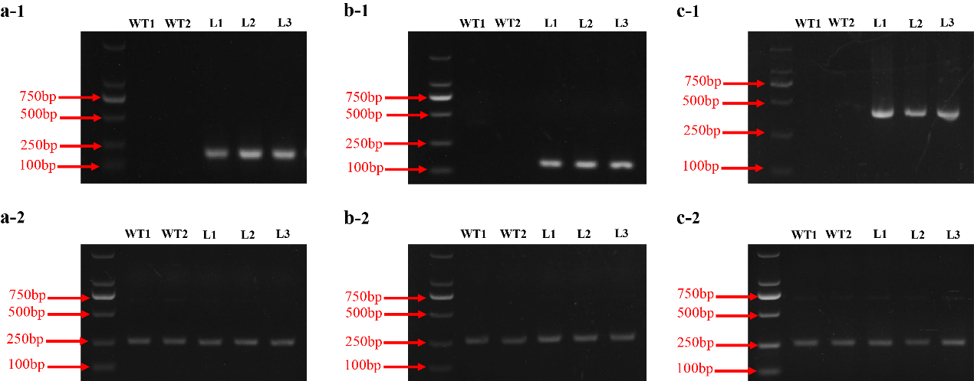

Fig. S3 Expression of TeAG1, TeAG2, TeAGL11-1 and TeAGL11-2 in seedlings of T1 transgenic lines by semi-quantitative RT-PCR. (a-1) 35S:TeAP1-1 transgenic lines. (b-1) 35S:TeFUL1 transgenic lines. (c-1) 35S:FUL3 transgenic lines. WT: wild type line; SL: strong phenotypic line; WL: weak phenotypic line; L: transgenic line. (a-2, b-2, c-2), the constitutive gene is Arabidopsis keeping-house gene AtEF1α

