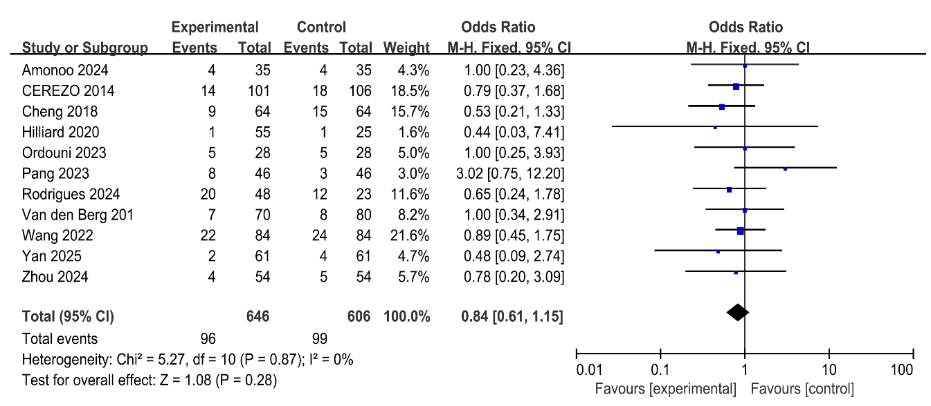 Figure S1. Sensitivity analyses for all-cause discontinuation rates: excluding studies with large-sample studies
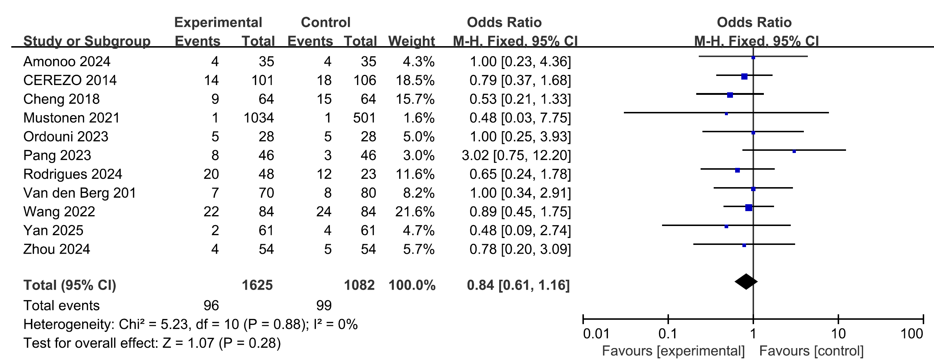
Figure S2. Sensitivity analyses for all-cause discontinuation rates: excluding studies with high risk of bias
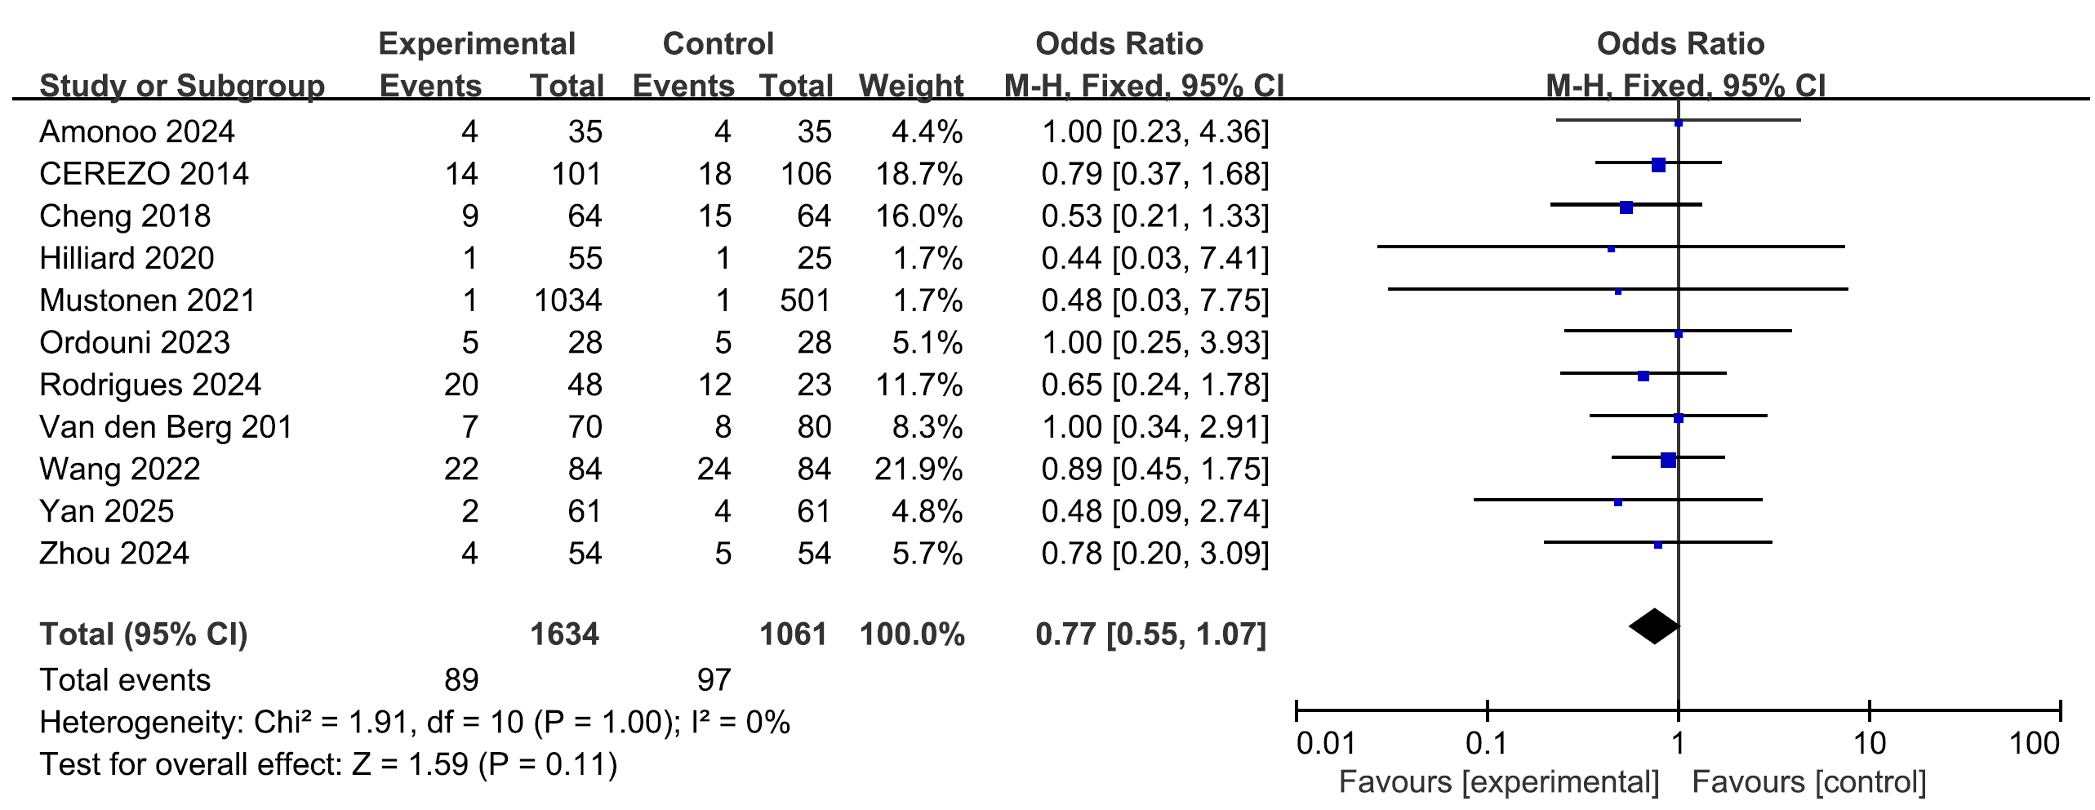
Figure S3. Sensitivity analyses for all-cause discontinuation rates: excluding studies with high risk of bias
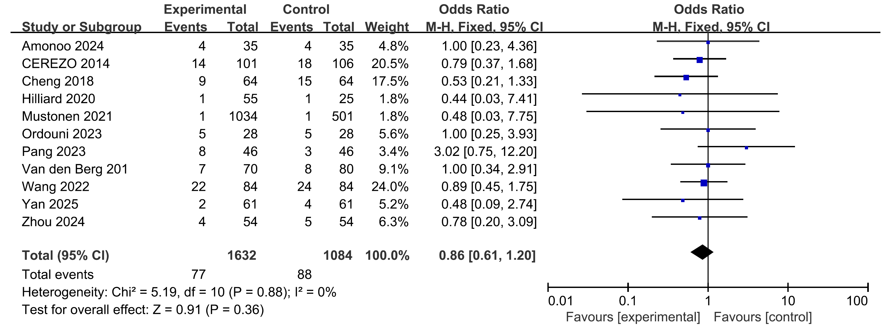
Figure S4. Sensitivity analyses for all-cause discontinuation rates: excluding studies with high risk of bias

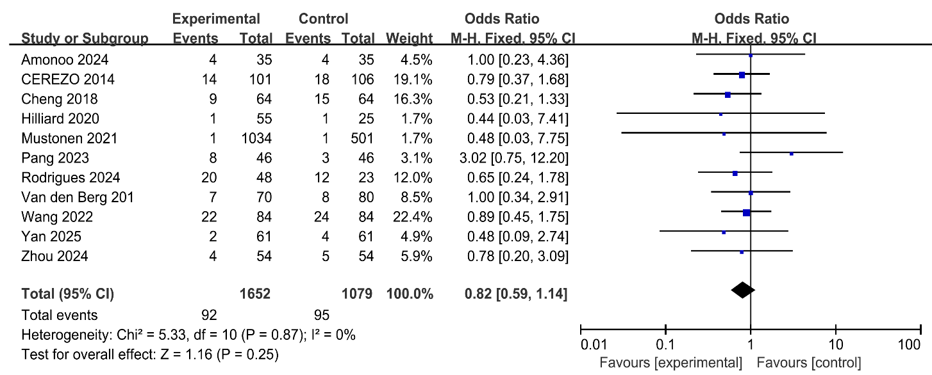
Figure S5. Sensitivity analyses for all-cause discontinuation rates: excluding studies with high risk of bias

Table S1. PubMed
#1 | ("chronic disease"[MeSH] OR "chronic disease*"[Title/Abstract] OR "chronic illness*"[Title/Abstract] OR "chronic condition*"[Title/Abstract] OR "non communicable disease*"[Title/Abstract] OR "noncommunicable disease*"[Title/Abstract] OR "chronically ill"[Title/Abstract])
#2 | ((("Stroke"[Mesh] OR cva[tiab] OR cvas[tiab] OR poststroke*[tiab] OR stroke*[tiab] OR apoplex*[tiab]) OR ((brain*[tiab] OR cerebr*[tiab] OR cerebell*[tiab] OR intracran*[tiab] OR intracerebral*[tiab] OR vertebrobasilar*[tiab]) AND vascular*[tiab] AND (disease[tiab] OR diseases[tiab] OR accident*[tiab] OR disorder*[tiab])) OR (cerebrovascular*[tiab] AND (disease[tiab] OR diseases[tiab] OR accident*[tiab] OR disorder*[tiab])) OR ((brain*[tiab] OR cerebr*[tiab] OR cerebell*[tiab] OR intracran*[tiab] OR intracerebral*[tiab] OR vertebrobasilar*[tiab]) AND (haemorrhag*[tiab] OR hemorrhag*[tiab] OR ischemi*[tiab] OR ischaemi*[tiab] OR infarct*[tiab] OR haematoma*[tiab] OR hematoma*[tiab] OR bleed*[tiab])) OR ("Hemiplegia"[Mesh] OR "Paresis"[Mesh] OR hemipleg*[tiab] OR hemipar*[tiab] OR paresis[tiab] OR paretic[tiab]))) OR ("cerebrovascular trauma"[MeSH])
#3 | (essential hypertension[MeSH] OR hypertension[Title/Abstract] OR hypertensive[Title/Abstract] OR "high blood pressure*"[Title/Abstract])
#4 | (((((((((heart failure[MeSH Terms]) OR (heart failure[Title/Abstract])) OR (CHF[Title/Abstract])) OR (HF[Title/Abstract])) OR (cardiac failure[Title/Abstract])) OR (heart decompensation[Title/Abstract])) OR (diastolic dysfunction[Title/Abstract])) OR (systolic dysfunction[Title/Abstract])) OR (HFpEF[Title/Abstract])) OR (HFrEF[Title/Abstract])
#5 | (Cardiovascular Diseases[Title/Abstract]) OR (("coronary artery disease"[MeSH] OR "coronary artery disease*"[Title/Abstract] OR "coronary arteriosclerosis"[Title/Abstract] OR "coronary atherosclerosis*"[Title/Abstract] OR "angina pectoris"[Title/Abstract] OR “CAD” [Title/Abstract] OR "heart disease*"[Title/Abstract] OR "myocardial infarction*"[Title/Abstract] OR "unstable angina*"[Title/Abstract] OR "angor pectoris"[Title/Abstract] OR "coronary thrombosis"[Title/Abstract] OR "acute coronary syndrome*"[Title/Abstract] OR "myocardial ischemia*"[Title/Abstract] OR "myocardial ischaemia*"[Title/Abstract]))
#6 | (Carcinoma[MeSH] OR Sarcoma[MeSH] OR Malignant Neoplasm[Title/Abstract] OR malignant tumor[Title/Abstract] OR Cancer[Title/Abstract])
#7 | (asthma[MeSH] OR asthma[Title/Abstract] OR "status asthmaticus"[Title/Abstract] OR "bronchial hyper reactivity"[Title/Abstract] OR asthmatic [Title/Abstract] OR wheeze[Title/Abstract] OR bronchial*[Title/Abstract] OR "obstructive lung disease*"[Title/Abstract])
#8 | ("renal insufficiency, chronic"[MeSH] OR "chronic renal insufficiency"[Title/Abstract] OR "chronic kidney failure"[Title/Abstract] OR "chronic renal failure"[Title/Abstract] OR "chronic renal disease ∗"[Title/Abstract] OR "chronic kidney disease*"[Title/Abstract] OR "chronic kidney disorder*" [Title/Abstract] CKD[Title/Abstract] OR ESRD[Title/Abstract] OR CRD[Title/Abstract] OR "chronic kidney insufficiency"[Title/Abstract])
#9 | (("pulmonary disease, chronic obstructive"[MeSH] OR "chronic obstructive pulmonary disease*"[Title/Abstract] OR "chronic bronchitis"[Title/Abstract] OR COPD[Title/Abstract] OR "chronic obstructive airway disease"[Title/Abstract] OR "chronic airflow obstruction"[Title/Abstract] OR "chronic obstructive lung disease"[Title/Abstract] OR emphysema*[Title/Abstract])) OR (COAD[Title/Abstract])
#10 | ((((((((((((((((diabetes mellitus[MeSH Terms]) OR (diabetes mellitus, type 2[MeSH Terms])) OR (insulin resistance[MeSH Terms])) OR (diabetes mellitus[Title/Abstract])) OR (diabetes mellitus type 2[Title/Abstract])) OR (insulin resistance[Title/Abstract])) OR (DMII[Title/Abstract])) OR (DM2[Title/Abstract])) OR (IDDM[Title/Abstract])) OR (NIDDM[Title/Abstract])) OR (noninsulin dependent[Title/Abstract])) OR (impaired glucose tolerance[Title/Abstract])) OR (impaired glucose tolerant[Title/Abstract])) OR (DM[Title/Abstract])) OR (T2D[Title/Abstract])) OR (T2DM[Title/Abstract])) OR (MODY[Title/Abstract])
#11 | ((((((((((((((((((((((strength-based[Title/Abstract]) OR (strengths-based[Title/Abstract])) OR (strength-based intervention[Title/Abstract])) OR (strengths-based intervention[Title/Abstract])) OR (strengths-based treatment[Title/Abstract])) OR (strengths-based applications[Title/Abstract])) OR (strengths based approaches[Title/Abstract]))) OR (strengths model[Title/Abstract])) OR (character strengths intervention[Title/Abstract])) OR (strengths intervention[Title/Abstract])) OR (character strength[Title/Abstract])) OR (signature strengths[Title/Abstract])) OR (psychological strengths[Title/Abstract])) OR (strengths inventory[Title/Abstract])) OR (strength-based counselling[Title/Abstract])) OR (strength-oriented[Title/Abstract])) OR (inner strength[Title/Abstract])) OR (personal strengths[Title/Abstract])) OR (strengths approaches[Title/Abstract])) OR (individual strengths[Title/Abstract])) OR (strength-centered therapy[Title/Abstract])) OR (health assets[Title/Abstract])
#12 | #1 OR #2 OR #3 OR #4 OR #5 OR #6 OR #7 OR #8 OR #9 OR #10
#13 | #11 AND #12

Table S2. Web of science
#1 | AB=(chronic disease*) OR AB=(chronic illness*) OR AB=(chronic condition*) OR AB=(non communicable disease*) OR AB=(noncommunicable disease*) OR AB=(chronically ill)
#2 | (TI=(("Stroke"[Mesh] OR cva OR cvas OR poststroke* OR stroke* OR apoplex* OR ((brain* OR cerebr* OR cerebell* OR intracran* OR intracerebral* OR vertebrobasilar*) AND vascular* AND (disease OR diseases OR accident* OR disorder*)) OR (cerebrovascular* AND (disease OR diseases OR accident* OR disorder*)) OR ((brain* OR cerebr* OR cerebell* OR intracran* OR intracerebral* OR vertebrobasilar*) AND (haemorrhag* OR hemorrhag* OR ischemi* OR ischaemi* OR infarct* OR haematoma* OR hematoma* OR bleed*)) OR ("Hemiplegia"[Mesh] OR "Paresis"[Mesh] OR hemipleg* OR hemipar* OR paresis OR paretic) OR "Chronic Disease"[Mesh] OR "Chronic Disease" OR "chronic illness" OR "chronic condition"))) OR AB=(("Stroke"[Mesh] OR cva OR cvas OR poststroke* OR stroke* OR apoplex* OR ((brain* OR cerebr* OR cerebell* OR intracran* OR intracerebral* OR vertebrobasilar*) AND vascular* AND (disease OR diseases OR accident* OR disorder*)) OR (cerebrovascular* AND (disease OR diseases OR accident* OR disorder*)) OR ((brain* OR cerebr* OR cerebell* OR intracran* OR intracerebral* OR vertebrobasilar*) AND (haemorrhag* OR hemorrhag* OR ischemi* OR ischaemi* OR infarct* OR haematoma* OR hematoma* OR bleed*)) OR ("Hemiplegia"[Mesh] OR "Paresis"[Mesh] OR hemipleg* OR hemipar* OR paresis OR paretic)))
#3 | AB=(hypertension) OR AB=(hypertension) OR AB=(high blood pressure*)
#4 | AB=(heart failure) OR AB=(CHF) OR AB=(HF) OR AB=(cardiac failure) OR AB=(heart decompensation) OR AB=(diastolic dysfunction) OR AB=(systolic dysfunction) OR AB=(HFpEF) OR AB=(HFrEF)
#5 | AB=(Cardiovascular Diseases) OR AB=(coronary artery disease*) OR AB=(coronary atherosclerosis*) OR AB=(angina pectoris) OR AB=(CAD) OR AB=(heart disease*) OR AB=(myocardial infarction*) OR AB=(unstable angina*) OR AB=(angor pectoris) OR AB=(coronary thrombosis) OR AB=(acute coronary syndrome*) OR AB=(myocardial ischemia*) OR AB=(myocardial ischaemia*)
#6 | AB=(“Carcinoma”) OR AB=( “Sarcoma”) OR AB=(“Malignant Neoplasm”) OR AB=(“malignant tumor”) OR AB=(“Cancer”)
#7 | AB=(asthma) OR AB=(status asthmaticus) OR AB=(bronchial hyper reactivity) OR AB=(asthmatic) OR AB=(wheeze) OR AB=(bronchial*) OR AB=(obstructive lung disease*)
#8 | AB=(chronic renal insufficiency) OR AB=(chronic kidney failure) OR AB=(chronic renal failure) OR AB=(chronic renal disease*) OR AB=(chronic kidney disease*) OR AB=(chronic kidney disorder*) OR AB=(CKD) OR AB=(ESRD) OR AB=(CRD) OR AB=(chronic kidney insufficiency)
#9 | AB=(chronic obstructive pulmonary disease*) OR AB=(chronic bronchitis) OR AB=(COPD) OR AB=(chronic obstructive airway disease) OR AB=(chronic airflow obstruction) OR AB=(chronic obstructive lung disease) OR AB=(emphysema*) OR AB=(COAD)
#10 | AB=(diabetes mellitus) OR AB=(diabetes mellitus type 2) OR AB=(insulin resistance) OR AB=(DMII) OR AB=(DM2) OR AB=(IDDM) OR AB=(NIDDM) OR AB=(noninsulin dependent) OR AB=(impaired glucose tolerance) OR AB=(impaired glucose tolerant) OR AB=(DM) OR AB=(T2D) OR AB=(T2DM) OR AB=(MODY)
#11 | AB=(“strength-based”) OR AB=(“strengths-based”) OR AB=(“strength-based intervention”) OR AB=(“strengths-based intervention”) OR AB=(“strengths-based treatment”) OR AB=(“strengths-based applications”) OR AB=(“strengths based approaches”) OR AB=(“strengths model”) OR AB=(“character strengths intervention”) OR AB=(“strengths intervention”) OR AB=(“character strength”) OR AB=(“signature strengths”) OR AB=(“psychological strengths”) OR AB=(“strengths inventory”) OR AB=(“strength-based counselling”) OR AB=(“strength-oriented”) OR AB=(“inner strength”) OR AB=(“personal strengths”) OR AB=(“strengths approaches”) OR AB=(“individual strengths”) OR AB=(“strength-centered therapy”) OR AB=(“health assets”)
#12 | #1 OR #2 OR #3 OR #4 OR #5 OR #6 OR #7 OR #8 OR #9 OR #10
#13 | #11 AND #12

Table S3. Embase
#1 | chronic AND 'disease'/mj OR 'chronic disease*':ab,ti OR 'chronic illness*':ab,ti OR 'chronic condition*':ab,ti OR 'non communicable disease*':ab,ti OR 'noncommunicable disease*':ab,ti OR 'chronically ill':ab,ti
#2 | cva:ti,ab,kw OR cvas:ti,ab,kw OR stroke:ti,ab,kw OR apoplex*:ti,ab,kw OR poststroke*:ti,ab,kw OR ((brain*:ti,ab,kw OR cerebr*:ti,ab,kw OR cerebell*:ti,ab,kw OR intracran*:ti,ab,kw OR intracerebral*:ti,ab,kw OR vertebrobasilar*:ti,ab,kw) AND vascular*:ti,ab,kw AND (disease:ti,ab,kw OR diseases:ti,ab,kw OR accident*:ti,ab,kw OR disorder*:ti,ab,kw)) OR (cerebrovascular*:ti,ab,kw AND (disease:ti,ab,kw OR diseases:ti,ab,kw OR accident*:ti,ab,kw OR disorder*:ti,ab,kw)) OR ((brain*:ti,ab,kw OR cerebr*:ti,ab,kw OR cerebell*:ti,ab,kw OR intracran*:ti,ab,kw OR intracerebral*:ti,ab,kw OR vertebrobasilar*:ti,ab,kw) AND (haemorrhag*:ti,ab,kw OR hemorrhag*:ti,ab,kw OR ischemi*:ti,ab,kw OR ischaemi*:ti,ab,kw OR infarct*:ti,ab,kw OR haematoma*:ti,ab,kw OR hematoma*:ti,ab,kw OR bleed*:ti,ab,kw)) OR 'chronic disease':ti,ab,kw OR 'chronic illness':ti,ab,kw OR 'chronic condition':ti,ab,kw
#3 | 'essential'/mj AND 'hypertension'/mj OR hypertension:ab,ti OR hypertensive:ab,ti OR 'high blood pressure*':ab,ti
#4 | 'heart'/mj AND 'failure'/mj OR 'heart failure':ab,ti OR chf:ab,ti OR hf:ab,ti OR 'cardiac failure':ab,ti OR 'heart decompensation':ab,ti OR 'diastolic dysfunction':ab,ti OR 'systolic dysfunction':ab,ti OR hfpef:ab,ti OR hfref:ab,ti
#5 | coronary AND 'artery'/mj AND 'disease'/mj OR 'cardiovascular diseases':ab,ti OR 'coronary artery disease*':ab,ti OR 'coronary arteriosclerosis':ab,ti OR 'coronary atherosclerosis*':ab,ti OR 'angina pectoris':ab,ti OR cad:ab,ti OR 'heart disease*':ab,ti OR 'myocardial infarction*':ab,ti OR 'unstable angina*':ab,ti OR 'angor pectoris':ab,ti OR 'coronary thrombosis':ab,ti OR 'acute coronary syndrome*':ab,ti OR 'myocardial ischemia*':ab,ti OR 'myocardial ischaemia*':ab,ti
#6 | 'carcinoma'/mj OR 'sarcoma'/mj OR 'malignant neoplasm'/mj OR 'malignant neoplasm':ab,ti OR cancer:ab,ti
#7 | 'asthma'/mj OR asthma:ab,ti OR 'status asthmaticus':ab,ti OR 'bronchial hyper reactivity':ab,ti OR asthmatic:ab,ti OR wheeze:ab,ti OR bronchial*:ab,ti OR 'obstructive lung disease*':ab,ti
#8 | 'renal'/mj AND insufficiency, AND chronic OR 'chronic renal insufficiency':ab,ti OR 'chronic kidney failure':ab,ti OR 'chronic renal failure':ab,ti OR 'chronic renal disease*':ab,ti OR 'chronic kidney disease*':ab,ti OR 'chronic kidney disorder*':ab,ti OR ckd:ab,ti OR esrd:ab,ti OR crd:ab,ti OR 'chronic kidney insufficiency':ab,ti
#9 | pulmonary AND 'disease,'/mj AND chronic AND obstructive OR 'chronic obstructive pulmonary disease*':ab,ti OR 'chronic bronchitis':ab,ti OR copd:ab,ti OR 'chronic obstructive airway disease':ab,ti OR 'chronic airflow obstruction':ab,ti OR 'chronic obstructive lung disease':ab,ti OR emphysema*:ab,ti OR coad:ab,ti
#10 | 'diabetes'/mj AND mellitus OR ('diabetes'/mj AND mellitus, AND type AND '2'/mj) OR 'insulin resistance'/mj OR 'diabetes mellitus':ab,ti OR 'diabetes mellitus type 2':ab,ti OR 'insulin resistance':ab,ti OR dmii:ab,ti OR dm2:ab,ti OR iddm:ab,ti OR niddm:ab,ti OR 'noninsulin dependent':ab,ti OR 'impaired glucose tolerance':ab,ti OR 'impaired glucose tolerant':ab,ti OR dm:ab,ti OR t2d:ab,ti OR t2dm:ab,ti OR mody:ab,ti
#11 | 'strength based':ab,ti OR 'strengths based':ab,ti OR 'strength-based intervention':ab,ti OR 'strengths-based intervention':ab,ti OR 'strengths-based treatment':ab,ti OR 'strengths-based applications':ab,ti OR 'strengths based approaches':ab,ti OR 'strengths model':ab,ti OR 'character strengths intervention':ab,ti OR 'strengths intervention':ab,ti OR 'character strength':ab,ti OR 'signature strengths':ab,ti OR 'psychological strengths':ab,ti OR 'strengths inventory':ab,ti OR 'strength-based counselling':ab,ti OR 'strength oriented':ab,ti OR 'inner strength':ab,ti OR 'personal strengths':ab,ti OR 'strengths approaches':ab,ti OR 'individual strengths':ab,ti OR 'strength-centered therapy':ab,ti OR 'health assets':ab,ti
#12 | #1 OR #2 OR #3 OR #4 OR #5 OR #6 OR #7 OR #8 OR #9 OR #10
#13 | #11 AND #12

Table S4. Cochrane library
#1 | MeSH descriptor:(Chronic Disease) this term only OR (chronic disease*):ti,ab,kw OR (chronic illness*):ti,ab,kw OR (chronic condition*):ti,ab,kw OR (non communicable disease*):ti,ab,kw OR (noncommunicable disease*):ti,ab,kw OR (chronically ill):ti,ab,kw
#2 | MeSH descriptor:(Stroke) this term only OR  MeSH descriptor:(Hemiplegia) this term only OR  MeSH descriptor:(Paresis) this term only OR  MeSH descriptor:(Cerebrovascular Trauma) this term only
#3 | (((cva):ti,ab,kw OR (cvas):ti,ab,kw OR (poststroke*):ti,ab,kw OR (stroke*):ti,ab,kw OR (apoplex*):ti,ab,kw OR (brain*):ti,ab,kw OR (cerebr*):ti,ab,kw OR (cerebell*):ti,ab,kw OR (intracran*):ti,ab,kw OR (intracerebral*):ti,ab,kw OR (vertebrobasilar*)):ti,ab,kw AND (vascular*):ti,ab,kw AND ((disease):ti,ab,kw OR (diseases):ti,ab,kw OR (accident*):ti,ab,kw OR (disorder*))):ti,ab,kw OR ((cerebrovascular*):ti,ab,kw AND ((disease):ti,ab,kw OR (diseases):ti,ab,kw OR (accident*):ti,ab,kw OR (disorder*))):ti,ab,kw OR (((brain*):ti,ab,kw OR (cerebr*):ti,ab,kw OR (cerebell*):ti,ab,kw OR (intracran*):ti,ab,kw OR (intracerebral*):ti,ab,kw OR (vertebrobasilar*)):ti,ab,kw AND ((haemorrhag*):ti,ab,kw OR (hemorrhag*):ti,ab,kw OR (ischemi*):ti,ab,kw OR (ischaemi*):ti,ab,kw OR (infarct*):ti,ab,kw OR (haematoma*):ti,ab,kw OR (hematoma*):ti,ab,kw OR (bleed*))):ti,ab,kw OR ((hemipleg*):ti,ab,kw OR (hemipar*):ti,ab,kw OR (paresis):ti,ab,kw OR (paretic)):ti,ab,kw
#4 | #2 OR #3
#5 | MeSH descriptor:(Essential Hypertension) this term only OR (hypertensive):ti,ab,kw OR (hypertension):ti,ab,kw OR (high blood pressure*):ti,ab,kw
#6 | MeSH descriptor:(Heart Failure) this term only OR (diastolic dysfunction):ti,ab,kw OR (systolic dysfunction):ti,ab,kw OR (HFpEF):ti,ab,kw OR (HFrEF):ti,ab,kw OR (heart failure):ti,ab,kw OR (CHF):ti,ab,kw OR (HF):ti,ab,kw OR (cardiac failure):ti,ab,kw OR (heart decompensation):ti,ab,kw
#7 | MeSH descriptor:(Coronary Artery Disease) this term only OR (Cardiovascular Diseases):ti,ab,kw OR (coronary artery disease*):ti,ab,kw OR (coronary arteriosclerosis):ti,ab,kw OR (coronary atherosclerosis*):ti,ab,kw AND (angina pectoris):ti,ab,kw OR (CAD):ti,ab,kw OR (heart disease*):ti,ab,kw OR (myocardial infarction*):ti,ab,kw OR (unstable angina*):ti,ab,kw AND (angor pectoris):ti,ab,kw OR (coronary thrombosis):ti,ab,kw OR (acute coronary syndrome*):ti,ab,kw OR (myocardial ischemia*):ti,ab,kw OR (myocardial ischaemia*):ti,ab,kw
#8 | MeSH descriptor:(Carcinoma) this term only OR MeSH descriptor:(Sarcoma) this term only OR (Malignant Neoplasm):ti,ab,kw OR (malignant tumor):ti,ab,kw OR (Cancer):ti,ab,kw
#9 | MeSH descriptor:(Asthma) this term only OR (asthma):ti,ab,kw OR (status asthmaticus):ti,ab,kw OR (bronchial hyper reactivity):ti,ab,kw OR (asthmatic):ti,ab,kw OR (wheeze):ti,ab,kw OR (bronchial*):ti,ab,kw OR (obstructive lung disease*):ti,ab,kw
#10 | MeSH descriptor:(Renal Insufficiency, Chronic) this term only OR (chronic renal insufficiency):ti,ab,kw OR (chronic kidney failure):ti,ab,kw OR (chronic renal failure):ti,ab,kw OR (chronic renal disease*):ti,ab,kw OR (chronic kidney disease*):ti,ab,kw OR (chronic kidney disorder*):ti,ab,kw OR (CKD):ti,ab,kw OR (ESRD):ti,ab,kw OR (CRD):ti,ab,kw OR (chronic kidney insufficiency):ti,ab,kw
#11 | MeSH descriptor:(Pulmonary Disease, Chronic Obstructive) this term only OR (chronic obstructive pulmonary disease*):ti,ab,kw OR (chronic bronchitis):ti,ab,kw OR (COPD):ti,ab,kw OR (chronic obstructive airway disease):ti,ab,kw OR (chronic airflow obstruction):ti,ab,kw OR (chronic obstructive lung disease):ti,ab,kw OR (emphysema*):ti,ab,kw OR (COAD):ti,ab,kw
#12 | MeSH descriptor:(Diabetes Mellitus) this term only OR MeSH descriptor:(Diabetes Mellitus, Type 2) this term only OR MeSH descriptor:(Insulin Resistance) this term only
#13 | (diabetes mellitus):ti,ab,kw OR (diabetes mellitus type 2):ti,ab,kw OR (insulin resistance):ti,ab,kw OR (DMII):ti,ab,kw OR (DM2):ti,ab,kw OR (IDDM):ti,ab,kw OR (NIDDM):ti,ab,kw OR (noninsulin dependent):ti,ab,kw OR (impaired glucose tolerance):ti,ab,kw OR (impaired glucose tolerant):ti,ab,kw OR (DM):ti,ab,kw OR (T2D):ti,ab,kw OR (T2DM):ti,ab,kw OR (MODY):ti,ab,kw
#14 | #12 OR #13
#15 | (strength-based):ti,ab,kw OR (strengths-based):ti,ab,kw OR (strength-based intervention):ti,ab,kw OR (strengths-based intervention):ti,ab,kw OR (strengths-based treatment):ti,ab,kw OR (strengths-based applications):ti,ab,kw OR (strengths based approaches):ti,ab,kw OR (strengths model):ti,ab,kw OR (character strengths intervention):ti,ab,kw OR (strengths intervention):ti,ab,kw OR (character strength):ti,ab,kw OR (signature strengths):ti,ab,kw OR (psychological strengths):ti,ab,kw OR (strengths inventory):ti,ab,kw OR (strength-based counselling):ti,ab,kw OR (strength-oriented):ti,ab,kw OR (inner strength):ti,ab,kw OR (personal strengths):ti,ab,kw OR (strengths approaches):ti,ab,kw OR (individual strengths):ti,ab,kw OR (strength-centered therapy):ti,ab,kw OR (health assets):ti,ab,kw
#16 | #1 OR #4 OR #5 OR #6 OR #7 OR #8 OR #9 OR #10 OR #11 OR #14
#17 | #15 AND #16

Table S5. CINAHL
#1 | (AB chronic disease* OR AB chronic illness* OR AB chronic condition* OR AB non communicable disease* OR AB noncommunicable disease* OR AB chronically ill) OR (MM "Chronic Disease")
#2 | ((MM "Stroke") OR (MM "Stroke Patients")) OR ( TI(cva OR cvas OR poststroke* OR stroke* OR apoplex*) OR AB(cva OR cvas OR poststroke* OR stroke* OR apoplex*)) OR ((TI(brain* OR cerebr* OR cerebell* OR intracran* OR intracerebral* OR vertebrobasilar*) OR AB(brain* OR cerebr* OR cerebell* OR intracran* OR intracerebral* OR vertebrobasilar*)) N3 (TI(vascular*) OR AB(vascular*)) N3 (TI(disease OR diseases OR accident* OR disorder*) OR AB(disease OR diseases OR accident* OR disorder*))) OR (TI(cerebrovascular*) OR AB(cerebrovascular*) N3 (TI(disease OR diseases OR accident* OR disorder*) OR AB(disease OR diseases OR accident* OR disorder*))) OR ((TI(brain* OR cerebr* OR cerebell* OR intracran* OR intracerebral* OR vertebrobasilar*) OR AB(brain* OR cerebr* OR cerebell* OR intracran* OR intracerebral* OR vertebrobasilar*)) N3 (TI(haemorrhag* OR hemorrhag* OR ischemi* OR ischaemi* OR infarct* OR haematoma* OR hematoma* OR bleed*) OR AB(haemorrhag* OR hemorrhag* OR ischemi* OR ischaemi* OR infarct* OR haematoma* OR hematoma* OR bleed*))) OR (DE "Hemiplegia" OR DE "General Paresis" OR TI(hemipleg* OR hemipar* OR paresis OR paretic) OR AB(hemipleg* OR hemipar* OR paresis OR paretic)))
#3 | ((AB hypertension OR AB hypertensive OR AB high blood pressure*) OR (MM "Essential Hypertension")
#4 | MM heart failure OR AB heart failure OR AB CHF OR AB HF OR AB cardiac failure OR AB heart decompensation OR AB diastolic dysfunction OR AB systolic dysfunction OR AB HFpEF OR AB HFrEF
#5 | MM coronary artery disease OR AB Cardiovascular Diseases OR AB coronary artery disease* OR AB coronary arteriosclerosis OR AB coronary atherosclerosis* OR AB angina pectoris OR AB CAD OR AB heart disease* OR AB myocardial infarction* OR AB unstable angina* OR AB angor pectoris OR AB coronary thrombosis OR AB acute coronary syndrome* OR AB myocardial ischemia* OR AB myocardial ischaemia*
#6 | MM Carcinoma OR MM Sarcoma OR AB Malignant Neoplasm OR AB malignant tumor OR AB Cancer
#7 | MM asthma OR AB asthma OR AB status asthmaticus OR AB bronchial hyper reactivity OR AB asthmatic OR AB wheeze OR AB bronchial* OR AB obstructive lung disease*
#8 | MM renal insufficiency, chronic OR AB chronic renal insufficiency OR AB chronic kidney failure OR AB chronic renal failure OR AB chronic renal disease* OR AB chronic kidney disease* OR AB chronic kidney disorder* OR AB CKD OR AB ESRD OR AB CRD OR AB chronic kidney insufficiency
#9 | MM pulmonary disease, chronic obstructive OR AB chronic obstructive pulmonary disease* OR AB chronic bronchitis OR AB COPD OR AB chronic obstructive airway disease OR AB chronic airflow obstruction OR AB chronic obstructive lung disease OR AB emphysema* OR AB COAD
#10 | (MM "Diabetes Mellitus, Type 2" OR MM diabetes mellitus OR AB insulin resistance OR AB impaired glucose tolerance OR AB impaired glucose tolerant OR AB DM OR AB T2D OR AB T2DM OR AB MODY) OR AB diabetes mellitus OR AB diabetes mellitus type 2 OR AB insulin resistance OR AB DMII OR AB DM2 OR AB IDDM OR AB NIDDM OR AB noninsulin dependent
#11 | AB strength-based OR AB strengths-based OR AB strength-based intervention OR AB strengths-based intervention OR AB strengths-based treatment OR AB strengths-based applications OR AB strengths based approaches OR AB strengths model OR AB character strengths intervention OR AB strengths intervention OR AB character strength OR AB signature strengths OR AB psychological strengths OR AB strengths inventory OR AB strength-based counselling OR AB strength-oriented OR AB inner strength OR AB personal strengths OR AB strengths approaches OR AB individual strengths OR AB strength-centered therapy OR AB health assets
#12 | #1 OR #2 OR #3 OR #4 OR #5 OR #6 OR #7 OR #8 OR #9 OR #10
#13 | #11 AND #12

Table S6. PsycINFO
#1 | AB chronic disease* OR AB chronic illness* OR AB chronic condition* OR AB non communicable disease* OR AB noncommunicable disease* OR AB chronically ill
#2 | (TI(cva OR cvas OR poststroke* OR stroke* OR apoplex*) OR AB(cva OR cvas OR poststroke* OR stroke* OR apoplex*)) OR ((TI(brain* OR cerebr* OR cerebell* OR intracran* OR intracerebral* OR vertebrobasilar*) OR AB(brain* OR cerebr* OR cerebell* OR intracran* OR intracerebral* OR vertebrobasilar*)) N3 (TI(vascular*) OR AB(vascular*)) N3 (TI(disease OR diseases OR accident* OR disorder*) OR AB(disease OR diseases OR accident* OR disorder*))) OR (TI(cerebrovascular*) OR AB(cerebrovascular*) N3 (TI(disease OR diseases OR accident* OR disorder*) OR AB(disease OR diseases OR accident* OR disorder*))) OR ((TI(brain* OR cerebr* OR cerebell* OR intracran* OR intracerebral* OR vertebrobasilar*) OR AB(brain* OR cerebr* OR cerebell* OR intracran* OR intracerebral* OR vertebrobasilar*)) OR (TI(haemorrhag* OR hemorrhag* OR ischemi* OR ischaemi* OR infarct* OR haematoma* OR hematoma* OR bleed*) OR AB(haemorrhag* OR hemorrhag* OR ischemi* OR ischaemi* OR infarct* OR haematoma* OR hematoma* OR bleed*))) OR (DE "Hemiplegia" OR DE "General Paresis" OR TI(hemipleg* OR hemipar* OR paresis OR paretic) OR AB(hemipleg* OR hemipar* OR paresis OR paretic)))
#3 | AB hypertension OR AB hypertensive OR AB high blood pressure*
#4 | AB heart failure OR AB CHF OR AB HF OR AB cardiac failure OR AB heart decompensation OR AB diastolic dysfunction OR AB systolic dysfunction OR AB HFpEF OR AB HFrEF
#5 | AB Cardiovascular Diseases OR AB coronary artery disease* OR AB coronary arteriosclerosis OR AB coronary atherosclerosis* OR AB angina pectoris OR AB CAD OR AB heart disease* OR AB myocardial infarction* OR AB unstable angina* OR AB angor pectoris OR AB coronary thrombosis OR AB acute coronary syndrome* OR AB myocardial ischemia* OR AB myocardial ischaemia*
#6 | AB Carcinoma OR AB Sarcoma OR AB Malignant Neoplasm OR AB malignant tumor OR AB Cancer
#7 | AB asthma OR AB status asthmaticus OR AB bronchial hyper reactivity OR AB asthmatic OR AB wheeze OR AB bronchial* OR AB obstructive lung disease*
#8 | AB chronic renal insufficiency OR AB chronic kidney failure OR AB chronic renal failure OR AB chronic renal disease* OR AB chronic kidney disease* OR AB chronic kidney disorder* OR AB CKD OR AB ESRD OR AB CRD OR AB chronic kidney insufficiency
#9 | AB chronic obstructive pulmonary disease* OR AB chronic bronchitis OR AB COPD OR AB chronic obstructive airway disease OR AB chronic airflow obstruction OR AB chronic obstructive lung disease OR AB emphysema* OR AB COAD
#10 | AB insulin resistance OR AB impaired glucose tolerance OR AB impaired glucose tolerant OR AB DM OR AB T2D OR AB T2DM OR AB MODY OR AB diabetes mellitus OR AB diabetes mellitus type 2 OR AB insulin resistance OR AB DMII OR AB DM2 OR AB IDDM OR AB NIDDM OR AB noninsulin dependent
#11 | AB strength-based OR AB strengths-based OR AB strength-based intervention OR AB strengths-based intervention OR AB strengths-based treatment OR AB strengths-based applications OR AB strengths based approaches OR AB strengths model OR AB character strengths intervention OR AB strengths intervention OR AB character strength OR AB signature strengths OR AB psychological strengths OR AB strengths inventory OR AB strength-based counselling OR AB strength-oriented OR AB inner strength OR AB personal strengths OR AB strengths approaches OR AB individual strengths OR AB strength-centered therapy OR AB health assets
#12 | #1 OR #2 OR #3 OR #4 OR #5 OR #6 OR #7 OR #8 OR #9 OR #10
#13 | #11 AND #12

Table S7. Scopus
#1 | ( TITLE ( chronic AND disease* ) OR TITLE ( chronic AND illness* ) OR TITLE ( chronic AND condition* ) OR TITLE ( non AND communicable AND disease* ) OR TITLE ( noncommunicable AND disease* ) OR TITLE ( chronically AND ill ) )
#2 | ( TITLE ( "cerebrovascular accident" OR "stroke" OR "chronic disease" OR cva OR cvas OR stroke OR apoplex* OR poststroke* ) OR TITLE ( ( ( brain* OR cerebr* OR cerebell* OR intracran* OR intracerebral* OR vertebrobasilar* ) AND vascular* AND ( disease OR diseases OR accident* OR disorder* ) ) ) OR TITLE ( ( cerebrovascular* AND ( disease OR diseases OR accident* OR disorder* ) ) OR ( ( brain* OR cerebr* OR cerebell* OR intracran* OR intracerebral* OR vertebrobasilar* ) AND ( haemorrhag* OR hemorrhag* OR ischemi* OR ischaemi* OR infarct* OR haematoma* OR hematoma* OR bleed* ) ) ) )
#3 | ( TITLE ( hypertension ) OR TITLE ( hypertensive ) OR TITLE ( high AND blood AND pressure* ) )
#4 | ( TITLE ( heart AND failure ) OR TITLE ( chf ) OR TITLE ( hf ) OR TITLE ( cardiac AND failure ) OR TITLE ( heart AND decompensation ) OR TITLE ( diastolic AND dysfunction ) OR TITLE ( systolic AND dysfunction ) OR TITLE ( hfpef ) OR TITLE ( hfref ) )
#5 | ( TITLE ( cardiovascular AND diseases ) OR TITLE ( coronary AND artery AND disease* ) OR TITLE ( coronary AND arteriosclerosis ) OR TITLE ( coronary AND atherosclerosis* ) OR TITLE ( angina AND pectoris ) OR TITLE ( cad ) OR TITLE ( heart AND disease* ) OR TITLE ( myocardial AND infarction* ) OR TITLE ( unstable AND angina* ) OR TITLE ( angor AND pectoris ) OR TITLE ( coronary AND thrombosis ) OR TITLE ( acute AND coronary AND syndrome* ) OR TITLE ( myocardial AND ischemia* ) OR TITLE ( myocardial AND ischaemia* ) )
#6 | ( TITLE ( carcinoma ) ) OR ( TITLE ( sarcoma ) ) OR ( TITLE ( malignant AND neoplasm ) ) OR ( TITLE ( cancer ) ) OR ( TITLE ( malignant AND tumor ) )
#7 | ( TITLE ( asthma ) OR TITLE ( status AND asthmaticus ) OR TITLE ( bronchial AND hyper AND reactivity ) OR TITLE ( asthmatic ) OR TITLE ( wheeze ) OR TITLE ( bronchial* ) OR TITLE ( obstructive AND lung AND disease* ) )
#8 | ( TITLE ( chronic AND renal AND insufficiency ) OR TITLE ( chronic AND kidney AND failure ) OR TITLE ( chronic AND renal AND failure ) OR TITLE ( chronic AND renal AND disease* ) OR TITLE ( chronic AND kidney AND disease* ) OR TITLE ( chronic AND kidney AND disorder* ) OR TITLE ( ckd ) OR TITLE ( esrd ) OR TITLE ( crd ) OR TITLE ( chronic AND kidney AND insufficiency ) )
#9 | ( TITLE ( chronic AND obstructive AND pulmonary AND disease* ) OR TITLE ( chronic AND bronchitis ) OR TITLE ( copd ) OR TITLE ( chronic AND obstructive AND airway AND disease ) OR TITLE ( chronic AND airflow AND obstruction ) OR TITLE ( chronic AND obstructive AND lung AND disease ) OR TITLE ( emphysema* ) OR TITLE ( coad ) )
#10 | ( TITLE ( insulin AND resistance ) OR TITLE ( impaired AND glucose AND tolerance ) OR TITLE ( impaired AND glucose AND tolerant ) OR TITLE ( dm ) OR TITLE ( t2d ) OR TITLE ( t2dm ) OR TITLE ( mody ) OR TITLE ( diabetes AND mellitus ) OR TITLE ( diabetes AND mellitus AND type 2 ) OR TITLE ( insulin AND resistance ) OR TITLE ( dmii ) OR TITLE ( dm2 ) OR TITLE ( iddm ) OR TITLE ( niddm ) OR TITLE ( noninsulin AND dependent ) )
#11 | ( TITLE-ABS ( “strength-based” ) OR TITLE-ABS ( “strengths-based” ) OR TITLE-ABS ( strength-based AND intervention ) OR TITLE-ABS ( strengths-based AND intervention ) OR TITLE-ABS ( strengths-based AND treatment ) OR TITLE-ABS ( strengths-based AND applications ) OR TITLE-ABS ( strengths AND based AND approaches ) OR TITLE-ABS ( strengths AND model ) OR TITLE-ABS ( character AND strengths AND intervention ) OR TITLE-ABS ( strengths AND intervention ) OR TITLE-ABS ( character AND strength ) OR TITLE-ABS ( signature AND strengths ) OR TITLE-ABS ( psychological AND strengths ) OR TITLE-ABS ( strengths AND inventory ) OR TITLE-ABS ( strength-based AND counselling ) OR TITLE-ABS ( strength-oriented ) OR TITLE-ABS ( inner AND strength ) OR TITLE-ABS ( personal AND strengths ) OR TITLE-ABS ( strengths AND approaches ) OR TITLE-ABS ( individual AND strengths ) OR TITLE-ABS ( strength-centered AND therapy ) OR TITLE-ABS ( health AND assets ) )
#12 | #1 OR #2 OR #3 OR #4 OR #5 OR #6 OR #7 OR #8 OR #9 OR #10
#13 | #11 AND #12

