Text S1. In present study, four early indica rice cultivars: Zhongjiazao-17 (ZJZ-17), Xiangzaoxian-6 (XZX-6), Lingliang you-7108 (LLY-7108) and Lingliang you-32 (LLY-32) were selected for pot experiments. ZJZ-17 is a cold sensitive cultivar, bred by the China National Rice Research Institute (CNRRI). XZX-6 a cold-tolerant cultivar bred by the Hunan Yuanjiang Agricultural Research Institute, (CNRRI) LLY-7108, a cold tolerant cultivar, was bred by Hunan Institute of Yahua Seed Industry Seed Industry Research Institute. LLY-32, a cold sensitive cultivar, were bred by Hunan Institute of Yahua Seed Industry Seed Industry Research Institute; China Institute of Rice Research. Rice (Oryza sativa) seeds were sterilized with 20% (v/v) NaClO and soaked into ultrapure water at 30 °C for two days. A pot consists of 3 rice seeds and cultured under normal condition in a growth chamber with relative humidity 60% (12 h light at 30 °C/12 h dark at 25 °C). Foliage spray of different NPs; ZnO (0, 50, 100 and 200 mg L⁻¹), Fe₂O₃ (0, 50, 75 and 100 mg L⁻¹), Tio₂ (0, 50, 75 and 100 mg L⁻¹) and CeO₂ (0, 50, 75 and 100 mg L⁻¹) were applied to rice plant as a foliage spray. For chilling stress treatment: 21-day-old rice plants were subjected to a cold stress condition (12 h light 14 °C /12 h dark, at 10°C) for five days. Next, the chilling-treated rice seedlings were transferred to a normal condition for 1 week. The rice seedlings after 32 days of functioning with or without NPs treatment were sampled for Phenotypic and physiological characterization. Three plant per treatment was measured (Three replicates) for Plant Height, roots length and dry biomasses as well 3-6 plants/ replicate depending on the weight to be evaluated in other different physiological measurements, and biochemical detection.

Table S1. Rice seedling growth under Low temperature stress and Nanoparticles application
NPs | Concentration  (mg/L) | Plant height  (cm) | Fresh weight  (g/plant) | Dry weight  (g/plant) | root length  (cm)
ZnO | Ck | 35.88 a | 15.43 a | 1.52 a | 21.84 a
 | 0 | 19.47 d | 8.60 d | 0.81 c | 11.38 d
 | 50 | 24.06 c | 9.93 cd | 0.92 c | 14.09 c
 | 100 | 27.92 b | 11.48 b | 1.24 b | 18.17 b
 | 200 | 26.75 bc | 11.13 bc | 1.18 b | 17.12 b
Fe₂O₃
 | CK | 35.04 a | 15.18 a | 1.52 a | 17.23 a
 | 0 | 17.49 d | 8.28 d | 0.79 c | 9.37 d
 | 50 | 23.88 b | 12.52 b | 1.28 b | 14.38 b
 | 75 | 23.34 b | 11.05 bc | 0.90 c | 11.53 c
 | 100 | 20.04 c | 10.71 c | 0.87 c | 10.18 cd
TiO₂
 | CK | 35.88 a | 16.68 a | 1.51 a | 22.68 a
 | 0 | 16.98 d | 9.46 c | 0.80 c | 12.51 b
 | 50 | 27.74 b | 11.32 b | 1.28 b | 12.83 b
 | 75 | 25.95 bc | 10.19 bc | 0.90 c | 12.64 b
 | 100 | 23.65 c | 9.75 c | 0.87 c | 12.70 b
CeO₂
 | CK | 33.58 a | 17.43 a | 1.74 a | 20.70 a
 | 0 | 19.30 d | 10.77 c | 0.81 c | 11.09 d
 | 50 | 23.82 c | 13.71 b | 0.92 c | 12.47 cd
 | 75 | 27.58 b | 15.05 b | 1.31 b | 15.67 b
 | 100 | 22.42 cd | 14.22 b | 0.89 c | 14.25 bc
Cultivars
 | LLY-7108 | 28.62 a | 13.74 a | 1.22 a | 16.73 a
 | LLY-32 | 25.04 b | 12.08 b | 1.09 b | 14.29 b
 | XZX-06 | 26.29 b | 11.57 b | 1.11 b | 15.04 b
 | ZJZ-17 | 22.38 c | 10.51 c | 0.98 c | 12.34 c
Data presented are the mean value of three replicates. The difference in letters indicates significant differences at (P < 0.05) using Tukey HSD test

Text S2. Plant Materials and Growth Conditions
In this study, four early indica rice cultivars, Zhongjiazao-17 (ZJZ-17), Xiangzaoxian-06 (XZX-06), Lingliangyou-7108 (LLY-7108), and Lingliangyou-32 (LLY-32) were selected for pot experiments. ZJZ-17 is a cold-sensitive variety developed by the China National Rice Research Institute (CNRRI). XZX-6, a cold-tolerant cultivar, was bred by the Hunan Yuanjiang Agricultural Research Institute, in collaboration with CNRRI (Tang, 2019). LLY-7108 is a cold-tolerant, while LLY-32 is a cold-sensitive hybrid cultivar developed by the Hunan Institute of Yahua Seed Industry Research Institute. Rice (Oryza sativa) seeds were sterilized by immersion in a 20% (v/v) NaClO solution and soaked in ultra-pure water at 30 °C for two days. Each pot contained 5 seeds and was maintained three seedlings in outside environment. Different nanoparticle (NP) treatments, including ZnO (100 mg/L), Fe₂O₃ (50 mg/L), TiO₂ (50 mg/L), and CeO₂ (75 mg/L) (ullahs et al. 2024), were applied via foliar spray. For chilling stress, 14, 21 and 28-day-old rice seedlings were subjected to low-temperature conditions (12-hour light at 14 °C/12-hour dark at 10 °C) for five days. The experiment was carried out in out-door condition, while for cold stress the pots were shift to the chamber for 5d, each treatment was replicated eight times. The cold-treated rice seedlings were returned to normal conditions and sampled for physiological and growth parameter after 7d recovery period. Three plants per treatment were measured for plant height, fresh and dry biomasses, as well 2-3 plants/replicate depending on the weight to be evaluated in other different physiological measurements and biochemical detection. Three replications were maintained for recording yield and yield component.

Table S2. Growth parameter and photosyenthetic pigments of rice seedling influence by cold stress and different nanoparticles application in rice cultivars.
Factors | Plant height  (cm) | Fresh weight  (g/plant) | Dry weight  (g/plant) | Chlorophyll a  Ug/g FW | Chlorophyll b  Ug/g FW
NPs
CK | 40.2 a | 15.2 a | 3.8 a | 206.2 a | 186.7 a
CS | 26.2 e | 6.5 e | 1.9 e | 107.5 f | 97.1 f
ZnO | 33.4 b | 9.8 c | 2.9 c | 169.5 c | 148.4 c
Fe₂O₃ | 35.2 b | 11.5 b | 3.2 b | 184.0 b | 167.8 b
TiO₂ | 29.2 d | 7.8 d | 2.3 d | 133.2 e | 113.1 e
CeO₂ | 31.2 c | 8.6 d | 2.6 c | 152.4 d | 128.1 d
CV | 1.95 | 0.88 | 0.31 | 9.83 | 9.29
Cultivars
LLY-7108 | 35.3 a | 10.9 a | 3.0 a | 174.6 a | 156.9 a
LLY-32 | 31.7 b | 9.2 b | 2.7 b | 147.1 c | 128.4 c
XZX-06 | 33.9 a | 10.5 a | 2.9 a | 165.9 b | 148.0 b
ZJZ-17 | 29.3 c | 9.1 b | 2.5 b | 147.5 c | 127.4 c
CV | 1.43 | 0.65 | 0.23 | 7.23 | 6.84
Stages
14th days | 22.0 c | 7.1 c | 1.0013 c | 151.2 c | 126.3 b
21th days | 31.3 b | 8.8 b | 3.348 b | 157.9 b | 144.7 a
28th days | 44.5 a | 13.9 a | 3.996 a | 167.3 a | 149.6 a
CV | 1.13 | 0.51 | 0.18 | 5.71 | 5.40

Data presented are the mean value of three replicates. The difference in letters indicates significant differences at (P < 0.05) using Tukey HSD test

Table S3. The used primers for the investigated genes in this study.

S.No | Gene name | Forward Primers | Forward Primers
1 | Actin | 5' CCAAGCAGCATGAAGATCAA 3' | 5' ATCTGCTGGAAGGTGCTGAG 3'
2 | psbQ | 5' CAACCTCAAGCCGCTCATC 3' | 5' ACGTGTAGTACTTCTCCG 3'
3 | Psbw | 5' ATGACCCGCCTGACCTACA 3' | 5' CCTTCTCCTCGAACTTGA 3'
4 | psbP | 5' GTTGTTCAAGGGCAAGATAAGG 3' | 5' CTCAAAAGTGTAGTAAGTTCGTCCA 3'
5 | OsLAX3 | 5' CTCGCTCACATTTCGTTTGG 3' | 5' CCTTGCGGGCGCGGTACT 3'
6 | OsIAA16 | 5' GTCACCACCTCCCTTGCTCT 3' | 5' TTTCCCTTGGCTCCATCAG 3'
7 | OsCOI1b | 5' GATTGGAGATAGAGGATTAGGGG 3' | 5' GAGTAGGACAAGACGGAA 3'

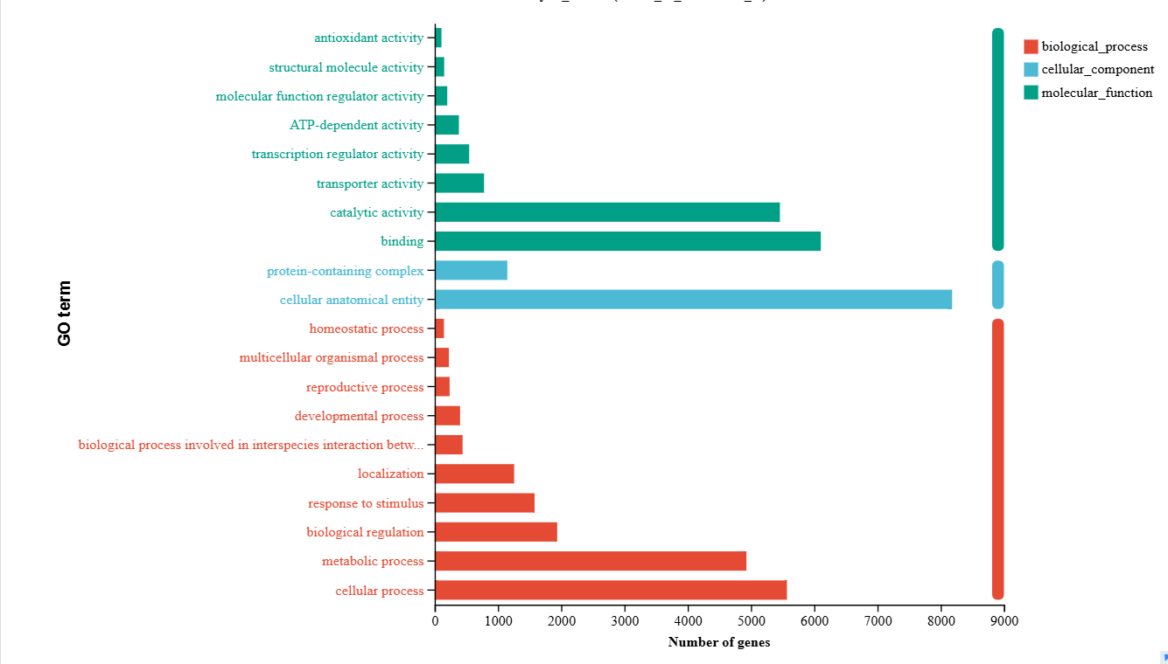
Figure S1. The ordinate in the figure represents the secondary classification term of GO, the abscissa represents the number of genes/transcripts in the secondary classification, and the color represents different gene sets.

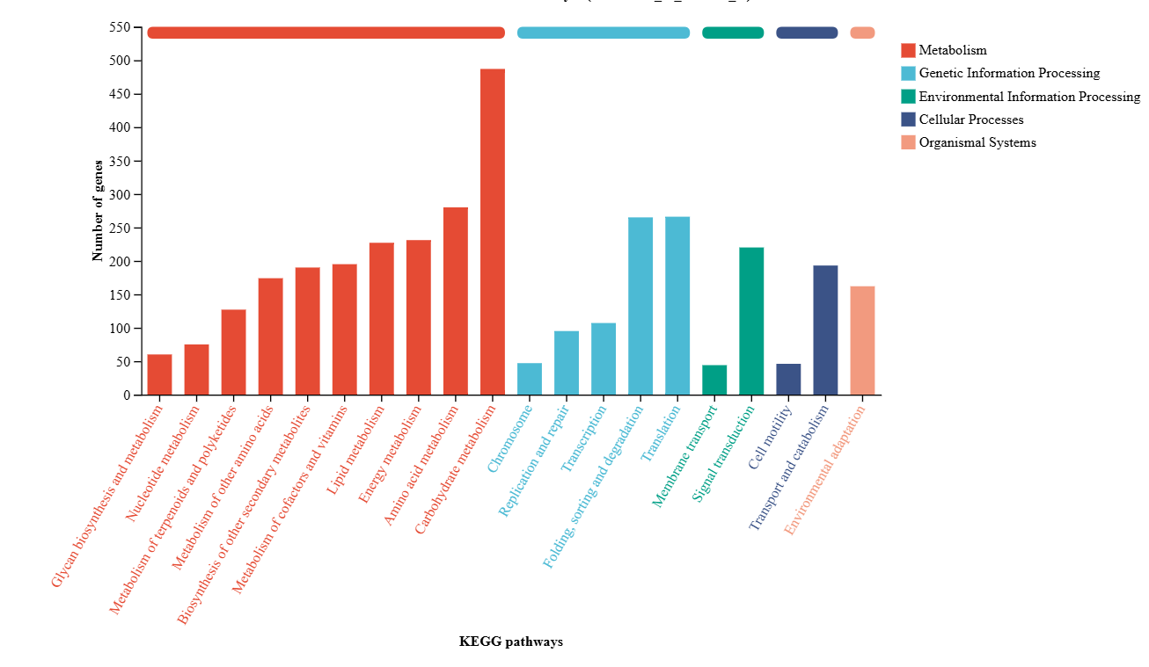Figure S2. The abscissa is the name of the KEGG metabolic pathway; The ordinate is the number of genes or transcripts annotated under that pathway.
Table S4. Highly co-expressed genes in different module.

Module | number
red | 500
magenta | 285
green | 704
black | 358
pink | 324
yellow | 1293
grey | 350
purple | 154
turquoise | 6012
brown | 1437
blue | 4833
Total | 16250

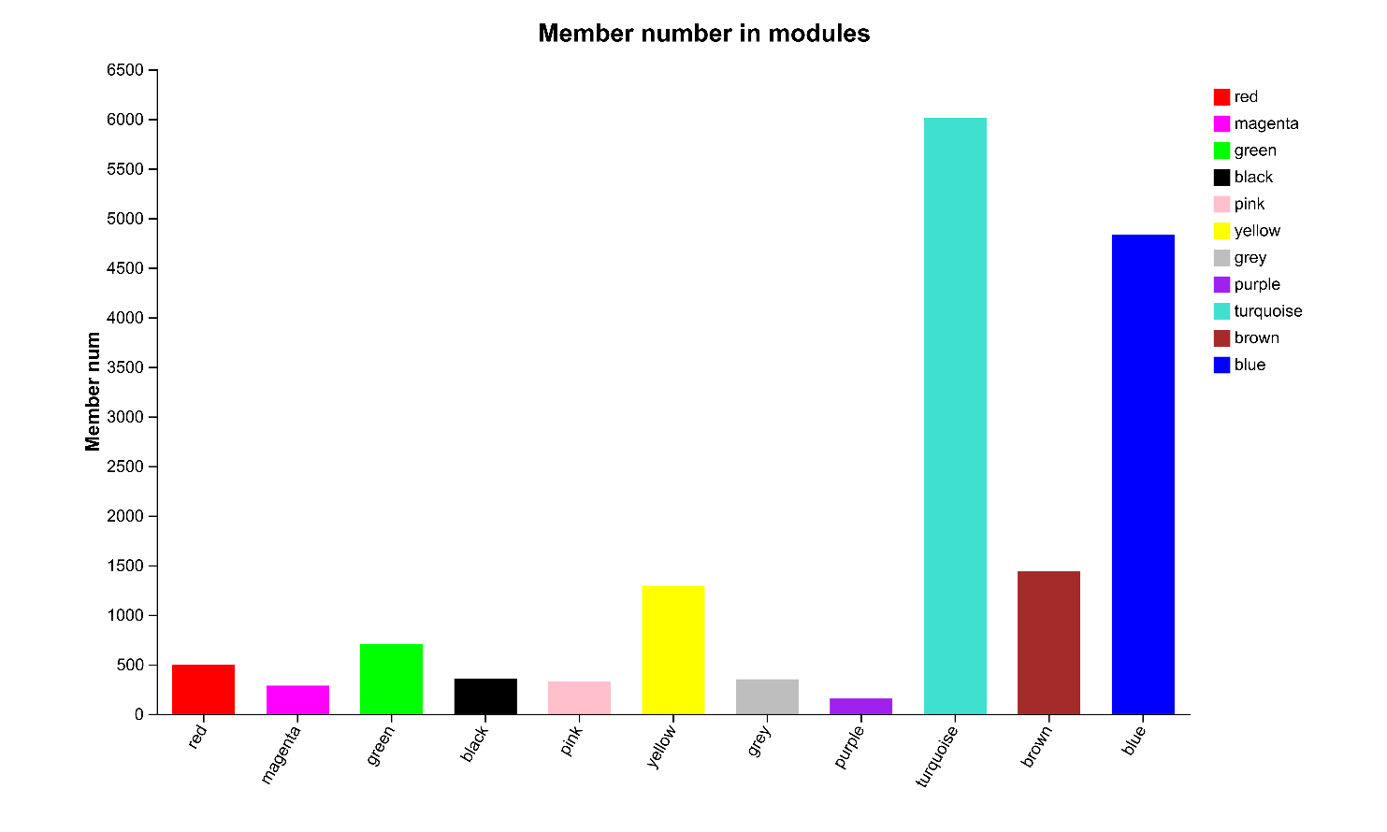

Figure S3. Member numbers in different module.

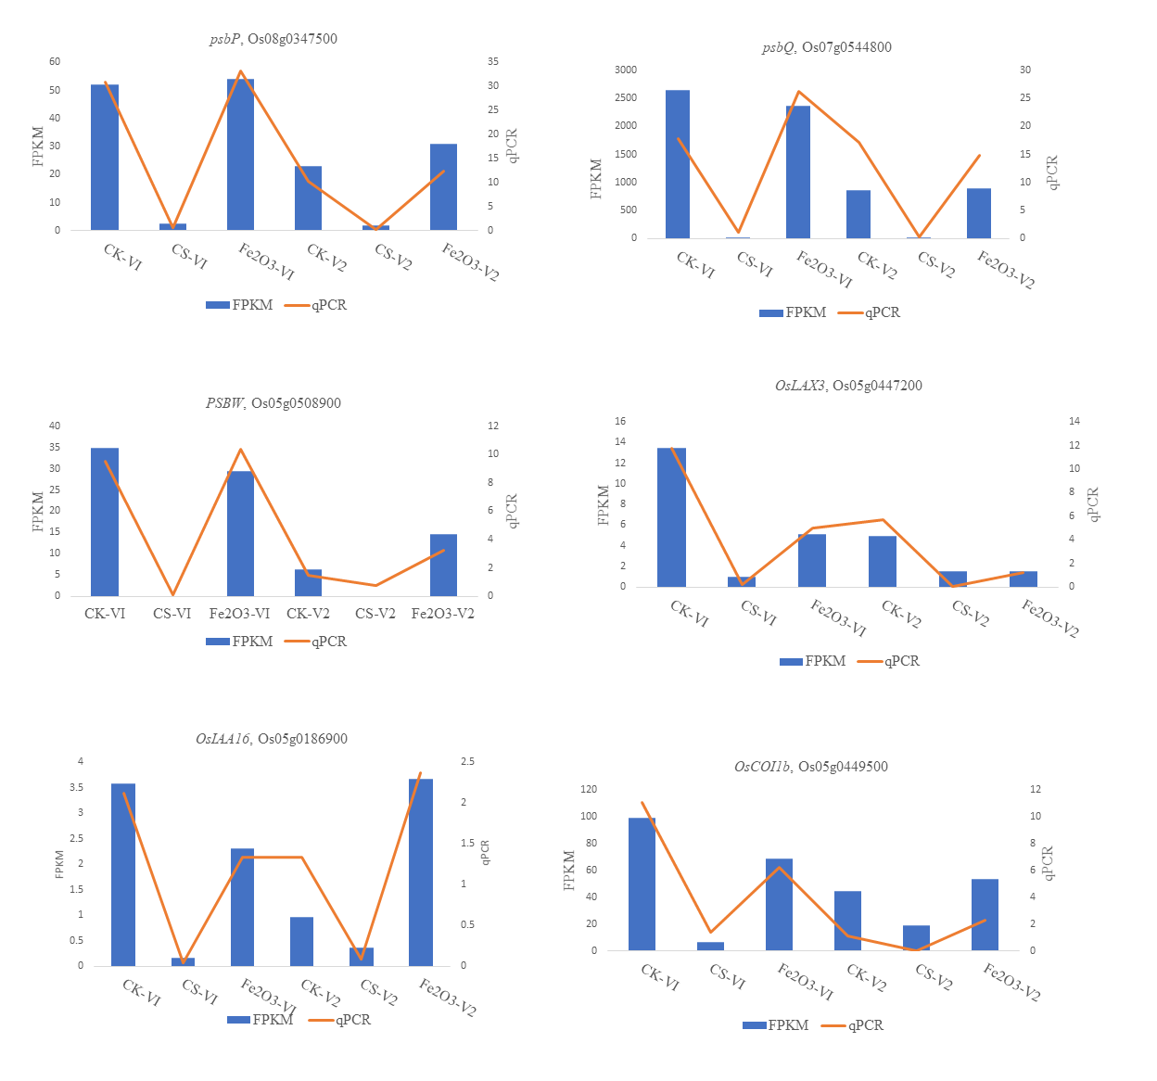
Figure S4. Validation of RNA-Seq data through qRT-PCR.

