Supporting Information
Enhancing the solubility and thermostability of nitrilase through surface hydrophobic residue engineering

Ziyi Li¹, Yina Ren¹, Yuxuan Jiang¹, Chenlan Yan¹, Yiqi Deng¹, Yiyi Li¹, Zhemin Zhou*^{1,2}, Laichuang Han*^{1,2}

¹ Key Laboratory of Industrial Biotechnology (Ministry of Education), School of Biotechnology, Jiangnan University, Wuxi, Jiangsu, China
² Key Laboratory of Industrial Synthetic Biology of Jiangsu Province, Jiangnan University, Wuxi, Jiangsu, 214122, China

*Corresponding authors:
Zhemin Zhou,
Key Laboratory of Industrial Biotechnology (Ministry of Education), School of Biotechnology, Jiangnan University.
Key Laboratory of Industrial Synthetic Biology of Jiangsu Province, Jiangnan University
Wuxi, Jiangsu, 214122, China
E-mail: zhmzhou@jiangnan.edu.cn

Laichuang Han,
Key Laboratory of Industrial Biotechnology (Ministry of Education), School of Biotechnology, Jiangnan University.
Key Laboratory of Industrial Synthetic Biology of Jiangsu Province, Jiangnan University
Wuxi, Jiangsu, 214122, China
E-mail: hanlaichuang@jiangnan.edu.cn

Contents
Figure S1 SDS-PAGE analysis of sfGFP fused proteins 3
Figure S2 SDS-PAGE analysis of the purified enzyme 4
Table S1 Plasmids and strains 5
Table S2 Primers 6

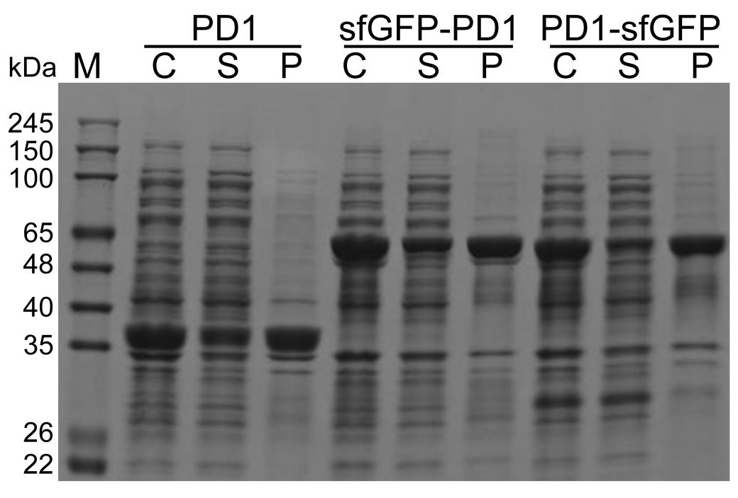

Figure S1 SDS-PAGE analysis of sfGFP fused proteins
PD1, sfGFP-PD1, and PD1-sfGFP are constructs representing the absence of sfGFP fusion, sfGFP fusion at the N-terminus, and sfGFP fusion at the C-terminus, respectively. Protein bands were stained with Coomassie Brilliant Blue. C, whole cells; S, Supernatant after cell lysis; P, Precipitate after cell lysis. M means marker.

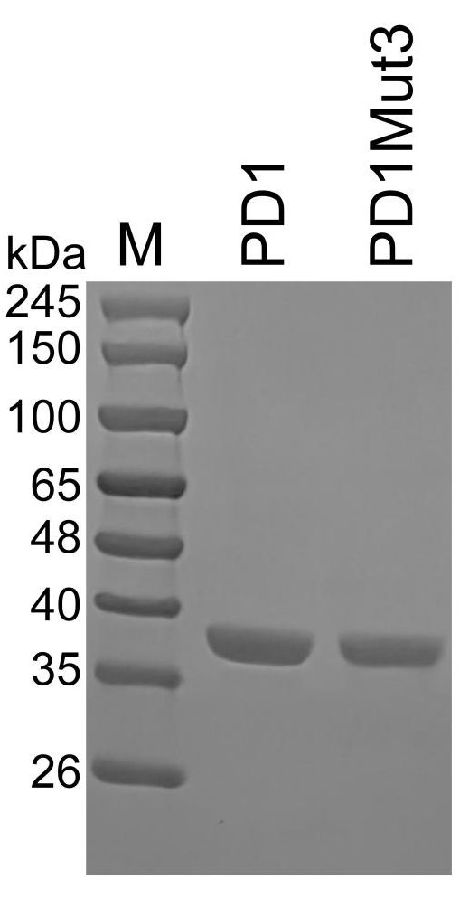

Figure S2 SDS-PAGE analysis of the purified enzyme
The purified enzyme was subjected to SDS-PAGE to determine its purity. Protein bands were stained with Coomassie Brilliant Blue. M means marker.

Table S1 Plasmids and strains
Plasmids and strains | Relevant characteristics | References or source
Plasmids
pET24a-PD1 | Derived from pET24a(+), the mutant PD1 of the nitrilase Nit6803 was expressed by P_{T7-lac} | Lab stork
pET24a-PD1-sfGFP | Derived from pET24a-PD1, sfGFP was fused to the C-terminus of PD1 | This study
pET24a-sfGFP-PD1 | Derived from pET24a-PD1, sfGFP was fused to the N-terminus of PD1 | This study
pET24a-PD1Mut3 | Derived from pET24a-PD1, the triple mutations I5S/V69C/I201T were introduced into PD1 | This study
Strains
E.coli ER2566 | F- λ- fhuA2 [lon] ompT lacZ::T7p07 gal sulA11 Δ(mcrC-mrr)114::IS10 R(mcr-73::miniTn10-TetS)2 R(zgb-210::Tn10)(TetS) endA1 [dcm] | Lab stork

Table S2 Primers
Primers | Sequences (5’-3’)
PI5-NNK-1 | ATATACATATGCTGGGCAAANNKATGCTGAACTATACCAAAAACATTC
PI5-NNK-2 | TTTGCCCAGCATATGTATATCTCC
PF25-NNK-1 | CAGATTAGCCCGGTGCTGNNKAGTCAGCAAGGCACCATGG
PF25-NNK-2 | CAGCACCGGGCTAATCTGCG
PV69-NNK-1 | AGCTTTGTGGAACCGCCGNNKCTGATGGGCAAAAGCCATC
PV69-NNK-2 | CGGCGGTTCCACAAAGCTAAAATAC
PL70-NNK-1 | TTTGTGGAACCGCCGGTGNNKATGGGCAAAAGCCATCTGAAAC
PL70-NNK-2 | CACCGGCGGTTCCACAAAGCTA
PI201-NNK-1 | GGCAGCTTCCTGGGTCAGNNKTTTGCGGATCAGATGGAAGTG
PI201-NNK-2 | CTGACCCAGGAAGCTGCCCG
PL234-NNK-1 | GGCTGACCGATGAACAGAAANNKCAGATTACCACCGATGAAAAAATGC
PL234-NNK-2 | TTTCTGTTCATCGGTCAGCCAGCC
PI5S-1 | ATATACATATGCTGGGCAAAAGCATGCTGAACTATACCAAAAACATTC
PF25N-1 | CAGATTAGCCCGGTGCTGAACAGTCAGCAAGGCACCATGG
PV69C-1 | AGCTTTGTGGAACCGCCGTGCCTGATGGGCAAAAGCCATC
PI201T-1 | GGCAGCTTCCTGGGTCAGACCTTTGCGGATCAGATGGAAGTG

