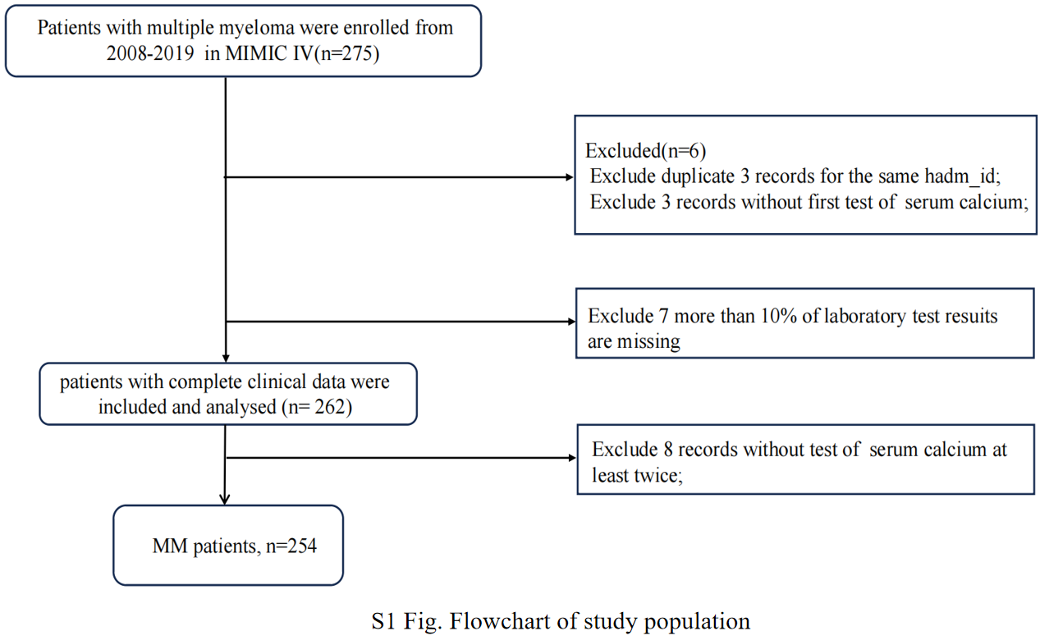

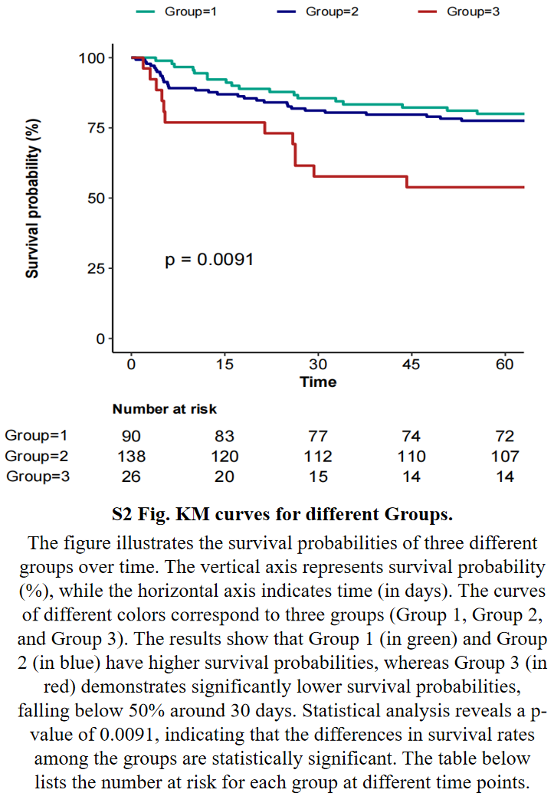

S1 Table. Baseline characteristics of the study population stratified by serum calcium trajectories
Variables | Total (n = 254) | 1 (n = 90) | 2 (n = 138) | 3 (n = 9) | 4 (n = 17) | p
Age(years) | 72.1 ± 10.9 | 71.4 ± 10.1 | 72.7 ± 11.4 | 71.4 ± 15.2 | 71.5 ± 8.7 | 0.833
sex, n (%) |  |  |  |  |  | 0.442
0 | 93 (36.6) | 30 (33.3) | 50 (36.2) | 4 (44.4) | 9 (52.9)
1 | 161 (63.4) | 60 (66.7) | 88 (63.8) | 5 (55.6) | 8 (47.1)
HR-mean(bpm) | 87.8 ± 15.4 | 88.5 ± 13.7 | 87.9 ± 16.7 | 93.3 ± 9.5 | 80.6 ± 13.6 | 0.177
SBP-mean(mmHg) | 116.8 ± 16.7 | 113.9 ± 14.3 | 118.3 ± 17.3 | 129.4 ± 9.0 | 114.2 ± 22.8 | 0.031
DBP-mean(mmHg) | 63.7 ± 10.9 | 62.4 ± 9.8 | 64.5 ± 11.8 | 64.5 ± 6.3 | 63.6 ± 10.8 | 0.558
RR-mean(bpm) | 19.9 ± 3.9 | 20.0 ± 4.1 | 19.6 ± 3.6 | 20.3 ± 4.3 | 21.5 ± 3.9 | 0.269
Temperature-mean(℃) | 36.8 ± 0.4 | 36.9 ± 0.5 | 36.8 ± 0.4 | 36.9 ± 0.6 | 36.8 ± 0.5 | 0.839
SpO2-mean(%) | 96.7 ± 1.9 | 96.5 ± 1.8 | 96.8 ± 1.9 | 97.0 ± 2.2 | 97.2 ± 1.8 | 0.506
Glucose-mean(mg/dL) | 138.1 ± 57.1 | 131.2 ± 43.8 | 141.3 ± 62.5 | 122.2 ± 31.1 | 157.9 ± 77.7 | 0.215
Hematocrit-min(%) | 26.0 ± 5.7 | 24.7 ± 5.2 | 26.9 ± 5.9 | 22.7 ± 6.0 | 27.5 ± 4.3 | 0.005
Hemoglobin-min(g/dL) | 8.6 ± 1.9 | 8.2 ± 1.8 | 8.8 ± 1.9 | 7.4 ± 1.8 | 9.0 ± 1.5 | 0.022
PLT-min (×10⁹/L) | 127.0(66.2, 189.2) | 125.0(60.8, 187.0) | 124.0(67.8, 178.2) | 130.0 (115.0, 149.0) | 163.0 (73.0, 232.0) | 0.517
WBC-max (×10⁹/L) | 8.0 (5.1, 12.1) | 7.9 (4.6, 13.9) | 8.1 (5.3, 11.8) | 7.7 (7.5, 8.3) | 9.7 (7.2, 12.2) | 0.688
Anion gap-max(mmol/L) | 16.8 ± 5.3 | 16.7 ± 5.2 | 16.9 ± 5.6 | 16.8 ± 4.5 | 16.6 ± 3.5 | 0.995
Bicarbonate-min(mmol/L) | 20.4 ± 4.6 | 19.4 ± 4.1 | 20.7 ± 4.6 | 20.4 ± 6.1 | 23.3 ± 4.5 | 0.01
BUN-max(mmol/L) | 31.5 (19.0, 55.0) | 29.0 (18.0, 55.5) | 33.0 (20.0, 53.0) | 60.0 (28.0, 69.0) | 24.0 (19.0, 40.0) | 0.286
Chloride-min(mmol/L) | 101.1 ± 8.0 | 102.4 ± 6.4 | 100.4 ± 9.0 | 101.0 ± 7.1 | 100.4 ± 7.2 | 0.31
Creatinine-max(mg/dL) | 1.5 (0.9, 3.0) | 1.5 (0.8, 3.2) | 1.5 (1.0, 2.9) | 2.3 (2.0, 3.7) | 1.2 (1.0, 1.7) | 0.103
Sodium-min(mmol/L) | 135.8 ± 6.7 | 135.8 ± 6.1 | 135.7 ± 7.3 | 135.9 ± 5.4 | 136.1 ± 4.7 | 0.995
Potassium-max(mmol/L) | 4.6 ± 1.0 | 4.5 ± 0.9 | 4.7 ± 0.9 | 4.9 ± 1.7 | 4.6 ± 1.0 | 0.482
INR-max(s) | 1.6 ± 0.7 | 1.6 ± 0.7 | 1.6 ± 0.8 | 1.3 ± 0.3 | 1.6 ± 0.7 | 0.688
PT-max(s) | 17.2 ± 7.9 | 17.3 ± 7.1 | 17.3 ± 8.6 | 14.5 ± 2.4 | 17.4 ± 8.2 | 0.775
APTT-max(s) | 31.6 (27.4, 41.8) | 31.2 (28.1, 39.9) | 31.1 (27.1, 40.7) | 41.9 (33.1, 50.0) | 34.6 (28.9, 38.9) | 0.562
Myocardial infarct, n (%) |  |  |  |  |  | 0.355
0 | 216 (85.0) | 78 (86.7) | 118 (85.5) | 8 (88.9) | 12 (70.6)
1 | 38 (15.0) | 12 (13.3) | 20 (14.5) | 1 (11.1) | 5 (29.4)
Congestive heart failure,  n (%) |  |  |  |  |  | 0.61
0 | 177 (69.7) | 66 (73.3) | 95 (68.8) | 6 (66.7) | 10 (58.8)
1 | 77 (30.3) | 24 (26.7) | 43 (31.2) | 3 (33.3) | 7 (41.2)
Peripheral vascular disease, n (%) |  |  |  |  |  | 0.196
0 | 238 (93.7) | 85 (94.4) | 129 (93.5) | 7 (77.8) | 17 (100)
1 | 16 ( 6.3) | 5 (5.6) | 9 (6.5) | 2 (22.2) | 0 (0)
Cerebrovascular disease,  n (%) |  |  |  |  |  | 0.512
0 | 231 (90.9) | 83 (92.2) | 125 (90.6) | 9 (100) | 14 (82.4)
1 | 23 ( 9.1) | 7 (7.8) | 13 (9.4) | 0 (0) | 3 (17.6)
Chronic pulmonary disease, n(%) |  |  |  |  |  | 0.468
0 | 193 (76.0) | 68 (75.6) | 106 (76.8) | 5 (55.6) | 14 (82.4)
1 | 61 (24.0) | 22 (24.4) | 32 (23.2) | 4 (44.4) | 3 (17.6)
Liver disease, n (%) |  |  |  |  |  | 0.89
0 | 234 (92.1) | 81 (90) | 128 (92.8) | 9 (100) | 16 (94.1)
1 | 20 ( 7.9) | 9 (10) | 10 (7.2) | 0 (0) | 1 (5.9)
Diabetes without cc, n (%) |  |  |  |  |  | 0.269
0 | 209 (82.3) | 76 (84.4) | 115 (83.3) | 6 (66.7) | 12 (70.6)
1 | 45 (17.7) | 14 (15.6) | 23 (16.7) | 3 (33.3) | 5 (29.4)
Renal disease, n (%) |  |  |  |  |  | 0.847
0 | 147 (57.9) | 53 (58.9) | 77 (55.8) | 6 (66.7) | 11 (64.7)
1 | 107 (42.1) | 37 (41.1) | 61 (44.2) | 3 (33.3) | 6 (35.3)
APSIII | 52.5 ± 22.7 | 55.9 ± 24.3 | 50.5 ± 22.2 | 54.7 ± 19.5 | 50.4 ± 19.1 | 0.343
SAPSII | 48.4 ± 12.4 | 48.8 ± 12.4 | 48.2 ± 12.7 | 49.7 ± 13.7 | 46.9 ± 10.9 | 0.933
OASIS | 32.2 ± 8.7 | 33.0 ± 8.5 | 31.4 ± 8.7 | 31.3 ± 9.2 | 33.9 ± 9.0 | 0.445
SOFA | 5.2 ± 3.4 | 5.5 ± 3.7 | 5.0 ± 3.3 | 6.4 ± 3.7 | 4.5 ± 2.4 | 0.436

Notes: Data presented are mean ± SD, median (IQR), or N (%).
Abbreviations: HR = Heart rate; bpm = beats per minute; RR = Respiratory Rate; bpm = breaths per minute; SBP = Systolic blood pressure; DBP = Diastolic blood pressure; PLT = platelet; WBC = white blood cell; BUN = urea nitrogen; INR = International Normalized Ratio; PT = Prothrombin Time; APTT = Activated Partial Thromboplastin Time; APSIII = Acute Physiology Score III; SAPS II = Simplified Acute Physiology Score II; OASIS = Oxford Acute Severity of Illness Score; SOFA = Sequential Organ Failure Assessment; min = the lowest value; max = the highest value
S2 Table. Characteristics of serum calcium at different time periods based on 60-day mortality
serum calcium | Total (n = 254) | Survival group (n = 193) | Non-survival group (n = 61) | p
Trajectory Class， n (%) |  |  |  | 0.033
1 | 90 (35.4) | 72 (37.3) | 18 (29.5)
2 | 138 (54.3) | 107 (55.4) | 31 (50.8)
3 | 9 ( 3.5) | 6 (3.1) | 3 (4.9)
4 | 17 ( 6.7) | 8 (4.1) | 9 (14.8)
value-day1 | 8.4 (7.8, 8.9) | 8.3 (7.8, 8.9) | 8.6 (7.8, 9.0) | 0.465
value-day3 | 8.3 (7.8, 8.7) | 8.3 (7.8, 8.7) | 8.3 (7.9, 8.9) | 0.687
value-day5 | 8.3 (7.8, 8.8) | 8.3 (7.7, 8.8) | 8.4 (8.0, 8.6) | 0.324
value-day7 | 8.3 (7.9, 8.8) | 8.4 (7.9, 8.8) | 8.3 (8.1, 8.8) | 0.721
value-week2(mean) | 8.4 (7.8, 8.8) | 8.5 (7.8, 8.9) | 8.4 (7.8, 8.6) | 0.459
value-week3(mean) | 8.5 (8.1, 8.8) | 8.4 (8.1, 8.8) | 8.7 (8.0, 8.9) | 0.419
value-week4(mean) | 8.7 (8.4, 9.0) | 8.7 (8.5, 9.0) | 8.4 (8.1, 9.0) | 0.214
max-value-hospital | 8.8 (8.5, 9.3) | 8.8 (8.4, 9.3) | 8.9 (8.6, 9.3) | 0.28
min-value-hospital | 7.7 (7.2, 8.2) | 7.6 (7.2, 8.1) | 7.7 (6.9, 8.4) | 0.984
avg--value-hospital | 8.3 (7.9, 8.7) | 8.3 (7.8, 8.7) | 8.3 (8.0, 8.7) | 0.608

S3 Table. Relationship between different serum calcium Groups and 60-day mortality in different models
Variable |  | Model1 |  |  | Model2 |  |  | Model3 |  |  | Model4
Variable |  | HR (95%CI) | p |  | HR (95%CI) | p |  | HR (95%CI) | p |  | HR (95%CI) | p
Group 1 |  | 0.35 (0.17~0.73) | 0.005 |  | 0.34 (0.16~0.72) | 0.004 |  | 0.27 (0.13~0.56) | 0.001 |  | 0.21 (0.1~0.45) | <0.001
Group 2 |  | 0.42 (0.21~0.81) | 0.01 |  | 0.39 (0.2~0.76) | 0.006 |  | 0.32 (0.16~0.62) | 0.001 |  | 0.3 (0.15~0.61) | 0.001
Group 3 |  | 1(Ref) |  |  | 1(Ref) |  |  | 1(Ref) |  |  | 1(Ref)
Model1: unadjusted model
Model2: adjusted for age, gender
Model3: adjusted for age, gender, SBP-mean, PLT-min, BUN-max and congestive heart failure
Model4: adjusted for age, gender, SBP-mean, PLT-min, BUN-max, congestive heart failure, APSIII, SAPSII, OASIS, SOFA

