Supplementary Information for
Atomical manipulating of Te cluster in photonic glass

Quan Dong^{1,2}, Shichao Lv¹, Yupeng Huang¹, Ziang Liu¹, Jingfei Chen¹, Jianrong Qiu³, and Shifeng Zhou^{1,}*

¹State Key Laboratory of Luminescent Materials and Devices, School of Materials Science and Engineering, South China University of Technology. Guangdong Provincial Key Laboratory of Fiber Laser Materials and Applied Techniques, Guangdong Engineering Technology Research and Development Center of Special Optical Fiber Materials and Devices, Guangzhou 510640, P. R. China.
²Key Laboratory of Testing and Tracing of Rare Earth Products, State Administration for Market Regulation, Jiangxi University of Science and Technology, Ganzhou 341000, P. R. China.
³College of Optical Science and Engineering, State Key Laboratory of Modern Optical Instrumentation, Zhejiang University, Hangzhou 310027, P. R. China.

Correspondence:
Shifeng Zhou (zhoushifeng@scut.edu.cn)

Fig. S1 AC-TEM image and elemental mapping for representative sample 90Ge-10Cs-0.5Te.

Fig. S2 NIR luminescence properties of Te-doped germanate glasses with different alkali metals: 70Ge-30R-0.5Te (R = Li–Cs). (a–d) PLE and PL spectra. (e–h) Excitation wavelength-dependent emission spectra.

Fig. S3 (a) Schematic of the fiber drawing process via the MIT method. (b) Photograph of the fiber preform under natural light. (c) Photograph of the final fiber exhibiting flexibility.

Fig. S4 Experimental setup for characterizing the ASE of Te cluster-activated fiber.

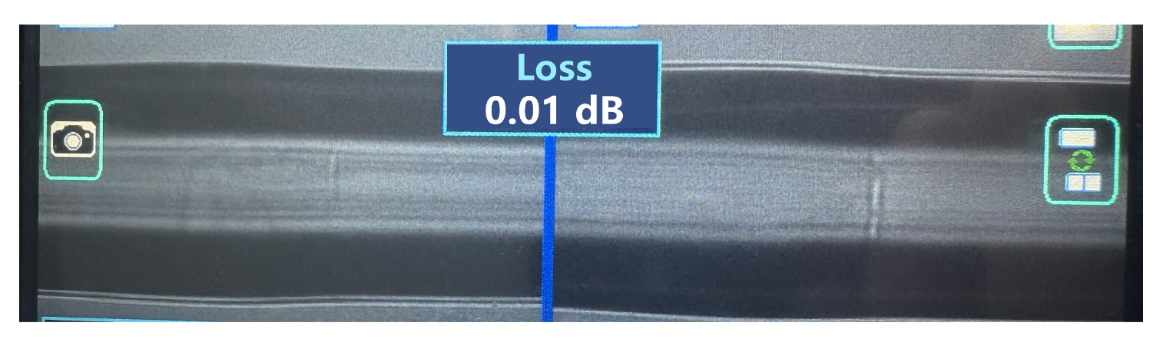
Fig. S5 Splicing loss at the interface between Te cluster-activated fiber and a standard commercial passive fiber.

Fig. S6 Emission spectrum of the red chip. The inset is the photograph of the chip under natural light.

Fig. S7 (a–e) Thermal response of the LED chip at different driving current. (f) Evolution of the glass emission spectrum with current. (g–j) Corresponding false-color NIR images showing intensity enhancement.
The performance of photonic materials is often compromised by thermal effects, which is particularly relevant when integrating them with LED chips due to significant Joule heating. To evaluate this, the temperature of a single chip was first monitored under various driving currents (Figure S7a–e). The results show that the chip temperature rises substantially with increasing current, reaching up to 155 °C. The Te cluster glass was then combined to the chip, and its NIR luminescence intensity was examined under the same driving conditions. As illustrated in Figure S8f, the NIR emission spectra of the glass intensifies with higher current. This enhancement was visually confirmed by NIR camera imaging (Figure S7g–j), where the emitted light brightness increased markedly. Notably, even at 900 mA, where the chip operates at high temperature (~155 °C), the glass maintains strong NIR luminescence, demonstrating good thermal stability under intense excitation.

Fig. S8 Schematic diagram of 2D NIR imaging.
The chip pumps the Te cluster glass, generating intense NIR emission that illuminates the target. The reflected light is then detected by an NIR camera to form an image.

Fig. S9 2D NIR imaging applications of Te cluster-activated glass. (a, b) Photographs of an object hidden behind an 850 nm long-pass filter under ambient light (a) and NIR light (b). (g, h) Visibility comparison through a scattering medium (diluted milk) under natural light (g) and NIR illumination (h). (i, j) A red-marked ancient painting under natural light (i) and NIR light (j).

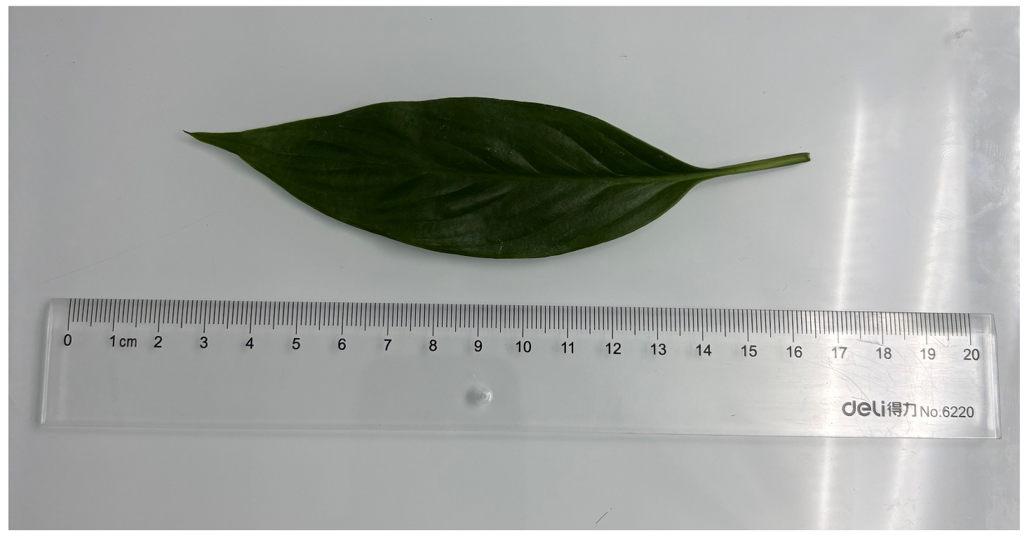
Fig. S10 Photograph of the leave under natural light for NIR imaging.

Fig. S11 (a, b) NIR images reveal water distribution in a fresh leaf (a) and its depletion upon dehydration (b).

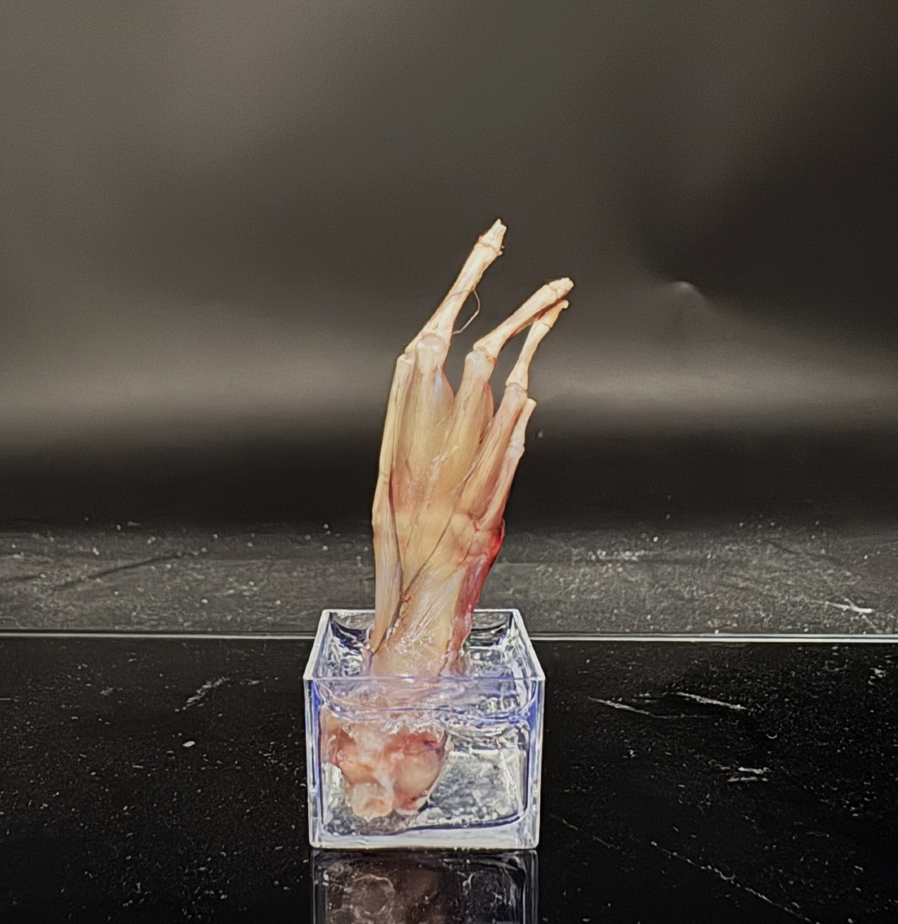
Fig. S12 Photograph of the frog toe specimen.

Fig. S13 Multi-angle NIR projection images of the frog toe specimen acquired over 360° rotation at 5° intervals.

Fig. S14 X-axis serial sections at varying depths with corresponding 2D projections.

Fig. S15 Y-axis serial sections at varying depths with corresponding 2D projections.

Fig. S16 Z-axis serial sections at varying depths with corresponding 2D projections.

Table S1. Potential assignment of Raman peaks for the Te-doped germanate and germanosilicate glasses
Peak  position (cm⁻¹) | Assignment | Reference
185 | Te cluster | 1, 2
370 | Overtone of the fundamental mode of Te cluster | 1, 2
450 | ≥ 5-membered ring, R₅ | 3-6
510 | 4-membered ring, R₄ | 3-6
600 | 3-membered ring, R₃ | 3-6
850 | Si-O-Si bend | 3
960 | Symmetric stretching of [SiO₄] with two NBO | 7
1100 | Symmetric stretching of [SiO₄] with one NBO | 3

Supplementary References
[1] L. Tan, S. Kang, Z. Pan, Y. Zhang, Y. Yue, S. Xu, M. Peng, L. Wondraczek, Adv. Opt. Mater., 4 (2016) 1624-1634.
[2] Q. Dong, K. Zhang, J. Chen, W. Chen, X. Feng, X. Li, Z. He, J. Qiu, S. Zhou, Ceram. Int., 49 (2023) 22313-22322.
[3] H. Aguiar, J. Serra, P. González, B. León, J. Non-Cryst. Solids, 355 (2009) 475-480.
[4] L. Tan, L. Huang, M. Peng, ACS Appl Mater Interfaces, 12 (2020) 51628-51636.
[5] M. Okuno, N. Zotov, M. Schmücker, H. Schneider, J. Non-Cryst. Solids, 351 (2005) 1032-1038.
[6] F.L. Galeener, J. Non-Cryst. Solids, 49 (1982) 53-62.
[7] P. McMillan, Am. Mineral., 69 (1984) 622-644.

