Supporting Information

A Proteoform-Resolved Atlas of Human Cardiac Histones

Zhan Gao¹, Isabella R. Clemmer², Hsin-Ju Chan², Kwame Osei², Holden T. Rogers², Thomas S. Weir², Matthew S. Fischer², Robert L. Gearhart², Scott J. Price³, Yanlong Zhu^{1,4}, Allan R. Brasier^{3,6}, Jingshing Wu⁵, Wuqiang Zhu^{7*}, and Ying Ge^{1,2,4*}

¹Department of Cell and Regenerative Biology, University of Wisconsin-Madison, Madison, Wisconsin 53705, USA.
²Department of Chemistry, University of Wisconsin-Madison, Madison, Wisconsin 53706, USA.
³Department of Medicine, University of Wisconsin-Madison, Madison, Wisconsin 53706, USA
⁴Human Proteomics Program, School of Medicine and Public Health, University of Wisconsin–Madison, Madison, Wisconsin 53705, USA
⁵Department of Pediatrics, Cardiovascular Research Center, University of Wisconsin-Madison, Madison, Wisconsin 53705, USA
⁶Institute for Clinical and Translational Research (ICTR), University of Wisconsin-Madison, Madison, WI 53705, USA
⁷Department of Cardiovascular Medicine, Physiology and Biomedical Engineering, Center for Regenerative Medicine, Mayo Clinic, Arizona 85259, USA

*Correspondence should be addressed to Y.G. (ying.ge@wisc.edu), and W.Z. (Zhu.Wuqiang@mayo.edu).
SUPPLEMENTAL TABLE OF CONTENTS
Supplementary Methods…………………………………………………………………………..4
Supplementary Notes……………………………………………………………………………...7
Supplemental Table and Figures
Supplementary Table 1. Effect of TFA wash on histone and sarcomere protein signal…………10
Supplementary Table 2. List of histone proteoforms identified in top-down LC-MS experiments………………………………………………………………………………………11
Supplementary Figure 1. Reproducibility of histone extraction from human heart tissue with and without TFA wash………………………………………………………………………………..16
Supplementary Figure 2. High instrumental reproducibility of top-down LC-MS analysis…….17
Supplementary Figure 3. Sample-to-sample reproducibility of top-down LC-MS analysis…….18
Supplementary Figure 4. TFA wash effectively depletes cardiac troponin I (cTnI) and enhances H3.3 signal……………………………………………………………………………………….19
Supplementary Figure 5. TFA wash after nuclei isolation enhances histone intensity………….20
Supplementary Figure 6. Quantification of representative histone variants signals……………..21
Supplementary Figure 7. Online top-down MS characterization of representative linker H1 variants…………………………………………………………………………………………...22
Supplementary Figure 8. Online top-down MS characterization of representative H2A variants…………………………………………………………………………………………...23
Supplementary Figure 9. Online top-down MS characterization of representative H2B variants…………………………………………………………………………………………...24
Supplementary Figure 10. Online top-down MS characterization of representative H3 variants.25
Supplementary Figure 11. Online top-down MS characterization of H4 proteoforms…………..26
Supplementary Figure 12. Representative quantitative analysis of proteoform abundances……27
Supplementary Figure 13. High-mass-accuracy intact-mass measurements enable confident assignment of acetylation on representative cardiac histones……………………………………28
Supplementary Figure 14. Separation of oxidized from non-oxidized H4 proteoforms………...29
Supplementary Figure 15. FTICR ECD-MS/MS analysis of H4 proteoforms…………………..30
Supplementary Figure 16. Partial ECD MS/MS spectra showing methylations on 3MeAcH4 and 4MeAcH4 proteoforms…………………………………………………………………………..31
Supplementary Figure 17. Partial ECD MSMS spectra showing methylations at lysine 20 (K20) on 3MeAcH4 proteoform………………………………………………………………………...32
Supplementary Figure 18. Partial ECD MSMS spectra showing methylations at lysine 20 (K20) on 4MeAcH4 proteoform………………………………………………………………………...33
Supplementary Figure 19. Partial ECD MSMS spectra showing two distinct acetylations at lysine 16 and 12 (K16 and K12) on 2MeAc2H4 proteoform…………………………………………...34
Supplementary Figure 20. H3.3 combinatorial methylation resolved by top‑down ECD‑MS/MS…………………………………………………………………………………….35
Supplementary Figure 21. FTICR ECD-MS/MS analysis for H3.3……………………………..36
Supplementary Figure 22. Partial ECD MSMS spectra showing multiple methylations co-occurring on H3.3………………………………………………………………………………..37
Supplementary Figure 23. Detection of truncated H2BC5 from top‑down LC-MS analysis……38
Supplementary Figure 24. FTICR ECD-MS/MS analysis for distinguishing H2B variants…….39
Supplementary Figure 25. ECD fragment ions for identification of H2B1/C1O/1J……………..40
Supplementary Figure 26. Diagnostic fragment ions for resolving H2B variants from FTICR ECD-MS/MS analysis……………………………………………………………………………40
Supplementary Figure 27. Identification of unknown histone variants using targeted online MS/MS and MS-BLAST search…………………………………………………………………41
Supplementary Figure 28. Online CID fragmentation map for T.mH2A1.1 aa[1–213]…………42

SUPPLEMENTARY METHODS

Histone Extraction from Cardiac Tissue
Cardiac tissue was cryopulverized and incubated with 10 volumes (mL per g tissue) of nuclei isolation buffer (NIB; 15 mM Tris‑HCl, 150 mM KCl, 15 mM NaCl, 5 mM MgCl₂, 250 mM sucrose, 1 mM dithiothreitol, 1 mM tris(2‑carboxyethyl)phosphine (TCEP), 1× HALT Protease and Phosphatase Inhibitor Cocktail, and 10 mM sodium butyrate) for 5 min to remove blood proteins. The homogenate was centrifuged at 10,000 × g for 5 min at 4 °C, and the supernatant discarded. The pellet was resuspended in NIB supplemented with 0.3% NP‑40, homogenized with a Polytron at maximum speed (at least 3 strokes) to lyse cells, and incubated on a shaker for 5 min; this wash–homogenization step was repeated once. The sample was then centrifuged at 10,000 × g for 5 min at 4 °C, and the supernatant was discarded. The pellet was resuspended in NIB (15 mM Tris‑HCl, 60 mM KCl, 15 mM NaCl, 5 mM MgCl₂, 250 mM sucrose, 1 mM dithiothreitol, 1 mM TCEP, 1× HALT inhibitors, and 10 mM sodium butyrate), followed by centrifugation at 5,000 × g for 5 min at 4 °C; the supernatant was discarded. In the traditional protocol¹, this NIB wash was performed two additional times. In the optimized workflow, three washes were performed in total, two NIB washes and a single TFA wash (0.1% TFA, 1 mM TCEP; 10 min on a shaker) inserted between the NIB washes. After the TFA wash, the sample was centrifuged at 5,000 × g for 5 min at 4 °C and the supernatant was discarded. Histones were extracted by adding 5 volumes (mL per g tissue) of 0.2 M H₂SO₄ to the pellet and rotating at 4 °C for 2 h. The mixture was centrifuged at 21,000 × g for 15 min at 4 °C, and histones in the supernatant were precipitated by adding 33% trichloroacetic acid (w/v) and incubating on ice for 2 h. The precipitate was washed once with ice‑cold acetone containing 0.1% HCl and twice with pure acetone, then air‑dried. After each acetone wash, samples were centrifuged at 10,000 × g for 2 min, and the acetone supernatant was carefully removed, minimizing disturbance of the histone pellet. Glass pipette tips were used to aspirate the solvent. All steps were done in a 4 °C cold room.

Online top-down RPLC-MS/MS Analysis of histone proteoforms
Histone pellet was dissolved in 100 µL of 10% ACN: 0.2% FA in H₂O, then centrifuged at 21,000 × g for 15 min at 4 °C to remove any particulates. The supernatant was then transferred to Amicon Ultra Centrifugal filters (10 kDa, 500 µL) pre‑washed with 500 µL of the same buffer and spinning at 14,000 × g for 5 min at 4 °C. Samples were concentrated by centrifuging the filters at 14,000 × g for 25 min at 4 °C, then transferred to chilled LC–MS vials for RPLC–MS/MS analysis. Top-down RPLC-MS/MS was performed on an Acquity ultra-high performance LC M-class system (Waters) coupled to a high-resolution maXis II quadrupole time-of-flight (QTOF) mass spectrometer (Bruker Daltonics). 2 µg of total protein was injected onto a home-packed diphenyl column [200 × 0.250 mm, 2.7 µm, 1,000 Å C4 (Halo)], and separated at a constant flow rate of 6 μL/min with the following conditions: 0–5 min, 10% B; 5–15 min, 10–15% B; 15–45 min, 15–25% B; 45–75 min, 25–45% B; 75–90 min, 45–50% B; 90–100 min, 50–55% B; 100–115 min, 55–95% B; 115–120 min, 95–10% B. All changes in the gradient are linear over each period. For the maXis II QTOF, mass spectra were acquired at a scan rate of 1 Hz over 200-3000 m/z range. Ion source parameters such as the end plate offset and capillary voltage were 500 and 4500 V, respectively. The nebulizer gas pressure (N₂), dry gas flow rate, and dry gas temperature were set to 0.5 bar, 4.5 L/min, and 220 °C, respectively. For ion transfer parameters, the funnel RF, multipole RF, quadrupole ion energy, low mass cutoff, and in-source collision-induced dissociation (isCID) energy were optimized to 400 Vpp, 400 Vpp, 5 eV, 650 m/z, and 15 eV, respectively. Additionally, collision RF, pre-pulse storage time, and collision cell transfer time were set to 2500 Vpp, 20 µs, and 110 µs, respectively. Data-dependent LC–MS/MS was performed on each protein extract. The three most intense ions in each mass spectrum were selected and fragmented by collision-induced dissociation (CID) with a scan rate of 0.5 Hz and 1 Hz from 200 to 3000 m/z. The isolation window for online Auto MS/MS CID was 10 m/z. The collision DC bias was set from 18 to 45 eV for CID, with nitrogen as the collision gas. All singly charged ions were excluded for fragmentation and dynamic exclusion was enabled after the collection of 4 of the same precursor ions to prevent fragmentation of the same species. For online targeted CID MS/MS experiments, the precursor ion was set with a width of at least 4 m/z. Collision energies were set to values ranging from 10 to 25 eV.

Offline FTICR Analysis of Histone Proteoforms
Individual histone fractions were collected following RPLC separation for offline MS/MS analysis. A TriVersa Nanomate System (Advion Biosciences) was coupled to a solariX XR 12-T Fourier Transform Ion Cyclotron Resonance mass spectrometer (FTICR-MS, Bruker Daltonics). Ionization was performed using nano-electrospray with the Nanomate, operated at 1.5–1.6 kV with a desolvating gas pressure of 0.50 PSI. The following instrumental parameters were applied: capillary exit, 240 V; deflector plate, 220 V; funnel 1, 150 V; skimmer 1, 50 V; funnel RF amplitude, 300 Vpp; octupole frequency, 5 MHz; octupole RF amplitude, 600 V; collision cell RF frequency, 2 MHz; collision cell RF amplitude, 2000 Vpp. The source dry gas was set to 3 L/min at 180 °C.
The mass range was 200–4000 m/z, and spectra were acquired with acquisition sizes ranging from 512K to 2M. Ions were transferred to the ICR cell with a 1 ms time-of-flight. For tandem MS (MS/MS) experiments, precursor ions were isolated within a defined m/z window and subjected to electron capture dissociation (ECD). Fragmentation was performed with ECD pulse length 50 ms, bias 1-1.5 V, lens 10-15 V and ion accumulation times of 5–50 s.

SUPPLEMENTARY NOTES
Supplementary Note 1. Evaluation of TFA wash and workflow reproducibility
We evaluated the impact of incorporating an additional TFA wash step using both SDS–PAGE and LC–MS analyses and demonstrated high reproducibility with or without TFA wash (Fig. S1-S3). In the absence of TFA wash, conventional acid extraction from cardiac tissue resulted in residual carryover of sarcomeric proteins into the histone pellet. During LC-MS, this carryover appears as interfering protein signals that compromised histone detection. For example, cardiac troponin I (cTnI) co-eluted within the H3.3 window, causing ion suppression and reducing histone signal intensities (Fig.S4). Based on our prior work that TFA could solubilize almost all sarcomere and other interfering proteins², we thus incorporated one TFA wash after nuclei isolation to improve nuclei purity (Fig. S5a). As expected, we observed that the TFA wash step depleted the interfering proteins and increased MS signal intensity for all H3, H2B variants (Fig. S5b, Fig. S6a) and most H2A variants (Fig. S5b, Fig. S6b). The most significant increase was observed for H4 (5.1‑fold; adj. p = 7.61E-4), while the largest fold change occurred for H3.1 (8.4‑fold; adj. p = 7.82E-3), as quantified by area under the curve (AUC) of their extracted ion chromatograms (EICs) (Table. S1). In contrast, linker histone H1 signal intensity decreased following the TFA wash (Fig. S6c), likely reflecting partial disruption of H1–DNA interactions and loosening of nucleosome structure during the brief acid treatment. Overall, this TFA wash markedly enhances core‑histone extractability while reducing H1 recovery. Notably, this reduction occurred uniformly across H1 variants, resulting in unchanged relative variant abundances and indicating no bias in variant-level quantification (Fig. S6d).

Supplementary Note 2: PTM levels Across histone families
Total phosphorylation (Ptotal) is modest overall with levels ranging from 0.02 to 0.23 mol P/mol protein. We observed clear phosphorylation peaks on the large H2A species (T.mH2A1 and U.H2A1–3), while phosphorylation levels were lowest on linker H1s (H1.4/H1.5) and H2A.J. Canonical H2As have phosphorylation levels consistently greater than what was detected for H1s, with an average of 0.06 mol P/mol protein. However, the Ptotals of canonical H2As were slightly lower than the large H2A species (average 0.13 mol P/mol protein) (Fig. 3j). Total succinylation (Stotal) is concentrated on H1 variants, with the highest levels observed on H1.5 (0.08 mol S/mol protein) and comparable quantities on H1.2/H1.4 (~0.07 mol S/mol protein). Contrary to H1 variants, there were uniformly low levels detected across the H2A family (average 0.02 mol S/mol protein), including H2A1C, H2A2A, and H2A.J (Fig. 3k). In our data, acetylation is the most abundant modification (average 0.60 mol Ac/mol protein). It is prominent on canonical H2As (~1.00 mol Ac/mol protein) and detectable on H2A.X (0.98 mol Ac/mol protein) and H2A.J (0.89 mol Ac/mol protein). By contrast, total acetylation is comparatively low on H2A.Z (0.10 mol Ac/mol protein), on the large H2As (T.mH2A1 and U.H2A1–3) (average 0.10 mol Ac/mol protein), and on H1s (average 0.57 mol Ac/mol protein) (Fig. 3l).

Supplementary Note 3: Top-Down MS/MS Mapping of Combinatorial H4 PTMs
The resulting sequence maps (Fig. 5j) pinpointed the methylation to arginine 3 (R3) and lysine 20 (K20) and placed acetylation on the N‑terminus (S1) and on lysine 12 and lysine 16 (K12/K16) (Fig. 4j). In the MS/MS spectra, near‑continuous c ions across the N‑terminal tail provided the key evidence: the +14.02 Da shifts on c3 ions at R3 confirmed R3me in 3MeAcH4 and R3me/R3me2 in 4MeAcH4 proteoforms (Fig. S16). Consistent with this assignment, the methylation distribution of the c19 ions from 3MeAcH4a and 4MeAcH4 proteoforms are nearly identical to that of the c3 ion, with no significant increase in dimethylation observed, indicating no additional methylation within residues G4-R19 (Fig. S17a, Fig. S18a). In contrast, the c22 ions, which extend across K20, show absence of mono-methylation peaks together with clear di‑ and trimethylation, suggesting variable K20 methylation states (me1/me2/me3) (Fig. S17b, Fig. S18b). A low abundance dimethyl c22 ion from 4MeAcH4 proteoform suggests that additional methylation is placed outside K20 (Fig. S18b).

SUPPLEMENTARY TABLES

Supplementary Table 1. Effect of TFA wash on histone and sarcomere protein signal. Summary of fold change in AUC (TFA wash / no TFA wash) with corresponding p-values and adjusted (adj.) p-values. Differences between groups were considered statistically significant at an adj. p-value < 0.05, based on the Benjamini–Hochberg method for controlling the false discovery rate.
Protein | Fold Change | p-value | Adj. p-value
H4 | 5.1 | 4.48E-05 | 8.96E-04
H3.1 | 8.4 | 2.30E-03 | 6.58E-03
H3.3 | 3.3 | 1.38E-03 | 6.58E-03
H2B2E | 2.1 | 2.28E-03 | 6.58E-03
H2A1C | 1.5 | 1.91E-03 | 6.58E-03
H3.2 | 4.7 | 9.00E-03 | 2.25E-02
H2A1 | 1.5 | 0.01 | 2.70E-02
H2A1B | 1.7 | 0.02 | 3.04E-02
H2A1J | 2.0 | 0.03 | 0.05
H2A.X | 1.4 | 0.04 | 0.06
H2A1H | 1.8 | 0.05 | 0.07
H2A2A | 1.2 | 0.08 | 0.11
H2A.J | 1.2 | 0.10 | 0.13
H2A.V | 1.2 | 0.13 | 0.16
H2A.Z | 0.7 | 0.36 | 0.40
H2A2B | 1.1 | 0.61 | 0.64
H2A2C | 1.0 | 0.88 | 0.88
cTnI | 0.5 | 2.42E-04 | 1.61E-03
cTnT | 0.2 | 1.14E-04 | 1.14E-03
Tpm | 0.5 | 1.38E-02 | 2.77E-02

Supplementary Table 2. List of histone proteoforms identified in top-down LC-MS experiments. Proteoform information including Uniprot identifiers, proteoform names, protein modifications, calculated (calc’d) and experimentally (expt’l) monoisotopic masses, and mass error. Proteoforms were either identified by MS/MS in this study or by accurate mass measurements based on previous publications or information derived from Uniprot. Abbreviations: N-terminal acetylation (N-acetyl); acetylation (acetyl); methylation (methyl); methionine (Met); trimethylation (trimethyl); phosphorylation (phosphoryl); succinylation (succinyl).
Uniprot ID | Protein | Modified Form | Calc'd Mass (Da) | Expt'l Mass (Da) | Error (ppm)
P07305 | H1.0 | Met Removal | 20719.15 | 20719.12 | 1.4
P07305 | H1.0 | Met Removal, Acetyl | 20761.16 | 20761.18 | 1.0
P16403 | H1.2 | Met Removal, N-Acetyl | 21262.72 | 21262.70 | 0.9
P16403 | H1.2 | Polymorphism |  | 21289.78
P16403 | H1.2 | Met Removal, N-Acetyl, Succinyl | 21362.73 | 21362.70 | 1.4
P16403 | H1.2 | Polymorphism |  | 21389.71
P16402 | H1.3 | Met Removal, N-Acetyl | 22247.29 | 22247.26 | 1.3
P10412 | H1.4 | Met Removal |  | 21720.99 | 0.0
P10412 | H1.4 | Met Removal, N-Acetyl | 21762.96 | 21762.96 | 0.0
P10412 | H1.4 | Met Removal, N-Acetyl, Acetyl | 21804.98 | 21804.98 | 0.0
P10412 | H1.4 | Met Removal, N-Acetyl, Phosphoryl | 21842.94 | 21842.95 | 0.5
P10412 | H1.4 | Met Removal, N-Acetyl, Succinyl | 21862.99 | 21862.97 | 0.9
P10412 | H1.4 | Met Removal, N-Acetyl, Succinyl, Phosphoryl | 21942.96 | 21942.86 | 4.7
P10412 | H1.4 | Met Removal, N-Acetyl, 2*Succinyl | 21963.00 | 21962.91 | 4.1
P16401 | H1.5 | Met Removal, N-Acetyl | 22477.44 | 22477.41 | 1.3
P16401 | H1.5 | Met Removal, N-Acetyl, Acetyl | 22519.45 | 22519.44 | 0.4
P16401 | H1.5 | Met Removal, N-Acetyl, Phosphoryl | 22557.40 | 22557.41 | 0.3
P16401 | H1.5 | Met Removal, N-Acetyl, Succinyl | 22577.45 | 22577.41 | 1.8
Q92522 | H1.10 | Met Removal, N-Acetyl | 22384.50 | 22384.47 | 1.3
Q16777 | H2A2C | Met Removal, N-Acetyl | 13890.81 | 13890.78 | 2.2
Q6FI13 | H2A2A | Met Removal, N-Acetyl | 13997.86 | 13997.84 | 1.4
Q6FI13 | H2A2A | Met Removal, N-Acetyl, Acetyl | 14039.87 | 14039.85 | 1.4
Q6FI13 | H2A2A | Met Removal, N-Acetyl, Phosphoryl | 14077.83 | 14077.82 | 0.7
Q6FI13 | H2A2A | Met Removal, N-Acetyl, Succinyl | 14097.88 | 14097.81 | 5.0
Q93077 | H2A1C | Met Removal, N-Acetyl | 14007.91 | 14007.93 | 1.4
Q93077 | H2A1C | Met Removal, N-Acetyl, Acetyl | 14049.92 | 14049.91 | 1.1
Q93077 | H2A1C | Met Removal, N-Acetyl, Phosphoryl | 14087.88 | 14087.88 | 0.0
Q93077 | H2A1C | Met Removal, N-Acetyl, Succinyl | 14107.93 | 14107.89 | 2.8
P0C0S8 | H2A1 | Met Removal, N-Acetyl | 13993.92 | 13993.93 | 0.7
P04908 | H2A1B | Met Removal, N-Acetyl | 14037.92 | 14037.92 | 0.0
P16104 | H2AX | Met Removal, N-Acetyl | 15046.38 | 15046.37 | 0.7
P16104 | H2AX | Met Removal, N-Acetyl, Acetyl | 15088.40 | 15088.37 | 2.0
P16104 | H2AX | Met Removal, N-Acetyl, Phosphoryl | 15126.35 | 15126.36 | 0.7
Q9BTM1 | H2A.J | Met Removal, N-Acetyl | 13921.90 | 13921.87 | 2.2
Q9BTM1 | H2A.J | Met Removal, N-Acetyl, Acetyl | 13963.91 | 13963.88 | 2.1
Q9BTM1 | H2A.J | Met Removal, N-Acetyl, Phosphoryl | 14001.86 | 14001.86 | 0.0
Q9BTM1 | H2A.J | Met Removal, N-Acetyl, Phosphoryl, Succinyl | 14021.91 | 14021.88 | 2.1
Q96KK5 | H2A1H | Met Removal, N-Acetyl | 13808.80 | 13808.81 | 0.7
Q99878 | H2A1J | Met Removal, N-Acetyl | 13838.81 | 13838.82 | 0.7
Q99878 | H2A1J | Met Removal, N-Acetyl, Acetyl | 13880.82 | 13880.81 | 0.7
Q99878 | H2A1J | Met Removal, N-Acetyl, Phosphoryl | 13918.78 | 13918.79 | 0.7
Q8IUE6 | H2A2B | Met Removal, N-Acetyl | 13897.81 | 13897.78 | 2.2
Q8IUE6 | H2A2B | Met Removal, N-Acetyl, Acetyl | 13939.82 | 13939.82 | 0.0
Q8IUE6 | H2A2B | Met Removal, N-Acetyl, Phosphoryl | 13977.78 | 13977.8 | 1.4
Q71UI9 | H2A.V | Met Removal | 13369.49 | 13369.48 | 0.7
P0C0S5 | H2A.Z | Met Removal | 13413.51 | 13413.51 | 0.0
P0C0S5 | H2A.Z | Met Removal, Acetyl | 13455.52 | 13455.50 | 1.7
O75367-2 | mH2A1.1 aa[1–213] | Truncated aa[1-213] | 22433.51 | 22433.46 | 2.2
O75367-2 | mH2A1.1 aa[1–213] | Truncated aa[1-213], Acetyl/Trimethyl | 22475.52 | 22475.54 | 0.9
O75367-2 | mH2A1.1 aa[1–213] | Phosphoryl | 22513.47 | 22513.50 | 1.3
O60814 | H2B1K | Met Removal | 13750.52 | 13750.53 | 0.7
P58876 | H2B1D | Met Removal | 13796.53 | 13796.52 | 0.7
P58876 | H2B1D | truncated aa[27-126] | 11195.03 | 11195.03 | 0.0
P58876 | H2B1D | truncated aa[27-126], Methyl Equivalents | 11209.05 | 11209.04 | 0.9
Q99880 | H2B1L | Met Removal | 13812.56 | 13812.52 | 2.9
Q16778 | H2B2E | Met Removal | 13780.53 | 13780.53 | 0.0
Q16778 | H2B2E | Met Removal, Acetyl | 13822.54 | 13822.53 | 0.7
Q99877 | H2B1N | Met Removal | 13782.51 | 13782.51 | 0.0
P68431 | H3.1 | Met Removal, 2*Methyl Equivalents | 15291.47 | 15291.49 | 1.3
P68431 | H3.1 | Met Removal, 3*Methyl Equivalents | 15305.49 | 15305.50 | 0.7
P68431 | H3.1 | Met Removal, 4*Methyl Equivalents | 15319.51 | 15319.51 | 0.2
P68431 | H3.1 | Met Removal, 5*Methyl Equivalents | 15333.52 | 15333.52 | 0.0
P68431 | H3.1 | Met Removal, 6*Methyl Equivalents | 15347.54 | 15347.53 | 0.5
P68431 | H3.1 | Met Removal, 7*Methyl Equivalents | 15361.55 | 15361.53 | 1.1
P68431 | H3.1 | Met Removal, 8*Methyl Equivalents | 15375.57 | 15375.54 | 2.2
P68431 | H3.1 | Met Removal, 9*Methyl Equivalents | 15389.58 | 15389.55 | 1.9
P68431 | H3.1 | Met Removal, 10*Methyl Equivalents | 15403.60 | 15403.60 | 0.0
P68431 | H3.1 | Met Removal, 11*Methyl Equivalents | 15417.62 | 15417.58 | 2.6
P68431 | H3.1 | Met Removal, 12*Methyl Equivalents | 15431.63 | 15431.57 | 3.9
P68431 | H3.1 | Met Removal, 13*Methyl Equivalents | 15445.65 | 15445.61 | 2.6
P68431 | H3.1 | Met Removal, 14*Methyl Equivalents | 15459.66 | 15459.60 | 3.9
Q71DI3 | H3.2 | Met Removal, 2*Methyl Equivalents | 15275.50 | 15275.51 | 0.7
Q71DI3 | H3.2 | Met Removal, 3*Methyl Equivalents | 15289.51 | 15289.53 | 1.3
Q71DI3 | H3.2 | Met Removal, 5*Methyl Equivalents | 15303.53 | 15303.54 | 0.7
Q71DI3 | H3.2 | Met Removal, 6*Methyl Equivalents | 15317.54 | 15317.55 | 0.7
Q71DI3 | H3.2 | Met Removal, 7*Methyl Equivalents | 15331.56 | 15331.56 | 0.0
Q71DI3 | H3.2 | Met Removal, 8*Methyl Equivalents | 15345.58 | 15345.56 | 1.3
Q71DI3 | H3.2 | Met Removal, 9*Methyl Equivalents | 15359.59 | 15359.57 | 1.3
Q71DI3 | H3.2 | Met Removal, 10*Methyl Equivalents | 15373.61 | 15373.57 | 2.6
Q71DI3 | H3.2 | Met Removal, 11*Methyl Equivalents | 15387.62 | 15387.57 | 3.2
Q71DI3 | H3.2 | Met Removal, 12*Methyl Equivalents | 15401.64 | 15401.57 | 4.5
Q71DI3 | H3.2 | Met Removal, 13*Methyl Equivalents | 15415.65 | 15415.61 | 2.6
Q71DI3 | H3.2 | Met Removal, 14*Methyl Equivalents | 15429.67 | 15429.60 | 4.5
Q71DI3 | H3.2 | Met Removal, 15*Methyl Equivalents | 15443.69 | 15443.63 | 3.9
P84243 | H3.3 | Met Removal, 2*Methyl Equivalents | 15215.49 | 15215.47 | 1.3
P84243 | H3.3 | Met Removal, 3*Methyl Equivalents | 15229.51 | 15229.52 | 0.7
P84243 | H3.3 | Met Removal, 4*Methyl Equivalents | 15243.52 | 15243.54 | 1.3
P84243 | H3.3 | Met Removal, 5*Methyl Equivalents | 15257.54 | 15257.55 | 0.7
P84243 | H3.3 | Met Removal, 6*Methyl Equivalents | 15271.56 | 15271.55 | 0.7
P84243 | H3.3 | Met Removal, 7*Methyl Equivalents | 15285.57 | 15285.56 | 0.7
P84243 | H3.3 | Met Removal, 8*Methyl Equivalents | 15299.59 | 15299.56 | 2.0
P84243 | H3.3 | Met Removal, 9*Methyl Equivalents | 15313.60 | 15313.56 | 2.6
P84243 | H3.3 | Met Removal, 10*Methyl Equivalents | 15327.62 | 15327.56 | 3.9
P84243 | H3.3 | Met Removal, 11*Methyl Equivalents | 15341.63 | 15341.56 | 4.6
P84243 | H3.3 | Met Removal, 12*Methyl Equivalents | 15355.65 | 15355.60 | 3.3
P84243 | H3.3 | Met Removal, 13*Methyl Equivalents | 15369.67 | 15369.60 | 4.6
P84243 | H3.3 | Met Removal, 14*Methyl Equivalents | 15383.68 | 15383.60 | 5.2
P62805 | H4 | Met Removal, N-Acetyl, Methyl Equivalents | 11285.37 | 11285.36 | 0.9
P62805 | H4 | Met Removal, N-Acetyl, 2*Methyl Equivalents | 11299.38 | 11299.38 | 0.0
P62805 | H4 | Met Removal, N-Acetyl, 3*Methyl Equivalents | 11313.40 | 11313.39 | 0.9
P62805 | H4 | Met Removal, N-Acetyl, 4*Methyl Equivalents | 11327.41 | 11327.38 | 2.6
P62805 | H4 | Met Removal, N-Acetyl, Acetyl, 2*Methyl Equivalents | 11341.39 | 11341.39 | 0.0
P62805 | H4 | Met Removal, N-Acetyl, Acetyl, 3*Methyl Equivalents | 11355.41 | 11355.39 | 1.8
P62805 | H4 | Met Removal, N-Acetyl, Acetyl, 4*Methyl Equivalents | 11369.42 | 11369.39 | 2.6
P62805 | H4 | Met Removal, N-Acetyl, 2*Methyl Equivalents, phosphoryl | 11379.35 | 11379.40 | 4.4
P62805 | H4 | Met Removal, N-Acetyl, 2*Methyl Equivalents, Succinyl | 11399.40 | 11399.37 | 2.6
P62805 | H4 | Met Removal, N-Acetyl, 2*Acetyl, 2*Methyl Equivalents | 11383.40 | 11383.40 | 0.0
P62805 | H4 | Met Removal, N-Acetyl, Acetyl, 2*Methyl Equivalents, Phosphoryl | 11421.36 | 11421.42 | 5.3
P62805 | H4 | Met Removal, N-Acetyl, Acetyl, 2*Methyl Equivalents, Succinyl | 11441.41 | 11441.38 | 2.6
P62805 | H4 | Met Removal, N-Acetyl, 2*Acetyl, 3*Methyl Equivalents | 11397.42 | 11397.41 | 0.9
P62805 | H4 | Met Removal, N-Acetyl, 2*Acetyl, 4*Methyl Equivalents | 11411.44 | 11411.40 | 3.5
P62805 | H4 | Met Removal, N-Acetyl, 2*Acetyl, 2*Methyl Equivalents, Phosphoryl | 11463.37 | 11463.4 | 2.6
P62805 | H4 | Met Removal, N-Acetyl, 2*Acetyl, 2*Methyl Equivalents, Succinyl | 11483.42 | 11483.36 | 5.2
P62805 | H4 | Met Removal, N-Acetyl, 3*Acetyl, 2*Methyl Equivalents | 11425.41 | 11425.41 | 0.0
P62805 | H4 | Met Removal, N-Acetyl, 3*Acetyl, 3*Methyl Equivalents | 11439.43 | 11439.42 | 0.9
P62805 | H4 | Met Removal, N-Acetyl, 3*Acetyl, 4*Methyl Equivalents | 11453.44 | 11453.4 | 3.5
P62805 | H4 | Met Removal, N-Acetyl, 4*Acetyl, 2*Methyl Equivalents | 11467.43 | 11467.38 | 4.4
P62805 | H4 | Met Removal, N-Acetyl, 4*Acetyl, 3*Methyl Equivalents | 11481.44 | 11481.39 | 4.4
P62805 | H4 | Met Removal, N-Acetyl, 3*Acetyl, 2*Methyl Equivalents, Succinyl | 11525.43 | 11525.38 | 4.3

SUPPLEMENTARY FIGURES
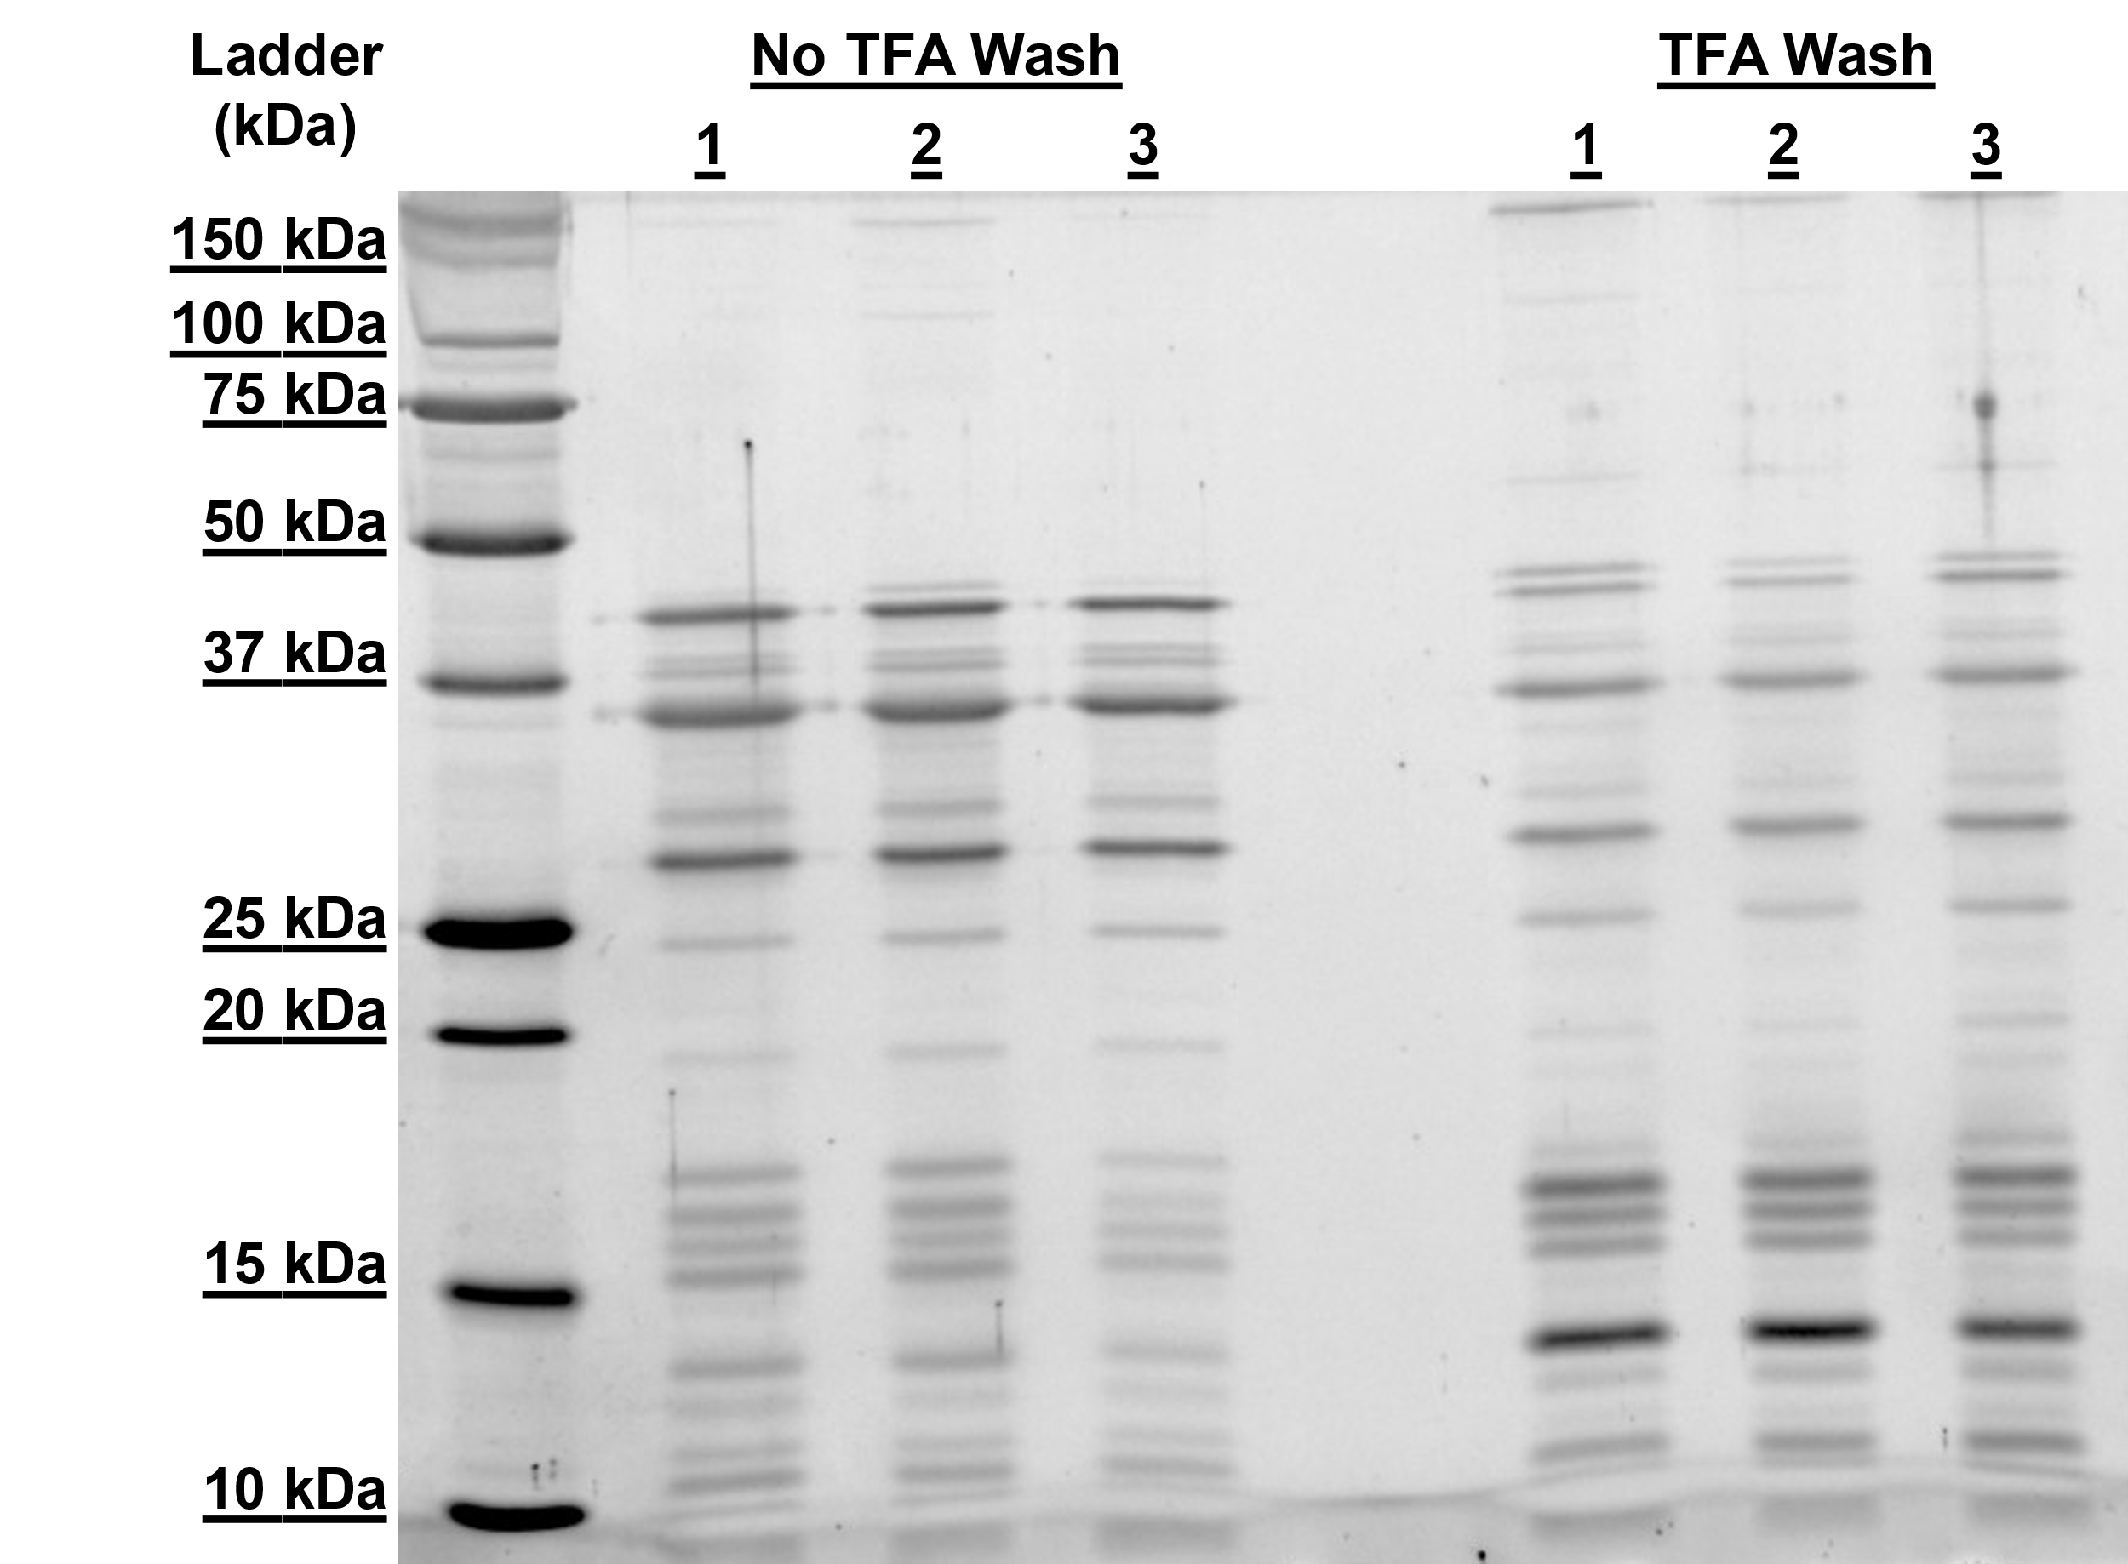

Supplementary Figure 1. Reproducibility of histone extraction from human heart tissue with and without TFA wash. Sypro Ruby–stained SDS–PAGE (1 µg total protein per lane) from extracts prepared without TFA wash (left) or with one TFA wash (right). Both workflows show highly reproducible protein bands and intensities across replicates.

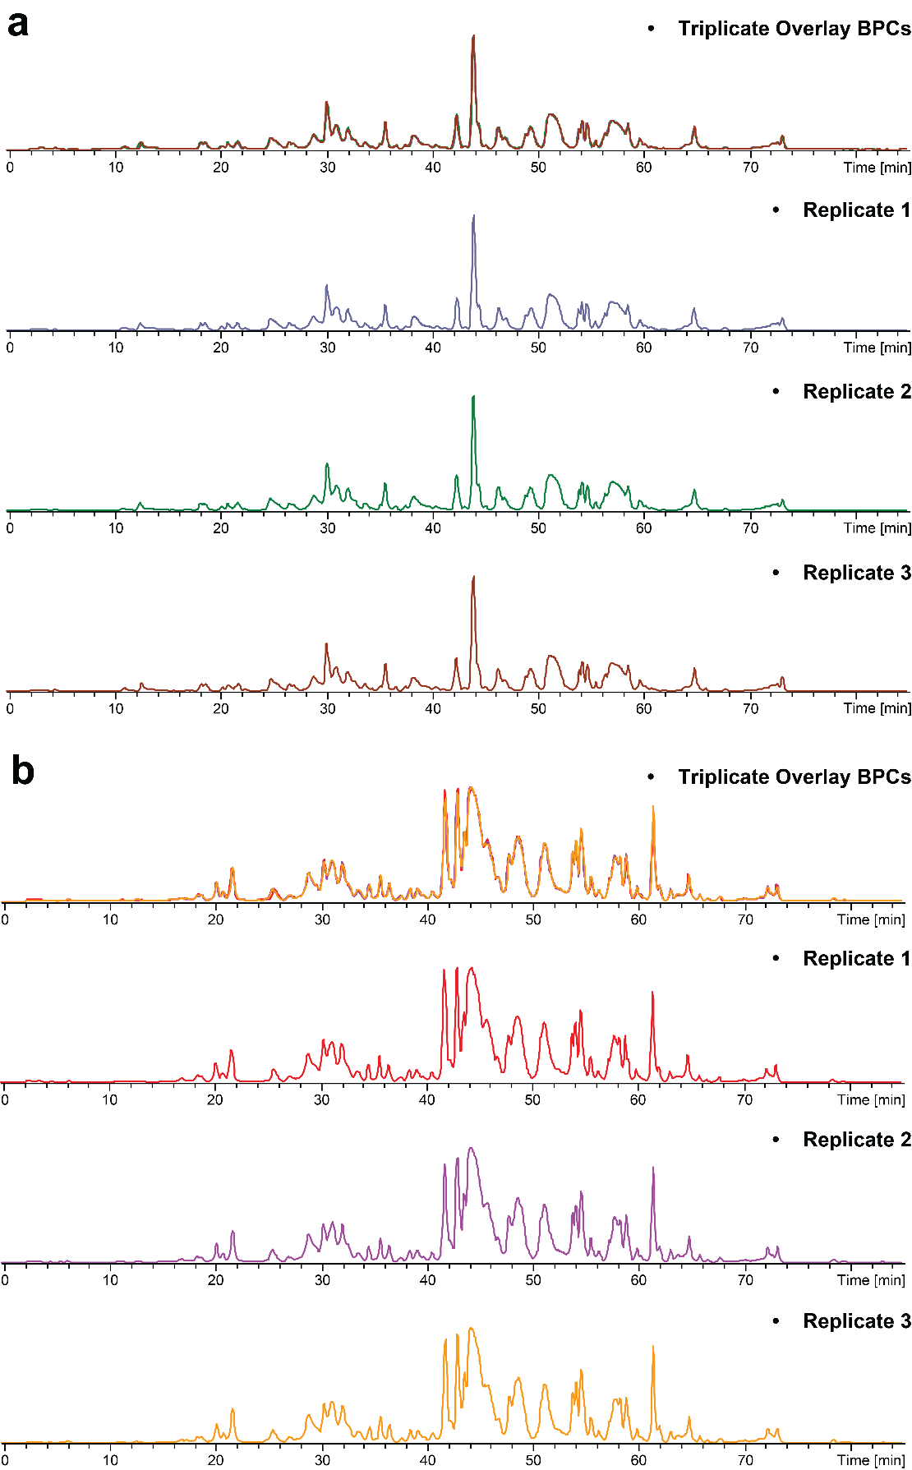
Supplementary Figure 2. High instrumental reproducibility of top-down LC-MS analysis. Base peak chromatograms (BPCs) from three replicate injections of the same histone extract show highly consistent traces, demonstrating high run-to-run reproducibility for both workflows: (a) without TFA wash and (b) with one TFA wash.
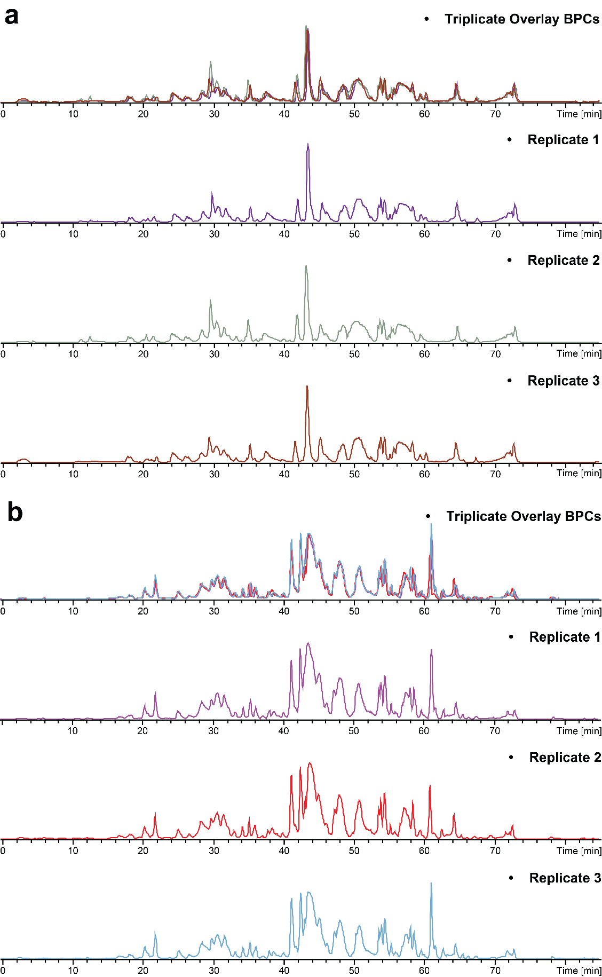
Supplementary Figure 3. Sample-to-sample reproducibility of top-down LC-MS analysis. Base peak chromatograms (BPCs) from three independent histone extracts overlap closely, demonstrating high reproducibility across samples for both workflows: (a) without TFA wash and (b) with one TFA wash.
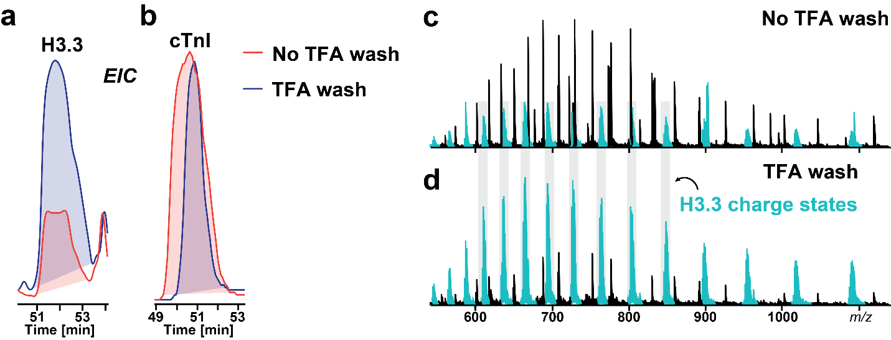Supplementary Figure 4. TFA wash effectively depletes cardiac troponin I (cTnI) and enhances H3.3 signal. EIC of (a) H3.3 and (b) cTnI with and without a TFA wash. MS1 scans from the same elution window (c) without (No TFA wash and (d) with (TFA wash, bottom) the wash. The TFA wash markedly reduces cTnI intensity while increasing the H3.3 signal, facilitating reliable quantification and downstream MS/MS. Grey bands denote representative H3.3 charge states.

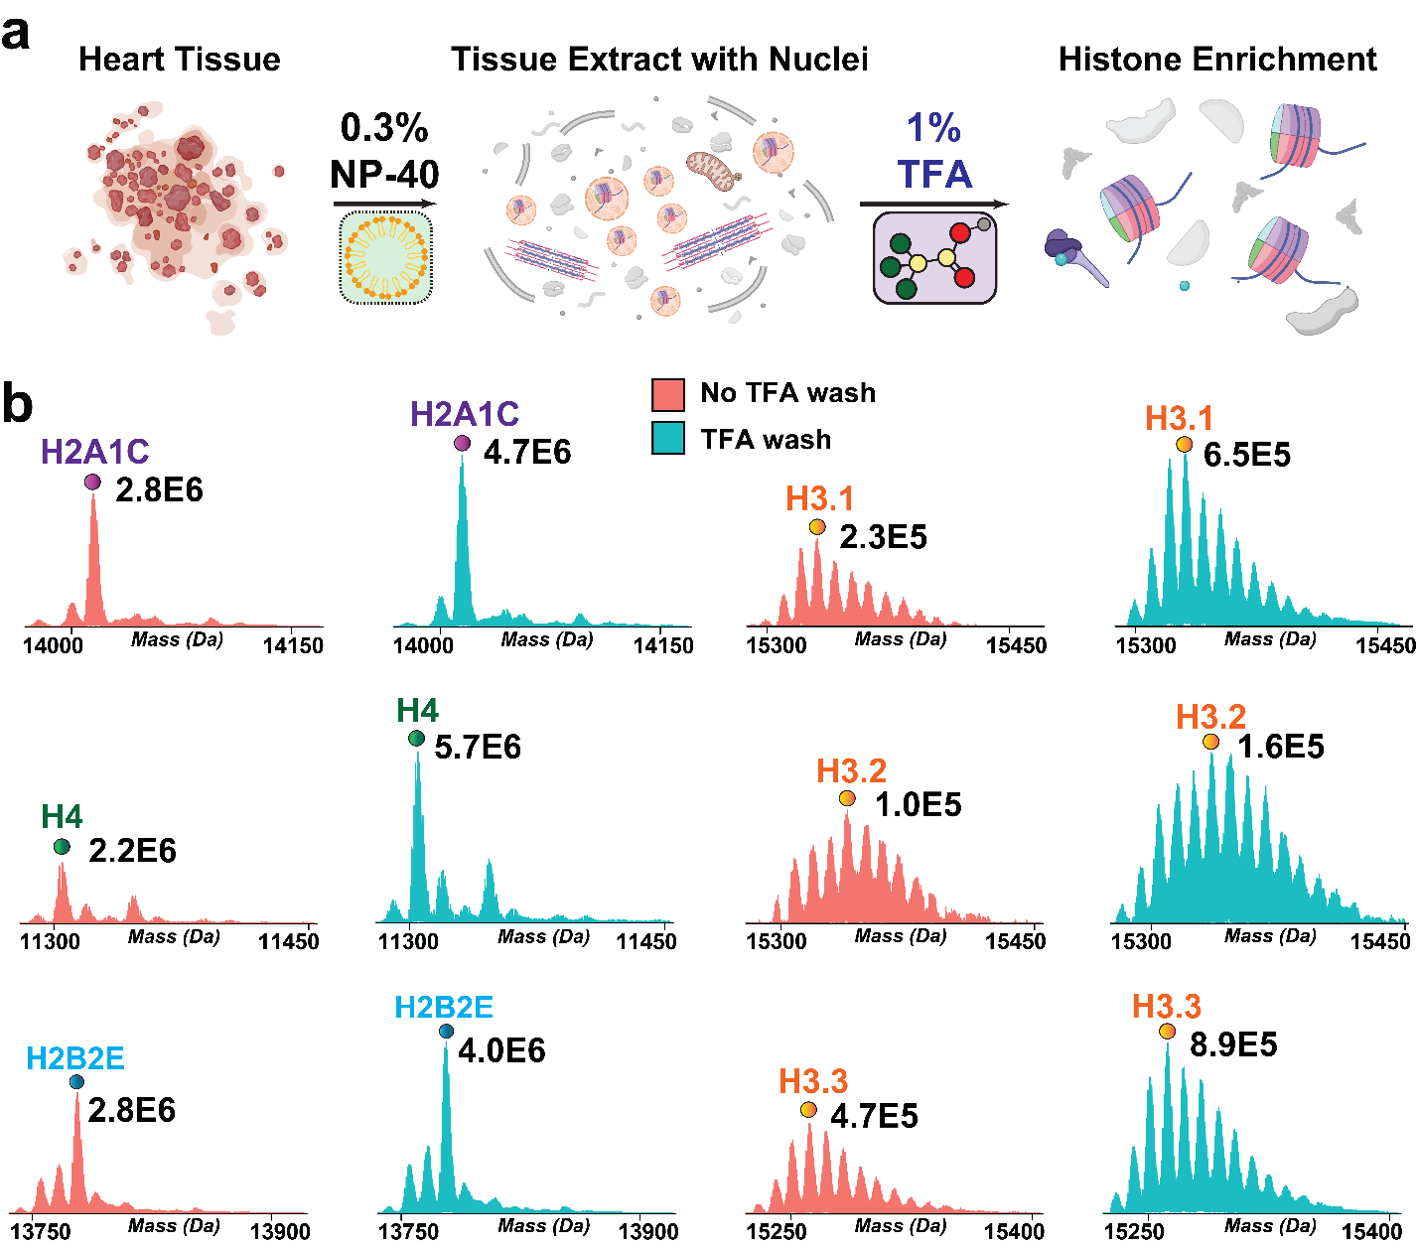

Supplementary Figure 5. TFA wash after nuclei isolation enhances histone intensity. (a) Cardiac tissue is lysed with 0.3% NP‑40 to isolate nuclei. A single TFA wash is then applied (1% TFA) before acid extraction. (b) Representative mass spectra illustrating the TFA wash significantly increases signal for histone variants. No-TFA wash spectra are normalized to the corresponding TFA wash spectra. Numeric labels indicate the intensity of the most abundant proteoform in each panel with and without TFA wash.

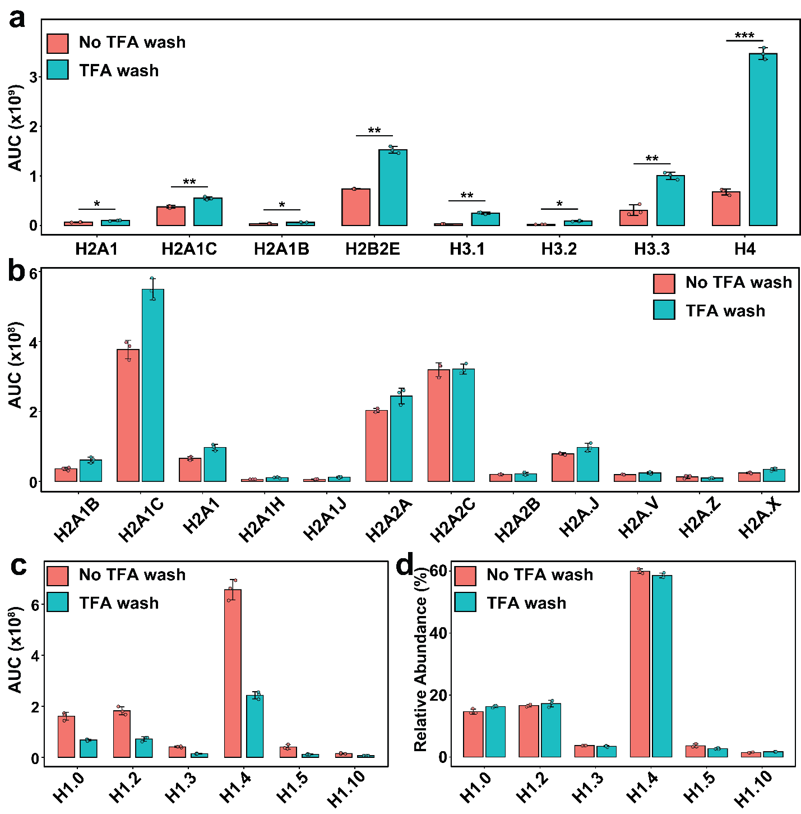

Supplementary Figure 6. Quantification of representative histone variants signals. (a) Histone variants with significantly increased AUC after TFA wash. Differences between groups were considered statistically significant at an adjusted (adj.) p-value < 0.05, based on the Benjamini–Hochberg method for controlling the false discovery rate (FDR). *adj. p<0.05, **adj. p<0.0 (b) AUC of representative H2A variants illustrating that most H2A variants gain signal following the TFA wash. (c) Linker H1 variants display reduced AUC after TFA wash. (d) Relative abundance of linker H1 variants is unchanged between conditions, indicating that the TFA wash does not bias variant‑level quantification despite lowering absolute linker H1 signal. Bar plots display the mean AUC for each protein, with error bars indicating standard deviation. N=3 extraction replicates for all histone variants.

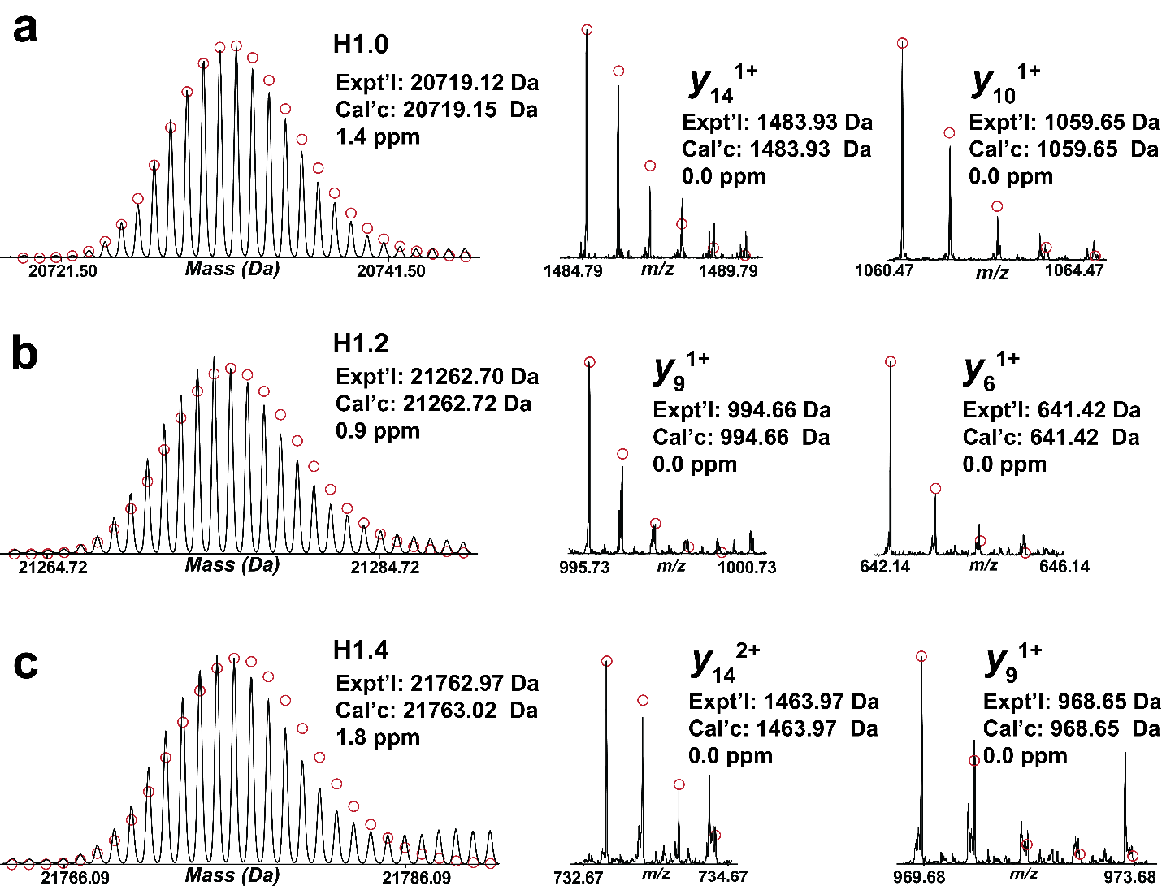

Supplementary Figure 7. Online top-down MS characterization of representative linker H1 variants. High accuracy MS1 spectra and representative MS/MS fragment ions for (a) H1.0, (b) H1.2, and (c) H1.4. Red circles represent the theoretical isotopic abundance distribution of isotopic peaks. Collision-induced dissociation was used for MS/MS.

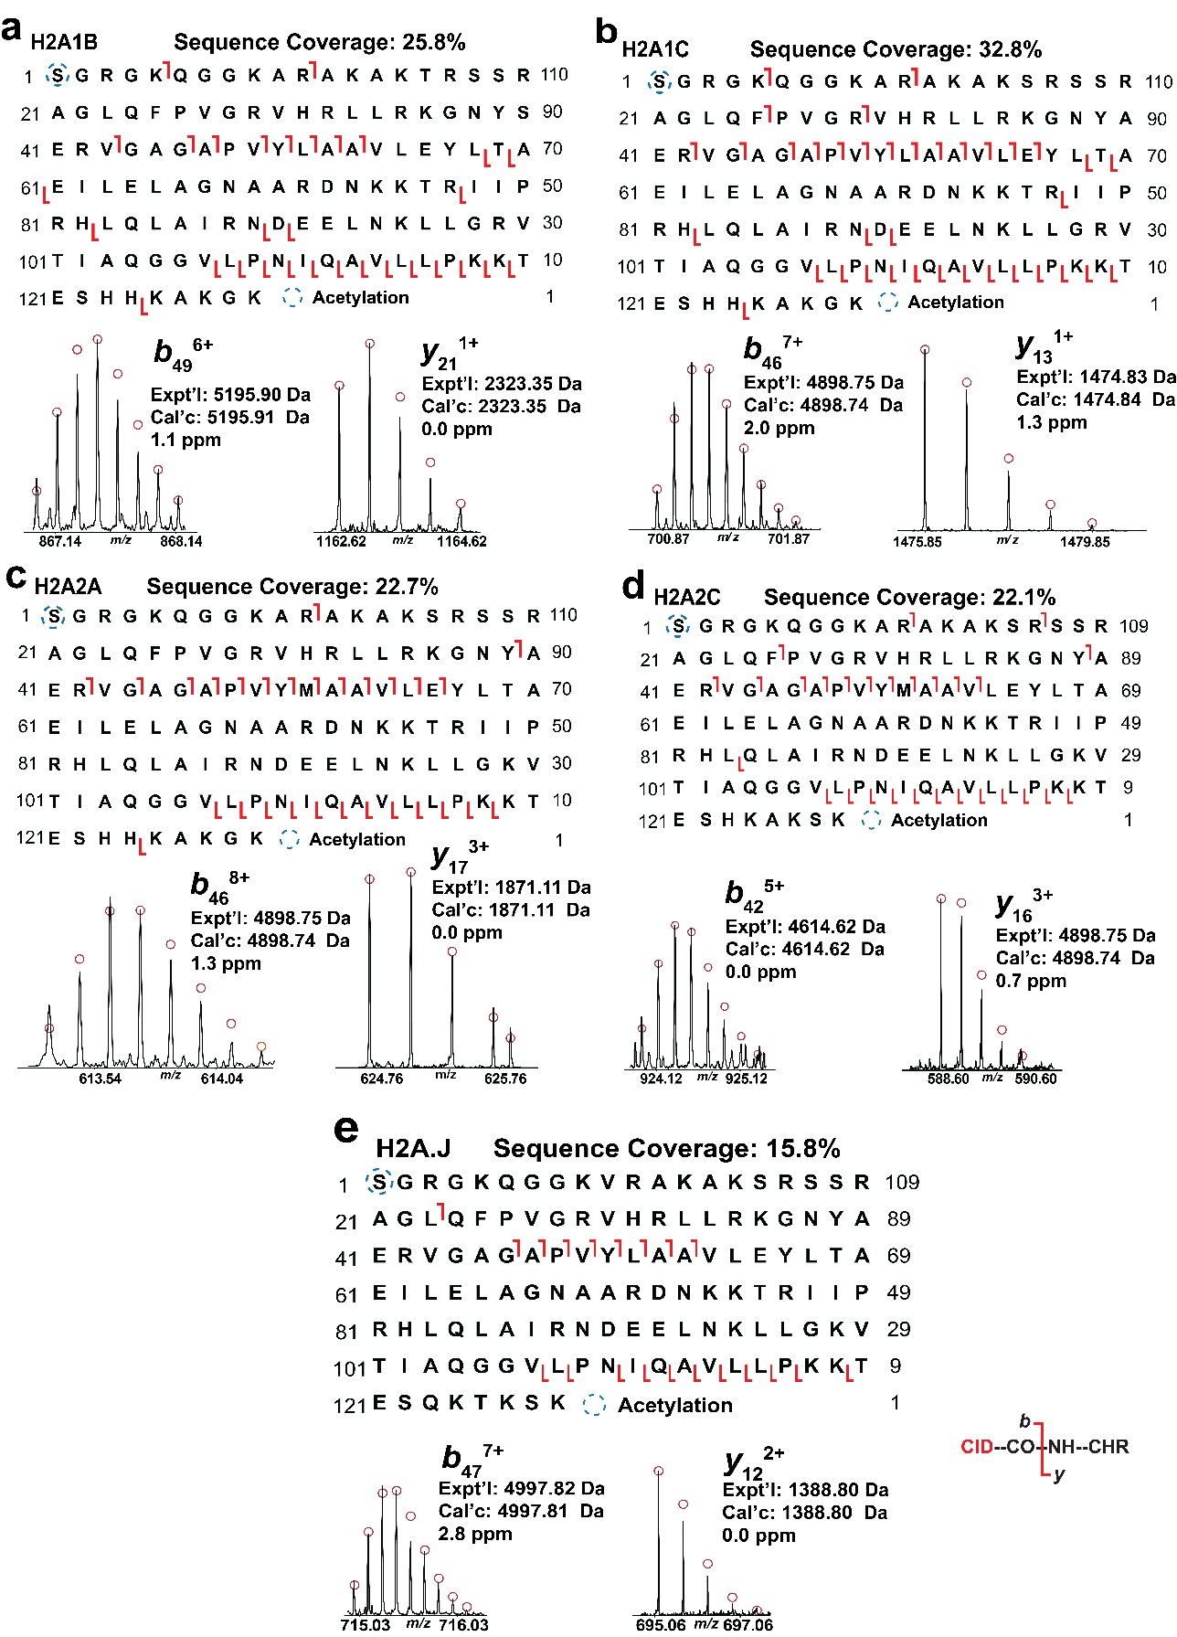Supplementary Figure 8. Online top-down MS characterization of representative H2A variants. Representative MS/MS fragment ions and sequence maps for (a) H2A1B, (b) H2A1C, (c) H2A2A, (d)H2A2C, and (e) H2A.J. Red circles represent the theoretical isotopic abundance distribution of isotopic peaks. Collision-induced dissociation was used for MS/MS.
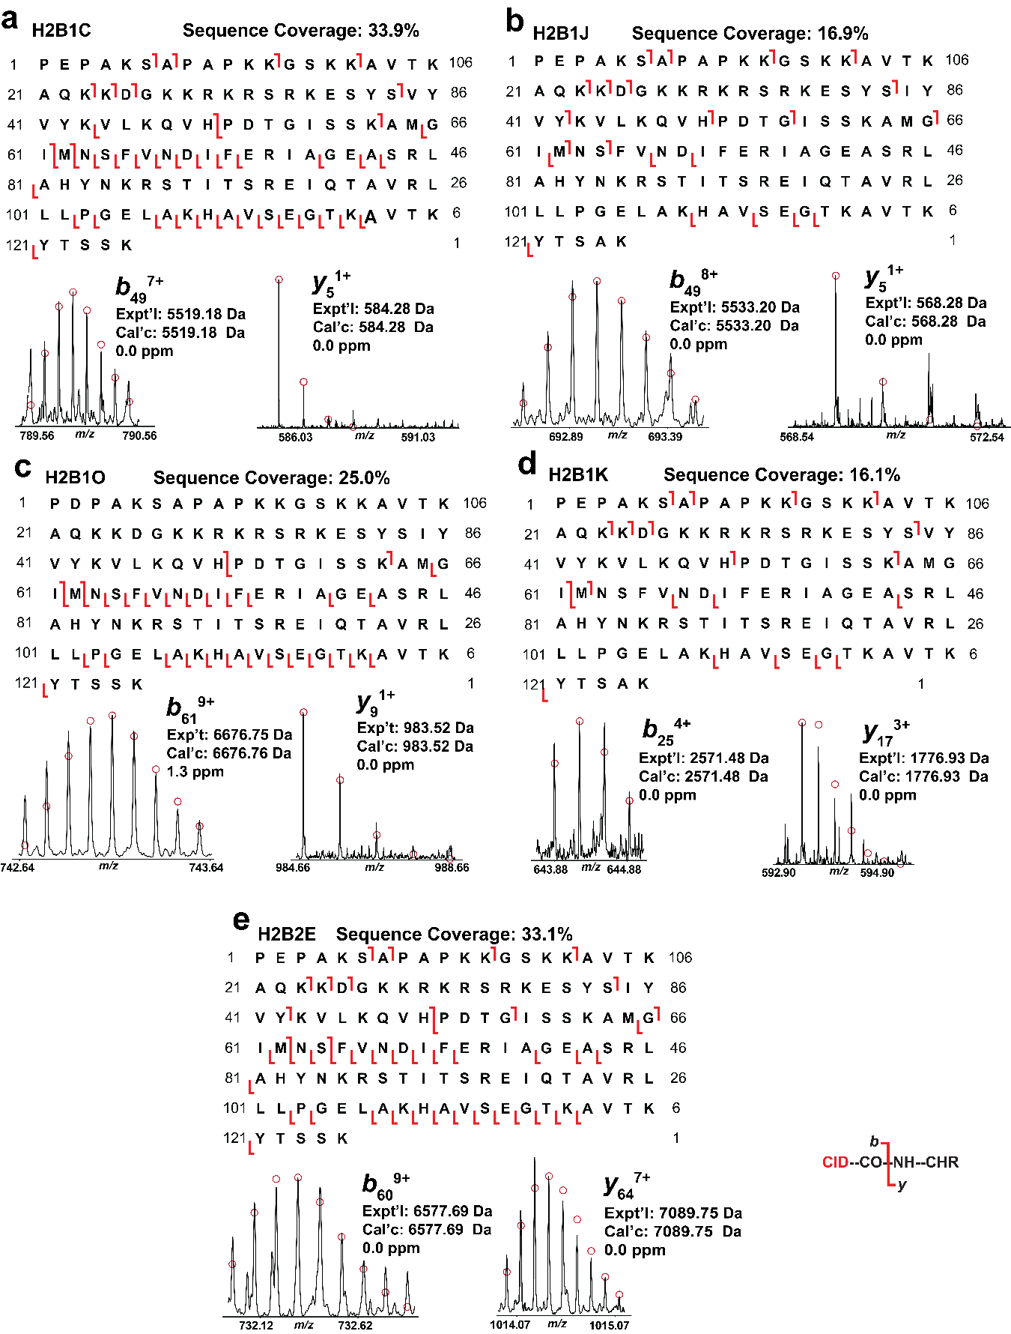Supplementary Figure 9. Online top-down MS characterization of representative H2B variants. Representative MS/MS fragment ions and sequence maps for (a) H2B1C, (b) H2B1J, (c) H2B1O, (d)H2B1K, and (e) H2B2E. Red circles represent the theoretical isotopic abundance distribution of isotopic peaks. Collision-induced dissociation was used for MS/MS.
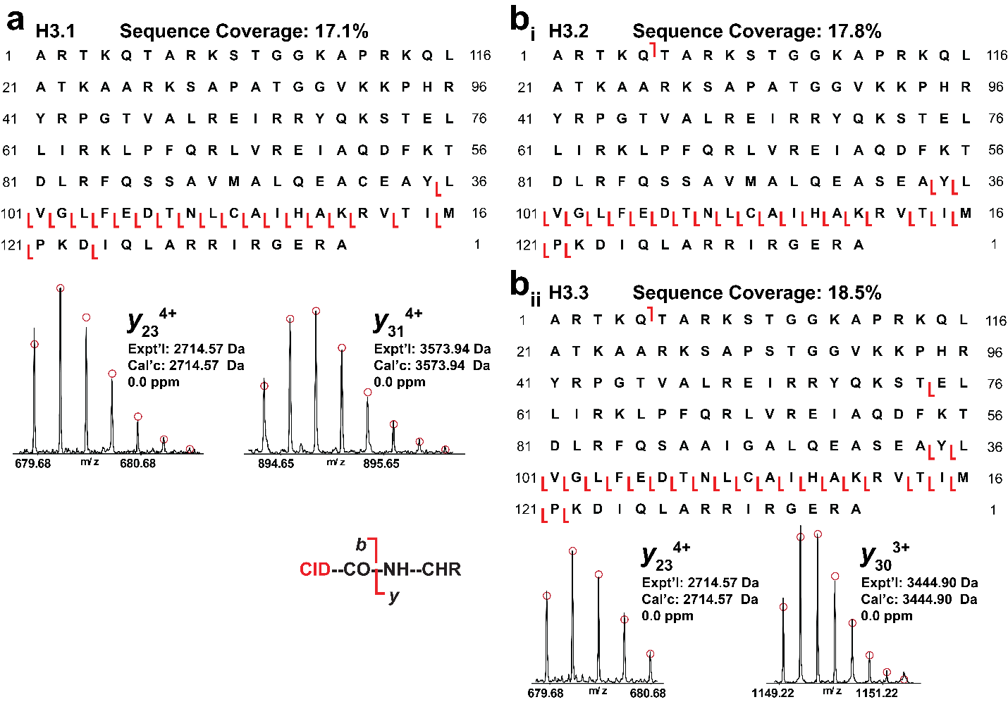Supplementary Figure 10. Online top-down MS characterization of representative H3 variants. Representative MS/MS fragment ions and sequence maps for (a) H3.1, and (b) combined H3.2 and H3.3. Because H3.2 and H3.3 differ by only minor residues and, only shared y-ions were observed. Red circles represent the theoretical isotopic abundance distribution of isotopic peaks. Collision-induced dissociation was used for MS/MS.

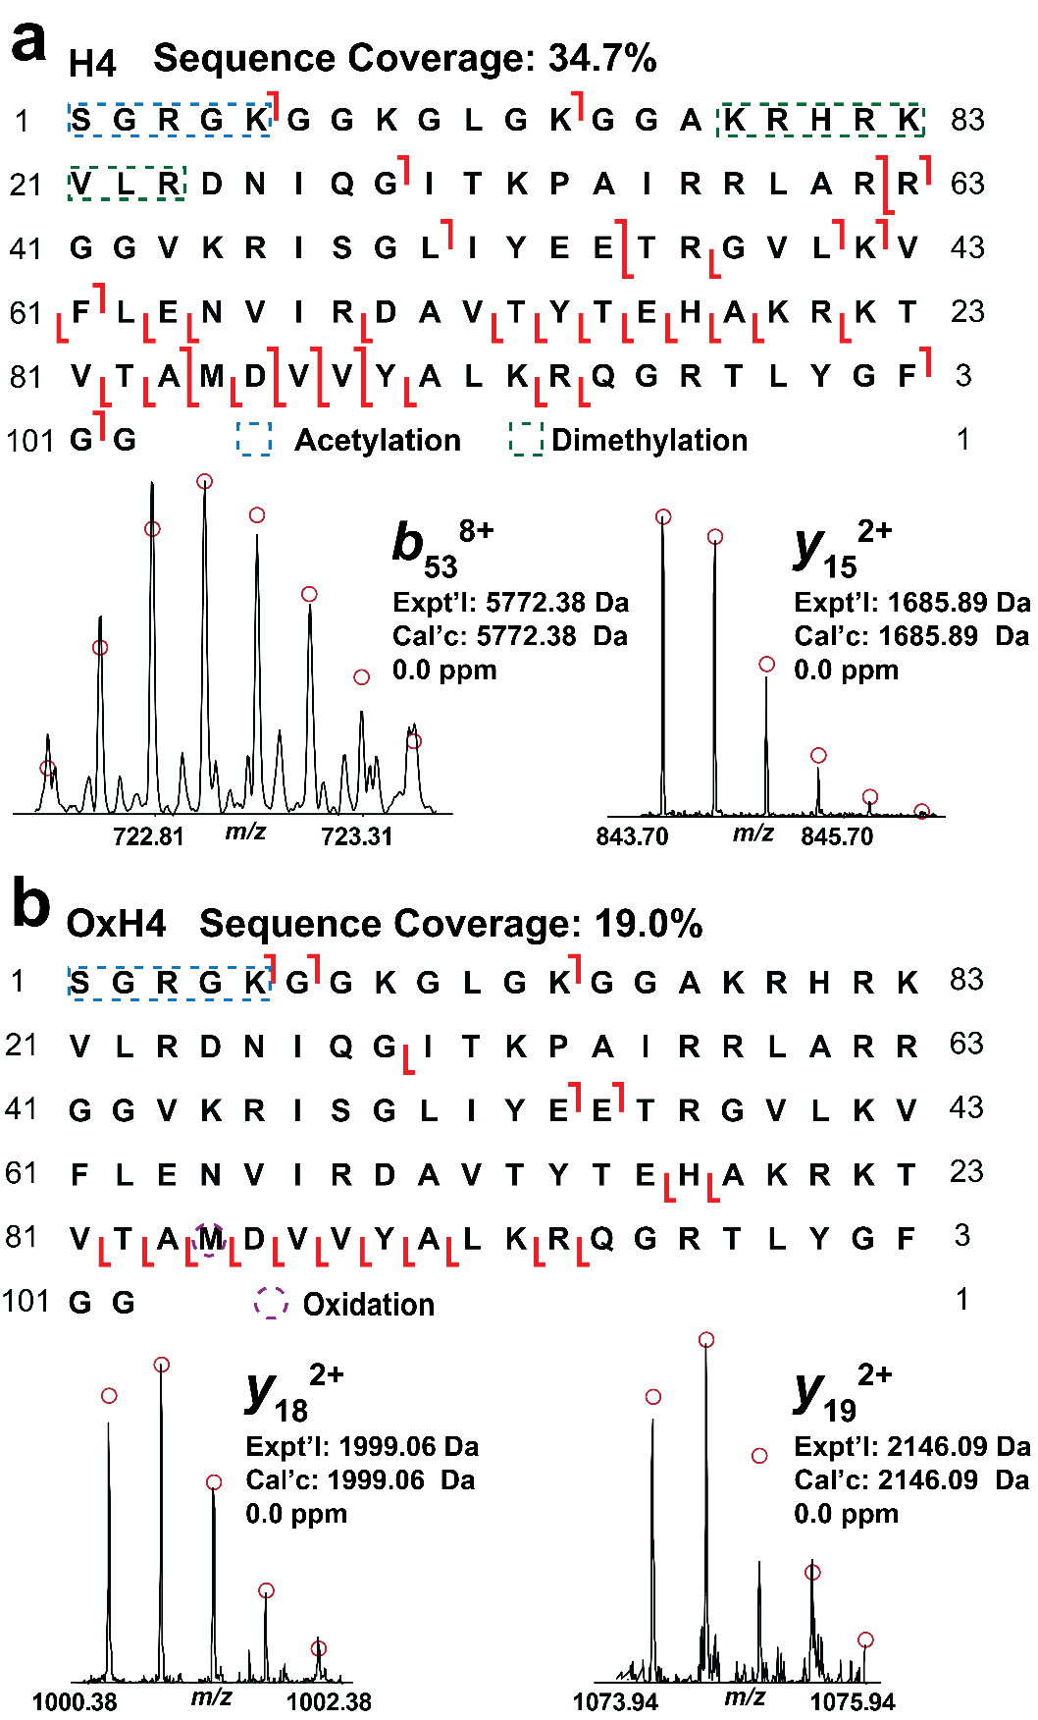
Supplementary Figure 11. Online top-down MS characterization of H4 proteoforms. Representative MS/MS fragment ions and sequence maps for (a) 2MeAcH4, and (b) oxidized (Ox) H4. Red circles represent the theoretical isotopic abundance distribution of isotopic peaks. Collision-induced dissociation was used for MS/MS.

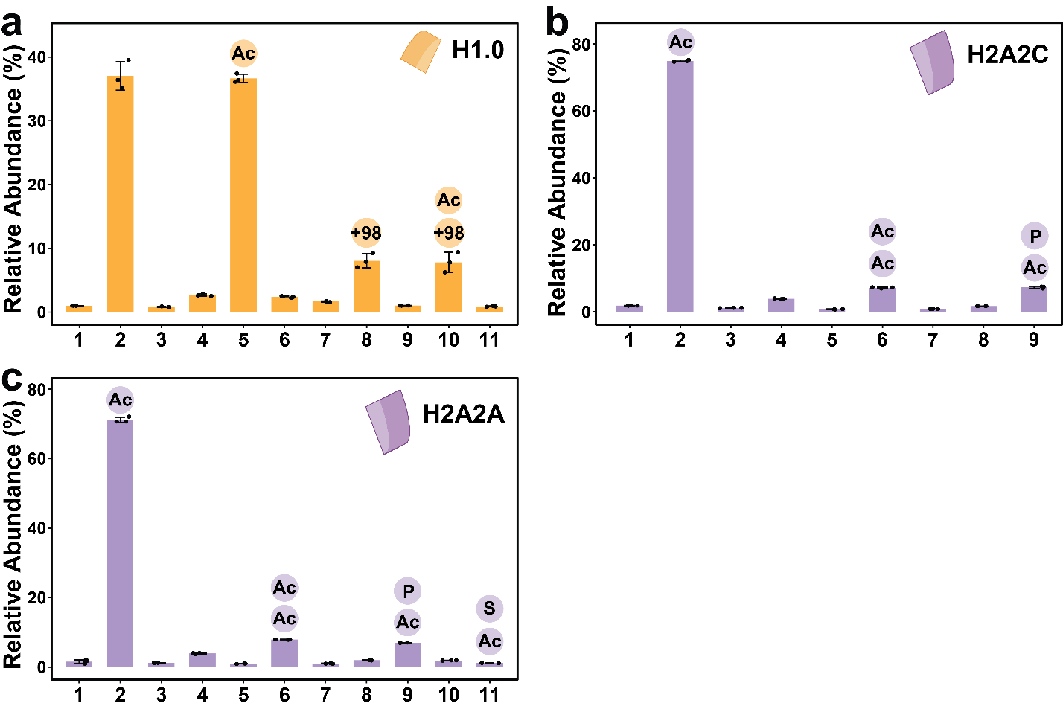
Supplementary Figure 12. Representative quantitative analysis of proteoform abundances. (a) linker H1.0 (yellow), (b) H2A2C (purple) and (c) H2A2C (purple). Colored circular icons represent PTMs present in a specific protein, “Ac” indicates acetylation, “P” indicates phosphorylation, “S” indicates succinylation, and “+98” indicates 98 Da mass shift. Bar plots display the mean relative abundance for each proteoform, with error bars indicating standard deviation. N=3 for each proteoform.

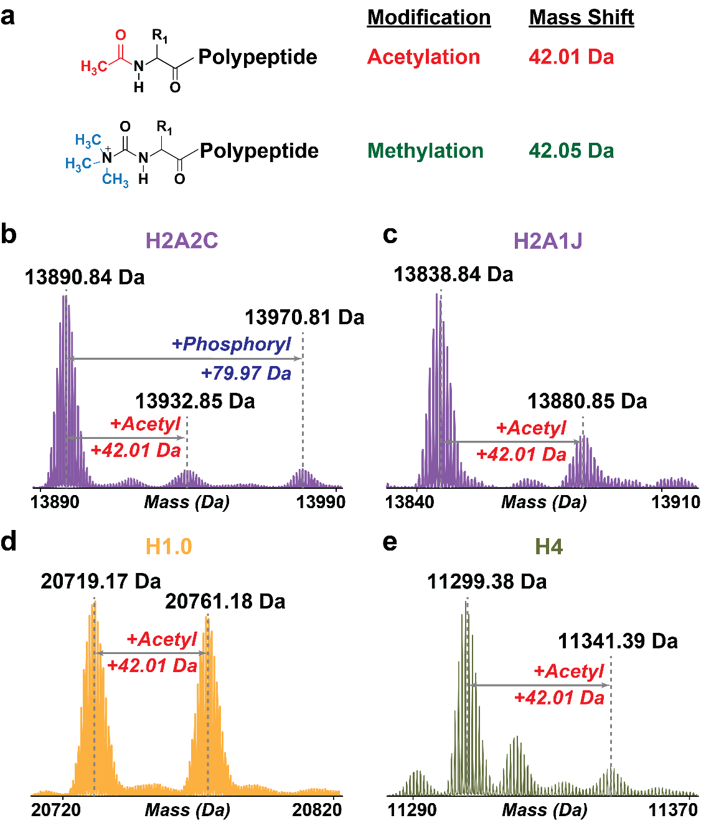
Supplementary Figure 13. High-mass-accuracy intact-mass measurements enable confident assignment of acetylation on representative cardiac histones. (a) Schematic highlighting the small mass difference between acetylation (+42.01 Da) and trimethylation (+42.05 Da), which can be resolved by high-resolution measurements. Representative deconvoluted MS1 spectra with monoisotopic mass (Da) are shown for (b) H2A2C, (c) H2A1J, (d) H1.0, and (e) H4. The dominant proteoform and the corresponding acetylated proteoform are indicated by dashed lines, with +42.01 Da mass shift annotated in red. For (a) H2A2C, an additional phosphorylated proteoform is observed with the characteristic +79.97 Da mass shift (blue). These high-resolution, high-accuracy mass differences support assignment of acetylation and phosphorylation at the proteoform level. Consistent with these assignments, a search of the UniProt database across the detected H1 and H2A families found no annotated trimethylation sites, further supporting assignment of the +42 Da mass shift on H1 and H2As to acetylation rather than trimethylation.
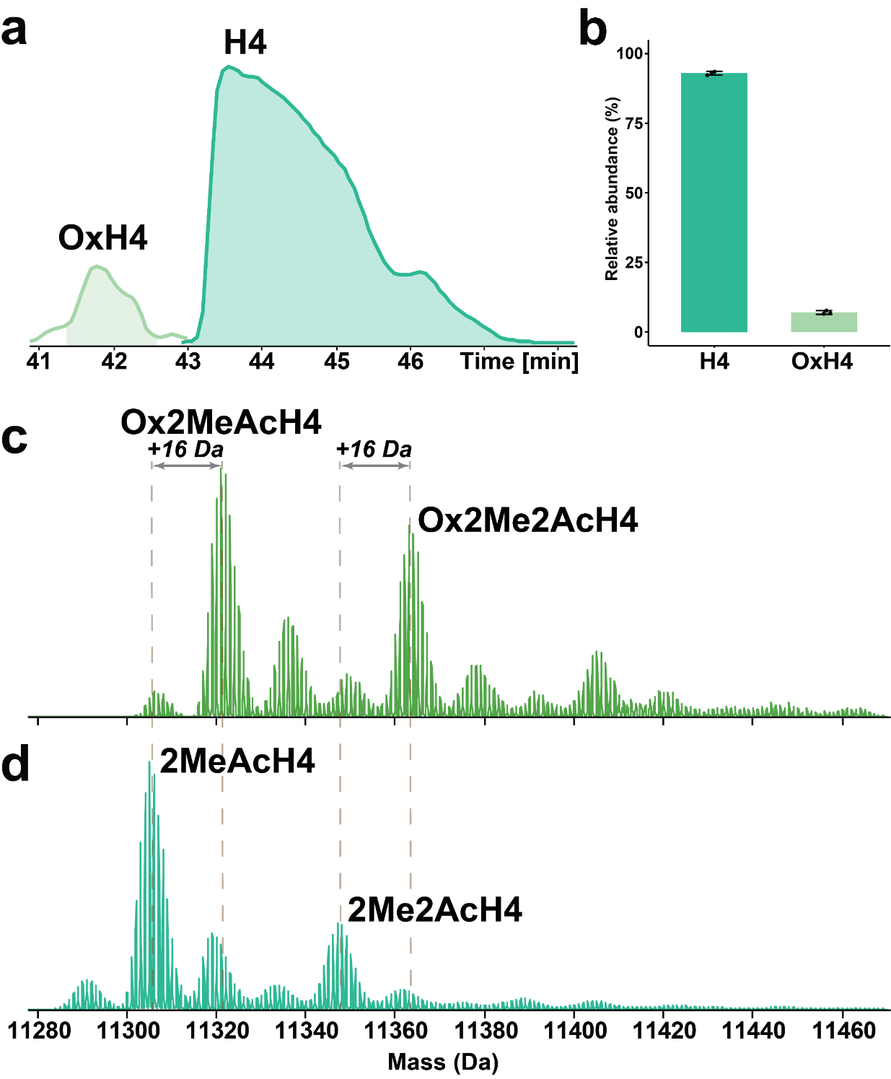
Supplementary Figure 14. Separation of oxidized from non-oxidized H4 proteoforms. (a) EIC showing two baseline separated peaks assigned to non‑oxidized H4 (H4) and oxidized H4 (OxH4). (b) Relative abundance by AUC indicates that OxH4 contributes only a small fraction of the total H4 signal. (c-d) Deconvoluted mass spectra of non-oxidized and oxidized H4 proteoforms exhibits a +16 Da shift relative to H4, consistent with monooxidation of the protein.

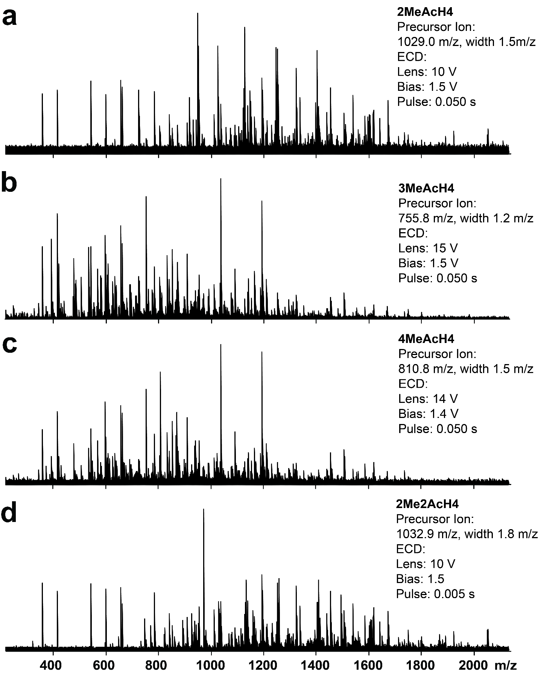
Supplementary Figure 15. FTICR ECD-MS/MS analysis of H4 proteoforms. MS/MS characterization of (a) 2MeAcH4, (b) 3MeAcH4, (c) 4MeAcH4 and (d) 2Me2AcH4. The specific precursor, isolation windows, and other acquisition parameters used to collect each spectrum are indicated within the corresponding panel.
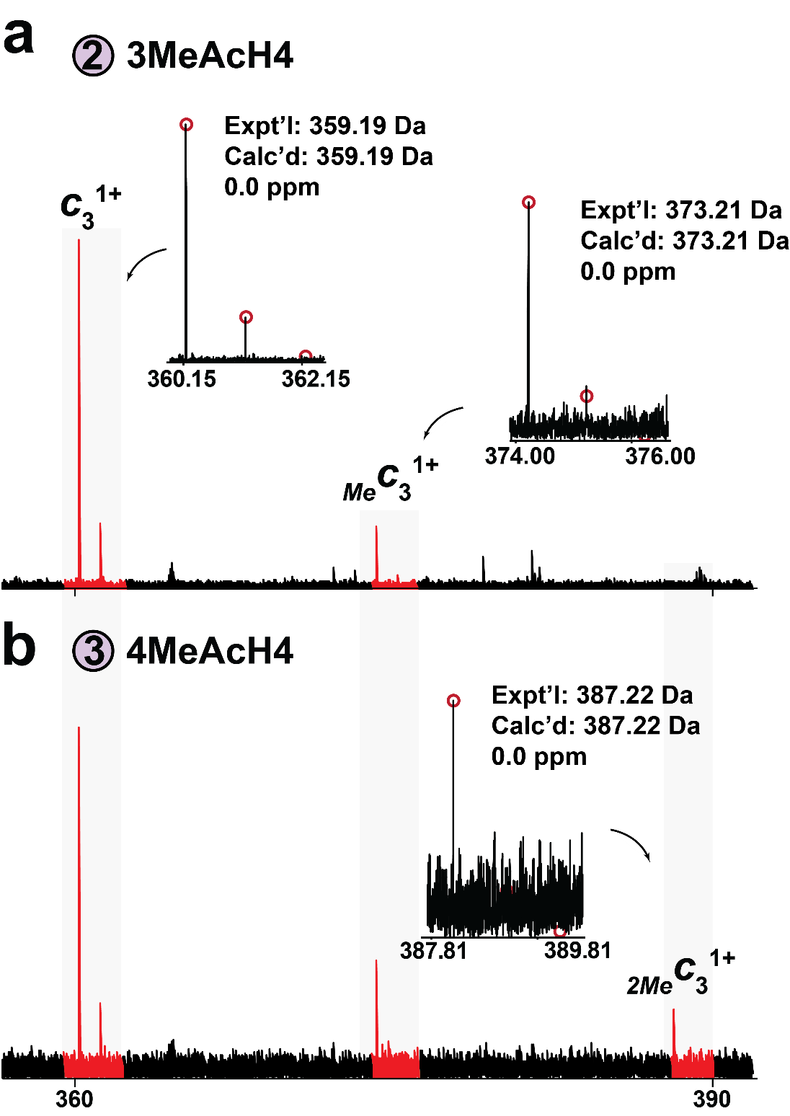
Supplementary Figure 16. Partial ECD MS/MS spectra showing methylations on 3MeAcH4 and 4MeAcH4 proteoforms. Ion pairs for c3 with +14.02 Da mass shifts indicating (a) one and (b) two methyl group additions on 3MeAcH4 and 4MeAcH4 proteoforms. The theoretical isotopic distributions are indicated by the red circles.

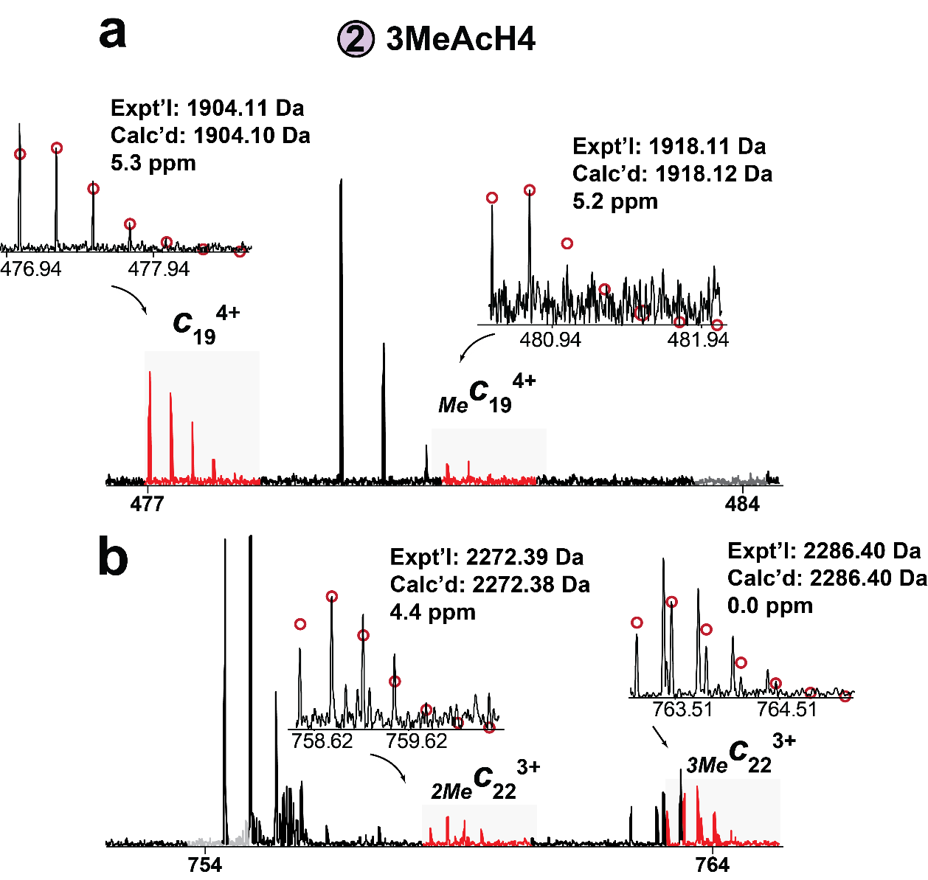
Supplementary Figure 17. Partial ECD MSMS spectra showing methylations at lysine 20 (K20) on 3MeAcH4 proteoform. (a) The methylation distribution of the c₁₉ ion matches c₃ ion, indicating no added methylation on residues R4–G19. (b) The c₂₂ ion shows absence of mono-methylation peak together with clear di‑ and trimethylation, suggesting variable K20 methylation states (me1/me2/me3).

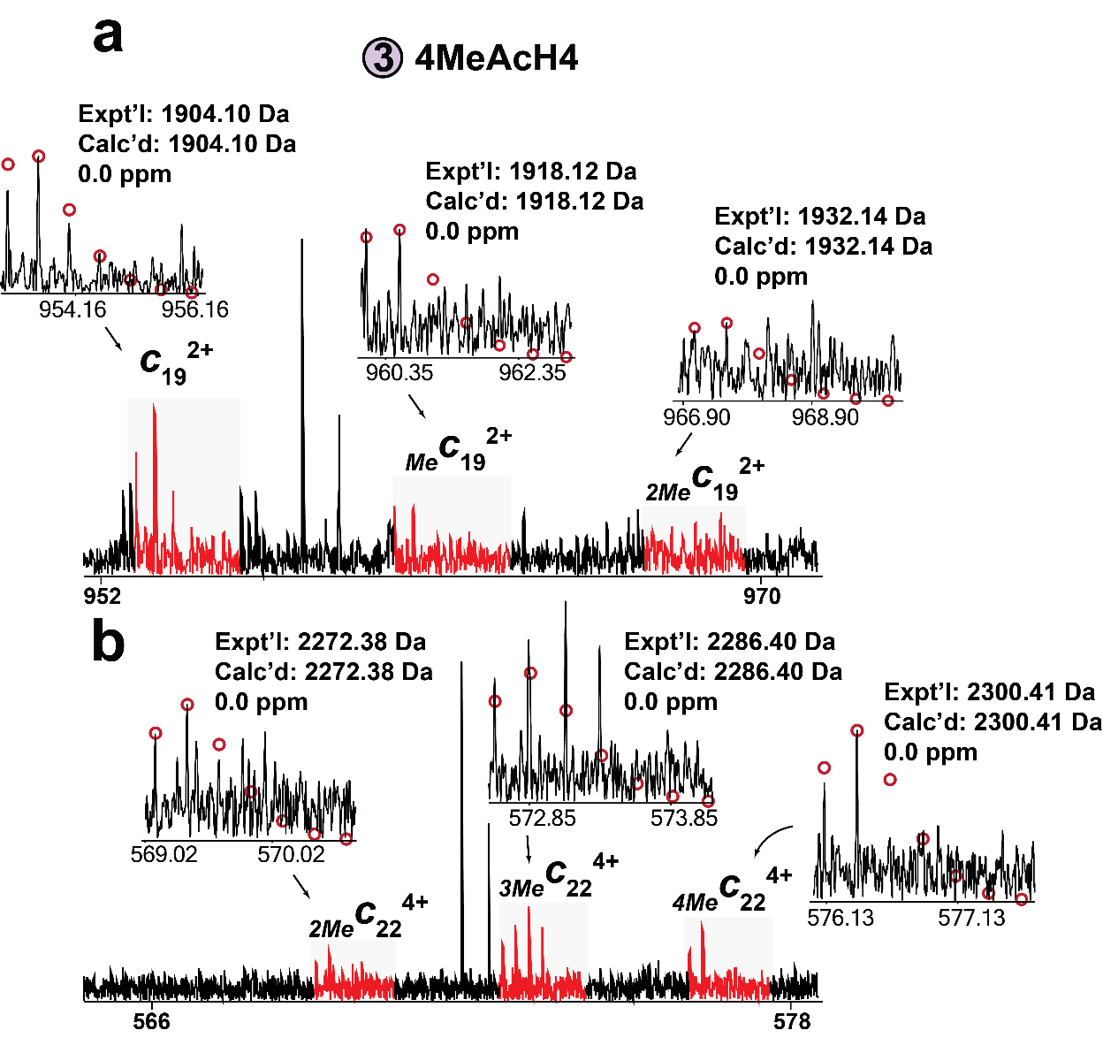
Supplementary Figure 18. Partial ECD MSMS spectra showing methylations at lysine 20 (K20) on 4MeAcH4 proteoform. (a) The methylation distribution of the c₁₉ ion matches c₃ ion, indicating no added methylation on residues R4–G19. (b) The c₂₂ ion shows a low abundance mono-methylation peak together with clear di‑ and trimethylation, suggesting variable K20 methylation states (me1/me2/me3) and that additional methylation is placed outside K20.

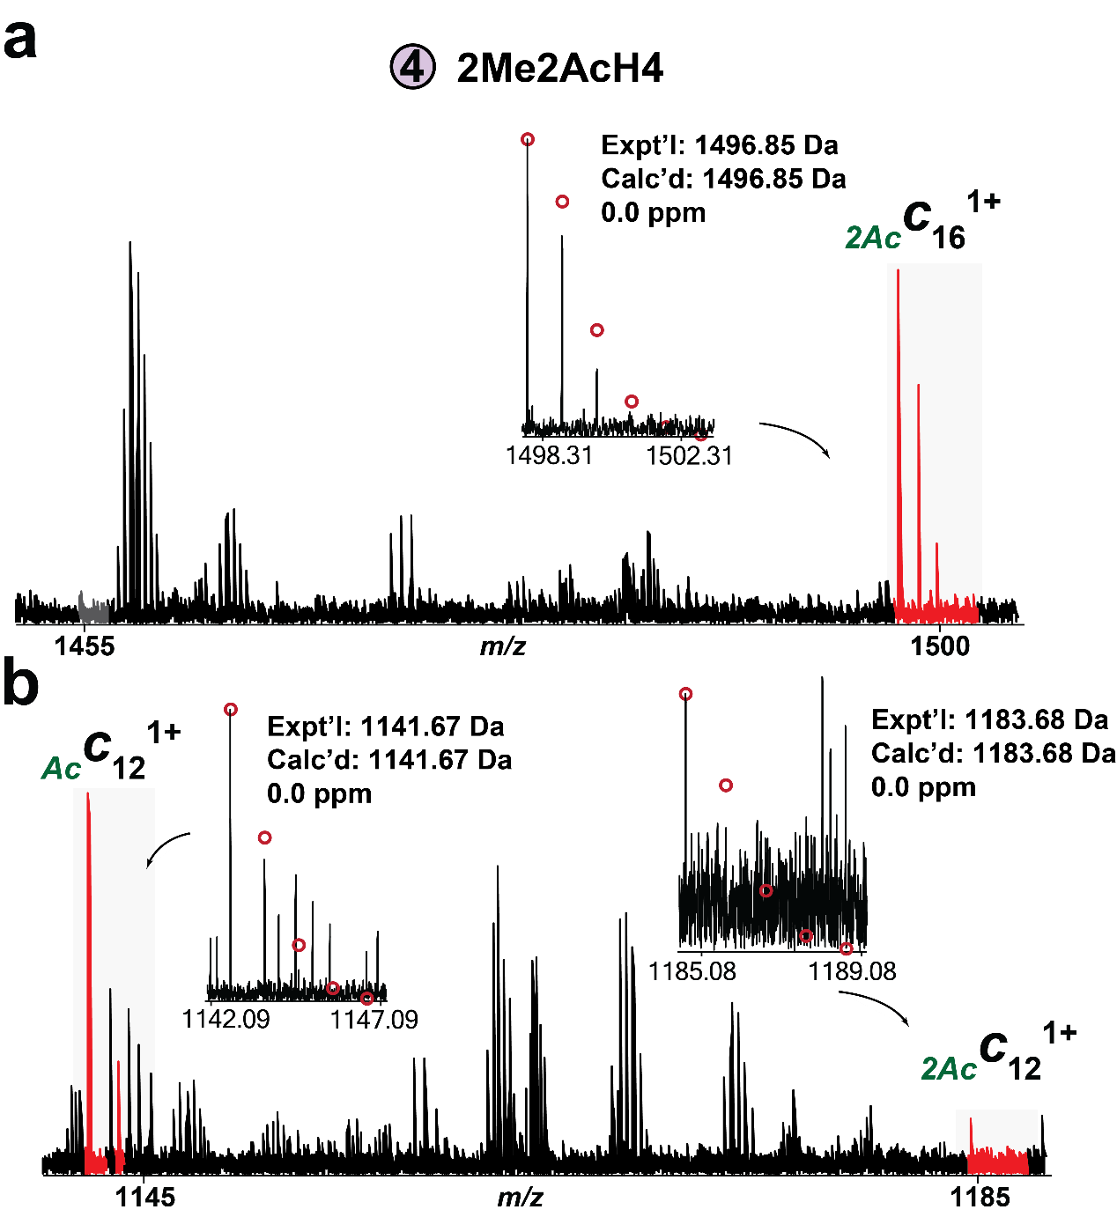
Supplementary Figure 19. Partial ECD MSMS spectra showing two distinct acetylations at lysine 16 and 12 (K16 and K12) on 2MeAc2H4 proteoform. (a) The diacetylated c16 ion suggests one acetyl group addition at K16. (b) c12 ion pairs with +42.01 Da mass shifts indicate another acetyl group addition at K12.

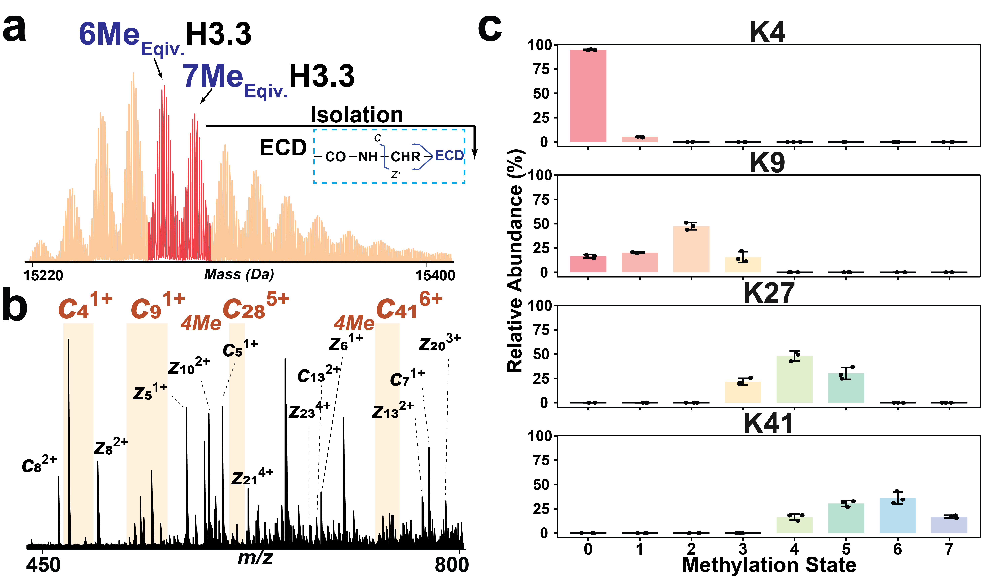
Supplementary Figure 20. H3.3 combinatorial methylation resolved by top‑down ECD‑MS/MS. (a) Deconvolved mass spectra of H3.3 highlighting two proteoforms (6 Me-Eqiv. and 7 Me-Eqiv.), which were co-isolated for ECD MS/MS analysis. (b) ECD MS/MS spectra highlighting sequence-informative c-ions. (c) Methylation levels of H3.3 at K4, K9, K27, and K41. Bar plots display the mean relative abundance for each fragment ion, with error bars indicating standard deviation. N=3 extraction replicates for each fragment ion.

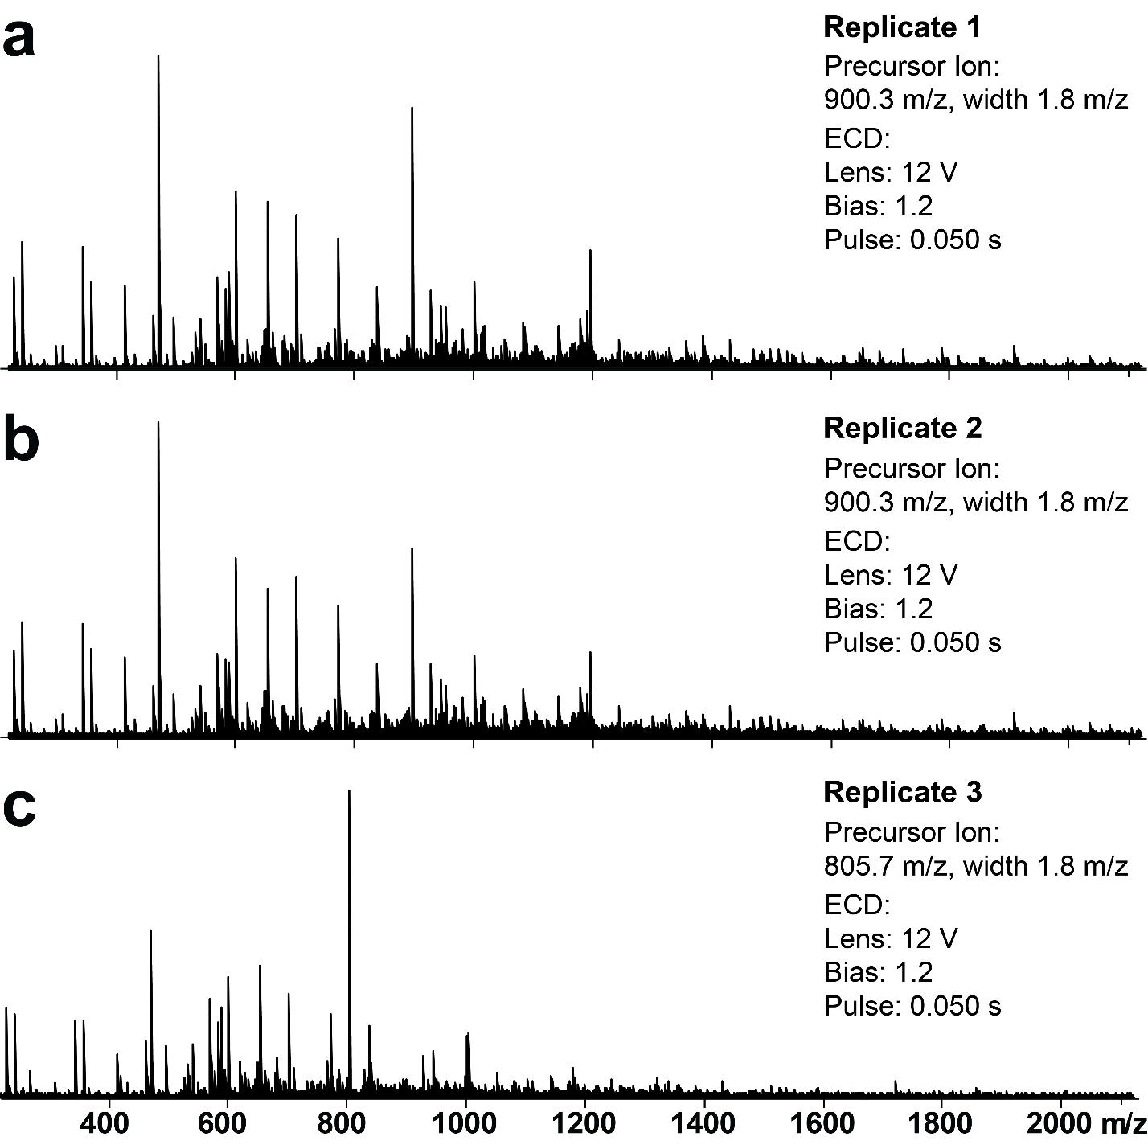
Supplementary Figure 21. FTICR ECD-MS/MS analysis for H3.3. ECD spectra acquired from the two precursor ions: (a-b) z = 17+, centered at 900.3 m/z; isolation window 1.8 m/z and (c) z = 19+, centered at 805.7 m/z; isolation window 1.8 m/z. All additional acquisition parameters are listed within each panel.

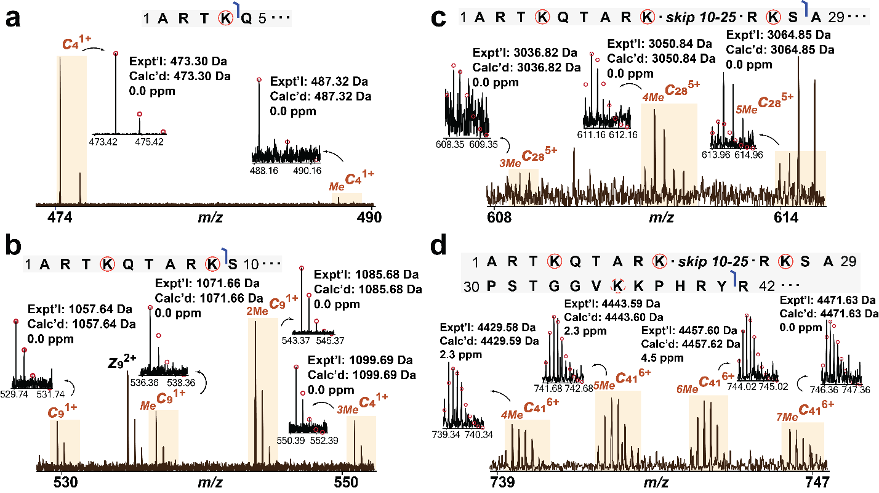
Supplementary Figure 22. Partial ECD MSMS spectra showing multiple methylations co-occurring on H3.3. Ion pairs for (a) c₄, (b) c₉, (c) c₂₈, and (d) c₄₁ with +14.02 Da mass shifts indicating methyl group additions. All individual ion assignments are within 3 ppm of the theoretical mass. The theoretical isotopic distributions are indicated by the red circles.

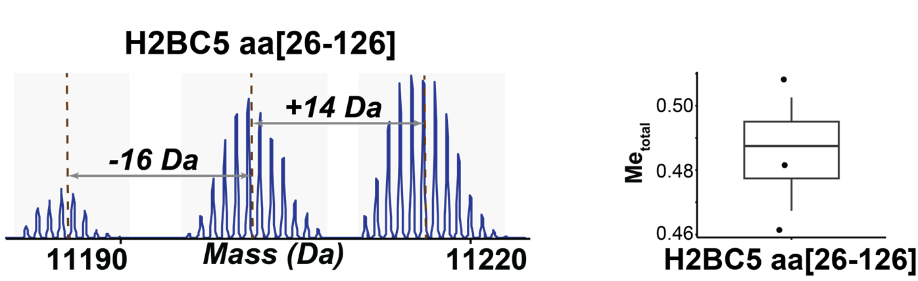
Supplementary Figure 23. Detection of truncated H2BC5 from top‑down LC-MS analysis. (a) Deconvoluted mass spectra of truncated H2BC5 with detected proteoforms. “+14 Da” indicates monomethylation; “-16 Da” indicates neutral oxygen loss. (b) Methylation level of truncated H2BC5 across replicates.
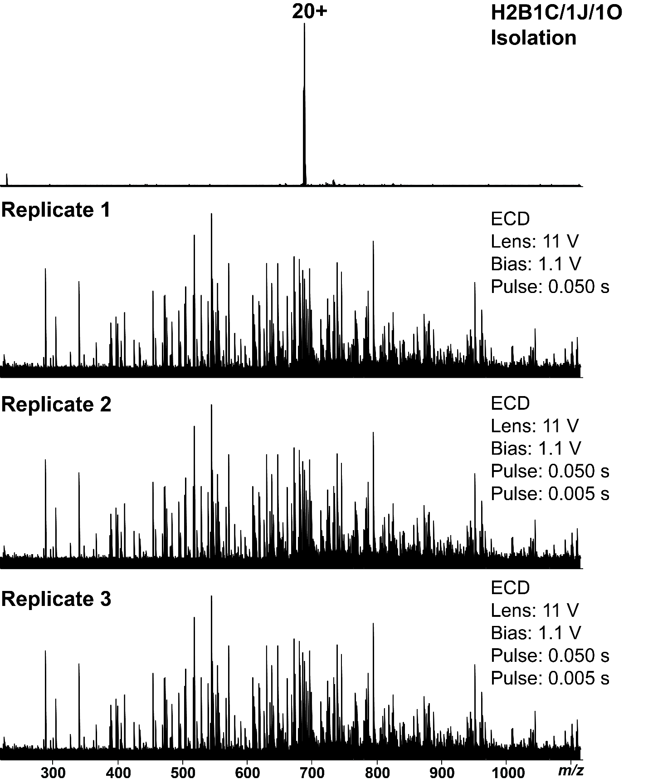
Supplementary Figure 24. FTICR ECD-MS/MS analysis for distinguishing H2B variants. Three replicate ECD spectra acquired from the same precursor ions that contains three H2B variants (z = 8+, centered at 689.7 m/z; isolation window 1.1 m/z). All additional acquisition parameters are listed within panel.

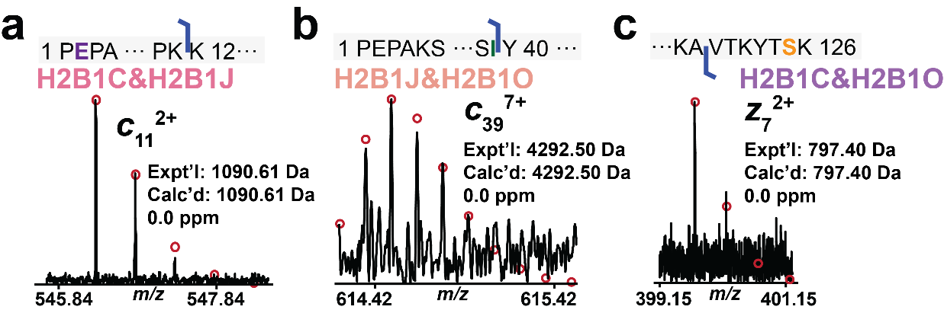
Supplementary Figure 25. ECD fragment ions for identification of H2B1/C1O/1J. (a) c₁₁ ion matches to H2B1C/1J. (b) c₃₉ ion matches to H2B1J/1O. (c) z₇ ion corresponds to H2B1C/H2B1O.

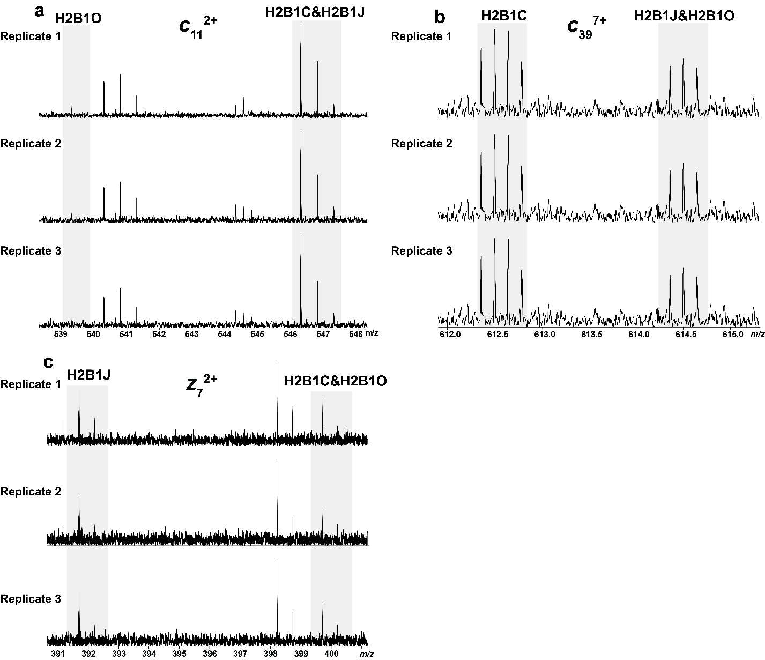Supplementary Figure 26. Diagnostic fragment ions for resolving H2B variants from FTICR ECD-MS/MS analysis. (a) c₁₁ ions for distinguishing H2B1O from H2B1C and H2B1J. (b) c₃₉ ions for distinguishing H2B1C from H2B1J and H2B1O. (c) z₇ ion for distinguishing H2B1J from H2B1C and H2B1O.

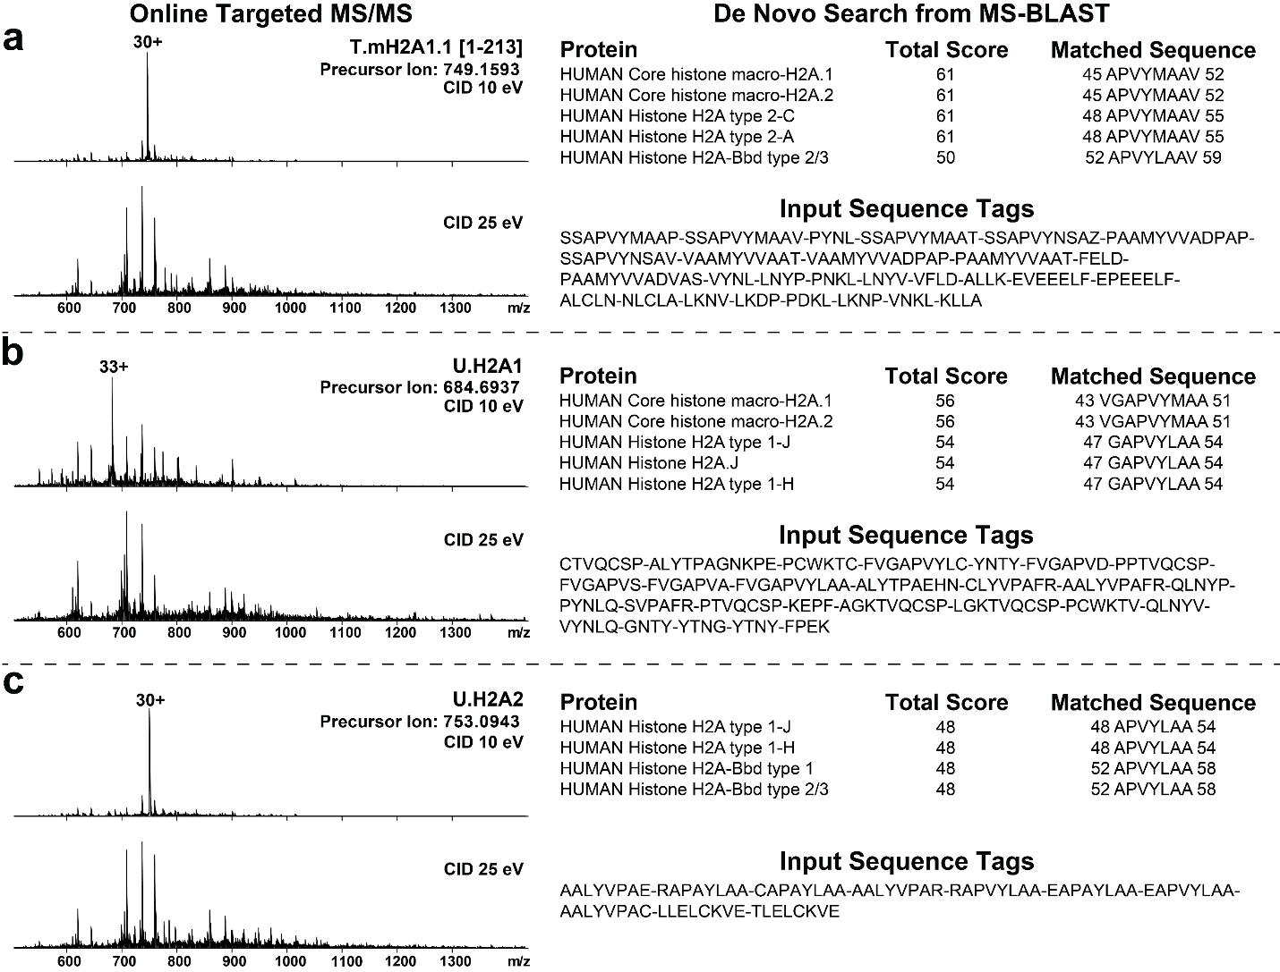
Supplementary Figure 27. Identification of unknown histone variants using targeted online MS/MS and MS-BLAST search. (a-c) Online targeted CID spectra (left) were acquired at 10 eV and 25 eV to generate fragment ions. Sequence tags generated from the spectra (right, “Input Sequence Tags”) were submitted to MS-BLAST, returning the top-matching proteins found in the SwissProt database, total scores, and matched sequence regions (right).

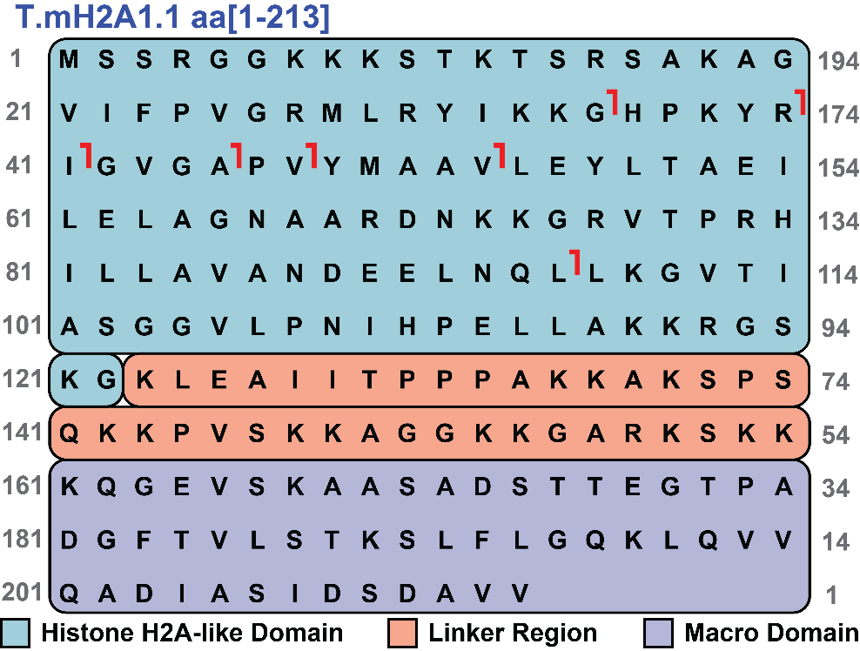
Supplementary Figure 28. Online CID fragmentation map for T.mH2A1.1 aa[1–213].

REFERENCES
1. Shechter, D., Dormann, H. L., Allis, C. D. & Hake, S. B. Extraction, purification and analysis of histones. Nat. Protoc. 2, 1445–1457 (2007).
2. Gao, Z. et al. Global Proteoform Alterations Across Multiple Cellular Compartments Underlie Obstructive Hypertrophic Cardiomyopathy. Circ. Heart Fail. 18, e012899 (2025).

