Complication | Definition
Atelectasis | Lung opacity on chest X-ray with a shift of the mediastinum, hilum or hemidiaphragm toward the affected area, and compensatory over-inflation in the adjacent non-atelectatic lung
Acute respiratory failure | Postoperative PaO₂ < 8 kPa (60 mmHg) on room air, a PaO₂:FiO₂ ratio <40 kPa (300 mmHg) or arterial oxyhemoglobin saturation measured with pulse oximetry < 90% requiring oxygen therapy
Pneumothorax | Air in the pleural space on chest X-ray with no vascular bed surrounding the visceral pleura
Pleural effusion | Chest radiograph blunting of the costophrenic angle, loss of sharp silhouette of the ipsilateral hemidiaphragm in upright position, evidence of displacement of adjacent anatomical structures or (in supine position) a hazy opacity in one hemithorax with preserved vascular shadows.  Or lung ultrasound evidence of extrapleural liquid/fluid: anechoic extrapleural densities.  Only cases requiring thoracocentesis were taken into account.
Pneumonia | Patient has received antibiotics for a suspected respiratory infection and met one or more of the following criteria: new or changed sputum, new or changed lung opacities on chest X-ray (or CT-scan), fever, white blood cell count > 12 x 10⁹
Aspiration pneumonitis | Acute lung injury after the inhalation of regurgitated gastric contents
eTable 1. Definition of postoperative pulmonary complications according to the European Perioperative Clinical Outcome definitions

eTable 2. Average intraoperative ventilatory parameters during surgery.
 | All patients (n = 275) | PPCs (n = 115) | Non PPCs (n = 160)
Duration of anesthesia (min) | 496 [395, 583] | 505 [420, 601] | 492 [377, 576]
Tidal volume (ml.kg⁻¹ of PBW) | 7.0 ± 0.5 | 7.0 ± 0.5 | 7.0 ± 0.5
Respiratory rate (breath/min) | 20.6 ± 2.4 | 20.5 ± 2.4 | 20.6 ± 2.3
Peak pressure (cmH₂O) | 26.7 ± 3.9 | 27.4 ± 3.8 | 26.2 ± 3.9
Plateau pressure (cmH₂O) | 19.7 ± 3.1 | 20.4 ± 3.3 | 191 ± 2.8
PEEP (cmH₂O) | 7.3 ± 1.5 | 7.5 ± 1.6 | 7.2 ± 1.4
Driving pressure (cmH₂O) | 12.4 ± 3.0 | 13.0 ± 3.1 | 11.9 ± 2.9
End tidal carbon dioxide (mmHg) | 39.2 ± 3.2 | 39.2 ± 3.4 | 39.2 ± 3.0
Intraoperative FiO₂ (%) | 54.1 ± 8.6 | 54.6 ± 8.8 | 53.8 ± 8.5
Intraoperative SpO₂ (%) | 96.3 ± 1.6 | 96.0 ± 1.7 | 95.5 ± 1.5
One-lung ventilation (OLV) | 246 (89.8) | 106 (92.2) | 140 (87.5)
Tidal volume in OLV (ml.kg⁻¹ of PBW) | 5.2 ± 0.6 | 5.2 ± 0.6 | 5.2 ± 0.6
Duration (min) | 170.0 ± 70.2 | 179.0 ± 75.5 | 163.9 ± 65.6
Mechanical power (J.min⁻¹) | 17.9 ± 4.5 | 17.9 ± 4.6 | 17.8 ± 4.5
Values are number (%), mean ± standard deviation or median [interquartile range]. FiO₂: inspired fraction of oxygen; PBW: prediceted body weight; PEEP: positive end-expiratory pressure; SpO₂: pulsed oxygen saturation.
Mechanical power (MP), which integrates ventilatory parameters derived from both ventilator settings and the mechanical properties of the patients' lungs, was calculated retrospectively offline as:
MP (J.min-1) = 0.098 x RR x VTe x 0.001 x (PEEP + 0.5 x (Pplat – PEEP) x (Ppeak – PEEP)).

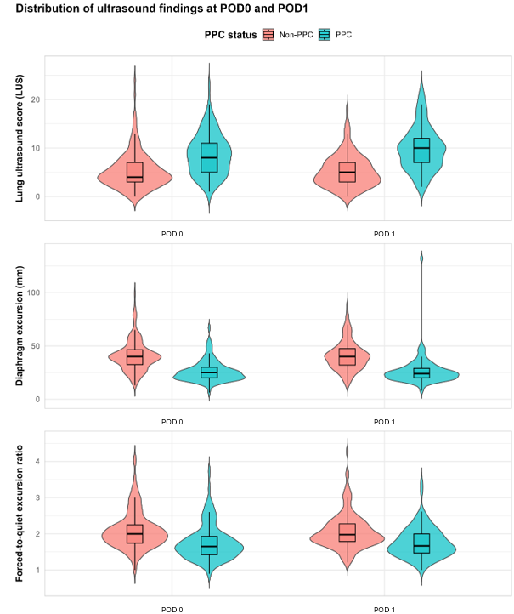
eFigure 1. Violin plots of lung ultrasound score (LUS) and diaphragmatic ultrasound (DUS) measurements on postoperative day 0 and 1 in patients with and without postoperative pulmonary complications within 7 days after esophagectomy.
The shape of each violin represents the distribution density, with horizontal lines indicating the median and interquartile range for each group. Abbreviations: POD: postoperative day

Table 3. Distribution of lung ultrasound across examined lung zones.
 | Time | PPC (n = 115) | Non-PPC (n = 160)
Anterior LUS score  Right  Left | POD0 | 0 [0-1]  0 [0-0]  0 [0-1] | 0 [0-0]  0 [0-0]  0 [0-0]
Lateral LUS score  Right  Left | POD0 | 2 [1-4]  1 [0-2]  1 [0-2] | 1 [0-2]  0 [0-1]  1 [0-1]
Posterior LUS score  Right  Left | POD0 | 5 [4-7]  2 [1-4]  3 [2-4] | 3 [2-5]  2 [1-2]  2 [1-3]
Anterior LUS score  Right  Left | POD1 | 0 [0-2]  0 [0-1]  0 [0-1] | 0 [0-0]  0 [0-0]  0 [0-0]
Lateral LUS score  Right  Left | POD1 | 3 [1-4]  1 [0-2]  1 [0.5-2] | 1 [0-2]  0 [0-1]  1 [0-1]
Posterior LUS score  Right  Left | POD1 | 6 [4-8  3 [2-4]  3 [2-4] | 4 [2-5]  1 [1-2]  2 [1-3]
Values are median [interquartile range]. Abbreviations: LUS: lung ultrasound; POD: postoperative day; PPC: postoperative pulmonary complications.

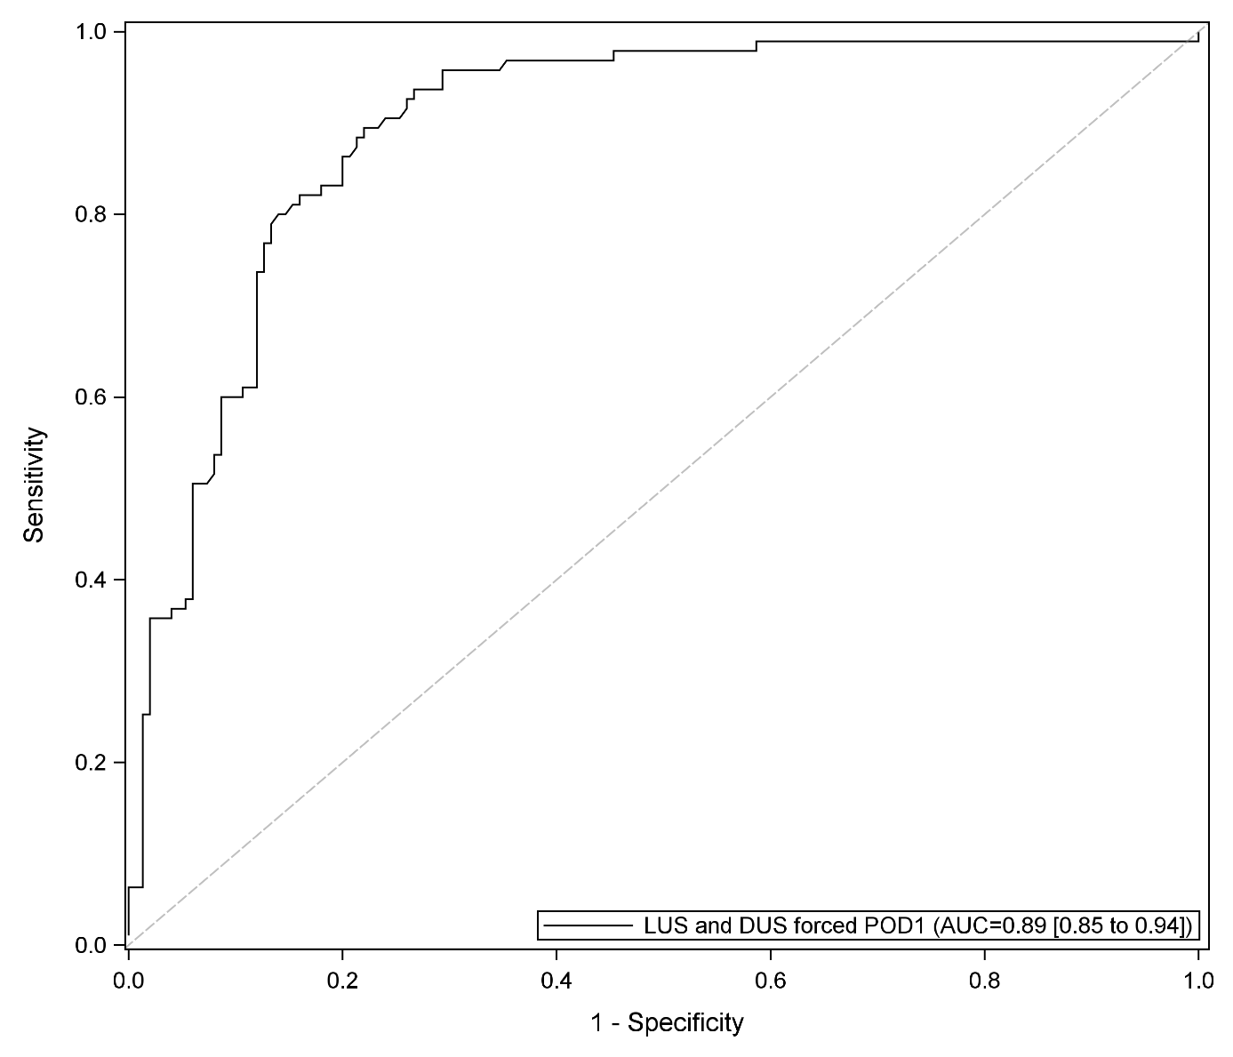
eFigure 2. ROC curve of combined diaphragmatic excursion in quiet breathing and lung ultrasound score at postoperative day 1 for prediction of postoperative pulmonary complications.
DUS : diaphragmatic ultrasound ; LUS : lung ultrasound score; POD0 : postoperative day 0

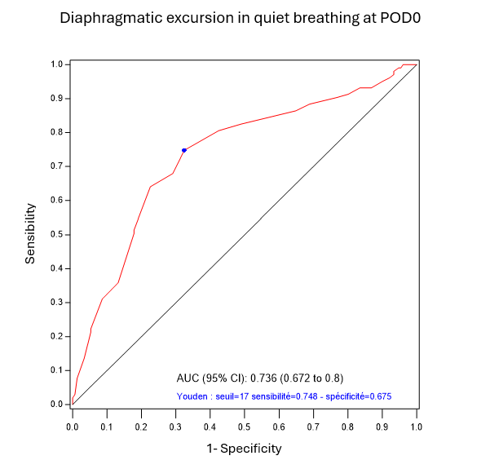
eFigure 3. ROC curve of diaphragmatic excursion in quiet breathing at postoperative day 0 for prediction of postoperative pulmonary complications.
Threshold = 17 mm, Sensibility = 0.75, Specificity= 0.68
DUS : diaphragmatic ultrasound ; LUS : lung ultrasound score; POD0 : postoperative day 0

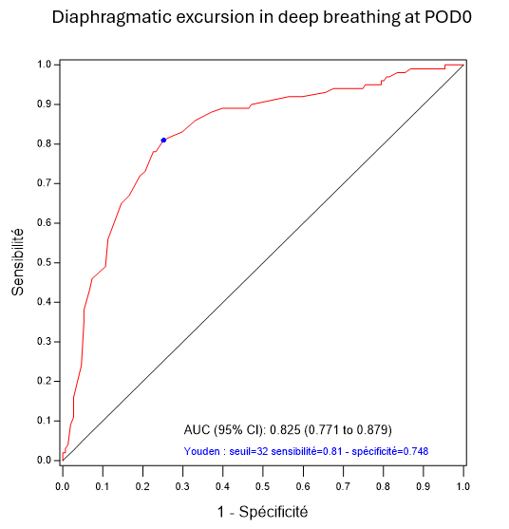
1- Specificity
Sensibility
eFigure 4. ROC curve of diaphragmatic excursion in deep breathing at postoperative day 0 for prediction of postoperative pulmonary complications.
Threshold 32 mm. Sensibility = 0.81 and specificity = 0.75
DUS : diaphragmatic ultrasound ; LUS : lung ultrasound score; POD0 : postoperative day 0

eTable 4. Association between lung ultrasound score (LUS) and individual PPC components
PPC component | POD0 LUS OR (95% CI) | p value | POD1 LUS OR (95% CI) | p value
Acute respiratory failure | 1.12 (1.04–1.19) | 0.001 | 1.15 (1.07–1.23) | <0.001
Pneumonia | 1.12 (1.04–1.20) | 0.003 | 1.13 (1.05–1.22) | <0.001
Pleural effusion | 1.13 (1.05–1.22) | 0.002 | 1.16 (1.08–1.25) | <0.001
Atelectasis | 1.08 (0.98–1.17) | 0.11 | 1.13 (1.04–1.23) | 0.005
Abbreviations: CI, confidence interval; LUS, lung ultrasound score; POD, postoperative day; PPC, postoperative pulmonary complication.

eTable 5. Association between diaphragmatic excursion during deep and individual PPC components
PPC component | POD0 DUS OR (95% CI) | p value | POD1 LUS OR (95% CI) | p value
Acute respiratory failure | 0.152 (0.074-0.314) | <0.001 | 0.098 (0.042-0.230) | <0.001
Pneumonia | 0.120 (0.048-0.301) | <0.001 | 0.137 (0.055-0.345) | <0.001
Pleural effusion | 0.234 (0.096-0.574) | 0.002 | 0.301 (0.132-0.684) | 0.004
Atelectasis | 0.324 (0.128-0.82) | 0.02 | 0.108 (0.031-0.373) | <0.001
Abbreviations: CI, confidence interval; DUS, diaphragmatic ultrasound; POD, postoperative day; PPC, postoperative pulmonary complication.
The diaphragmatic excursion during deep breathing was categorized using a threshold that optimized the Youden index (32 mm for POD0 and 31 mm for POD1).

eTable 6. Variables not retained in the final multivariable model
 | p-value
Surgical approach | 0.83
Neoplastic histology | 0.79
Preoperative hemoglobin | 0.75
Smoking status | 0.74
ASA score | 0.08
Abbreviations: ASA, American Society of Anesthesiologists

