Supplementary material for
Making drawings speak through mathematical metrics.
Cédric Sueur^{1,2}, Lison Martinet¹, Benjamin Beltzung¹, Marie Pelé³
1: Université de Strasbourg, CNRS, IPHC UMR 7178, Strasbourg, France
2: Institut Universitaire de France, Paris, France
3 : Anthropo-Lab, ETHICS EA7446, Lille Catholic University, Lille, France
Corresponding author: Cédric Sueur, cedric.sueur@iphc.cnrs.fr; IPHC UMR 7178, 23 rue Becquerel 67087 Strasbourg, France

Details about metrics, their calculation and a value range for each instruction in dataset#1
1. μMLE
Details about the use of this metric for drawing analysis are developed and detailed in Martinet et al. (2021)¹. μMLE is the maximum likelihood exponent that results from the analyses of the drawing-line length distribution. This analysis originates from the random walk or Lévy walk theory ^{2,3}. The random walk analysis determines whether the distribution of drawing lines follows a power law or an exponential law. If the distribution follows an exponential law, we expect the drawing to be random, meaning that the individual who is drawing does not intend to represent any specific thing. In contrast, a power distribution should reflect a non-random and oriented behaviour, as found for the daily paths of animals in their natural environments (i.e. goal-oriented and efficient movements ^{2,3}).
As the coordinate scoring of the drawing was continuous (one point per frame), we focused on active changes ^{4,5}: a selection of points was carried out for each drawing via a change-point test under R software (version 1.1.383; CPT, script available in Noser and Byrne, 2014). Two consecutive points (i and j) in the drawing determined a step or a vector of a length L (i, j). We then calculated the step lengths S on Excel with latitude x and longitude y (in pixels). Step lengths between 0 and 10 pixels were removed since they often corresponded to very short, inactive movements such as imprecise lines or finger sideslips, and caused inaccuracies. We then determined whether the step length frequency distribution of a drawing followed a power law (y = a*x^{μ}) or an exponential law (y = a.e ^{x*λ}) using the Maximum Likelihood Method ^{1,6}. Log-likelihood of the exponential and power distributions for each drawing could then be compared using the Akaike Information Criterion (AIC). We retained the model retained (power or exponential) with the lowest AIC, with a minimum difference of 2 between the two AICs ⁷. All the drawings produced followed a power law. The Maximum Likelihood Estimate of the power law exponent μMLE was then used to draw conclusions on the efficiency of the representation for each drawing. This index is comprised of values between 1 and 3. The higher the index, the more the line was considered to be directed, well planned and efficient ^{8,9}.
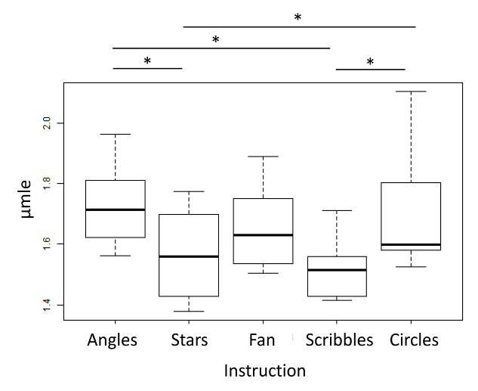
Figure S1: Boxplot of the μMLE according to instructions. Stars indicate significant difference between two instructions with p <0.05. ANOVA test gives a p= 0.0003.
2. Drawing distance
Drawing distance is the total distance of drawing in pixels, from the first point to the last. Two consecutive points (i and j) in the drawing determined a step or a vector of a length L (i, j). We then calculated the step lengths S on Excel with latitude x and longitude y (in pixels). We calculate the sum of all lengths S as the drawing distance.
Figure S2: Boxplot of the drawing distance according to instructions. Stars indicate significant difference between two instructions with p <0.05. Kruskal-Wallis test gives a p-value <0.0001.
3. Angle distribution metric
Goal directedness in animals is assessed by individuals moving in straight lines with limited tortuosity, except when they arrive at a food resource site and start to forage. Drawing intentionality can be considered similar to animal food research efficiency ^{1,10}. Analyses of angle distributions (i.e. turning angles) between two trajectories or lengths can be considered as a reliable way to measure goal directedness and tortuosity ^{11–13}. A turning angle is the difference in direction for two successive vectors or steps. We followed the same methodology as described in 1. μMLE. As coordinate scoring of the drawing was continuous (one point per frame), we focused on active changes ^{4,5}: a selection of points was carried out for each drawing via a change-point test under R software (version 1.1.383; CPT). Step lengths between 0 and 10 pixels were removed as they often corresponded to very short, inactive movements such as imprecise lines or finger sideslips, and caused inaccuracies. Function ATAN2 in Excel was then used to calculate the angle (in radians) between two consecutive points and convert radians into degrees. We applied corrections to only retain angles between 0° and 180°, as movements are oriented. We then calculated the survival distribution of angles (i.e. going from 1 or 100% of points to 0) for each drawing. A cubic function was fitted to the distribution. Examples of drawings and the respective distributions are given in Figure S3. 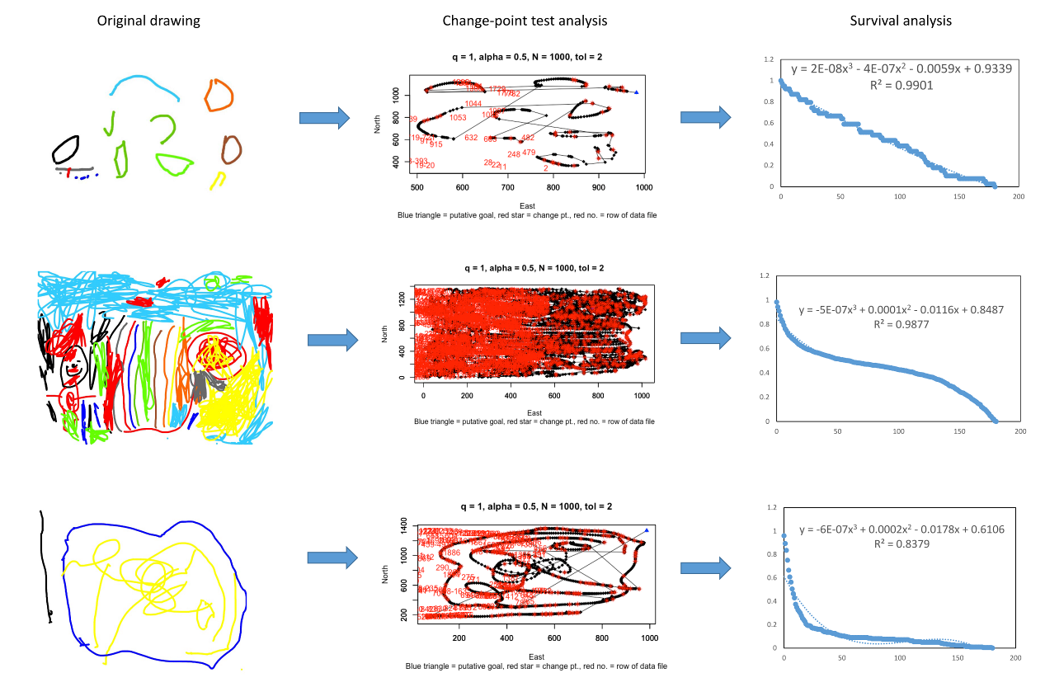
Figure S3: Analysis of angles distribution. The original drawing is transformed into vectors (i.e. trajectories) following the change-point test, and angles are calculated. The angle survival distribution is then fitted with a cubic function.
The cubic function is y=-ax³+bx²-cx+d. The more the distribution looks like a straight line, the lower the values of a, b and c will be. The more the curve looks like a sigmoid or inversed power function, the higher the values of a, b and c will be. The three constants a, b and c are highly correlated and can be combined using a principal component analysis, where one dimension explained 82% of variance for dataset#1 (dimension 2 = 15%) and 90% of variance for dataset#2 (dimension 2 = 5%). We used the values of dimension 1 as values for the angle distribution metric for each drawing.
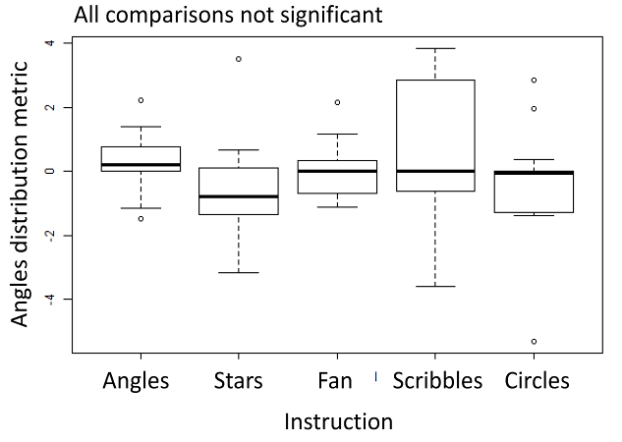
Figure S4: Boxplot of the angle distribution metric according to each instruction. ANOVA testing provides a P value of 0.329
4. Minimum convex polygon
The minimum convex polygon draws the smallest polygon around points with all interior angles measuring less than 180 degrees. Minimum convex polygons are common estimators of home range ¹⁴ but represent the cover of drawing on the screen, between 0 (no drawing at all) to 100% (the drawing covered the entire screen). We used the scissors select tool in GIMP 2.10.22 ^{15,16} to select the minimum convex polygon of drawings.
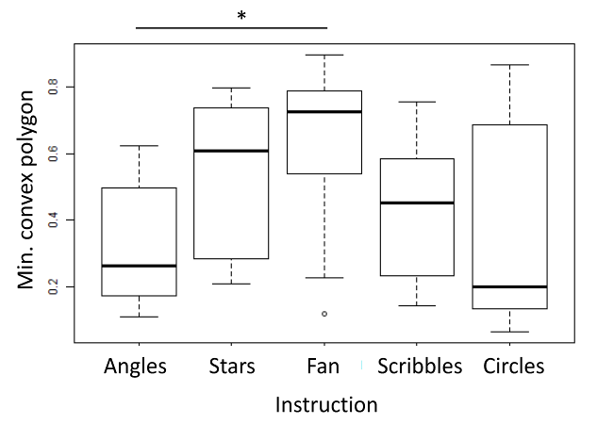
Figure S5: Boxplot of the minimum convex polygon according to instructions. Stars indicate significant difference between two instructions with p <0.05. ANOVA testing provides a P value of 0.016.
5. Hurst index
Details about the calculation of this metric can be found in Beltzung et al (2021)¹⁷. Fractality or long-term processes can be measured by different methodological approaches, each of which has its own fractal statistical parameter. Here, the difficulty lies in the fact that numerous estimators have been defined for each parameter, yet the effectiveness of these very estimators is still debated in the literature ^{18,19}. Studies often focus on one or a small number of estimators without a rigorous reason (such as comparing them). As a consequence, there is no simple and systematic way to estimate the long-memory process, which often results in errors or misleading conclusions in studies ²⁰. The most widespread way to assess and quantify long-memory processes in temporal sequences is the estimation of the Hurst exponent H. Indeed, a behavioural state is influenced by previous states following two different scenarios: persistence (H>0.5) when a positive correlation occurs, meaning that a long sequence is likely to be followed by a long sequence in the future, and anti-persistence (H <0.5) when a long sequence is likely to be followed by a short sequence, i.e. a negative correlation ²¹. Here, we combined different methods using a PCA as explained in ¹⁷.
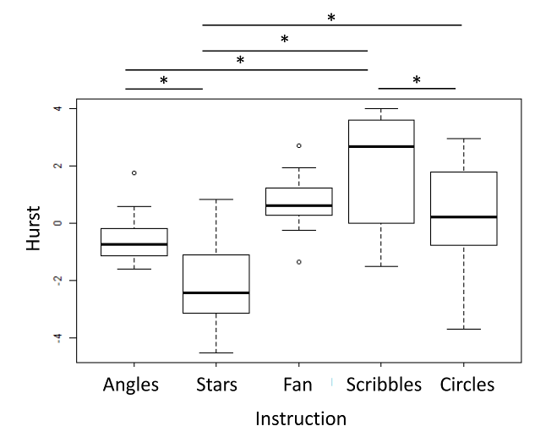
Figure S6: Boxplot of the Hurst index according to each instruction. Stars indicate significant difference between two instructions with p <0.05. ANOVA test gives a p <0.0001.
6. Temporal Gini index
The Gini index was calculated on the binary sequences (drawing / non-drawing) and describes the uniformity of the distribution. This index is a real number between 0 and 1, where a value of 0 indicates perfect equality, and a value of 1 indicates maximal inequality. The interpretation of this index on behavioural sequences can be questioned, as well as the temporal sequence to consider. The Gini index was calculated by using the R package “DescTools” ²².

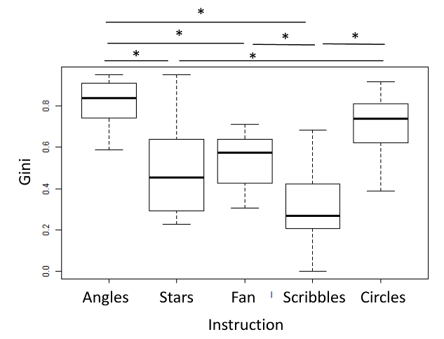
Figure S7: Boxplot of the Gini metric according to instructions. Stars indicate significant difference between two instructions with p <0.05. ANOVA test: p <0.0001.
7. Entropy index
The Shannon entropy index ^{23,24} has not been calculated for temporal binary sequences, but for the cumulative sum of drawing time at each second. This index characterises the quantity of information contained in a variable. The higher the quantity of information, the higher the uncertainty (the entropy). For a string of sequences with n distinct sequences, each sequence has a frequency of p. The entropy index was calculated by using the R package “DescTools” ²². The entropy of Shannon H is calculated according to the formula:
$$H=-\sum_{i=\&}^{n}{p_{i}}\log_{2}p_{i}$$

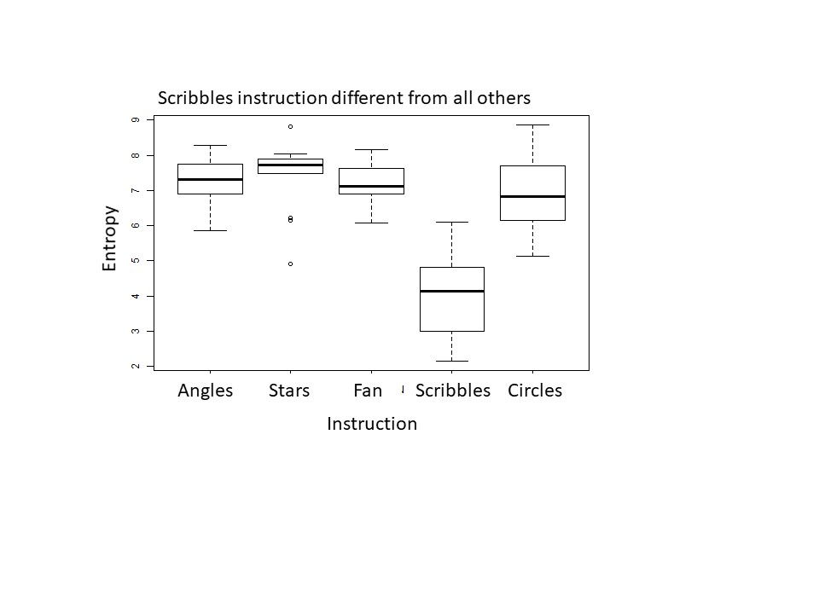
Figure S8: Boxplot of the entropy metric according to instructions. Stars indicate significant difference between two instructions with p <0.05. ANOVA test: p <0.0001.
8. Drawing duration
The duration of the drawing session is defined as the time from the first point on the touchscreen to the last, including the time spent drawing and time without drawing between these two points.

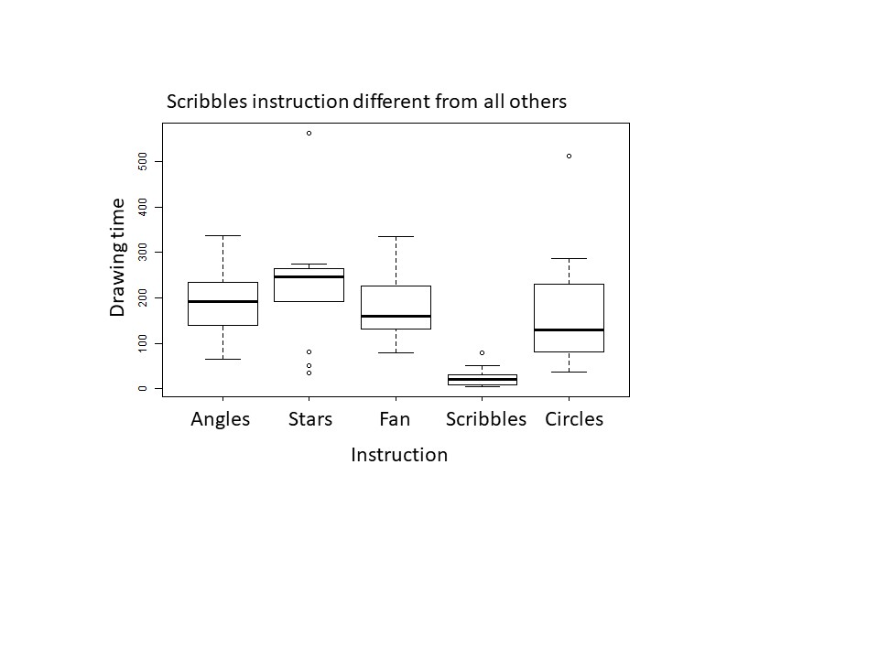
Figure S9: Boxplot of the drawing duration according to instructions. Stars indicate significant difference between two instructions with p <0.05. ANOVA test: p <0.0001.
9. Number of sequences
Number of drawing and non-drawing sequences during the test.
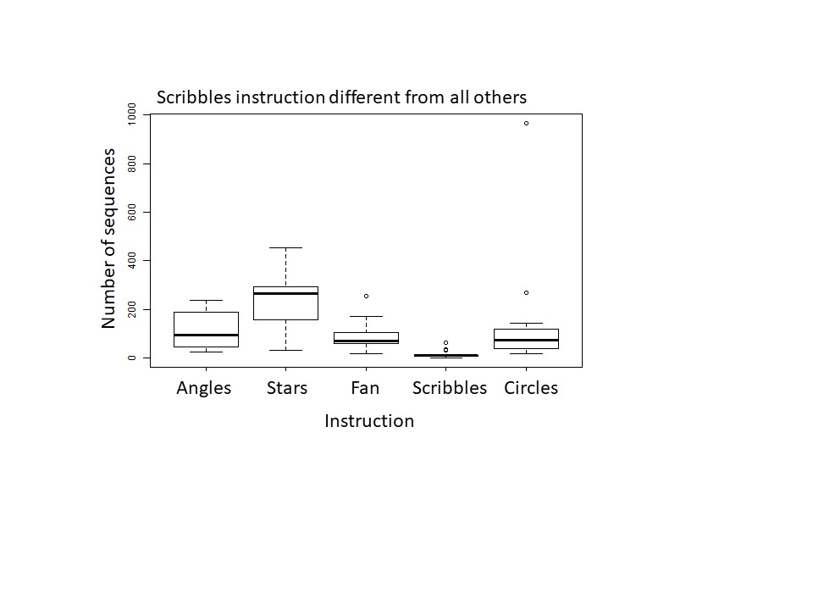
Figure S10: Boxplot of the number of sequences according to instructions. Stars indicate significant difference between two instructions with p <0.05. Kruskal-Wallis test: p <0.0001.
10. Drawing speed
Drawing distance divided by the drawing duration (i.e. duration of drawing only, not including duration of non-drawing during the test).
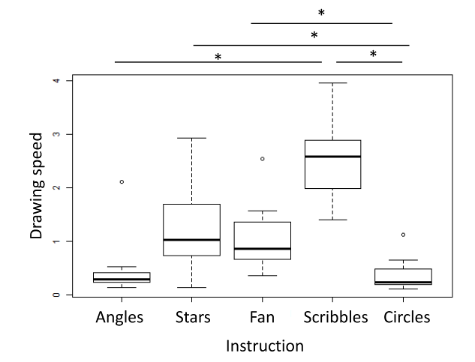
Figure S11: Boxplot of the drawing speed according to instructions. Stars indicate significant difference between two instructions with p <0.05. ANOVA test: p <0.0001.
11. Drawing time proportion
Duration of drawing divided by the duration of drawing session.
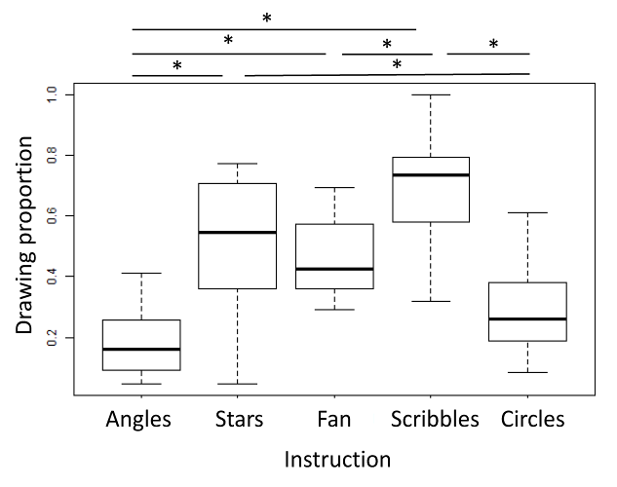
Figure S12: Boxplot of the drawing proportion according to instructions. Stars indicate significant difference between two instructions with p <0.05. ANOVA test: p <0.0001.
12. Mean colorimetric profile
Mean distribution of intensity levels for the Red, Green, or Blue colours respectively and after removal of the white (screen) colour on the parts covered by drawing (after selection with the minimum convex polygon).
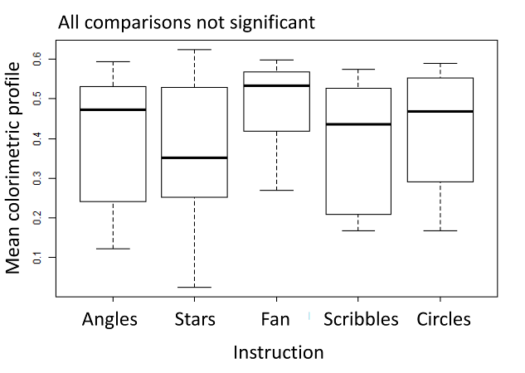
Figure S13: Boxplot of the mean colorimetric profile according to instructions. Stars indicate significant difference between two instructions with p <0.05. ANOVA test: p=0.319.
13. Standard deviation of the colorimetric profile
Standard deviation of the distribution of intensity levels for the Red, Green, or Blue colours respectively, on the parts covered by drawing (after selection with the minimum convex polygon).
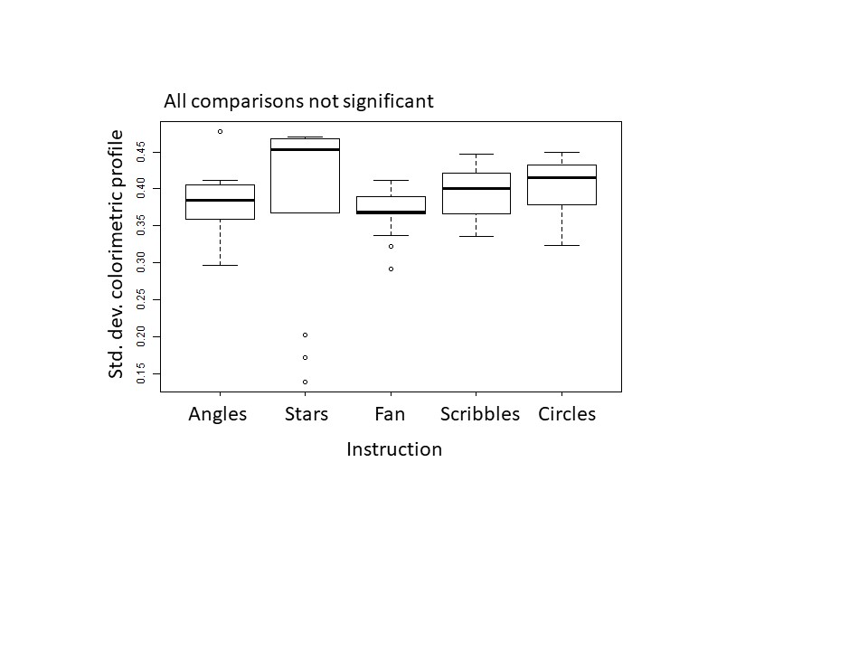
Figure S14: Boxplot of the standard deviation of the colorimetric profile according to instructions. Stars indicate significant difference between two instructions with p <0.05. ANOVA test: p=0.675.
14. Number of colours
Number of colours used from the ten proposed colours. The ten proposed colours are black, grey, red, blue, dark green, light green, sky blue, brown, orange and yellow.
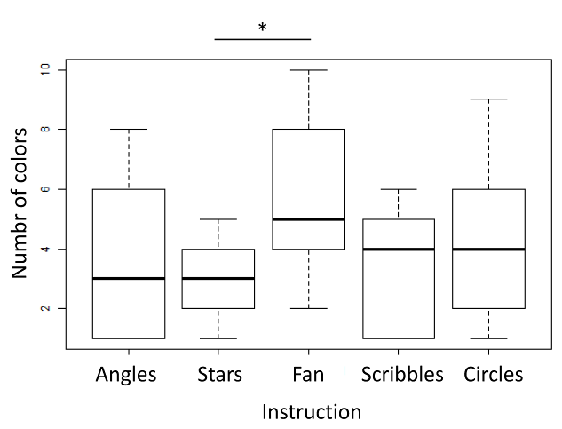
Figure S14: Boxplot of the number of colours according to instructions. Stars indicates significant difference between two instructions with p <0.05. Kruskal-Wallis test: p=0.04.

Supplementary figures and tables referenced in the main text

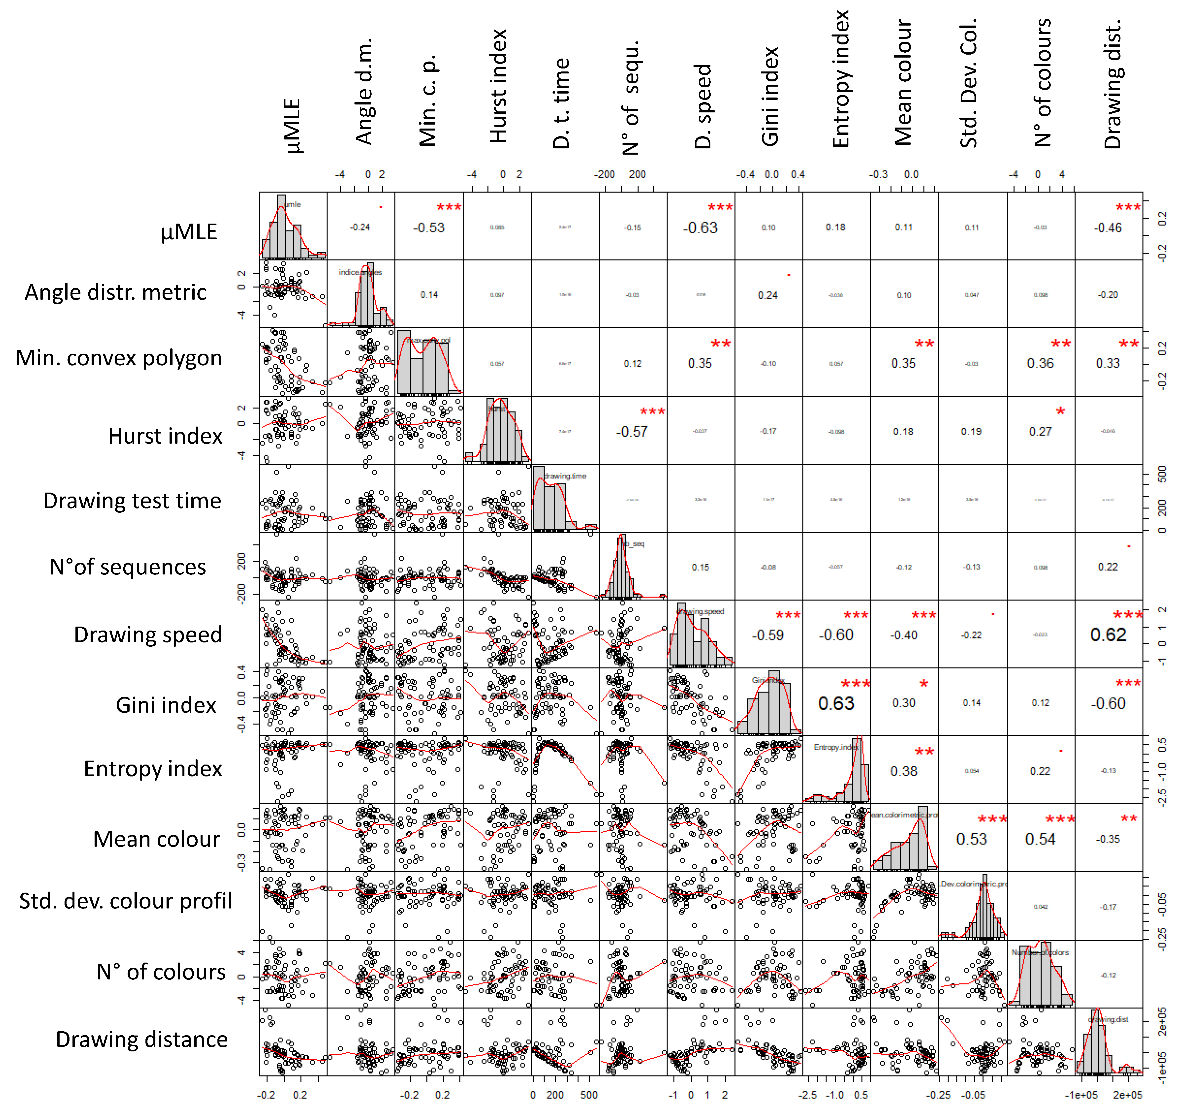
Figure S15: correlation chart of the 13 metrics for dataset#1 (first step, after removal of the drawing-time proportion and correction according to the drawing test time). The diagonal of the graph provides the distribution of each metric, whilst the bottom left and the top-right provide the correlation figure and the correlation coefficient between two metrics, respectively. Statistical value is given with the correlation coefficient: * means p <0.05, ** means p <0.01, and *** means p <0.001.
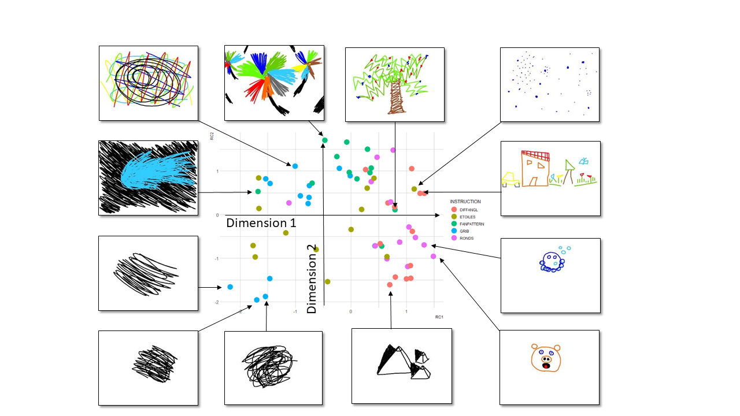
Figure S16a: Examples of Dataset#1 (first step) drawings according to Dimension 1 and Dimension 2, provided by the PCA. Dimension 1 may represent representativeness in drawing whilst Dimension 2 may represent diversity in drawings.

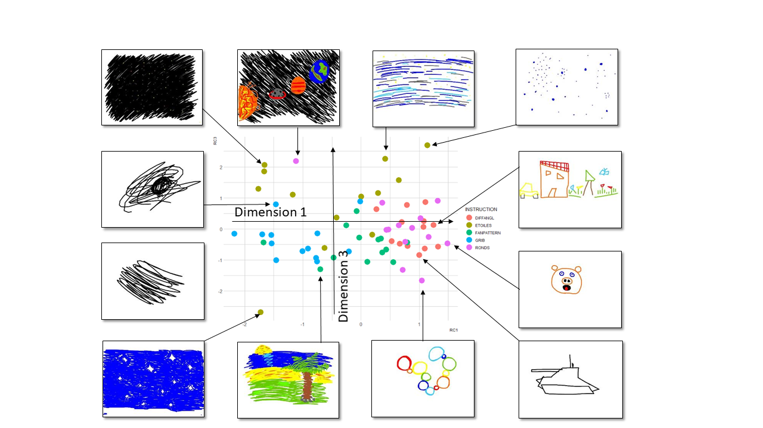
Figure S16b: Examples of Dataset#1 (first step) drawings according to Dimension 1 and Dimension 3, provided by the PCA. Dimension 1 may represent representativeness in drawing whilst Dimension 3 may represent periodicity in drawings.

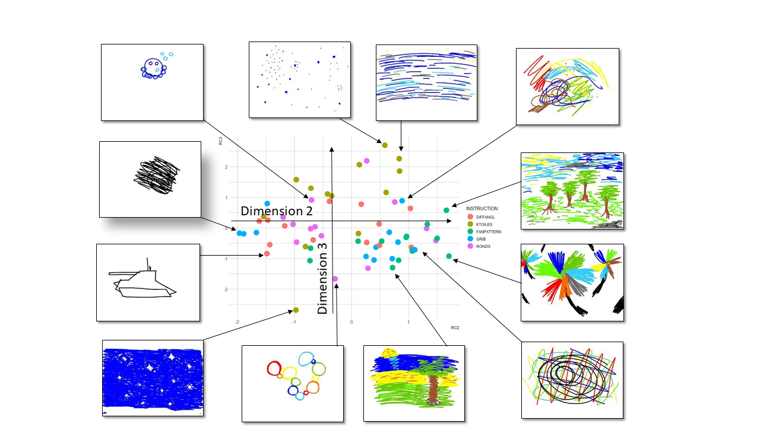
Figure S16c: Examples of Dataset#1 (first step) drawings according to Dimension 2 Dimension 3, provided by the PCA. Dimension 2 may represent diversity in drawing whilst Dimension 3 may represent periodicity in drawings.
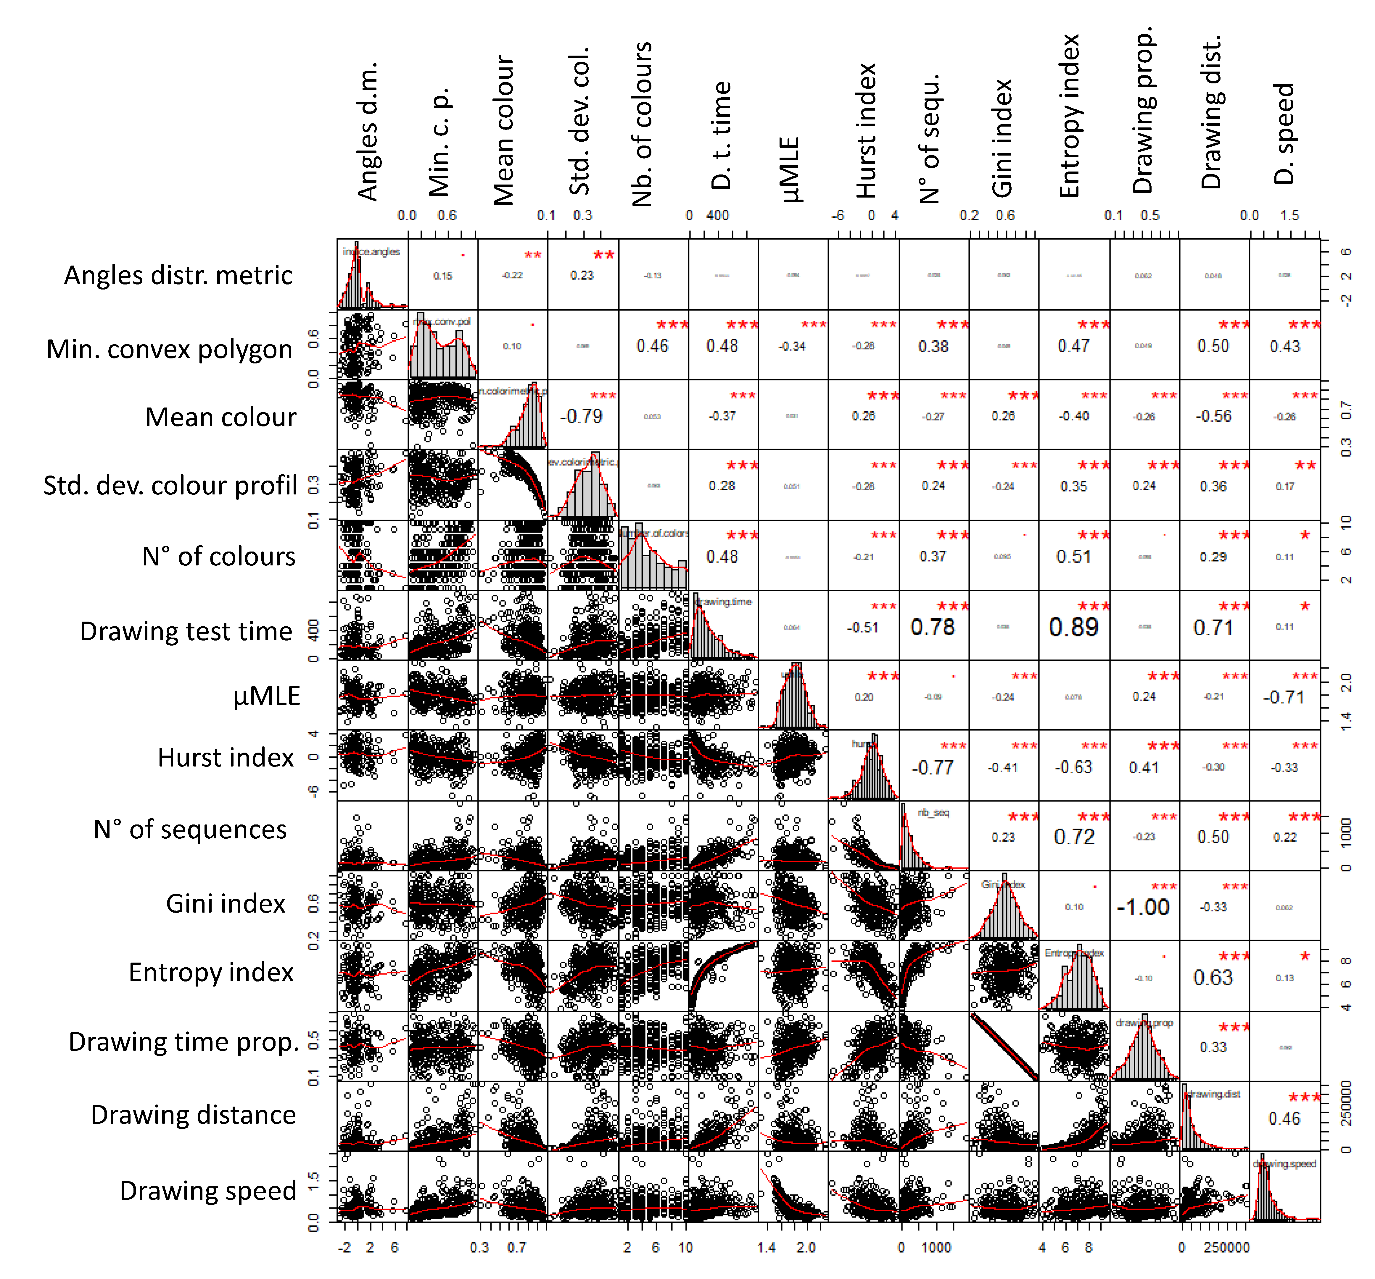
Figure S17: Correlation chart of the 14 metrics for dataset#2 (second step). The diagonal of the graph provides the distribution of each metric, whilst the bottom left and the top-right provide the correlation figure and the correlation coefficient between two metrics, respectively. Statistical value is given with the correlation coefficient: * means p <0.05, ** means p <0.01, and *** means p <0.001.

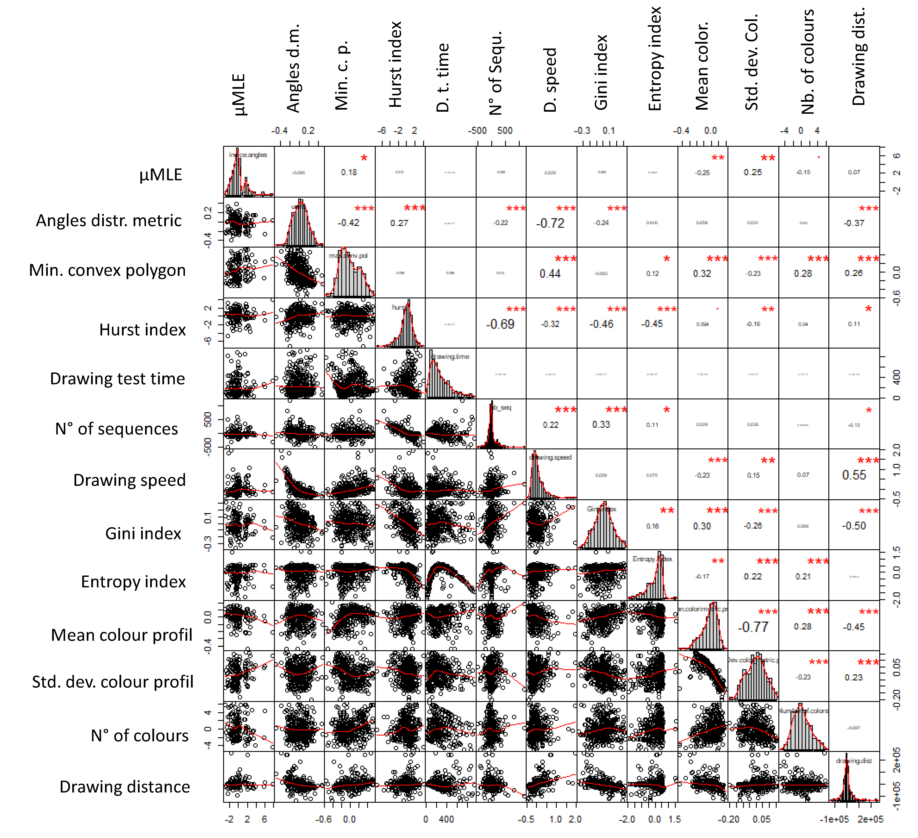
Figure S18: Correlation chart of the 13 metrics for dataset#2 (second step, after removal of the drawing-time proportion and correction according to the drawing test time). The diagonal of the graph provides the distribution of each metric, whilst the bottom left and the top-right provide the correlation figure and the correlation coefficient between two metrics, respectively. Statistical value is given with the correlation coefficient: * means p <0.05, ** means p <0.01, and *** means p <0.001.

Table S1: Loading of the 13 metrics on the three Varimax rotation PCA dimensions (before selection of variables with loading superior to 0.4) of Dataset#1
 | Dim1 | Dim2 | Dim3
μMLE | 0.639 | -0.373 | 0.314
Angle distribution metric |  | 0.347
Min. conv. pol. | -0.451 | 0.725 | -0.159
Hurst index | -0.14 | 0.195 | 0.849
Drawing test time
Number of sequences | -0.115 |  | -0.755
Drawing speed | -0.911 |  | -0.12
Gini index | 0.762 | 0.301 | -0.213
Entropy index | 0.624 | 0.375 | -0.235
Mean colour profile | 0.365 | 0.758 | 0.254
Std. dev. colour profile | 0.221 | 0.296 | 0.398
Number of colours |  | 0.716
Drawing distance | -0.746 |  | -0.228

Table S2: Mann-Whitney test for each metric of each dimension between the scribbles of toddlers and those drawn by adults. p-values<0.05 are in bold print.
Dimension | Metrics | W | p-value | Mean for toddlers | Mean for adults
1 | μMLE | 101 | 0.225 | -0.07±0.14 | -0.12±0.09
1 | drawing distance | 47 | 0.097 | 30239±72983 | 26505±14882
1 | drawing speed | 29 | 0.007 | 0.31±0.73 | 1.04±0.68
2 | Mean colour Profil | 93 | 0.473 | 0.01±0.09 | -0.05±0.16
2 | Number of colours | 118 | 0.03 | 2.79±2.68 | 0.09±1.
3 | Hurst | 84 | 0.769 | 1.29±1.03 | 0.71±2.0
3 | Number of sequences | 11 | <0.0001 | -52.12±33.0 | 5.39±18.3

References
1. Martinet, L. et al. New indices to characterize drawing behavior in humans ( Homo sapiens ) and chimpanzees ( Pan troglodytes ). Sci. Rep. 11, 3860 (2021).
2. Sueur, C. A Non-Lévy Random Walk in Chacma Baboons: What Does It Mean? PLoS ONE 6, e16131 (2011).
3. Sueur, C., Briard, L. & Petit, O. Individual Analyses of Lévy Walk in Semi-Free Ranging Tonkean Macaques (Macaca tonkeana). PLoS ONE 6, e26788 (2011).
4. Byrne, R. W., Noser, R., Bates, L. A. & Jupp, P. E. How did they get here from there? Detecting changes of direction in terrestrial ranging. Anim. Behav. 77, 619–631 (2009).
5. Noser, R. & Byrne, R. W. Change point analysis of travel routes reveals novel insights into foraging strategies and cognitive maps of wild baboons. Am. J. Primatol. 76, 399–409 (2014).
6. Edwards, A. et al. Revisiting Levy flight search patterns of wandering albatrosses, bumblebees and deer. NATURE 449, 1044-U5 (2007).
7. Burnham, K. P. & Anderson, D. R. Multimodel inference understanding AIC and BIC in model selection. Sociol. Methods Res. 33, 261–304 (2004).
8. Bartumeus, F., Da Luz, M., Viswanathan, G. & Catalan, J. Animal search strategies: A quantitative. random-walk analysis. ECOLOGY 86, 3078–3087 (2005).
9. Viswanathan, G. M. et al. Lévy flight search patterns of wandering albatrosses. Nature 381, 413–415 (1996).
10. Martinet, L. & Pelé, M. Drawing in nonhuman primates: What we know and what remains to be investigated. J. Comp. Psychol. (2020).
11. Bartumeus, F., Catalan, J., Viswanathan, G. M., Raposo, E. P. & da Luz, M. G. E. The influence of turning angles on the success of non-oriented animal searches. J. Theor. Biol. 252, 43–55 (2008).
12. Hurford, A. GPS Measurement Error Gives Rise to Spurious 180° Turning Angles and Strong Directional Biases in Animal Movement Data. PLOS ONE 4, e5632 (2009).
13. Potts, J. R. et al. Finding turning-points in ultra-high-resolution animal movement data. Methods Ecol. Evol. 9, 2091–2101 (2018).
14. Nilsen, E. B., Pedersen, S. & Linnell, J. D. C. Can minimum convex polygon home ranges be used to draw biologically meaningful conclusions? Ecol. Res. 23, 635–639 (2008).
15. Lecarme, O. & Delvare, K. The book of GIMP: A complete guide to nearly everything. (No Starch Press, 2013).
16. Peck, A. Beginning gimp: From novice to professional. (Apress, 2006).
17. Beltzung, B. et al. To draw or not to draw: understanding the temporal organization of drawing behaviour using fractal analyses. bioRxiv (2021) doi:10.1101/2021.08.29.458053.
18. Stadnitski, T. Measuring fractality. Front. Physiol. 13 (2012).
19. Stadnytska, T., Braun, S. & Werner, J. Analyzing Fractal Dynamics Employing R. 29 (2010).
20. Karagiannis, T., Molle, M. & Faloutsos, M. Understanding the Limitations of Estimation Methods for Long-Range Dependence. 23 (2006).
21. Delignières, D., Torre, K. & Lemoine, L. Methodological issues in the application of monofractal analyses in psychological and behavioral research. Nonlinear Dyn. Psychol. Life Sci. 9, 435–461 (2005).
22. Signorell, A. et al. DescTools: Tools for descriptive statistics. R Package Version 099 18, (2016).
23. Gray, R. M. Entropy and Information Theory. (Springer Science & Business Media, 2011).
24. Leff, H. S. Entropy, its language, and interpretation. Found. Phys. 37, 1744–1766 (2007).

