Supplementary Material for

Analysis of nifH DNA and RNA reveals a disproportionate contribution to nitrogenase activities by rare plankton-associated diazotrophs
Qingsong Yang^{1, 3},Junde Dong^{1, 2}, Manzoor Ahmad^{1, 3}, Juan Ling¹, Weiguo Zhou^{1, 3}, Yehui Tan¹, Yuanzhou Zhang⁴, Dandan Shen⁵*, Yanying Zhang ^{1, 2}*
¹CAS Key Laboratory of Tropical Marine Bio-resources and Ecology, Guangdong Provincial Key Laboratory of Applied Marine Biology, South China Sea Institute of Oceanology, Chinese Academy of Sciences, 510301 Guangzhou, China
²Tropical Marine Biological Research Station in Hainan, South China Sea Institute of Oceanology, Chinese Academy of Sciences,572000Sanya, China
³University of Chinese Academy of Sciences,100049 Beijing, China
⁴State Oceanic Administration Sansha Marine Environmental Monitoring Center Station, 570311,Haikou,China
⁵Section of Biological Oceanography, Leibniz Institute for Baltic Sea Research, 18119, Warnemünde, Germany
*Correspondence:
Dandan Shen, dandan.shen@io-warnemuende.de
Yanying Zhang,zyy@scsio.ac.cn

Contents:
Supplementary Table S1
Supplementary Table S2
Supplementary Table S3
Supplementary Table S4
Supplementary Fig. S1
Supplementary Fig. S2
Supplementary Fig. S3

Table S1 Geolocation of the stations, sampling depth, and sample volume
Station | Geolocation | Water depth (m) | Sampling depth (m) | Sample volume (L)
A | 21°59.789′, 114°59.924′ | 57.8 | 55 | 12304.9
B | 21°29.443′, 115°29.513′ | 108.7 | 105 | 22549.1
C | 20°30.026′, 116°30.022′ | 435.5 | 200 | 18840.0
D | 21°19.931′, 118°0.070′ | 1475.8 | 200 | 41860.1
E | 21°30.040′, 119°29.665′ | 2999.0 | 200 | 36914.6
F | 22°30.142′, 119°30.078′ | 227.0 | 200 | 36679.1
G | 23°18.133′, 117°42.110′ | 33.9 | 31 | 7418.3
H | 22°29.836′, 118°30.106′ | 64.3 | 60 | 18427.9
I | 22°46.199′, 116°44.916′ | 33.3 | 31 | 6594.0

Table S2 Alpha-diversity indexes of the total and active communities in each sample
 | Station | Shannon index | Simpson index | Pielou evenness | Chao1
Total communities | A | 1.21 | 1.45 | 0.23 | 223.02
Total communities | B | 0.97 | 1.32 | 0.19 | 200.25
Total communities | C | 1.00 | 1.33 | 0.20 | 200.55
Total communities | D | 0.86 | 1.27 | 0.17 | 183.77
Total communities | E | 0.89 | 1.28 | 0.18 | 189.52
Total communities | F | 0.89 | 1.28 | 0.18 | 187.39
Total communities | G | 0.91 | 1.30 | 0.18 | 217.62
Total communities | H | 0.86 | 1.27 | 0.17 | 196.36
Total communities | I | 1.03 | 1.33 | 0.20 | 200.64
Active communities | A | 1.84 | 2.31 | 0.35 | 247.45
Active communities | B | 0.99 | 1.33 | 0.20 | 192.10
Active communities | C | 1.55 | 2.20 | 0.30 | 211.91
Active communities | D | 1.09 | 1.38 | 0.21 | 227.56
Active communities | E | 1.00 | 1.32 | 0.19 | 214.92
Active communities | F | 1.56 | 2.39 | 0.29 | 268.32
Active communities | G | 0.92 | 1.29 | 0.18 | 205.18
Active communities | H | 1.80 | 2.21 | 0.34 | 264.03
Active communities | I | 1.07 | 1.38 | 0.21 | 200.90

Table S3 Nutrient concentrations at the sampling stations.
Station | Column average(μmol L⁻¹) |  |  |  |  |  | Surface water(μmol L⁻¹)
Station | Nitrite+Nitrate | Ammonium | Phosphate | Silicate |  | Nitrite+Nitrate |  | Ammonium | Phosphate | Silicate
A | 0.39 | 0.57 | 0.27 | 5.00 |  | 0.19 |  | 0.44 | 0.27 | 3.95
B | 0.85 | 0.14 | 0.20 | 4.00 |  | 0.30 |  | 0.48 | 0.07 | 1.94
C | 1.79 | 0.18 | 0.32 | 6.32 |  | 0.32 |  | 0.43 | 0.12 | 1.65
D | 2.37 | 0.13 | 0.42 | 5.22 |  | 0.22 |  | 0.00 | 0.03 | 2.13
E | 3.22 | 0.04 | 0.47 | 4.69 |  | 0.08 |  | 0.62 | 0.07 | 1.56
F | 1.45 | 0.08 | 0.21 | 3.69 |  | 0.75 |  | 0.08 | 0.12 | 2.23
G | 4.93 | 0.00 | 0.38 | 4.92 |  | 5.38 |  | 0.00 | 0.37 | 5.78
H | 0.37 | 0.28 | 0.12 | 1.97 |  | 0.63 |  | 0.00 | 0.17 | 1.56
I | 0.84 | 0.48 | 0.09 | 0.93 |  | 0.81 |  | 0.5. | 0.07 | 0.98

Table S4 Monte Carlo permutation test of the effects of environmental variables on the nifH-derived communities
 | Water column (average) | Sea surface
Nitrate+Nitrite | 0.100* | 0.503
Ammonium | 0.064* | 0.402
Phosphate | 0.094* | 0.608
Silicate | 0.405 | 0.969
Temperature | 0.040** | 0.732
Salinity | 0.910 | 0.608
pH | 0.021** | 0.019**
Dissolved oxygen | 0.990 | 0.290
Asterisks indicate the level of significance: *P< 0.1; **P< 0.05

Fig. S1 Water quality profiles at each station as determined by the CTD sampler.

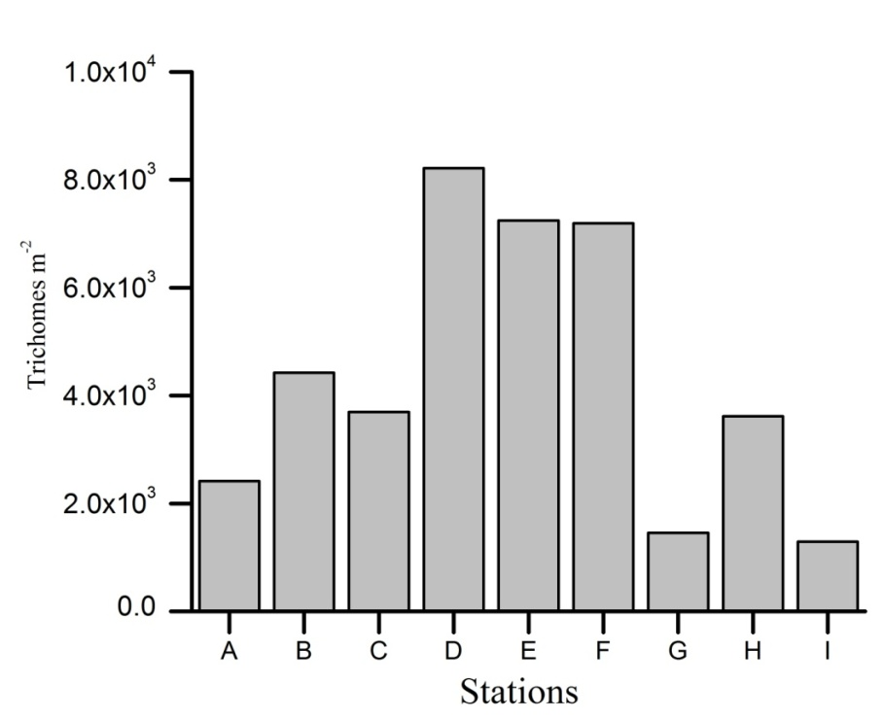
Fig. S2 Abundance of Trichodesmium in at the nine stations. Cell numbers were determined by microscopic counting.

Fig. S3 Redundancy analysis (RDA) ordination plot showing the relationships between environmental variables and taxa in the DNA and RNA libraries: (a) average values from the water column and (b)the values from the sea surface. Taxa are shown in red (R: taxa derived from the RNA library; D: taxa derived from the DNA library). Tricho, Trichodesmium; HetCyan, heterocystous cyanobacteria; SphCyan, spherical cyanobacteria; Gamma, Gammaproteobacteria; Delta, Deltaproteobacteria; Beta, Betaproteobacteria; Clu III, cluster III. Environmental variables that correlated significantly with the taxa are indicated in green, otherwise in blue. Temp, temperature; DO, dissolved oxygen; Sali, salinity; Nitr, nitrate+nitrite; Phos, phosphate; Ammo, ammonium; Sili, silicate.

