In-silico phenotype-correlation analysis of Inherited variations in Autism Spectrum Disorder families identify complex interplay between genes encoding Sensory functions and Repetitive-Behaviours- a pilot study from India
Meghana Kommerahalli RameshRaju ^{1#}, Snijesh Valiya Parambath², Durbagula Srividhya ³, Bhagyalakshmi Shankarappa⁴, Ramachandra Nallur Basappa^{1*}, and Ashitha S.Niranjana Murthy ^{4#*}

- Department of Studies in Genetics and Genomics, University of Mysore, Mysore- 570005, Karnataka, India
- Department of Molecular Medicine, St. John’s Research Institute, St. John’s National Academy of Health Science, Bangalore-560034, Karnataka, India
- Centre for Advance Research and Excellence in Autism and Developmental Disorders (CAREADD), St. John’s Research Institute, St. John’s National Academy of Health Science, Bangalore-560034, Karnataka, India.
- Molecular Genetics Laboratory, Department of Psychiatry, National Institute of Mental Health and Neuroscience Bangalore-560034, Karnataka, India
# Co-First Authors
* Corresponding Author
Dr. Ashitha S.Niranjana Murthy
DST INSPIRE Faculty-Fellow
Molecular Genetics Laboratory, Department of Psychiatry
National Institute of Mental Health and Neuroscience
Bangalore-560034, Karnataka, India
Email: ashithasnm09@gmail.com
ORCID ID: 0000-0001-7651-0670
SUPPLEMENTARY MATERIAL:
Supplementary Methods- Detailed description of the WES analysis methodology applied in this study:
Family Relatedness Kinship Analysis:
The relatedness check between probands and parents in each trio set was performed using Ancestry and Kinship (AKT) and VCFTools. All 23 trio families passed QC acceptance with expected kinship scores based on the relationship.
Data Pre-processing and DNA Alignment:
Quality control of paired end sequence raw data was performed using FastQC. Low quality reads with Phred score ≤ 20 and adapters contaminants in the data were eliminated using TrimGalore and Cutadapt. The trimmed high quality paired ends from each sample were aligned to the reference genome (build GRCh38) using Burrows-Wheeler Aligner (BWA). The aligned samples were sorted and duplicated reads were marked by MarkDuplicates module in GATK tool. The deduped bam files are processed with BaseRecalibrator and ApplyBQSR modules to improve the base quality score which may be occurred due to systemic errors.
Variant Calling:
We called out transmitted or inherited germline variants in each sample using GATK best practice pipeline. Inherited variants in each child within a trio set were compared with parents to establish the line of inheritance (paternally and maternally). Inherited variants referring to those transmitted down to off-springs by any one or both parents were both subjected to further analysis.
Variant Annotation:
The variants were annotated using ensemble tool Variant Effector Predictor (VEP) to identify different classes of variants like SNPs, insertions deletions (InDels). Splice variants were also identified. Functional impact on their respective genes, transcripts, and protein sequence were assessed. Only ‘high’ impact variants (Frameshift InDels, Stopgain stop loss, splice variants) and ‘moderate’ impact variants (nsSNPs) were included for further analysis.
Variant Filtering:
Inherited variants were filtered based on read quality and allele frequency
- Variant Quality filtering:
At the level of variants, stringent parameters like depth (DP ≥ 20), Genotype Quality (GQ ≥ 20), Variant Allele Frequency (VAF ≥ 0.4) and allelic depth at mutated base (ADR ≥ 5) were applied to remove false positive calls.
- Population allele frequency based filtering:
The annotated variants were filtered using global minor allele frequency (GMAF < 1%) to remove the common variants across populations using 1000Genome, gnomAD, ExAC and ALSPAC. Genome-Asia database was used to filter out variants common to the Asian population.
Functional variants and genes prioritization:
Prioritization was performed at two levels for inherited variants, first at the level of variants and subsequently at the level of genes:
- Variant prioritization:
We considered only variants with ‘high’ impact as annotated by VEP including frameshift InDels, stopgain, stoploss, splice-site variants and ‘moderate’ impact missense/nonsynonymous SNPs (nsSNPs). All nsSNPs were further subjected to ‘SNP effect Prediction’ to identify deleterious/damaging variants. A total of 25 such prediction tools were used to determine the effect of nsSNPs on protein structure and function and thereby, separate damaging variants (D) from benign/tolerant variations (T). We considered a nsSNP as a damaging variant if ≥15 tools or ≥60% of 25 tools predicted it to be damaging.
- Gene prioritization:
To prioritize genes carrying protein-truncating and damaging variants, we employed four different gene sensitivity scores followed by ‘combined weighted’ scoring to determine genic intolerance to functional mutations:
- Essential genes: constitute a minimal gene set required for survival, as they encode functions considered a foundation of life and thus likely to be common across cells (Zhang, 2004)
- Haploinsufficiency Scores (HI) predicts if genes require two copies to maintain normal function deploying a dominant effect on the phenotype; HI is the most relatable mechanism of heterozygous loss-of-function mutations where a single functional copy of a gene is not sufficient to maintain normal function (Huang et al., 2010). Higher HI score and lower HI percentile indicates greater pathogenicity due to the loss of this gene. High ranks (e.g. 0-10%) indicate a gene which is more likely to exhibit the features of haploinsufficient genes, low ranks (e.g. 90-100%) indicate a gene is more likely to NOT exhibit haploinsufficiency.
- Residual Variation Intolerance Score (RVIS) was obtained from common missense and loss-of-function (LoF) variants versus total number of protein coding variants regardless of their frequencies. Gene with lower RVIS is more likely to disrupt gene function; i.e. when S<0, the gene has less common functional variation than predicted reflecting purifying selection. Moreover, 25th percentile RVIS threshold displayed an increased enrichment of DNMs implicated in neurodevelopmental disorders (Petrovski et al., 2013).
- LoFtool scores discriminates between genes that do and do not cause disease (mostly early onset)- especially for neurodevelopmental disorder genes making it an attractive method for investigating complex brain diseases with strong genetic effects. LOFtool is the ratio of LoF to synonymous mutations for each gene, adjusting for the gene de novo mutation rate and evolutionary protein conservation (Fadista et al., 2016). Since LOF mutations has the highest pathogenicity, they serve as the best proxy to measure genic intolerance. Genes with lower LoFtool percentiles represent the genes that are most intolerant to functional variation.
Weighted Scoring:
In order to quantify the cumulative evolutionary and functional pressure levied on individual genes, all four score categories were independently divided into different score ranges and assigned corresponding differential weights- starting from the highest weighted score of 5 decreasing to the lowest weighted score of 0 in descending order of gene’s mutation sensitivity scores derived from all four scoring methods. The summation of these four weighted scores provided ‘combined weighted score’ for each gene. The highest combined weight a gene could score was 22.5, the least was 0 and the minimum cut-off was set to 1.5 and were thereafter referred to as ‘weighted genes’.
Additionally, inherited genes were cross-checked for prior reporting within Simons Foundation Autism Research Initiative (SFARI) and Denovo database (Denovo-DB) that included DNMs in cases and controls from 13 published literature on ASD, severe NDDs and controls from the Deciphering Developmental Disorders (DDD) study (DDD Study, 2017). Such genes reported earlier in either of these two databases were thereafter considered known and referred to as ‘reported genes’, the rest were called ‘unreported genes’. Further, these genes were subjected to functional enrichment analysis, brain tissue expression analysis, protein interaction and network analysis to better identify genes with probable roles in ASD manifestation.
Weighted score distribution across individual score range
Gene-Scoring Category | Score Range | Weighted score | Highest Weighted score
Essential genes | na | 2.5 | 2.5
HaploInsufficiency (HI) score | 1-0.75 | 5 | 5
HaploInsufficiency (HI) score | 0.75-0.5 | 4
HaploInsufficiency (HI) score | 0.5- 0.25 | 3
HaploInsufficiency (HI) score | 0.25-0.1 | 2
HaploInsufficiency (HI) score | 0.1-0.01 | 1
HaploInsufficiency (HI) score | <0.01 | 0
Residual Variant Intolerance Score (RVIS) | <-5.0 | 5 | 5
Residual Variant Intolerance Score (RVIS) | (-5 to -2.5) | 4
Residual Variant Intolerance Score (RVIS) | (-2.5 to -1) | 3
Residual Variant Intolerance Score (RVIS) | (-1 to -0.5) | 2
Residual Variant Intolerance Score (RVIS) | (-0.5 to -0.4) | 1
Residual Variant Intolerance Score (RVIS) | <-0.4 | 0
Loss of Function (LOF) Tool | <1E-04 | 5 | 5
Loss of Function (LOF) Tool | 0.001 to 0.005 | 4
Loss of Function (LOF) Tool | 0.005 to 0.01 | 3
Loss of Function (LOF) Tool | 0.01 to 0.05 | 2
Loss of Function (LOF) Tool | 0.05 to 0.1 | 1
Loss of Function (LOF) Tool | >0.1 | 0
LOFTool with 3X brain tissue expression |  | 5 | 5
Highest Total score |  |  | 22.5

Gene Function Analysis:
- Enrichment Analysis:
Following the Gene Set Enrichment Analysis (GSEA) method, filtered inherited genes were enriched to their biological and molecular functions using the tool EnrichR. Several inbuilt gene-set libraries for pathways like KEGG 2021 pathway Human, WikiPathways 2021 Human, Reactome 2016, Panther 2016, Gene Ontology (GO) database and disease databases like ClinVar 2019, HDSigDB Human 2021, PhenGenI Association 2021, PheWeb 2019, Orphanet Augmented 2021. (Chen et al. 2013 and Kuleshov et al. 2016). Mainly, we screened for genes with neuronal functions and genes producing ASD linked behaviours. The Human Phenotype Ontology (HP) and MGI Mammalian Phenotype (MP) datasets provided the most relevant clues on the involvement of genes in autism and its associated behavioural phenotypes. After combining all enrichment terms obtained from different gene-datasets, they were first prioritised using a cut-off of p-value ≤ 0.01to identify the most significantly enriched term for our input gene-set. Secondly each gene was manually screened for their biological roles and selected for genes with neuronal functions and autism associated behaviours. Enrichment terms linked to cancer disease, tumor formation, metabolic disease, neurodegenerative disease, retinal disease, severe syndromic disorders were excluded.
Brain tissue expression analysis:
RNA-seq data of 524 human brain samples from the BrainSpan database was used to determine the spatiotemporal expression patterns of inherited genes associated with ASD. The dataset consisted of 32 gene expression proﬁles across 13 developmental stages ranging from 8 weeks post-conception to 8 years from 26 brain structures (Sunkin et al., 2012). The human brain samples from 16 brain regions across different developmental stages were classified into prenatal and postnatal stages based on Human Brain Transcriptome dataset and further readjusted based on availability of samples. Subsequently, genes expressed across samples with standard deviation (SD) ≤ 0.5 were excluded to include only those genes expressed variably with SD ≥ 0.5 across all brain-tissue regions aiming for a clearer spatio-temporal expression pattern. Thereafter, differential gene expression analysis was carried out between the brain-tissue sample from prenatal and postnatal stages. Thus, we identified and classified genes into predominantly prenatally expressed and postnatally differentially expressed genes (DEGs).
BrainSpan Brain-tissue expression dataset
Stage | Time period | Classification
Stage 1 | Fetal:1-38pcw | Prenatal
Stage 2 | Infancy to Early Childhood 0-3yrs | Postnatal
Stage 3 | Mid-late childhood: 4-15years | Postnatal
Stage 4 | Adolescence: 18-25 yrs | Postnatal
Stage 5 | Adulthood: 25-40 yrs | Postnatal

- Protein-protein interaction pathway construction:
Pathway construction was performed on Ingenuity Pathway Analysis (IPA) software [IPA®, QIAGEN Redwood City]. The tool IPA depicts interactions between input gene sets in the context of established expression, molecular signalling pathways, structural and functional homology, identify the most affected interactions and gain insights on their specific biological processes. Only direct, experimentally observed high-confidence predicted interactions were chosen for pathway construction. All database sources for gene-protein, protein-protein, miRNA interactions in mammalian species and all molecular relationships, biomarkers, tissue types were consulted for Protein-Protein Interaction (PPI) network building. However, only specific developmental, neurological, psychological, hereditary, metabolic, connective tissue, skeletal and muscular disorders associated with ASD were chosen to conduct interaction analysis. Indirect, chemical interactions were excluded.
We used IPA to map molecular interactions between inherited DEGs upregulated prenatally and postnatally were assessed separately.
Statistical Analysis:
Post functional characterisation of inherited weighted genes, they were statistically checked for cross-function associations using Chi-Square test on SPSS software with p-value ≤ 0.01. Binary clustering of weighted genes with respect to each functional characteristic was done (coded into 0 and 1) and the number of genes in each cluster were compared across two functions at a time using a 2*2 table.
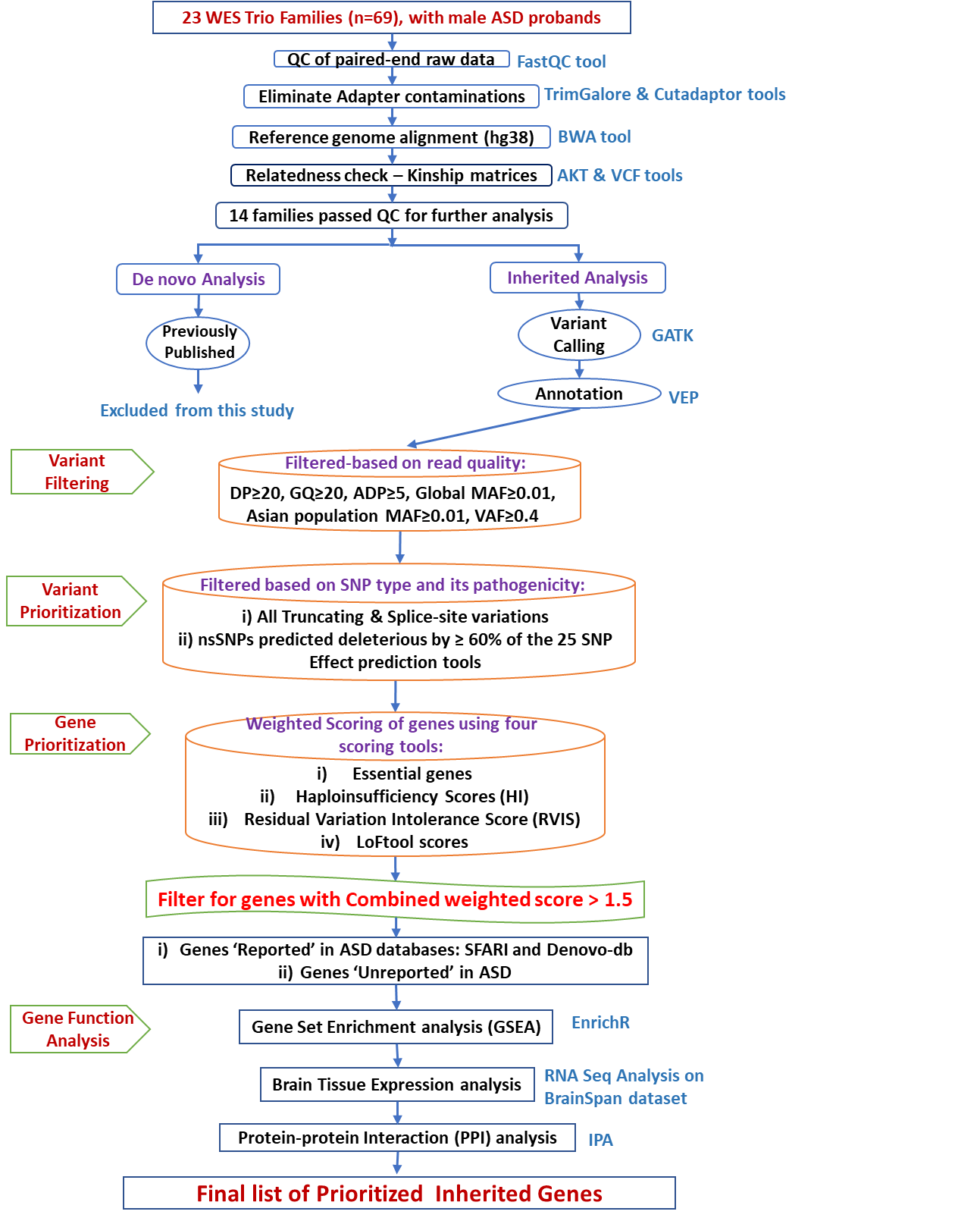
RESULTS:
Summary on inherited variations identified:
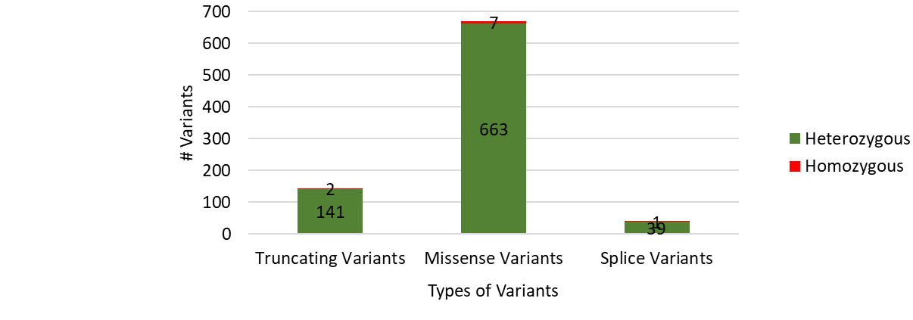
Supplementary Fig S1: Total counts of homozygous and heterozygous inherited variations identified within the cohort are represented in red and green colours, respectively (variants counts indicated numerically).
Inherited variations and genes prioritization:
Supplementary Table S1A: Prioritization of inherited genes
 | # Genes | # Variants
Transmitted in all probands | 5433 | 7863
Filtered for Genome Asia MAF ≤ 0.01 | 5198 | 7390
Filtered for VAF ≥ 0.4 | 4765 | 6535
High+Moderate (%60D)-excluding inframeSNPs | 1084 | 1173
Removed false positives | 1069 | 1156
Genes filtered by weighted scoring  SFARI genes  DenovoDB  Unreported genes | 751  67  212  472 | 853
After excluding genes found only in parents, we collected a total of 5,433 inherited genes carrying 7,863 variations. Of them, we excluded 235 genes as they carried variants with MAF≤ .01 and 433 genes with VAF ≥ 0.4, leaving behind a total of 4,765 genes holding 6,535 variants.

Supplementary Table S1B: Distribution of ‘Combined weighted’ scores across reported ASD genes and unreported genes to assess their mutational intolerance
‘Combined Weighted score’ range | Reported ASD genes |  |  |  |  |  |  |  |  | Total unreported genes
‘Combined Weighted score’ range | Total genes |  | Total SFARI genes |  | # Score 1 | # Score 2 | # Score 3 | Total DenovoDB genes
‘Combined Weighted score’ range | # | % | # | % | # | # | # | # | % | # | %
20-21 | 1 | 0.14 | 0 | 0 | 0 | 0 | 0 | 0 | 0 | 1 | 0.22
15-20 | 3 | 0.4 | 1 | 1.5 | 1 | 0 | 0 | 1 | 0.48 | 1 | 0.22
10--15 | 34 | 4.53 | 5 | 7.47 | 3 | 1 | 1 | 13 | 6.14 | 16 | 3.39
5--10 | 263 | 35.02 | 32 | 47.77 | 13 | 9 | 10 | 87 | 41.04 | 144 | 30.51
1.5-5 | 450 | 59.93 | 29 | 43.29 | 1 | 6 | 22 | 111 | 52.36 | 310 | 65.68
Total | 751 | 100 | 67 | 100 | 18 | 16 | 33 | 212 | 100 | 472 | 100
While 450 out of 751 inherited genes (60%) lie within the score range 1.5 to 5, majority of the SFARI genes scored above 5 points (38 genes, 56.7%), whereas most of denovo-db genes scored below 5 points (52.3%) similar to 65.6% of unreported genes. Notably 22/33 (67%) SFARI score 3 genes also gathered weighted-score between 1.5 to 5, indicating that both denovo-db and unreported genes included evolutionarily conserved, mutationally sensitive and bio-functionally essential genes.

Supplementary Table S2A: Recurrently mutated genes in our cohort
# Variations | # Individuals | Genes
4 | 3 | CRAT, HKDC1, USP45
3 | 11 | LRP2, COL1A1, COL6A6, DNAH3, DSG4, FBLN2, FLNB, FRAS1, KIF1B, USP13, ZFYVE16
2 | 69 | AATK, ABCG5, ACP2, AGRN, ALAS1, ART5, CACNA1D, CACNA1H, CFHR5, CHD7, CHMP7, CLCN2, DBNL, DOCK7, DPYD etc.
1 | 668 | AASDHPPT, ABCA13, ABCA8, ABCC12, ABCC9, ACADL, ACBD5, ACOX2, ADAMTS14, ADAMTSL5, ADCY6, ADCY7, ADGRA3, ADGRV1, ADHFE1, ADSL, AGA, AGBL4, AGPAT5, ALDH1L2, ALDOB, ALG3, PAX5, PCCA etc.

Supplementary Table S2B: Inheritance patterns of prioritised genes
 | P1 (mother) | % | P2 (father) | % | both | %
# Inherited genes | 341 | 45.40 | 346 | 46.07 | 64 | 8.522
# High-Confidence genes | 14 | 1.86 | 16 | 2.13 | 4 | 0.533
# Suggestive-evidence genes | 18 | 2.4 | 17 | 2.264 | 2 | 0.266

Supplementary Table S2C: Behaviour Sub-group classification
Groups | Subgroup list | # Unique Genes | %
Core | ASD + Social Interaction (SI) +Restrictive Repetitive Behaviour (RRB) | 149 | 27.70
Associated | Communication & Language (CL) + Cognition, Intelligence & Learning (CIL), Emotions & Moods (EM), Activities (Act) | 200 | 37.17
Seno-motor | Sensory Impairments, Motor Skills & Motor Disease (SM) | 69 | 12.83
Comorbidities & others | Comorbidities & Other Behaviours (Comorb) | 120 | 22.30
Total |  | 538 | 100

Genes within the core group displayed important neuronal functions pertaining to neuron growth, differentiation, pruning, axon and dendrite projections, axon guidance, synaptic transmission, neurotransmitter signalling etc. and additionally includes genes enriched with autism behaviours like autistic traits, aspergers syndrome, lack of preference for social novelty, reduced social interactions, vocalizations and social recognition and genes causing repetitive and restricted behaviours in animals like increased self-grooming, stereotyped circling behaviour and cognitive deﬁcits such as impaired learning and memory. The auxiliary group included genes with associated neuronal functions because of their involvement in psychiatric comorbidities of ASD like ADHD, OCsD, Schizophrenia, epilepsy, other ASD associated syndromes, cognitive and intellectual disability etc. The last group of suspected gene with neuronal functions included genes causing several different syndromes with mental retardation, brain tumours of different neuronal cells etc. Behavioural genes were grouped into four domains and seven sub-domains.
Gene CNTNAP2 was the most prominent behaviour gene mutated in our cohort that was linked to all 10 behaviour subgroups. Genes GABRB3, WFS1, ESR1, CHD7, EP300, SORL1, KIF1B, DPYD, SPAST, ADSL, ANK3, CNTN5, CTNNA2, GATM, HIVEP2, KALRN, PITX3, PRF1 and RYR3 produced more than seven ASD linked behaviours (Supplementary Table). Gene VCP- linked to poor speech outcome, and 26 other genes were associated with RRB and social behaviours. 121 genes are known to produce one of three core ASD behaviours accounting for 22.5% of behaviour genes in our cohort.

Supplementary Fig S2: Enrichment of inherited genes for neuronal functions

Supplementary Table S3A: Description of sensory genes
 | # Genes | % Total Behaviour Genes
Total Sensory Genes | 116 | 21.56134
 | # Genes | % Sensory Genes
Neuronal | 86 | 74.13793
Non-Neuronal | 30 | 25.86207
Core Groups | 43 | 37.06897
Associated Groups | 71 | 61.2069
Core + Associated | 82 | 70.68966
Maternally | 61 | 52.58621
Paternally | 51 | 43.96552
Both Maternally + Paternally | 4 | 3.448276
Hetero | 113 | 97.41379
Homo | 3 | 2.586207

Supplementary Table S3B: Distribution of different class of sensory genes across core and associated behavioural sub-group genes
Core & Associated ASD behaviour | # Total core+  associated genes | # All sensory genes | % sub-  groups | # Hearing  genes | % sub-  groups | # Tactile Stimuli  genes | % sub-  groups | # Visual  genes | % sub-  groups | # Vibratory  genes | % sub-  groups
ASD | 109 | 33 | 30.28 | 11 | 10.09 | 16 | 14.68 | 7 | 6.42 | 3 | 2.75
SI | 49 | 13 | 26.53 | 3 | 6.122 | 7 | 14.29 | 3 | 6.12 | 1 | 2.04
RRB | 21 | 13 | 61.9 | 7 | 33.33 | 5 | 23.81 | 2 | 9.52 | 0 | 0
CL | 105 | 20 | 19.05 | 5 | 4.762 | 11 | 10.48 | 3 | 2.86 | 2 | 1.9
CIL | 163 | 51 | 31.29 | 18 | 11.04 | 18 | 11.04 | 12 | 7.36 | 4 | 2.45
EM | 85 | 28 | 32.94 | 11 | 12.94 | 14 | 16.47 | 4 | 4.71 | 2 | 2.35
Act | 87 | 31 | 35.63 | 13 | 14.94 | 14 | 16.09 | 1 | 1.15 | 1 | 1.15
Total | 349 | 116 | 33.24 | 42 | 12.03 | 44 | 12.61 | 20 | 5.73 | 6 | 1.72

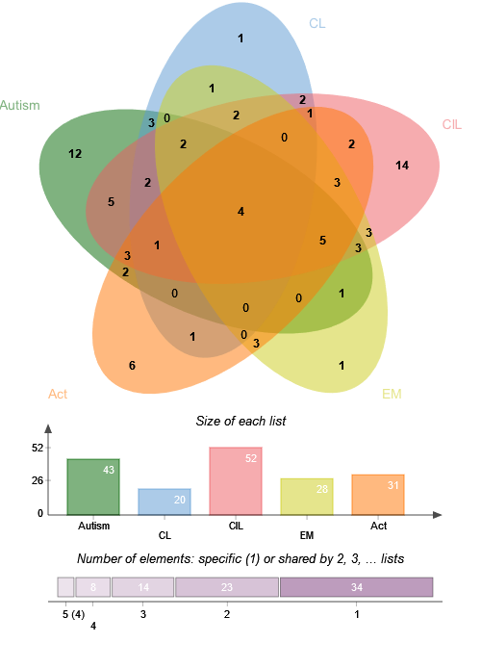
CNTNAP2, ESR1, WFS1, GATM
Supplementary Fig S3: Overlap of sensory genes across core and associated behavioural sub-group genes
Supplementary Table S3C: Overlap of ASD core and associated behaviour genes within comorbidities genes
 | EP | % | SCZ | % | ID | % | BP | % | ADHD | % | Anxiety | % | depression | % | Circa  dian | %
ASD | 56 | 51.38 | 29 | 26.61 | 21 | 19.27 | 8 | 23.5 | 9 | 8.26 | 8 | 7.34 | 3 | 9.38 | 16 | 14.68
SI | 35 | 71.43 | 17 | 34.69 | 5 | 10.2 | 6 | 17.6 | 3 | 6.12 | 6 | 12.2 | 3 | 9.38 | 10 | 12.66
RRB | 9 | 42.86 | 6 | 28.57 | 4 | 19.05 | 3 | 8.82 | 5 | 23.8 | 3 | 14.3 | 1 | 3.13 | 4 | 5.063
CL | 51 | 48.57 | 18 | 17.14 | 23 | 21.9 | 11 | 32.4 | 7 | 6.67 | 7 | 6.67 | 3 | 9.38 | 16 | 20.25
CIL | 74 | 45.4 | 29 | 17.79 | 12 | 7.362 | 16 | 47.1 | 16 | 9.82 | 18 | 11 | 4 | 12.5 | 26 | 32.91
EM | 35 | 41.18 | 22 | 25.88 | 9 | 10.59 | 13 | 38.2 | 12 | 14.1 | 33 | 38.8 | 32 | 100 | 20 | 25.32
Act | 26 | 29.89 | 13 | 14.94 | 5 | 5.747 | 5 | 14.7 | 5 | 5.75 | 16 | 18.4 | 6 | 18.8 | 20 | 25.32
 | 232 |  | 87 |  | 74 |  | 34 |  | 31 |  | 33 |  | 32 |  | 79

Supplementary Table S4A: Behaviour roles of differentially expressed genes
 | # Total Genes | Behaviour genes |  | Core, Associated & Senso-motor behaviour |  | Comorbidities & other behaviours |  | Chi.sq test p-value
 | # Total Genes | # | % | # Genes | % | # Genes | % | Chi.sq test p-value
Up regulated Prenatally | 93 | 76 | 81.72 | 64 | 68.82 | 12 | 15.79 | 0.0012
Up regulated Postnatally | 105 | 81 | 77.14 | 59 | 56.19 | 22 | 27.16 | 0.0012
DEG with Neuronal Functions | 124 | 109 | 87.90 | 93 | 75 | 16 | 14.68 | 0.0028
DEG without Neuronal Functions | 74 | 48 | 64.86 | 30 | 40.54 | 18 | 37.5 | 0.0028

Supplementary Fig S4: Prenatally (top panel) and Postnatally (bottom panel) overexpressed genes
References:
Fadista, J., Oskolkov, N., Hansson, O., & Groop, L. (2016). LoFtool: a gene intolerance score based on loss-of-function variants in 60 706 individuals. Bioinformatics, 33(4), 471–474. https://doi.org/10.1093/bioinformatics/btv602
Huang, N., Lee, I., Marcotte, E. M., & Hurles, M. E. (2010). Characterising and Predicting Haploinsufficiency in the Human Genome. PLoS Genetics, 6(10), e1001154. https://doi.org/10.1371/journal.pgen.1001154
Petrovski, S., Wang, Q., Heinzen, E. L., Allen, A. S., & Goldstein, D. B. (2013). Genic Intolerance to Functional Variation and the Interpretation of Personal Genomes. PLoS Genetics, 9(8), e1003709. https://doi.org/10.1371/journal.pgen.1003709
Study, D. D. D. (2017). Prevalence and architecture of de novo mutations in developmental disorders. Nature, 542(7642), 433–438. https://doi.org/10.1038/nature21062
Sunkin, S. M., Ng, L., Lau, C., Dolbeare, T., Gilbert, T. L., Thompson, C. L., Hawrylycz, M., & Dang, C. (2012). Allen Brain Atlas: an integrated spatio-temporal portal for exploring the central nervous system. Nucleic Acids Research, 41(D1), D996–D1008. https://doi.org/10.1093/nar/gks1042
Zhang, R. (2004). DEG: a database of essential genes. Nucleic Acids Research, 32(90001), 271D – 272. https://doi.org/10.1093/nar/gkh024

