Supplementary Materials
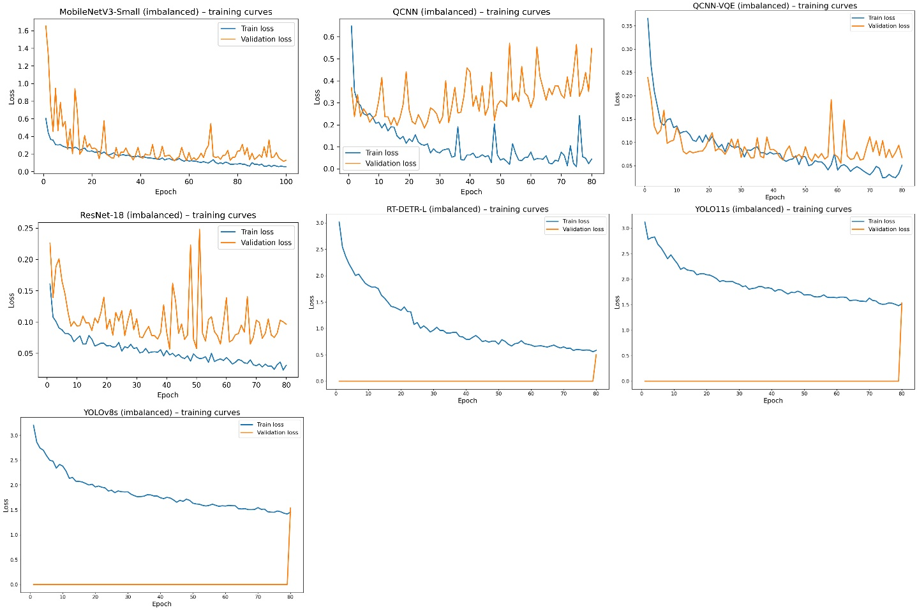
Figure S1 | Training and validation loss curves for the imbalanced scenario.
Training and validation loss evolution across epochs for all evaluated models trained on the imbalanced dataset: MobileNetV3-Small, ResNet-18, QCNN, and QCNN-VQE (classification on ground-truth crops), as well as YOLOv8-s, YOLOv11-s, and RT-DETR-L (end-to-end detection on full images).
For crop-based classifiers, losses show stable convergence without pronounced overfitting despite class imbalance. For detection models, validation loss is reported only at evaluation checkpoints defined by the Ultralytics framework, explaining the sparse or zero-valued validation curves. Best-performing checkpoints reported in the main text are selected based on validation criteria, as described in the Methods section.
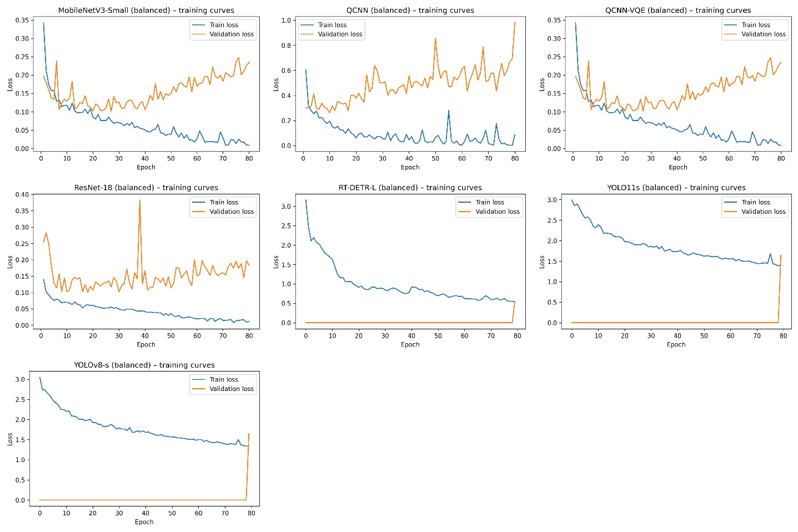
Supplementary Figure S2. Training and Figure S2 | Training and validation loss curves for the balanced scenario.
Training and validation loss evolution across epochs for all evaluated models trained on the balanced dataset: MobileNetV3-Small, ResNet-18, QCNN, and QCNN-VQE (classification on ground-truth crops), as well as YOLOv8-s, YOLOv11-s, and RT-DETR-L (end-to-end detection on full images).
For crop-based classifiers, losses indicate stable convergence after rebalancing, with no systematic overfitting. For detection models, validation loss is reported only at evaluation checkpoints defined by the Ultralytics framework, resulting in sparse or delayed validation curves. Best checkpoints used in the main analysis are selected based on validation criteria described in the Methods section.alidation loss curves on the balanced dataset.

Reproducibility (runtime environment)
All experiments were run under Windows 10 (build 26200), with PyTorch 2.5.1+cu121 (CUDA 12.1, cuDNN 90100), Ultralytics 8.3.225 and PennyLane 0.43.0, on an NVIDIA GeForce RTX 4070 Laptop GPU (8 GB). TF32 for CUDA matrix multiplications is disabled. We use fixed seeds and deterministic settings when supported by the libraries; some GPU operations and some detection pipelines can nonetheless limit strict determinism, as documented in Methods.

Architecture of QCNN and QCNN-VQE models
Hybrid quantum-classical models (QCNN and QCNN-VQE) are designed as classifiers operating on individual sherd crops of standardised size 64 x 64 pixels in colour (RGB), normalised to the interval [0, 1]. Rather than projecting 4096 pixel intensities directly onto a small number of qubits, we introduce a lightweight classical convolutional head that compresses visual information before quantum encoding. Concretely, each image is first normalised (intensities in [0, 1]) and processed by a small CNN composed of two convolution-nonlinearity-pooling blocks, followed by global average pooling. This CNN produces a feature vector of dimension $n_{q}$ (fixed to $n_{q}=6$ in our experiments), which forms the bottleneck between the purely classical part and the quantum circuit.
The quantum register therefore contains 6 qubits initialised in the state $|0⟩^{⊗6}$. Encoding into Hilbert space is performed via angle encoding: each scalar component $z_{i}$ of the compressed feature vector is injected via a parameterised rotation on the corresponding qubit, typically of the form:
$$\left|0⟩→R_{Y}\left(πz_{i}\right) R_{Z}\left(πz_{i}\right) \right|0⟩,$$
optionally including the $R_{Z}\left(πz_{i}\right)$ term to enrich phase encoding. This step defines a first state $|ψ_{enc}\left(x\right)⟩$ that already carries a non-linear synthesis of the sherd pattern (smooth or decorated surface for terra sigillata, hue variations in OW fabrics, grey gradients for reduced-fired ceramics).
On this encoded state, we then apply a shallow parameterised circuit that we refer to (by abuse of language) as a “quantum convolutional neural network” inspired by Cong et al. (2019) and more recent QCNN developments for image analysis. In practice, it is a PQC classifier applied to a vector of compressed features, not a quantum convolutional network operating directly on pixels with pooling.
The circuit is organised into $l$ repeated blocks (here $l=2$), each combining parameterised single-qubit gates and a local entanglement pattern. In each block $l$, for each qubit $q_{i}$ we apply a sequence of rotations $R_{Y}\left(θ_{i}^{\left(l,Y\right)}\right)$ and $R_{Z}\left(θ_{i}^{\left(l,Z\right)}\right)$, then a ring entanglement pattern implemented as a chain of CNOT gates between neighbours (0->1, 1->2, …, 4->5, 5->0). This local connectivity models correlations between “quantum regions” of the descriptor while controlling circuit depth. The parameters $θ$ of all these gates are optimised jointly with the weights of the classical convolutional head.
After the last quantum block, we perform expectation-value measurements on each qubit by evaluating the Pauli-$Z$ observable. This yields an output vector:
$$h\left(x\right)=\left(⟨Z_{0}⟩,…,⟨Z_{5}⟩\right),$$
which acts as a high-level descriptor of the sherd in quantum feature space. In the standard QCNN model, this vector is passed to a classical linear layer of dimension 6->3, producing three logits corresponding to terra sigillata, oxidised common ware (OW) and reduced common ware (RW). A softmax then provides class probabilities, and training minimises the categorical cross-entropy between predictions and labels.
QCNN-VQE keeps the same “backbone” (classical CNN + quantum circuit + readout of $⟨Z_{i}⟩$) but replaces the linear head with a variational head inspired by Variational Quantum Eigensolver (VQE) algorithms. For each class $c$, we define an effective Hamiltonian:
$$H_{c}=\sum_{i=0}^{n_{q}-1}{α_{c,i}}Z_{i},$$
where $n_{q}=6$ is the number of qubits (indexed $i∈\{0,…,5\}$), $Z_{i}$ denotes the Pauli-$Z$ operator applied to qubit $i$ (identity on other qubits), and the real coefficients $α_{c,i}$ are trainable parameters specific to class $c$. For an output state $|ψ_{θ}\left(x\right)⟩$, the logit associated with class $c$ is proportional to the opposite of the “energy”:
$$l_{c}\left(x\right)=-⟨ψ_{θ}\left(x\right)\left|H_{c}\right|ψ_{θ}\left(x\right)⟩.$$
The three energies $E_{c}=⟨H_{c}⟩$ (one per class $c∈\{Sig,OW,RW\}$) are then transformed into probabilities via a softmax applied to $-E_{c}$.
In QCNN-VQE, the class observables $H_{c}$are defined as linear combinations of Pauli-Z operators acting on the readout qubits, for example
$$H_{c}=\sum_{i=0}^{5}{α_{c,i}}Z_{i},$$
where the coefficients $α_{c,i}$are trainable parameters.
This VQE-inspired formulation should be understood as a variational classification scheme (shallow circuit, state-vector simulation), rather than as the solution of a physical Hamiltonian.
All quantum circuits are numerically simulated in the state-vector regime (using a default.qubit-type backend), without finite sampling (“shots”). Expectation values are therefore computed analytically, and gradients are obtained via automatic differentiation on the quantum simulator coupled with PyTorch. The parameters of the classical convolutional head, the quantum circuit, and— in the QCNN-VQE variant — the coefficients $α_{c,i}$of the class observables $H_{c}$, are optimized end-to-end by stochastic gradient descent (Adam optimizer) on the 64 × 64 sherd crops.

Models evaluated and training protocols
We retained five representative models: three from classical deep learning and two hybrid quantum approaches.
YOLOv8-s (Ultralytics). A fast convolutional object detector, “small” version (about 11 million parameters) of the 8th-generation YOLO (2023). It performs in a single pass localisation (bounding box) and classification of objects, via a CNN architecture with multi-scale prediction. Inputs are resized to 448 x 448 pixels with default anchors (Ultralytics, 2023).
YOLOv11-s. A more recent Ultralytics variant derived from YOLOv5/7 and optimised with additional contributions (e.g., improved CSP backbone, lightweight attention layers). It has about 10 million parameters. In our implementation, it is trained with the same hyperparameters as YOLOv8-s to ensure a fair comparison (Ultralytics, 2024).
RT-DETR-L (Real-Time Detection Transformer). An end-to-end Transformer detector proposed by Baidu, in its “Large” version (about 33 million parameters, i.e., about 63 MB of weights). It uses a hybrid encoder combining local attention and a feature pyramid to process the image efficiently at multiple scales, then a decoder with $N$ queries that directly outputs boxes and classes, removing the need for NMS. We configured RT-DETR-L with 300 queries and 6 attention layers according to the original paper, and trained it as an object detector on our images (which may contain one or multiple sherds, from a single fragment to several dozen depending on the scene).
ResNet-18. ResNet-18 was selected as a lightweight classical convolutional classifier to establish a direct point of comparison with the hybrid QCNN models (He et al. 2016). The network was trained from an ImageNet-pretrained initialization, using full fine-tuning, on cropped images centered on a single sherd (GT crops), resized to 64 × 64 pixels in RGB. The training settings (optimizer, learning rate, scheduler, maximum number of epochs, and early stopping) are identical to those used for the other classifiers and are summarized in Table 4, in order to ensure a fair comparison. For crop-based classifiers (ResNet-18, MobileNetV3-Small, and hybrid models), the initial learning rate was set to (10^{-4}) for CNNs and (10^{-3}) for QCNNs, using the Adam optimizer and early stopping based on the validation loss. The model converges within approximately a dozen epochs on both datasets (imbalanced and balanced), with a final weight size of about 42.7 MB (stored as a .pth file). The comparison with QCNN models is performed on the same three-class classification task (sigillata, OW, RW) using isolated crops.
MobileNetV3-Small. Selected as a second lightweight convolutional classifier representative of compact architectures optimised for embedded solutions (Howard et al. 2019). It is also trained on GT crops centred on a single sherd, with the same train/validation split, the same seed (42) and the same reproducibility principles as for ResNet-18 and QCNN models. MobileNetV3-Small has far fewer parameters than ResNet-18 and produces a weights file of about 17.6 MB, while targeting the same three-class classification task (terra sigillata, OW, RW), enabling a direct comparison between classical CNNs and hybrid quantum models on the same data.
QCNN (hybrid CNN/PQC classifier). In our implementation, 64 x 64 crops are not encoded pixel by pixel. A lightweight CNN produces a feature vector of dimension $n_{q}=6$, which is then angle-encoded on 6 qubits. By abuse of language, we keep the name “QCNN” for this hybrid CNN/PQC classifier, although it does not perform quantum convolutions/pooling directly on pixels.
QCNN-VQE. Variant of the hybrid CNN/PQC classifier above, in which the quantum decision head is formulated in a VQE-inspired variational framework (applied here to a classification cost function, not to an energy problem). The CNN backbone (compression into 6 features) and the encoding scheme on 6 qubits are identical; only the variational head and/or the objective differ, in order to assess whether a VQE formalism improves stability or class separation.
All models are trained on the same training dataset for the considered scenario (imbalanced or balanced). We controlled reproducibility by fixing identical initial conditions: fixed random seed (42), deactivation of non-deterministic CuDNN algorithms, identical batching (fixed batch size with the same base augmentations for classical models), no sample mixing between epochs (same train/val split), etc. Training hyperparameters (learning rate, optimiser - Adam for crop classifiers, AdamW for detectors - scheduler and early stopping based on validation loss stagnation) were harmonised to allow fair performance comparisons. Models generally converged in fewer than 50 epochs; the maximum was set to 80 epochs (100 for MobileNetV3-Small), and the best validation checkpoint was retained for final evaluation. ResNet-18 typically converged earlier (around 20 epochs with early stopping), despite a maximum set to 80.
For detection models (YOLO, RT-DETR), detection metrics (mAP) are computed in the standard way over all annotated objects in each image. In addition to COCO metrics (AP@0.5 and AP@[0.5:0.95]), we report an end-to-end F1 (per class and macro-averaged) to characterise jointly localisation and labelling at a fixed operating threshold. For this measure, predictions are filtered by a confidence threshold and then matched to ground-truth boxes via one-to-one IoU-based matching (IoU >= 0.5). In our implementation (evaluation script), matching is greedy: all prediction-GT pairs are sorted by decreasing IoU and selected sequentially as long as IoU exceeds the threshold and neither box has already been associated. A matched pair counts as a true positive if the predicted class matches the GT class; in case of class mismatch, it contributes a false positive for the predicted class and a false negative for the GT class. Unmatched predictions count as false positives, and unmatched GT boxes count as false negatives.
We note that YOLOv8 and YOLOv11 cannot be made fully deterministic: some CUDA kernels used for augmentation, interpolation or NMS are intrinsically non-deterministic. Even with all seeds fixed, these models show slight run-to-run variations (<0.5 F1 points), without affecting comparative conclusions.
Main training hyperparameters (optimiser, learning rate, scheduler, batch size, seeds and early stopping) are summarised in Table 4 to facilitate reproducibility and fair comparison between approaches (Loshchilov, Hutter 2016; 2019). Full configurations used for each model (including detector-specific parameters and hybrid-classifier parameters) are documented and versioned in the associated Zenodo repository (DOI: 10.5281/zenodo.18010842).

Training protocol and hyperparameters
To ensure fair comparison between architectures, all models are trained under a homogeneous protocol as far as possible. For crop-based classifiers (classical CNNs and hybrid quantum-classical models), we use a standard optimisation scheme (Adam optimiser, early stopping on validation loss, scheduler based on performance stagnation), with fixed seeds and deterministic settings when supported by the used libraries.
For end-to-end detectors (YOLOv8-s, YOLOv11-s, RT-DETR-L), we rely on the reference implementations provided by Ultralytics, keeping strictly identical hyperparameters between YOLOv8-s and YOLOv11-s to isolate architectural effects. When some aspects of the detection pipeline (e.g., specific CUDA operations) prevent strict determinism, this is explicitly stated.
For end-to-end detection, the three detectors (RT-DETR-L, YOLOv11-s and YOLOv8-s) use a single, identical input resolution in order to standardise compute budget and isolate architectural effects. Following Ultralytics training configurations, images are resized to 448 x 448 pixels (imgsz = 448) during training, evaluation and inference. Predictions (bounding boxes and classes) are then automatically reprojected into the original image coordinate system by the framework, so that detection metrics are computed in native image coordinates.
Model | Task | Input | Optimiser | Initial LR | Batch size | Max epochs | Early stopping | Scheduler / criterion | Reproducibility conditions
MobileNetV3-Small | Classification | GT crops 64x64 (RGB) | Adam | 1x10^-3 | 12 | 100 | Yes (patience = 15) | ReduceLROnPlateau (val loss) | Seed fixed (=42), PyTorch determinism enabled
ResNet-18 | Classification | GT crops 64x64 (RGB) | Adam | 1x10^-4 | 12 | 80 | Yes (patience = 15) | ReduceLROnPlateau (val loss) | ImageNet initialisation, seed fixed
QCNN | Classification | GT crops 64x64 (RGB) | Adam | 2x10^-3 | 12 | 80 | Yes (patience = 15) | ReduceLROnPlateau (val loss) | Quantum circuit simulated (state-vector), seed fixed
QCNN-VQE | Classification | GT crops 64x64 (RGB) | Adam | 2x10^-3 | 12 | 80 | Yes (patience = 15) | ReduceLROnPlateau (val loss) | VQE-inspired variant, same backbone as QCNN
YOLOv8-s | Detection | Images 448x448 | AdamW | 2x10^-3 | 12 | 80 | Yes (patience = 50) | Cosine LR (Ultralytics) | Ultralytics implementation, seed fixed (=42), partial determinism
YOLOv11-s | Detection | Images 448x448 | AdamW | 2x10^-3 | 12 | 80 | Yes (patience = 50) | Cosine LR (Ultralytics) | Hyperparameters identical to YOLOv8-s
RT-DETR-L | Detection | Images 448x448 | AdamW | 2x10^-3 | 12 | 80 | Yes (patience = 50) | Cosine LR (Ultralytics) | 300 queries, 6 attention layers, seed fixed
Table 4 - Summary of training hyperparameters.

Reproducibility and runtime environment (GPU)
Experiments were performed under Windows 10 (build 10.0.26200). Training of classical models relies on PyTorch 2.5.1+cu121 (CUDA 12.1, cuDNN 90100) and an NVIDIA GeForce RTX 4070 Laptop GPU (8 GB). The NVIDIA driver used is 581.83 (nvidia-smi indicates CUDA 13.0 compatibility), and the use of TF32 for CUDA matrix multiplications is disabled (allow_tf32 = False). Detectors are trained via Ultralytics v8.3.225. Hybrid quantum-classical models use PennyLane v0.43.0 for quantum-circuit simulation (state-vector backend).
For reproducibility, seeds are fixed (seed = 42) and deterministic options are enabled when supported by the libraries and compatible with GPU execution. Limits of determinism (notably some CUDA operations in detection pipelines) are reported when relevant. Model sizes are reported in “weights-only” format (state_dict without optimiser states) to compare compactness independently of training artefacts.

