OVEM Grade | OVEM description | OVEM view | Neo Grade | Neo description | Neo view
1 | visible bone around the entire circumference of the screw through the critical bone corridor of the entire cervical pedicle | 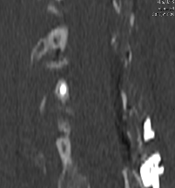 | 0 | the screw is completely contained within the pedicle on CT axial view | 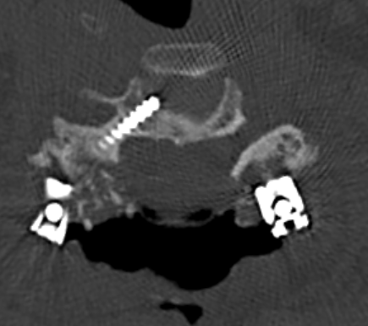
2 | minor cortical breaches limited to the screw thread within the critical bone corridor of the entire pedicle | 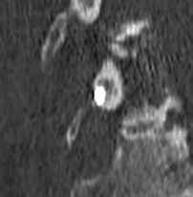 | 1 | breach of the pedicle with deviation, which is less than 2 mm (i.e., less than half of the screw diameter); on CT axial view | 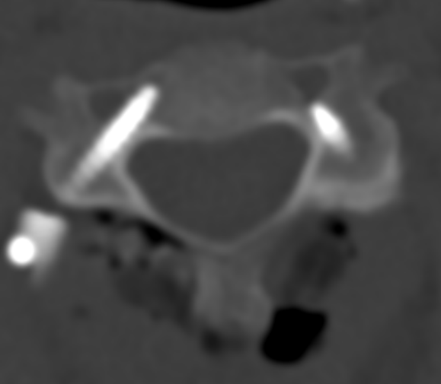
3 | cortical breach including the internal diameter of the screw through the critical zone of the pedicle in any direction without neuro-vascular injury | 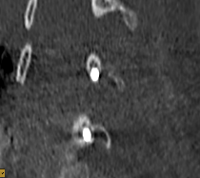 | 2 | breach of the pedicle with deviation of more than 2 mm and less than 4 mm on CT axial view | 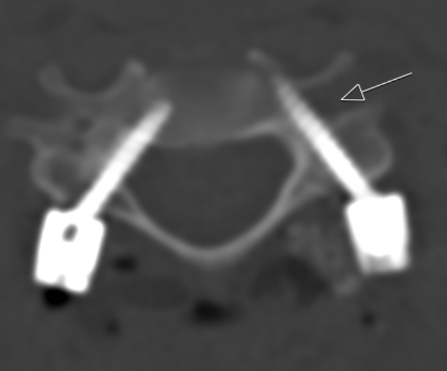
4 | grade 3 screw causing either vertebral artery (VA) and/or neural injury | 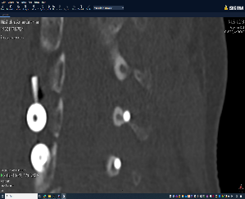 | 3 | breach of the pedicle with deviation of more than 4 mm (i.e., complete misplacement) on CT axial view | 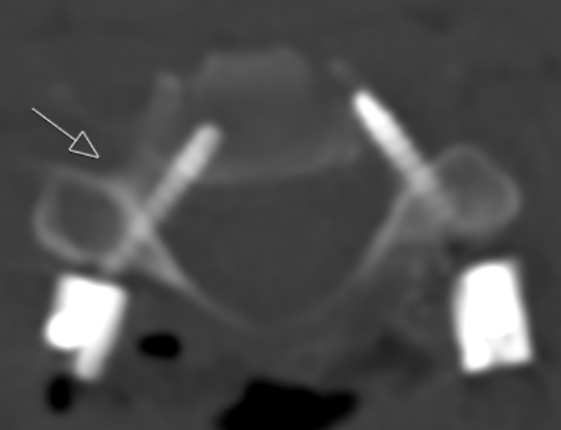

Table 1: Details regarding grading of both OVEM and Neo classifications

