MiR-182 regulates IL-6 in the cardiac context: implications for human atrial electrical remodelling

SUPPLEMENTARY DATA

SUPPLEMENTARY FIGURES

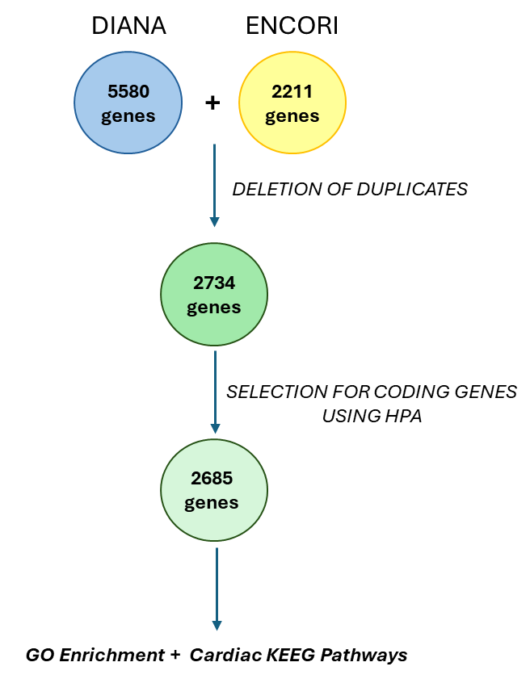
Figure Supplement 1. Strategy used to select coding genes directly targeted by miR-182-5p. The cartoon shows the main steps followed, exploiting the DIANA and ENCORI platforms, to obtain a list of coding genes directly recognized by miR-182-5p, selecting for those resulted to have at least one experimental evidence of direct recognition among miR-182-5p seeds and relative seed-matches. HPA= Human protein Atlas; GO= gene ontology; KEEG= Kyoto Encyclopedia of Genes and Genomes.
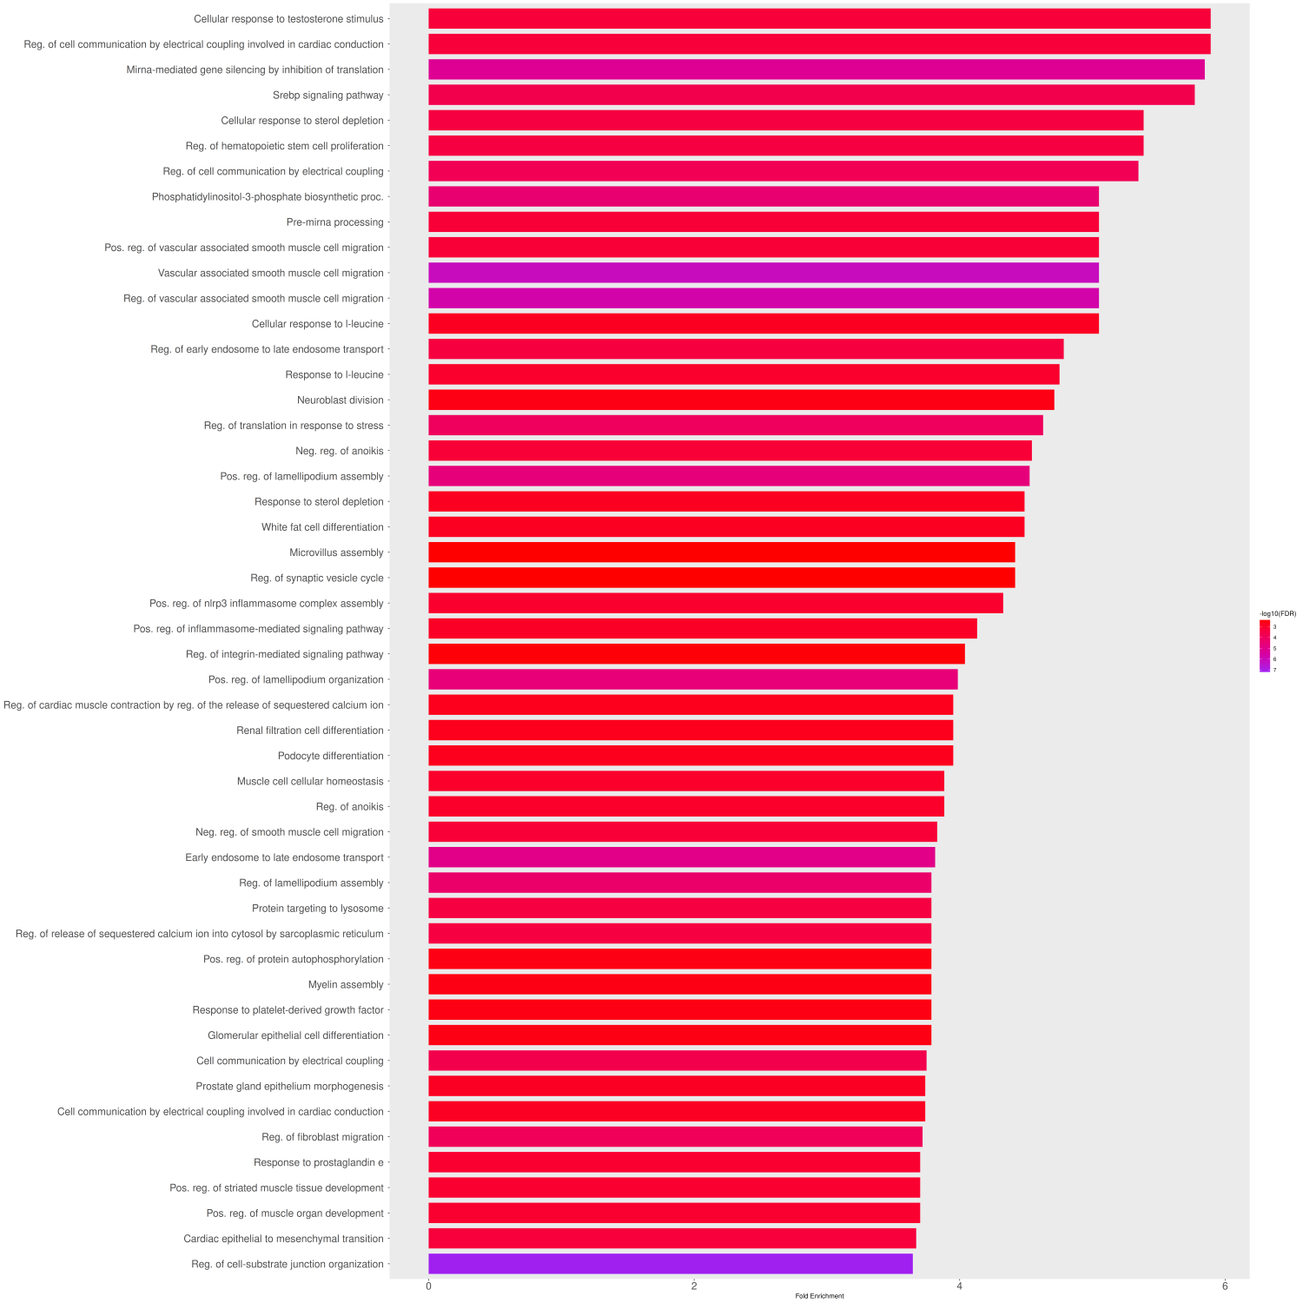
Figure Supplement 2. The preliminary in silico investigation unveiled key GO terms among direct miR-182-5p targeted genes. Bar plot obtained with ShinyGO platform inferring for 2685 genes.

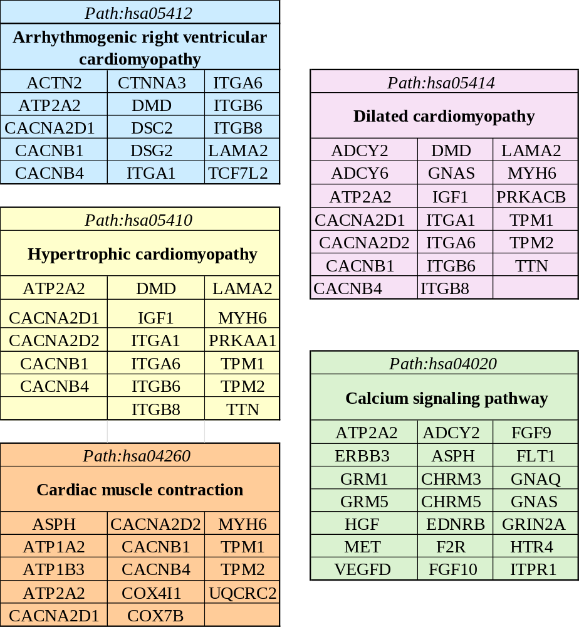
Figure Supplement 3. The miR-182-5p directly recognizes in silico genes belonging to key cardiac KEEG pathways. List of human genes directly recognized by miR-182-5p mapped to cardiac KEEG pathways.

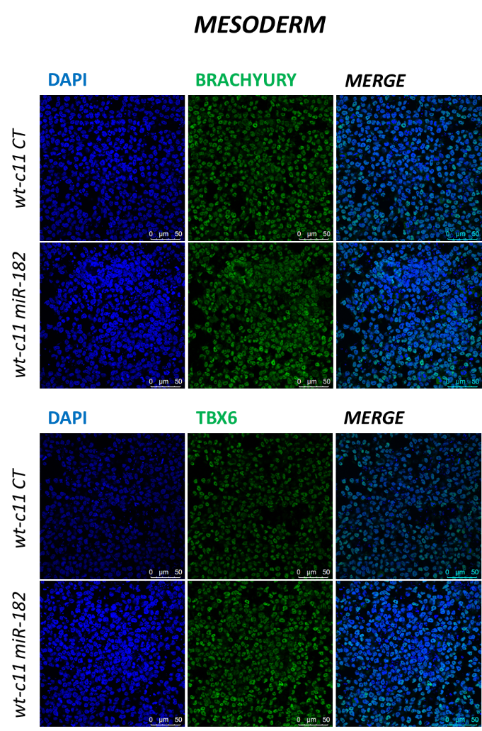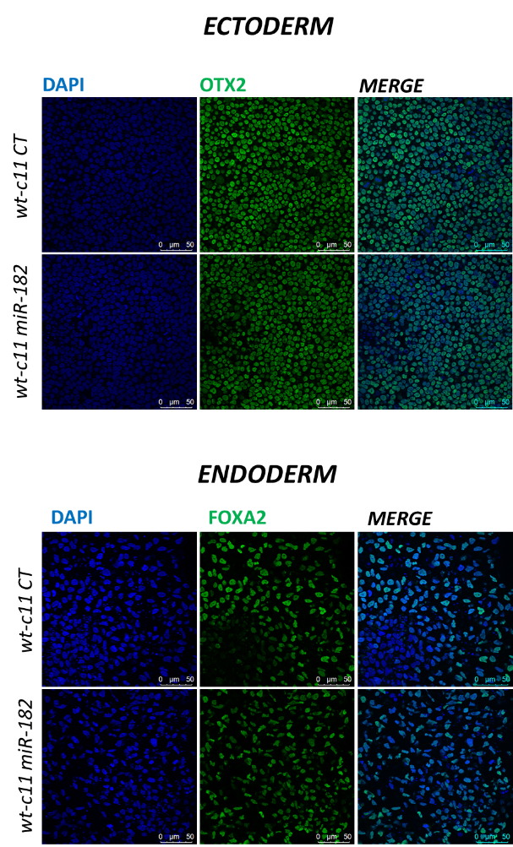
C
B
A

Figure Supplement 4. The transgenic wt-c11 miR-182 hiPSC line maintains the pluripotency and the ability to differentiate into the mesoderm, ectoderm and endoderm germ layers. Confocal images (250 μm x 250 μm; exported at 300 dpi resolution) showing the expression of mesodermal markers (A) (Up: BRACHYURY; down: TBX6), of ectodermal OTX2 (B) and endodermal FOXA2 (C) markers by immunostaining in hiPSC wt-c11 miR-182 line and in hiPSC wt-c11 CT line as control. Blu: DAPI; Green: gene of interest. Scale bars= 50µm.

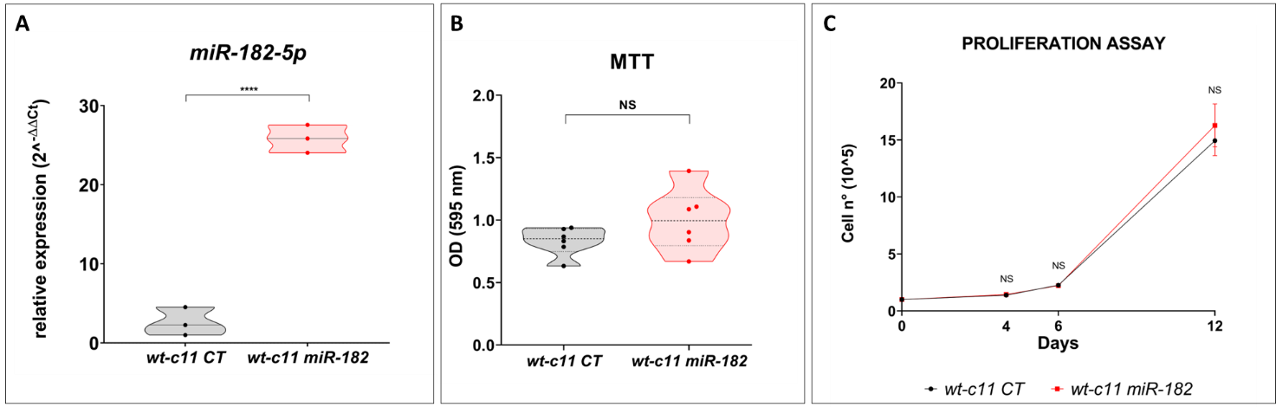
Figure Supplement 5. MiR-182 stable overexpression in hiPSCs does not affect cell viability and cell proliferation. A) Plot showing the expression of miR-182-5p in wt-c11 miR-182 and in wt-c11 CT hiPSCs measured by RT-PCR. Each point represents a BR collecting the RNA from a pool of 10⁶ hiPSCs. Statistics: Student's t-test with α=0,05 and ****p<0,0001. B) Plot showing in wt-c11 miR-182, and in wt-c11 CT hiPSCs cell viability evaluated by MTT assay conducted 48h after cell seeding (10.000 cells per well). Columns show absorbance values measured at 595 nm of 6 BR. Each experimental biological value (n=6 each group) was measured mediating 3 TR. Statistics: Student's t-test with α=0,05 and p=0,167. C) Time course of wt-c11 CT and wt-c11 miR-182 cell proliferation during cardiac differentiation (n° of cells plated at Day-1 = 100.000 cells/well). Graph represents the mean cell counts plus SEM (BR: Day0 n=4; Day4 n=5; Day6 n=5; Day12 n=4). Statistics: Student's t-test with α=0,05; Day0 p=0,628; Day4 p=0,19; Day6 p=0,42; Day12 p=0,74. BR: Biological Replicates, TR: Technical Replicates.

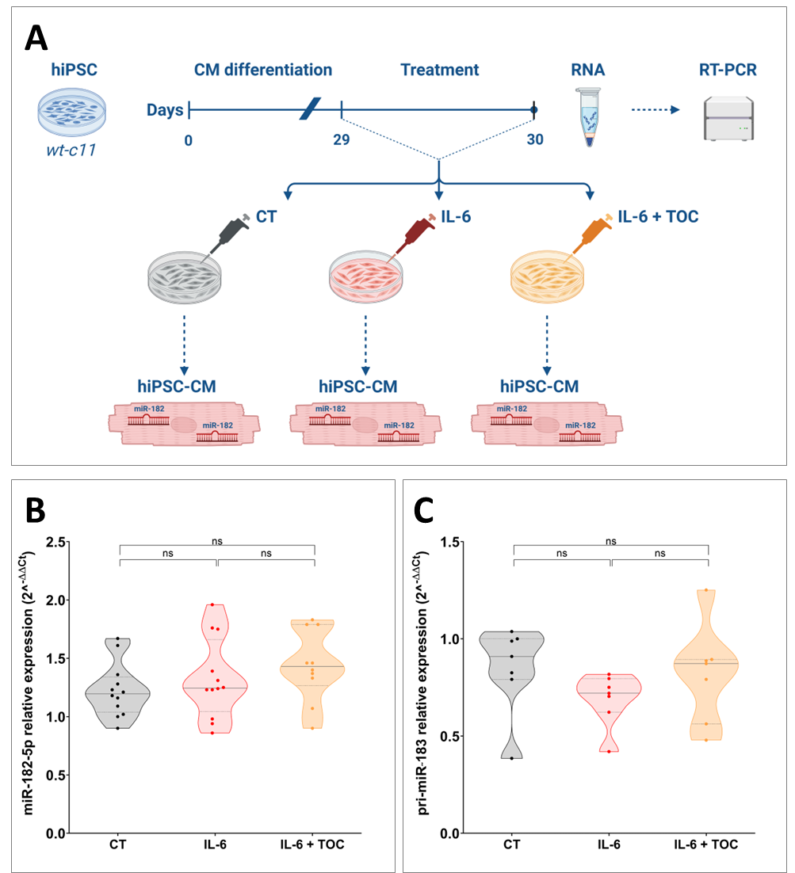
Figure supplemental 6. IL-6 does not upregulate miR-182 in hiPSC-CMs at 30 days of maturation. A) Cartoon showing the experimental plan used to test if IL-6 regulates miR-182 expression in hiPSC-CMs. B) Plot representing miR-182-5p expression levels measured by RT-PCR assay, with/without IL-6 (50ng/mL)±TOC (10ng/mL), in wt-c11 CT at 30 days of maturation (4 BR each group, CT n=12 TR; IL-6 n=12 TR; IL-6+TOC n=10 TR). Statistics: Ordinary one-way Anova with α=0,05; p=0,256. C) Plot representing pri-miR˜183 expression levels measured by RT-PCR assay, with/without IL-6 (50ng/mL)±TOC (10ng/mL), in wt-c11 CT at 30 days of maturation of 4 BR each group (TR CTn=7; IL-6n=7; IL-6+TOCn=7). Statistics: Ordinary one-way Anova with α=0,05; p=0,345. BR: Biological Replicates, TR: Technical Replicates.

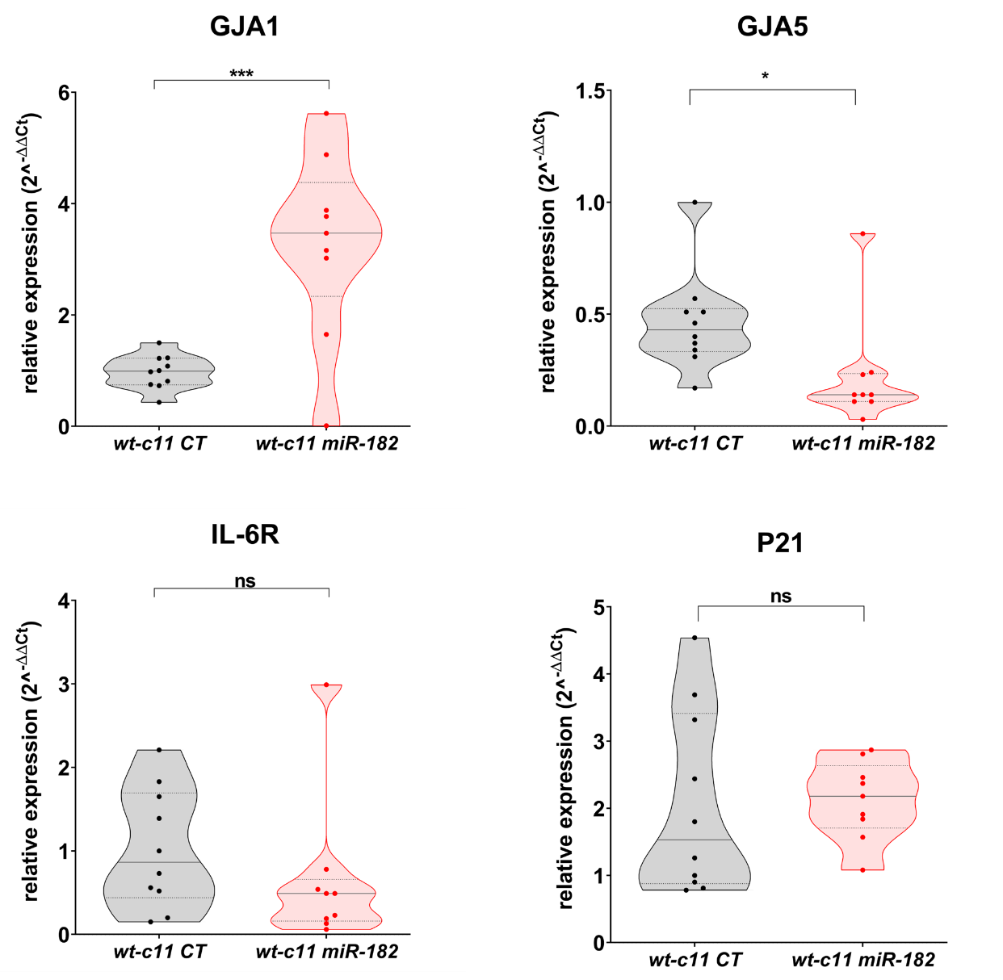
Figure supplemental 7. MiR-182 overexpression alters the expression of genes involved in human CMs function and remodelling. Plots showing expression levels of genes codifying for gap junctions (GJA1; GJA5), IL-6 receptor (IL-6R) and the Cyclin-Dependent Kinase Inhibitor 1 (P21), measured by RT-PCR in wt-c11 CT (n=10 BR) and wt-c11 miR-182 (n=9 BR) CMs at 30 days of maturation. Statistics: Student’ t-test with α=0.05. GJA5 *p=0,046; GJA1 ***p=0,0002; IL-6R p=0,33; P21 p=0,66. BR: biological Replicates.

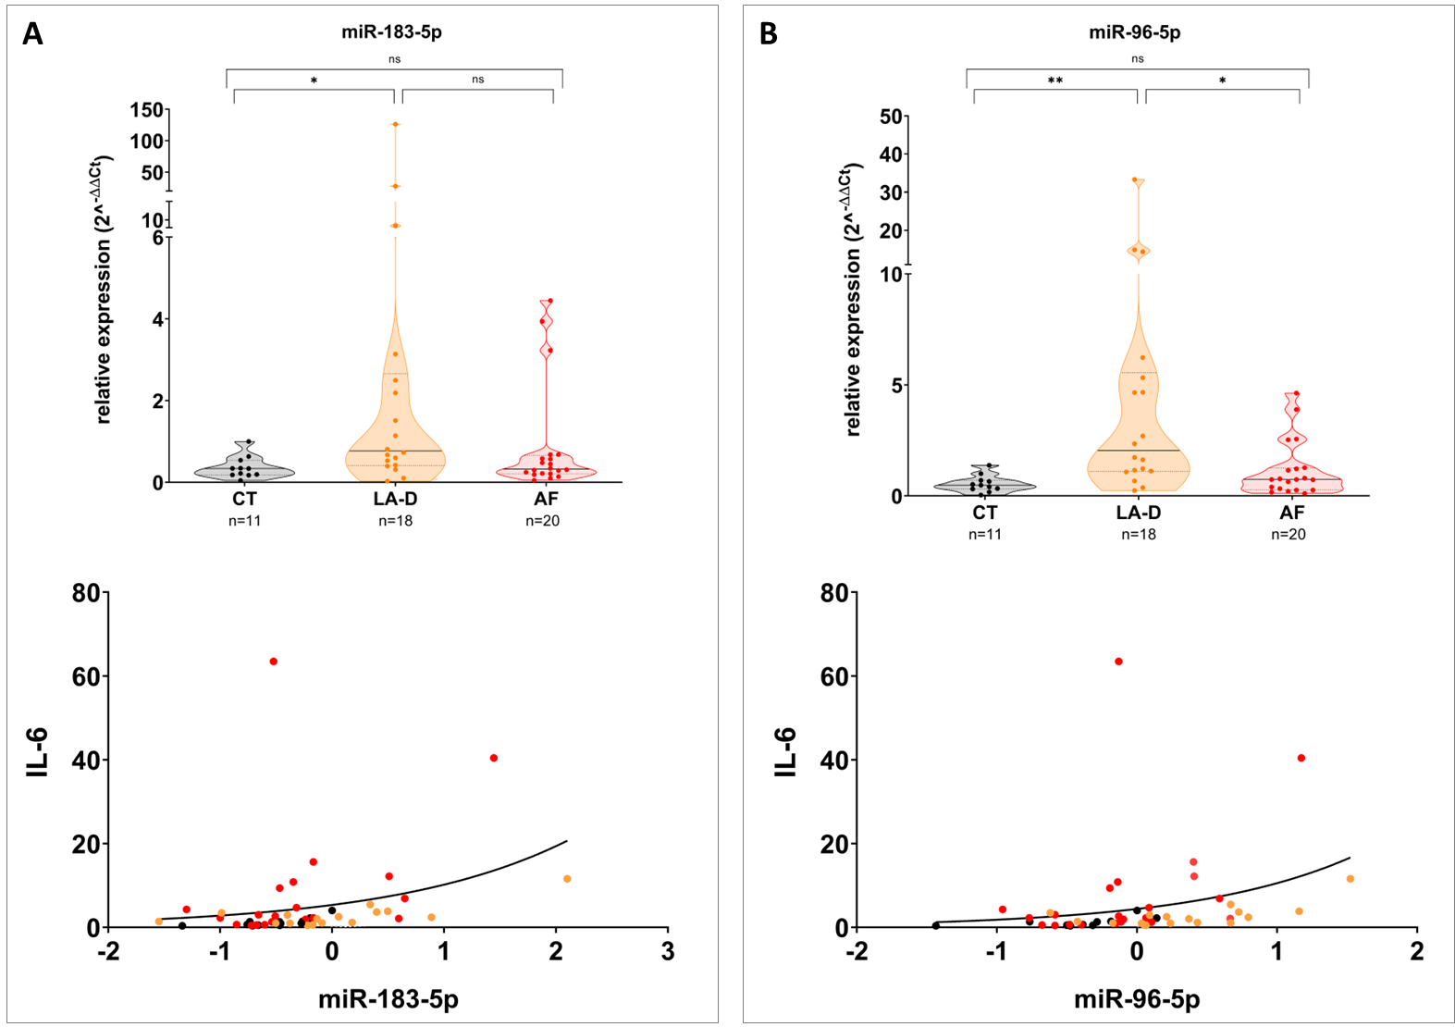

Figure Supplement 8. MiR-183-5p and miR-96-5p are not differently expressed in accordance with atrial disease severity and do not correlate with IL-6 expression. A-Up) Plot representing the expression of miR-183-5p in CT (n=11), LA-D (n=18) and AF (n=20) patients, analysed by RT-PCR. Statistics Kruskal-Wallis test with α=0,05 *p=0,0156 [Dunn’s comparison: LA-D vs CT *MRD=-14,44; AF vs CT MRD=-4.150; LA-D vs AF MRD=10,29]. A-Down) Graph representing the relationship between miR-183-5p vs IL-6 RNA expressions in human left atrial samples, in semi-logarithmic scale [x=Log(x)]. Data do not correlate: miR-183-5p vs IL-6 p=0,059. B-Up) Plot representing the expression of miR-96-5p in CT, LA-D and AF patients, calculated by RT-PCR. Statistics Kruskal-Wallis test with α=0,05 ***p=0,0008 [Dunn’s comparison: LA-D vs CT MRD=-19,34**; AF vs CT MRD=-6,427; LA-D vs AF MRD=12,91*]. B-Down) Graph representing the relationship between miR-96-5p vs IL-6 RNA expressions in human left atrial samples, in semi-logarithmic scale [x=Log(x)]. Data do not correlate: miR-96-5p vs IL-6 p=0,086.
(Note: the semi-logarithmic scale better represented the relationship among data, however the data manipulated in linear scale showed: miR-183-5p vs IL-6 p=0,186; miR-96-5p vs IL-6 p=0,085).

SUPPLEMENTARY TABLE

Supplemental S-Table 1

 |  |  |  | CT |  | LA-D | AF
Hypertension (yes-no) n° |  |  |  |  | - | 15 - 3 | 12 - 8
Surgery (CABG-valve replacement) n° |  |  |  |  | - | 0 - 18 | 3 - 17
EF (min-max) % |  |  |  |  | - | 55 - 65 | 55 - 60
Drug Therapy (n°)
Beta blockers |  |  |  |  | - | 9 | 13
Diuretics |  |  |  |  | - | 9 | 8
Aspirin |  |  |  |  | - | 6 | 3
ACE-I |  |  |  |  | - | 3 | 8
Anticoagulants |  |  |  |  | - | 5 | 7
Digoxin |  |  |  |  | - | 3 | 6
Calcium channel blockers |  |  |  |  | - | 2 | 10
Nitrates |  |  |  |  | - | 6 | 2

Table Supplemental 1. Additional characteristics and drug therapy of patients. EF = Ejection Fraction; ACE = Angiotensin converting enzyme inhibitors; CABG= Coronary Artery by-pass Graft Surgery. LA-D n=18; AF n=20.

SUPPLEMENTARY METHODS

Reagents
Quiazol reagent, miRneasy mini Kit (Quiagen); iScript™ cDNA Synthesis Kit, SsoAdvanced™ Universal SYBR® Green Supermix, PrimePCR™ SYBR® Green Assay (BIORAD); Mir-X™ miRNA First-Strand Synthesis Kit (TAKARA); oligonucleotides-primers (Eurofins genomics); pLV-[has-mir-182] plasmid (Biosettia), SuperScript™ IV VILO™ Master Mix; Corning®Matrigel matrix (Corning); mTeSR Plus medium (Stem Cell Technologies); Ethylenediaminetetraacetic acid (EDTA, Sigma Aldrich); phosphate-buffered saline (PBS, Sigma Aldrich); PSC Cardiomyocyte Differentiation Kit (Thermo Fisher Scientific); TrypLE (Thermo Fisher Scientific); Y27632 (Stem Cell Technologies); RPMI medium (Thermo Fisher Scientific); B27 supplement (Thermo Fisher Scientific); Lipo3000 (Invitrogen); Puromycin (Thermo Fisher Scientific); STEMdiff™ Trilineage Differentiation Kit (Stem Cell Technologies); 4% paraformaldehyde (Thermo Fisher Scientific); Triton X-100 (Sigma Aldrich); bovine serum albumin (BSA, Sigma Aldrich); anti-Brachyury (R&D Systems); anti-TBX6 (R&D Systems); anti-FOXA2 (R&D Systems); anti-OTX2 (R&D Systems); anti-goat antibody Alexa FluorTM Plus 488 (Invotrogen); 4',6-diamidin-2-phenylindole (DAPI, Roche); di-4-ANBDQPQ (Cytocybernetics); interleukin-6 (IL-6, Sigma Aldrich); Tocilizumab (TOC, MedChemExpress); human fibronectin (Gibco); IL-6 Human ELISA KIT (Invitrogen, Life Technologies), (D-(+)-glucose (Sigma Aldrich), sodium chloride (NaCl, Sigma Aldrich); potassium Chloride (KCl, Sigma Aldrich); magnesium chloride (MgCl_{2,} Sigma Aldrich); calcium chloride (CaCl_{2,} Sigma Aldrich); Hepes (Sigma Aldrich); sodium hydroxide (NaOH Sigma Aldrich); Atropine ( Sigma Aldrich); Acetylcholine (ACh, Sigma Aldrich), 3-(4,5-dimethylthiazol-2-yl)-2,5-diphenyltetrazolium bromide (MTT, Sigma-Aldrich); 2-propanol (Sigma-Aldrich); chloroform (Sigma-Aldrich); trypan blue (Trypan Blue Stain, 0.4% Logos Biosystem); MS-222 (Sigma Aldrich).

List of primers
Human genes
PrimePCR™ SYBR® Green Assay BIORAD | Catalog number: #10025636
pri-miR˜183 F | CTTCCTCAGCACAGA
pri-miR˜183 R | GAGTCCTCGCCCGAT
Zebrafish genes
Name | sequence 5' --> 3'
eef1a1l1 F | CTGGAGGCCAGCTCAAACAT
eef1a1l1 R | ATCAAGAGTAGTACCGTCAGCAT
Rpl13α F | TCT GGAGGACTGTAAGAG GTA TGC
Rpl13α R | AGACGCACAATCTTGAGAGCA
il6 F | TCCTGGTGAACGACATCAAA
il6 R | TCATCACGCTGGAGAAGTTG
miRNAs
hsa-miR-182-5p F | TTTGGCAATGGAAGA
hsa-miR-183-5p F | TATGGCACTGGTAGA
hsa-miR-96-5p F | TTTGGCACTAGCAGA
U6 F Takara | Catalog number: #638313
mQ1 R universal primer | Catalog number: #638313

Bioinformatics and in silico analyses
To delineate the functional landscape of miR-182-5p/target interactome, we integrated experimental evidences from the DIANA-TarBase (v8.0)(1) and ENCORI (StarBase v.2.0)(2) tools, yielding an initial pool of 5.580 and 2.211 target genes, respectively, specifically filtering for experimentally supported interactions in human background, with at least one experimental evidence of a direct recognition between miR-182-5p (the major active form of miR-182 (3)) and the relative target. The ENCORI platform integrates large-scale CLIP-seq data to provide direct evidence of physical molecular interaction among miR-182-5p seeds and relative seed-matches. Redundant entries were excluded and the subsequent list of 2.734 genes was refined selecting only for protein-coding transcripts, by cross-reference with the official Human Protein Atlas (HPA) (4). The selection reduced the gene set in 2.685 terms (Figure Supplement 1), used to perform a Gene Ontology (GO) Enrichment analyses (Figure Supplement 2) and the identification of cardiac KEEG pathways (Figure Supplement 3), exploiting the online platform ShinyGO (v.0.77) (5). For all downstream analyses at least a False Discovery Rate (FDR) <0,05 and a minimum pathway size of 2 was used.

Trilineage differentiation and immunostaining
HiPSC wt-c11 miR-182 and wt-c11 CT lines were differentiated into the three main embryonic germ layers using STEMdiff™ Trilineage Differentiation Kit (Stem Cell Technologies), following the manufacturer’s instructions. Briefly, at 70%-80% of confluency, hiPSC colonies were dissociated into single cells using the recombinant enzyme TrypLe and seeded onto Matrigel-coated circular glass slides (2 cm2) placed in a 24-well plate at the appropriate cell density (100.000 cells/well for mesoderm; 400.000 cells/well for endoderm and ectoderm). The next day, the culture medium was replaced with the lineage specific STEMdiff™ Trilineage medium that was daily refreshed. At day 5 (for endoderm and mesoderm) and day 7 (for ectoderm) of cell culturing, the cells were fixed for immunofluorescent staining at room temperature with 4% paraformaldehyde for 15 minutes and washed with PBS. Cells were permeabilized with Triton X-100 0.3%/PBS for 10 minutes. Cells were then washed with the blocking solution (PBS supplemented with 10% bovine serum albumin), for 1h at room temperature. The cells were incubated at 4°C overnight with the primary antibodies (anti-Brachyury, 1:100, #AF2085, R&D Systems; anti-TBX6, 1:100, #AF4744, R&D Systems; anti-FOXA2, 1:50, #AF2400, R&D Systems; anti-OTX2, 1:200, #AF1979, R&D Systems). The following day, after 1h incubation with the anti-goat secondary antibody Alexa FluorTM Plus 488 (1:500, #A32814, Invitrogen), nuclei were stained with DAPI (1:1000 in PBS, 10 minutes, #10236276001, Roche). Images were acquired by confocal microscopy (Leica SP8 Confocal Microscope, Leica Microsystems, Wetzlar, Germany).

MTT assay
Cell viability was assessed using a colorimetric assay based on 3-(4,5-dimethylthiazol-2-yl)-2,5-diphenyltetrazolium bromide (MTT, Sigma-Aldrich). 10.000 cells per well were seeded in a 96-well plate in complete medium and cultured for 48 hours. Subsequently, cells were incubated with MTT reagent (0.5 mg/ml in phosphate-buffered saline) at 37°C for 3 hours in the dark. Formazan crystals formed within the cells were dissolved by adding 100 μl of 2-propanol (Sigma-Aldrich). Absorbance was measured at 595 nm using a spectrophotometer (NanoDrop, Thermo Fisher). Each experimental biological value (n=6 each group) was measured mediating 3 technical replicates.
Proliferation assay
100,000 cells/well of hiPS wt-c11 miR-182 line, or hiPS wt-c11 CT line as control, were seeded in 24-well plates containing complete culture medium. Cells were differentiated as described in paragraph “Culture and Cardiac differentiation from human induced pluripotent stem cells” main method section. The number of wt-c11 CT and wt-c11 miR-182 cells was determined on days 4, 6 and 12 of cardiac differentiation using the LunaII cell counter (Logos Biosystem) and trypan blue (Trypan Blue Stain, 0.4% Logos Biosystem) staining to exclude non-viable cells (positive for the dye).
ELISA assay
RPMI+B27 medium was used as growth medium for mature hiPS-CMs, seeded in 24 well plate. 500µL of spent cell medium were collected for each replicate after 2 days, as explicated by standards of good laboratory practice, and centrifuged at 1,500 rpm for 10 min at 4°C. The supernatant samples were transferred in new tubes and immediately stored at -80°C. Samples were defreezed 1 time only before use to perform the ELISA assay. Standard curve was prepared with RPMI+B27 as diluent; however identical results were obtained using the standard kit diluent from ELISA commercial kit. Analyses were performed analysing the IL-6 content of 12 biological cell media from wt-c11 miR-182-CMs, compared with 12 biological cell media from wt-c11 CT-CMs, from CMs at 30 days of maturation.

References
1. Karagkouni D, Paraskevopoulou MD, Chatzopoulos S, Vlachos IS, Tastsoglou S, Kanellos I, et al. DIANA-TarBase v8: a decade-long collection of experimentally supported miRNA–gene interactions. Nucleic Acids Research. 2018 Jan 4;46(D1):D239–45.
2. Li JH, Liu S, Zhou H, Qu LH, Yang JH. starBase v2.0: decoding miRNA-ceRNA, miRNA-ncRNA and protein–RNA interaction networks from large-scale CLIP-Seq data. Nucl Acids Res. 2014 Jan;42(D1):D92–7.
3. Kozomara A, Birgaoanu M, Griffiths-Jones S. miRBase: from microRNA sequences to function. Nucleic Acids Research. 2019 Jan 8;47(D1):D155–62.
4. Uhlén M, Fagerberg L, Hallström BM, Lindskog C, Oksvold P, Mardinoglu A, et al. Tissue-based map of the human proteome. Science. 2015 Jan 23;347(6220):1260419.
5. Ge SX, Jung D, Yao R. ShinyGO: a graphical gene-set enrichment tool for animals and plants. Valencia A, editor. Bioinformatics. 2020 Apr 15;36(8):2628–9.

