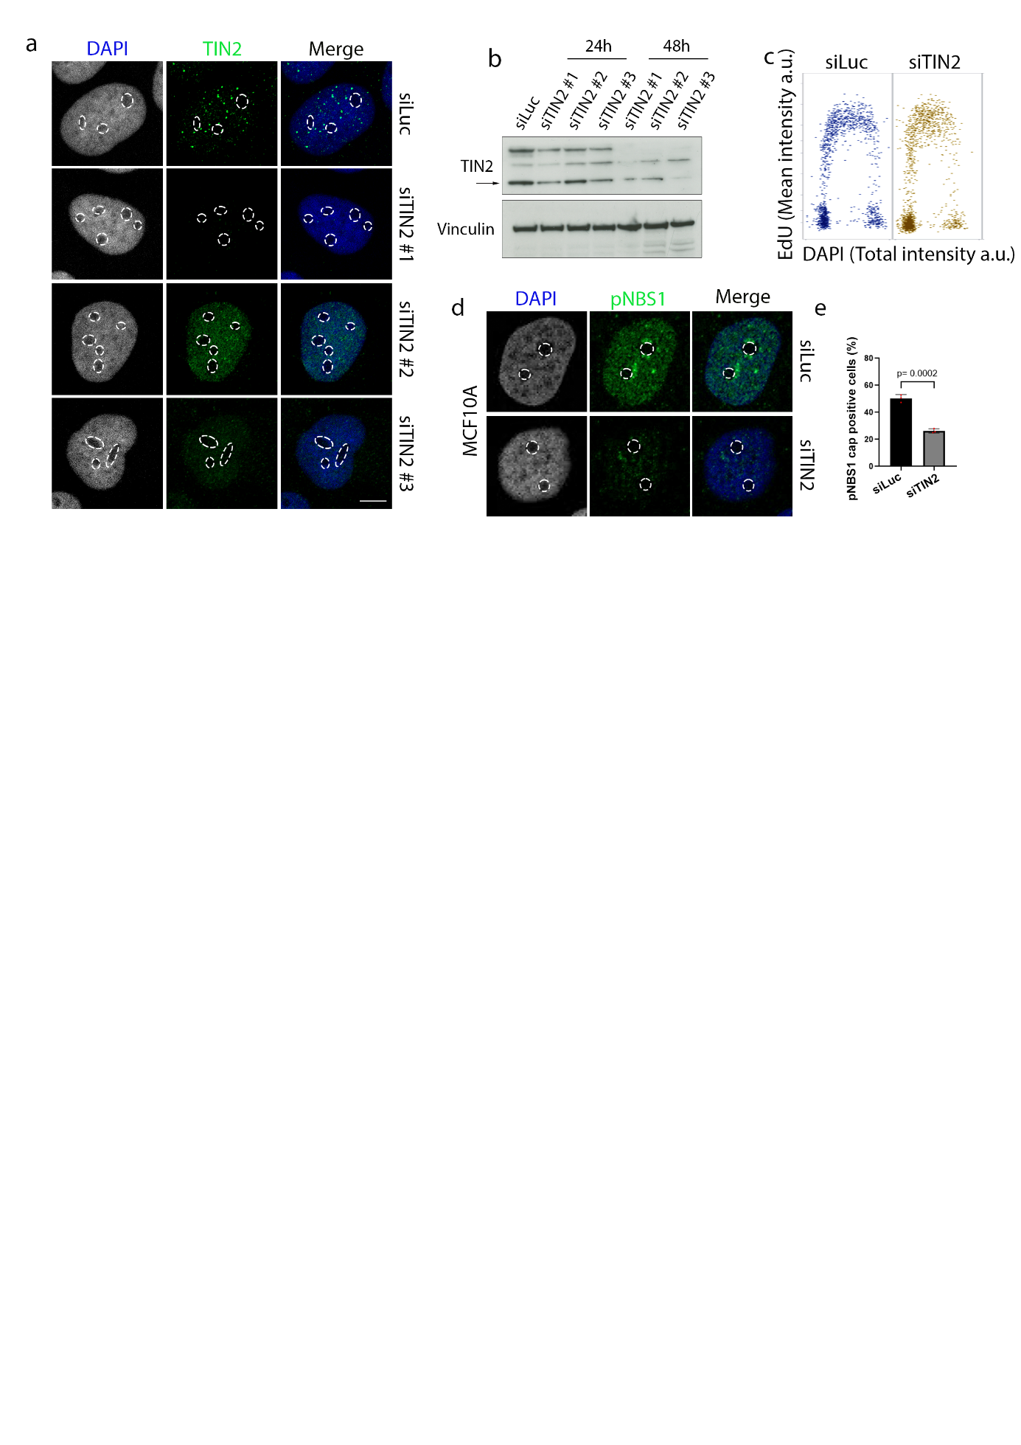

Supplementary Figure 1. TIN2 is an upstream n-DDR factor. (a) TIN2 staining. U2OS cells transfected with indicating siRNAs for 48 hours prior to IF (b) Cells were treated as in (a) for 24 or 48 hours and analysed by WB. Vinculin was used as a loading control. Arrow indicating the short TIN2 isoform (TIN2S). (c) Cell cycle analysis in cells treated with siRNA #1 for 48 hours. Cells were pulsed with EdU for 30 minutes prior to fixation and Click-IT chemistry. Experiment was performed in two independent replicates. (d) TIN2 depletion affects nucleolar cap formation in MCF10A. MCF10A were transfected with siRNA for 48 hours, followed by Cas9 and sgRNA transfection. (e) Quantification of (d), positive cells for p-NBS1 at nucleolar cap. Bar graph depicts mean values +/−SD. Red dots indicate biological replicates. Experiments performed in three biological replicates, unless otherwise stated. For statistical analysis unpaired t-test was applied. Statistical significance is depicted with p-values. Dotted lines mark the nucleoli. Scale bars 10 μm.
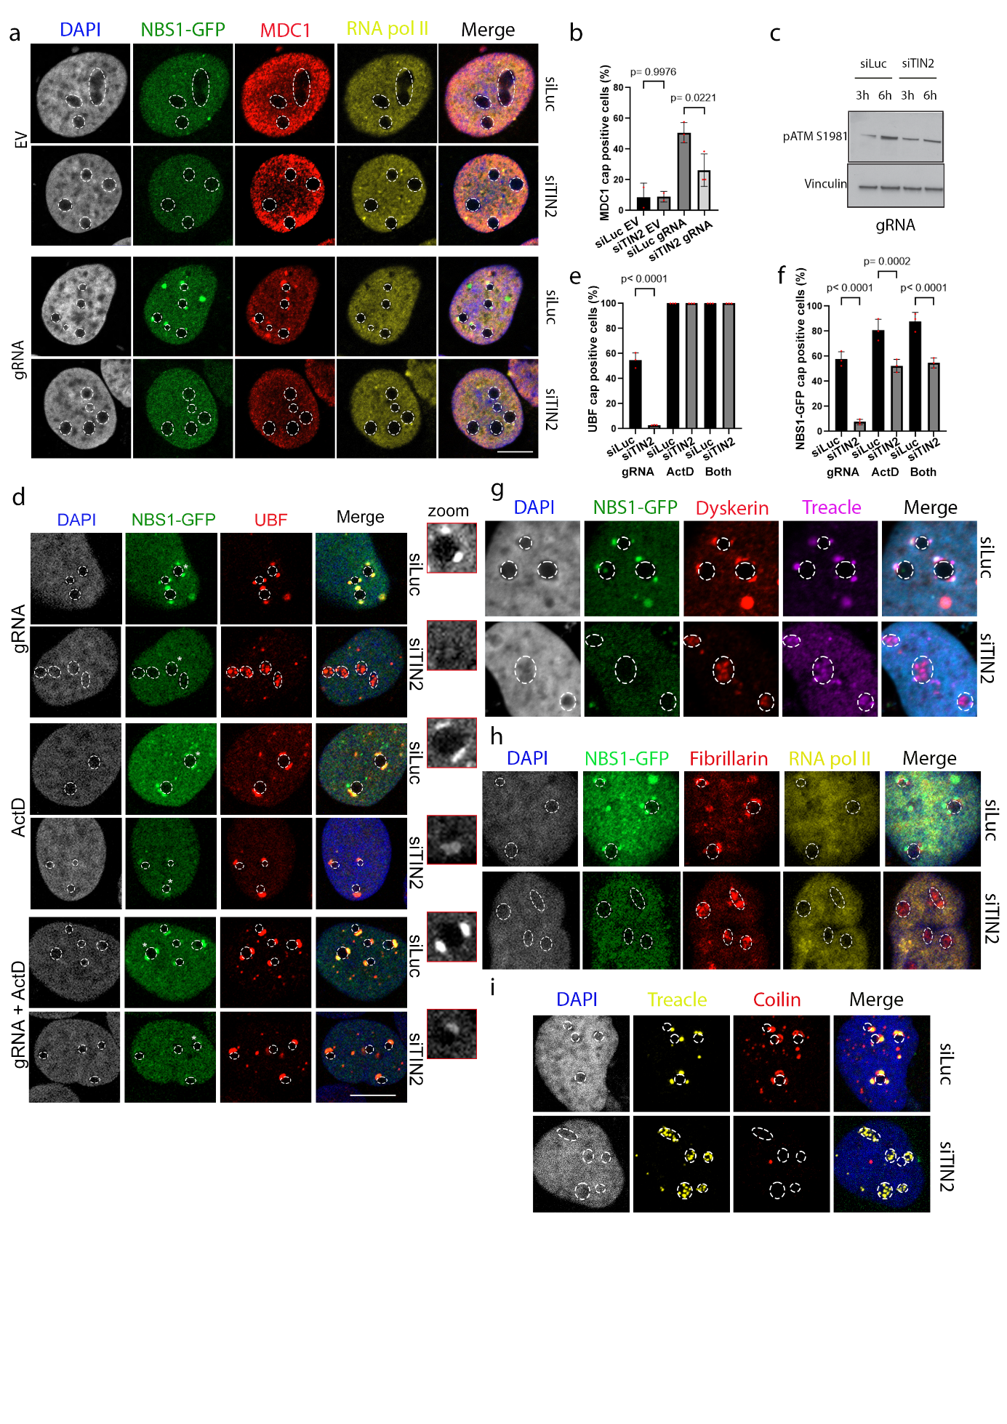

Supplementary Figure 2. TIN2 promotes n-DDR signalling cascade initiation and nucleolar restructuring upon rDNA DSBs. (a) TIN2 depletion abrogates MDC1 from the nucleolar caps. U2OS-Cas9-NBS1-GFP cells were treated with siRNA for 48 hours and transfected with EV or gRNA for 6 hours. (b) Quantification of (a), cells with MDC1 nucleolar caps. (c) TIN2 depletion impairs ATM phosphorylation upon gRNA. Cells were treated as in (a) and cell lysates were prepared at the indicated timepoints for WB analysis. Vinculin was used as a loading control. (d) Forced RNA pol I inhibition does not fully rescue the signalling cascade defects of TIN2 depletion. U2OS-Cas9-NBS1-GFP cells were transfected with siRNA for 48 hours and transfected with gRNA, treated with 50ng/mL ActD or both at the same time for a total of 6 hours. Nucleoli zoomed are marked with a star in the NBS1-GFP panel. Zoomed NBS1-GFP caps are shown in red squares. (e) Quantification of (d), cells with UBF at nucleolar caps. (f) Quantification of (d), cells with NBS1-GFP at nucleolar caps. (g) TIN2 depletion interferes with dyskerin translocation to the nucleolar periphery. U2OS-Cas9-GFP-NBS1 cells were transfected with siRNA for 48 hours, followed by gRNA transfection for 6 hours. (h) TIN2 depletion disrupts fibrillarin segregation in response to rDNA damage. Cells were treated as in (g). (i) TIN2 depletion abrogates coilin accumulation around nucleoli in response to rDNA damage. Cells were treated as in (g). Bar graphs depict mean values +/−SD. Red dots indicate biological replicates. Experiments performed in three biological replicates. For statistical analysis ordinary one-way ANOVA was applied. Statistical significance is depicted with p-values. Dotted lines mark the nucleoli. Scale bars 10 μm.
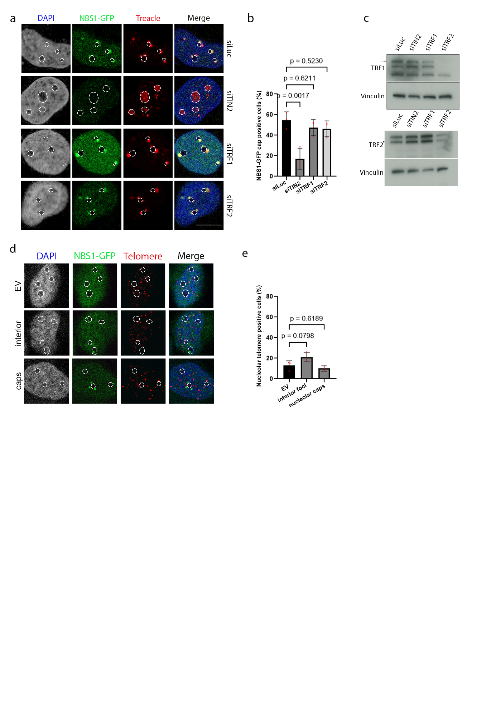

Supplementary Figure 3. TIN2 nucleolar activity independent of canonical shelterin role at telomeres. (a) TRF1 and TRF2 are not necessary for nucleolar cap formation. U2OS-Cas9-NBS1-GFP cells were transfected with siRNA for 48 hours, followed by gRNA transfection for 6 hours. (b) Quantification of (a), NBS1-GFP cap positive cells. (c) Cell lysates from (a) were analysed with WB. Vinculin was used as a loading control. Arrow is showing the band of interest. (d) Telomere signal was not detected inside nucleoli upon rDNA damage. U2OS-Cas9-NBS1-GFP cells were transfected with EV or gRNA and fixed at different timepoints (3 and 6 hours), prior to telomere FISH. Representative images showing cells without rDNA damage (EV), early response with NBS1-GFP nucleolar interior foci (interior) and late response with NBS1-GFP at nucleolar caps (caps). (e) Quantification of (d), cells with nucleolar telomeric foci. In the EV all cells were counted, in both interior and cap samples only NBS1-GFP positive cells were counted. Bar graphs depict mean values +/−SD. Red dots indicate biological replicates. Experiments performed in three biological replicates. For statistical analysis ordinary one-way ANOVA was applied. Statistical significance is depicted with p-values. Dotted lines mark the nucleoli. Scale bars 10 μm.
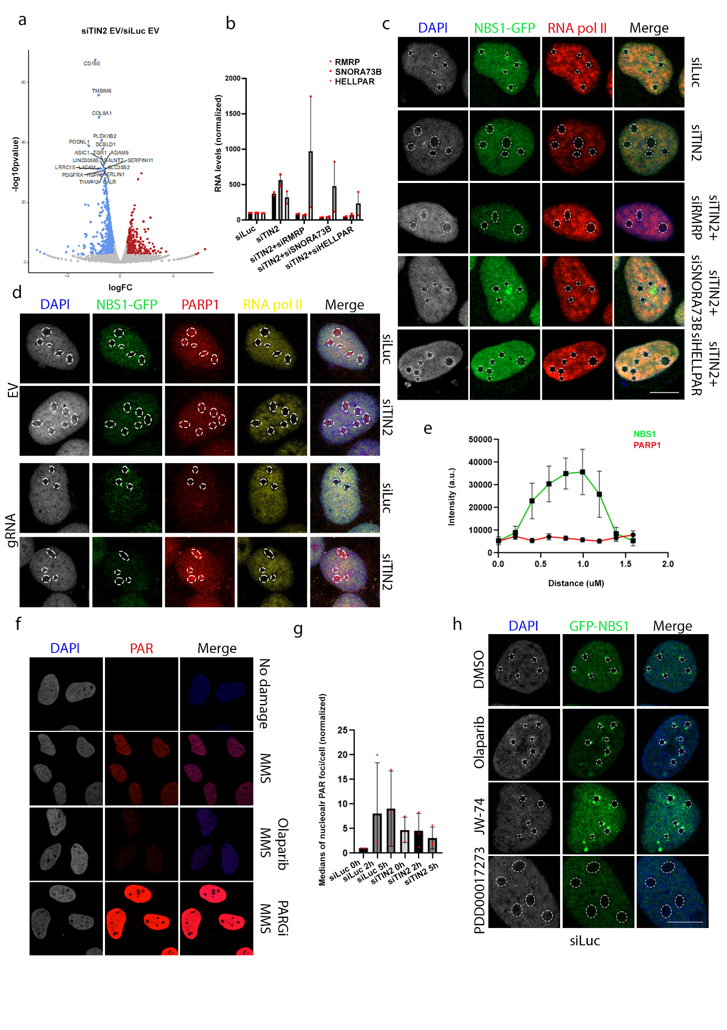

Supplementary Figure 4. TIN2 depletion leads to increased nucleolar SNORA73B levels and loss of PAR dynamics. (a) APEX RNA-seq shows that TIN2 depletion leads to reduced RNAs in the nucleolus compared to control cells (siLuc). (b) Validation of RNA depletion with qPCR. This experiment was performed in two biological replicates, and technical triplicates within each sample. (c) Representative images of (Figure 3d). Cells were treated with siRNA for 48 hours, followed by gRNA transfection for 6 hours. (d) PARP1 is released to the nucleoplasm upon rDNA damage, which is not taking place in TIN2 depleted cells. U2OS-Cas9-GFP-NBS1 cells were transfected with siRNA for 48 hours and gRNAs for 6 hours. The experiment was performed in two biological replicates. (e) PARP1 accumulation is not detected at nucleolar caps marked by NBS1-GFP. Nucleolar caps from siLuc gRNA cells in (a) were used to analyse co-localisation of PARP1 with NBS1-GFP at the nucleolar caps. 7 nucleolar caps from different cells were analysed for the intensity of the two proteins. (f) Representative images of control samples for the PAR stain. U2OS-Cas9-NBS1-GFP cells were treated with DMSO, 1.2mM MMS for 1 hour, 10uM Olaparib or 10uM PDD00017273 1 hour prior to MMS treatment. (g) Quantification of (Figure 3e), nucleolar PAR foci with CellProfiler. Bar graph with median values of three biological replicates. (h) Representative images of (Figure 3g). Cells were treated with corresponding inhibitor for 24 hours, followed by gRNA transfection for 6 hours. For statistical analysis of normalized data one sample t-test compared to a hypothetical value (1) was performed. Bar graphs depict mean values +/−SD. Red dots indicate biological replicates. Statistical significance is depicted with p-values. Dotted lines mark the nucleoli.
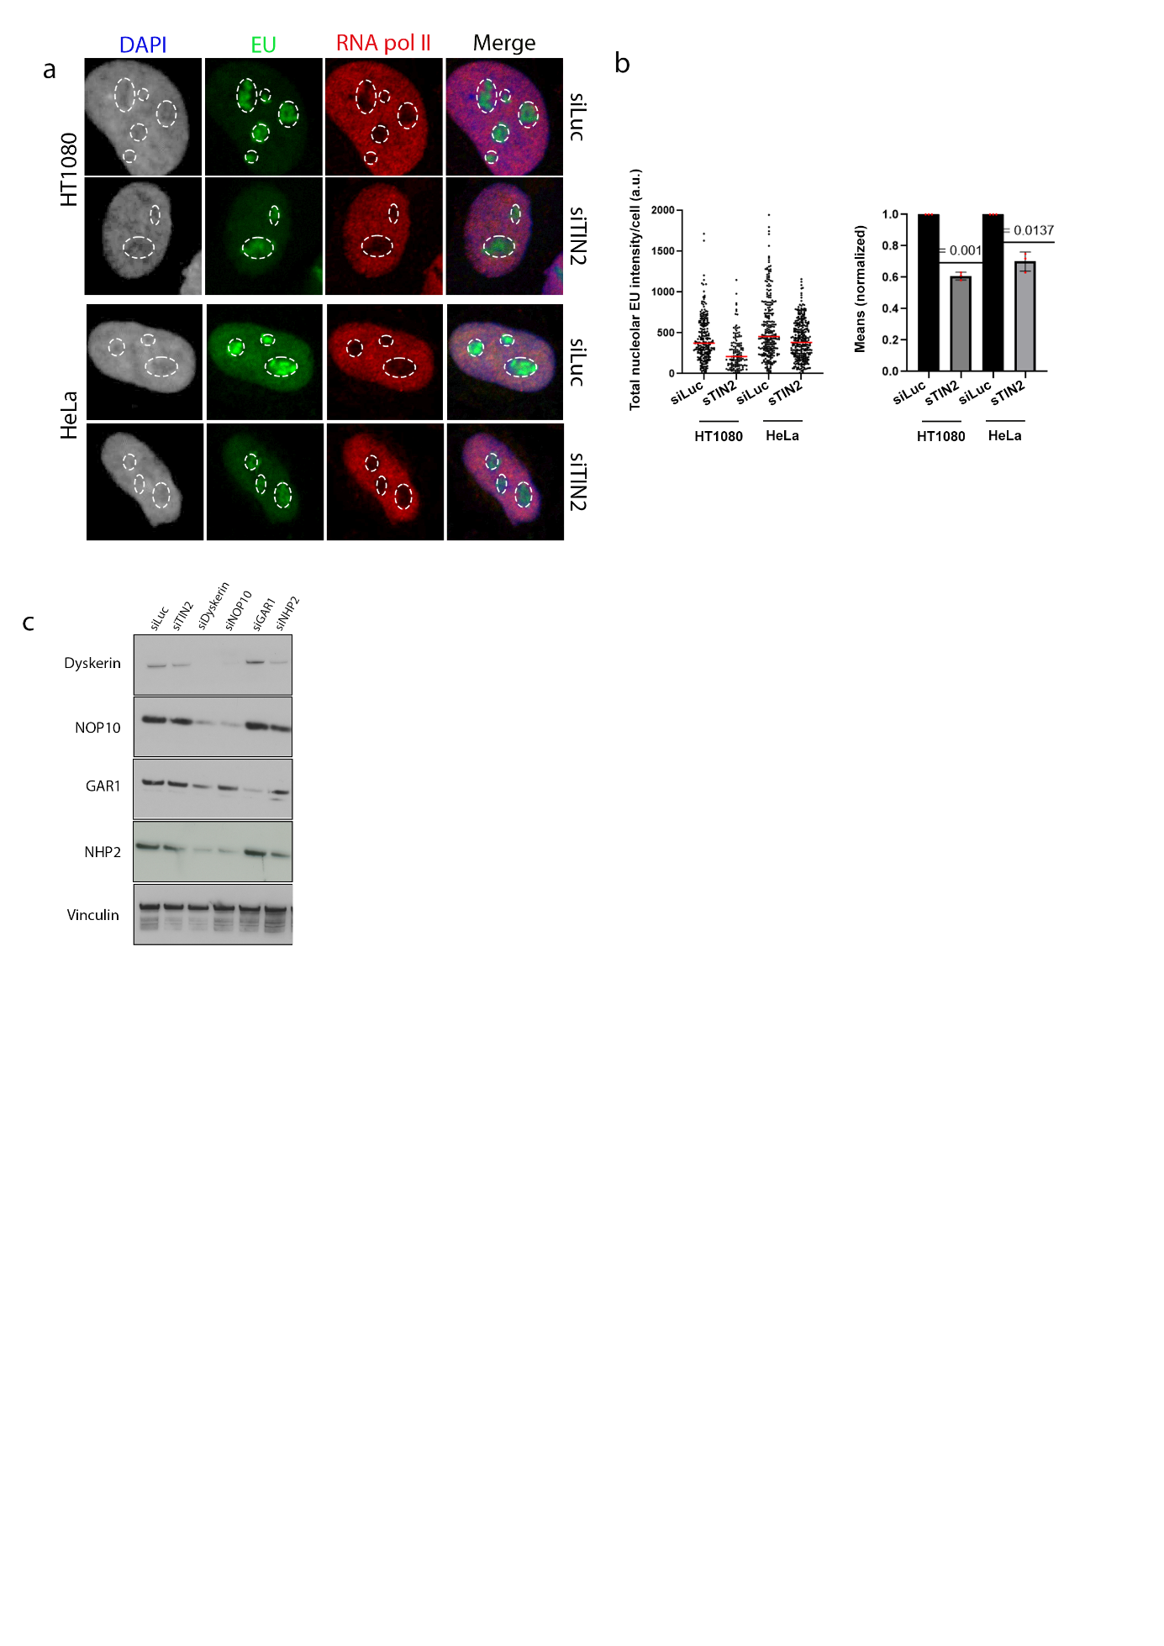

Supplementary Figure 5. TIN2 supports nucleolar transcription independent of cell-type. (a) HT1080 and HeLa cells were treated with siRNA for 48 hours and pulsed with 5’-EU for 25 minutes prior to Click-IT chemistry and IF. (b) Quantification of (a), nucleolar EU with CellProfiler using RNA pol II as a nucleolar mask. (left) Data are presented as individual values. One representative experiment is shown. (right) Bar graph depicts the mean values of three biological replicates normalized to their control (siLuc). (c) Cell lysates from (7a) were analysed with WB. Vinculin was used as a loading control. Bar graphs depict mean values +/−SD. Red dots indicate biological replicates. Scatter plots depict median values with red horizontal line. Experiments performed in three biological replicates. For statistical analysis of normalized data one sample t-test compared to a hypothetical value (1) was applied. Statistical significance is depicted with p-values. Dotted lines mark the nucleoli.

