Supplementary document

Quality control of mRNA sequencing data

For mRNA sequencing, the multidimensional scaling (MDS) plots revealed a distinction for cell type (neurons and glia) (Supp. Fig 1). Due to obvious misplacement in MDS plot (Supp Fig 1 A), samples 37 and 38 were excluded from further analysis.
As shown in Supp. Fig 2, the NeuN+ fraction enriched for neuronal- and the NeuN- fraction for glial genes, which indicates a successful separation of neurons and glia.

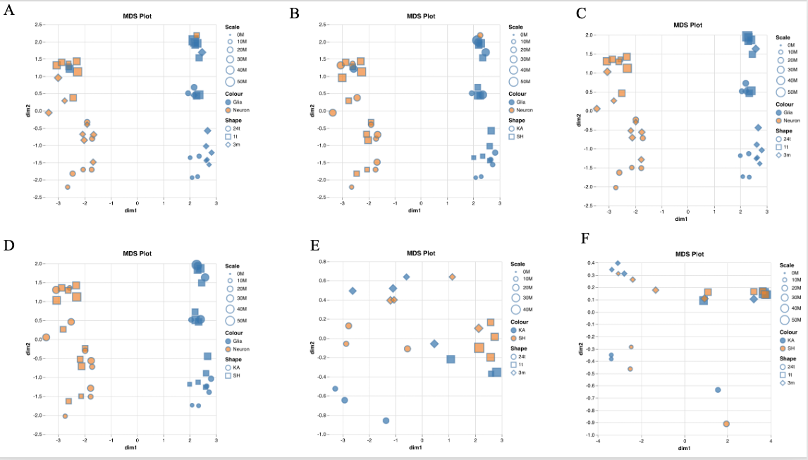

Supp. Fig. 1: Multidimensional scaling plots of mRNAseq data at 1 hour, 24 hours and 3 months past injection
Multidimensional scaling plots of the 100 most variable genes from the RNAseq datasets. (A)-(F): Orange for neurons and blue for glia; (A), (B), (D)-(F): Circle for KA and box for SH group; (C): box for 1 hour past injection, circle for 24 hours past injection and diamond for 3 months past injection.
Dimension 1 and Dimension 2 on x- / y- axis.
(A) MDS plot of the 100 most variable genes at all time points and all original samples sorted according to time point; samples 37 (orange, upper right quadrant) and 38 (blue, upper left quadrant) were later removed from all analyses due to obvious misplacement
(B) MDS plot of the 100 most variable genes at all time points and all original samples sorted according to treatment; samples 37 (orange, upper right quadrant) and 38 (blue, upper left quadrant) were later removed from all analyses due to obvious misplacement
(C) MDS plot of the 100 most variable genes after removal of samples 37 and 38 at all time points; sorted according to time point.
(D): MDS plot of the 100 most variable genes after removal of samples 37 and 38 at all time points; sorted according to treatment.
(E): MDS plot of the 100 most variable genes in the neuronal fraction at all time points
(F): MDS plot of the 100 most variable genes in the glial fraction at all time points

Supp. Fig. 2: Enrichment of neuronal and glial genes in the NeuN+ and NeuN- fractions at 1 hour, 24 hours and 3 months post injection
Normalized counts of RNAseq data for a selection of neuronal and non-neuronal genes in the NeuN+ and NeuN- fractions. Rbfox3 (NeuN): Neurons, Aldh1l1: Astrocytes, Cx3Cr1: Microglia, Mpb: Oligodendrocytes, Pdgfrb: Pericytes, and Pecam1: Endothelial cells.
(A)-(C): x-axis: respective cell fraction, G-Glia, K-Kainic acid group, N-Neurons, S-Sham group, 1 – 1 hour past injection, 24 – 24 hours past injection, 3 – 3 months past injection.
(A) Normalised gene counts at 1 hour past injection
(B) Normalised gene counts at 24 hours past injection
(C) Normalised gene counts at 3 months past injection

Detailed methods

Fluorescence activated nuclei sorting
All solutions and tubes were pre-chilled on ice prior to use, samples kept on ice whenever possible, and centrifugations performed at 4 °C. Mixing or resuspension of samples/nuclei was done by gentle pipetting with a 1 mL tip.

Reagents and solutions
The following reagents were used: Sucrose (Sigma-Aldrich cat.no. S0389), Tricine (Sigma-Aldrich cat. no. T0377), KCl (VWR cat. no. 26764.298), MgCl₂•6H₂O (Merck Millipore cat. no. 1058330250), CaCl₂•2H₂O ₍Sigma-Aldrich cat. no. C7902), Protease Inhibitor Cocktail (Biotools cat. no. B14001), Triton X-100 (Sigma Aldrich cat. no. T8532), Debris Removal Solution (DRS) (Miltenyi cat.no. 130-109-398), DPBS (ThermoFisher Scientific cat.no. 14190144), anti-NeuN Alexa Fluor488 (anti-NeuN-488) (Millipore cat. No. MAB377X), propidium iodide 100 µg/mL (PI) (Miltenyi, cat.no. 130-093-233), mirVana lysis buffer (RNA lysis buffer) (from mirVana miRNA Isolation Kit, Ambion cat. no. AM 1560).
Incubation Buffer (IB): 0.25M sucrose, 25 mM KCl, 5 mM MgCl₂, 20 mM Tricine-KOH, pH 7.8 Homogenization buffer (HB): IB supplemented with Triton X-100 to 0.1% and 1x Protease Inhibitor Cocktail
Homogenization of tissue
Tubes of pooled hippocampi hemispheres were put on ice for immediate processing. Per tube, 1 mL of HB was added, and hippocampi were allowed to thaw for 1 min, Tissue and buffer were poured into a GentleMACS C Tube (Miltenyi cat.no. 130-093-237) for homogenization on a GentleMACS dissociator (Miltenyi) using the m_brain_02_01 program. C tubes were spun down at 100 x g for 30 sec to pellet undissolved tissue, and the homogenate was collected through a 70 μm filter into a 15 mL conical tube. The homogenization procedure was performed twice more on undissolved tissue. 20 µL of suspension was diluted with IB to 100 µL and used to count nuclei on a NucleoCounter NC-100 (Chemometec). The average number of nuclei per homogenized hippocampal hemisphere was1.07x10⁶, 830.000 and 1.21x10⁶ for the 1 hour, 24 hours and 3 months samples, respectively. In parallel with the hippocampal samples, a NeuN-negative control sample containing 50 mg of adult mouse liver was processed to facilitate gating in downstream nuclear sorting. This sample was run on GentleMACS using the m_liver_03 program.

Debris removal
The exact volume of each sample was measured and 290 μL of DRS added per mL of nuclei suspension. After gentle mixing, samples were overlaid with 4 mL DPBS and spun at 3000 x g for 20 min, with slow acceleration and brake turned off. Upper layer, debris interphase, and lower layer were discarded, and nuclear pellets were resuspended in 100 μL IB per one million nuclei (based on counting on filtered homogenate, see Homogenization of tissue) and transferred to 5 mL polypropylene tubes.

Staining of nuclei
Anti-NeuN-488 was added to each tube to a final concentration of 0.1 µg/mL, and samples incubated for 1 h on ice in the dark. Samples were not washed prior to sorting, as additional centrifugation resulted in a significant loss of nuclei.

Nuclei sorting
Sorting of nuclei was performed on a BD FACSAria (BD Biosciences). 0.1 µg PI (DNA stain) was added to each sample approximately five minutes prior to sorting. The instrument was set to gently agitate the sample at 100 rpm. The following strategy was used for gating (Supp. Fig 4): 1) A nuclear gate was defined by PI-positive events (excitation by 488 nm laser, emission collected by 616/23 band-pass filter). 2) Aggregated nuclei were excluded in a dot plot using the pulse width of side scatter (SSC-w) versus the pulse area of forward scatter (FSC-a). 3) The NeuN-negative gate was set based on signal from anti-NeuN-488 stained liver sample (excitation by 488 nm laser, emission collected by 530/30 band-pass filter). NeuN-positive and NeuN-negative hippocampal nuclei were sorted into 5mL tubes prefilled with 2 mL DPBS. On average, for the 1-hour samples,35% of nuclei present in the filtered homogenate were recovered after sorting, with 72% sorted as NeuN-positive, and 28% sorted as NeuN-negative. For the 24-hours samples, on average, 31% of nuclei present in the filtered homogenate were recovered after sorting, with 66% sorted as NeuN-positive, and 34% sorted as NeuN-negative. For the 3-months samples, the percentages were 29% (recovery), 70% (NeuN-positives), and 30 % (NeuN-negatives). Mean purity of the sorted fractions was 96% (for 24 hours 93% and 95% for the NeuN+ and NeuN- population respectively). Immediately after sorting 3 μL of 1 M MgCl₂ and 5 μL of 1 M CaCl₂ were added per mL of nuclei suspension (to avoid nuclear disruption during centrifugation, as suggested by [1]), followed by gentle mixing. Half of each sample was transferred to a new tube, all tubes were spun at 500 x g for 5 min, and supernatants were discarded. One pellet of NeuN-negative nuclei and one pellet of NeuN-positive nuclei were each resuspended in 500 µL RNA lysis buffer. Lysates were stored at -80 °C, with RNA extraction performed within 24 h. The remaining pellets were stored for DNA extraction (not used in the present work).

Supp. Fig3. Sorting of NeuN-positive and NeuN-negative nuclei by flow cytometry
(A, B) Nuclei were defined as PI-positive events, and aggregated nuclei were excluded in a SSC-w vs FSC-a plot. Single nuclei from a tissue not expressing NeuN (adult mouse liver) were used to define the NeuN-positive and NeuN-negative gates (A), and hippocampal nuclei were sorted accordingly (B). Figure taken from Berger et al. [2] for illustration purposes.

Isolation of total RNA from sorted nuclei
Lysates were thawed on ice and total RNA extracted according to procedures E and F.I in the mirVana miRNA Isolation Kit protocol (Ambion cat. no. AM 1560). Up-concentration was performed using the RNA Clean & Concentrator-5 kit (Zymo Research cat.no. R1015), followed by elution in 8 µL nuclease-free water. RNA concentration and integrity were assessed on Bioanalyzer (Agilent Technologies), using the RNA Pico Kit (Agilent Technologies cat.no. 5067-1513). For 1 hour and 3 months past injection , the mean yield from NeuN-positive and NeuN-negative nuclei was approximately 58 ng and 5 ng per sorted hemisphere, respectively. Mean RNA Integrity number (RIN) was 8.2. For 24 hours past injection, tean yield from NeuN-positive and NeuN-negative nuclei was approximately13 ng and 1ng per sorted hemisphere. Mean RNA Integrity number (RIN) was 7.9.

High throughput mRNA-sequencing library prep
SMART-Seqv4 Ultra Low Input RNA Kit for Sequencing (Takara Bio cat.no. 634891) was used for mRNA specific cDNA synthesis and amplification through oligo(dT) priming, using an input of 1 ng total RNA and 10 cycles of PCR. cDNA concentrations were measured on Qubit (DNA HS assay), and 1 ng of each sample was fragmented on Covaris LE220 (Covaris) using the recommended settings in the SMART-Seqv4 protocol. Fragmented cDNA was purified with 2 volumes AMPure XP beads, eluted in 10 µL 10 mM Tris-Cl, and measured on Qubit. Sequencing libraries were prepared from fragmented cDNA using the ThruPlex DNA-seq Kit (Rubicon Genomics cat.no. R400407) according to manufacturer’s instructions. Library concentration was measured on Qubit, and fragment distribution analysed on HS D5000 Screen Tape on TapeStation (Agilent cat.no. 5067-5592/3).
Schematic overview over experimental setup
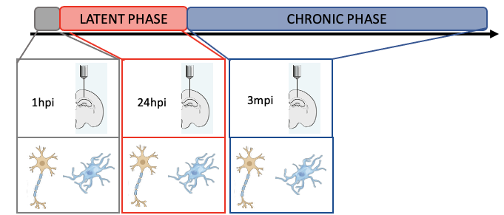
Supp. Fig. 4 Schematic overview over experimental setup
Timeline on the top: acute phase (1 hour past injection – 1hpi), latent phase (24 hours past injection – 24hpi) and chronic phase (3 months past injection – 3mpi) of epileptogenesis in a kainic acid mouse model of temporal lobe epilepsy. Per time point (1 hour and 3 months), and per group (kainic acid group, or sham group), right hippocampi from 8 mice were pooled 2 to 1 prior to further processing (n = 4 per group). In the 24 hpi group, 8 mice were pooled 4 to 1 and 2 to 1 resulting in sample size n = 3 per group. Cell nuclei were sorted into neuronal enriched and glial enriched fractions using Flow cytometry based on NeuN+ staining. Downstream analyses were performed using R (DESeq2).

References

1. Jiang Y, Matevossian A, Huang HS, Straubhaar J, Akbarian S. Isolation of neuronal chromatin from brain tissue. BMC neuroscience. 2008;9:42.
2. Berger TC, Vigeland MD, Hjorthaug HS, Etholm L, Nome CG, Tauboll E, et al. Neuronal and glial DNA methylation and gene expression changes in early epileptogenesis. PloS one. 2019;14(12):e0226575.

