Supplementary Figures
Supplementary Figure 1: Environmental Layout a) Site 1 b) Site 3
- Site 1 Layout
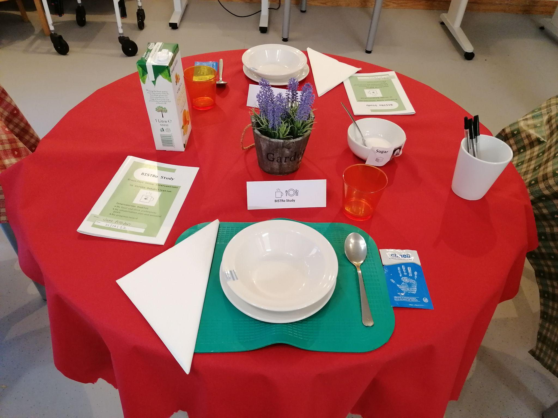
b) Site 2 Layout
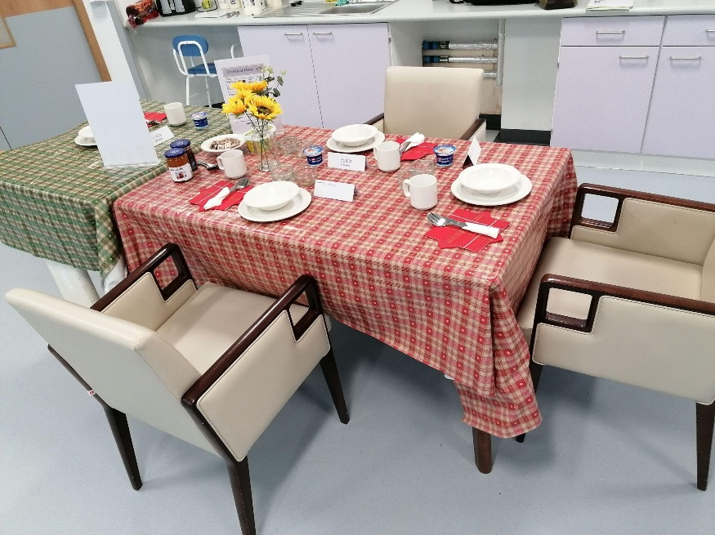

Supplementary Figure 2: Food Preparation Station (Site 1)
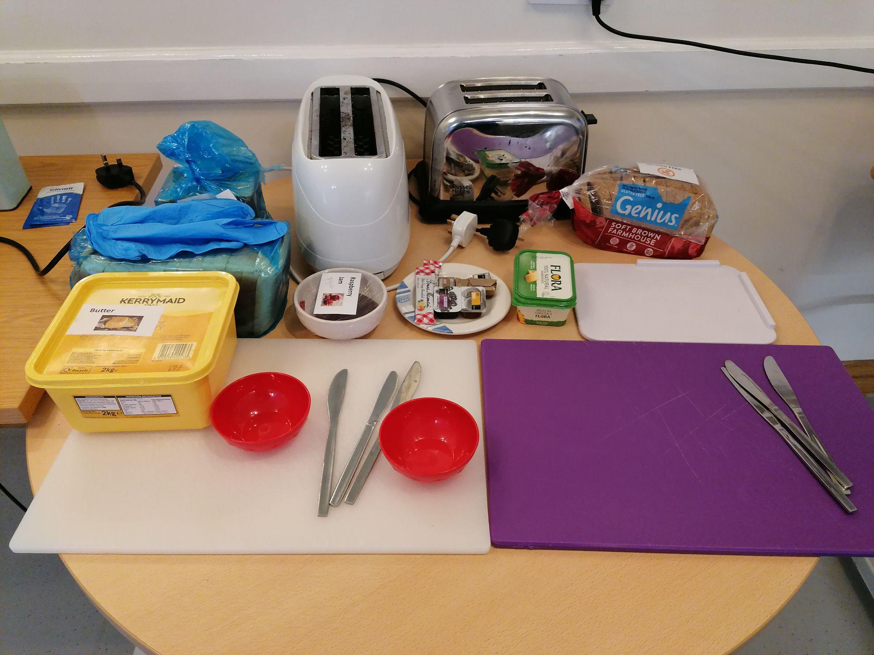
Supplementary Figure 3: Food Preferences (Booklet illustration)
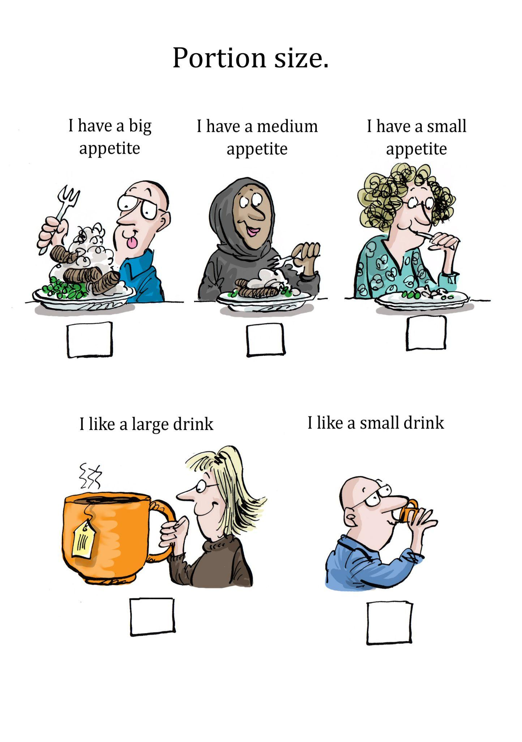
Supplementary Figure 4: Patient completing the daily log in the patient booklet.
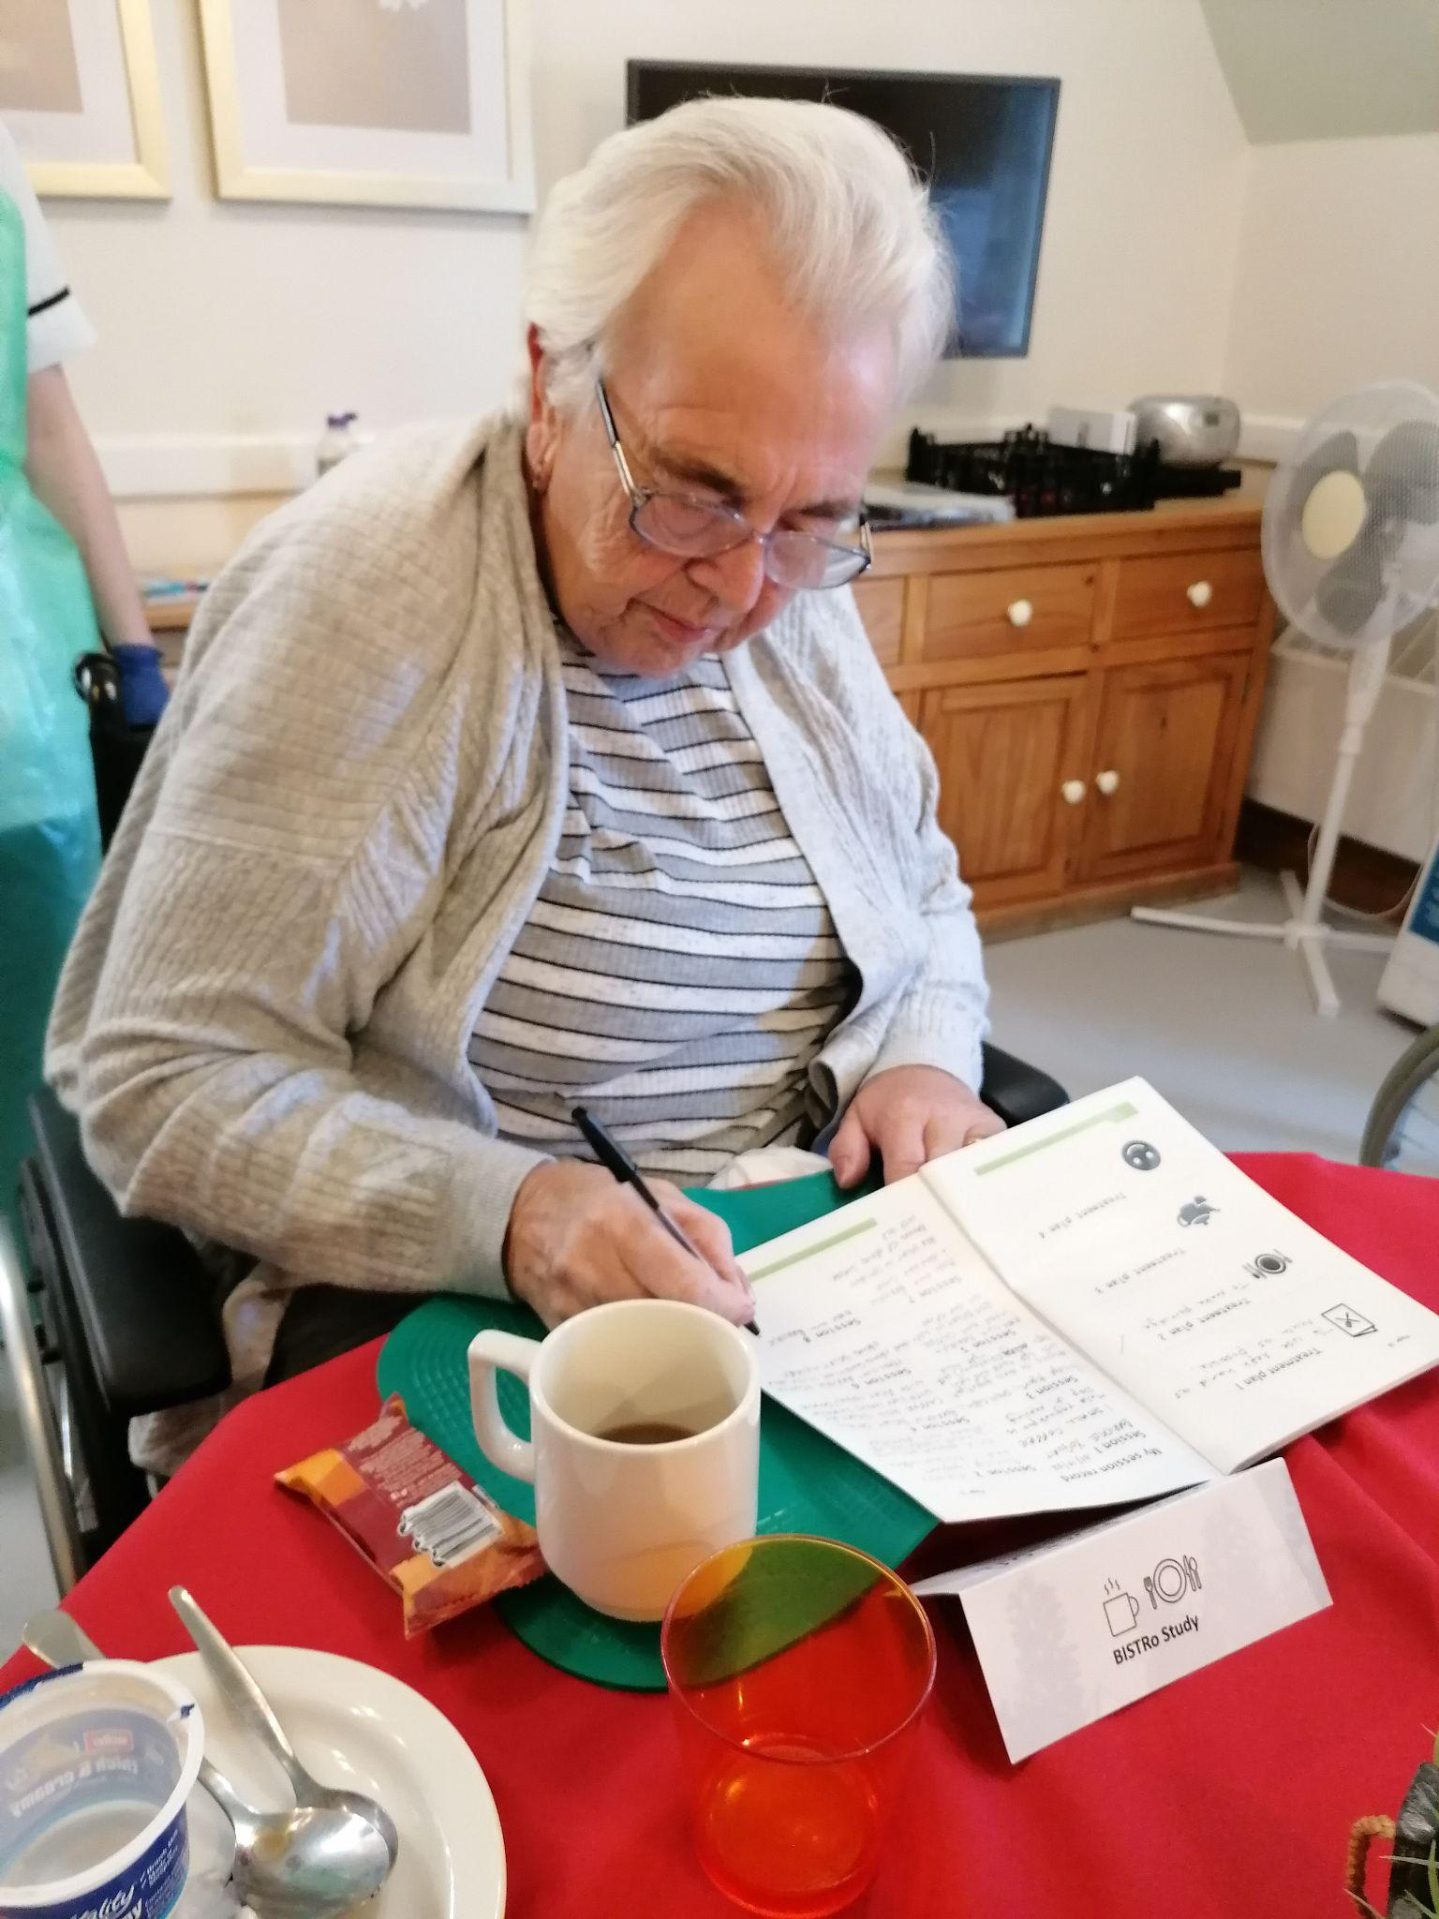

Supplementary Figure 5: Healthy Eating Illustrations
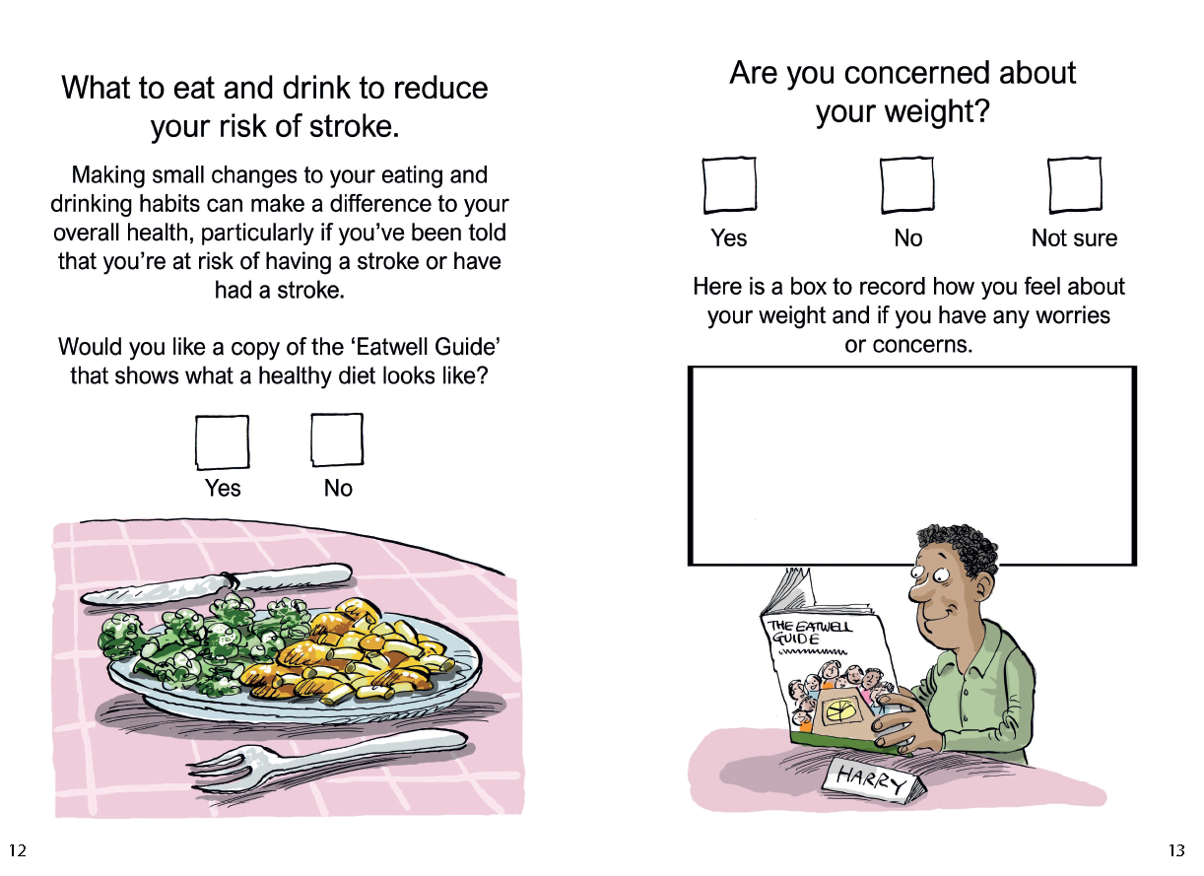
Supplementary Figure 6: Codesign Poster (used in the open research event to engage key stakeholders).
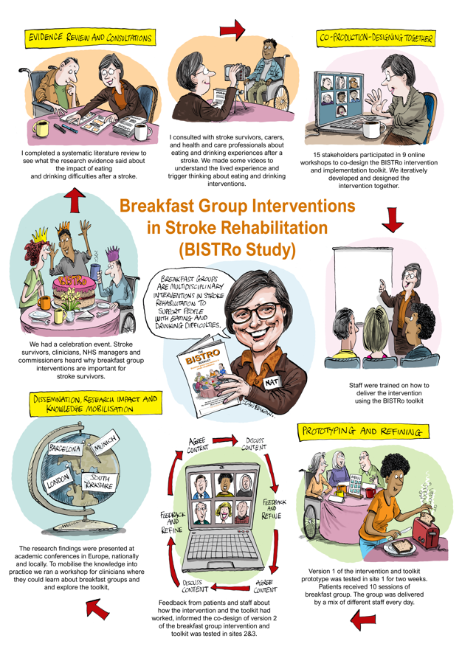

Supplementary Figure 7: Stroke Survivor Poem
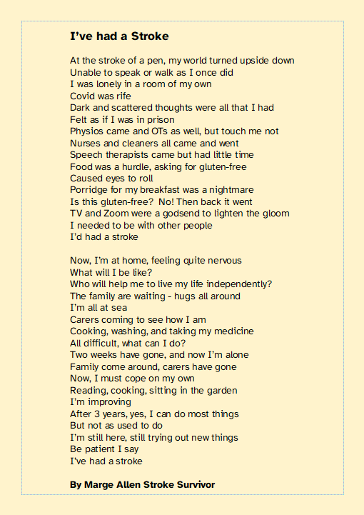

Supplementary Figure 8: Artefacts from the open research event a) Patient Booklet
b) Illustrations c) The Breakfast Group d) Food Preparation
- Patient Booklet b) Illustrations with quotes
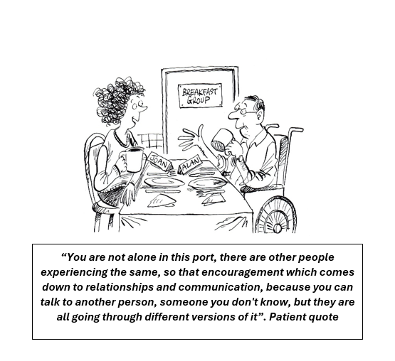
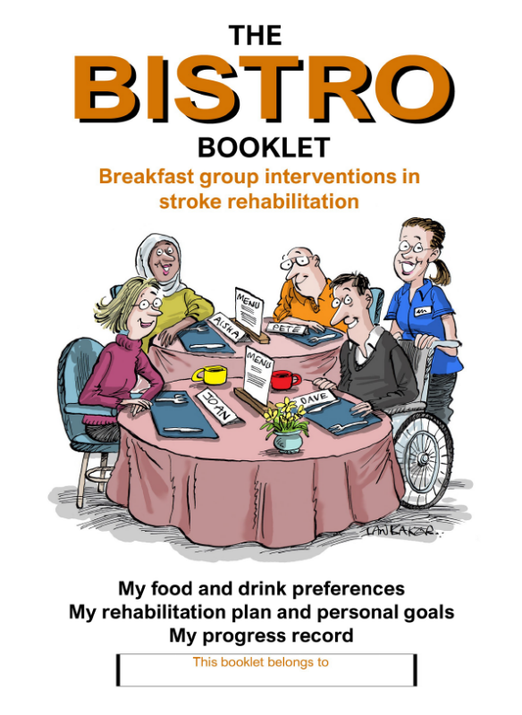
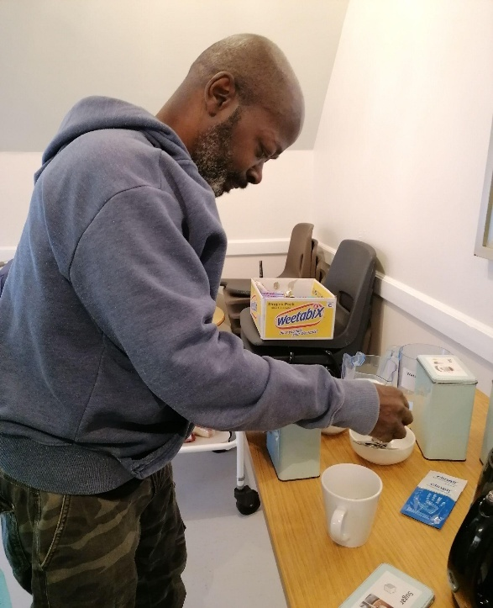
- The Breakfast Group d) Food Preparation
