Supporting Information

A sonopiezoresponse COF-based smart nanoreactor orchestrating in situ bioorthogonal chemistry and cuproptosis for enhanced tumor piezocatalytic therapy

Chunyuan Hou^{1,‡}, Yu Zhang^{1,‡,}*, Jun Gu¹, Jun Wan¹, Ziyao Zhao¹, Peicheng Wang¹, Shujun Feng^{2,}* and Jun Luo^{1,}*

¹School of Chemistry and Chemical Engineering, Nanjing University of Science and Technology, Nanjing, 210094, China
²State Key Laboratory of Natural Medicines, Department of Pharmaceutics, China Pharmaceutical University, Nanjing, 210009, China

Experimental Section
Materials and Instruments
All chemicals were purchased from Sigma and Aladdin Reagent Company without further purification unless otherwise indicated. Methyl thiazolyl tetrazolium (MTT), Hoechst3342, Lyso-tracker-Red, JC-1 Assay Kit, 2’-7’dichlorofluorescin diacetate (DCFH-DA) and DiR dyes were purchased from Beyotime Institute of Biotechnology Co. LLC. (Nantong, China). Calcein/PI Cell Viability/Cytotoxicity Assay Kit and SDS-PAGE Gel Quick Preparation Kit were purchased from KeyGEN Bio TECH Corp, Ltd (Nanjing, China).
Apparatus
Powder X-ray diffraction (PXRD) patterns were conducted by a D8 Advance diffractometer (Bruker, Germany). Fourier transform infrared spectroscopy (FT-IR) was measured by INVENIO X infrared spectrometer (Bruker, Germany)). X-ray photoelectron spectroscopy (XPS) was characterized by PJI5000VersaProbe (ULVAC-PHI, Japan). The solid-state UV-Vis absorbance was obtained on a UV-2600 spectrometer (Shimadzu, Japan). N₂ adsorption desorption isotherms were measured at 77 K on an ASAP 3020 system to obtain Brunauer-Emmett-Teller (BET) surface area (Merck KGaA, Germany). The fluorescence (FL) spectra, UV-vis absorption spectra and MTT assay were carried out on Safire microplate analyzer (Molecular Devices, America). Scanning electron microscopy (SEM) imaging was done on a JSM-7800F scanning electron microscope (JEOL, Japan). Transmission electron microscopy (TEM) images were got from JEM-2800 transmission electron microscopy (JEOL, Japan). Steady-state photoluminescence (PL) spectra and time-resolved fluorescence (TRF) spectra were recorded on a FLS 1000 FL spectrophotometer (Edinburgh Instruments, UK). Electron paramagnetic resonance (EPR) spectra was got from EMXplus-9./12 (Bruker, Germany). Fluorescent images were taken by an inverted fluorescence microscope (Nikon Instruments, Japan) and confocal laser scanning microscopy (Olympus FV3000, Japan). All electrochemical measurements were conducted with a CHI800 workstation (CH Instruments, China). The relative SDT experiments were carried out using an ultrasound therapy equipment UT 1021 (Nu-Tek, China).
Cell line and animals
The 4T1 cell line was obtained from the Cell Bank of the Chinese Academy of Sciences. All cell lines were cultured in DMEM supplemented with 10% FBS (Gibco) and penicillin/streptomycin. All cell lines were cultured in incubator at 37℃ under an atmosphere of 5% CO₂ and 90% relative humidity. Female BALB/c mice were purchased form Nanjing Qinglongshan Experimental Animal center. Mice used in experiments were 6-8 weeks old. All animal experiments were performed in accordance with the National Institute of Health Guidelines under the protocols approved by the Animal Ethical and Welfare Committee of Nanjing University of Science and Technology (Approval No: AUCU-NUST2023012).
Synthesis of CuCOF-1C, CuCOF-1N, CuCOF-2C, and CuCOF-2N
TAPB (28.12 mg, 0.08 mmol) or TTA (28.35 mg, 0.08 mmol), BPA (25.46 mg, 0.12 mmol) or DBPy (25.46 mg, 0.12 mmol) and Cu(OTf)₂ (28.93 mg, 0.08mmol) were weighed into a 10 mL glass-tube. 1 mL Mesitylene, 1 mL 1,4-dioxane and 0.2 mL 6M AcOH were then added to the mixture. After sonicating for five minutes, the tube was kept at room temperature for 10 minutes. The resulting precipitate was filtered, washed with methanol and ethanol, and then subjected to Soxhlet extraction with THF as the solvent for 24 h. The power was dried in the vacuum oven at 80℃ for 12h.
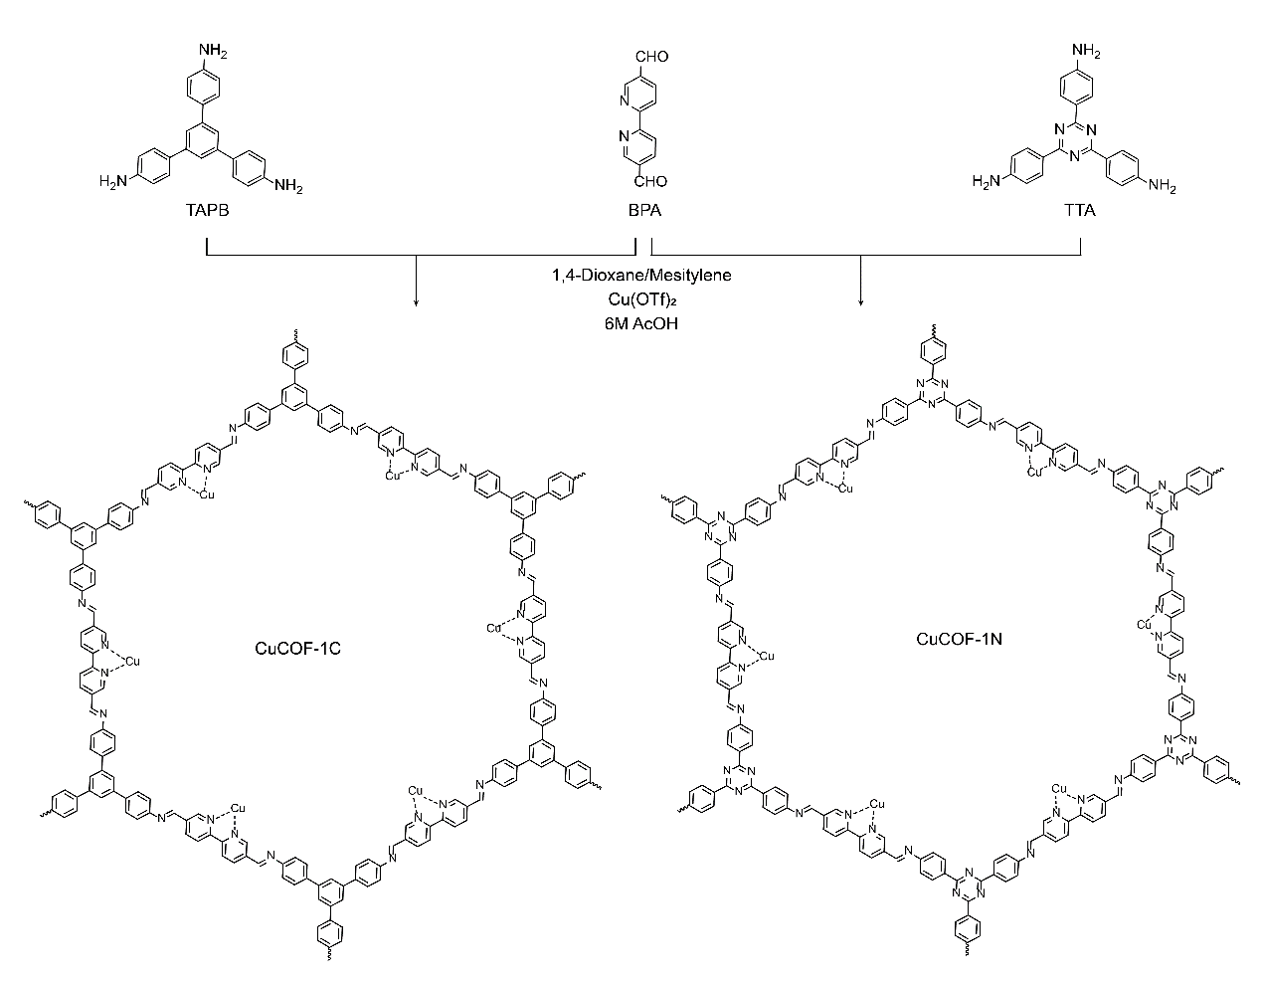
Scheme S1. Synthetic route of CuCOF-1C and CuCOF-1N.
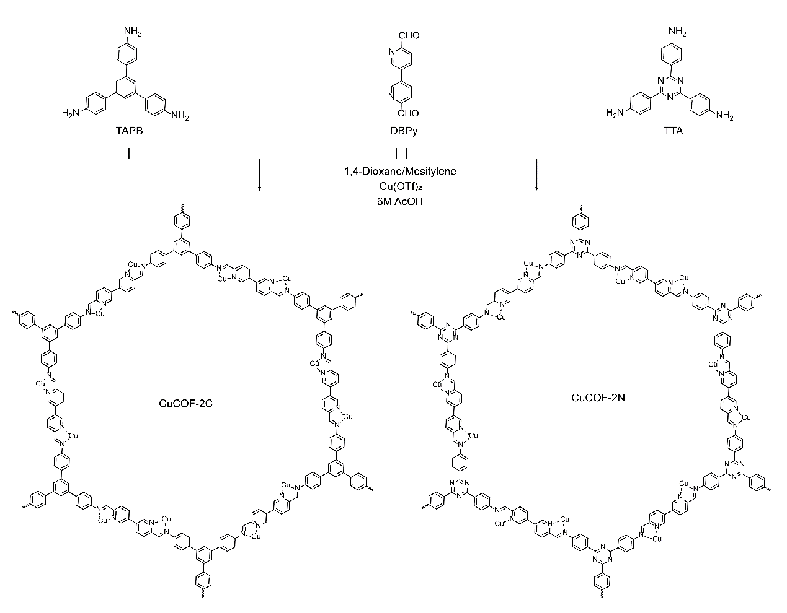
Scheme S2. Synthetic route of CuCOF-2C and CuCOF-2N.
Preparation of nanosheet CuCOF-1C, CuCOF-1N, CuCOF-2C, and CuCOF-2N
CuCOF-X (1 mg·mL⁻¹) (X=1C, 1N, 2C or 2N) in water was sonicated in an ultrasound bath for 30 min at the power of 300 W. The dispersion was then sonicated with a sonic probe for 2 h at the power of 1200 W, 30%. The sonic probe worked every 3 s with interval of 4 s. After that, the resulting solution was extruded through a polycarbonate membrane with pore size of 200 nm. Then, the nanosheet SonoCOF was collected through centrifugation at 15000 rpm for 10 min and washed with deionized water three times. Finally, the products were lyophilized and stored at room temperature under nitrogen for further use.
Preparation of Lipsome Cu1C@D-FA, Cu1N@D-FA, Cu2C@D-FA, and Cu2N@D-FA
DPPC (20 mg), DC-Chol (10 mg) and DSPE-PEG₂₀₀₀-FA (10 mg) was dissolved in chloroform (3 mL). The mixture was evaporated for 30 min at 55 °C to form a lipid film. The film was hydrated with CuCOF-X nanosheet (in DI Water, 1 mg·mL⁻¹, 2mL) and DOX-Proc (in DI Water, 1 mg·mL⁻¹, 1mL). Subsequently, the liposome suspension was extruded sequentially 11 times through polycarbonate membrane filters with pore sizes of 400, 200, and 100 nm. Products were purified by Sephadex G50 column.
Preparation of Cu2N-FA and Cu2N@D-PEG
The preparation method for Cu2N-FA is the same as that of CuX@D-FA, just without the addition of DOX. Similaly, DSPE-PEG₂₀₀₀ instead of DSPE-PEG₂₀₀₀-FA to obtain Cu2N@D-PEG.
CAT-like activity of Cu-coordinated COFs
O₂ generation was detected in real-time using a dissolved oxygen meter (JPSJ-605F, China). The O₂ production was monitored under the following four conditions: (1) H₂O₂ (2 mM)+US; (2) CuCOF-1C+H₂O₂; (3) CuCOF-1N+H₂O₂; (4) CuCOF-2C+H₂O₂; (5) CuCOF-2N+H₂O₂; (6) CuCOF-2N+H₂O₂+US.
Assessment of drug loading rate (LR)
The concentrations of DOX-Proc in CuX@D-FA was quantified by the HPLC (Shimadzu).^{[1]} The loading rate of each component were calculated as below:
$$LR\left(\%\right)=\frac{W_{d}}{W_{t}}×100\%$$
where W_{d} is the total amount of DOX-Proc in formulations, W_{t} is the total amount of formulations.
Chemical synthesis of coumarin derivative cd-Pro
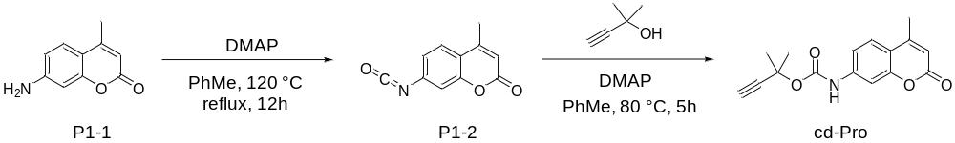
Scheme S3. Synthetic route of cd-Pro.
7-Amino-4-methylcoumarin (P1-1) (350 mg, 2 mmol), bis(trichloromethyl)carbonate (593.5 mg, 2 mmol) and DMAP (268.8 mg, 2.2 mmol) was dissolved in 35 mL of toluene. The reaction mixture was stirred at 120 ℃ for 12 h under nitrogen to yield intermediate P1-2. Propargyl alcohol (2.2 mmol) and DMAP (268.8 mg, 2.2 mmol) were then added after cooling the mixture to room temperature. The reaction mixture was stirred at 80 ℃ for 5 h under nitrogen. After cooling to room temperature, the reaction mixture was washed by brine and water, and was concentrated under reduced pressure. The residue was purified by flash chromatography on silica gel to yield coumarin derivative cd-Pro.

Chemical synthesis of Doxorubicin (Dox) prodrug DOX-Proc
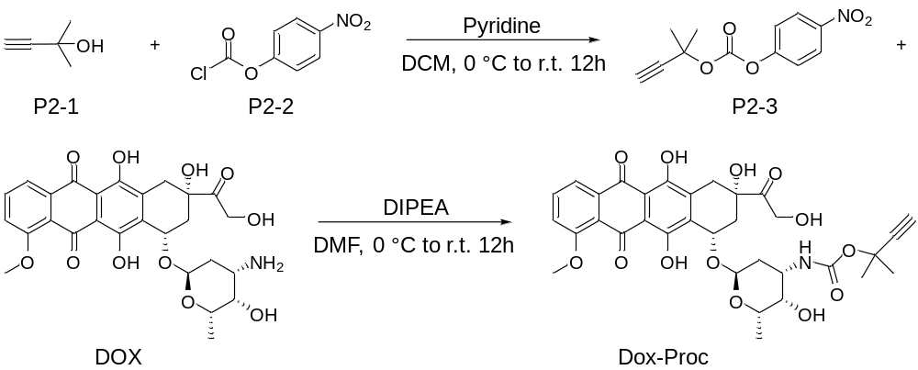
Scheme S4. Synthetic route of DOX-Proc.
P2-1 (841 mg, 10.0 mol) in CH₂Cl₂ (50 mL) in an ice bath were added 4-nitro-phenyl chloroformate (2.4 g, 12 mol) and pyridine (1.6 ml, 20.0 mol). The mixture was stirred at room temperature for 12 h before washing with brine (50 mL). The organic phase was dried with anhydrous Na₂SO₄ and the solvent was removed under reduced pressure. The crude product was purified by flash chromatography on silica gel to yield P2-3. P2-3 (299 mg, 1.2 mol) and Dox (580 mg, 1.0 mol) were dissolved in DMF (20 mL), followed by the addition of DIPEA (1.0 mL, 6.0 mol). After stirring the mixture for 12 h at room temperature, the reaction was quenched with saturated aqueous NH₄Cl (50 mL). The organic phase was separated and dried over anhydrous Na₂SO₄. The solvent was removed under reduced pressure. The crude product was purified by flash column chromatography on silica gel to yield Dox-Proc.
Stability of Cu2N@D-FA
Cu2N@D-FA (100 µg·mL⁻¹) was dispersed in DI Water, PBS, DMEM and DMEM (containing 10% fetal bovine serum (FBS)) at 37 °C for 48 h, followed by monitoring the size changes with DLS every 6 h.
ROS detection
DPBF was dissolved in DMF as a storage solution (1 mg·mL⁻¹), and then 30 μL of DPBF solution was mixed with 3 mL of various sample aqueous solutions (100 µg·mL⁻¹). The mixed solution was irradiated for different minutes by US (1 W·cm⁻², 1 MHz, 50% duty cycle). After US irradiation, the UV absorption of DPBF was measured by a microplate reader.
Detection of singlet oxygen
SOSG was dissolved in MeOH to make a storage solution (2.5 mM), and then 4 μL of SOSG solution was mixed with 2 mL of H₂O as a working solution (5 μM). 200 μL of SOSG working solution was mixed with 200 μL aqueous solution of various samples (100 µg·mL⁻¹), respectively. Then the mixed solution was irradiated by US (1 W·cm⁻², 1 MHz, 50% duty cycle). After that, the fluorescence intensity of SOSG was measured (E_{x} = 488 nm, E_{m} = 530 nm) by a microplate reader.
Detection of superoxide anions
DHE was dissolved in DMSO to make a storage solution (10 mM), and then 100 μL of DHE solution was mixed with 1 mL of H₂O to obtain a working solution (1 mM). 200 μL of the DHE working solution was mixed with 200 μL of aqueous solution of various samples, respectively. Then, the mixed solutions were irradiated by US (1 W·cm⁻², 1 MHz, 50% duty cycle). After that, the fluorescence intensity of DHE was measured (λex = 535 nm, λem = 610 nm) by a Safire microplate analyzer.
Detection of hydroxyl radical
30 μL of CuCOF-X (1 mg·mL⁻¹) and 30 μL of TMB (10 mg·mL⁻¹) were mixed. ·OH was monitored with or without US (1 W·cm⁻², 1 MHz, 50% duty cycle). The generation of ·OH was evaluated through monitoring the typical 652 nm absorption of formed ox-TMB. The UV-vis spectral change was recorded by a microplate reader.
Cellular uptake
Cu2N@D-FA (10 mg) or Cu2N@D-PEG and FITC (2 mg) were dispersed in 5 mL of PBS and stirred under light-protected conditions for 24 h. The dispersion was centrifuged (12000 rpm, 5 min) and washed three times with PBS to remove the supernatant. 4T1 cells were seeded in 12-well plates (2.5 × 10⁵ cell per well) and grown overnight to reach 70-90% confluence. And then they were incubated with FITC-labeled Cu2N@D-FA or Cu2N@D-PEG (100 μg·mL⁻¹). Cells were harvested at different time points (1, 2, 4, 8, and 12 h), stained with Hoechst 33342 (1 μL, 1 mM) for 15 min, and then washed three times with PBS. Finally, 4T1 cells were imaged using a fluorescence microscope (E_{x}/E_{m} = 488/525 nm for FITC, E_{x}/E_{m} =350/460 nm for Hoechst 33342). The fluorescence intensity was quantified by ImageJ.
Endosomal escape of Cu2N@D-FA in 4T1 cells
4T1 cells were seeded in confocal dishes (5 × 10⁵ cell per dish) and grown overnight to reach 70-90% confluence. The culture medium was replaced by 1 mL DMEM cell culture medium containing FITC-labeled Cu2N@D-FA (50 μg·mL⁻¹) and incubated for 8 h. The cells were treated with or without ultrasound stimulation (1 W·cm⁻², 1 MHz, 50% duty cycle) for 3 min, and then stained with Hoechst33342 and LysoTracker Red for 20 min. After that, the cells were washed with PBS thrice and imaged by CLSM ((Ex/Em = 577/590 nm for LysoTracker Red, Ex/Em = 488/525 nm for FITC, Ex/Em = 350/460 nm for Hoechst33342). The Pearson correlation coefficient and co-localization profiles of FITC and LysoTracker Red were calculated by Image J.
Cell viability assessment
For the MTT assay, the 4T1 cells were seeded in 96-well plates (5 × 10³ cells per well) and grown overnight to reach 70-90% confluence, followed by incubating with different concentrations of drugs for 8 h. The cells were treated with or without ultrasound irradiation (1 W·cm⁻², 1 MHz, 50% duty cycle) for 3 min and incubated for another 16 h under the same condition. After 16 hours, the MTT solution (20 µL, 5 mg·mL⁻¹) was added to each well. After 4 hours of incubation, the medium was removed, and then DMSO (200 µL) was added. The absorbance of each well was measured at 490 nm using a microplate reader.
Live-dead staining assay
4T1 cells were seeded in 24-well plates (1×10⁵ cells per well) and grown overnight to reach 70-90% confluence. And then they were incubated with CuX@D-FA or Cu2N-FA (100 μg·mL⁻¹). After incubating for 8 hours, the cells were treated with or without ultrasound irradiation (1 W·cm⁻², 1 MHz, 50% duty cycle) for 3 min and then incubated at the same conditions. After 16 hours, the cells were washed three times with PBS, followed by adding Calcein AM (2 µM) and propidium iodide (PI, 8 µM). After incubating for 30 min, images were taken with a fluorescent microscope. Green fluorescence emission from Calcein AM (Ex/Em = 495/520 nm) and red fluorescence (Ex/Em = 530/620 nm) from PI were detected.
Measurement of intracellular ROS levels
4T1 cells were seeded in 12-well plates (2.5×10⁵ cells per well) and grown overnight to reach 70-90% confluence. And then they were incubated with CuX@D-FA or Cu2N-FA (100 μg·mL⁻¹) for 8 hours. After washing three times with PBS, the cells were incubated with DCFH-DA (1 μL, 1 mM) and Hoechst 33342 (1 μL, 1 mM) for 30 min in fresh culture medium (0.5 mL). The cells were treated with or without ultrasound stimulation (1 W·cm⁻², 1 MHz, 50% duty cycle) for 3 min per well, followed by washing three times with PBS. Finally, 4T1 cells were imaged using a fluorescence microscope (E_{x}/E_{m} = 495/529 nm for DCFH-DA, E_{x}/E_{m} = 350/460 nm for Hoechst 33342). The fluorescence intensity was quantified by ImageJ.
Measurement of mitochondrial membrane potential
The mitochondrial membrane potential changes were measured using a JC-1 Assay Kit. 4T1 cells were seeded in 12-well plates (2.5×10⁵ cells per well) and grown overnight to reach 70-90% confluence, followed by incubating with CuX@D-FA or Cu2N-FA (100 μg·mL⁻¹) for 8 h. The cells were treated with or without ultrasound (1 W·cm⁻², 1 MHz, 50% duty cycle) for 3 min and incubated for another 6 h under the same conditions, followed by washing three times with PBS. Depolarization of the mitochondrial membrane was characterized by a shift from red fluorescence to green fluorescence. Finally, 4T1 cells were imaged with a fluorescence microscope. The green fluorescent emission (E_{x}/E_{m} = 514/529 nm) of JC1-monomerand and red fluorescent emission (E_{x}/E_{m} = 585/590 nm) of JC1-aggregate were measured and analyzed by ImageJ.
Western blot analysis
4T1 cells were seeded in 6-well plates (5×10⁵ cells per well) and grown overnight to reach 70-90% confluence, followed by incubating with Cu2N@D-FA (100 μg·mL⁻¹) for 8 h. The cells were treated with or without ultrasound (1 W·cm⁻², 1 MHz, 50% duty cycle) for 3 min and incubated for another 6 h under the same conditions, followed by washing three times with PBS. The 4T1 cells treated with different formulations were incubated with 300 µL RIPA buffer supplemented with protease inhibitor cocktail and phenylmethylsulfonyl fluoride on the ice for 15 min. Whole proteins were then extracted and quantified using BCA protein assay kit. After boiling at 95℃ for 10 min, equivalent amounts of proteins (30 µg) were analyzed using 10% sodium dodecyl sulfate polyacrylamide gel electrophoresis. Proteins were transferred onto polyvinylidene difluoride membranes for 55 min and were blocked with 5% skim milk for 2 h. The membranes were incubated with primary antibodies against FDX1 and LIAS at 4°C overnight. After washing with TBST, the membranes were incubated with secondary antibody at 1:5000 dilution for additional 2 h at room temperature, followed by detecting with the Tanon-5200 chemiluminescent imaging system.
Pharmacokinetic study of Cu2N@D-FA
To evaluate the pharmacokinetics of Cu2N@D-FA, Sprague Dawley rats were intravenously administrated with free DOX (1 mg·kg⁻¹) and Cu2N@D-FA (4 mg·kg⁻¹), respectively. Plasma samples were collected at various time points, subsequently treated with US irradiation (1 W·cm⁻², 1 MHz, 50% duty cycle) for 3 min, and then the DOX content was measured by HPLC. The pharmacokinetic parameters were calculated by a software of PKSolver V2.0.
In vivo tumor targeting and biodistribution of Cu2N@D-FA
4T1 cells (1×10⁷) were subcutaneously injected into female BALB/c mice. When tumor volume reached ~ 100 mm³, mice were randomly assigned into two different groups (n = 6 for each group) to evaluate the tumor targeting and biodistribution of Cu2N@D-FA. Tumor-bearing mice were intravenously injected with DiR-labeled Cu2N@D-FA or Cu2N@D-PEG (4.2 mg·kg⁻¹) and imaged at the indicated time (4, 8, 12 and 24 h). Moreover, 24 h after injection, the tumor bearing mice were sacrificed, and major organs were obtained and imaged.
In vivo antitumor effects
The subcutaneous 4T1 bearing mice were randomly divided into four groups (n=6) for investigating antitumor effects: (1) saline US+(control); (2) DOX; (3) Cu2N-FA US+; (4) Cu2N@D-FA US+. Saline, DOX, Cu2N-FA, and Cu2N@D-FA were intravenously injected every 2 days (injection dose of 4 mg·kg⁻¹) for 14 days. Then, the tumor was irradiated with ultrasound (3 min, 1 W·cm⁻², 1 MHz, 50% duty cycle) at 12 h after injection, and the tumor volume was measured during the treatment. At the end of the treatments, mice were sacrificed, then tumor tissues in different groups were collected, weighted, imaged, and analyzed by ROS, DLAT, FDX1, LIAS, H&E, JC-1, HIF-1α and TUNEL staining. The major organs, including the heart, liver, spleen, lung, and kidney, were also harvested and analyzed by H&E staining.
Statistics
All experiments were repeated at least 3 times with 5-10 biological replicates. Data are represented as mean ± SD. Error bars represent the standard error of the mean from independent samples. Statistical analysis was performed with GraphPad Prism 8 software. Statistical significance was calculated using two-tailed Student’s t test or one-way ANOVA. * represents P < 0.05, ** represents P < 0.01 and *** represents P < 0.001.

Supplementary Figures
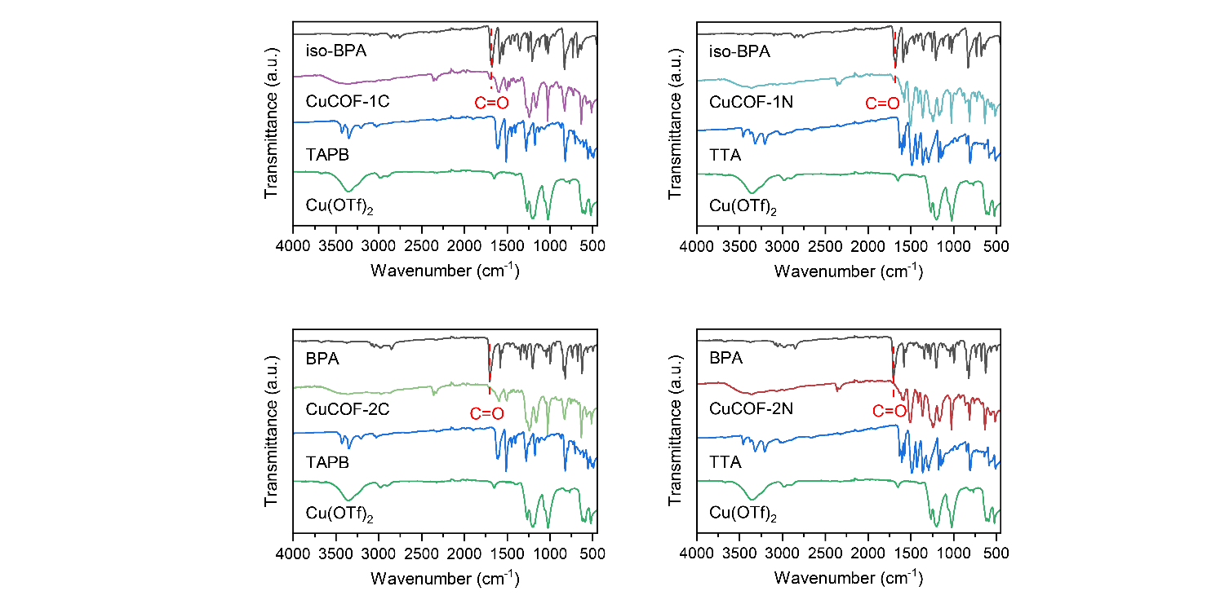
Figure S1. The FT-IR spectra of Cu-coordinated COFs with corresponding monomers.
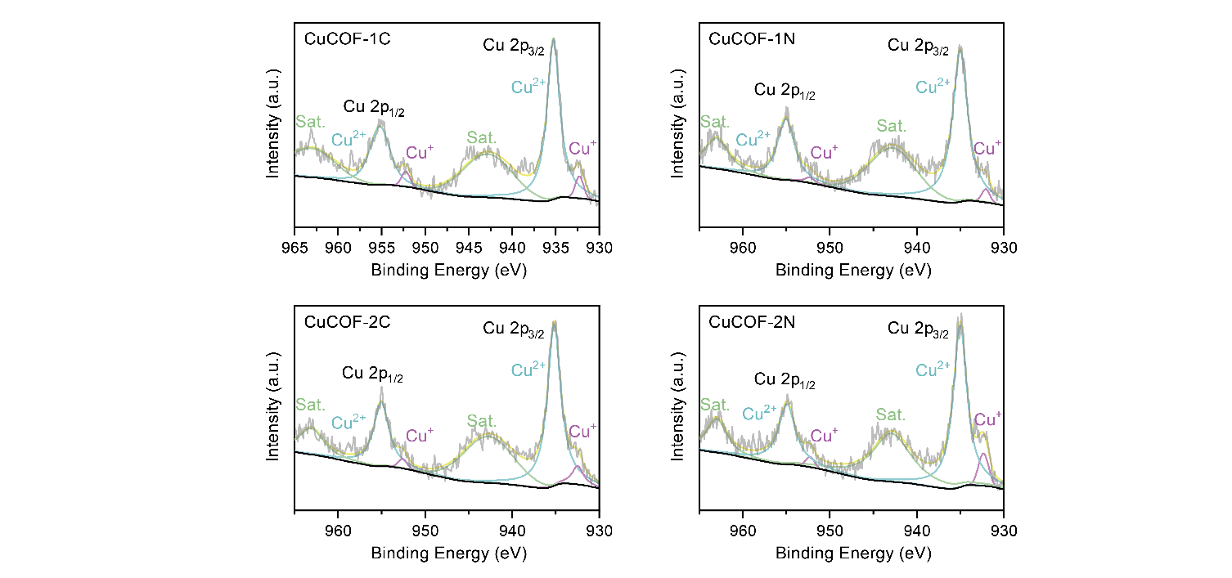
Figure S2. Cu 2p XPS patterns of Cu-coordinated COFs.
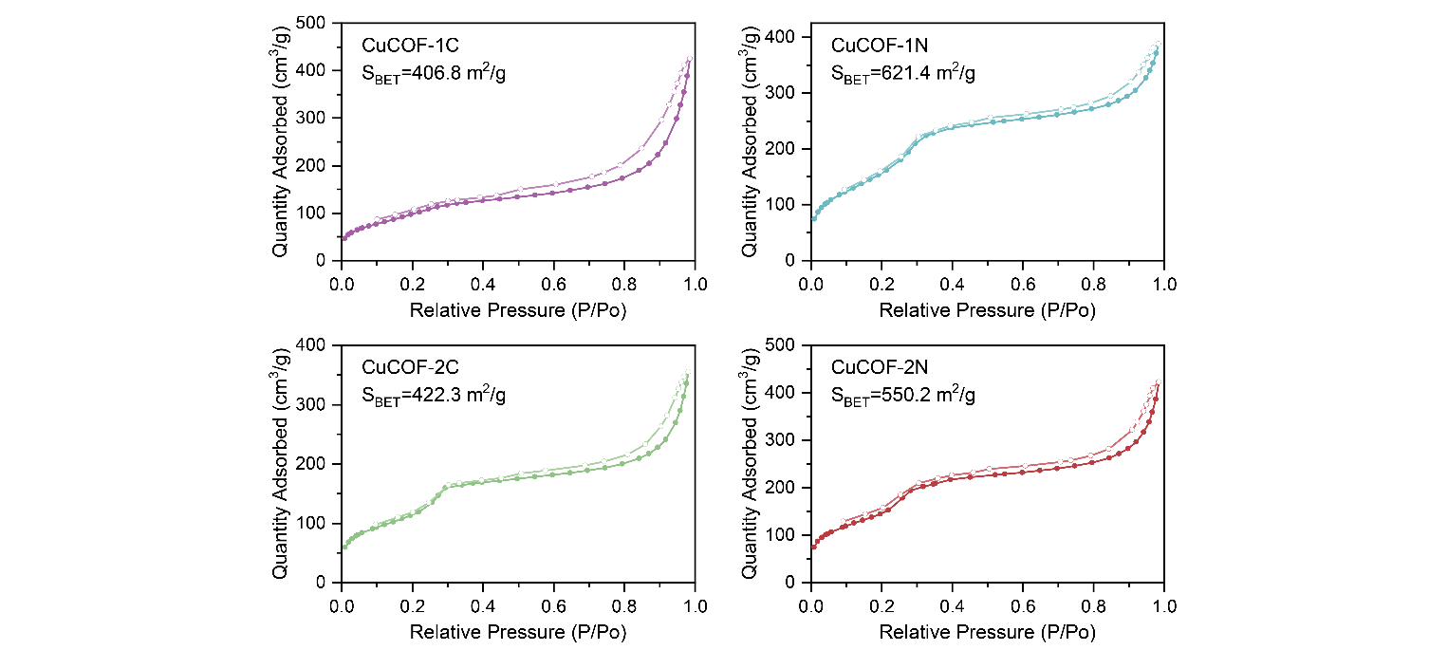
Figure S3. N₂ adsorption-desorption isotherms of Cu-coordinated COFs.
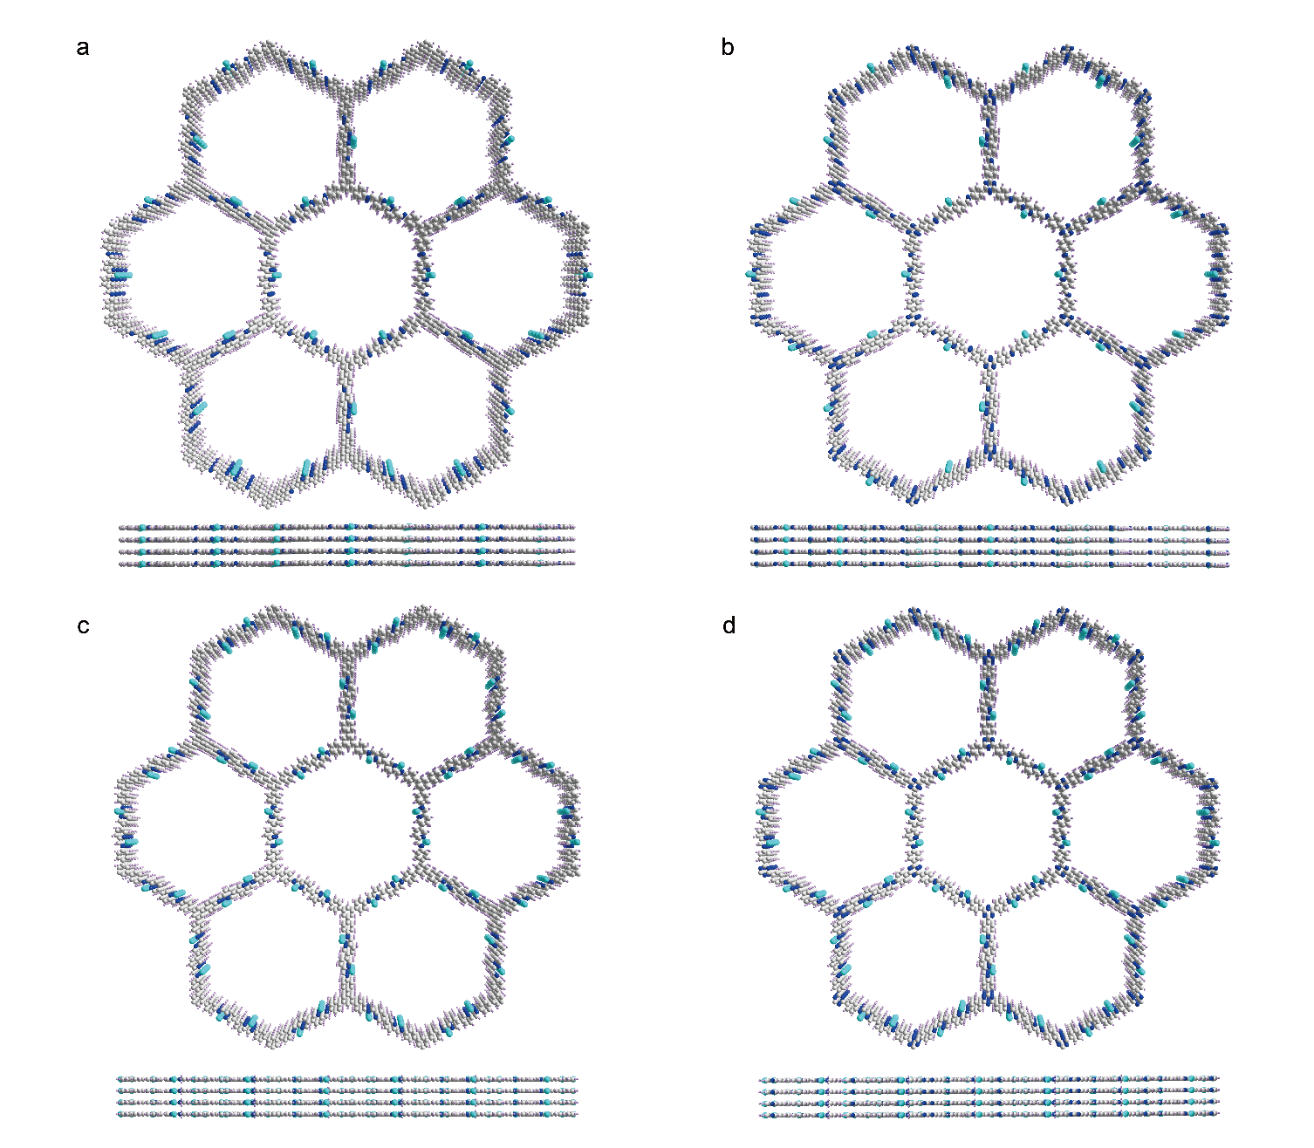
Figure S4. Optimized structures with the AA stacking mode. (a) CuCOF-1C, (B) CuCOF-1N, (c) CuCOF-2C and (d) CuCOF-2N.
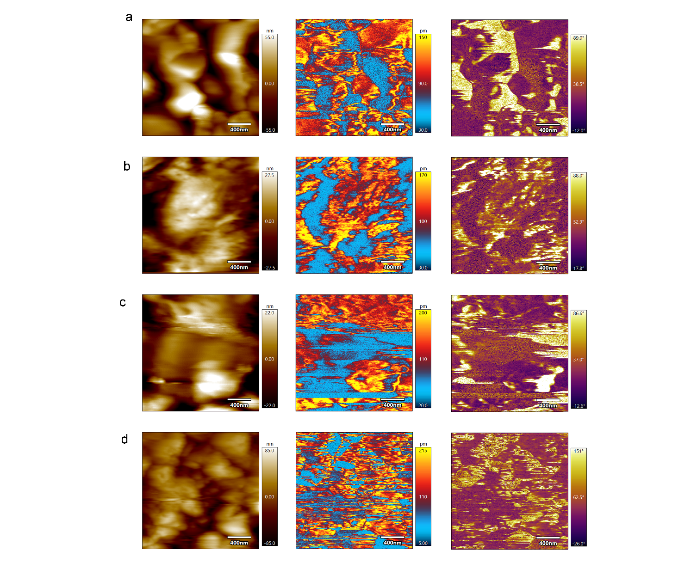
Figure S5. Morphology, amplitude and phase images of (a) CuCOF-1C, (b) CuCOF-1N, (c) CuCOF-2C, and (d) CuCOF-2N.

Figure S6. UV-Vis DRS spectra of Cu-coordinated COFs.
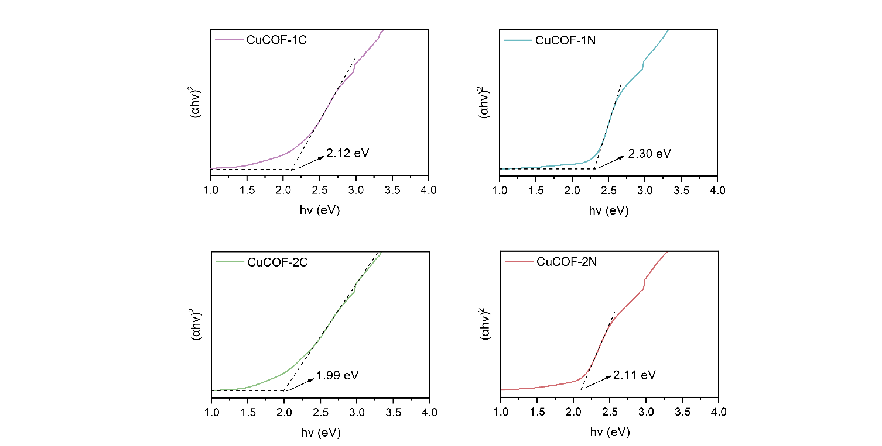
Figure S7. The band gap of Cu-coordinated COFs measured by UV-Vis reflectance spectra.
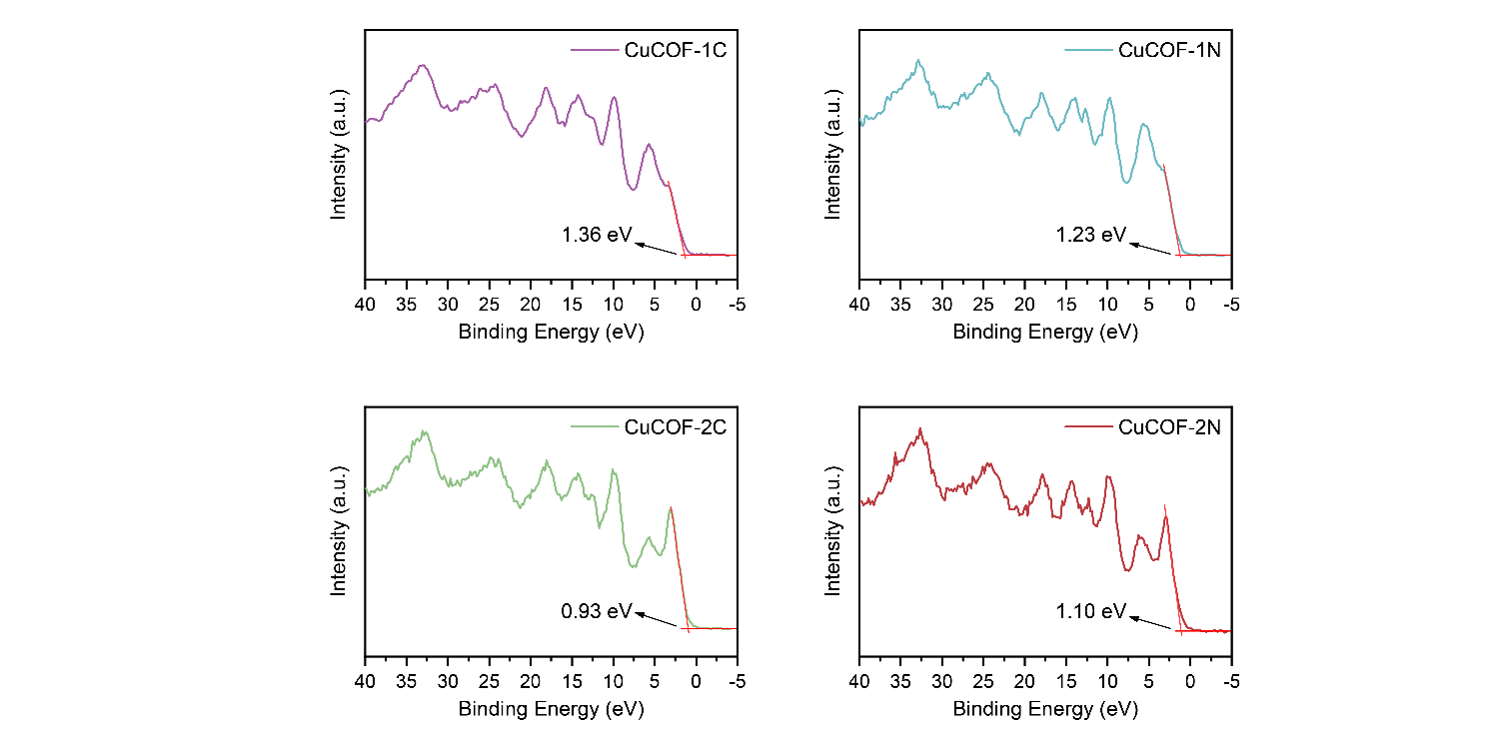
Figure S8. The position of the valence band of Cu-coordinated COFs measured by VB-XPS.

Figure S9. Nyquist plots gathered from EIS measurements.
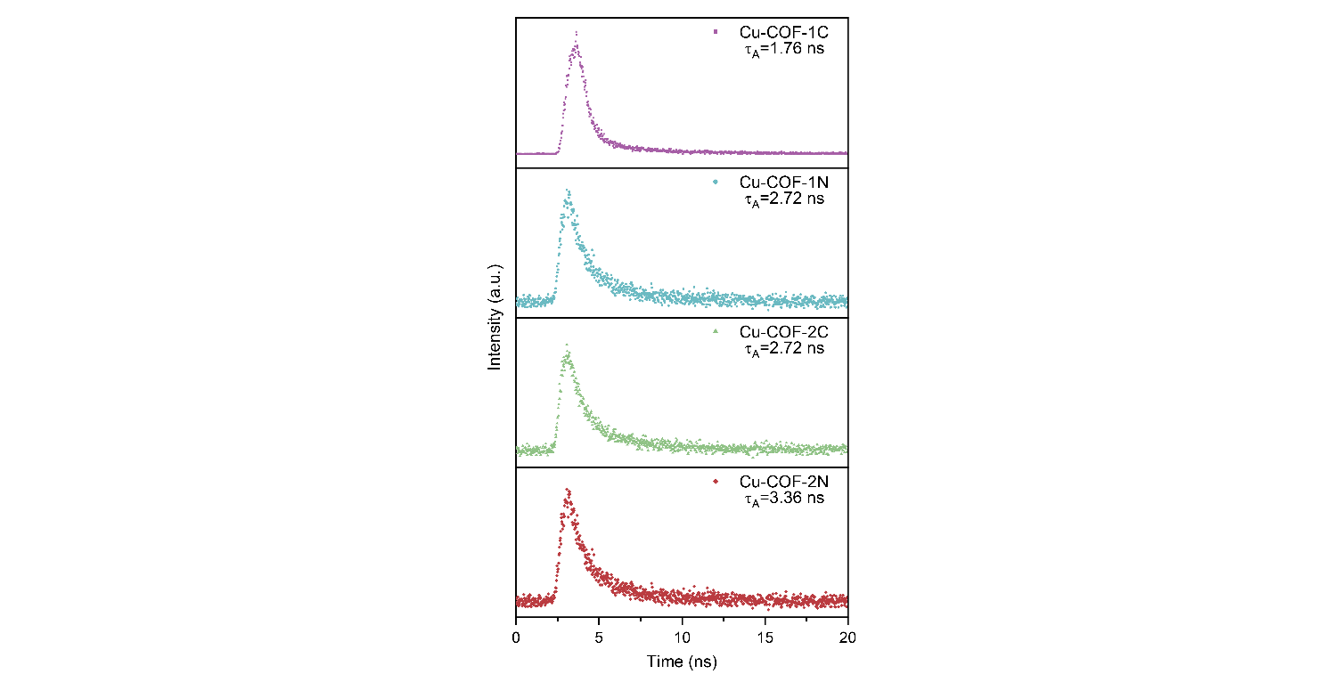
Figure S10. Time-resolved transient spectra.
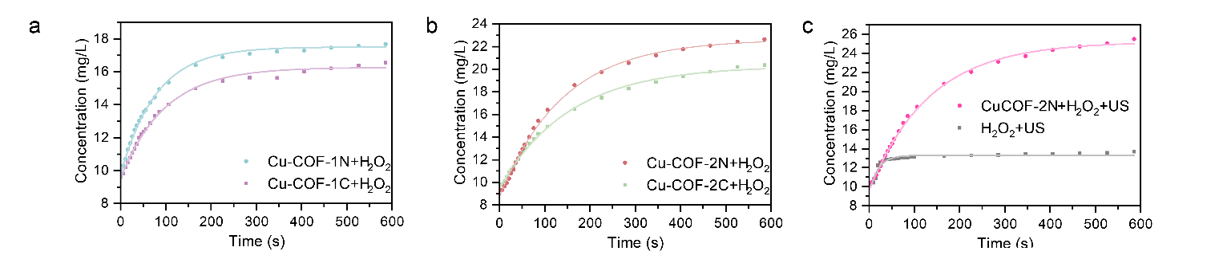
Figure S11. The oxygen production capacity with different treatments measured by oxygen dissolving apparatus.
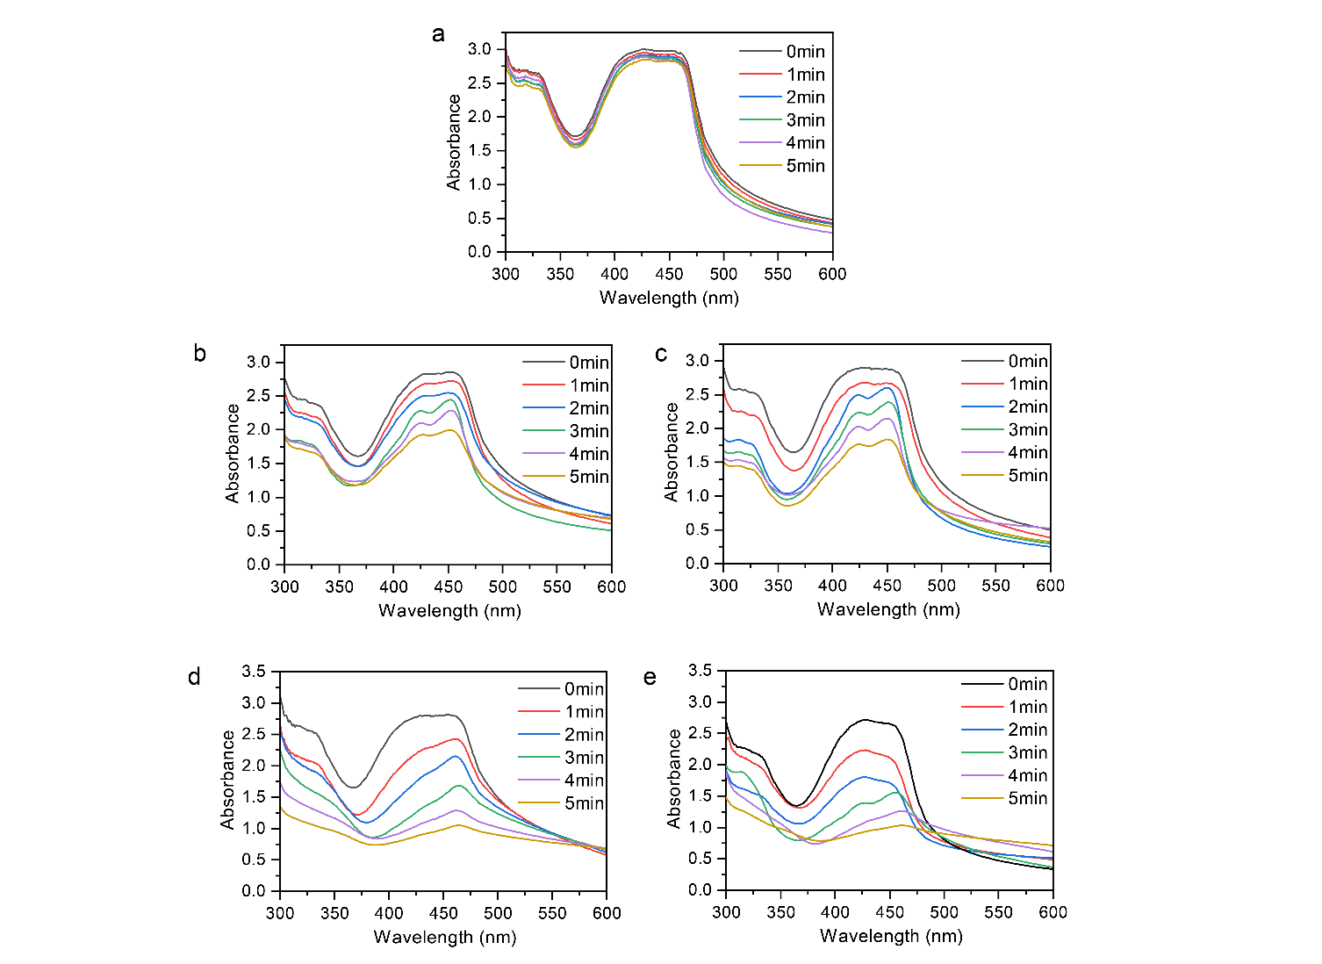
Figure S12. Changes of absorbance of DPBF in (a) H₂O, (b) CuCOF-1C, (c) CuCOF-1N, (d) CuCOF-2C, and (e) CuCOF-2N under US irradiation for 5 min (1 W·cm⁻², 1 MHz, 50% duty cycle).
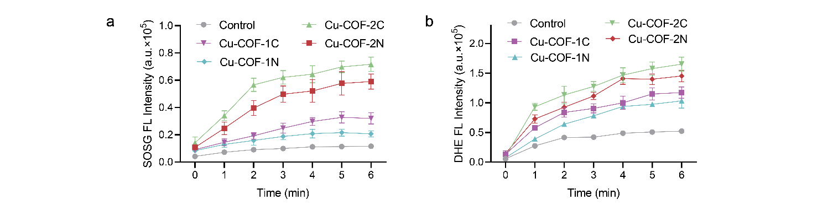
Figure S13. (a) SOSG FL intensity mixed with different solutions under US treatment at different time points (1 W·cm⁻², 1 MHz, 50% duty cycle); (b) DHE FL intensity mixed with different solutions under US treatment at different time points (1 W·cm⁻², 1 MHz, 50% duty cycle).
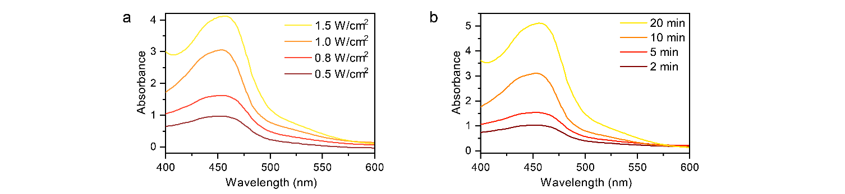
Figure S14. UV-Vis absorbance spectra of CuCOF-2N and neocuproine with US irradiation (a) Power density-dependent Cu(I) generation under US irradiation; (b) Time-dependent Cu(I) generation ranging from 2 to 20 min (1 W·cm⁻², 1 MHz, 50% duty cycle).

Figure S15. In situ Cu 2p XPS pattern of CuCOF-2N (Dark or xenon irradiation for 10 min).

Figure S16. Fluorescence intensity at 460 nm of cd-Pro incubated with Cu-coordinated COFs at different time points.
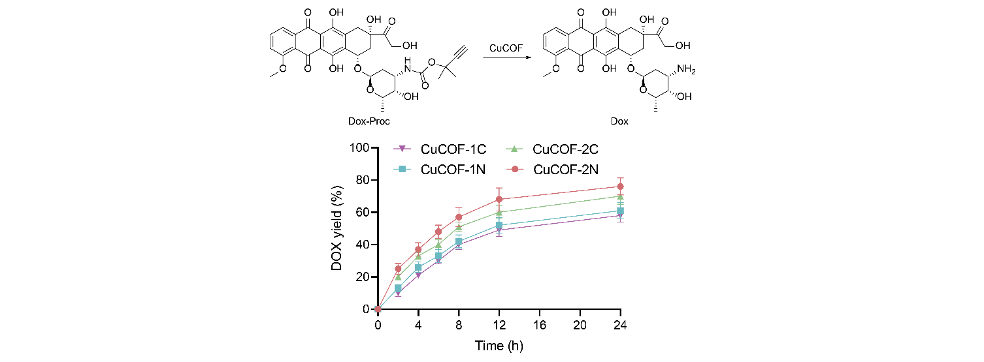
Figure S17. The catalytic conversion of DOX-Proc in the presence of Cu-coordinated COFs. The data are presented as the mean ± SD (n=6)

Figure S18. (a, b)TEM images of liposome Cu2N@D-FA; (c) HAADF image.

Figure S19. The sizes of CuCOF-2N and Cu2N@D-FA measured by DLS.

Figure S20. Zeta potentials of CuCOF-2N and Cu2N@D-FA measured by DLS.

Figure S21. Size changes of Cu2N@D-FA in deionized water, PBS, DMEM and DMEM (contained 10% FBS) at 37℃ for 48 h.
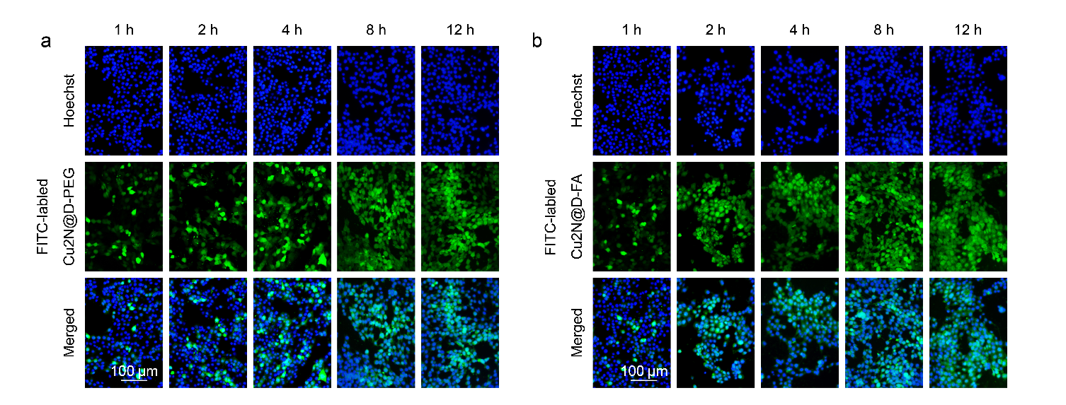
Figure S22. Cell uptake images of (a) Cu2N@D-PEG and (b) Cu2N@D-FA in 4T1 cells.
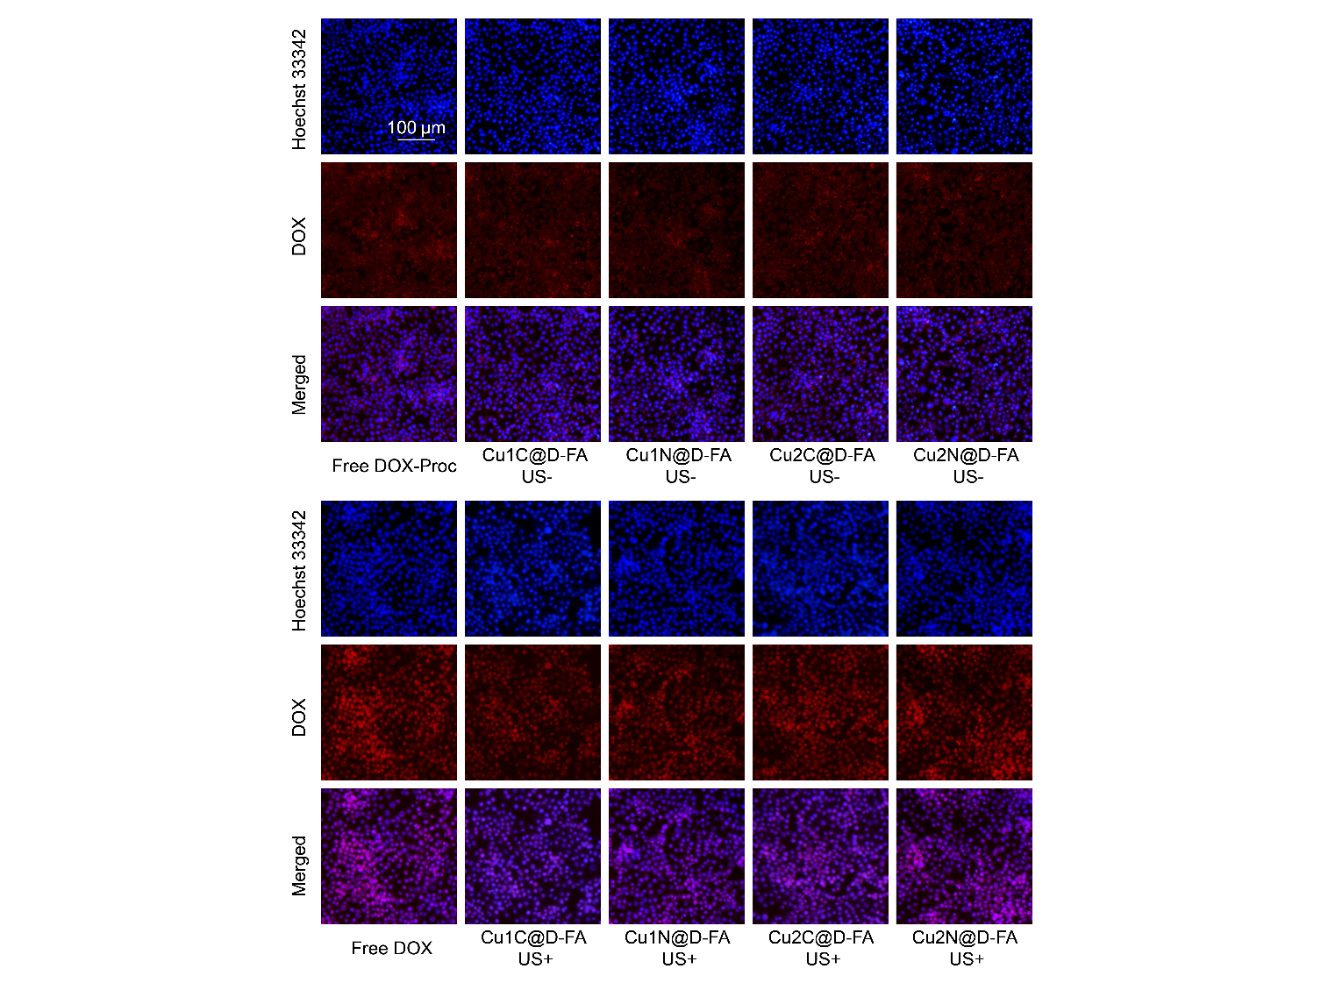
Figure S23. Fluorescence images of 4T1 cells incubated with DOX-Proc and CuX@D-FA with or without US irradiation.
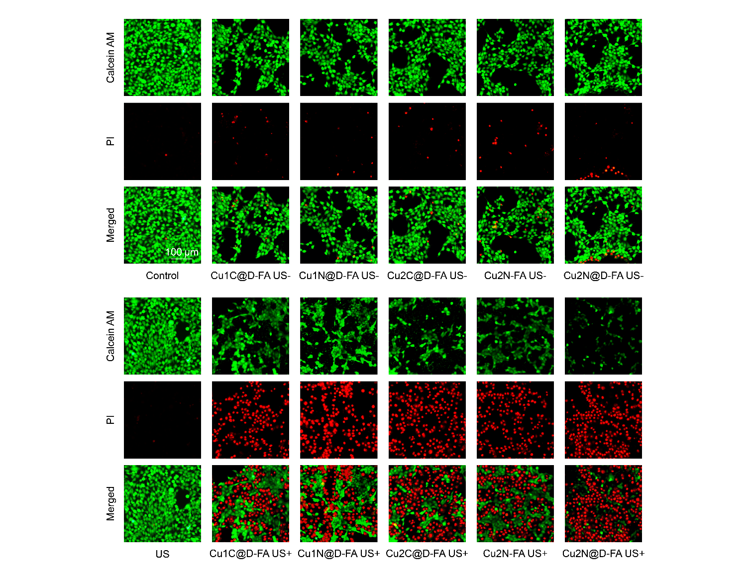
Figure S24. Live/dead staining of 4T1 cells after different treatments.
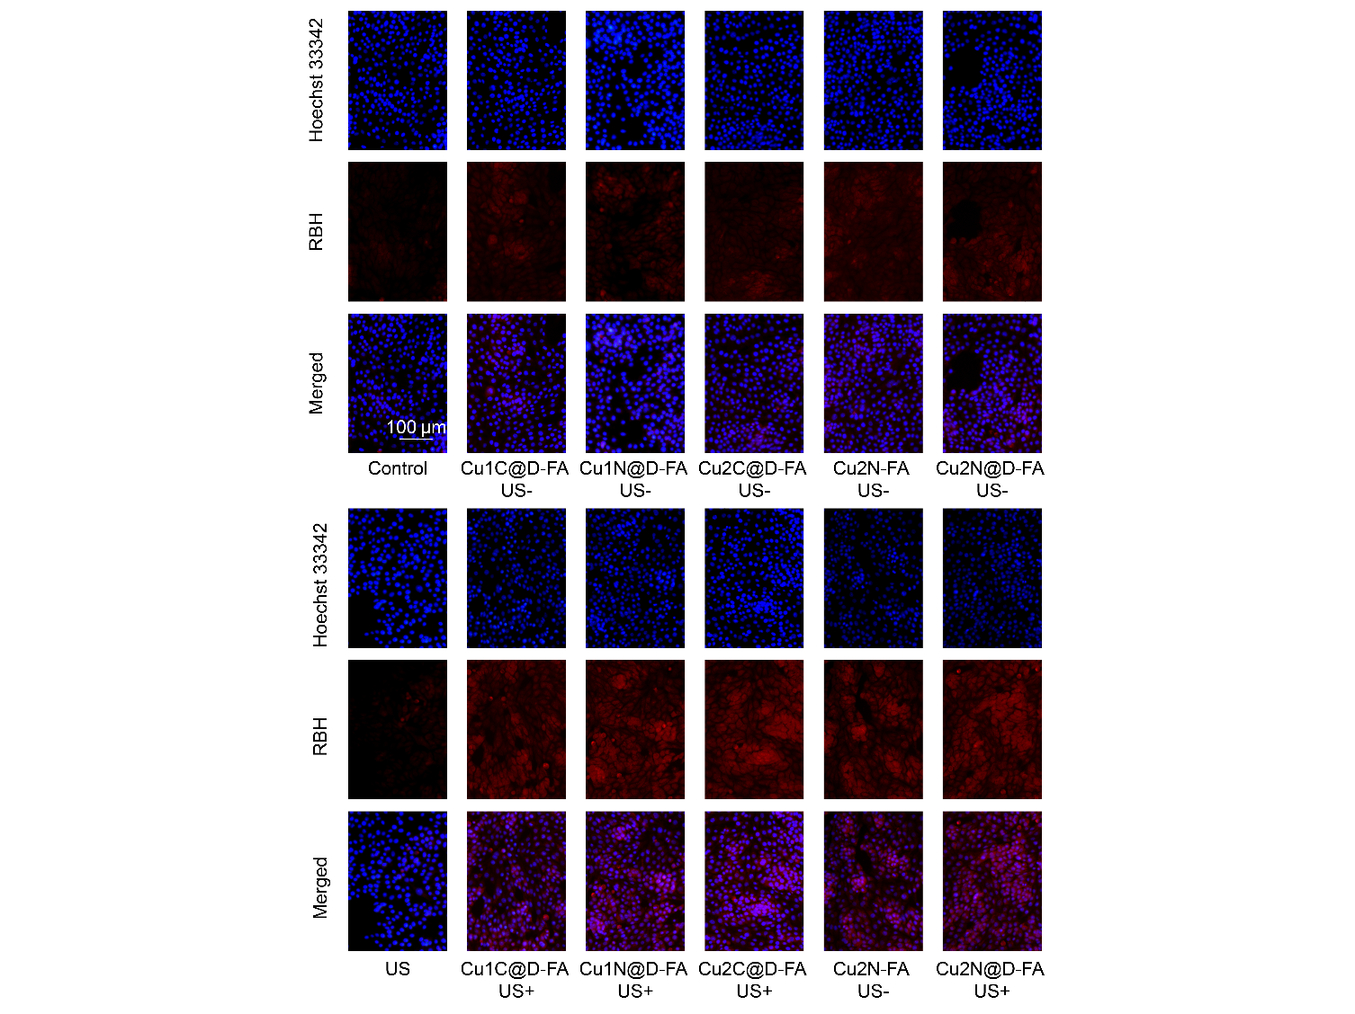
Figure S25. Fluorescence images of RBH in 4T1 cells after different treatments.

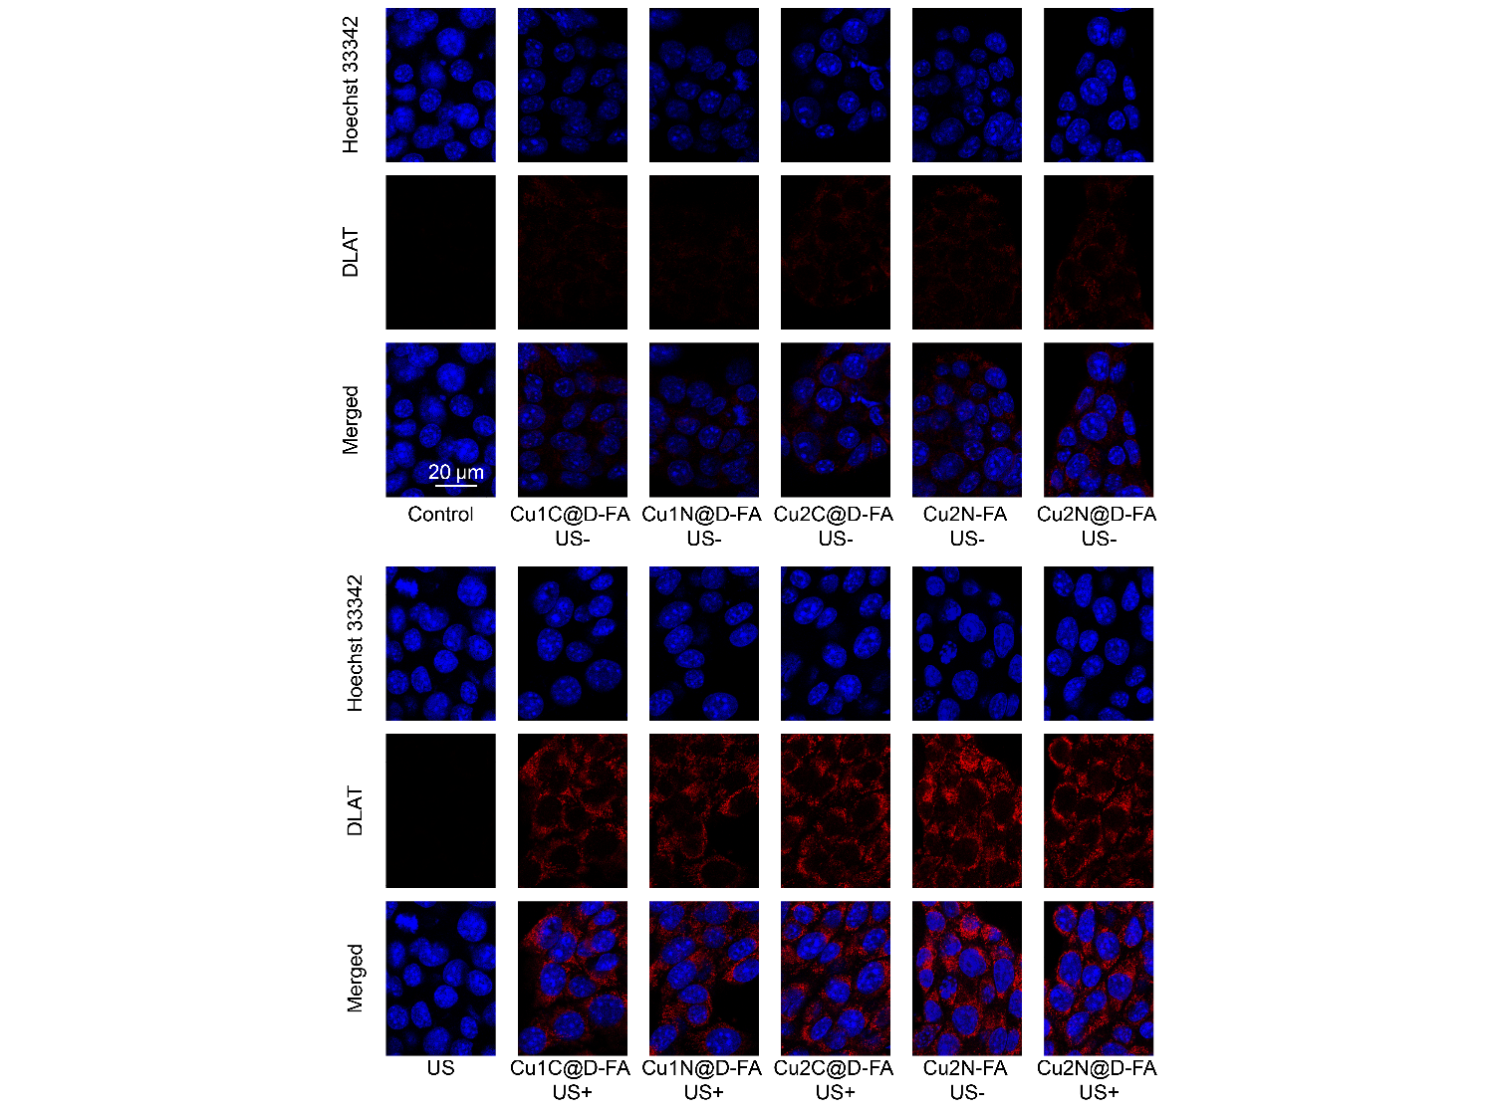
Figure S26. Immunofluorescence images of DLAT in 4T1 cells after different treatments.
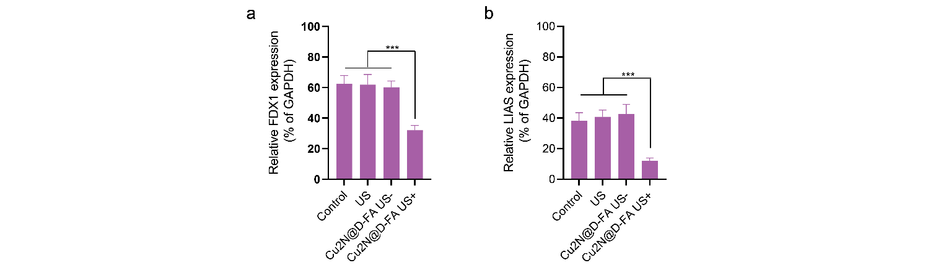
Figure S27. The expression of FDX1 and LIAS in 4T1 cells were analyzed and quantified by western blotting.

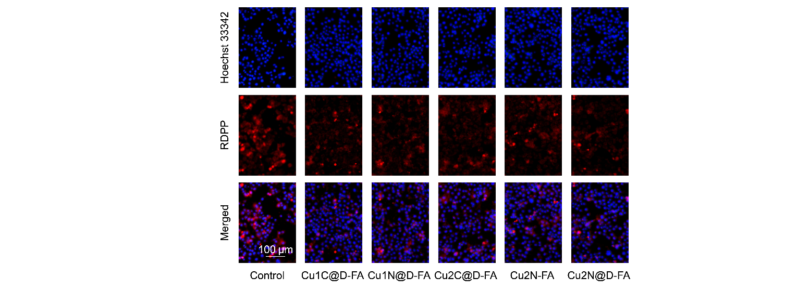
Figure S28. Fluorescence images of RDPP in 4T1 cells after different treatments.
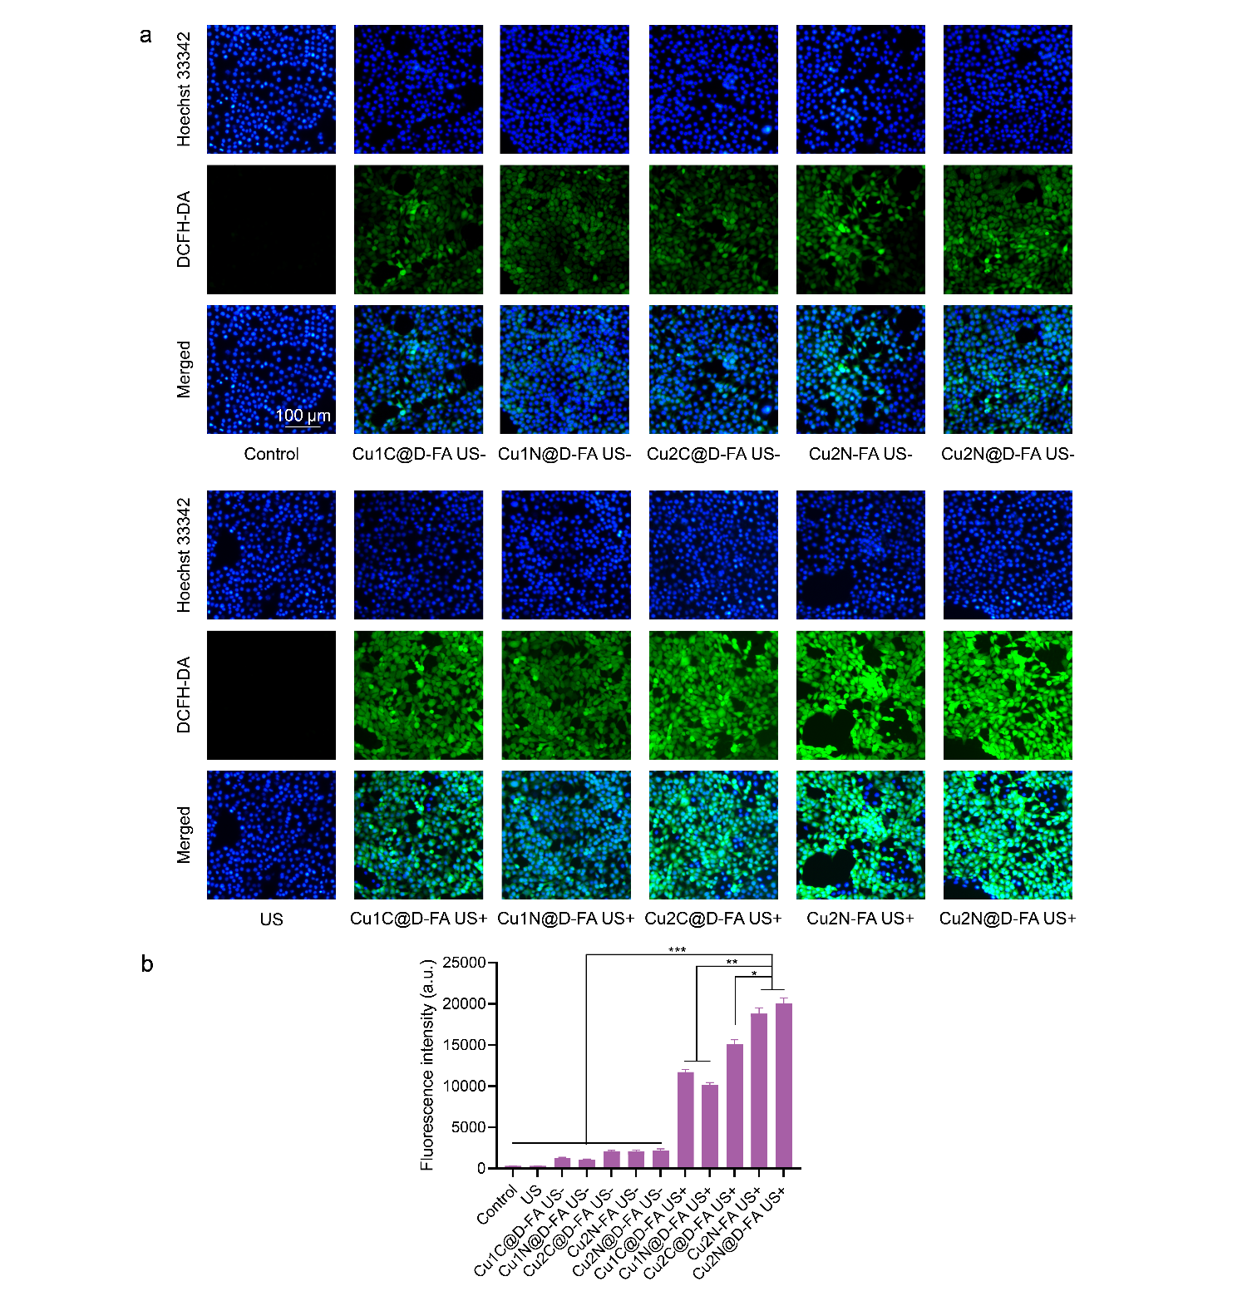
Figure S29. Fluorescence images of ROS in 4T1 cells after different treatments and quantification of the intracellular ROS fluorescence intensity.

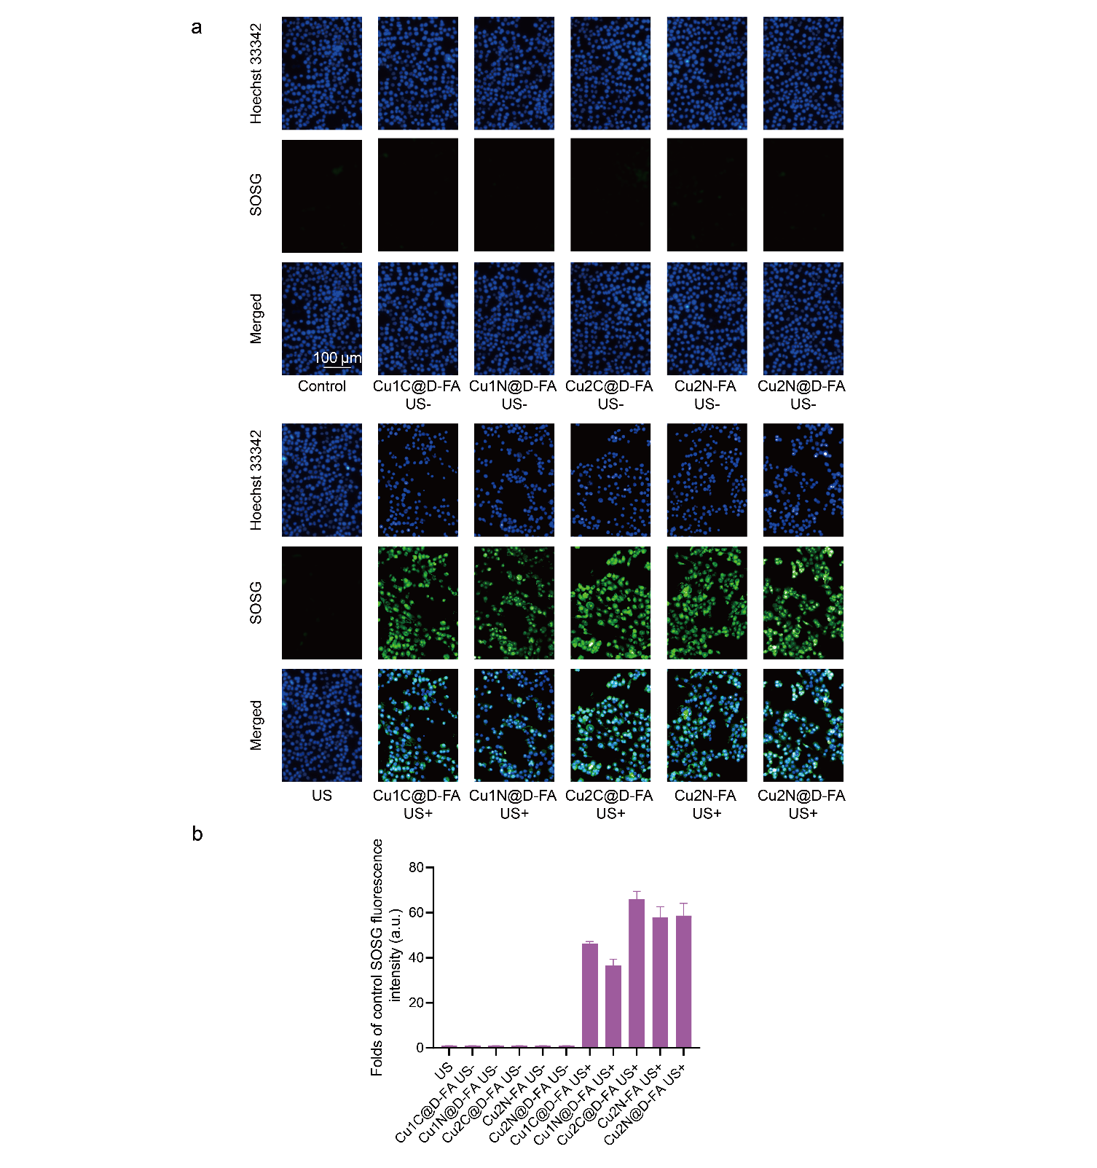
Figure S30. Fluorescence images of SOSG in 4T1 cells after different treatments and quantification of the intracellular SOSG fluorescence intensity.

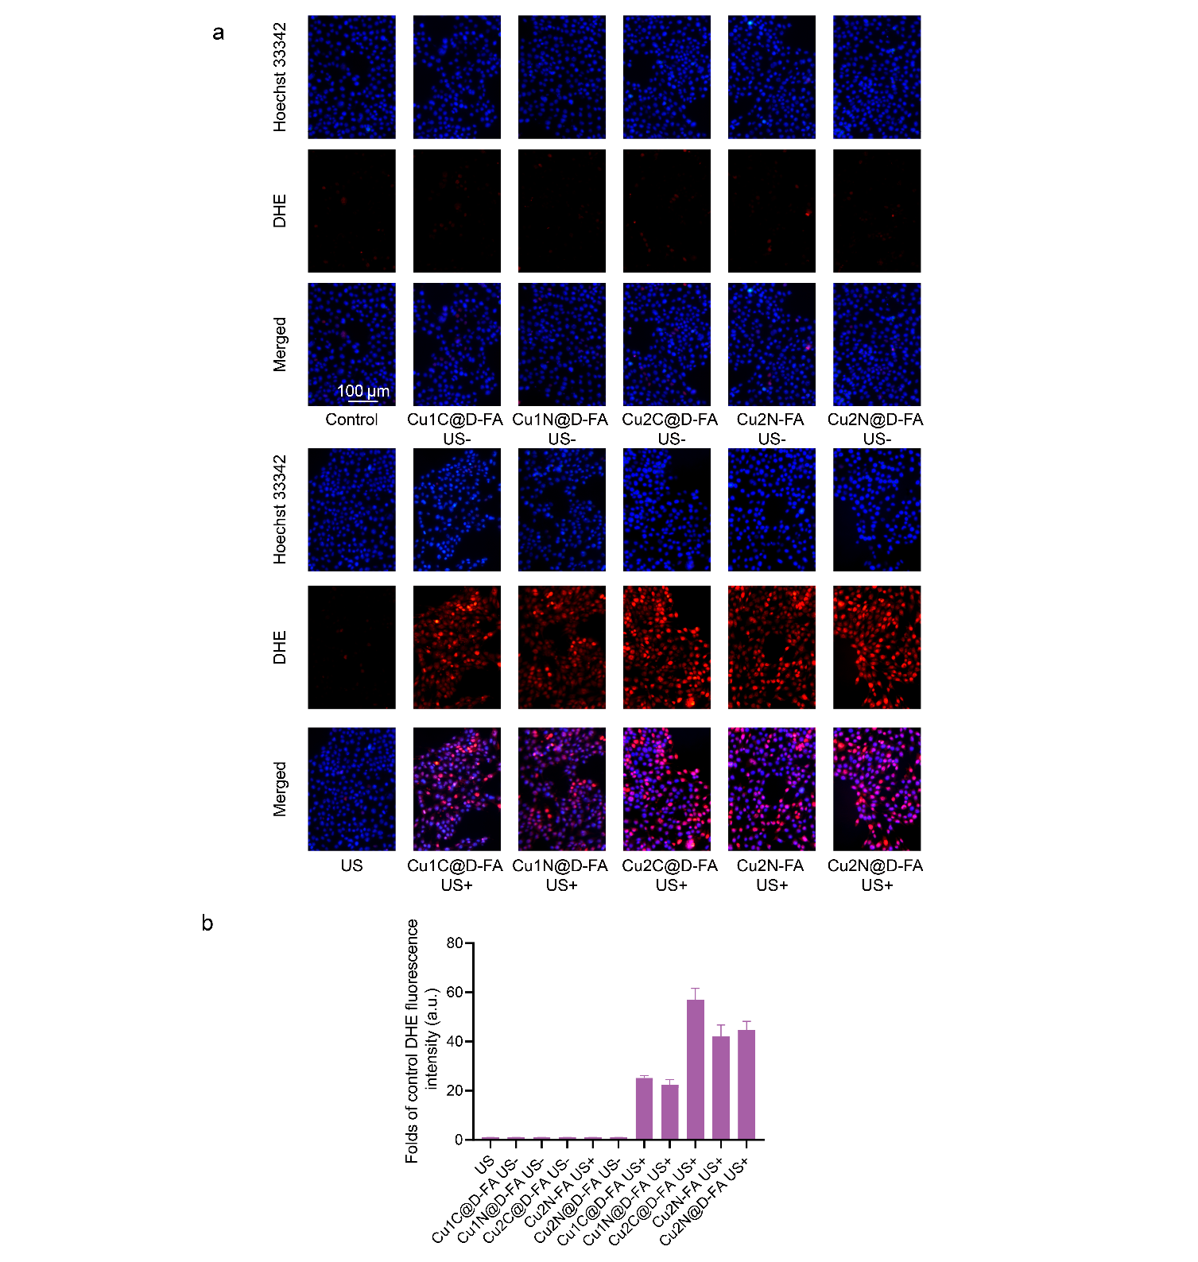
Figure S31. Fluorescence images of DHE in 4T1 cells after different treatments and quantification of the intracellular DHE fluorescence intensity.

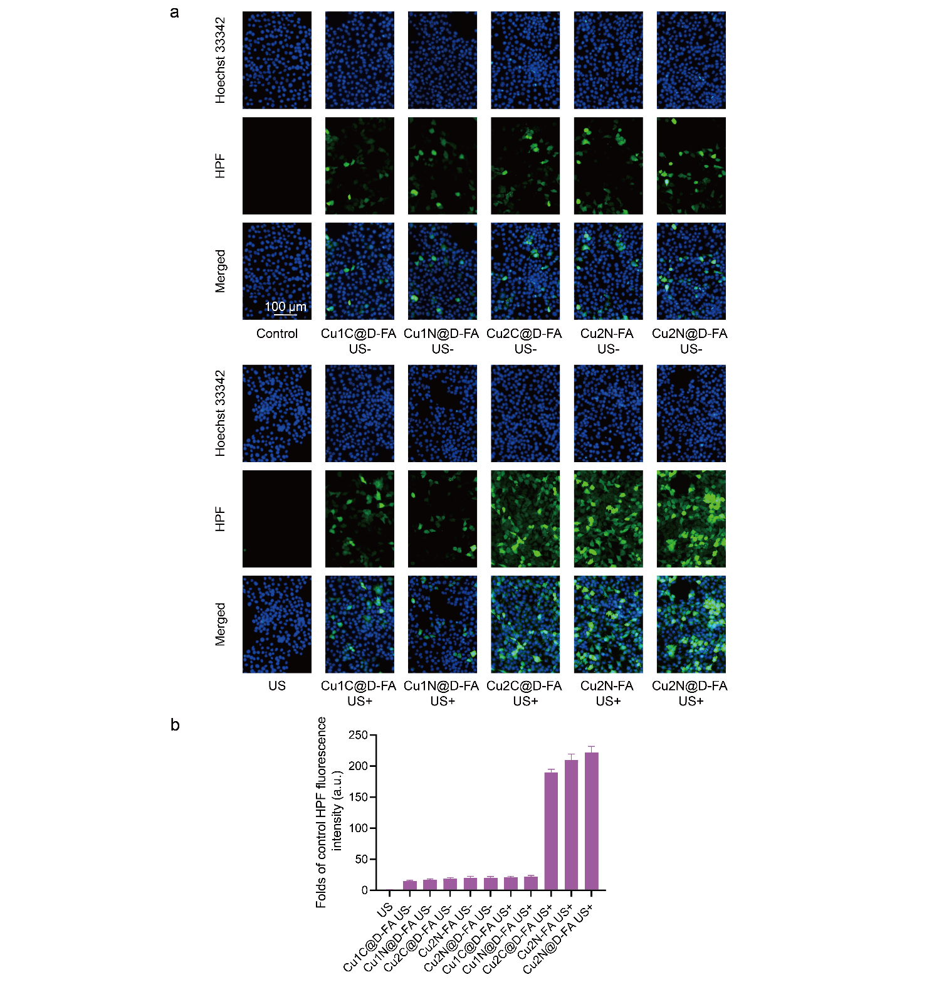
Figure S32. Fluorescence images of HPF in 4T1 cells after different treatments and quantification of the intracellular HPF fluorescence intensity.

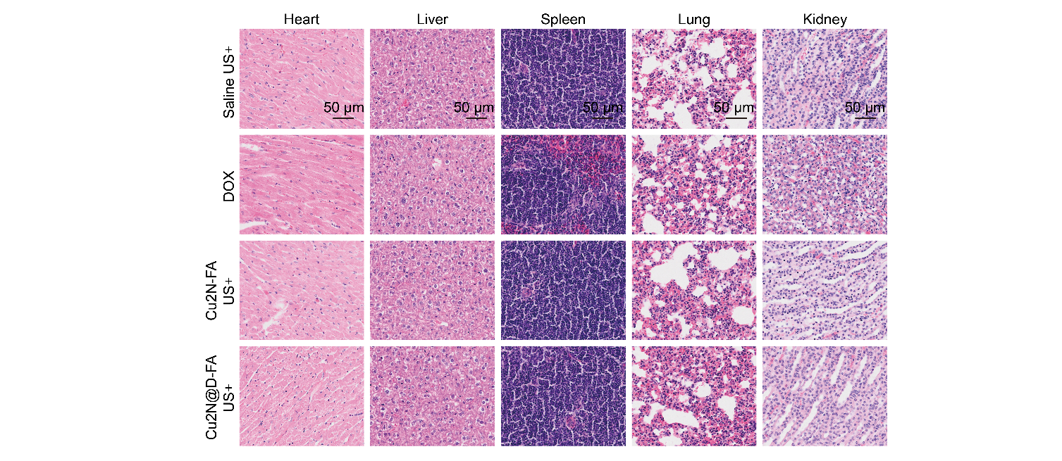
Figure S33. H&E-stained major organ tissue after 14-day treatment.

NMR spectra of synthesized compounds
Figure S33. ¹H NMR of cd-Pro.
Figure S34. ¹³C NMR of cd-Pro.
Figure S35. ¹H NMR of P2-3.

Figure S36. ¹³C NMR of P2-3.
Figure S37. ¹H NMR of DOX-Proc.
Figure S38. ¹³C NMR of DOX-Proc.

Table S1. Characterization of CuCOF-2N, Cu2N@D-PEG, Cu2N-FA, Cu1C@D-FA, Cu1N@D-FA, Cu2C@D-FA and Cu2N@D-FA. The data are presented as mean ± SD (n=6).
Formulations | Partical size (nm) | Zeta potential (mV) | LR_{DOX-Proc}  (%)
CuCOF-2N | 105.23 ± 4.26 | -1.65 ± 1.14 | —
Cu2N@D-PEG | 129.85 ± 5.16 | -15.23 ± 3.27 | 22.5 ± 1.9
Cu2N-FA | 122.32 ± 3.76 | -13.72 ± 2.69 | —
Cu1C@D-FA | 142.13 ± 6.21 | -17.93 ± 3.45 | 19.2 ± 2.8
Cu1N@D-FA | 126.49 ± 5.95 | -16.71 ± 2.77 | 27.6 ± 3.1
Cu2C@D-FA | 149.38 ± 6.46 | -20.64 ± 4.31 | 21.5 ± 2.7
Cu2N@D-FA | 135.12 ± 3.54 | -16.28 ± 2.68 | 25.8 ± 2.3

Table S2. Pharmacokinetic parameters of free DOX and Cu2N@D-FA. The data are presented as mean ± SD (n=3).
Formulations | T_{1/2} (h) | AUC_{0-inf} (μg/mL·h) | MRT_{0-inf} (h)
Free DOX | 1.67 ± 0.18 | 10.26 ± 0.45 | 1.92 ± 0.18
Cu2N@D-FA | 23.26 ± 1.64 | 174.79 ± 4.5 | 23.53 ± 0.63

Table S3. Fractional atomic coordinates for CuCOF-1C
CuCOF-1C
a=44.5796 Å b=44.5830 Å c=3.5159 Å α=90° β=90° γ=120°
Atom | x/a | y/b | z/c | Atom | x/a | y/b | z/c
C1 | 2.71951 | 0.35346 | -0.49672 | C78 | 2.08749 | 0.56247 | -0.49672
C2 | 2.75683 | 0.36604 | -0.49672 | C79 | 2.05127 | 0.54514 | -0.49672
C3 | 2.76954 | 0.3429 | -0.49672 | C80 | 2.03223 | 0.50895 | -0.49672
C4 | 2.80518 | 0.35529 | -0.49672 | C81 | 2.04984 | 0.4902 | -0.49672
C5 | 2.82783 | 0.39105 | -0.49672 | C82 | 2.08595 | 0.50751 | -0.49672
N6 | 2.81482 | 0.41294 | -0.49672 | C83 | 2.19486 | 0.50253 | -0.49671
C7 | 2.78033 | 0.40167 | -0.49672 | C84 | 2.21089 | 0.48253 | -0.49671
C8 | 2.86611 | 0.40692 | -0.49672 | C85 | 2.24694 | 0.49835 | -0.49671
C9 | 2.88282 | 0.38747 | -0.49672 | C86 | 2.26702 | 0.53466 | -0.49671
C10 | 2.919 | 0.40483 | -0.49672 | C87 | 2.25091 | 0.55473 | -0.49672
C11 | 2.92045 | 0.45973 | -0.49672 | C88 | 2.25602 | 0.67159 | -0.49672
N12 | 2.88528 | 0.44215 | -0.49672 | C89 | 2.27491 | 0.7078 | -0.49673
N13 | 2.99516 | 0.4918 | -0.49672 | C90 | 2.25778 | 0.72686 | -0.49673
C14 | 2.97597 | 0.45835 | -0.49672 | C91 | 2.22143 | 0.70927 | -0.49673
C15 | 2.93809 | 0.44106 | -0.49672 | C92 | 2.2026 | 0.67315 | -0.49673
C16 | 2.29523 | 0.48814 | -0.49671 | N93 | 2.26219 | 0.47675 | -0.49671
C17 | 2.30822 | 0.46372 | -0.49671 | N94 | 2.27771 | 0.76392 | -0.49673
C18 | 2.2852 | 0.42783 | -0.49671 | C95 | 2.26347 | 0.78313 | -0.49673
C19 | 2.29768 | 0.4047 | -0.49671 | C96 | 2.28409 | 0.821 | -0.49673
C20 | 2.33344 | 0.41791 | -0.49671 | Cu97 | 2.38719 | 0.90552 | -0.49673
N21 | 2.35528 | 0.45282 | -0.49671 | Cu98 | 2.40188 | 0.46064 | -0.49671
C22 | 2.3439 | 0.47598 | -0.49671 | Cu99 | 2.8535 | 0.45953 | -0.49672
C23 | 2.34928 | 0.39549 | -0.49671 | H100 | 2.7101 | 0.37299 | -0.49672
C24 | 2.3297 | 0.35936 | -0.49671 | H101 | 2.75075 | 0.31378 | -0.49672
C25 | 2.34691 | 0.34042 | -0.49671 | H102 | 2.8153 | 0.33633 | -0.49672
C26 | 2.40198 | 0.39372 | -0.49671 | H103 | 2.77087 | 0.42116 | -0.49672
N27 | 2.38451 | 0.41145 | -0.49671 | H104 | 2.86695 | 0.35797 | -0.49672
C28 | 2.53431 | 0.28163 | -0.49672 | H105 | 2.93317 | 0.38947 | -0.49672
C29 | 2.49816 | 0.26664 | -0.49672 | H106 | 2.93563 | 0.48925 | -0.49672
C30 | 2.47762 | 0.23046 | -0.49672 | H107 | 2.98851 | 0.44147 | -0.49672
C31 | 2.49244 | 0.20921 | -0.49673 | H108 | 2.31427 | 0.5172 | -0.49671
C32 | 2.52859 | 0.22476 | -0.49673 | H109 | 2.25606 | 0.41739 | -0.49671
C33 | 2.54984 | 0.26092 | -0.49672 | H110 | 2.27879 | 0.3756 | -0.49671
C34 | 2.58801 | 0.27679 | -0.49672 | H111 | 2.36333 | 0.50495 | -0.49671
C35 | 2.47013 | 0.17104 | -0.49673 | H112 | 2.30021 | 0.34585 | -0.49671
C36 | 2.48159 | 0.28832 | -0.49672 | H113 | 2.33144 | 0.31091 | -0.49671
C37 | 2.43393 | 0.15586 | -0.49673 | H114 | 2.4315 | 0.40792 | -0.49671
C38 | 2.4127 | 0.11991 | -0.49673 | H115 | 2.55151 | 0.31101 | -0.49672
C39 | 2.42721 | 0.09849 | -0.49673 | H116 | 2.44818 | 0.21773 | -0.49673
C40 | 2.4634 | 0.11341 | -0.49673 | H117 | 2.54125 | 0.20799 | -0.49673
C41 | 2.48466 | 0.14943 | -0.49673 | H118 | 2.42159 | 0.17292 | -0.49673
C42 | 2.60322 | 0.2558 | -0.49672 | H119 | 2.38333 | 0.10789 | -0.49673
C43 | 2.63917 | 0.27052 | -0.49672 | H120 | 2.47552 | 0.09616 | -0.49673
C44 | 2.66058 | 0.30647 | -0.49672 | H121 | 2.51403 | 0.16147 | -0.49673
C45 | 2.64564 | 0.32771 | -0.49672 | H122 | 2.58616 | 0.2264 | -0.49672
C46 | 2.60962 | 0.31293 | -0.49672 | H123 | 2.6512 | 0.25319 | -0.49672
C47 | 2.50152 | 0.32464 | -0.49672 | H124 | 2.66288 | 0.35709 | -0.49672
C48 | 2.48547 | 0.34478 | -0.49672 | H125 | 2.59757 | 0.33025 | -0.49672
C49 | 2.44933 | 0.32892 | -0.49672 | H126 | 2.531 | 0.33795 | -0.49672
C50 | 2.42938 | 0.29263 | -0.49672 | H127 | 2.50187 | 0.37424 | -0.49672
C51 | 2.44537 | 0.2726 | -0.49672 | H128 | 2.3999 | 0.27935 | -0.49672
N52 | 2.69731 | 0.32056 | -0.49672 | H129 | 2.42898 | 0.24314 | -0.49672
N53 | 2.43333 | 0.34994 | -0.49672 | H130 | 2.3825 | 0.30706 | -0.49671
C54 | 2.39996 | 0.33641 | -0.49671 | H131 | 2.44418 | 1.04893 | -0.49673
C55 | 2.38312 | 0.3574 | -0.49671 | H132 | 2.34432 | 1.00837 | -0.49674
N56 | 2.40456 | 1.06177 | -0.49673 | H133 | 2.30227 | 0.94384 | -0.49674
C57 | 2.41524 | 1.03954 | -0.49673 | H134 | 2.43152 | 0.98815 | -0.49673
C58 | 2.39048 | 1.00224 | -0.49674 | H135 | 2.27223 | 0.8922 | -0.49674
C59 | 2.35462 | 0.98956 | -0.49674 | H136 | 2.23746 | 0.82599 | -0.49674
C60 | 2.33135 | 0.95393 | -0.49674 | H137 | 2.33472 | 0.82341 | -0.49673
C61 | 2.34443 | 0.93125 | -0.49674 | H138 | 2.24571 | 0.60956 | -0.49672
N62 | 2.37933 | 0.94423 | -0.49673 | H139 | 2.14906 | 0.61366 | -0.49672
C63 | 2.40257 | 0.97871 | -0.49673 | H140 | 2.14549 | 0.51357 | -0.49671
C64 | 2.32199 | 0.89298 | -0.49674 | H141 | 2.10262 | 0.592 | -0.49672
C65 | 2.28583 | 0.8763 | -0.49674 | H142 | 2.03714 | 0.56053 | -0.49672
C66 | 2.26698 | 0.84012 | -0.49673 | H143 | 2.03461 | 0.46068 | -0.49672
C67 | 2.32041 | 0.83861 | -0.49673 | H144 | 2.1001 | 0.49213 | -0.49672
N68 | 2.33802 | 0.87378 | -0.49673 | H145 | 2.16537 | 0.48909 | -0.49671
C69 | 2.21621 | 0.59596 | -0.49672 | H146 | 2.19452 | 0.45306 | -0.49671
C70 | 2.19947 | 0.61555 | -0.49672 | H147 | 2.29649 | 0.54783 | -0.49671
C71 | 2.16313 | 0.59822 | -0.49672 | H148 | 2.26726 | 0.5842 | -0.49672
C72 | 2.14355 | 0.56199 | -0.49672 | H149 | 2.2704 | 0.65645 | -0.49672
C73 | 2.16089 | 0.54309 | -0.49672 | H150 | 2.30443 | 0.72192 | -0.49673
C74 | 2.19714 | 0.55965 | -0.49672 | H151 | 2.20714 | 0.7245 | -0.49673
C75 | 2.21462 | 0.53883 | -0.49671 | H152 | 2.17308 | 0.65902 | -0.49672
C76 | 2.10521 | 0.54383 | -0.49672 | H153 | 2.23405 | 0.77061 | -0.49673
C77 | 2.21965 | 0.65388 | -0.49672

Table S4. Fractional atomic coordinates for CuCOF-1N
CuCOF-1N
a=44.3903 Å b=44.3992 Å c=3.5126 Å α=90° β=90° γ=120°
Atom | x/a | y/b | z/c | Atom | x/a | y/b | z/c
C1 | 0.58814 | -0.52112 | -0.55278 | C75 | 0.67106 | -0.71171 | -0.58357
C2 | 0.5755 | -0.49629 | -0.55031 | N76 | 0.6212 | -0.51032 | -0.5528
C3 | 0.59877 | -0.46029 | -0.54822 | N77 | 0.59373 | -0.80168 | -0.59018
C4 | 0.58636 | -0.43692 | -0.54671 | C78 | 0.60746 | -0.82148 | -0.59434
C5 | 0.55046 | -0.45005 | -0.54726 | C79 | 0.58648 | -0.85947 | -0.59636
N6 | 0.52844 | -0.48508 | -0.5493 | N80 | 0.46672 | -1.10081 | -0.58649
C7 | 0.53972 | -0.50843 | -0.55091 | Cu81 | 0.48168 | -0.49293 | -0.55011
C8 | 0.53459 | -0.42749 | -0.54635 | Cu82 | 0.48287 | -0.94441 | -0.58991
C9 | 0.5542 | -0.39119 | -0.5451 | N83 | 0.87996 | -0.54203 | -0.56468
C10 | 0.53685 | -0.37221 | -0.54539 | C84 | 0.90204 | -0.50894 | -0.56301
C11 | 0.48163 | -0.42581 | -0.54797 | C85 | 0.93959 | -0.49595 | -0.56181
N12 | 0.49921 | -0.44354 | -0.5476 | C86 | 0.95253 | -0.5191 | -0.56123
N13 | 0.345 | -0.31959 | -0.55904 | C87 | 0.98839 | -0.50654 | -0.56026
C14 | 0.38027 | -0.30346 | -0.56006 | C88 | 1.0114 | -0.47066 | -0.55993
N15 | 0.39908 | -0.2682 | -0.56452 | C89 | 0.99849 | -0.44772 | -0.56051
C16 | 0.383 | -0.249 | -0.568 | C90 | 0.96275 | -0.46 | -0.5614
N17 | 0.34768 | -0.26538 | -0.56679 | C91 | 1.04951 | -0.45486 | -0.55923
C18 | 0.32855 | -0.30071 | -0.56228 | C92 | 1.06658 | -0.47414 | -0.55848
C19 | 0.29025 | -0.31853 | -0.56124 | C93 | 1.10296 | -0.45678 | -0.55804
C20 | 0.40397 | -0.21074 | -0.57318 | C94 | 1.1223 | -0.42034 | -0.55833
C21 | 0.39813 | -0.32388 | -0.5567 | C95 | 1.1051 | -0.40102 | -0.55897
C22 | 0.44035 | -0.19445 | -0.57704 | C96 | 1.0688 | -0.41858 | -0.55936
C23 | 0.46062 | -0.15828 | -0.58153 | C97 | 1.16032 | -0.40334 | -0.55817
C24 | 0.44489 | -0.1378 | -0.58218 | N98 | 1.17989 | -0.36979 | -0.55954
C25 | 0.40844 | -0.15391 | -0.57846 | Cu99 | 1.03738 | -0.39847 | -0.56019
C26 | 0.38811 | -0.19022 | -0.57403 | H100 | 0.56857 | -0.55019 | -0.55468
C27 | 0.27288 | -0.29945 | -0.56295 | H101 | 0.62801 | -0.44995 | -0.54776
C28 | 0.23652 | -0.31655 | -0.56223 | H102 | 0.60544 | -0.40773 | -0.54505
C29 | 0.2171 | -0.35289 | -0.55979 | H103 | 0.52012 | -0.5375 | -0.55273
C30 | 0.23448 | -0.37202 | -0.55801 | H104 | 0.58382 | -0.37757 | -0.54386
C31 | 0.27076 | -0.35494 | -0.5587 | H105 | 0.55234 | -0.34257 | -0.5444
C32 | 0.37911 | -0.36034 | -0.55403 | H106 | 0.45198 | -0.44014 | -0.54916
C33 | 0.3963 | -0.37952 | -0.55138 | H107 | 0.45361 | -0.21079 | -0.57652
C34 | 0.43265 | -0.36251 | -0.55119 | H108 | 0.4902 | -0.14527 | -0.58471
C35 | 0.45171 | -0.326 | -0.55371 | H109 | 0.39536 | -0.1374 | -0.57906
C36 | 0.43455 | -0.30689 | -0.55649 | H110 | 0.35852 | -0.20324 | -0.57108
N37 | 0.44966 | -0.38271 | -0.54915 | H111 | 0.2884 | -0.26981 | -0.56493
C38 | 0.48324 | -0.36855 | -0.54828 | H112 | 0.22258 | -0.30086 | -0.56363
C39 | 0.50047 | -0.38934 | -0.54688 | H113 | 0.21895 | -0.40166 | -0.55598
C40 | 0.45536 | -1.07901 | -0.58676 | H114 | 0.28471 | -0.37062 | -0.5572
C41 | 0.47989 | -1.04146 | -0.59096 | H115 | 0.34947 | -0.37452 | -0.554
C42 | 0.51594 | -1.02852 | -0.59581 | H116 | 0.38067 | -0.40915 | -0.54936
C43 | 0.53915 | -0.99275 | -0.59856 | H117 | 0.48135 | -0.31183 | -0.5535
C44 | 0.52587 | -0.97012 | -0.59646 | H118 | 0.45017 | -0.27726 | -0.5586
N45 | 0.4908 | -0.98329 | -0.5922 | H119 | 0.50032 | -0.33902 | -0.54859
C46 | 0.46756 | -1.01796 | -0.58925 | H120 | 0.42618 | -1.08901 | -0.58371
C47 | 0.54834 | -0.93171 | -0.59751 | H121 | 0.52644 | -1.04728 | -0.59753
C48 | 0.58463 | -0.91502 | -0.60066 | H122 | 0.56838 | -0.98249 | -0.60245
C49 | 0.6036 | -0.87872 | -0.60007 | H123 | 0.43847 | -1.02756 | -0.58544
C50 | 0.55 | -0.87708 | -0.59346 | H124 | 0.59825 | -0.93102 | -0.60364
N51 | 0.53226 | -0.91241 | -0.59428 | H125 | 0.63324 | -0.86457 | -0.60262
N52 | 0.66154 | -0.63296 | -0.57158 | H126 | 0.53569 | -0.86174 | -0.59047
C53 | 0.67651 | -0.65322 | -0.57495 | H127 | 0.76858 | -0.63716 | -0.57154
N54 | 0.71172 | -0.63798 | -0.57387 | H128 | 0.83403 | -0.60981 | -0.56929
C55 | 0.73205 | -0.60284 | -0.56956 | H129 | 0.84491 | -0.50582 | -0.56207
N56 | 0.71687 | -0.58282 | -0.56638 | H130 | 0.77927 | -0.53321 | -0.56396
C57 | 0.68165 | -0.5977 | -0.5673 | H131 | 0.7161 | -0.5269 | -0.56027
C58 | 0.66556 | -0.57563 | -0.56356 | H132 | 0.68891 | -0.48867 | -0.55318
C59 | 0.77022 | -0.5867 | -0.56806 | H133 | 0.58475 | -0.58159 | -0.55977
C60 | 0.65498 | -0.69144 | -0.57955 | H134 | 0.61199 | -0.61999 | -0.5662
C61 | 0.78561 | -0.60763 | -0.56943 | H135 | 0.6051 | -0.69182 | -0.57655
C62 | 0.82175 | -0.59259 | -0.56824 | H136 | 0.56891 | -0.75762 | -0.58329
C63 | 0.84304 | -0.55645 | -0.56576 | H137 | 0.66462 | -0.76401 | -0.59062
C64 | 0.82777 | -0.53534 | -0.56422 | H138 | 0.70066 | -0.69841 | -0.58371
C65 | 0.79157 | -0.55042 | -0.56531 | H139 | 0.63695 | -0.80941 | -0.59659
C66 | 0.68656 | -0.53934 | -0.56002 | H140 | 0.89235 | -0.48952 | -0.56247
C67 | 0.67161 | -0.51817 | -0.55617 | H141 | 0.93376 | -0.54837 | -0.56155
C68 | 0.63548 | -0.53293 | -0.55597 | H142 | 0.99862 | -0.52552 | -0.55974
C69 | 0.61427 | -0.56929 | -0.55971 | H143 | 0.95272 | -0.44086 | -0.56178
C70 | 0.62927 | -0.59049 | -0.56336 | H144 | 1.05086 | -0.50377 | -0.55824
C71 | 0.61855 | -0.70798 | -0.57959 | H145 | 1.11711 | -0.47227 | -0.55745
C72 | 0.59851 | -0.74433 | -0.58337 | H146 | 1.12078 | -0.37139 | -0.55916
C73 | 0.61465 | -0.7645 | -0.58724 | H147 | 1.17355 | -0.41971 | -0.55682
C74 | 0.65113 | -0.74789 | -0.58738

Table S5. Fractional atomic coordinates for CuCOF-2C
CuCOF-2C
a=44.4510 Å b=44.3412 Å c=3.5145 Å α=90° β=90° γ=120°
Atom | x/a | y/b | z/c | Atom | x/a | y/b | z/c
C1 | 0.757 | -0.40791 | -0.4537 | Cu82 | 0.76511 | -0.46307 | -0.45361
C2 | 0.79494 | -0.39448 | -0.45363 | Cu83 | 0.48152 | -0.3875 | -0.45268
N3 | 0.806 | -0.41804 | -0.45356 | Cu84 | 0.28989 | -0.34173 | -0.45165
C4 | 0.84006 | -0.40879 | -0.45344 | N85 | 0.45593 | -0.71799 | -0.45206
C5 | 0.86547 | -0.37333 | -0.45339 | C86 | 0.46882 | -0.73867 | -0.45195
C6 | 0.85449 | -0.34856 | -0.45347 | C87 | 0.44387 | -0.77664 | -0.45166
C7 | 0.81914 | -0.359 | -0.45359 | N88 | 0.40942 | -0.78722 | -0.45152
C8 | 0.90289 | -0.36223 | -0.45321 | C89 | 0.38422 | -0.8212 | -0.45127
C9 | 0.91398 | -0.38691 | -0.45317 | C90 | 0.3936 | -0.84709 | -0.45113
C10 | 0.94938 | -0.37633 | -0.45296 | C91 | 0.42915 | -0.83667 | -0.45126
N11 | 0.96228 | -0.31737 | -0.45282 | C92 | 0.45452 | -0.80134 | -0.45153
C12 | 0.9282 | -0.32675 | -0.45303 | C93 | 0.36667 | -0.88441 | -0.45087
N13 | 1.03161 | -0.2935 | -0.45234 | C94 | 0.33123 | -0.8946 | -0.45071
C14 | 1.01149 | -0.32717 | -0.45252 | C95 | 0.30577 | -0.92981 | -0.45051
C15 | 0.97349 | -0.34081 | -0.45278 | C96 | 0.31602 | -0.95481 | -0.45048
C16 | 0.34439 | -0.27806 | -0.45152 | N97 | 0.35048 | -0.94447 | -0.45062
C17 | 0.35826 | -0.30229 | -0.45167 | C98 | 0.37582 | -0.91047 | -0.45082
N18 | 0.33507 | -0.33702 | -0.45177 | Cu99 | 0.406 | -0.74592 | -0.45179
C19 | 0.34468 | -0.36162 | -0.45193 | C100 | 0.28916 | -0.99328 | -0.45031
C20 | 0.38015 | -0.35125 | -0.452 | N101 | 0.3062 | -1.01429 | -0.45036
C21 | 0.40456 | -0.31539 | -0.4519 | Cu102 | 0.3557 | -0.9846 | -0.45056
C22 | 0.39374 | -0.29068 | -0.45174 | C103 | 0.20686 | -1.03311 | -0.95036
C23 | 0.39151 | -0.37744 | -0.45219 | H104 | 0.74541 | -0.39006 | -0.45375
C24 | 0.36701 | -0.41327 | -0.45224 | H105 | 0.84782 | -0.42972 | -0.45339
C25 | 0.37769 | -0.43807 | -0.45241 | H106 | 0.8745 | -0.31958 | -0.45343
N26 | 0.43645 | -0.39189 | -0.45248 | H107 | 0.81065 | -0.33863 | -0.45365
C27 | 0.42696 | -0.36718 | -0.45231 | H108 | 0.89403 | -0.41591 | -0.45332
C28 | 0.56971 | -0.4959 | -0.45336 | H109 | 0.95798 | -0.39663 | -0.45293
C29 | 0.5333 | -0.51354 | -0.45318 | H110 | 0.92034 | -0.3059 | -0.45305
C30 | 0.51514 | -0.55004 | -0.45303 | H111 | 1.02329 | -0.34483 | -0.45247
C31 | 0.53271 | -0.56891 | -0.45304 | H112 | 0.36185 | -0.24854 | -0.45143
C32 | 0.56912 | -0.55065 | -0.45321 | H113 | 0.32405 | -0.3904 | -0.45201
C33 | 0.58794 | -0.51414 | -0.45338 | H114 | 0.43354 | -0.30617 | -0.45195
C34 | 0.6264 | -0.49519 | -0.45352 | H115 | 0.41382 | -0.26172 | -0.45166
C35 | 0.51311 | -0.60747 | -0.45282 | H116 | 0.33805 | -0.4224 | -0.45215
C36 | 0.51432 | -0.49401 | -0.45312 | H117 | 0.35753 | -0.467 | -0.45245
C37 | 0.47665 | -0.62566 | -0.45266 | H118 | 0.44767 | -0.33842 | -0.45228
C38 | 0.45808 | -0.66202 | -0.45242 | H119 | 0.58501 | -0.46622 | -0.45348
C39 | 0.47563 | -0.68079 | -0.45233 | H120 | 0.48552 | -0.56491 | -0.45288
C40 | 0.51207 | -0.66285 | -0.45249 | H121 | 0.58394 | -0.56548 | -0.45323
C41 | 0.53063 | -0.62647 | -0.45273 | H122 | 0.46191 | -0.61074 | -0.45272
C42 | 0.64465 | -0.51346 | -0.45353 | H123 | 0.42847 | -0.67651 | -0.45229
C43 | 0.68094 | -0.49559 | -0.45361 | H124 | 0.52662 | -0.67795 | -0.45243
C44 | 0.69955 | -0.45921 | -0.45369 | H125 | 0.56024 | -0.61196 | -0.45287
C45 | 0.68152 | -0.44077 | -0.4537 | H126 | 0.62986 | -0.54314 | -0.45346
C46 | 0.64524 | -0.45864 | -0.45362 | H127 | 0.69548 | -0.5107 | -0.45361
C47 | 0.53242 | -0.45744 | -0.45313 | H128 | 0.69648 | -0.41108 | -0.45377
C48 | 0.51447 | -0.43905 | -0.45303 | H129 | 0.63069 | -0.44355 | -0.45363
C49 | 0.47817 | -0.4569 | -0.45293 | H130 | 0.56204 | -0.44249 | -0.45322
C50 | 0.4599 | -0.49342 | -0.45293 | H131 | 0.52943 | -0.40937 | -0.45304
C51 | 0.47786 | -0.51178 | -0.45302 | H132 | 0.43029 | -0.50822 | -0.45285
N52 | 0.73668 | -0.44155 | -0.4537 | H133 | 0.4629 | -0.54147 | -0.45302
N53 | 0.46037 | -0.43751 | -0.45279 | H134 | 0.40914 | -0.48047 | -0.45274
C54 | 0.42679 | -0.45098 | -0.45269 | H135 | 0.28281 | -0.16636 | -0.45078
C55 | 0.41314 | -0.42659 | -0.45253 | H136 | 0.18296 | -0.16815 | -0.45106
C56 | 0.2532 | -0.18134 | -0.45093 | H137 | 0.18512 | -0.26595 | -0.45149
C57 | 0.23481 | -0.16326 | -0.45089 | H138 | 0.13746 | -0.191 | -0.45146
C58 | 0.19842 | -0.18232 | -0.45108 | H139 | 0.07188 | -0.22436 | -0.45193
C59 | 0.18034 | -0.2188 | -0.4513 | H140 | 0.0727 | -0.32306 | -0.45214
C60 | 0.1993 | -0.23627 | -0.45132 | H141 | 0.13853 | -0.28966 | -0.45168
C61 | 0.23574 | -0.21787 | -0.45113 | H142 | 0.20822 | -0.28866 | -0.45134
C62 | 0.25539 | -0.23672 | -0.4512 | H143 | 0.24173 | -0.32083 | -0.45149
C63 | 0.14188 | -0.23842 | -0.45154 | H144 | 0.33995 | -0.22107 | -0.45121
C64 | 0.25334 | -0.12472 | -0.4507 | H145 | 0.3064 | -0.18873 | -0.45106
C65 | 0.1231 | -0.22069 | -0.45161 | H146 | 0.30552 | -0.11921 | -0.45073
C66 | 0.08684 | -0.23905 | -0.45187 | H147 | 0.33673 | -0.05338 | -0.4505
C67 | 0.06873 | -0.27542 | -0.45207 | H148 | 0.23632 | -0.05657 | -0.45036
C68 | 0.08726 | -0.29338 | -0.45199 | H149 | 0.20501 | -0.12246 | -0.4506
C69 | 0.12356 | -0.27498 | -0.45173 | H150 | 0.49817 | -0.72736 | -0.45207
C70 | 0.23782 | -0.27328 | -0.45131 | H151 | 0.35571 | -0.82853 | -0.45116
C71 | 0.25628 | -0.29114 | -0.4514 | H152 | 0.43758 | -0.85709 | -0.45115
C72 | 0.29256 | -0.2728 | -0.45137 | H153 | 0.48322 | -0.79327 | -0.45163
C73 | 0.31034 | -0.23627 | -0.45124 | H154 | 0.32298 | -0.87405 | -0.45074
C74 | 0.29186 | -0.21841 | -0.45116 | H155 | 0.27711 | -0.93772 | -0.45038
C75 | 0.2898 | -0.1053 | -0.45066 | H156 | 0.40429 | -0.90325 | -0.45094
C76 | 0.30713 | -0.0689 | -0.45053 | H157 | 0.27216 | -0.99968 | -0.71456
C77 | 0.28824 | -0.05145 | -0.45043 | H158 | 0.27223 | -0.99977 | -0.18538
C78 | 0.2519 | -0.07063 | -0.45045 | H159 | 0.19699 | -1.06147 | -0.87121
C79 | 0.23461 | -0.10694 | -0.45058 | H160 | 0.19699 | -1.03179 | -1.24576
N80 | 0.31077 | -0.29177 | -0.45148 | H161 | 0.19699 | -1.02092 | -0.73411
Cu81 | 1.00295 | -0.27224 | -0.45251 | H162 | 0.23648 | -1.01827 | -0.95036

Table S6. Fractional atomic coordinates for CuCOF-2N
CuCOF-2N
a=44.2481 Å b=44.1293 Å c=3.5082 Å α=90° β=90° γ=120°
Atom | x/a | y/b | z/c | Atom | x/a | y/b | z/c
C1 | 0.82536 | -0.40738 | -0.56468 | C77 | 0.35662 | -0.0516 | -0.565
C2 | 0.86346 | -0.39391 | -0.56469 | C78 | 0.32009 | -0.07089 | -0.565
N3 | 0.87456 | -0.4176 | -0.5647 | C79 | 0.30275 | -0.10739 | -0.56498
C4 | 0.90877 | -0.40832 | -0.56472 | N80 | 0.37938 | -0.29064 | -0.5648
C5 | 0.93431 | -0.3727 | -0.56473 | Cu81 | 1.07242 | -0.27115 | -0.56481
C6 | 0.92329 | -0.3478 | -0.56472 | Cu82 | 0.83347 | -0.46283 | -0.5647
C7 | 0.88779 | -0.35827 | -0.5647 | Cu83 | 0.55097 | -0.38677 | -0.56467
C8 | 0.9719 | -0.36156 | -0.56475 | Cu84 | 0.35843 | -0.34084 | -0.56478
C9 | 0.98303 | -0.38637 | -0.56475 | N85 | 0.52519 | -0.71653 | -0.56484
C10 | 1.01859 | -0.37575 | -0.56477 | C86 | 0.53812 | -0.73733 | -0.56485
N11 | 1.03157 | -0.3165 | -0.56478 | C87 | 0.51304 | -0.77547 | -0.56489
C12 | 0.99733 | -0.32591 | -0.56476 | N88 | 0.47844 | -0.78609 | -0.5649
N13 | 1.1012 | -0.29252 | -0.56482 | C89 | 0.4531 | -0.82023 | -0.56493
C14 | 1.08099 | -0.32636 | -0.5648 | C90 | 0.46252 | -0.84626 | -0.56494
C15 | 1.04282 | -0.34006 | -0.56478 | C91 | 0.49823 | -0.8358 | -0.56493
C16 | 0.41315 | -0.27685 | -0.56479 | C92 | 0.52372 | -0.8003 | -0.5649
C17 | 0.4271 | -0.30119 | -0.56477 | Cu93 | 0.47502 | -0.74458 | -0.56486
N18 | 0.40382 | -0.33609 | -0.56476 | C94 | 0.43545 | -0.88375 | -0.56497
C19 | 0.41349 | -0.3608 | -0.56474 | C95 | 0.39985 | -0.89397 | -0.56499
C20 | 0.44912 | -0.35036 | -0.56473 | C96 | 0.37426 | -0.92934 | -0.56501
C21 | 0.47363 | -0.31433 | -0.56474 | C97 | 0.38453 | -0.95448 | -0.56501
C22 | 0.46275 | -0.28951 | -0.56476 | N98 | 0.41915 | -0.94411 | -0.56499
C23 | 0.46054 | -0.37668 | -0.56471 | C99 | 0.44461 | -0.90995 | -0.56497
C24 | 0.43594 | -0.41268 | -0.5647 | C100 | 0.35753 | -0.99314 | -0.56502
C25 | 0.44667 | -0.43759 | -0.56469 | N101 | 0.37465 | -1.01425 | -0.56501
N26 | 0.50569 | -0.39118 | -0.56468 | Cu102 | 0.42437 | -0.98444 | -0.56499
C27 | 0.49615 | -0.36636 | -0.5647 | H103 | 0.81373 | -0.38944 | -0.56467
N28 | 0.63826 | -0.49596 | -0.56467 | H104 | 0.91655 | -0.42936 | -0.56473
C29 | 0.60281 | -0.51329 | -0.56468 | H105 | 0.94341 | -0.31868 | -0.56472
N30 | 0.58494 | -0.54883 | -0.5647 | H106 | 0.87927 | -0.33778 | -0.56469
C31 | 0.60221 | -0.56705 | -0.56471 | H107 | 0.96268 | -0.41542 | -0.56473
N32 | 0.63765 | -0.54945 | -0.5647 | H108 | 1.02722 | -0.39614 | -0.56477
C33 | 0.65582 | -0.5139 | -0.56468 | H109 | 0.98912 | -0.3052 | -0.56476
C34 | 0.69426 | -0.49497 | -0.56467 | H110 | 1.09285 | -0.34411 | -0.56481
C35 | 0.58261 | -0.6056 | -0.56474 | H111 | 0.43069 | -0.24719 | -0.56481
C36 | 0.58385 | -0.49375 | -0.56467 | H112 | 0.39277 | -0.38972 | -0.56473
C37 | 0.54603 | -0.62373 | -0.56476 | H113 | 0.50275 | -0.30505 | -0.56473
C38 | 0.52737 | -0.66027 | -0.56479 | H114 | 0.48292 | -0.26041 | -0.56477
C39 | 0.54499 | -0.67916 | -0.5648 | H115 | 0.40684 | -0.42186 | -0.56471
C40 | 0.58161 | -0.66114 | -0.56479 | H116 | 0.42642 | -0.46667 | -0.56468
C41 | 0.60027 | -0.62458 | -0.56476 | H117 | 0.51696 | -0.33746 | -0.5647
C42 | 0.71245 | -0.51342 | -0.56468 | H118 | 0.53133 | -0.60865 | -0.56474
C43 | 0.74891 | -0.49548 | -0.56468 | H119 | 0.49762 | -0.67482 | -0.5648
C44 | 0.76763 | -0.45892 | -0.56467 | H120 | 0.59621 | -0.67632 | -0.5648
C45 | 0.74953 | -0.44035 | -0.56466 | H121 | 0.63002 | -0.61002 | -0.56474
C46 | 0.71308 | -0.4583 | -0.56466 | H122 | 0.69749 | -0.54325 | -0.56469
C47 | 0.60212 | -0.45706 | -0.56466 | H123 | 0.76351 | -0.51067 | -0.56469
C48 | 0.58409 | -0.43857 | -0.56466 | H124 | 0.76457 | -0.41052 | -0.56465
C49 | 0.54761 | -0.4565 | -0.56466 | H125 | 0.69847 | -0.44311 | -0.56465
C50 | 0.52925 | -0.49322 | -0.56467 | H126 | 0.63187 | -0.44212 | -0.56466
C51 | 0.54728 | -0.51168 | -0.56467 | H127 | 0.59913 | -0.40874 | -0.56465
N52 | 0.80492 | -0.44118 | -0.56468 | H128 | 0.4995 | -0.50808 | -0.56467
N53 | 0.52974 | -0.43702 | -0.56466 | H129 | 0.53225 | -0.5415 | -0.56467
C54 | 0.496 | -0.45055 | -0.56467 | H130 | 0.47827 | -0.48019 | -0.56467
C55 | 0.48228 | -0.42605 | -0.56468 | H131 | 0.20762 | -0.18951 | -0.5649
N56 | 0.32122 | -0.18106 | -0.56492 | H132 | 0.14164 | -0.22305 | -0.56487
C57 | 0.30314 | -0.16363 | -0.56494 | H133 | 0.1425 | -0.32223 | -0.56482
N58 | 0.26772 | -0.18204 | -0.56492 | H134 | 0.20864 | -0.28865 | -0.56485
C59 | 0.2503 | -0.21756 | -0.5649 | H135 | 0.27631 | -0.2875 | -0.56485
N60 | 0.26862 | -0.23472 | -0.56488 | H136 | 0.31001 | -0.31988 | -0.56481
C61 | 0.30408 | -0.21662 | -0.56489 | H137 | 0.40867 | -0.21959 | -0.56484
C62 | 0.32376 | -0.23544 | -0.56487 | H138 | 0.37493 | -0.18712 | -0.56488
C63 | 0.21186 | -0.23722 | -0.56488 | H139 | 0.37398 | -0.11973 | -0.56495
C64 | 0.32167 | -0.12509 | -0.56496 | H140 | 0.40536 | -0.05349 | -0.56498
C65 | 0.19312 | -0.21933 | -0.56488 | H141 | 0.30442 | -0.05678 | -0.56502
C66 | 0.15668 | -0.2378 | -0.56486 | H142 | 0.27301 | -0.12301 | -0.56498
C67 | 0.1385 | -0.27435 | -0.56484 | H143 | 0.5676 | -0.72597 | -0.56484
C68 | 0.15712 | -0.2924 | -0.56484 | H144 | 0.42447 | -0.82758 | -0.56493
C69 | 0.19359 | -0.2739 | -0.56486 | H145 | 0.50667 | -0.85633 | -0.56495
C70 | 0.30605 | -0.27212 | -0.56485 | H146 | 0.55255 | -0.79221 | -0.5649
C71 | 0.32461 | -0.29005 | -0.56483 | H147 | 0.39158 | -0.8733 | -0.56499
C72 | 0.36108 | -0.27159 | -0.56482 | H148 | 0.34547 | -0.93727 | -0.56503
C73 | 0.37893 | -0.23488 | -0.56484 | H149 | 0.47322 | -0.90271 | -0.56496
C74 | 0.36035 | -0.21695 | -0.56487 | H150 | 0.34047 | -0.99955 | -0.82985
C75 | 0.35825 | -0.10569 | -0.56496 | H151 | 0.34051 | -0.99966 | -0.29971
C76 | 0.37563 | -0.06911 | -0.56498

[1] Wang X, Dong M J, Yang J, et al. Adv. Funct. Mater, 2024, 34, 2408846.

