Temporary carbon dioxide removal to offset short-lived climate forcers
This file includes:
Supplementary Figures 1-6, and Supplementary Tables 1-9

Supplementary Figure 1. Simplified scheme of temporary CDR strategies modeled in this paper. Carbon capture within all the temporary CDR strategies is conceptualized as a negative pulse (Dirac delta-function δ(t)) at t = 0. This is followed by varying release functions: exponential release (a), linear release (b), constant release (c) and a positive pulse at the end of storage timescale (d). Case (a) is presented in main text.

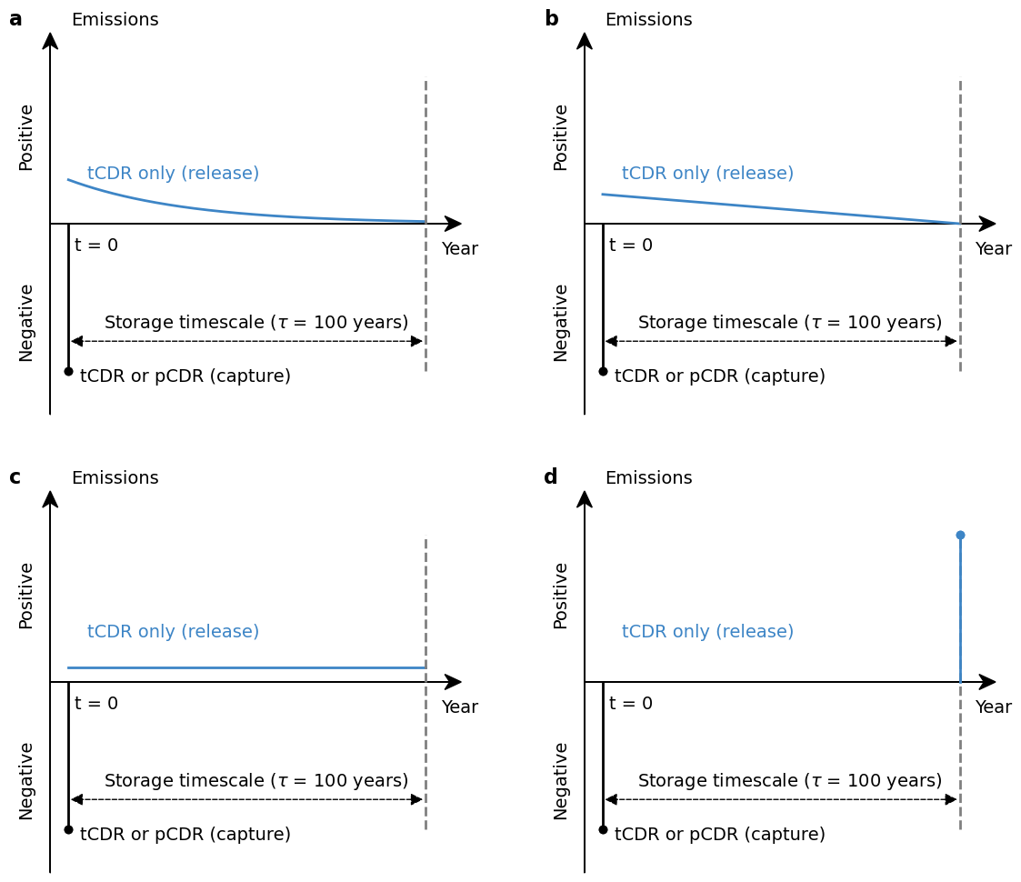
Supplementary Figure 2. Climate impact of temporary CDR strategies modeled in this paper. Carbon capture within all the temporary CDR strategies is conceptualized as a negative pulse (Dirac delta-function δ(t)) at t = 0. This is followed by varying release functions: exponential release (a), linear release (b), constant release (c) and a positive pulse at the end of storage timescale (d). Case (a) is presented in main text.
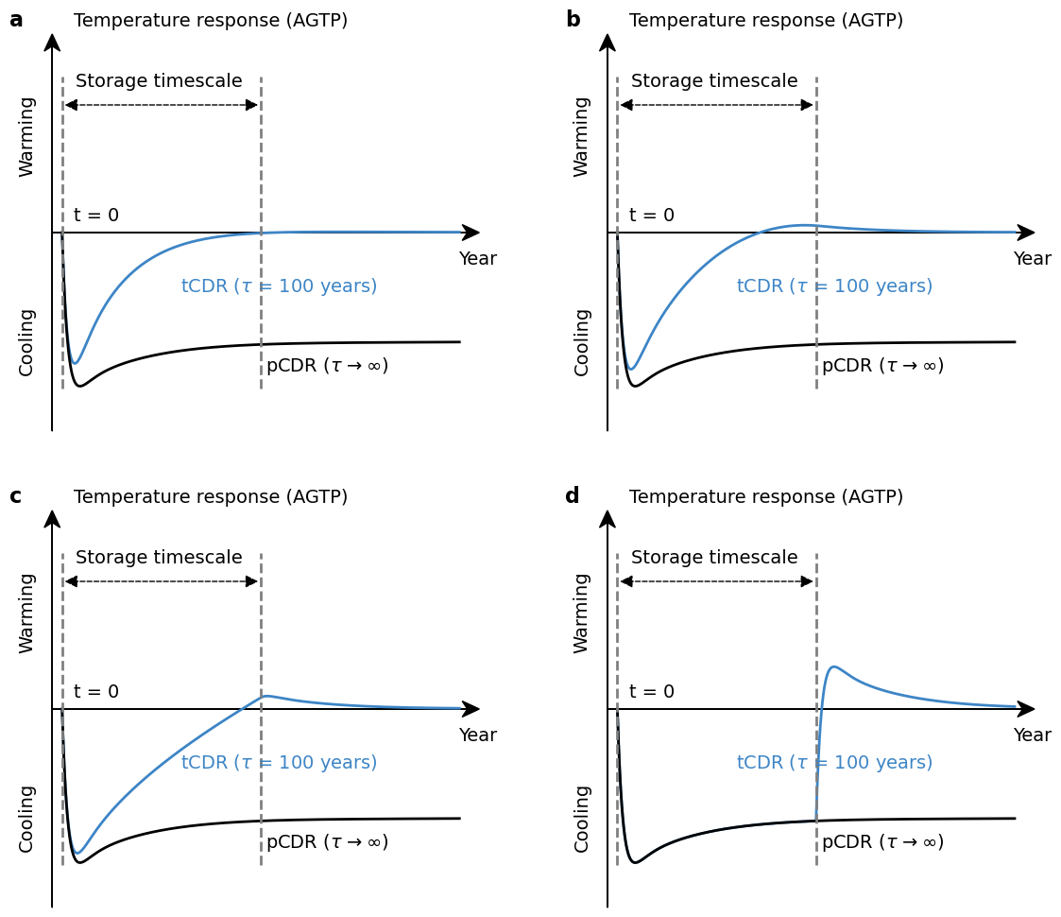

Supplementary Figure 3. Climate impact of temporary CDR and non-CO₂ emissions at different points of the carbon-climate cause-effect chain. Results for temporary CDR are represented by solid lines, each differentiated by color to indicate different storage timescales (τ). Non-CO₂ emissions are shown as dashed lines, with their specific lifetimes noted in parentheses. Consistent with the main text, the function form of temporary CDR is illustrated using a combination of a negative pulse followed by an exponential release.

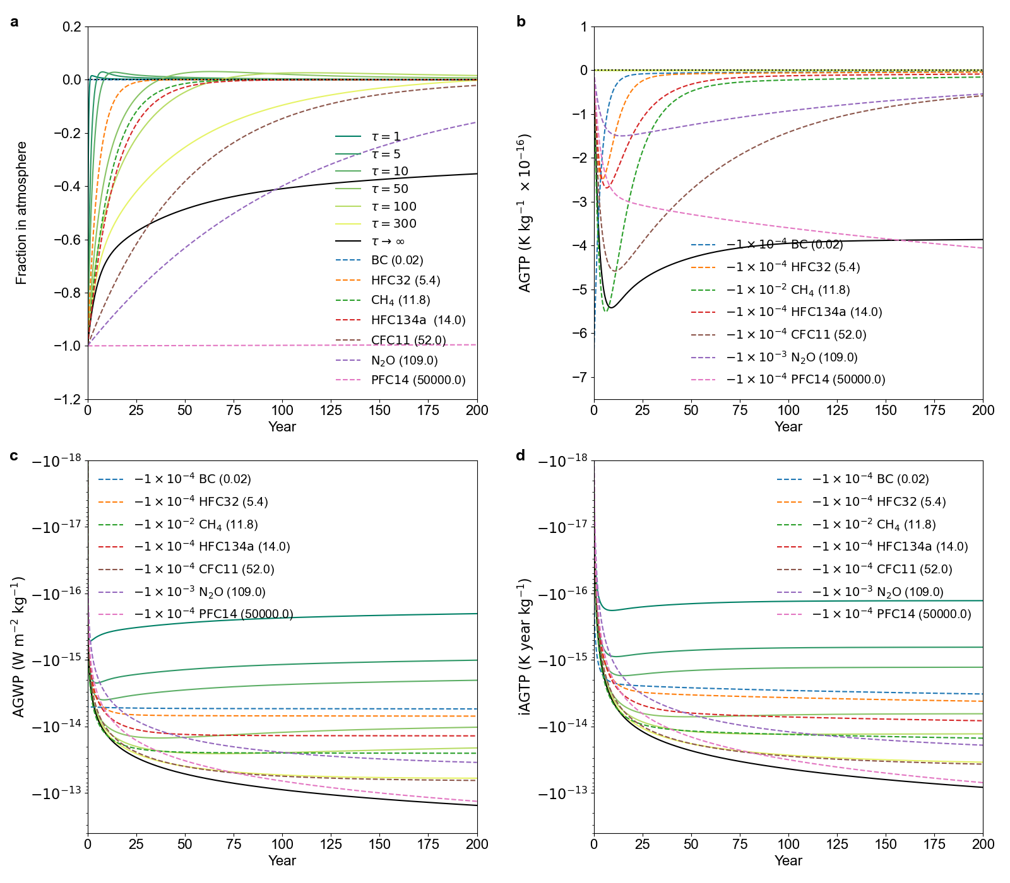

Supplementary Figure 4. Amount of temporary CDR required to offset unit anthropogenic emissions across various storage timescales and time horizons. Same as Figure 2, but the mitigation metric α is calculated using AGWP instead of iAGTP. The scale of both axes for time horizon (TH) and storage timescale (𝜏) are linear between 0 and 100 and logarithmic afterward. The panels are arranged in ascending order of species lifetimes from panel a to h (see Table 1 for details).
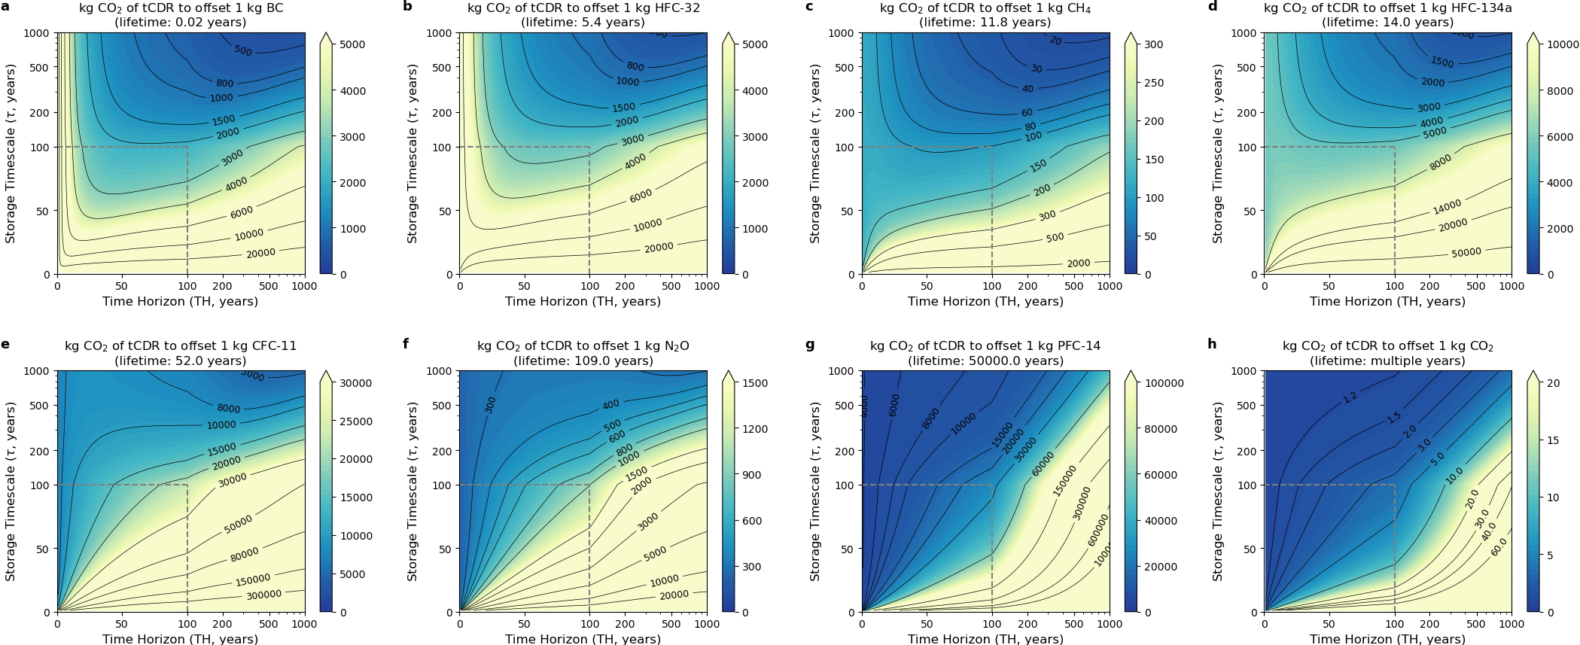
Supplementary Figure 5. Simplified illustration of afforestation/reforestation as a temporary CDR option. a. time-profile of CDR from a carbon flux perspective. b. time-profile of CDR from a carbon stock perspective. c. AGTP-based temperature response. For computational simplicity, afforestation/reforestation is modeled as a temporary CDR (tCDR; blue line), where plant growth follows a piecewise linear process (rotation timescale: 50 years) and biomass decomposition exhibits exponential decay (storage timescale: 100 years). For comparison, two permanent CDR (pCDR) approaches are shown: pCDR-a (solid black line), representing one-time permanent capture (e.g., DACCS without leakage), and pCDR-b (dotted black line), which shares the same plant growth-based capture phase as tCDR but prevents carbon release through permanent storage (e.g., wood vaults).
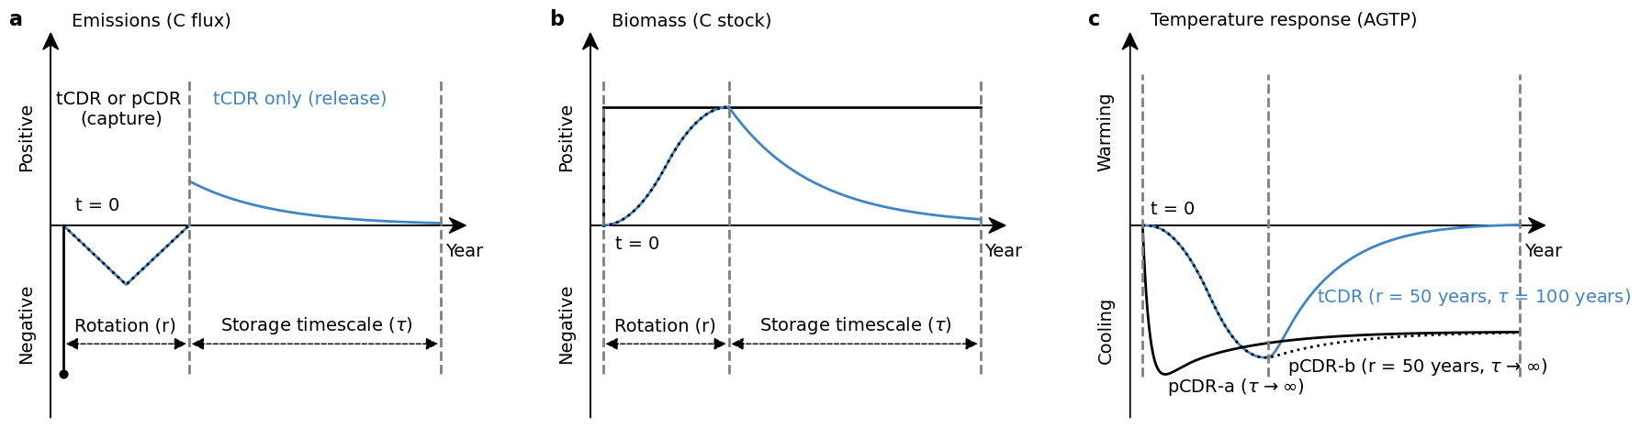
Supplementary Figure 6. Amount of temporary CDR required to offset unit CH₄ emissions from fossil and biogenic sources. The contribution of the CH₄ oxidation into CO₂ is calculated based on the Equation 7.S.M.5.8 from IPCC AR6 WG1, applicable to both fossil and biogenic sources. In addition, a biogenic correction of 2.75 kg CO₂ per kg CH₄ is applied exclusively to biogenic sources, accounting for rapid biological CO₂ uptake and methane release. Consequently, CH₄ emission from fossil sources exhibit slightly higher compensation ratios compared to biogenic sources.
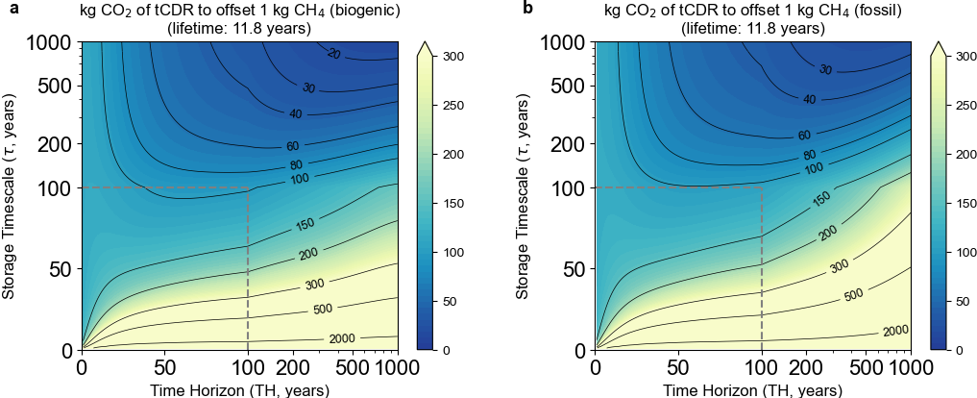

Supplementary Table 1. Parameters of the IRF for the carbon dioxide response used in IPCC AR6.
$$a_{1}$$ | $$a_{2}$$ | $$a_{3}$$ | $$a_{4}$$ | $$τ_{1}$$ | $$τ_{2}$$ | $$τ_{3}$$ | $$τ_{4}$$
0.2173 | 0.2763 | 0.2824 | 0.224 | ∞ | 4.304 | 36.54 | 394.4

Supplementary Table 2. Parameters of the IRF for the temperature response used in IPCC AR6.
$$λ$$  (W m⁻² K⁻¹) | $$a_{T,1}$$ | $$a_{T,2}$$ | $$τ_{T,1}$$  (year) | $$τ_{T,2}$$  (year)
0.7578 | 0.5856 | 0.4144 | 3.424 | 285.0

Supplementary Table 3. Parameters of the IRF for the climate-carbon feedback response used in IPCC AR6.
$$γ$$  (GtC yr⁻¹ K⁻¹) | $$a_{F,1}$$ | $$a_{F,2}$$ | $$a_{F,3}$$ | $$τ_{F,1}$$  (year) | $$τ_{F,2}$$  (year) | $$τ_{F,3}$$  (year)
3.015 | 0.6368 | 0.3322 | 0.0310 | 2.376 | 30.14 | 490.1

Supplementary Table 4. Amount of temporary CDR required to offset unit anthropogenic emissions across various storage timescales and time horizons. Same as Table 1, but the mitigation metric α is calculated using AGWP instead of iAGTP.

Species | Lifetime  (years) | Radiative  efficiency  (W m⁻² kg⁻¹) | TH = 100 |  |  |  | TH → ∞
Species | Lifetime  (years) | Radiative  efficiency  (W m⁻² kg⁻¹) | Bioplastic  (𝜏 = 20) | Wood products  (𝜏 = 100) | Biochar  (𝜏 = 500) | Bioplastic  (𝜏 = 20) |  | Wood products  (𝜏 = 100) | Biochar  (𝜏 = 500)
BC | 0.02 | 2.54×10⁻⁹ | 11400 | 2180 | 830 | 22200 |  | 4450 | 889
HFC-32 | 5.4 | 1.21×10⁻¹¹ | 14600 | 2800 | 1070 | 28500 |  | 5710 | 1140
CH₄ | 11.8 | 2.00×10⁻¹³ | 528 | 101 | 38.5 | 1030 |  | 206 | 41.3
HFC-134a | 14.0 | 9.24×10⁻¹² | 28900 | 5550 | 2110 | 56600 |  | 11300 | 2260
CFC-11 | 52.0 | 1.19×10⁻¹¹ | 118000 | 22600 | 8590 | 271000 |  | 54300 | 10900
N₂O | 109 | 3.56×10⁻¹³ | 5170 | 992 | 377 | 17000 |  | 3400 | 680
PFC-14 | 50000 | 6.32×10⁻¹² | 140000 | 26800 | 10200 | 138000000 |  | 27600000 | 5530000
CO₂ | multiple | 1.71×10⁻¹⁵ | 18.9 | 3.62 | 1.37 | ∞ |  | ∞ | ∞

Supplementary Table 5. Global warming potentials (GWPs), global temperature potentials (GTPs) and integrated global temperature potentials (iGTPs) for anthropogenic emissions and temporary CDR (tCDR). The functional form of temporary CDR follows that shown in the main text (Supplementary Figure 1a). Time horizons of 20, 100, and 500 years are chosen as illustration, with storage timescales (τ) of 20, 100, and 500 years used for temporary CDR.
 | GWP20 | GWP100 | GWP500 | GTP20 | GTP100 | GTP500 | iGTP20 | iGTP100 | iGTP500
CO₂ | 1 | 1 | 1 | 1 | 1 | 1 | 1 | 1 | 1
BC | 2170 | 604 | 176 | 206 | 112 | 32 | 2570 | 665 | 199
HFC-32 | 2700 | 776 | 226 | 873 | 148 | 41.9 | 3050 | 847 | 255
CH₄ | 81.3 | 28 | 8.17 | 52.7 | 5.58 | 1.55 | 86.8 | 30.3 | 9.19
HFC-134a | 4150 | 1530 | 448 | 2960 | 317 | 85.7 | 4380 | 1650 | 504
CFC-11 | 8330 | 6250 | 2150 | 8490 | 3580 | 477 | 8290 | 6440 | 2380
N₂O | 273 | 274 | 133 | 297 | 235 | 41.6 | 269 | 276 | 143
PFC-14 | 5300 | 7400 | 10700 | 6110 | 9110 | 13200 | 5150 | 7270 | 10500
tCDR(𝜏=20) | -0.288 | -0.053 | -0.0102 | -0.0292 | 0.00583 | 0.00208 | -0.338 | -0.0609 | -0.0124
tCDR(𝜏=100) | -0.735 | -0.277 | -0.0519 | -0.559 | -0.00456 | 0.0102 | -0.769 | -0.301 | -0.0623
tCDR(𝜏=500) | -0.938 | -0.728 | -0.273 | -0.891 | -0.508 | -0.0109 | -0.947 | -0.744 | -0.305

Supplementary Table 6. Amount of temporary CDR required to offset unit anthropogenic emissions across various storage timescales and time horizons. Same as Table 1, but the function form of temporary CDR is replaced with a combination of a negative pulse followed by a linear release, as detailed in Supplementary Figure 1b.

Species | Lifetime  (years) | Radiative  efficiency  (W m⁻² kg⁻¹) | TH = 100 |  |  |  | TH → ∞
Species | Lifetime  (years) | Radiative  efficiency  (W m⁻² kg⁻¹) | Bioplastic  (𝜏 = 20) | Wood products  (𝜏 = 100) | Biochar  (𝜏 = 500) | Bioplastic  (𝜏 = 20) |  | Wood products  (𝜏 = 100) | Biochar  (𝜏 = 500)
BC | 0.02 | 2.54×10⁻⁹ | 11000 | 2120 | 825 | 15900 |  | 3310 | 752
HFC-32 | 5.4 | 1.21×10⁻¹¹ | 14000 | 2700 | 1050 | 20100 |  | 4190 | 952
CH₄ | 11.8 | 2.00×10⁻¹³ | 499 | 96.5 | 37.6 | 733 |  | 153 | 34.7
HFC-134a | 14.0 | 9.24×10⁻¹² | 27200 | 5270 | 2050 | 40200 |  | 8370 | 1900
CFC-11 | 52.0 | 1.19×10⁻¹¹ | 106000 | 20500 | 7980 | 193000 |  | 40200 | 9130
N₂O | 109 | 3.56×10⁻¹³ | 4550 | 880 | 343 | 12100 |  | 2520 | 572
PFC-14 | 50000 | 6.32×10⁻¹² | 120000 | 23200 | 9010 | 98300000 |  | 20500000 | 4650000
CO₂ | multiple | 1.71×10⁻¹⁵ | 16.5 | 3.19 | 1.24 | ∞ |  | ∞ | ∞

Supplementary Table 7. Amount of temporary CDR required to offset unit anthropogenic emissions across various storage timescales and time horizons. Same as Table 1, but the function form of temporary CDR is replaced with a combination of a negative pulse followed by a constant release, as detailed in Supplementary Figure 1c.
Species | Lifetime  (years) | Radiative  efficiency  (W m⁻² kg⁻¹) | TH = 100 |  |  |  | TH → ∞
Species | Lifetime  (years) | Radiative  efficiency  (W m⁻² kg⁻¹) | Bioplastic  (𝜏 = 20) | Wood products  (𝜏 = 100) | Biochar  (𝜏 = 500) | Bioplastic  (𝜏 = 20) |  | Wood products  (𝜏 = 100) | Biochar  (𝜏 = 500)
BC | 0.02 | 2.54×10⁻⁹ | 7290 | 1380 | 742 | 10600 |  | 2190 | 493
HFC-32 | 5.4 | 1.21×10⁻¹¹ | 9290 | 1760 | 945 | 13400 |  | 2780 | 624
CH₄ | 11.8 | 2.00×10⁻¹³ | 332 | 62.9 | 33.8 | 488 |  | 101 | 22.8
HFC-134a | 14.0 | 9.24×10⁻¹² | 18100 | 3430 | 1850 | 26700 |  | 5550 | 1250
CFC-11 | 52.0 | 1.19×10⁻¹¹ | 70600 | 13400 | 7180 | 128000 |  | 26700 | 5990
N₂O | 109 | 3.56×10⁻¹³ | 3030 | 574 | 308 | 8040 |  | 1670 | 375
PFC-14 | 50000 | 6.32×10⁻¹² | 79700 | 15100 | 8110 | 65400000 |  | 13600000 | 3050000
CO₂ | multiple | 1.71×10⁻¹⁵ | 11 | 2.08 | 1.12 | ∞ |  | ∞ | ∞

Supplementary Table 8. Amount of temporary CDR required to offset unit anthropogenic emissions across various storage timescales and time horizons. Same as Table 1, but the function form of temporary CDR is replaced with a combination of a negative pulse followed by a positive pulse at the end of the storage timescale, as detailed in Supplementary Figure 1d.

Species | Lifetime  (years) | Radiative  efficiency  (W m⁻² kg⁻¹) | TH = 100 |  |  |  | TH → ∞
Species | Lifetime  (years) | Radiative  efficiency  (W m⁻² kg⁻¹) | Bioplastic  (𝜏 = 20) | Wood products  (𝜏 = 100) | Biochar  (𝜏 = 500) | Bioplastic  (𝜏 = 20) |  | Wood products  (𝜏 = 100) | Biochar  (𝜏 = 500)
BC | 0.02 | 2.54×10⁻⁹ | 3640 | 665 | 665 | 5270 |  | 1090 | 298
HFC-32 | 5.4 | 1.21×10⁻¹¹ | 4630 | 847 | 847 | 6670 |  | 1370 | 377
CH₄ | 11.8 | 2.00×10⁻¹³ | 166 | 30.3 | 30.3 | 243 |  | 50.1 | 13.8
HFC-134a | 14.0 | 9.24×10⁻¹² | 9040 | 1650 | 1650 | 13300 |  | 2740 | 753
CFC-11 | 52.0 | 1.19×10⁻¹¹ | 35200 | 6440 | 6440 | 64000 |  | 13200 | 3620
N₂O | 109 | 3.56×10⁻¹³ | 1510 | 276 | 276 | 4010 |  | 825 | 227
PFC-14 | 50000 | 6.32×10⁻¹² | 39700 | 7270 | 7270 | 32600000 |  | 6710000 | 1840000
CO₂ | multiple | 1.71×10⁻¹⁵ | 5.46 | 1 | 1 | ∞ |  | ∞ | ∞

Supplementary Table 9. Amount of temporary CDR required to offset unit CH₄ emissions from fossil and biogenic sources. Results for a time horizon (TH) approaching infinity are not presented due to the perpetual atmospheric presence of CO₂ from CH₄ oxidation, rendering the compensation ratio indefinable.

Species |  | TH = 100
 | 𝜏 = 20 | 𝜏 = 100 | 𝜏 = 500
CH₄ (fossil) | 529 | 107 | 43.3
CH₄ (biogenic) | 484 | 97.8 | 39.6

