Supplementary Information

Overcoming hydrophobicity: A maximally filled methane clathrate hydrate under conditions of early Titan and ocean-exoplanets
Katarzyna Skrzyńska^{1*}, Erwan Le Menn², Olivier Bollengier², Baptiste Journaux³, Apostolos Pantousas¹, Mohamed Mezouar¹, Gabriel Tobie² and Anna Pakhomova^{1*}
¹European Synchrotron Radiation Facility, 38000 Grenoble, France;
²Laboratory of Planetology and Geosciences, 44322 Nantes, France;
³Department of Earth and Space Science, University of Washington, Seattle, Washington 98195, United States;
∗Corresponding author e-mails: katarzyna.skrzynska@esrf.fr; anna.pakhomova@esrf.fr

Table of Contents
Text S1: Previous knowledge on high-pressure phase transitions in methane clathrate hydrates 3
Text S2: Stoichiometry evolution of methane hydrate at high pressure 4
Text S3: Methane Hydrate Compressibility and Equation of State Analysis 5
Text S4: Dissociation of methane hydrate into constituent ices 6
Text S5 Comparison of crystallographic models for MH-IIb and MH-IIa 7
Table S1: Nomenclature and reported phase transitions of high-pressure methane hydrates 8
Table S2: Compilation of identified phases in the pressure range of Experiment (Exp.) 1 and 2. 9
Table S3 Results of fitting V-P data of Experiment 1 10
Table S4 Comparison of atom distances within the large cage of MH-IIa and MH-IIb 11
Figure S1: Structural features of MH-I: 12
Figure S2: Pictures of the sample chambers at the given pressure step of Experiment 1 13
Figure S3 Framework comparison of high-pressure methane hydrate phases: 14
Figure S4: Small cages of MH-IIb at 1.66 GPa (blue) in comparison to small cages of MH-IIa (red) at 1.15 GPa 15
Figure S5: Dependence of CH₄ site occupancies and pressure in the MH-IIa and the MH-IIb phases 16
Figure S6: Fourier difference maps of the residual electron density within the 5¹²6⁸ large cages of MH-IIa 17
Figure S7: Evolution of equivalent isotropic atomic displacement parameter (U_{equiv}) of the oxygen sites upon compression 18
Figure S8: Comparison of large cages in two hexagonal methane hydrate structures (MH-IIa and MH-IIb) 19
Figure S9: Evolution of selected carbon – oxygen distances in MH-IIb 20
Figure S10: The Lennard-Jones potential curve for methane–methane interactions 21
Figure S11: Relative evolution of cage volumes upon compression in MH-IIa and MH-IIb 22
References 23

Text S1: Previous knowledge on high-pressure phase transitions in methane clathrate hydrates
At low pressures, CH₄ hydrate (MH-I) crystallizes in an archetypal clathrate-I structure¹ (sI, Table S1). This phase persists until approximately 0.9 GPa, where early diffraction and Raman studies identified a transition to a high-pressure polymorph known as MH-II ^{2–5}. Although MH-II unit cell parameters suggested a hexagonal (sH) framework – typically stabilized by dual-sized guest molecules ¹ – the exact structure has remained uncertain ^{3,4,6}. Loveday et al. (2001) initially proposed a structure in relation to the sH framework ^{4,6}, later refining the data to describe a framework that accommodates multiple guest molecules within the large cage based on findings in argon-water and krypton-water systems ^{5,7–10}. This sH model was subsequently employed in a powder neutron diffraction study ¹¹.
The transition pathway of MH-II at higher pressures (>1.4 GPa) remains contentious. Hirai et al. (2001) attributed the broadening of Raman bands at 2900 – 2950 cm⁻¹, corresponding to C-H stretching vibrations of CH₄, in the pressure range of 1.6 GPa – 2.1 GPa to the emergence of a orthorhombic phase, termed “structure B” (Table S1) ³. However, alternative interpretations of these spectral anomalies abound. Shimizu et al. (2002) linked the band broadening – and subsequent splitting above 1.4 GPa – to distinct methane populations in small versus large cages, or to abrupt occupancy changes within the existing MH-II framework ^{12,13}. In the recent spectroscopic work, Scelta et al. (2022) proposed that these features (1.75 – 2.0 GPa) arise from the microscale coexistence (2-3 μm) of sH and filled ice ¹⁴. Above 1.9 – 2 GPa, MH-II transforms either to filled ice (MH-III) or decomposes into ice VII and solid methane depending on the compression rate ^{6,15}.

Text S2: Stoichiometry evolution of methane hydrate at high pressure
The observed MH-I → MH-IIa phase transition at 0.91 GPa aligns with previously reported experiments (Table S1, S2). Earlier studies reported the ideal composition of MH-I as (CH₄)₈(H₂O)₄₆, corresponding to 5.75 water molecules per methane molecule, assuming full occupancy of both 5¹² and 5¹²6² cages ⁶, or reported only the relative occupancy ratio between these cages ^{16,17}. Our data reveal that the composition of MH-I slightly varies as a function of pressure (Fig. 1). The C1 site of cage 5¹²6² is fully occupied over the entire pressure range of MH-I existence, whereas the occupancy of the C2 site within the smaller cage 5¹² slightly increases upon compression from 0.90(4) to 0.95(3). The compositional evolution of MH-IIa clathrate is more pronounced. The presence of 3–5 methane molecules within it has been proposed, based on a model postulating six sites around the cage waist (C4 site in this paper, Fig. 3b), with a maximum occupancy of each being 0.5 ^{6,16}. In our experiments we observed residual electron density around the large cage waist at pressure points of 0.91 and 1.02 GPa in Experiment 1 and 1.08 GPa in Experiment 2. However, inserting these densities into the structural model was fruitless, presumably due to the disorder and low occupancy of the site. Therefore, the stoichiometries of the hydrate MH-IIa at 0.91 GPa, 1.02 GPa (Experiment 1) and 1.08 GPa (Experiment 2) do not take these electron densities into account leading to the overestimated H₂O/CH₄ ratio of at most 5.98, 5.92 and 5.67 the chemical composition of (CH₄)_{5.69}(H₂O)₃₄, (CH₄)_{5.74}(H₂O)₃₄ and (CH₄)₆(H₂O)₃₄ respectively (Fig. 1). In the next pressure steps of 1.15 and 1.28 GPa in Experiment 1 and 1.14 GPa (decompression point) and 1.17 GPa in Experiment 2, the electron density around the cage waist was successfully inserted into the model (C4 site) (Text S2), resulting in six sites with partial occupancy factors of 0.25(7) and 0.27(5) in Experiment 1 and 0.14(2) and 0.26(4) in Experiment 2 (Fig. 3b, Fig. S5). Importantly, data collection between 1.08 and 1.17 GPa in Experiment 2 employed a dwell time of nearly 20 hours. Given that the stoichiometry observed at 1.17 GPa (Experiment 2) is consistent with the 1.15 GPa point in Experiment 1, we conclude that the increase in methane content is driven by pressure and the process is independent of time. Thus, our data shows that the large cage of MH-IIa includes up to 3.34 methane molecules, giving H₂O/CH₄ ratio in MH-IIa is 3.94:1. In turn, the previously postulated H₂O/CH₄ ratio of 3.4:1 corresponds to MH-IIb. Within the stability field of the MH-IIb phase, the H₂O/CH₄ ratio decreases from 3.79 at 1.44 GPa to a limiting value of 3.40 (>1.54 GPa). The large cage hosts only three C4 sites around its waist, whose occupancies increased from 0.66(7) at 1.44 GPa to full occupancy at 1.66 GPa (Figs. 4(d), S5). In total, the large cage hosts five CH₄ molecules in a new hydrate structure – two fully occupied axial C3 sites and three C4 sites around the waist.

Text S3: Methane Hydrate Compressibility and Equation of State Analysis
Quantifying the compressibility of methane clathrate hydrate poses difficulties as they are stable solely within a narrow pressure range at room temperature, making the acquisition of an adequate number of pressure-volume (P-V) data points particularly challenging. Furthermore, as our results demonstrate, the stoichiometry of methane hydrates may vary during compression. Thus, their compressibility is dependent on both pressure and evolving stoichiometry. Consequently, by analogy with porous materials, we report apparent bulk moduli for these phases¹⁸. Unit-cell volumes from Experiment 1 were fitted using a second-order Birch-Murnaghan equation of state (EOS) with the EoSFit GUI software¹⁹.
For MH-I and MH-IIa, the complete datasets of Experiment 1 were fitted despite variations in stoichiometry in view of limited number of data points. This yields K₀ values of 8.4(7) and 11.1(12) GPa, respectively. The V–P data points from Experiment 2 align well with the fitted EoS. In contrast, the MH-IIb phase required a refined approach. An initial fit of the full dataset of Experiment 1 suggested a K₀ value of 8.7(5). However, this dataset includes the initial stages of the phase stability region (1.44-1.54 GPa), where significant stoichiometric evolution occurs. Excluding the 1.44 GPa point – where the stoichiometry deviates most significantly – reduced the value to 8.2(6) GPa. Finally, by restricting the fit to the regime of constant composition (>1.54 GPa), we determined a definitive K₀ of 7.8(7) GPa. Again, the V–P data points from Experiment 2 align well with the fitted EoS of MH-IIb. This result indicates that the MH-IIb phase is more compressible than MH-IIa. Further details on the fitting procedures are provided in Table S3.

Text S4: Dissociation of methane hydrate into constituent ices
Upon reaching 1.79 GPa in Experiment 1, we observed the crystallization of ice VI, which grew from liquid water released during the sI → sH phase transition following the stoichiometric scheme (CH₄)_{x}(H₂O)₄₆ → (CH₄)_{x}(H₂O)₃₄ + 12 H₂O. The associated volume reduction caused an immediate pressure drop to 1.61 GPa. Further compression to 2.26 GPa triggered the transformation to ice VII, accompanied by the emergence of solid methane I and a distinct change in the sample's optical texture (Fig. S2). This final decomposition event lowered the pressure to 2.16 GPa. By the maximum experimental pressure of 2.47 GPa, the hydrate had fully dissociated into a mixture of ice VII and methane I. Collectively, these observations define the upper stability limit of the MH-IIb phase at approximately 2.26 GPa, beyond which the clathrate structure collapses completely into its constituent phases, water and methane ices.

Text S5 Comparison of crystallographic models for MH-IIb and MH-IIa
To determine the correct symmetry and crystal structure of the MH-IIb phase, we refined and compared several structural models using the dataset at the MH-IIb onset of 1.44 GPa. Initial refinements using the standard centrosymmetric space group of structure sH (P6/mmm) yielded unsatisfactory fit statistics (R₁ = 15.03 %, R₂ = 53.72 %). Inspection of the structure revealed that the thermal ellipsoids for the O4 oxygen site were unphysically elongated, suggesting unresolved disorder or incorrect symmetry. Attempting to model this by splitting the O4 atom into two partially occupied sites, analogous to the structure at 1.28 GPa, within the P6/mmm space group improved the agreement (R₁ = 10.81 %, R₂ = 45.42 %). However, lowering the symmetry to the non-centrosymmetric space group P$\overline{6}$2m resulted in a superior fit quality (R₁ = 9.23 %, R₂ = 23.90 %) and yielded physically sensible anisotropic displacement parameters for all oxygen atoms. Symmetry check using PLATON did not identify any missing symmetry elements. This symmetry-reduced model remains robust upon further compression; at 2.13 GPa, the P$\overline{6}$2m refinement yields excellent reliability factors (R₁ = 7.01 %, R₂ = 18.87 %), confirming the structure of MH-IIb. A structure solution could not be obtained in space group P$\overline{6}$m2.
Similar comparative refinements were performed on the dataset corresponding to a pressure of 1.28 GPa, the final pressure point of the MH-IIa phase. In this instance, the P6/mmm structural model with split O4 site yielded R₁ = 7.18 %, R₂ = 22.65 %. In contrast, the P$\overline{6}$2m model resulted in inferior statistics, with R₁ = 8.56 %, R₂ = 26.86 %, and noticeably elongated ADP for the O4 and O5 sites. Importantly, the symmetry check performed on the P$\overline{6}$2m model using PLATON identified the additional missing symmetry elements, explicitly recommending the higher-symmetry P6/mmm.
The transition from the MH-IIa (P6/mmm) to the MH-IIb (P$\overline{6}$2m) corresponds to a symmetry-lowering mainly defined by the loss of the inversion center and 6-fold rotation axis, which is replaced by a 6-fold roto-inversion axis. This reduction in symmetry is driven by the triangular ordering of methane guests within the large cages, which also imposes a triangular distortion on the cage. Therefore, the structure, both framework and guest arrangement, is incompatible with the centrosymmetric P6/mmm space group. Instead, it adopts a non-centrosymmetric 3-fold periodicity within the P$\overline{6}$2m space group.

Table S1: Nomenclature and reported phase transitions of high-pressure methane hydrates

structure details (this work) |  | structure symbols, transition pressures of this work | ^{4,15} | ³ | ¹⁴
space group | unit cell parameters  [Å, Å³]
Pm3n | a = 11.7623(50)  V = 1627.33(11) | sI | MH-I or SIMH | structure I | MH-I
MH-I → MH-IIa phase transition |  | 0.91 GPa | ~0.90 GPa | ~0.80 GPa | ~0.90
P6/mmm | a = 11.9546(7)  c = 10.023(6)  V = 1240.5(7) | sH | MH-II | structure A | MH-II
MH-IIa → MH-IIb phase transition |  | 1.28 – 1.44 GPa |  | 1.6 GPa
P$\overline{6}$2m | a = 11.8153(7)  c = 9.949(5)  V = 1202.8(6) | sH-II |  | structure B
MH-II → filled ice  or  MH-II → ice VII + methane I |  |  | ~1.9 – 2.2 GPa |  | ~1.8 – 2 GPa
 |  |  | MH-III  (filled ice) | structure C | MH-III

Table S2: Compilation of identified phases in the pressure range
of Experiment (Exp.) 1 and 2.

Exp | pressure  [GPa] | unit cell parameters of found hydrates  [Å, Å³] |  |  | identified phases
Exp | pressure  [GPa] | a | c | V | MH |  |  | ice |  | methane
 |  |  |  |  | I | IIa | IIb | VI | VII | I
1 | 0.52±0.02 | 11.7623(5) |  | 1627.33(11)
1 | 0.62±0.02 | 11.7331(4) |  | 1615.25(11)
2 | 0.643±0.01 | 11.7177(4) |  | 1608.89(10)
1 | 0.72±0.02 | 11.6876(5) |  | 1596.53(12)
1 | 0.83±0.02 | 11.6526(5) |  | 1582.21(12)
1 | 0.91±0.02 | 11.6305(5) |  | 1573.24(13)
 |  | MH-I → MH-IIa transition
1 | 0.91±0.02 | 11.9546(7) | 10.023(6) | 1240.4(7)
1 | 1.02±0.01 | 11.9157(7) | 9.992(5) | 1228.6(7)
2 | 1.08±0.02 | 11.9113(17) | 10.0025(7) | 1229.0(3)
2 | 1.14±0.03 | 11.868(2) | 9.9674(15) | 1215.8(3)
1 | 1.15±0.02 | 11.8754(6) | 9.977(5) | 1218.5(6)
2 | 1.17±0.01 | 11.8749(1) | 9.9707(9) | 1217.63(18)
1 | 1.28±0.02 | 11.8363(7) | 9.979(7) | 1210.8(8)
 |  | MH-IIa → MH-IIb transition
1 | 1.44±0.02 | 11.8153(7) | 9.9490(5) | 1202.8(6)
2 | 1.45±0.02 | 11.8160(8) | 9.9420(7) | 1202.11(14)
1 | 1.54±0.02 | 11.8007(4) | 9.921(4) | 1196.4(4)
1 | 1.66±0.02 | 11.7769(6) | 9.896(4) | 1188.7(5)
1 | 1.70±0.09 | emergence of ice VI
1 | 1.79±0.02 | 11.7269(7) | 9.909(5) | 1176.7(6)
1 | 1.95±0.02 | 11.6903(5) | 9.84(5) | 1164.6(5)
1 | 2.08±0.02 | 11.6508(6) | 9.837(5) | 1156.4(6)
1 | 2.13±0.02 | 11.6203(1) | 9.836(8) | 1150.2(9)
1 | 2.21±0.05 | emergence of ice VII
1 | 2.47±0.06

Table S3 Results of fitting V-P data of Experiment 1 using various approaches by the second-order Birch-Murnaghan equation of state. More detailed explanation in Text S3.

MH phase | No. of data points | No. of fitted points | stoichiometry | comment | V₀ [Å³] | K₀ [GPa]
MH-I | 5 | 5 | 7.80-7.89CH₄·46H₂O | all points of Exp. 1 | 1721(10) | 8.4(7)
MH-IIa | 4 | 4 | 5.69-8.62CH₄·34H₂O | all points of Exp. 1 | 1331(10) | 11.1(12)
MH-IIb | 7 | 7 | 8.97-10CH₄·34H₂O | all points of Exp. 1 | 1369(8) | 8.7(5)
MH-IIb | 7 | 6 | 9.80-10CH₄·34H₂O | excluding 1.44 GPa | 1379(11) | 8.2(6)
MH-IIb | 7 | 5 | 10CH₄·34H₂O | > 1.54 GPa | 1389(17) | 7.8(7)

Table S4 Comparison of atom distances within the large cage of MH-IIa and MH-IIb

pressure [GPa] | atom 1 | atom 2 | distance [Å]
1.15 GPa | O4 | C4 | 3.04(6)
 | C4 | C4 | 3.21(11)
1.28 | O4B | C4 | 2.62(5)
 | O4A | C4 | 3.14(5)
 | C4 | C4 | 3.46(9)
MH-IIa → MH-IIb phase transition
1.44 | O5 | C4 | 3.08(5)
 | C4 | C4 | 3.70(9)

Figure S1: Structural features of MH-I: (a) crystal structure of sI at 0.91 GPa; (b) two cages of sI framework. The red spheres represent O atoms of water molecules; red lines indicate hydrogen bonds; the brown spheres represent carbon atoms of methane molecules; green color indicates the cages 5¹²6² and 5¹² within the framework

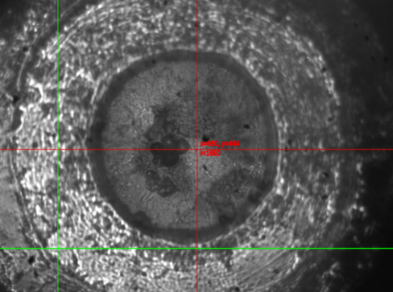 | 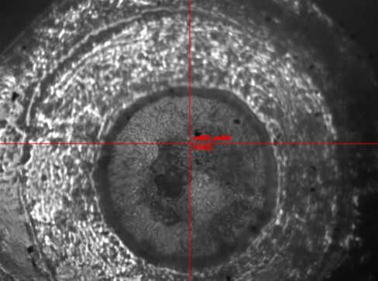
(a) sI methane hydrate  at 0.72 GPa | (b) sI methane hydrate at 0.88 GPa
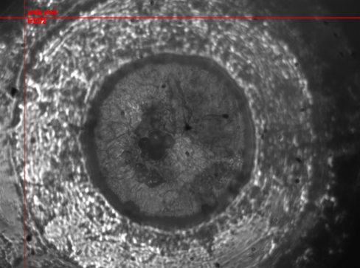 | 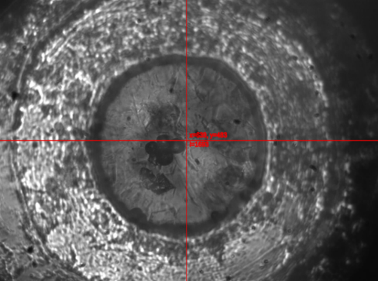
(c) coexistence of sH and sI methane hydrates at 0.91 GPa | (d) sH methane hydrate  at 1.02 GPa
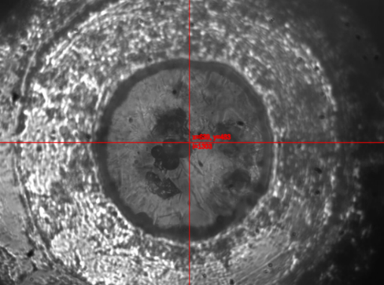 | 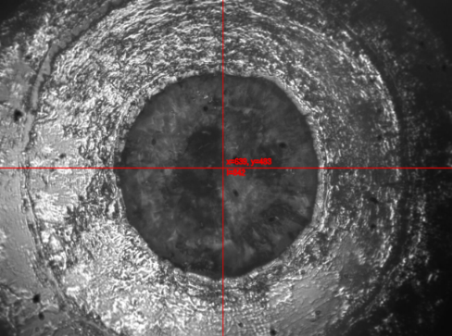
(e) MH-IIb methane hydrate at 1.44 GPa | (f) MH-IIb and ice VI methane hydrate at 1.79 GPa
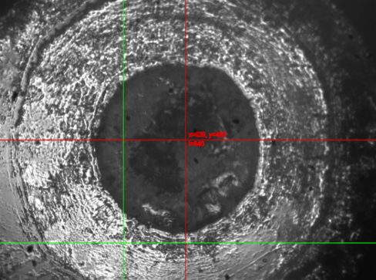
(g) ice VII and methane I at 2.21 GPa
Figure S2: Pictures of the sample chambers at the given pressure step of Experiment 1.
The diameter of the sample chamber was ~ 300 μm.

Figure S3 Framework comparison of high-pressure methane hydrate phases:
(a) General view of the MH-IIa structure at 1.15 GPa. (b) General view of the MH-IIb structure at 1.66 GPa. Red and brown spheres represent oxygen (water) and carbon (methane) atoms, respectively, while red lines denote hydrogen bonds. The large cage 5¹²6⁸ is highlighted in green within the framework. Solid lines outline the unit cell boundaries.
Figure S4: Small cages of MH-IIb at 1.66 GPa (blue) in comparison to small cages of MH-IIa (red) at 1.15 GPa: (a, b) 5¹² cage and (c, d) 4³5⁶6³ cage in different orientations.

Figure S5: Dependence of CH₄ site occupancies and pressure in the MH-IIa
and the MH-IIb phases. The dashed line separates the pressure ranges corresponding
to the MH-IIa and MH-IIb structures.

Figure S6: Fourier difference maps of the residual electron density within the 5¹²6⁸ large cages of MH-IIa, without including the C4 site into the structural models: (a) 0.91 GPa, (b) 1.28 GPa. Isosurfaces are of 0.2 Å³.

Figure S7: Evolution of equivalent isotropic atomic displacement parameter (U_{equiv}) of the oxygen sites upon compression.

Figure S8: Comparison of large cages in two hexagonal methane hydrate structures (MH-IIa and MH-IIb). The red colour represents a large cage in MH-IIa at 1.15 GPa (a) and 1.28 GPa (b), while the blue color represents a large cage in MH-IIb at 1.44 GPa (a, b). The brown color represents the C4 methane site in MH-IIa, whereas the green color represents C4 in MH-IIb. Yellow arrows indicate the displacement of O4 and O5 in MH-IIb regarding O4 in MH-IIa.
Note that C4 becomes fully occupied in MH-IIb upon compression.

Figure S9: Evolution of selected carbon – oxygen distances in MH-IIb during compression. C4–O4 is within large cage, 5¹²6⁸; C1–O2 is within a medium cage, 4³5⁶6³;
C2–O3 is within a small cage 5¹².
Figure S10: The Lennard-Jones potential curve for methane–methane interactions according to the OPLS molecular dynamics method²⁰. σ is equal to 3.73 Å.
Figure S11: Relative evolution of cage volumes upon compression in MH-IIa and MH-IIb. The pressure of 1.28 GPa with split oxygens has been omitted in the graph. The dashed line separates the pressure ranges corresponding to the MH-IIa and MH-IIb structures. 5¹²6⁸ is a large cage, 4³5⁶6³ is a medium cage, and 5¹² is a small cage.

References
1. Sloan, E. D. & Koh, C. Clathrate Hydrates of Natural Gases. (CRC Press, 2007).
2. Chou, I.-M. et al. Transformations in methane hydrates. Proc. Natl. Acad. Sci. U.S.A. 97, 13484–13487 (2000).
3. Hirai, H. et al. High-pressure structures of methane hydrate observed up to 8 GPa at room temperature. The Journal of Chemical Physics 115, 7066–7070 (2001).
4. Loveday, J. S., Nelmes, R. J. & Guthrie, M. High-pressure transitions in methane hydrate. Chemical Physics Letters 350, 459–465 (2001).
5. Loveday, J. S., Nelmes, R. J., Klug, D. D., Tse, J. S. & Desgreniers, S. Structural systematics in the clathrate hydrates under pressure. Can. J. Phys. 81, 539–544 (2003).
6. Loveday, J. S. et al. Stable methane hydrate above 2 GPa and the source of Titan’s atmospheric methane. Nature 410, 661–663 (2001).
7. Loveday, J. S. & Nelmes, R. J. High-pressure gas hydrates. Phys. Chem. Chem. Phys. 10, 937–950 (2008).
8. Manakov, A. Yu. et al. Argon Hydrates: Structural Studies at High Pressures. Doklady Physical Chemistry 378, 148–151 (2001).
9. Manakov, A. Yu. et al. Structural Investigations of Argon Hydrates at Pressures up to 10 kbar. Journal of Inclusion Phenomena 48, 11–18 (2004).
10. Tulk, C. A., Klug, D. D., Chakoumakos, B. C. & Yang, L. Intercage guest correlations and guest clusters in high-pressure clathrate hydrates. Phys. Rev. B 80, 052101 (2009).
11. Tulk, C. A. et al. Cage occupancies in the high pressure structure H methane hydrate: A neutron diffraction study. The Journal of Chemical Physics 136, 054502 (2012).
12. Shimizu, H., Kumazaki, T., Kume, T. & Sasaki, S. In Situ Observations of High-Pressure Phase Transformations in a Synthetic Methane Hydrate. J. Phys. Chem. B 106, 30–33 (2002).
13. Sasaki, S., Kume, T. & Shimizu, H. in Microscopic observation and in-situ Raman studies on some single-crystalline gas hydrates under high pressure 191 (Bremerhaven, Germany, 2006).
14. Scelta, D., Fanetti, S., Berni, S., Ceppatelli, M. & Bini, R. Addressing Open Issues about the Structural Evolution of Methane Clathrate Hydrate. J. Phys. Chem. C 126, 19487–19495 (2022).
15. Loveday, J. S., Nelmes, R. J., Guthrie, M., Klug, D. D. & Tse, J. S. Transition from Cage Clathrate to Filled Ice: The Structure of Methane Hydrate III. Phys. Rev. Lett. 87, 215501 (2001).
16. Sum, A. K., Burruss, R. C. & Sloan, E. D. Measurement of Clathrate Hydrates via Raman Spectroscopy. J. Phys. Chem. B 101, 7371–7377 (1997).
17. Choukroun, M., Morizet, Y. & Grasset, O. Raman study of methane clathrate hydrates under pressure: new evidence for the metastability of structure II. J Raman Spectroscopy 38, 440–451 (2007).
18. Walsh, J. B. First Pressure Derivative of Bulk Modulus for Porous Materials. Journal of Applied Physics 42, 1098–1100 (1971).
19. Gonzalez-Platas, J., Alvaro, M., Nestola, F. & Angel, R. EosFit7-GUI: a new graphical user interface for equation of state calculations, analyses and teaching. J Appl Cryst 49, 1377–1382 (2016).
20. Jorgensen, W. L., Madura, J. D. & Swenson, C. J. Optimized intermolecular potential functions for liquid hydrocarbons. J. Am. Chem. Soc. 106, 6638–6646 (1984).

