Supporting Materials for
Spectroscopic characterization, virtual drug designing, quantum and optoelectronics properties of Schiff base metal (II) complexes
Aprajitaª, Mukesh Choudharyª*
ª Department of Chemistry, National Institute of Technology Patna, Patna- 800005(Bihar) India.
*Corresponding author: mukesh@nitp.ac.in
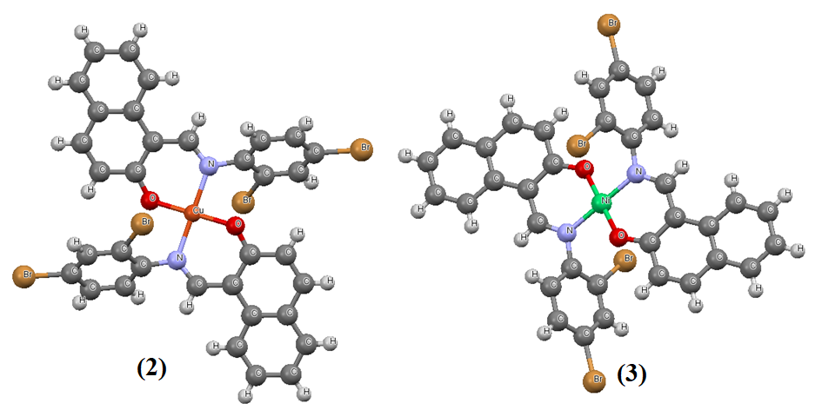
Figure S1. Optimized geometry of Cu-complex(1) and Ni-Complex (2).
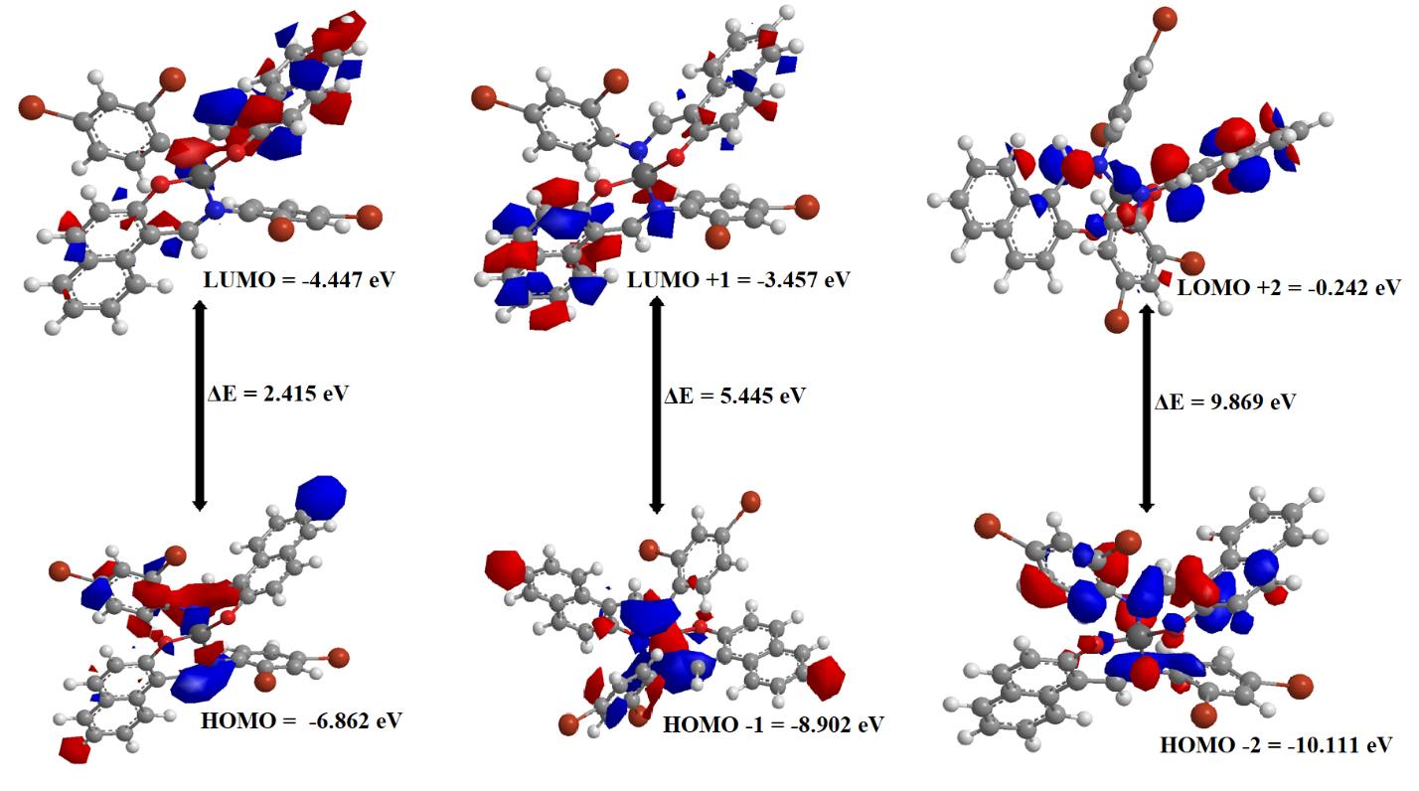
Figure S2. Frontier molecular orbital diagrams of Cu-complex (2).
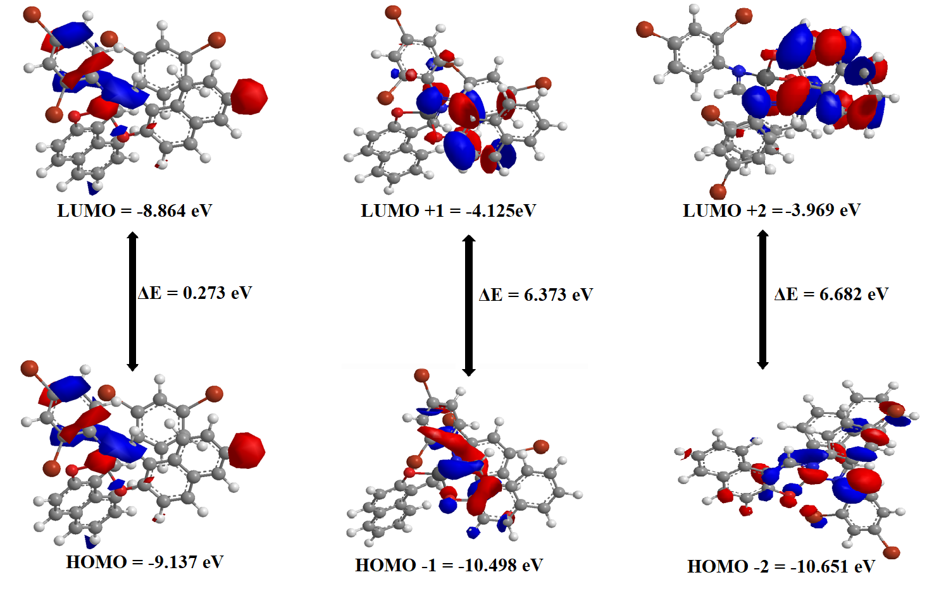
Figure S3. Frontier molecular orbital diagrams of Ni-complex (3).

Table S1. The theoretical calculations for Pt-complex (1) using detailed TD-DFT levels of theory while the experimental absorption wave lengths are given in parenthesis.
 | Excited State | Wave length (nm) | Oscillator Strength | Transitions | Nature
Pt-complex (1) | S0S14 | 420 (412) | 0.152 | 204 ->206 | MLCT
 | S0S11 | 325 (323) | 0.427 | 206 ->209 | MLCT
 | S0S19 | 315 (278) | 0.265 | 205 ->208 | MLCT

Table S2. SwissADME computed parameter in the different sections of the one-panel-par-molecule outputs (physicochemical properties, lipophilicity, pharmacokinetics, drug-likeness and medicinal chemistry) for HL and their Pt-complex (1), Cu-complex (2) and Ni-complex (3).
 | HL | Pt-complex (1) | Cu-complex (2) | Ni-complex (3)
Physicochemical properties
Formula | C₁₇H₁₁Br₂NO | C₃₄H₂₀Br₄PtN₂O₂ | C₃₄H₂₀Br₄CuN₂O₂ | C₃₄H₂₀Br₄NiN₂O₂
Molecular weight (g/mol) | 405.08 | 1003.23 | 871.70 | 866.84
Num. heavy atoms | 21 | 43 | 43 | 43
Num. atom. heavy atoms | 16 | 32 | 32 | 32
Fraction Csp³ | 0.00 | 0.00 | 0.00 | 0.00
Num. rotatable bonds | 2 | 2 | 2 | 2
Num. H-bond acceptors | 2 | 2 | 2 | 2
Num. H-bond donors | 1 | 0 | 0 | 0
Molar Refractivity | 95.07 | 194.00 | 194.00 | 194.00
TPSA (Å²) | 32.59 | 43.06 | 43.18 | 43.18
Lipophilicity
Log P_{o/w} (iLOGP) | 3.53 | 0.00 | 0.00 | 0.00
Log P_{o/w} (XLOGP3) | 5.50 | 11.21 | 11.21 | 11.21
Log P_{o/w} (WLOGP) | 5.82 | 11.15 | 11.15 | 11.16
Log P_{o/w} (MLOGP) | 4.66 | 6.83 | 6.83 | 6.83
Log P_{o/w} (SILICOS-IT) | 5.75 | 7.36 | 6.54 | 6.51
Consensus Log P_{o/w} | 5.05 | 7.31 | 7.15 | 7.14
Water Solubility
Log S (ESOL) | -6.25 | -13.54 | -12.73 | -12.70
Solubility (mg/ml; mol/l) | 2.29e-04;  5.65e-07 | 2.69e-11;  2.86e-14 | 1.64e-10;  1.88e-13 | 1.75e-10;  2.02e-12
Class (soluble) | Poorly | Insoluble | Insoluble | Insoluble
Log S (Ali) | -5.94 | -12.09 | -12.09 | -12.09
Solubility (mg/ml; mol/l) | 4.62e-04;  1.14-06 | 8.14e-10;  8.12-13 | 7.09e-10;  8.12e-13 | 7.04e-10;  8.12e-13
Class(soluble) | Moderately | Insoluble | Insoluble | Insoluble
Log S (SILICOS-IT)) | -7.73 | -16.10 | -15.88 | -15.87
Solubility (mg/ml; mol/l) | 7.64e-06;  1.86e-08 | 8.01e-14;  7.96e-17 | 1.16e-13;  1.33e-16 | 1.18e-13;  1.36e-16
Class (soluble) | Poorly | Insoluble | Insoluble | Insoluble
Pharmacokinetics
Gl absorption | High | Low | Low | Low
BBB permeant | Yes | No | No | No
P-gp substrate | No | Yes | Yes | No
CYP1A2 inhibitor | Yes | No | No | No
CYP2C19 inhibitor | Yes | No | No | No
CYP2C9 inhibitor | Yes | No | No | No
CYP2D6 inhibitor | No | No | No | No
CYP3A4 inhibitor | No | No | No | No
Log K_{p} (cm/s) | -4.27 | -4.46 | -8.91 | -3.63
Drug likeness
Lipinski | Yes | No | No | No
Ghose | No | No | No | No
Veber | Yes | Yes | No | Yes
Egan | Yes | No | No | No
Muegge | No | No | No | No
Bioavailability Score | 0.55 | 0.17 | 0.17 | 0.17
Medicinal Chemistry
PAINS | 0 | 0 | 0 | 0
Drug-likeness | No | No | No | No
Synthetic accessibility | 2.07 | 6.02 | 5.71 | 5.39

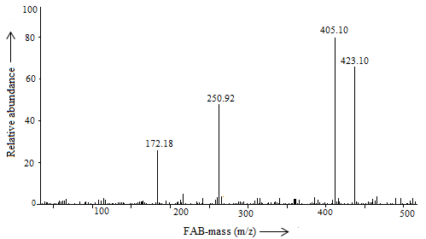
Figure S4. FAB mass (m/z) spectrum of bidentate Schiff base ligand (HL).

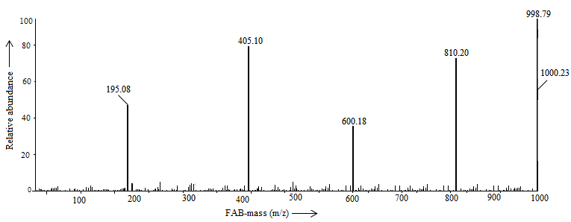
Figure S5. FAB mass (m/z) spectrum for Pt-complex (1) of bidentate ligand (HL).

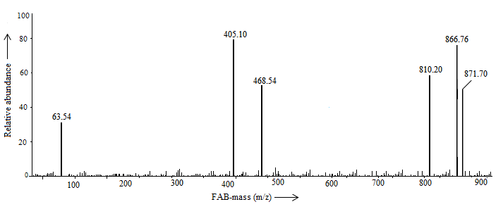
Figure S6. FAB mass (m/z) spectrum for Cu-complex (2) of bidentate ligand (HL).

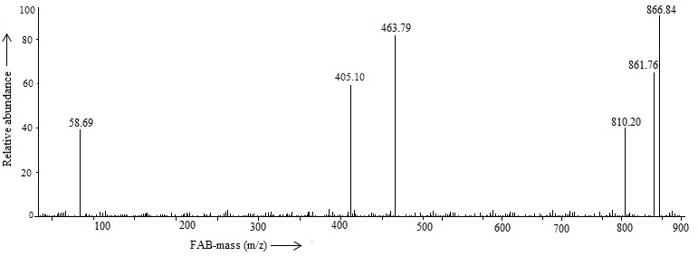 Figure S7. FAB mass (m/z) spectrum for Ni-complex (3) of bidentate ligand (HL).

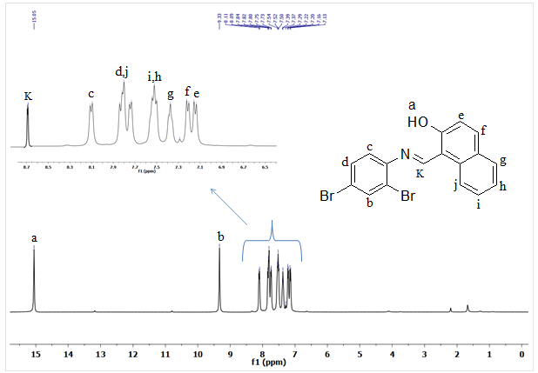

Figure S8. ¹H-NMR spectrum of 1-(E-(2, 4-dibromophenylimino) methyl) naphthalene-2-ol (HL) as bidentate ligand.

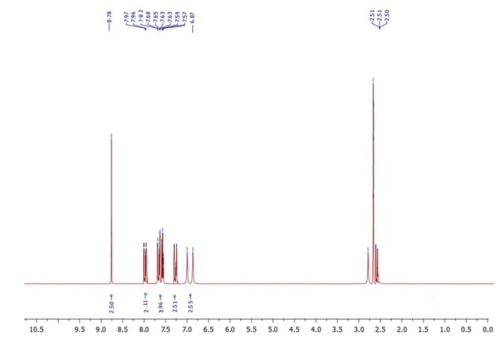
Figure S9. ¹H-NMR spectrum of Pt-complex (1) of bidentate ligand (HL).

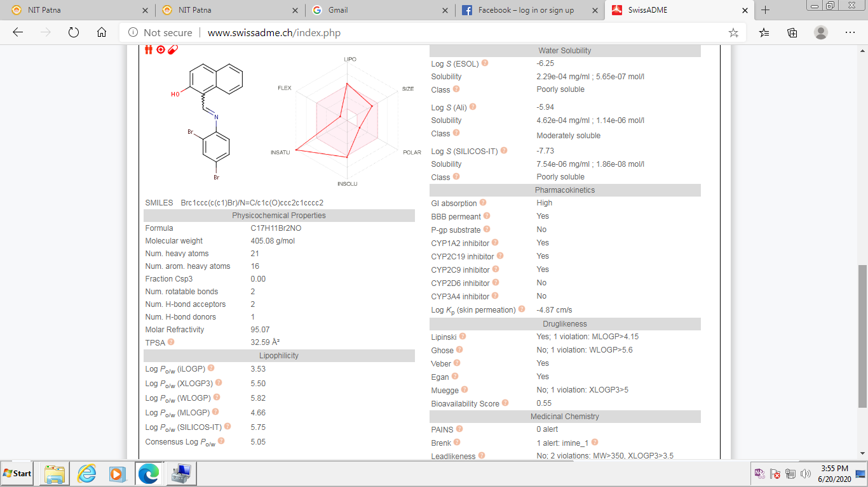Figure S10. SwissADME submission page, canonical SMILES and computed parameter values are grouped in the different sections of the one-panel-par-molecule output for HL.
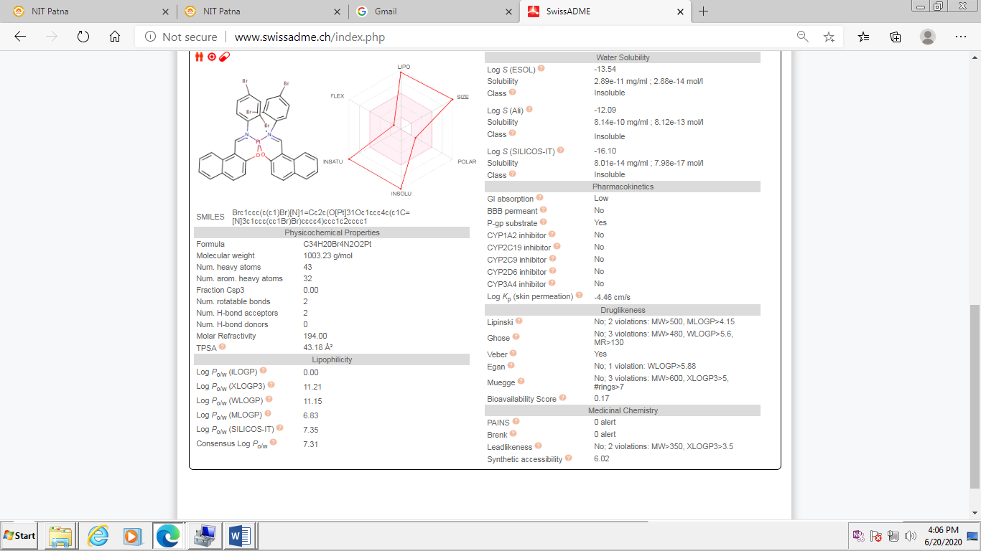
Figure S11. SwissADME submission page, canonical SMILES and computed parameter values are grouped in the different sections of the one-panel-par-molecule output for Pt-complex (1).

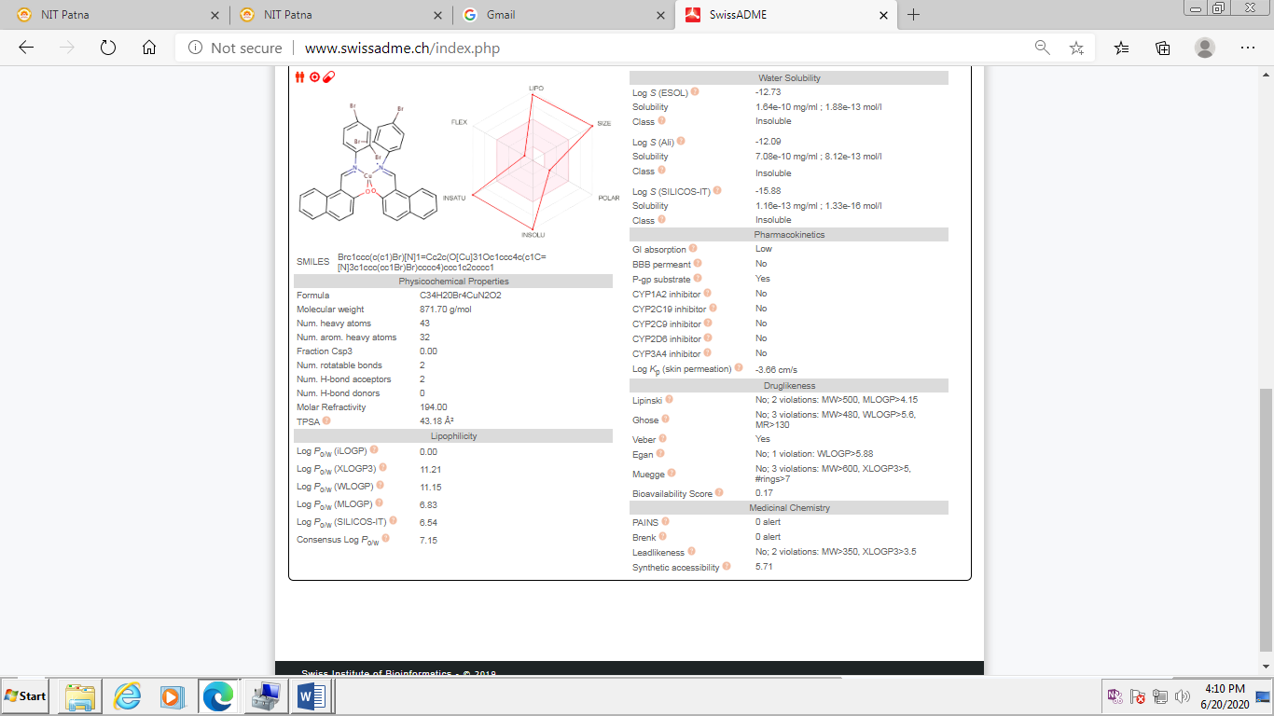
Figure S12. SwissADME submission page, canonical SMILES and computed parameter values are grouped in the different sections of the one-panel-par-molecule output for Cu-complex (2).

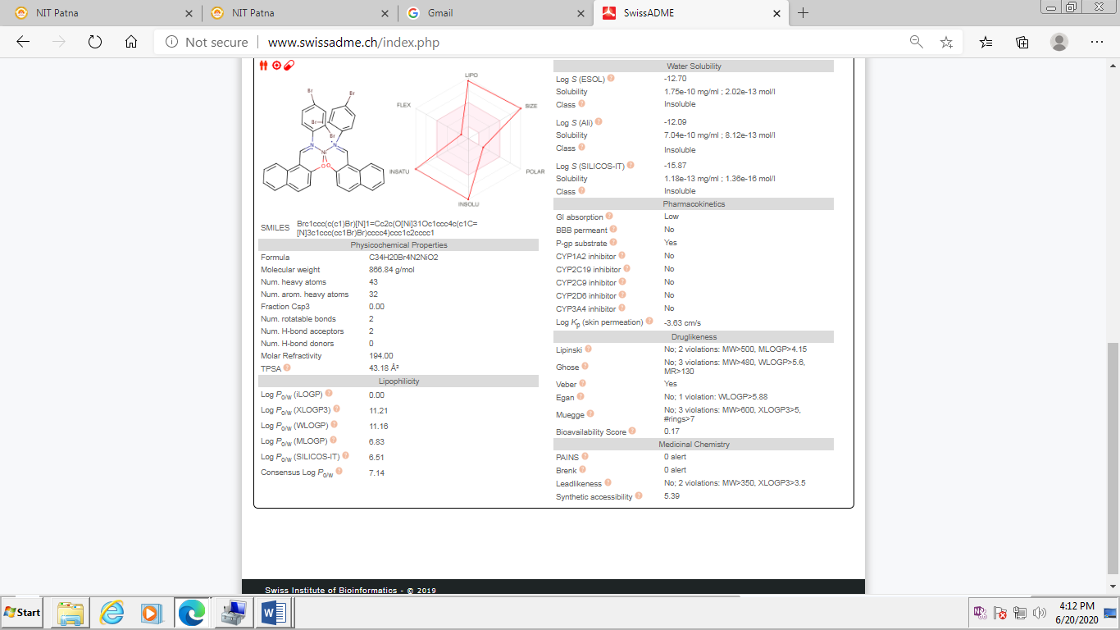
Figure S13. SwissADME submission page, canonical SMILES and computed parameter values are grouped in the different sections of the one-panel-par-molecule output for Ni-complex (3).

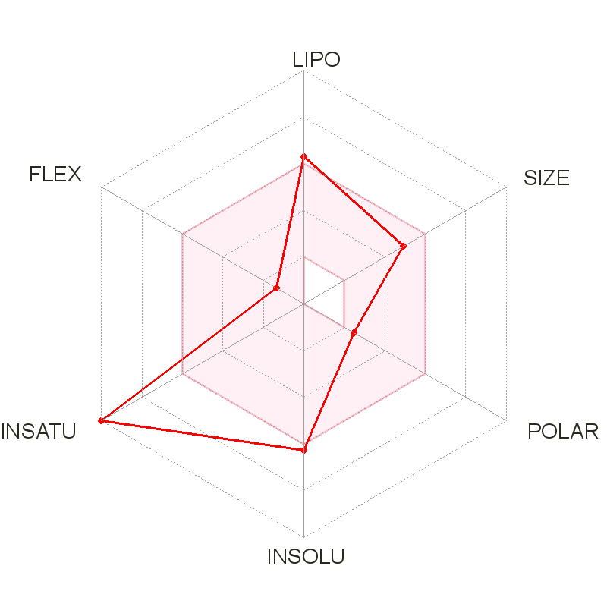
Figure S14. The bioavailability radar enables a first glance at the drug-likeness of HL.
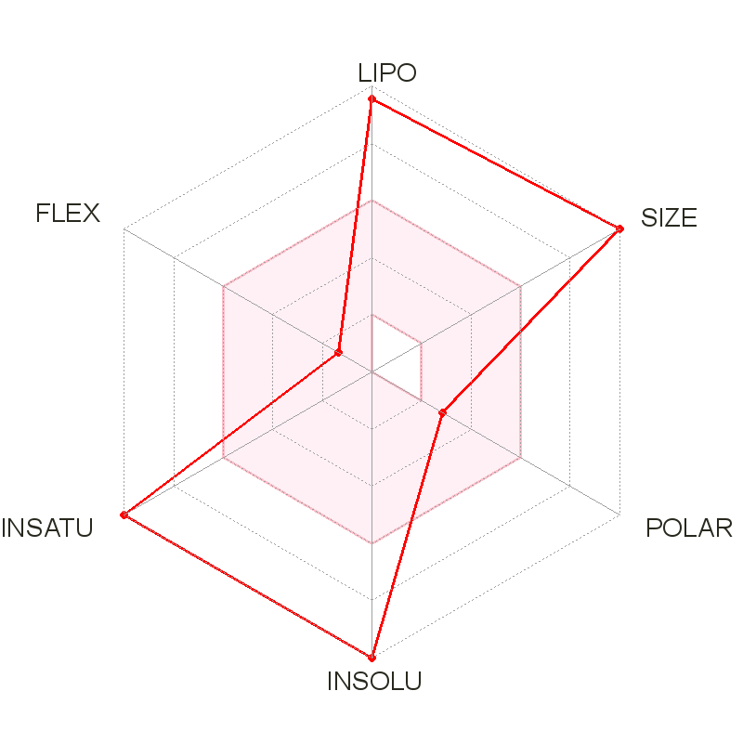
Figure S15. The bioavailability radar enables a first glance at the drug-likeness of Pt-complex (1).
Figure S16. The bioavailability radar enables a first glance at the drug-likeness of Cu-complex (2).
Figure S17. The bioavailability radar enables a first glance at the drug-likeness of Ni-complex(3).
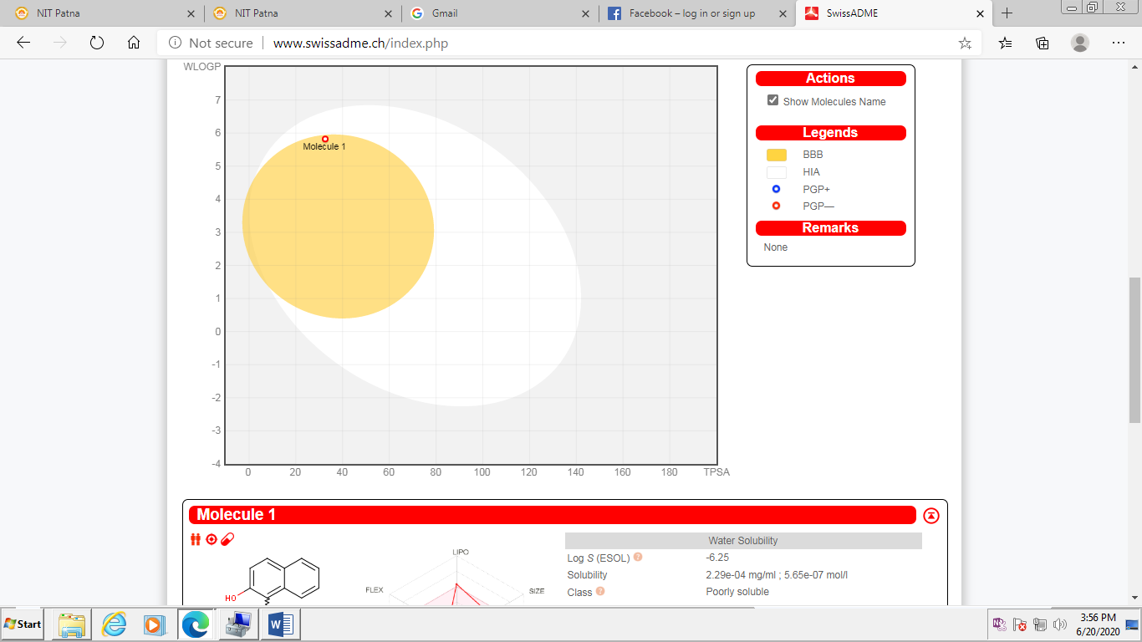
Figure S18. The BOILED-Egg construction for HL.
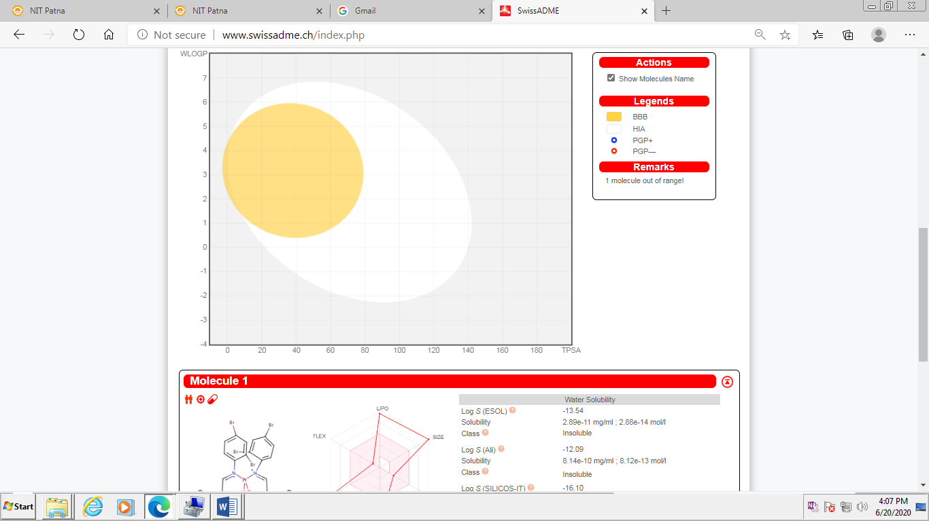
Figure S19. The BOILED-Egg construction for Pt-complex (1).
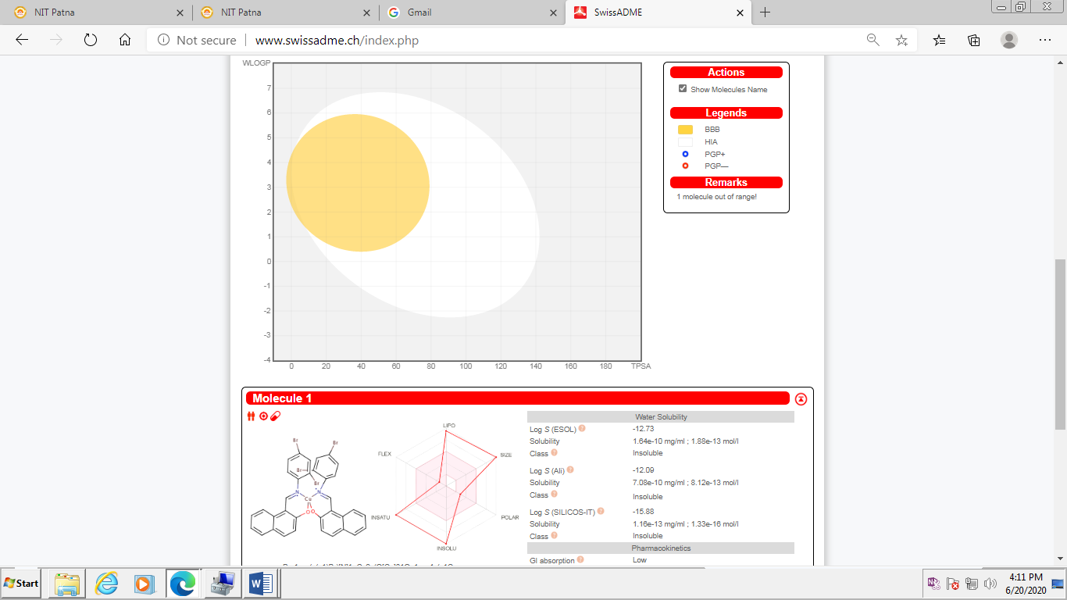
Figure S20. The BOILED-Egg construction for Cu-complex (2).
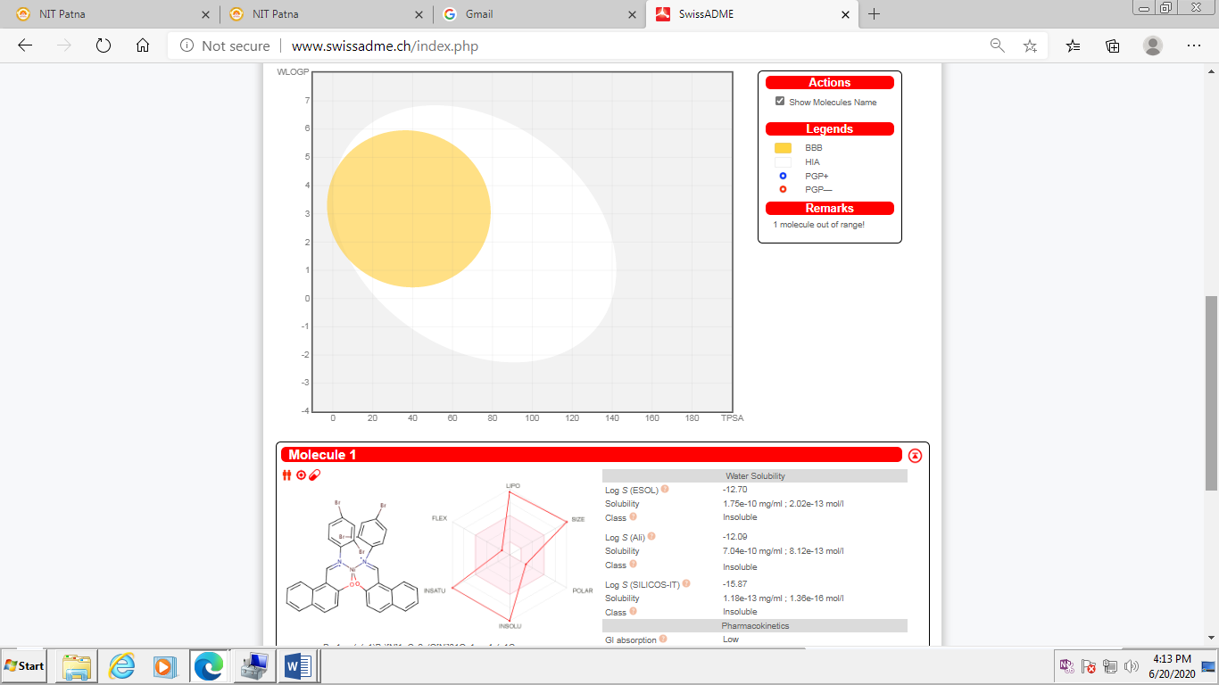
Figure S21. The BOILED-Egg construction for Ni-complex (3).

