Supplementary Materials
Anticonvulsant Activity, Molecular Modeling and Synthesis of Spirooxindole-4H-Pyran Derivatives using a Novel Reusable Organocatalyst
Leila Emami¹, Leila Moezi², Leila Amiri-Zirtol¹, Fatemeh Pirsalami², Masoumeh Divar¹, Aida Solhjoo³, Soghra Khabnadideh¹
¹Pharmaceutical Sciences, Research Center, Shiraz University of Medical Sciences, Shiraz, Iran.
²Department of Pharmacology, School of Medicine, Shiraz University of Medical Sciences, Shiraz, Iran.
³Faculty of Pharmacy, Shiraz University of Medical Sciences, Shiraz, I.R.Iran.

Instrumentation
Melting points were measured by a Buchi melting point B-540 B.V.CHI apparatus and are uncorrected. Fourier transform infrared (FT-IR) spectra were run on a Bruker Equinox by KBr pills in the 400-4000 cm⁻¹ region. Raman spectroscopy was recorded from 500 to 3500 cm⁻¹ on an Almega Thermo Nicolet Dispersive Raman Spectrometer using a Nd:YLF laser source operating at wavelength of 532 nm. X-ray diffraction (XRD) patterns were recorded on a Philips X-pert diffractometer equipped with a Cu-Ka radiation (λ = 1.54 A°) in the 2θ range from 5 to 80. Field emission scanning electron microscopy (FE-SEM) image was recorded using FE-SEM MIRA 3-XMU with a high-energy beam of electrons. The magnetic measurement was carried out using a vibrating sample magnetometer model VSM-4 inh. Energy-dispersive X-ray spectroscopy (EDS) analysis was performed using Zeiss SIGMA VP-500.

FESEM images of GO (a) and GO-A.P (b) with different magnifications.
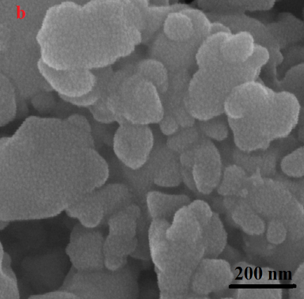
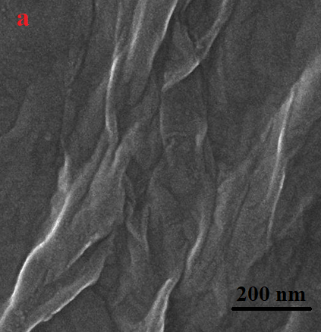

EDS mapping analysis distribution of O (a), N (b), C (c) and GO-A.P. (d).
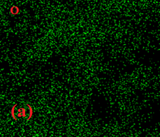
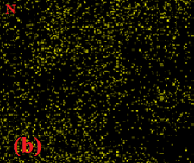

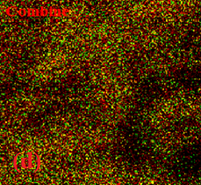
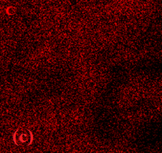

Thermal gravimetric analysis curves of GO (a) and GO-A.P. (b).
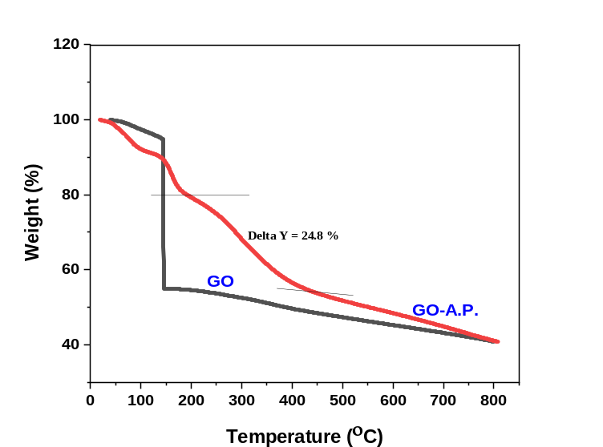

Corresponding author: Tel.: +98-71-32424127-8; Fax: +98-71-32424126; E-mail: khabns@sums.ac.ir

