Supplementary Information
For
Conformational Entropy Bottleneck Underlies Nanopore Interception of Polymers: Dominant Roles of Branching Architecture and Excluded Volume
Yiren Wang¹, Haorong Huang¹, Jiawen Yang², Xin Guan¹, Mo Zhu¹, Mingming Ding², Lianwei Li^{1*}
¹ College of Chemistry and Environmental Engineering, Shenzhen University, Shenzhen, China 518060
² School of Chemical Engineering and Light Industry, Guangdong University of Technology, Guangzhou, China 510006

Content
- Experimental section..................................................................................................................3
- Summarized molecular parameters of H-PS samples............................................................10
- Summarized molecular parameters of L-PS samples............................................................11
- Summarized information of nanochannels.............................................................................11
- SEC curve of AB₂-type PS macromonomers..........................................................................12
- FTIR spectra of bromine-terminated PS macromonomers, azide-terminated PS macromonomers and hyperbranched PS ...............................................................................12
- ¹H NMR spectra of AB₂-type initiator, bromine-terminated PS macromonomer and azide-terminated PS macromonomer................................................................................................13
- SEC curves of standard mixtures of linear PS standard samples.........................................14
- Scaling law between the size and molecular weight of PS in toluene...................................14
- Transmembrane pressure and corresponding Poiseuille pore diameter for different AAO-D_{n}………………………………………………………………………………………………15
- Stability test of the membrane before and after the interception experiment.....................15
- Dependence of transmembrane pressure on solvent viscosity…………………...…………16
- Dependence of translocation probability on critical retention volume…………………….16
- Determination of the critical interception size………………………………………………17
- Reference...................................................................................................................................18
EXPERIMENTAL SECTION
Materials. All chemicals, unless otherwise specified, were purchased from commercial suppliers and used without further purification. Propargyl 2,2-bis[(2-bromo-2-methylpropanoyloxy)methyl]propionate was synthesized according to literature procedures¹, with its structure confirmed by ¹H NMR (Fig. S3a). Styrene (Alfa Aesar, AR) was purified by passage through a basic alumina column to remove inhibitors and subsequently distilled under reduced pressure before storage at -18 °C. Toluene (Sigma-Aldrich, 99%), Dichloromethane (DCM, General-Reagent, AR), Anisole (Sigma-Aldrich, 99%) and tetrahydrofuran (THF, Aladdin, AR) were distilled over calcium hydride prior to use. Cyclopentane (Sinopharm, 99.5%) was used as received. Azobisisobutyronitrile (AIBN, TCI, 98%) was recrystallized from methanol. Copper(I) bromide (CuBr, Sigma-Aldrich, 98%) was washed with glacial acetic acid to remove soluble oxidized species, followed by ethanol, and dried under vacuum. Dimethylformamide (DMF, General-Reagent, AR) was dried over anhydrous magnesium sulfate and then distilled under reduced pressure. Aluminum foils (Aladdin, 99.999%), methanol (Aladdin, AR), tris(2-(dimethylamino)ethyl)amine (Me₆TREN, TCI, 98%), pentamethyldiethylenetriamine (PMDETA, Alfa Aesar, 99%), tin(II)-2-ethylhexanoate (Sn(EH)₂, Sigma-Aldrich, 95%), perchloric acid (HClO₄, Aladdin, 70%), sodium azide (NaN₃, Aladdin, 99%), ethanol (Sinopharm, AR), oxalic acid (Aladdin, 99%), chromic acid (H₂CrO₄, Dayang Chem, 98%), phosphoric acid (H₃PO₄, Alfa Aesar, 85%), copper(II) chloride dihydrate (CuCl₂·2H₂O, Alfa Aesar, 99%), and hydrochloric acid (HCl, Sinopharm, AR) were used as received without additional treatment.
Size Exclusion Chromatography (SEC).​ The molecular weights (number-average M_{n}, weight-average M_{w}, and peak M_{p}) along with the polydispersity index (M_{w}/M_{n}) of polystyrene and related intermediate samples were determined by single-detector size exclusion chromatography (SEC). The system consisted of a BWAIC P98II HPLC pump and a series of Shodex KF-800 columns (KF-806, KF-804, and KF-802.5; each 8 × 300 mm), providing effective separation across molecular weight ranges of approximately 1.5 × 10⁵ - 2 × 10⁷ g/mol, 7 × 10³ - 3 × 10⁵ g/mol, and 3 × 10² - 8 × 10³ g/mol, respectively. Detection was carried out using a Shodex RI-201H refractive index detector placed downstream of the column set. HPLC-grade tetrahydrofuran (THF) was employed as the mobile phase at a flow rate of 1.0 mL/min. The system was calibrated with a series of narrow-dispersity polystyrene standards with molecular weights of 2050, 9460, 28500, 68000, 156000, 696000, and 3500000 g/mol.
Proton Nuclear Magnetic Resonance Spectroscopy (¹H-NMR). All ¹H NMR measurements were performed at room temperature using a Bruker Avance III Ascend 400 MHz spectrometer. Samples were dissolved in deuterated chloroform (CDCl₃) containing tetramethylsilane (TMS) as an internal standard for chemical shift calibration.
Fourier Transform Infrared Spectroscopy (FTIR).‌ Measurements were conducted using a Bruker VECTOR-22 spectrometer. This sample was mixed with potassium bromide at a mass ratio of 1:100, and then pressed into small pellet for measurement. Spectral data were acquired with 64 cumulative scans at a resolution of 4 cm⁻¹.
Preparation of AB₂ Polystyrene Macromonomers. In a typical synthesis, propargyl 2,2-bis[(2‑bromo‑2‑methylpropanoyloxy)methyl]propionate (0.251 g, 0.534 mmol), Me₆TREN (0.123 g, 0.534 mmol), Sn(EH)₂ (0.216 g, 0.534 mmol), styrene (100 g, 0.962 mol), and anisole (110 mL) were successively added to a 250 mL glass tube equipped with a magnetic stir bar. The mixture was stirred until homogeneous, degassed via three freeze‑pump‑thaw cycles, and charged with CuBr (0.077 g, 0.053 mmol) while frozen. The sealed tube was immersed in an oil bath at 80 °C for 11.0 h, then quenched in liquid nitrogen. The crude product was diluted with THF, passed through a short alumina column to remove metal residues, and concentrated by rotary evaporation. The polymer was precipitated into cold methanol, collected, and dried under vacuum at 40 °C to afford the target macromonomer (yield 14.26 g, 78.5%; M_{w} = 3.41 × 10⁴ g/mol). Other PS macromonomers were prepared analogously (Fig. S1).
Azidation Substitution Reaction. 4.0 g (0.12 mmol) of alkynyl-(polystyrene-bromine)₂, 50 mL of N,N-dimethylformamide (DMF), and 0.300 g (4.70 mmol) of sodium azide were added to a 100 mL round-bottom flask. The mixture was stirred at room temperature for 36 hours. After removing most of the solvent under reduced pressure, the remaining portion was diluted with tetrahydrofuran, and the supernatant was collected after high-speed centrifugation and poured into an excess of cold methanol for precipitation. The precipitate was dried overnight in a vacuum oven at room temperature to obtain an AB₂ polystyrene macromonomer (yield 3.40 g, 85%) containing one alkynyl functional group and two azide functional groups. Following the same experimental procedure, the bromine-terminated PS monomers of other molecular weights were replaced with azide-terminated AB₂ macromonomers.
Preparation of Hyperbranched Samples from AB₂ Macromonomers via Azide−Alkyne Cycloaddition Reaction. A 5 mL dried glass tube equipped with a magnetic stir bar was charged successively with PS₃₄₀​ (200 mg, 0.006 mmol), PMDETA​ (10.4 mg, 0.06 mmol), and DMF​ (2 mL). After thorough mixing, the solution was degassed via two freeze–vacuum–thaw cycles. CuBr​ (4.79 mg, 0.03 mmol) was then added to the frozen mixture, and the tube was subjected to an additional freeze–vacuum–thaw cycle before being sealed under vacuum. The sealed tube was immersed in an oil bath at 40 °C for 24 h. After reaction, the mixture was diluted with THF and quickly passed through a neutral alumina column. Residual copper salts and ligand were removed by repeated precipitation from THF/methanol. The final product, hyperbranched polystyrene H‑PS_{1/170}​ (entry 8, Table S1), was collected by filtration and dried under vacuum at 45 °C overnight (yield: ~180 mg). Other H‑PS samples with varying branching densities and molecular weights (Table S1) were prepared following analogous procedures.
Calculation of Translocation Probability (P_{t}) and critical retention volume (R_{h,c}). In this work, the translocation probability (P_{t}) was determined by comparing the size-exclusion chromatography (SEC) traces of the hyperbranched polymer stock solution and the permeate collected after nanochannel interception. The SEC curve of the stock solution (C₀) served as the concentration reference. The corresponding SEC signal of the permeate solution (C) was normalized to C₀ on the same retention volume scale, yielding P_{t} directly from the ratio of the two chromatograms:
where Cand C₀ represent the normalized polymer concentrations in the permeate and stock solutions, respectively. This method effectively eliminates signal fluctuations from instrumental and operational variations, allowing a precise and reproducible assessment of the interception behavior. The typical uncertainty in P_{t} determination was within ± 3%.
Fabrication of Double-Through AAO Nanochannel Membranes. High-purity aluminum foils were electropolished in a 1:4 (v/v) mixture of 65% HClO₄ and ethanol at 20 V and 10 ℃. Ordered porous templates were fabricated via a two-step anodization process in 0.3 M oxalic acid at 7 ℃ under 40 V. For membranes D₁-D₃ (target pore diameters: 28-41 nm; interpore distance: 66 ± 5nm), the first anodization was performed for 18 h, followed by oxide removal in a mixture of 1.8 wt% H₂CrO₄ and 6 wt% H₃PO₄ at 45 ℃ for 8 h to generate hexagonal concaves. For membranes D₄-D₇ (55-96 nm diameter; interpore distance: 99 ± 8 nm), the first anodization duration was extended to 36 h, with identical etching conditions. The second anodization (24 h) yielded highly ordered nanopores. The aluminum substrate was selectively dissolved using a CuCl₂/HCl solution (7.0 g CuCl₂·2H₂O, 100 mL 40 wt% HCl, 100 mL DI water), exposing barrier layers at both ends. Double-through channels were formed by immersing membranes in 5 wt% H₃PO₄ at 30 ℃ with precisely controlled etching durations: D₁ (10 min), D₂ (15 min), D₃ (25 min), D₄ (40 min), D₅ (60 min), D₆ (90 min), and D₇ (120 min). This protocol yielded seven distinct double-through AAO membranes with cylindrical pores spanning 28-96 nm in diameter. Morphological fidelity and dimensional uniformity were confirmed by field-emission scanning electron microscopy (FE-SEM), with representative pore structures and size distributions detailed in Table S3.
Model and Simulation Details. Based on experimental observations and computational efficiency considerations, we constructed a simplified polystyrene (PS) model. Each polymer chain consists of 700 styrene monomer units, and five distinct initial conformations were prepared to investigate how the starting geometry influences the radius-of-gyration (R_{g}) distribution. The molecular topology was generated using Sobtop². Partial charges and force-field parameters were assigned within the Amber99sb framework³. To ensure sufficient relaxation and to avoid trapping in local minima, the initial structures were placed in a 30 nm × 30 nm × 30 nm periodic simulation box. Toluene was used as the solvent to represent the solution environment for conformational and statistical analyses.
Molecular dynamics simulations were performed under periodic boundary conditions using the GROMACS 2022.5 package⁴. The simulation protocol comprised energy minimization (EM), NPT equilibration, and NVT production. EM was first carried out to remove unfavorable contacts. The system was then equilibrated for 20 ns in the NPT ensemble at 300 K and 1 bar with a 2 fs integration time step. Subsequently, a total of 100 ns of cyclic annealing was conducted in the NVT ensemble: the temperature was gradually increased from 300 K to 378 K, held briefly at the elevated temperature to facilitate crossing conformational energy barriers, and then cooled back to 300 K to obtain well-relaxed chain conformations for subsequent statistical analysis. Short-range interactions were evaluated using a Verlet neighbor list, while long-range electrostatics were treated with the particle-mesh Ewald (PME) method; bond lengths involving hydrogen atoms were constrained. Trajectory post-processing and the calculation of structural observables, including Rg, were performed using the built-in GROMACS gmx analysis tools, based on the trajectories collected after completion of the annealing procedure⁴. Molecular visualization and trajectory inspection were carried out using VMD⁵.
Table S1. Summary of relative molecular structure parameters of hyperbranched PS samples measured by SEC.
Samples | Entry | M_{n}ª/10⁵ (g/mol) | M_{w}ª/10⁵ (g/mol) | M_{p}ª/10⁵ (g/mol) | <M_{w}/M_{n}>ª
H-PS_{1/25} | 1 | 0.19 | 0.09 | 0.39 | 2.14
H-PS_{1/25} | 2 | 0.38 | 0.13 | 0.94 | 3.04
H-PS_{1/25} | 3 | 0.77 | 0.16 | 3.15 | 4.83
H-PS_{1/95} | 4 | 0.57 | 0.25 | 1.15 | 2.29
H-PS_{1/95} | 5 | 1.18 | 0.38 | 3.01 | 3.06
H-PS_{1/95} | 6 | 3.22 | 0.47 | 13.12 | 6.89
H-PS_{1/170} | 7 | 0.49 | 0.32 | 0.75 | 1.51
H-PS_{1/170} | 8 | 1.27 | 0.51 | 2.99 | 2.50
H-PS_{1/170} | 9 | 2.73 | 0.68 | 9.03 | 4.01
H-PS_{1/170} | 10 | 4.65 | 0.85 | 18.55 | 5.49
H-PS_{1/650} | 11 | 2.11 | 1.24 | 3.66 | 1.70
H-PS_{1/650} | 12 | 2.30 | 0.73 | 6.39 | 3.18
H-PS_{1/650} | 13 | 5.13 | 1.61 | 18.04 | 3.18
ª Data are obtained by analyzing the SEC data based on the classical calibration method.
Table S2. Summary of relative molecular structure parameters of linear PS samples measured by SEC.
Samples | M_{n}ª/10⁵ (g/mol) | M_{w}ª/10⁵ (g/mol) | M_{p}ª/10⁵ (g/mol) | <M_{w}/M_{n}>ª | <R_{g}>^{b}/nm | <C*>^{c}/(g/L)
L-PS₁ | 0.96 | 0.4 | 0.6 | 2.39 | 11.2 | 26.5
L-PS₂ | 2.8 | 1.3 | 2.6 | 2.15 | 21.2 | 11.4
L-PS₃ | 5.8 | 2.7 | 7.1 | 2.12 | 32.6 | 6.5
L-PS₄ | 7.4 | 5.8 | 3.3 | 2.23 | 37.7 | 5.4
L-PS₅ | 9.8 | 3.4 | 5.0 | 2.89 | 44.5 | 4.3
ª Data are obtained by analyzing the SEC data based on the classical calibration method.
^{b} Data are estimated based on the scaling relation of R_{g} = 1.06 × 10⁻²M_{w}^{0.575} in toluene⁶.
^{c} Data are estimated based on the scaling relation of C* = 2.11 × 10⁻²M_{w}^{-0.782} in toluene⁶.

Table S3. Summarized information of nanochannels with different average pore sizes calculated based on scanning electron microscopy characterization and Poiseuille equation
Series | D_{SEM,F}ª/nm | D_{SEM,B}ª/nm | [(D_{SEM,F}+D_{SEM,B})/2]ª  /nm | Đª | Nª/  (10¹⁰pores/cm²) | D_{Poiseuille}^{b}/nm | Q_{micro}^{c}/  (10⁻²¹ m³/s) | v_{micro}^{c}/  (10⁻⁶ m/s)
D₁ | 30 | 28 | 29 | 1.02 | 2.71 | 28 | 2.06 | 3.35
D₂ | 40 | 36 | 38 | 1.01 | 2.62 | 32 | 2.11 | 2.62
D₃ | 46 | 44 | 45 | 1.01 | 2.42 | 41 | 2.31 | 1.75
D₄ | 68 | 64 | 66 | 1.01 | 1.02 | 55 | 5.44 | 2.29
D₅ | 78 | 76 | 77 | 1.01 | 0.87 | 72 | 6.39 | 1.57
D₆ | 82 | 80 | 81 | 1.00 | 0.71 | 88 | 7.83 | 1.29
D₇ | 96 | 94 | 95 | 1.00 | 0.62 | 96 | 8.97 | 1.24
ª Data were obtained by analyzing the scanning electron microscope images using the IMAGE-J software.
^{b} Data were obtained by analyzing the transmembrane pressure using the Poiseuille equation.
^{c} Data are estimated based on the the macroscopic flow rate Q = 0.2 mL/h.

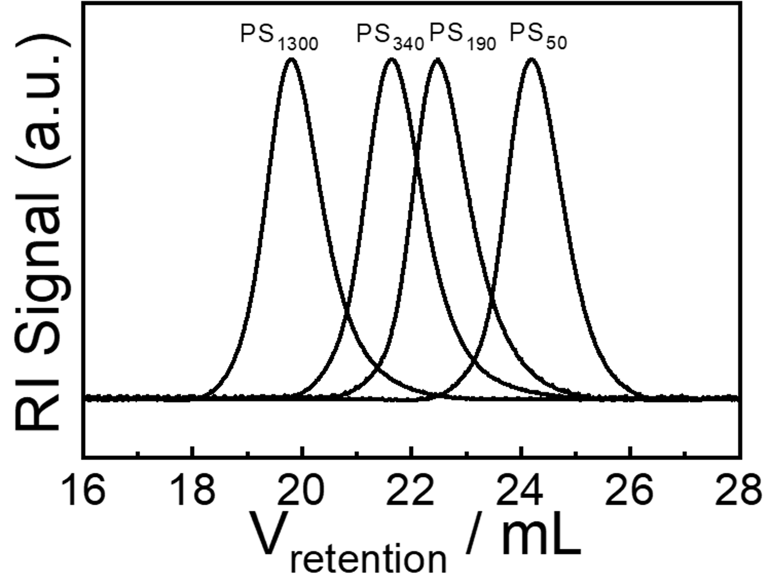
a S1. SEC curves of prepared AB₂-type PS₁₃₀₀, PS₃₄₀, PS₁₉₀ and PS₅₀ macromonomers in THF.
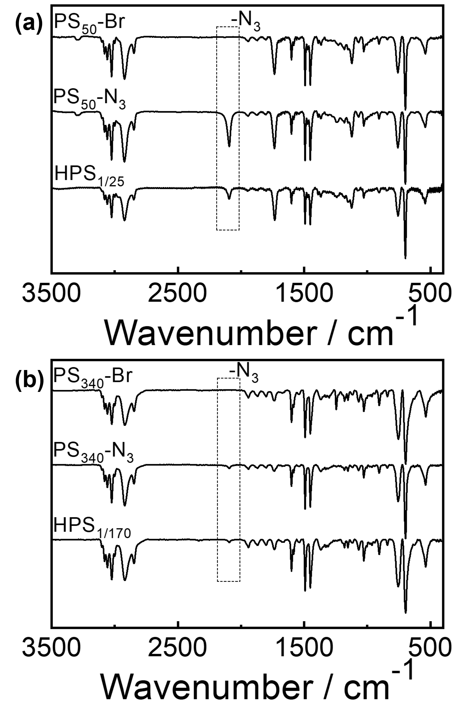
Figure S2. FTIR spectra of bromine and azide functionalized macromonomers, and
hyperbranched polymers corresponding to (a) PS₅₀ and (b) PS₃₄₀.

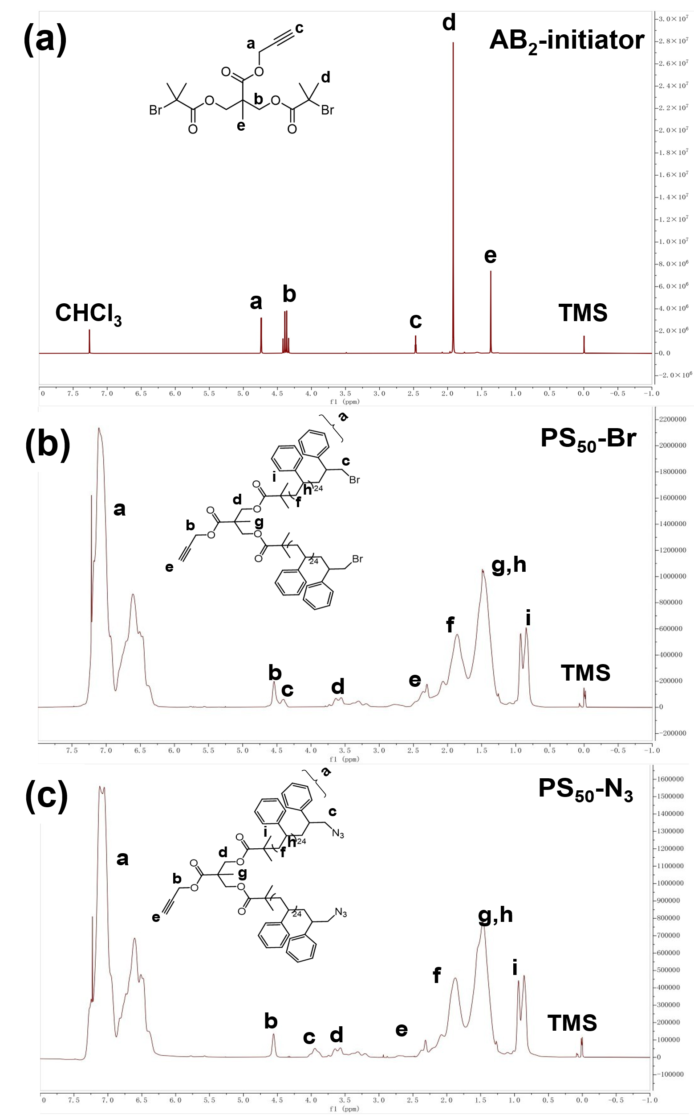
Figure S3. ¹H NMR spectra of (a) AB₂ initiator; (b) bromine and (c) azide functionalized macromonomers corresponding to PS₅₀.

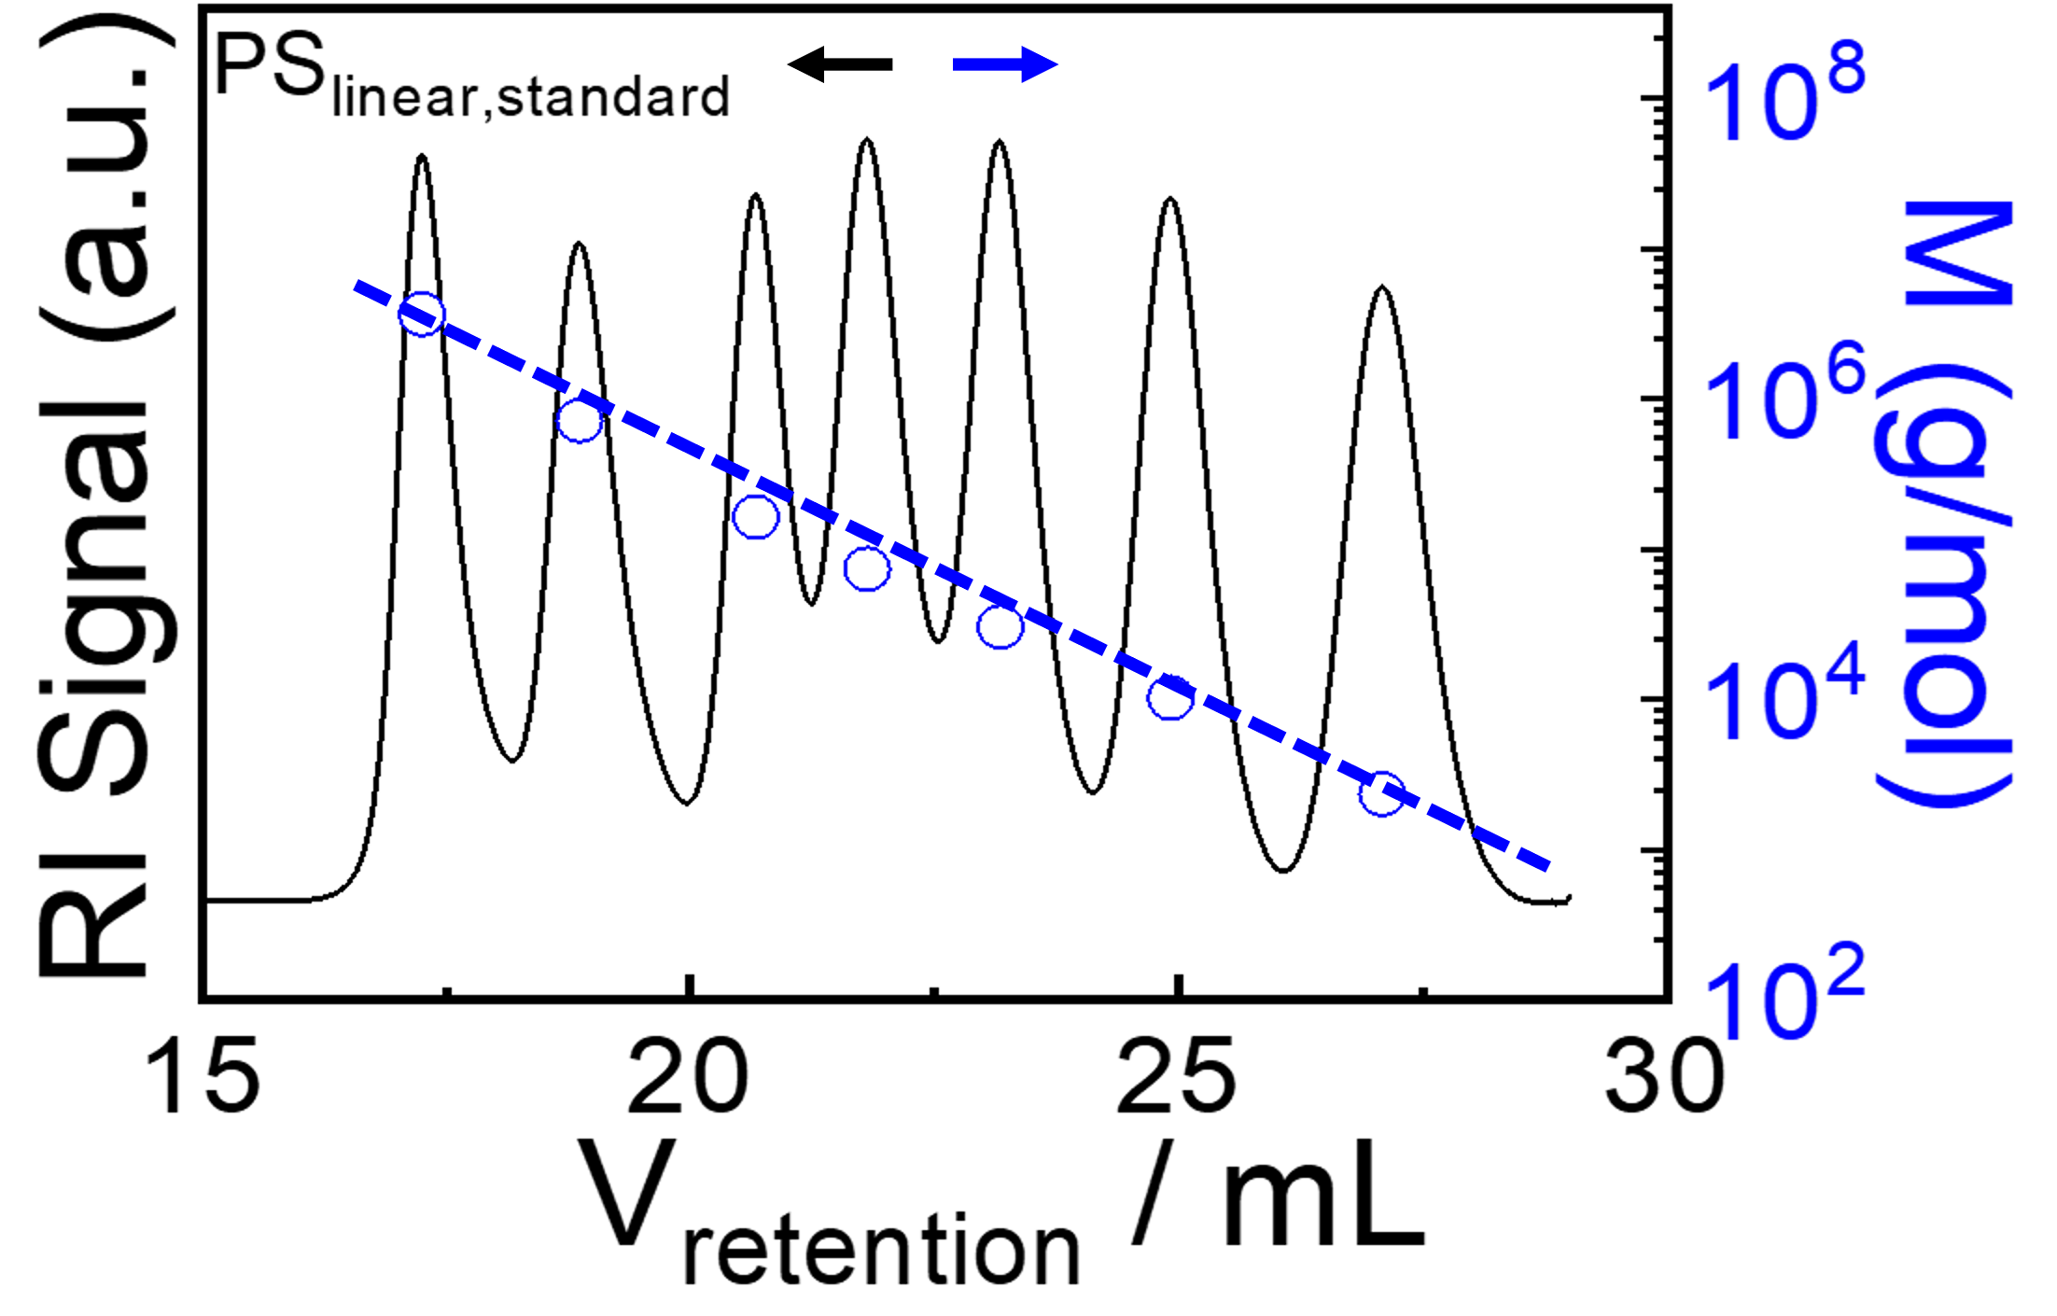
Figure S4. SEC curves of standard mixtures of linear polystyrene standard samples(M_{w} = 3,500,000, 696,000, 156,000, 68,000, 28,500, 9,460, and 2,050 g/mol) (black solid line) and the molecular weight calibration curve (blue dashed line).

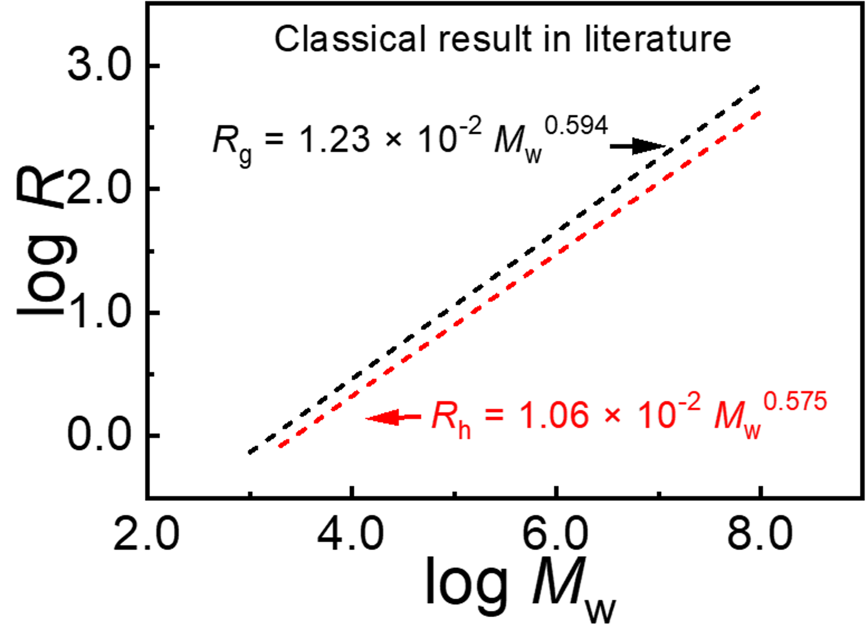
Figure S5. Scaling laws between the radius of gyration (R_{g}) and hydrodynamic radius (R_{h}) with weight-average molecular weight (M_{w}) for polystyrene in toluene⁶.

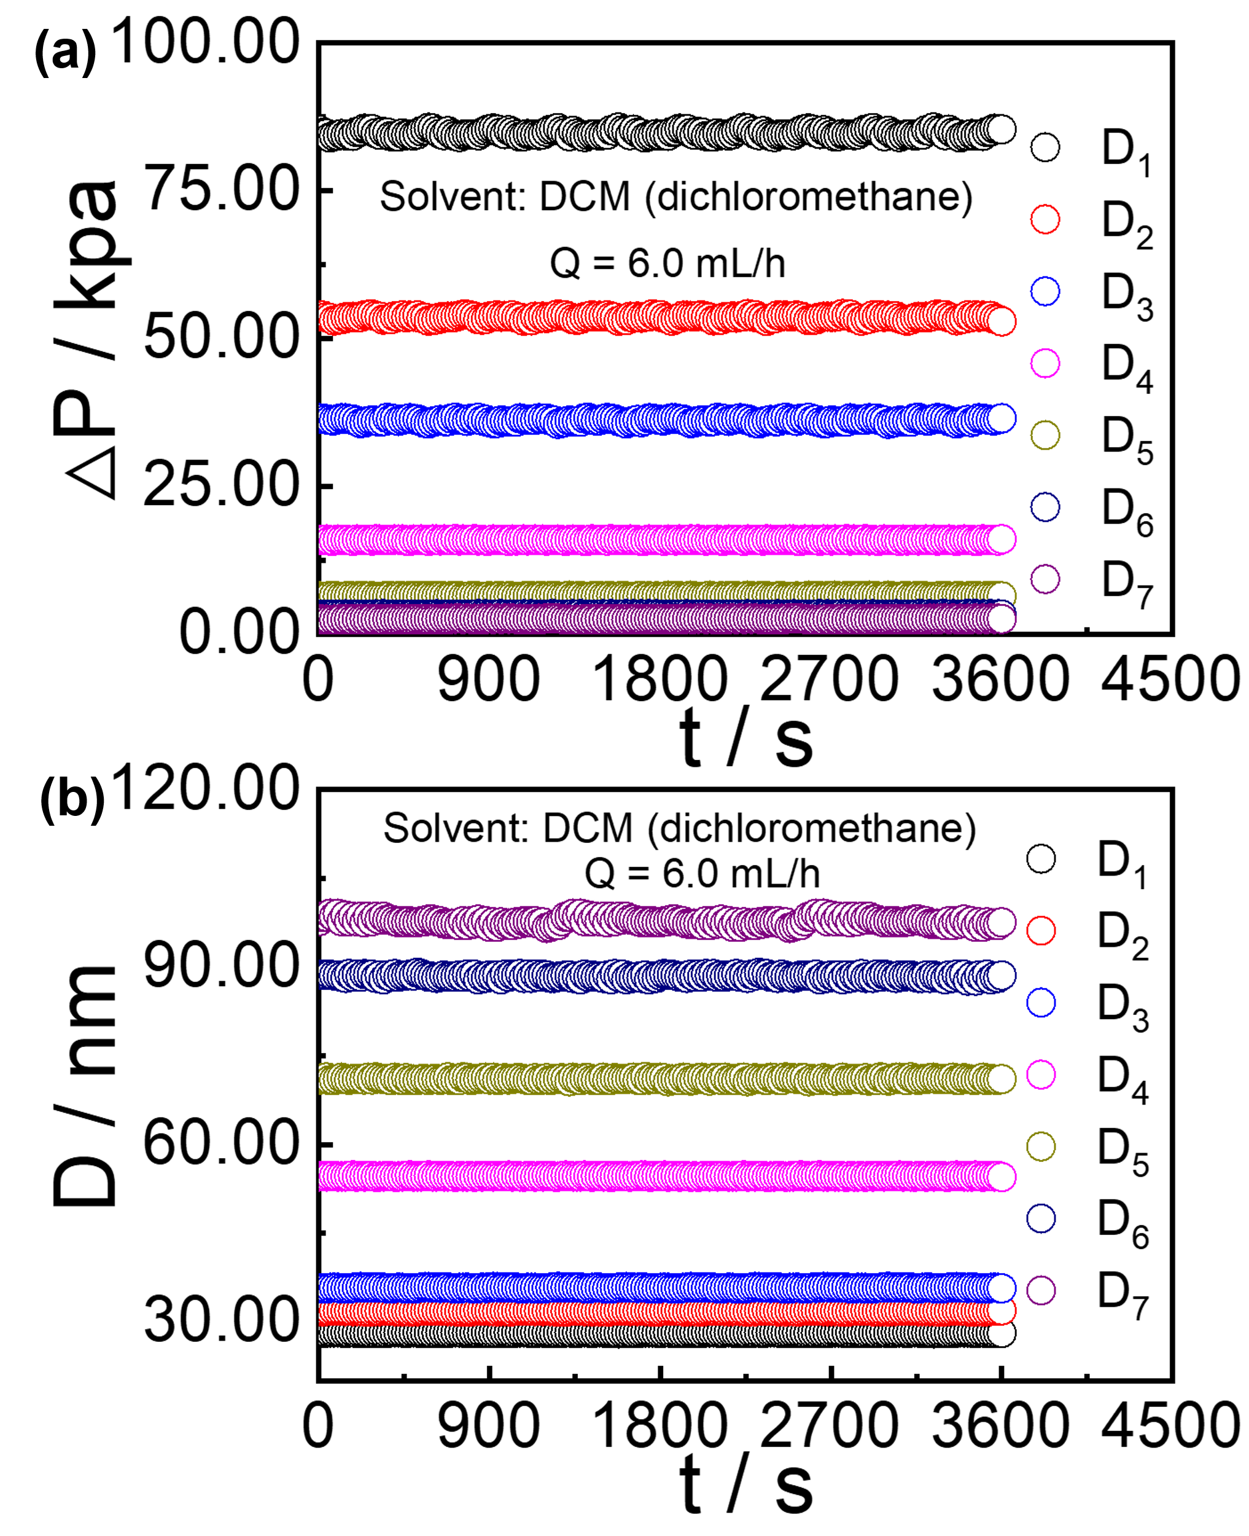
Figure S6. (a) Transmembrane pressure (ΔP) versus time (t) for seven membranes with different pore sizes (AAO D₁-D₇) using dichloromethane (DCM) as the solvent at a flow rate (Q) of 6.0 mL/h. (b) Pore size (D) calculated via the Hagen-Poiseuille equation versus time (t) for the same membranes under identical solvent and flow rate conditions.

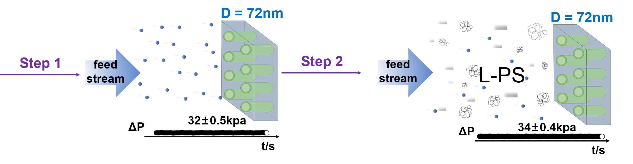
Figure S7. Sequential interception protocol (solvent→L-PS) with reverse solvent flushing to minimize polarization effects, where transmembrane pressure (ΔP) remains stable (32±0.5 - 34±0.4 kPa) during experiments with D = 72 nm AAO membranes, indicating membrane structural stability.

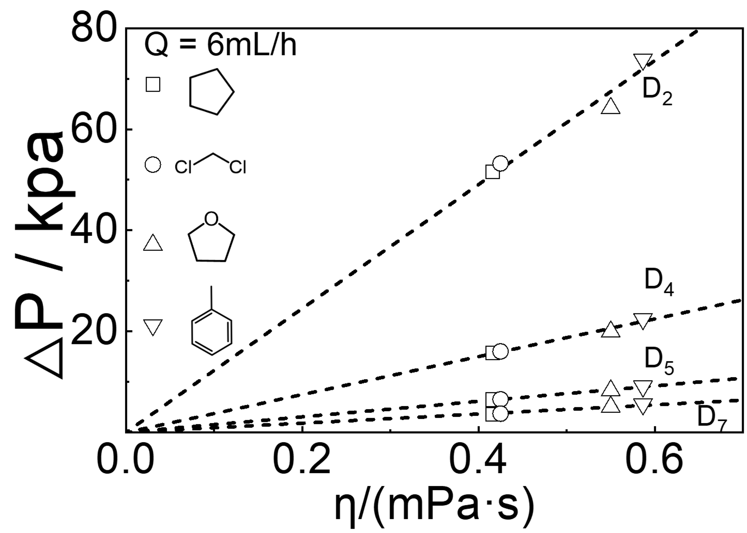
Figure S8. The solvent viscosity (η) dependence of the transmembrane pressure (ΔP) at at a fixed flow rate of 6 mL/h, for membranes with different pore sizes (D₂, D₄, D₅, D₇) and various solvents (as indicated by molecular structures).

Figure S9. Dependence of translocation probability (P_{t}) on critical retention volume (V_{retention}) for nanopore D₁ - D₃ (a-b) and D₅ – D₇ (d-f).
Figure S10. Dependence of translocation probability (P_{t}) on hydrodynamic radius (R_{h}) for nanopore D₄, where the intersection point of the gray band and the curve is R_{h,c}.

References
(1) Li, L.; He, C.; He, W.; Wu, C. Formation Kinetics and Scaling of “Defect-Free” Hyperbranched Polystyrene Chains with Uniform Subchains Prepared from Seesaw-Type Macromonomers. Macromolecules 2011, 44, 8195-8206.
(2) Lu, T. Sobtop, version 1.0 (dev4); http://sobereva.com/soft/Sobtop (accessed Jan 30, 2026).
(3) Showalter, S. A.; Brüschweiler, R. Validation of Molecular Dynamics Simulations of Biomolecules Using NMR Spin Relaxation as Benchmarks: Application to the AMBER99SB Force Field. J. Chem. Theory Comput. 2007, 3, 961-975.
(4) Abraham, M. J.; Murtola, T.; Schulz, R.; Páll, S.; Smith, J. C.; Hess, B.; Lindahl, E. GROMACS: High performance molecular simulations through multi-level parallelism from laptops to supercomputers. SoftwareX 2015, 1, 19-25.
(5) Humphrey, W.; Dalke, A.; Schulten, K. VMD: Visual molecular dynamics. J. Mol. Graph. 1996, 14, 33-38.
(6) Fetters, L. J.; Hadjichristidis, N.; Lindner, J. S.; Mays, J. W. Molecular Weight Dependence of Hydrodynamic and Thermodynamic Properties for Well‐Defined Linear Polymers in Solution. J. Phys. Chem. Ref. Data 1994, 23, 619-640.

