Supplementary materials to paper “Heat Transfer in Porous Low–k Materials: Modeling Based on Fractional Calculus and Material Structure Fractality”
In Fig. A, the measured thermal conductivity for samples with different porosity values is represented by circles for each material. In Ref. [7], these experimental thermal conductivity data were approximated with lines according to the DEM and CP theories. A significant difference was observed between the experimental data and the established models. The authors⁷ proposed a hypothesis regarding the role of residual porogens, which may not increase the density significantly while still affecting thermal conductivity.
According to our developed theory, however, these data can be explained by the fractality of the porous material. As follows from Eq. (11), the effective thermal conductivity depends on the pore length as $\frac{1}{L^{2}}$ while the pore volume is proportional to L. Consequently, thermal conductivity should depend on the square of density $λ^{eff}\sim ρ_{por}^{2}$. After plotting thermal conductivity as a function of density squared, good agreement with the data is obtained.
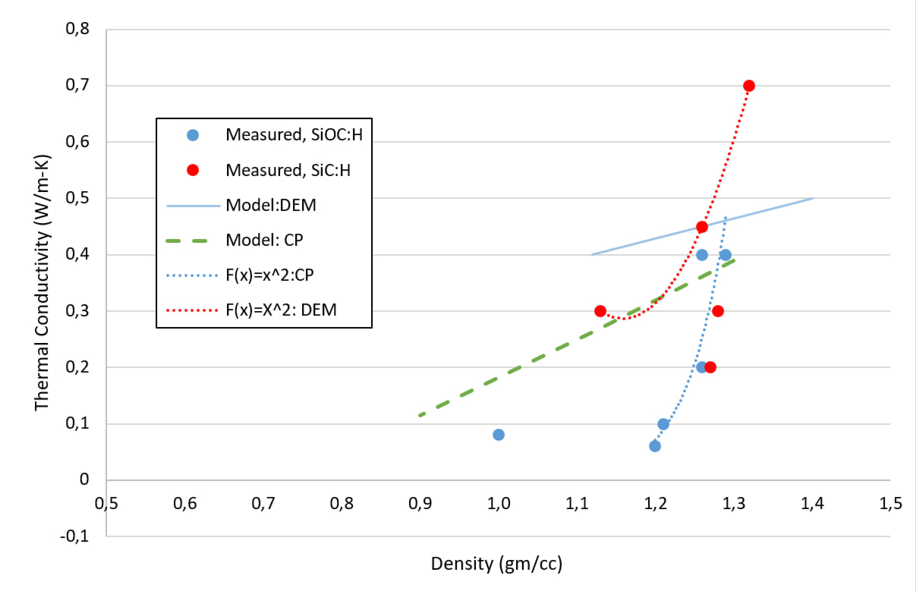

Fig. A. Density dependence of thermal conductivity of low-k oxides in experimental data and models available in the literature ⁷ and developed fractal theory - quadratic curves.

