Supplementary Information: Breaking the Paradigm of Stacking: A Minimalist Infrared Detection System Based on Meta-Composite Design with Athermalized Performance

Supplementary Information 1. Detailed Performance Specifications of MCOS
The detailed system performance specifications for the MCOS are summarized in Table S1.
Table S1. System parameters.
Indicator | Value
Wavelength (μm) | 8-12
F/# | 1.05
Aperture(mm) | 58
FOV (°) | 20
Focal length (mm) | 60
Table S2 presents a comparison of the specific performance parameters between this work and other studies.
Table S2. Performance comparison between MCOS and other hybrid refractive-diffractive systems.
 | Wavelength (μm) | Focusing efficiency  (%) | Aperture  (mm) | FOV  (°) | Athermalization  range  (℃)
Ref.[1] | 0.55-0.8 | 8.5 | 10 | - | No
Ref.[2] | 0.42 - 0.68 | - | 8 | - | No
Ref.[3] | 0.455,0.525,  0.630 | ~60  (max) | 3.2 | 30 | No
Ref.[4] | 0.4-0.7 | 51–70 | 0.09 | - | No
Ref.[5] | 8-14 | ＞50 | 7 | 30 | No
Ref.[6] | 0.9-1.7 | 96.7  (relative) | 12.7 | 178 | No
This Work | 8-12 | 87.46 | 58 | 20 | -40~60

Supplementary Information 2. Ray-tracing analysis and structural parameters of MCOS
Fig. S1 illustrates the detailed configuration of the MCOS, optimized through ray-optics simulations. The system achieves high-performance light-field modulation and imaging via a meta-hybrid design combining a metasurface with a diffractive aspherical surface.
Fig. S1 | Optimization of MCOS configuration based on ray-optics simulations.
This hybrid system integrates a diaphragm onto the front surface of the meta-composite lens to effectively modulate the incident beams. In the figure, ray bundles in six colors—blue, cyan, pink, yellow, red, and green—represent the optical trajectories of incident plane waves at angles of θ = 0°, 2°, 4°, 6°, 8°, and 10°, respectively. Ray-tracing results demonstrate that beams from all fields of view are precisely focused onto the image plane after modulation by the MCOS, exhibiting superior aberration correction capability and focusing uniformity across a wide field of view.
The specific parameters of the MCOS are as follows; Table S3 lists the surface type, radius of curvature, thickness, and material for each surface in the MCOS. The physical thickness T1 of the meta-composite lens is 5.2 mm. An air gap with a length D1 of 53.7 mm is set between the meta-composite lens and the rear refractive lens to provide sufficient phase evolution space. As the compensation element of the system, the refractive lens has a thickness T2 of 7.7 mm, and the distance D2 between its back surface and the focal plane is 18.9 mm. The effective focal length (EFL) of the entire optical system is 60 mm, and the total track length (TTL) is 85.5 mm.
Table S3. Parameters of MCOS.
Surface. Number | Surface.  Type | Radius  (mm) | Thickness  (mm) | Material
S1 | Plane | Inf. | Inf. | -
S2 | Binary 2 | 49.309 | 5.200 | IG6
S3 | Asphere | 62.365 | 53.364 | -
S4 | Asphere | 27.774 | 7.658 | IG6
S5 | Asphere | 28.533 | 15.331 | -
S6 | Plane | Inf. | - | -
Table S4 lists the phase coefficients of the metasurface; after optimization, only two terms are retained, indicating that low-order phase terms alone are sufficient to effectively correct aberrations. This also demonstrates the complementary advantages of the meta-hybrid design, which enables effective control over the surface complexity of the phase profile.
Table S4. Phase coefficients of metasurface.
Surface. Number | $$M$$ | $$A_{1}$$ | $$A_{2}$$
S2 | 1 | 4.510180435473000E-002 | 6.631650245838000E-006

Supplementary Information 3. Simulation analysis of focal spot stability for MCOS across a wide temperature range
The MCOS demonstrates exceptional stability in focusing performance across a wide temperature range (-40 to 60°C). Observations of the focal spot distributions under different temperature gradients reveal that the wavefront aberrations of the system are effectively compensated during environmental changes. The central peak intensity of the spot remains consistently stable, with no significant energy dispersion or spot distortion observed.
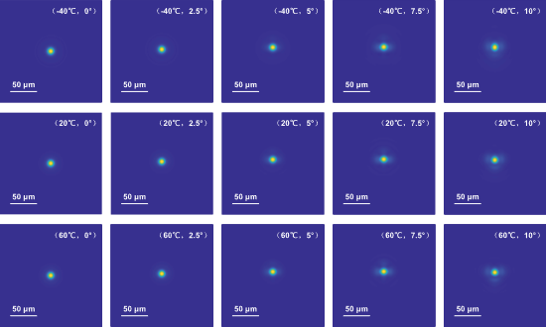
Fig. S2 | Energy distribution maps of focal spots (PSF) at different temperatures and representative fields of view (Scale bar: 50 μm).
Across the entire field of view, the FWHM of the focal spots is significantly smaller than the 50 μm scale bar. Furthermore, under severe temperature fluctuations, the spot morphological characteristics and energy concentration exhibit only negligible variations. The high stability of the spot morphology strongly validates the thermal characteristic compensation strategy between the metasurface and the diffractive aspherical substrate in the MCOS design. This complementary effect successfully achieves the athermalization of the system, maintaining excellent imaging quality even under drastic temperature shifts.
Particularly under oblique incidence at a 10° field of view, although the spot expands slightly due to off-axis factors, its performance remains nearly symmetrical at both high and low temperature extremes. This reflects the robust self-compensation mechanism of the MCOS during thermal expansion, which effectively suppresses defocus and thermally-induced aberrations. These features ensure that the system maintains high-resolution detection capabilities even under extreme climatic conditions.

Supplementary Information 4. Quantitative Analysis of System Focusing Efficiency Based on Simulations
Fig. S3 Simulation analysis of system focusing efficiency. (a) Normalized PSF distribution, where the red dashed box defines the focal energy region used for efficiency calculation; (b) Intensity profile of the PSF center along the x-direction; (c) Encircled energy (EE) curve extracted based on PSF integration.
To quantitatively evaluate the focusing performance of the system, we first obtained the PSF distribution through simulation, as shown in Fig.S3a. This PSF fully characterizes the spatial energy distribution of the light field at the focal plane. By extracting the intensity profile of the center along the x-direction (Fig. S3b), it can be observed that the focal spot exhibits high symmetry, with a FWHM of 10.1 μm (as labeled in the figure). In calculating the system focusing efficiency, we defined 3 times the FWHM as the effective radius of the focal energy, corresponding to the circular region demarcated by the red dashed line in Fig. S3a, to exclude background noise and accurately capture the core optical energy. Finally, based on the radial integration of the PSF spatial distribution, the dynamic curve of encircled energy (EE) as a function of radius was derived. As shown in Fig.S3c, the optical energy exhibits a rapid convergence trend as the statistical radius increases. Within the 3×FWHM radius, the system focusing efficiency reaches 87.46%, physically validating the superior energy manipulation and imaging focusing capabilities of the MCOS.

Supplementary Information 5. Fabrication flowchart and sample characterization
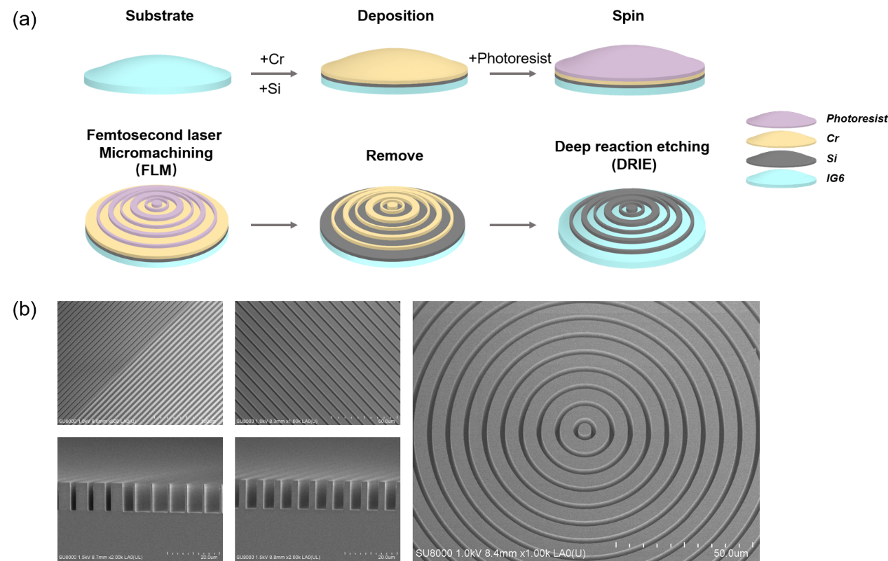
Fig. S4 Fabrication process and sample characterization of the meta-composite lens. (a) Fabrication flowchart of the meta-composite lens based on concentric ring structures; (b) Top and cross-sectional views of the off-center regions, and an oblique view of the center region of the meta-composite lens.
To verify the theoretical feasibility, an experimental prototype of the MCOS was successfully fabricated and integrated. The fabrication flowchart and microscopic characterization of the meta-composite lens samples are shown in Fig. S4. The double-sided aspherical lens was ultra-precisely machined using the single-point diamond turning (SPDT) process, ensuring sub-micrometer accuracy for the high-order aspherical surface profile. Subsequently, annular microstructures were precisely constructed on the lens substrate surface via femtosecond laser machining (FLM) and deep reactive ion etching (DRIE) processes. Scanning electron microscopy (SEM) characterization results are presented in Fig. S4b, showing that the fabricated meta-atoms are intact and uniformly arranged. The etching height was precisely controlled at 10.8µm, which is in high agreement with the design model.

Supplementary Information 6. Athermalized imaging experimental system
Fig. S5 | Optical test system configuration for athermalized imaging experiments. (a, b) Schematic and photograph of the test system for high-temperature imaging experiments; (c) Schematic of the test system for low-temperature imaging experiments; (d) High-contrast infrared test target based on blackbody radiation differences; (e) Integrated MCOS lens barrel under a controlled low-temperature environment.
For the high-temperature environment test, as shown in Fig. S5a, the complete test system—comprising a blackbody source, a resolution target, the MCOS module, and a detector, with a testing distance of approximately 80 cm—was entirely placed within a controlled environmental chamber. The experiment utilized an auxiliary heat source to generate uniform thermal field radiation, raising the ambient temperature inside the chamber to a constant level above 60°C to simulate the operating states of the device under high-temperature exposure or high-power-consumption conditions. The photograph of the actual high-temperature experimental setup is shown in Fig. S5b, where multi-point temperature measurements were conducted on the lens barrel surface using thermocouples to ensure that the optical components reached thermal equilibrium.
As shown in Fig.S5c, a local temperature control strategy was adopted for the low-temperature environment testing. The blackbody radiation source and the test target, shown in Fig.S5d, were maintained outside the chamber. Owing to the operational requirement of opening the refrigeration chamber during imaging, the MCOS and detector assembly were pre-installed within the controlled environment (Fig. S5e). The chamber was pre-cooled to -82°C to counteract the thermal shock induced by air convection upon opening. Experimental observations indicate that the local ambient temperature stabilized at approximately -50°C during characterization, thereby rigorously satisfying the requisite test condition of -40°C. This setup effectively simulates the operational behavior of the system in cryogenic environments.

Supplementary Information 7. UAV imaging tests under multi-state operational conditions
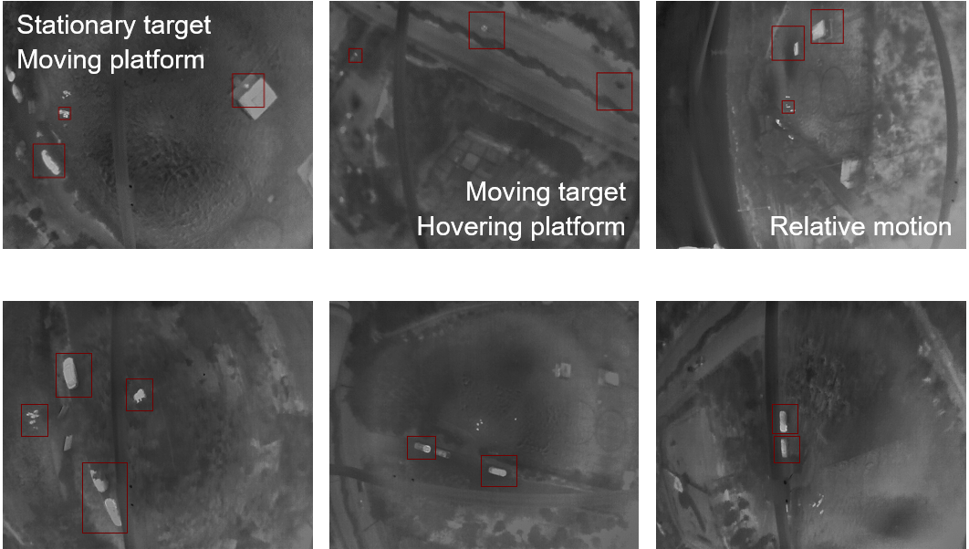
Fig. S6 | Multi-dimensional UAV-borne imaging test results.
Multi-dimensional flight tests were conducted in complex outdoor environments, covering simulated scenarios such as active inspection, stationary surveillance, and dual-dynamic maneuver tracking. By dynamically capturing ground targets at a flight altitude of 120 m under these three typical operational states, the acquired raw infrared images (Fig. S6) clearly demonstrate the MCOS's capability for ground target acquisition. Even in complex scenarios involving high-speed device movement or dynamically changing targets, the system maintains stable imaging contrast. Field tests indicate that the effective infrared detection range of the system reaches up to 2 km. The infrared target recognition rates across multiple scenarios consistently exceed 90%, fully proving the practical value of the MCOS in UAV-borne infrared reconnaissance missions.

References
1. Sawant, R. et al. Aberration-corrected large-scale hybrid metalenses. Optica 8, 1405–1411 (2021).
2. Zhang, Q. et al. Vectorial Generalized Snell’s Law‐Enabled Differentiable Ray Tracing for Large‐Aperture Visible Achromatic Hybrid Meta‐Optics. Laser & Photonics Reviews 19, e00448 (2025).
3. Chen, Q. et al. Hybrid Meta-Optics Enabled Compact Augmented Reality Display with Computational Image Reinforcement. ACS Photonics 11, 3794–3803 (2024).
4. Richards, C. A. et al. Hybrid achromatic microlenses with high numerical apertures and focusing efficiencies across the visible. Nat Commun 14, 3119 (2023).
5. Zang, G. et al. Inverse Design of Aberration-Corrected Hybrid Metalenses for Large Field of View Thermal Imaging Across the Entire Longwave Infrared Atmospheric Window. ACS Nano 18, 33653–33663 (2024).
6. He, X. et al. Hybrid Meta-optics Enabled Ultra-Broadband and High-efficiency Polarization Imaging. Laser & Photonics Reviews 9, e00623 (2025).

