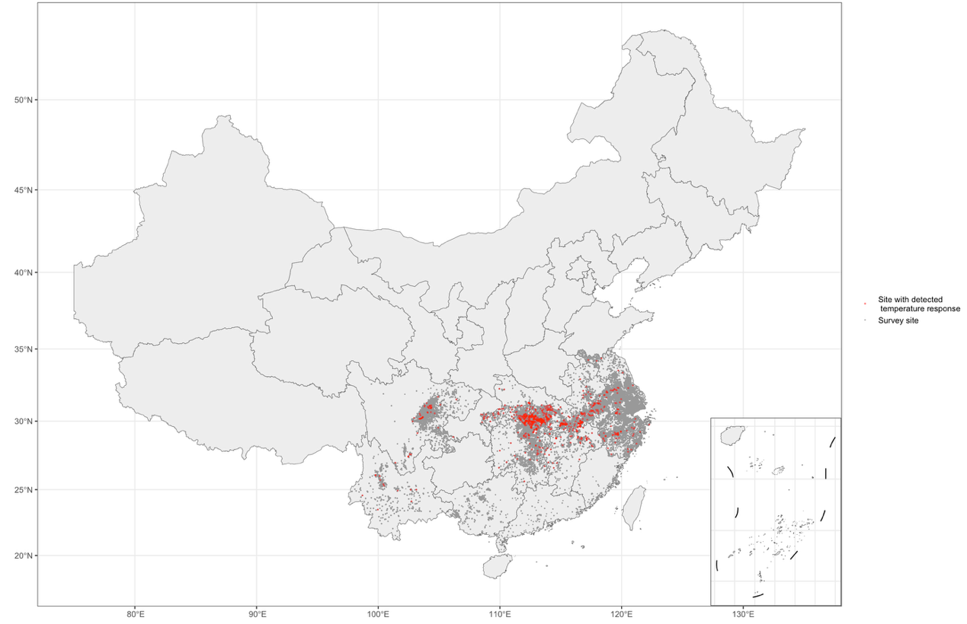
Figure A1: Plot of the distribution survey site and the sample sites of Oncomelania hupensis
The grey points represent sites for sliding window models; the red points represent sampling sites with detected temperature responses

