- Results from the time-window model.
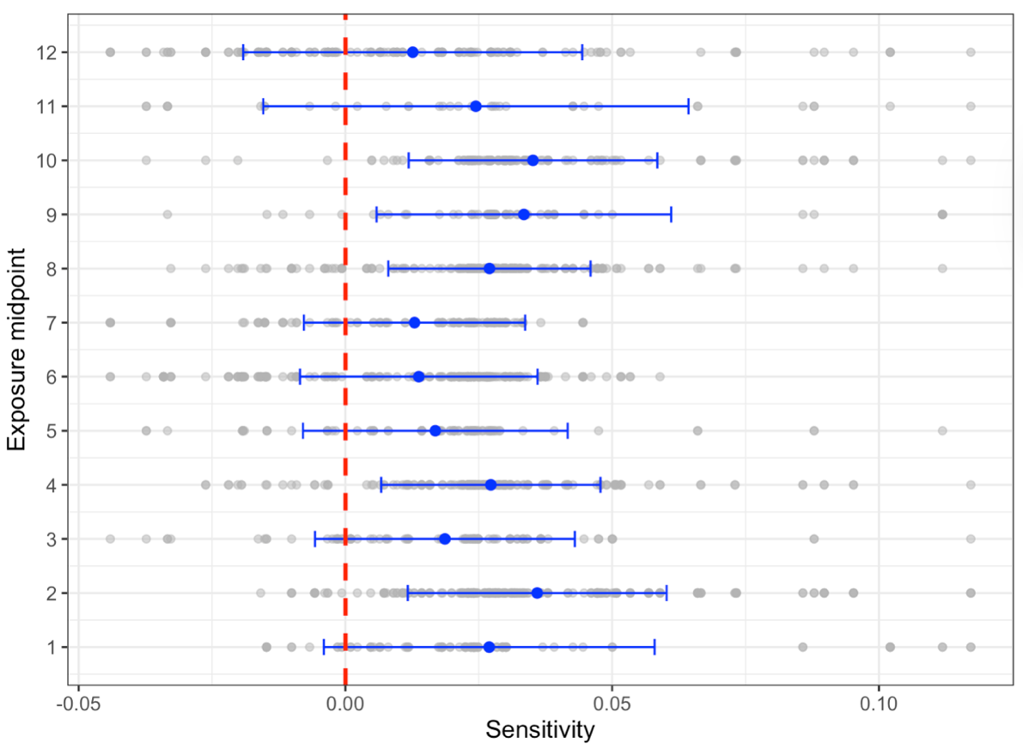
Figure A1: Relationship between the midpoint and sensitivity to minimum temperature

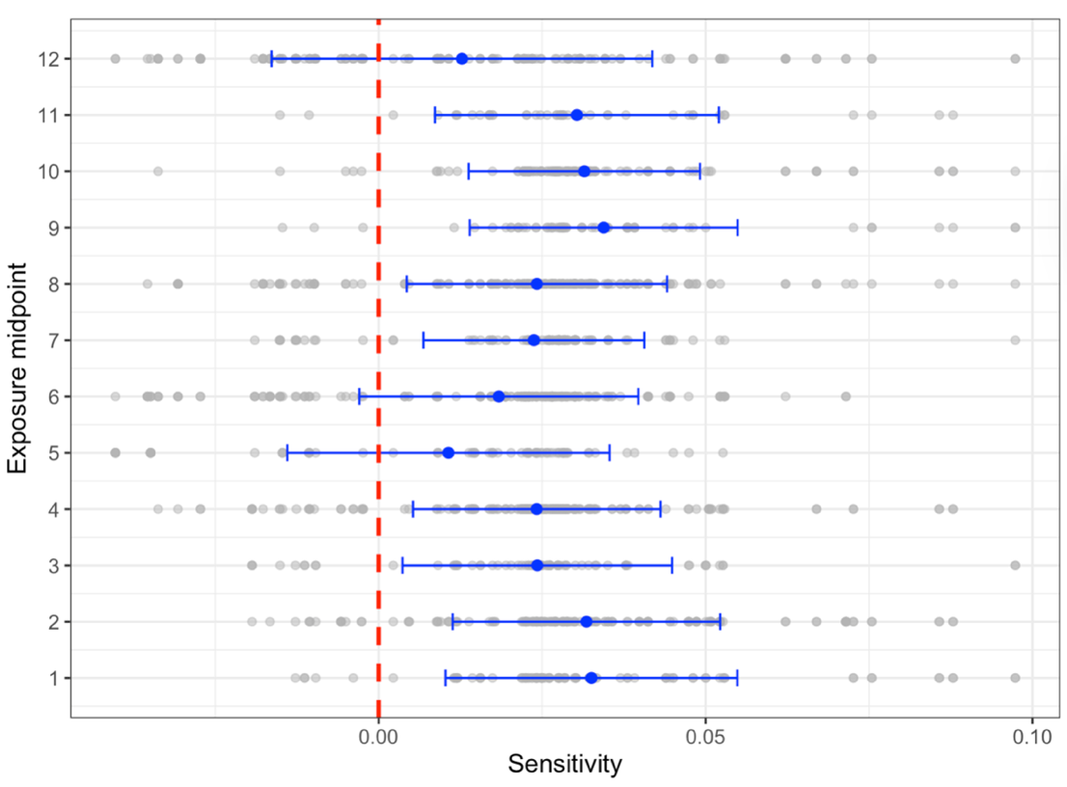
Figure A2: Relationship between the midpoint and sensitivity to maximum temperature

