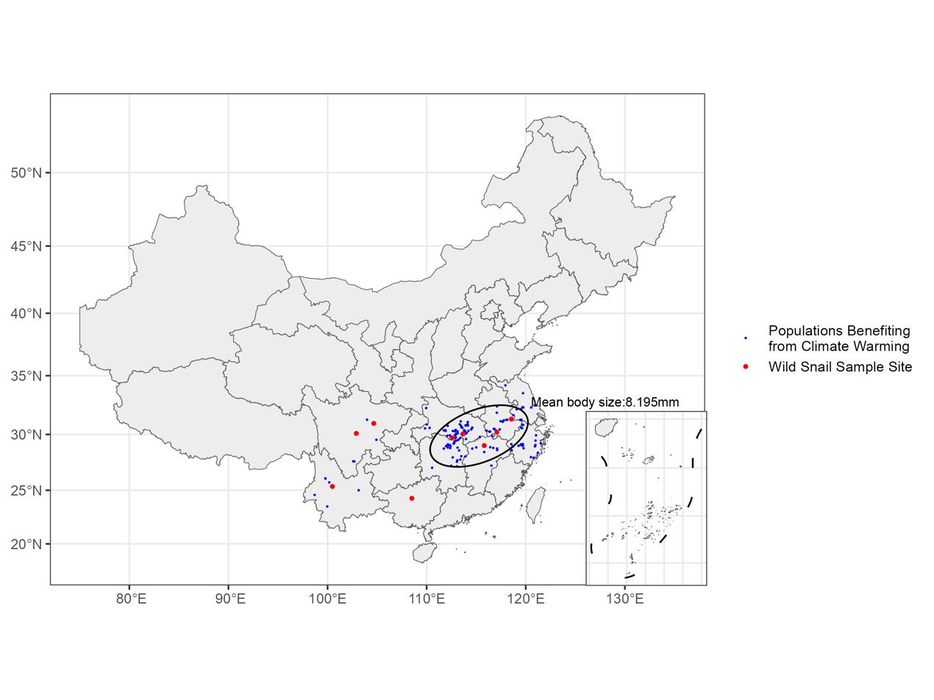
Figure A1: Spatial distribution of populations benefiting from climate warming and wild snail sampling sites

