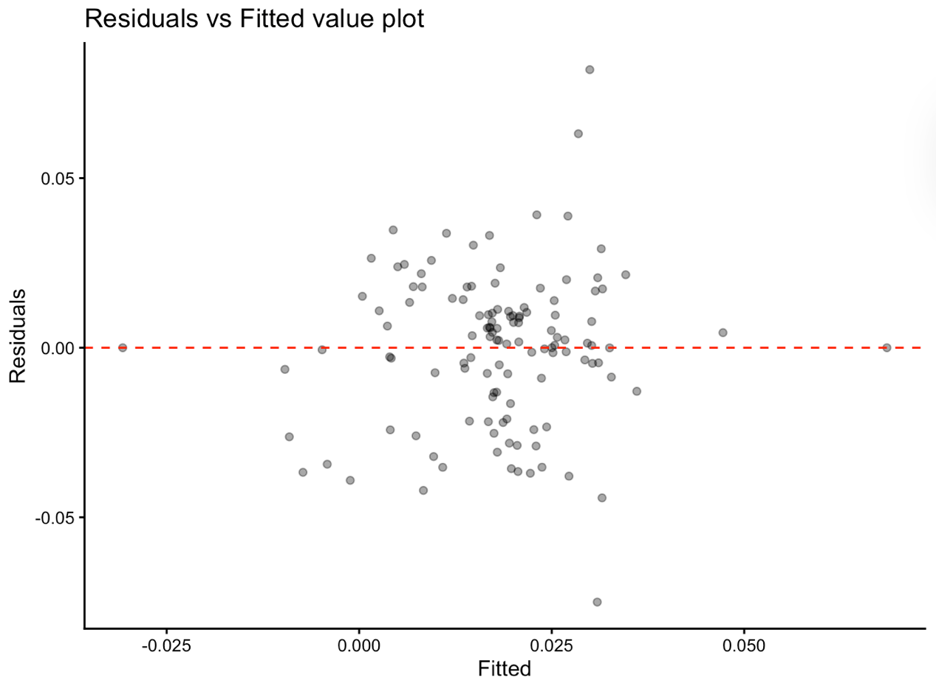
Figure A1: Model diagnosis result from the Residuals vs fitted value plot (Sensitivity)

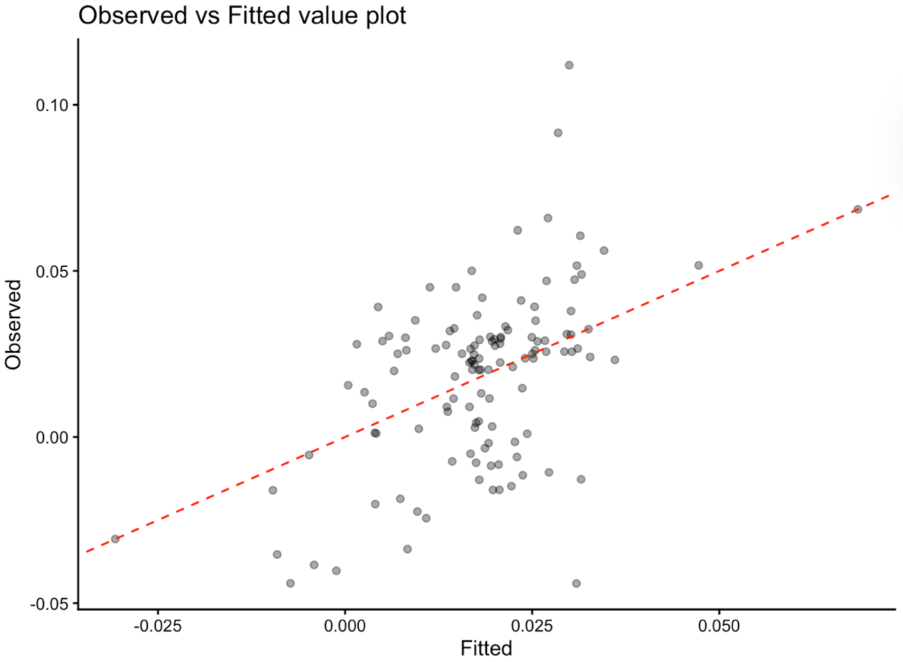
Figure A2: Model diagnosis result from the Observed vs fitted value plot (Sensitivity)
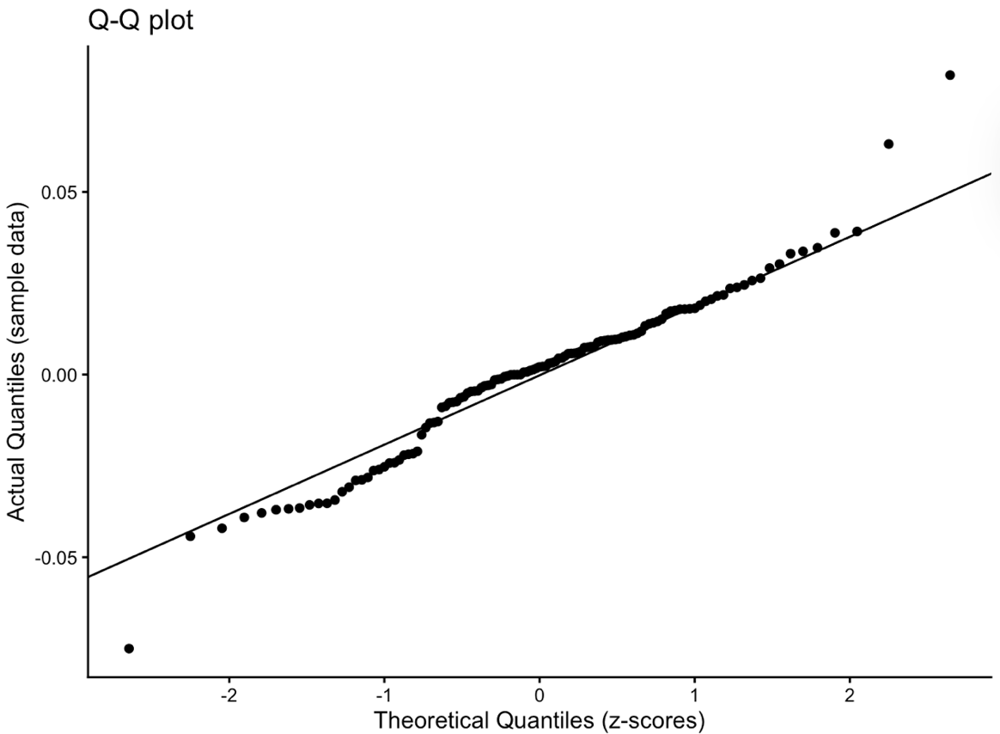
Figure A3: Model diagnosis result from Q-Q plot (Sensitivity)

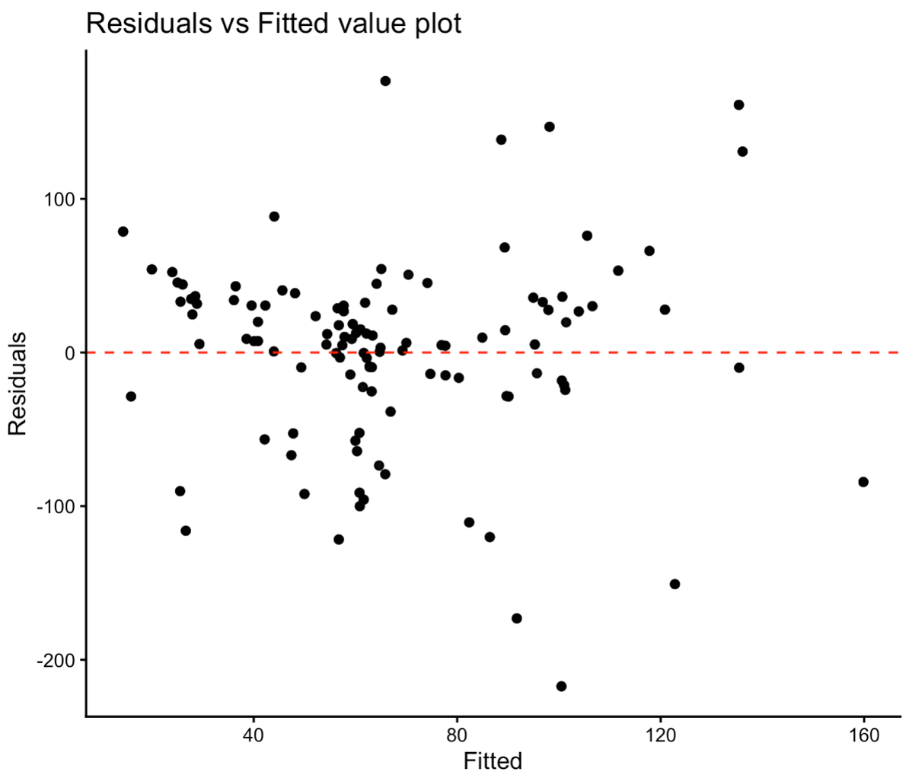
Figure A4: Model diagnosis result from the Residuals vs fitted value plot (duration)

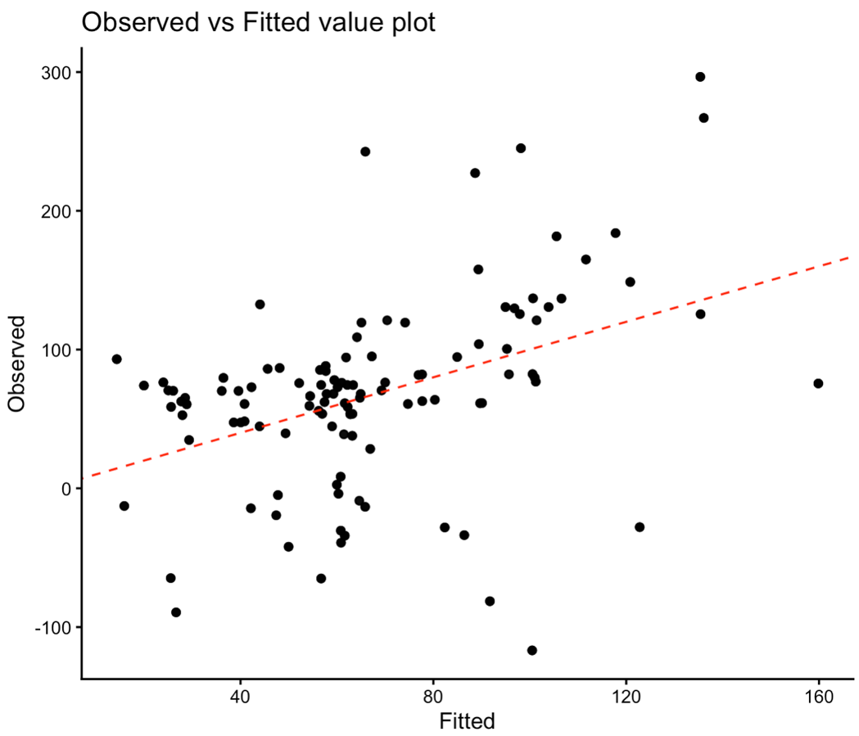
Figure A5: Model diagnosis result from the Observed vs fitted value plot (duration)

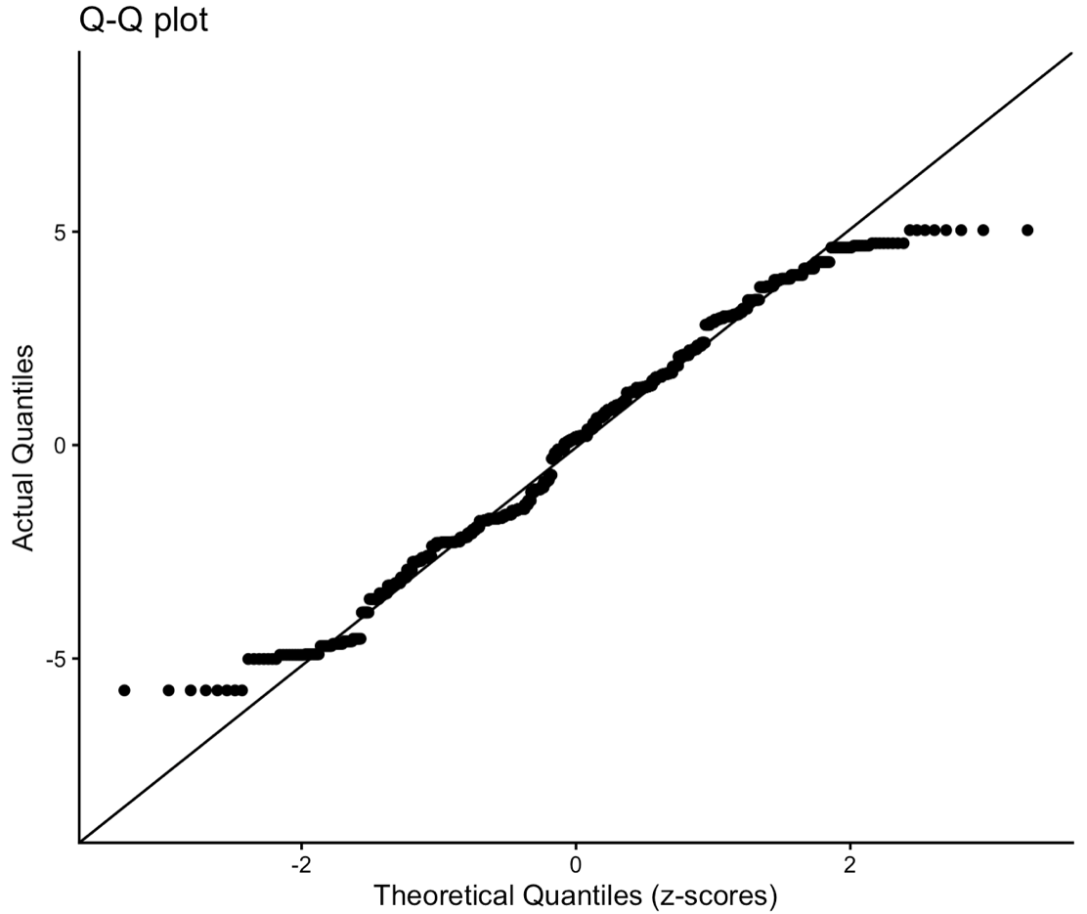
Figure A6. Model diagnosis result from Q-Q plot (duration)
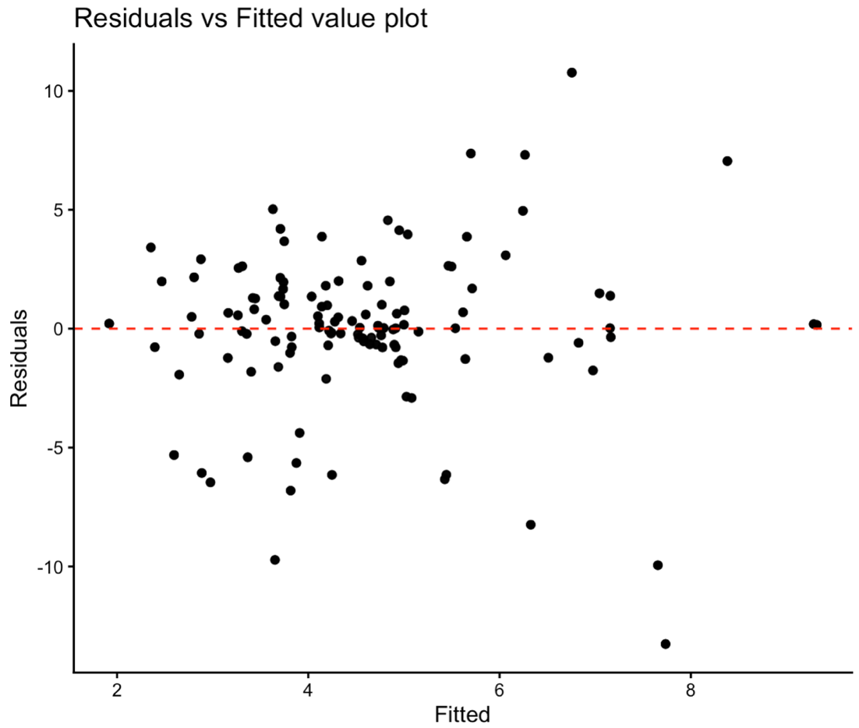
Figure A7. Model diagnosis result from the Residuals vs Fitted Value plot (midpoint)

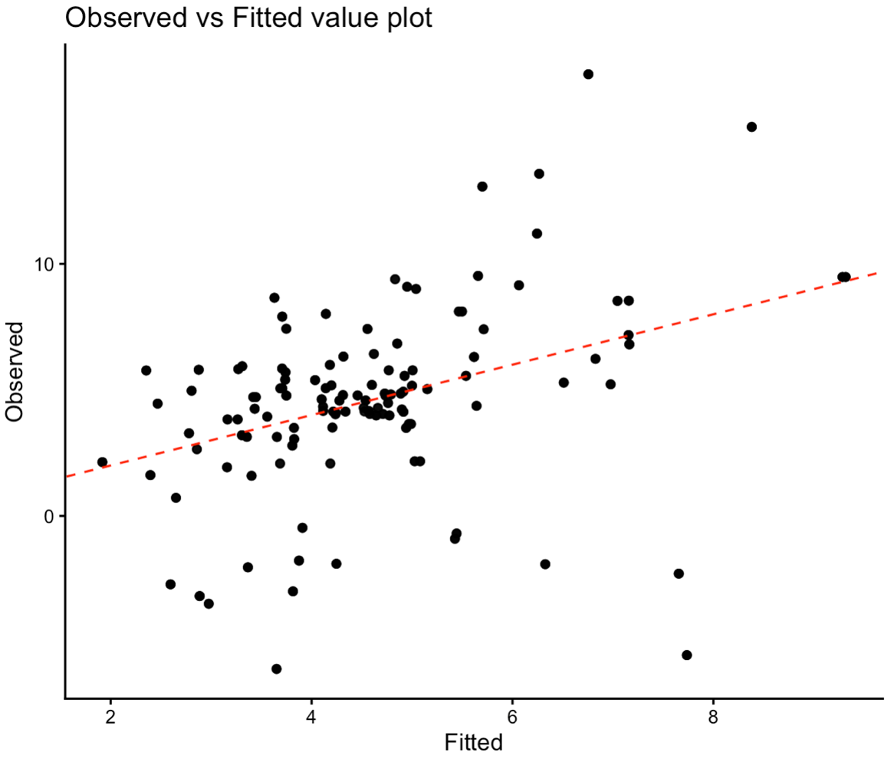
Figure A8. Model diagnosis result from the Observed vs fitted value plot (midpoint)
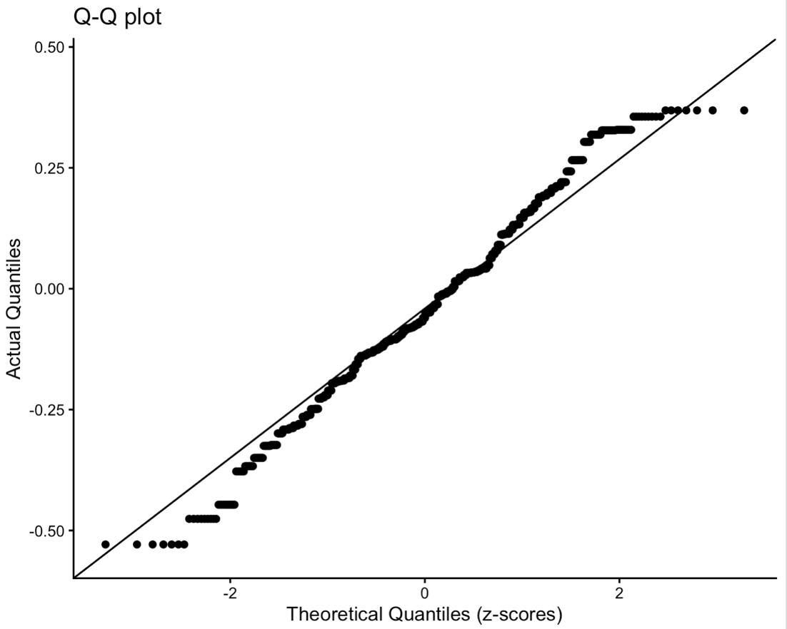
Figure A9. Model diagnosis result from Q-Q plot (midpoint)

Table A1: Model Evaluations general linear mixed-effect model
 | RMSE | MAE | MSE
Minimum temperature
Temperature sensitivity | 0.02314868 | 0.01626265 | 0.0005367794
Exposure duration | 3.128281 | 2.235021 | 7.211119
Exposure timing (midpoint) | 6.415689 | 2.130625 | 8.252869
Mean temperature
Temperature sensitivity | 0.02045981 | 0.0142445 | 0.0004196259
Exposure duration | 2.744217 | 2.096904 | 6.291358
Exposure timing (midpoint) | 6.363738 | 2.023031 | 7.505726
Maximum temperature
Temperature sensitivity | 0.02387835 | 0.01765483 | 0.0005709868
Exposure duration | 3.05658 | 2.268145 | 7.327478
Exposure timing (midpoint) | 6.392129 | 2.043366 | 7.585203

