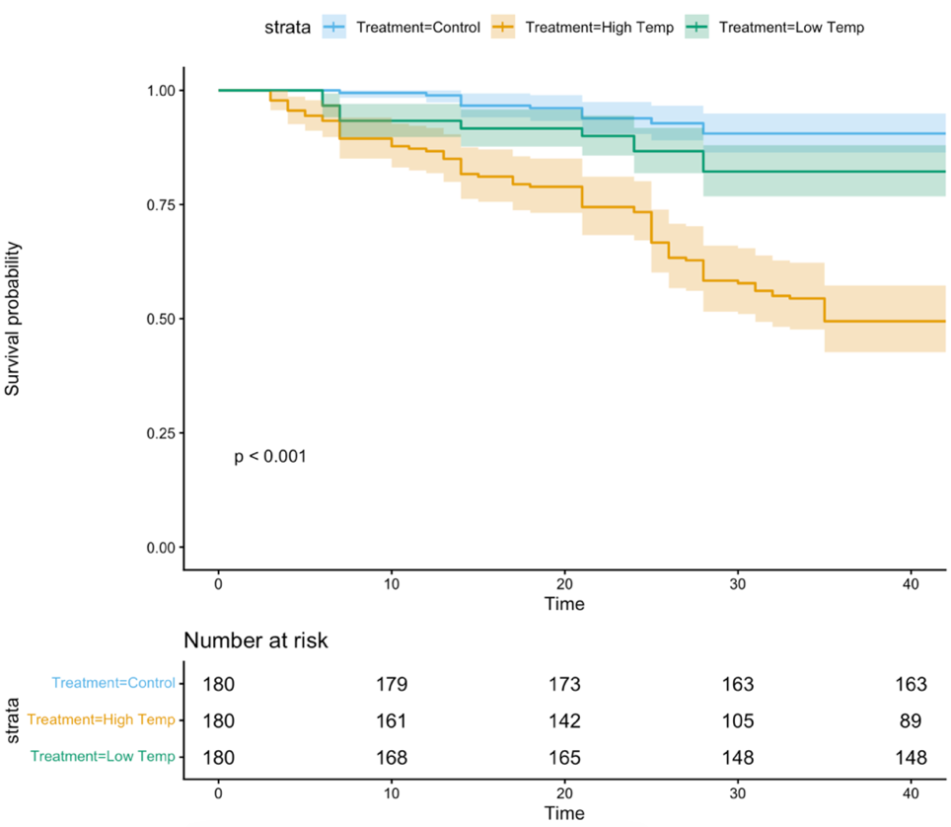
Figure A1: The survival analysis of the controlled temperature experiment

