Supplementary material
A temperature-sensitive, reusable PTA-AgNO₃-CS supramolecular polymer for 3D printing and strain sensing
Shengqiang Liao^{1,#}, Miaomiao Jia^{1,#}, Juncheng Wang¹, Jiawen Liu¹, Xianzhi Kong^{2,*}, Pengfei Huo^{1,*}, Jidong Dong^{1,*} and Dawei Zhang^{1,∗}
1 State Key Laboratory of Woody Oil Resources Utilization, Northeast Forestry University, Harbin 150040, People’s Republic of China
2 Institute of Petroleum Chemistry, Heilongjiang Academy of Sciences, Harbin 150040, People’s Republic of China
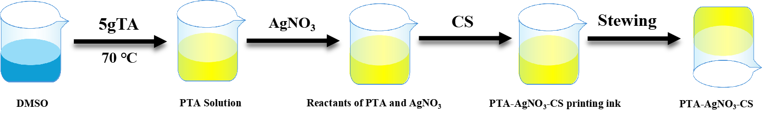
Fig. S1 Schematic diagram of PAC supramolecular polymer preparation
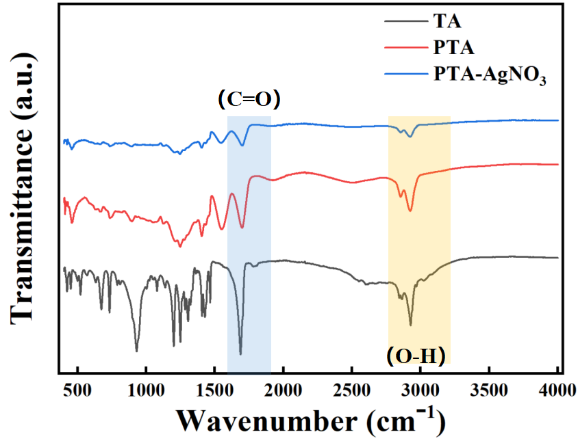
Fig. S2 Infrared spectra of TA, PTA, and PTA-AgNO₃
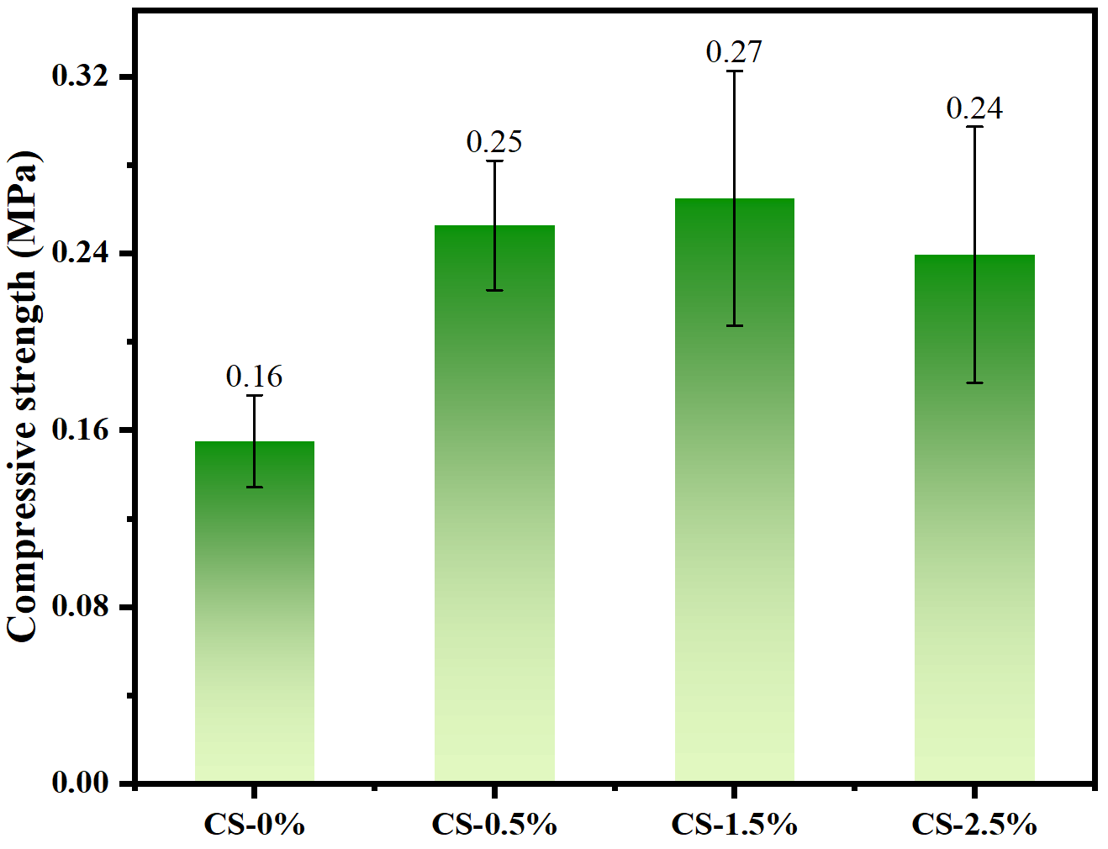
Fig. S3 Compressive strength of PTA-AgNO₃-CS supramolecular polymer with CS content.
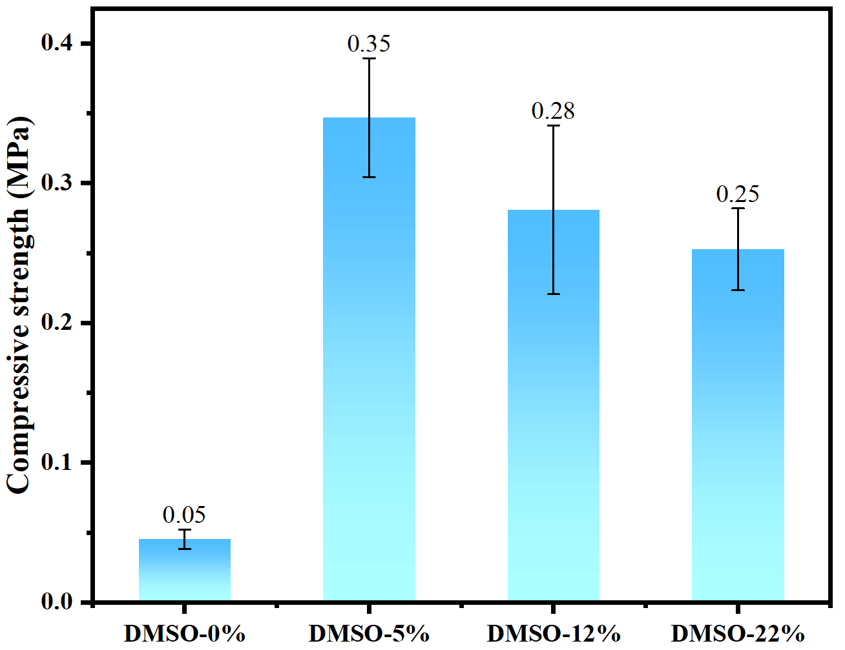
Fig. S4 Compressive strength of PTA-AgNO₃-CS supramolecular polymer with DMSO content
Fig. S5 SEM image of PTA-AgNO₃-CS supramolecular polymer
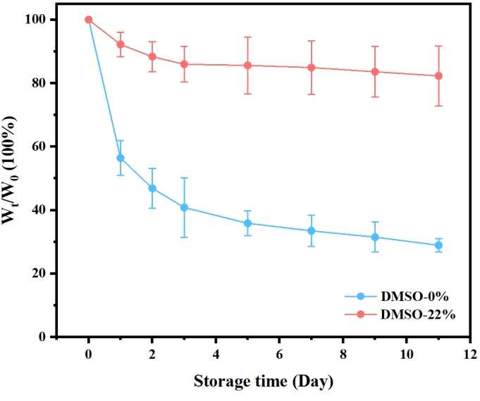
Fig. S6 Weight variation curve of DMSO-0% and DMSO-22% PTA-AgNO₃-CS supramolecular polymer stored at room temperature for 11 days
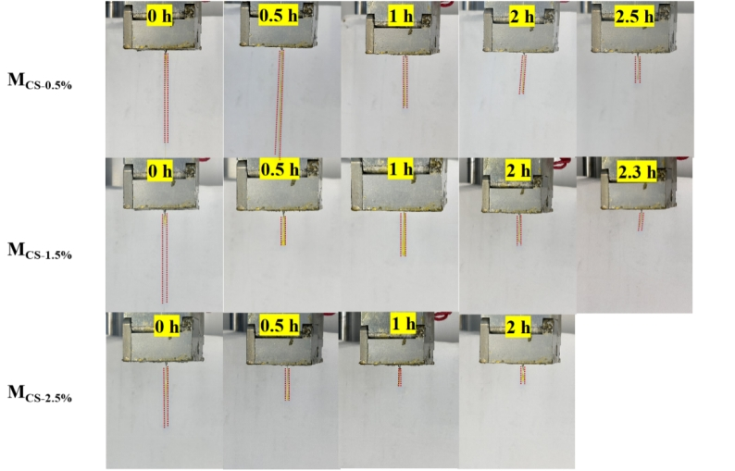
Fig. S7 The filament drawing of M_{CS-0.5%}, M_{CS-1.5%} and M_{CS-2.5%} printing inks after different crosslinking time

# Shengqiang Liao and Miaomiao Jia have contributed equally to the work. * Corresponding author. Xianzhi Kong: kongxianzhi2023@hipc.org.cn; Pengfei Huo: huopengfei@nefu.edu.cn; Jidong Dong: dongjidong@nefu.edu.cn and Dawei Zhang: zhangdawei@nefu.edu.cn

