Supplementary Tables and Figures

Supplementary Tables

Supplementary Table S1. pCyTOF whole blood staining panel
Metal label | Specificity | Clone | Supplier | Cat# | Cocktail
89Y | CD45 | HI30 | Standard BioTools | 3089003B | Boyle surface-frozen
141Pr | CD7 | CD7-6B7 | Biolegend | 343111 | HIMC surface-frozen
142Nd | CD19 | HIB19 | Standard BioTools | 3142001B | HIMC surface-frozen
143Nd | CD45RA | HI100 | Standard BioTools | 3143006B | Boyle surface-liquid drop-in
144Nd | pPLCg2 | K86-689.37 | Standard BioTools | 3144015A | HIMC-intracellular-frozen
145Nd | CD4 | RPA-T4 | Standard BioTools | 3145001B | HIMC surface-frozen
146Nd | IgD | IA6-2 | Standard BioTools | 3146005B | HIMC surface-frozen
147Sm | CD20 | 2H7 | Standard BioTools | 3147007B | HIMC surface-frozen
148Nd | IgA | Polyclonal | Standard BioTools | 3148007B | Boyle surface-frozen
149Sm | CD25 | 2A3 | Standard BioTools | 3149010B | HIMC surface-frozen
150Nd | pSTAT5 | 47 | Standard BioTools | 3150005A | HIMC-intracellular-frozen
151Eu | CD123 | 6H6 | Standard BioTools | 3151001B | HIMC surface-frozen
152Sm | Akt | D9E | Standard BioTools | 3152005A | HIMC-intracellular-frozen
153Eu | pSTAT1 | 4a | Standard BioTools | 3153005A | HIMC-intracellular-frozen
154Sm | CD127 | R34-34 | Novus Biological | DDX0700P-100 | Boyle surface-frozen
155Gd | CD27 | L128 | Standard BioTools | 3155001B | HIMC surface-frozen
156Gd | pP38 | D3F9 | Standard BioTools | 3156002A | HIMC-intracellular-frozen
158Gd | pSTAT3 | 4 | Standard BioTools | 3158005A | HIMC-intracellular-frozen
159Tb | CD11c | Bu15 | Standard BioTools | 3159001B | HIMC surface-frozen
160Gd | CD14 | M5E2 | Standard BioTools | 3160001B | HIMC surface-frozen
162Dy | CD66b | 80H3 | Standard BioTools | 3162023B | Boyle surface-frozen
163Dy | CD56 | NCAM16.2 | Standard BioTools | 3163007B | HIMC surface-frozen
164Dy | IkBalpha | L35A5 | Standard BioTools | 3164004A | HIMC-intracellular-frozen
165Ho | CD16 | B73.1 | Standard BioTools | 3167001B | Boyle surface-frozen
167Er | CD38 | HIT2 | Standard BioTools | 3168002B | HIMC surface-frozen
168Er | CD8 | SK1 | Standard BioTools | 3169010B | HIMC surface-frozen
169Tm | CD33 | WM53 | Standard BioTools | 3170001B | Boyle surface-frozen
170Er | CD3 | UCHT1 | Standard BioTools | 3167001B | HIMC surface-frozen
171Yb | pERK 1/2 | D13.14.4E | Standard BioTools | 3171010A | HIMC-intracellular-frozen
172Yb | Ki67 | B56 | Standard BioTools | 3172024B | Boyle-intracellular-frozen
173Yb | CD21 | Bu32 | Biolegend | 354902 | Boyle surface-frozen
174Yb | HLA-DR | L243 | Standard BioTools | 3174001B | HIMC surface-frozen
175Lu | pS6 | N7548 | Standard BioTools | 3175009A | HIMC-intracellular-frozen
176Yb | CREB | 87G3 | Standard BioTools | 3176005A | Boyle-intracellular-frozen
209Bi | CD11b | ICRF44 | Standard BioTools | 3209003B | Boyle surface-frozen
Supplementary Table S2: PBMC immunophenotyping CyTOF panel
Metal label | Specificity | Clone | Supplier | Cat# | Cocktail
113In | CD57 | HNK-1 | Biolegend | 359602 | HIMC frozen
115In | live/dead
141Pr | CCR6 | G034E3 | Standard BioTools | 3141003A | Boyle frozen
142Nd | CD19 | SJ25C1 | Biolegend | 363002 | HIMC frozen
143Nd | CD4 | SK3 | Biolegend | 344602 | HIMC frozen
144Nd | CD8 | SK1 | Biolegend | 344702 | HIMC frozen
145Nd | CD39 | A1 | Biolegend | 328202 | HIMC frozen
146Nd | IgD | IA6-2 | Biolegend | 348202 | HIMC frozen
147Sm | CD85j | 292319 | R&D Systems | MAB20172 | HIMC frozen
148Nd | CD11c | Bu15 | Biolegend | 337202 | HIMC frozen
149Sm | CD16 | 3G8 | Biolegend | 302002 | HIMC frozen
150Nd | CD3 | UCHT1 | Biolegend | 300402 | HIMC frozen
151Eu | CD38 | HB-7 | Biolegend | 356602 | HIMC frozen
152Sm | CD27 | L128 | BD Biosciences | special order | HIMC frozen
153Eu | CD21 | Bu32 | Biolegend | 354902 | Boyle frozen
154Sm | CD14 | M5E2 | Biolegend | 301802 | HIMC frozen
155Gd | Vd2 TCR | B6 | Biolegend | 331402 | Boyle frozen
156Gd | CD94 | HP-3D9 | BD Biosciences | 555887 | HIMC frozen
157Gd | CD86 | IT2.2 | Biolegend | 305402 | HIMC frozen
158Gd | CXCR5 | RF8B2 | BD Biosciences | 552032 | HIMC frozen
159Tb | CXCR3 | G025H7 | Biolegend | 353702 | HIMC frozen
160Gd | CCR7 | 150503 | R&D Systems | MAB197 | HIMC frozen
162Dy | CD45RA | HI100 | Biolegend | 304102 | HIMC frozen
164Dy | CD20 | 2H7 | Biolegend | 302302 | HIMC frozen
165Ho | CD127 | A019D5 | Biolegend | 351302 | HIMC frozen
166Er | CD33 | P67.6 | Biolegend | 366602 | HIMC frozen
167Er | LAG3 | 11C3C65 | Biolegend | 369302 | Boyle frozen
168Er | CD49b | P1E6-C5 | Biolegend | 359302 | Boyle frozen
169Tm | ICOS | DX29 | BD Biosciences | 557801 | HIMC frozen
170Er | CD161 | DX12 | BD Biosciences | 556079 | HIMC frozen
171Yb | TCRgd | B1 | Biolegend | 331202 | HIMC frozen
172Yb | PD-1 | EH12.1 | BD Biosciences | 562138 | HIMC frozen
173Yb | CD123 | 9F5 | BD Biosciences | 555642 | HIMC frozen
174Yb | CD56 | NCAM16.2 | BD Biosciences | 559043 | HIMC frozen
175Lu | HLA-DR | G46-6 | BD Biosciences | 556642 | HIMC frozen
176Yb | CD25 | M-A251 | Biolegend | 356102 | HIMC frozen
209Bi | CD11b | ICRF44 | Standard BioTools | 3209003B | Boyle frozen

Supplementary Table 3: PBMC CD4 T cells, Tr1 coinhibitory flow cytometry panel
Target | Flurophor |  | Clone | Source | Dilution |  | Catalogue #
Pre-Stain
LAG3 | Alexa Fluor 647 |  | 11C3C65 | Biolegend | 1/50 |  | 369304
CCR2 | APC-Cy7 |  | K036C2 | Biolegend | 1/120 |  | 357220
CCR5 | BV 650 |  | 3A9 | BD Biosciences | 1/80 |  | 564999
TIGIT | PE Dazzle |  | VSTM3 | Biolegend |  |  | 372716
TIM3 | BV605 |  | F38-2E2 | Thermo Fisher | 1/100 |  | 16-3109-85
Surface Stain
CD161 | Alexa Fluor 700 |  | HP-3G10 | Biolegend | 1/200 |  | 339942
CD45RA | BUV 563 |  | HI100 | BD Biosciences | 1/800 |  | 565702
CD4 | BUV 737 |  | SK3 | BD Biosciences | 1/120 |  | 564305
CD8 | BUV 496 |  | RPA-T8 | BD Biosciences | 1/800 |  | 612942
CD3 | BUV 805 |  | SK7 | BD Biosciences | 1/500 |  | 612893
CXCR3 | BV421 |  | IC6/CXCR3 | BD Biosciences | 1/100 |  | 562558
CD38 | BV480 |  | HIT2 | BD Biosciences | 1/50 |  | 566137
CD14 | BV510 |  | M5E2 | Biolegend | 1/100 |  | 301842
CD19 | BV510 |  | SJ25C1 | Biolegend | 1/100 |  | 363020
CD127 | BV570 |  | A019D5 | Biolegend | 1/50 |  | 351308
CXCR5 | BV711 |  | J252D4 | Biolegend | 1/50 |  | 356934
ICOS | BV750 |  | C398.4A | Biolegend | 1/100 |  | 313558
CD49b | FITC |  | Y418 | Invitrogen | 1/100 |  | 11-0498-42
PD1 | PE/Cy7 |  | EH12.1 | BD Biosciences | 1/100 |  | 561272
CD16 | PE/Fire 640 |  | 3G8 | Biolegend | 1/200 |  | 302068
CD25 | PE/Fire 700 |  | M-A251 | Biolegend | 1/100 |  | 356146
CCR7 | PerCP Cy5.5 |  | 150503 | BD Biosciences | 1/80 |  | 561144
Intra-cellular Stain
CTLA-4 |  | BV750 | BNI3 | BD Biosciences | 1/120 |  | 563931
Ki67 |  | BUV395 | B56 | BD Biosciences | 1/200 |  | 564071
NKG7 |  | PE | 2G9A10F5 | Beckman Coulter | 1/2000 |  | IM3293

Supplementary Table 4: Antigen-induced marker assay flow cytometry panel
Antibody |  | Clone | Source | Dilution | Catalogue Number
Pre-Stain
LAG3 | BV421 | T47-530 | BD Biosciences | 1/50 | 565720
CD49b | FITC | Y418 | Invitrogen | 1/100 | 11-0498-42
CCR7 | PerCP Cy5.5 | G043H7 | Biolegend | 1/25 | 353220
Surface Stain
CD161 | AF700 | HP-3G10 | Biolegend | 1/50 | 339942
OX40 | APC | ACT35 | BD Biosciences | 1/50 | 563473
CD45RA | BUV563 | HI100 | BD Biosciences | 1/400 | 565702
CD8 | BUV496 | RPA-T8 | BD Biosciences | 1/100 | 612942
CD3 | BUV805 | SK7 | BD Biosciences | 1/50 | 612893
CD69 | BUV737 | FN50 | BD Biosciences | 1/100 | 612817
CD14 | BV510 | M5E2 | Biolegend | 1/100 | 301842
CD19 | BV510 | HIB19 | Biolegend | 1/100 | 302241
CCR4 | BV605 | L291H4 | Biolegend | 1/100 | 359418
CCR6 | BV650 | 11A9 | BD Biosciences | 1/50 | 563922
CXCR5 | BV711 | J252D4 | Biolegend | 1/50 | 356934
CD4 | BV785 | OKT4 | Biolegend | 1/50 | 317442
CD25 | PE | BC96 | Biolegend | 1/200 | 302906
PD1 | PE/Cy7 | EH12.1 | BD Biosciences | 1/50 | 561272

Supplementary Table 5: scRNAseq participant characteristics and parasitemia at time of ruxolitinib or placebo administration. BMI, body mass index.
 | All (n=8) | Ruxolitinib (n=4) | Placebo (n=4)
Male sex, n (%) | 4 (50) | 3 (75) | 1 (25)
Age, years (median, range) | 28 (18-39) | 35 (21-39) | 27 (18-29)
BMI, Kg/m² (median, range) | 23 (20-31) | 26 (20-31) | 22 (20-28)
Race white, n (%) | 6 (75) | 2 (50) | 4 (100)
Parasitemia, parasites/ml (geometric mean, range) | 15320 (1387-121691) | 10041 (4772-37107) | 23373 (1387-121691)

Supplementary Table 6: Antibodies used to stain cells for scRNAseq
Antibody |  | Clone | Source | Dilution | Catalogue Number
Surface Stain
Ex vivo dataset:
CD3 | BV510 | SK7 | Biolegend | 1/50 | 344828
CD4 | AF647 | SK3 | Biolegend | 1/100 | 344636
CD45RA | BB515 | HI100 | BD Biosciences | 1/400 | 564552
CD19 | PE | H1B19 | Biolegend | 1/100 | 302208
AIM dataset:
CD3 | AF700 | SK7 | Biolegend | 1/50 | 344822
CD4 | PerCP Cy5.5 | OKT4 | Biolegend | 1/50 | 317428
CD69 | PE | FN50 | Biolegend | 1/50 | 310906
OX40 | APC | ACT35 | BD Biosciences | 1/50 | 563473
Hashtags
TotalSeq-C0251 anti-human Hashtag 1 |  | LNH-94; 2M2 | Biolegend | 0.3ug/sample | 394661
TotalSeq-C0252 anti-human Hashtag 2 |  | LNH-94; 2M2 | Biolegend | 0.3ug/sample | 394663
TotalSeq-C0253 anti-human Hashtag 3 |  | LNH-94; 2M2 | Biolegend | 0.3ug/sample | 394665
TotalSeq-C0254 anti-human Hashtag 4 |  | LNH-94; 2M2 | Biolegend | 0.3ug/sample | 394667
TotalSeq-C0255 anti-human Hashtag 5 |  | LNH-94; 2M2 | Biolegend | 0.3ug/sample | 394669
TotalSeq-C0256 anti-human Hashtag 6 |  | LNH-94; 2M2 | Biolegend | 0.3ug/sample | 394671
TotalSeq-C0257 anti-human Hashtag 7 |  | LNH-94; 2M2 | Biolegend | 0.3ug/sample | 394673
TotalSeq-C0258 anti-human Hashtag 8 |  | LNH-94; 2M2 | Biolegend | 0.3ug/sample | 394675
TotalSeq-C0259 anti-human Hashtag 9 |  | LNH-94; 2M2 | Biolegend | 0.3ug/sample | 394677
TotalSeq-C0260 anti-human Hashtag 10 |  | LNH-94; 2M2 | Biolegend | 0.3ug/sample | 394679
TotalSeq-C0296 anti-human Hashtag 11 |  | LNH-94; 2M2 | Biolegend | 0.3ug/sample | 328941
TotalSeq-C0262 anti-human Hashtag 12 |  | LNH-94; 2M2 | Biolegend | 0.3ug/sample | 394683
TotalSeq-C0263 anti-human Hashtag 13 |  | LNH-94; 2M2 | Biolegend | 0.3ug/sample | 394685
TotalSeq-C0264 anti-human Hashtag 14 |  | LNH-94; 2M2 | Biolegend | 0.3ug/sample | 394687
TotalSeq-C0265 anti-human Hashtag 15 |  | LNH-94; 2M2 | Biolegend | 0.3ug/sample | 394689
TotalSeq-C0276 anti-human Hashtag 16 |  | LNH-94; 2M2 | Biolegend | 0.3ug/sample | 394691
TotalSeq-C0277 anti-human Hashtag 17 |  | LNH-94; 2M2 | Biolegend | 0.3ug/sample | 394621
TotalSeq-C0277 anti-human Hashtag 18 |  | LNH-94; 2M2 | Biolegend | 0.3ug/sample | 394693
TotalSeq-C0279 anti-human Hashtag 19 |  | LNH-94; 2M2 | Biolegend | 0.3ug/sample | 394695

Supplementary Figures

Supplementary Figure 1: Analysis of phosphoproteins in CD4 T cells during malaria.
A. Mean Signal Intensity (MSI) of phosphorylated proteins in CD4+ T cells following stimulation of whole blood with PBS (un-stimulated condition), IFNβ, IL-2 and PMA/Ionomycin at the pre-inoculation (baseline) time point for 15 minutes. The box plots show the extent of the lower and upper quartiles and the median, while each point represents a study participant (n=20). B. Volcano Plots showing the coefficient and p values of mixed model analysis of the effect of infection (pre-treatment time point (T, day 8/9) compared to inoculation time point (I, day 0)), on the mean signal intensity (MSI) of the phosphorylated proteins and Ki67 in CD4+ T cell subsets in unstimulated cells. Proteins with a significant change are in red. C-F. Coefficient from mixed effect models analysing MSI for phosphoproteins in unstimulated cells in indicated CD4 T cell subset, analysing changes with time (C/E), comparing T with T+1.5 and T+5 and for the interaction between timepoint and treatment (D/F). Coefficient is indicated for each subset and timepoint, with significant changes in red. Related to Figure 1

Supplementary Figure 2: pSTATs in CD4 T cells during malaria following IFNβ and IL-2 stimulations.
A) Coefficient from mixed effect models analysing MSI for phosphoproteins in cells stimulated with IFNβ in indicated CD4 T cell subset, analysing changes with time (A) comparing T with T+1.5 and T+5 and for the interaction between timepoint and treatment (B). Coefficient is indicated for each subset and timepoint, with significant changes in red. C) pSTAT5 expression in CD4 T cells at I, T, T+1, T+5 in IL-2 stimulated cultures. Data are log transformed median signalling intensity, with thin lines representing each participant and coloured by treatment group. Prior to randomisation data are in grey; following randomisation ruxolitinib-treated participants are red and placebo-treated are blue. TX is p values for the interaction term between each timepoint (compared to T) and treatment groups. p values for the comparison between each timepoint and T are shown for the placebo (PBO) and ruxolitinib (RUX) groups, and were determined from contrasts. D) Coefficient from mixed effect models analysing MSI for pSTAT5 in cells stimulated with IL-2 in indicated CD4 T cell subset, analysing changes with time comparing T with T+1.5 and T+5 and for the interaction between timepoint and treatment. Significant changes are indicated in red. E) Fold change between T and T+1.5 expression of pSTAT5 in total CD4 T cells and CD4 T cell subsets for IL-2 stimulated cells. Data for each participant are shown. Related to Figure 1

Supplementary Figure 3: Phosphorylation of proteins in PMA stimulated cultures in CD4 T cells during malaria.
A) Coefficient from mixed effect models analysing MSI for pCREB, pERK and pS6 in cells stimulated with PMA/Ion in indicated CD4 T cell subset, analysing changes with time comparing T with T+1.5 and T+5 and for the interaction between timepoint and treatment. Significant changes are indicated in red. B) Fold change between T and T+1.5 expression of pERK and pCREB in total CD4 T cells and CD4 T cell subsets for PMA/Ion stimulated cells. Data for each participant are shown. Related to Figure 1

Supplementary Figure 4: CD4 T cell frequencies and activation
A) PBMCs were collected at 5 time points in first and second infection. *one participant in the Rux group in second infection tested positive for COVID-19 and received malaria treatment early. B/C) PBMCs were analysed by CyTOF and CD4 T cells identified for further analysis. D/E) CD38+ICOS+ Th1, and CD38+PD1+ICOS+ Tfh2 and Tfh1 CD4 T cells in first and second infection. Data are log10 frequencies of CD4 T cells, with thin lines representing each participant. Prior to randomisation data are in grey, following randomisation ruxolitinib-treated participants are in red and placebo-treated are in blue. P values are from linear mixed effect models, with bold lines representing the mean of the predicted values from the fitted models for each group. TX is p values for the interaction term between each timepoint (compared to T) and treatment groups (underlined in green). P values for the comparison between each timepoint and T are shown for the placebo (PBO, underlined in blue) and ruxolitinib (RUX, underlined in red) groups, and were determined from contrasts. Related to Figure 2.
Supplementary Figure 5: Tr1 cell analysis strategy
A) CD4+ T cells were identified based on FSC/SSC, live/dead staining, CD14-CD19-/CD3+, CD4+ cells. B) CD4+ cells were exported after gating and analysed in R. Batch correction was performed in cyCombine, Treg cells removed (CD25+CD127low), and Tr1 cells identified based on LAG3+CD49b+. Related to Figure 3.

Supplementary Figure 6: Gating Strategy employed to identify the AIM+ CD4⁺ T cell populations
After gating for the CD45RA⁺ CCR7⁺ naive cells, a “not” gate was used to remove this population and the other CD4⁺ T cell subsets were identified from the non-naive CD4+ T cells. Following this, Boolean gating was using to examine AIM⁺ CD4⁺ T cells. Figure represents PBMCs from Day 15 for D726 in the Placebo group following 18 hour culture with parasitised red blood cells. AND gates were set to analyse all AIM⁺ cells and subset. Related to Figure 4.

Supplementary Figure 7: AIM+ CD4 T cell response during first and second infection
Parasite specific CD4 T cells were identified using Activation Induced Marker assay at inoculation (I), treatment (T) and post treatment timepoints (T+3, T+7 and T+20) in first infection, and at re-inoculation (rI), re-treatment (rT) and post treatment timepoints (rT+3, rT+7, EOS) in second infection. A. Coefficient of linear mixed models comparing first to second infection inoculation (I verse rI) interaction term of ruxolitinib treatment group. Only AIM+ Tfh1 cells were elevated at rI, and this was not impacted by ruxolitinib. B/C) AIM+ Th2, AIM+ Tfh (total Tfh) and AIM+ Tfh2, and AIM+Tfh-Tr1 cells in first and second infection. Data are log10 frequencies of malaria specific AIM+ CD4 T cells, with thin lines representing each participant. Prior to randomisation is in grey, following randomisation ruxolitinib-treated participants are red and placebo are blue. P values are from linear mixed effect models, with bold lines representing the mean of the predicted values from the fitted models for each group. TX is p values for the interaction term between each timepoint (compared to T) and treatment groups (underlined in green). P values for the comparison between each timepoint and T are shown for the placebo (PBO, underlined in blue) and ruxolitinib (RUX, underlined in red) groups, which were determined from contrasts. P value for the difference at rT between placebo and ruxolitinib group, calculated from the intercept is shown at rT.

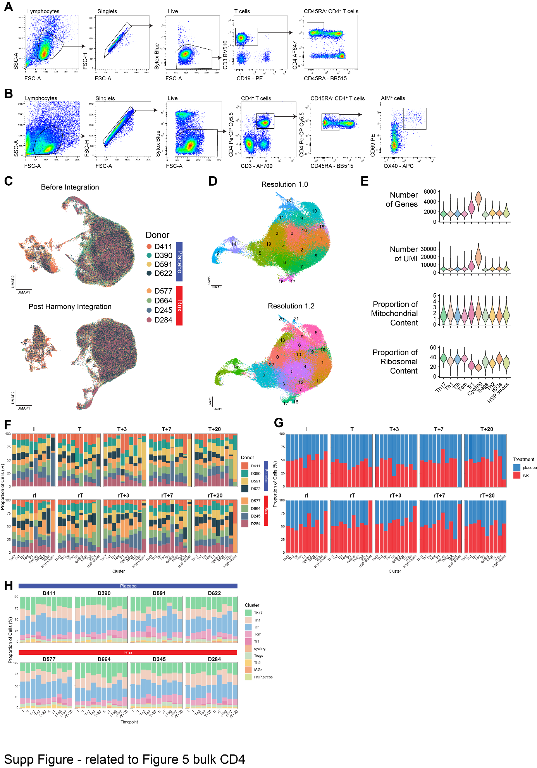
Supplementary Figure 8: scRNAseq analysis of CD4⁺ T cell responses during first and second infection. A) Flow cytometry gating strategy for isolating ex vivo antigen experienced (CD45RA⁻) CD4⁺ T cells and B) AIM⁺ (CD69⁺OX40⁺) CD4⁺ T cells. C) UMAP visualisation of ex vivo and AIM⁺ CD4⁺ T cells coloured by donor prior to and post-Harmony integration by donor. D) UMAP visualisation showing clustering of the ex vivo CD4⁺ T cells at resolution 1 and 1.2. E) Violin plots showing quality control metrics for the ex vivo CD4⁺ T cells. F) Stacked bar graphs split by timepoint showing the proportion of donor or G) treatment group per ex vivo CD4⁺ T cell cluster. H) Stacked bar graphs split by donor showing the proportion of ex vivo CD4+ T cell cluster per timepoint.
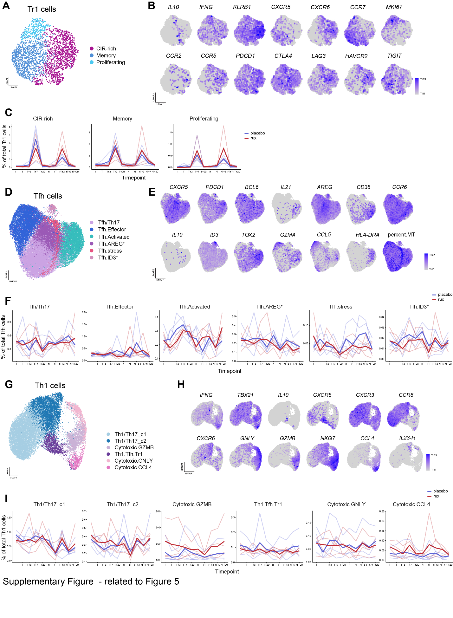

Supplementary Figure 9: scRNAseq Th1-Tfh-Tr1 axis cells re-clustering.
A) UMAP visualisation shows three clusters of Tr1 cells after subsetting and re-clustering and B) expression of select cluster marker genes. C) Line graphs showing the cluster frequency as a percentage of total Tr1 cells during first and second infections. Lines are coloured by treatment group, with bold lines representing group means and transparent lines showing frequencies for each participant. D) UMAP visualisation shows six clusters of Tfh cells after subsetting and re-clustering and E) expression of select cluster marker genes. F) Line graphs showing the cluster frequency as a percentage of total Tfh cells during first and second infections. Lines are coloured by treatment group, with bold lines representing group means and transparent lines showing frequencies for each participant. G) UMAP visualisation shows six clusters of Th1 cells after subsetting and re-clustering and H) expression of select cluster marker genes. I) Line graphs showing the cluster frequency as a percentage of total Th1 cells during first and second infections. Lines are coloured by treatment group, with bold lines representing group means and transparent lines showing frequencies for each participant.

Supplementary Figure 10: AIM+ scRNAseq data and malaria specific cells.
A) UMAP visualisation showing clustering of the AIM+ CD4⁺ T cells. B) Violin plots showing quality control metrics for the AIM+ CD4⁺ T cells. C) Upset plot showing the number of shared marker genes between clusters in AIM+ data set. The bar graph on the right shows the total number of differentially expressed cluster marker genes for each subset. D) Subset proportions of AIM+ CD4 T cells at each timepoint, by treatment group. E) Subset proportions of malaria-specific cells identified within ex vivo data set based on TCR analysis of AIM+ data set.

