Supplementary Figure 1

Supplementary Figure 2

Supplementary Figure 3
Supplementary Figure 4

Supplementary Figure 5

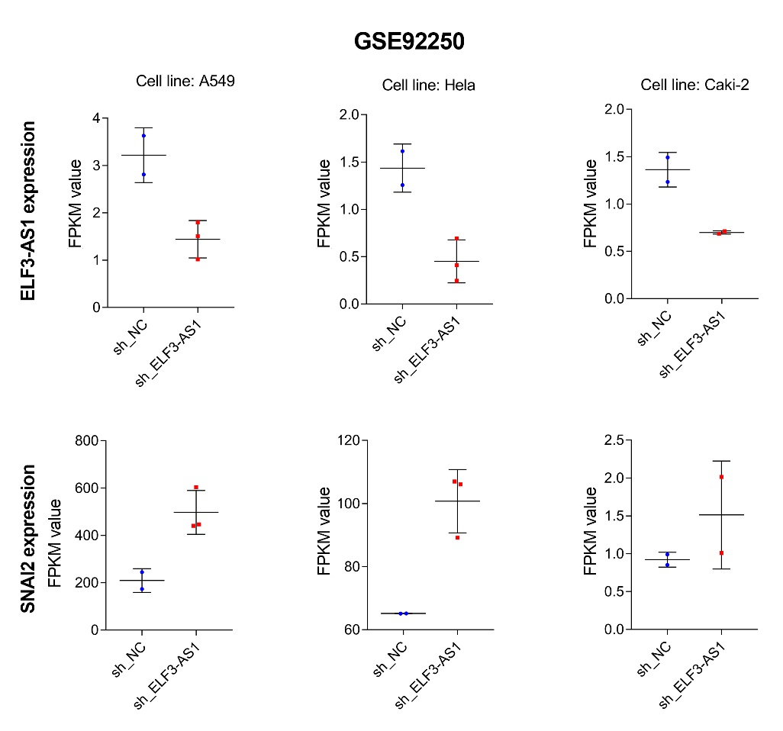

Supplementary Figure 6

