Supplementary Information
Commonalities and differences in national pathways toward net-zero emissions

Contents
Supplementary Figures 2
1. Regression of key variables taking Emissions|CO2 2
2. Regression of key variables taking changes from base year 2020 3
3. Regression charts with countries shown in color 4
4. Cumulative carbon emissions in net-zero scenario and effort sharing budgets by taking Emissions|CO2 7
5. Emissions coverage by taking Emissions|CO2 8
6. Individual countries cumulative emissions vs effort sharing allocation of global emissions 9
Supplementary Tables 12
Table 1: Models considered for main figures in the manuscript 12
Table 2: Models considered for supplementary Fig. 1, Fig. 4, Fig. 5 13

Supplementary Figures

Regression of key variables taking Emissions|CO2
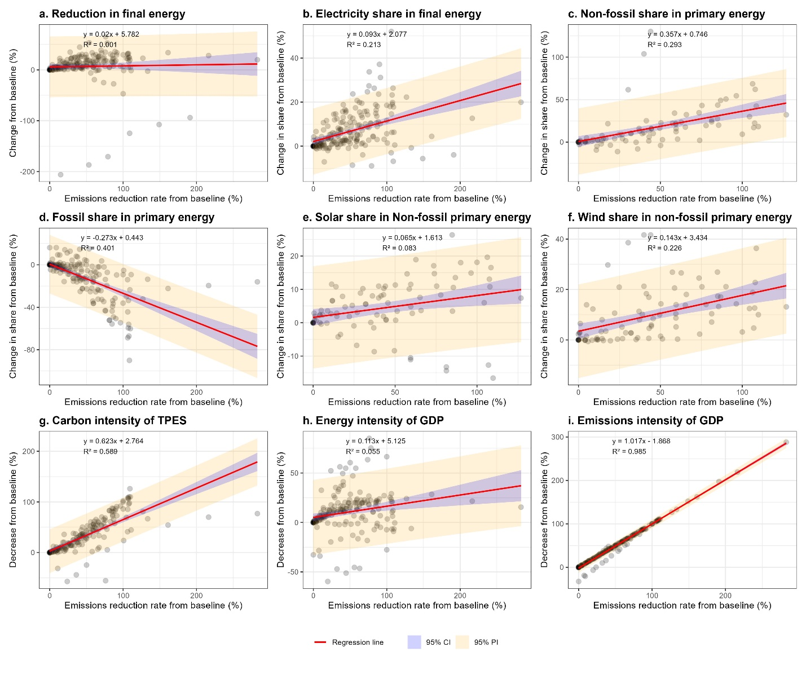

Regression of key variables taking changes from base year 2020
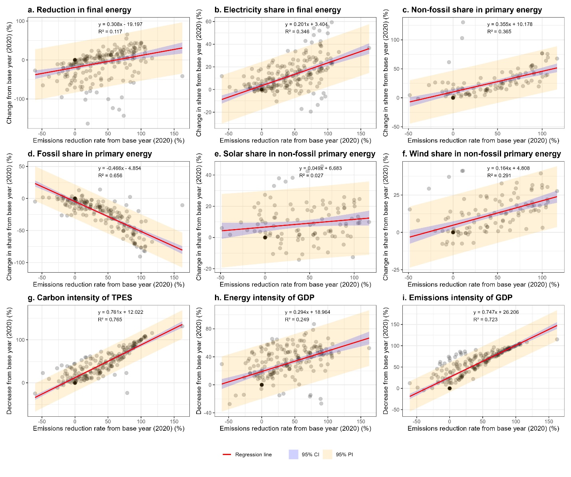

Regression charts with countries shown in color
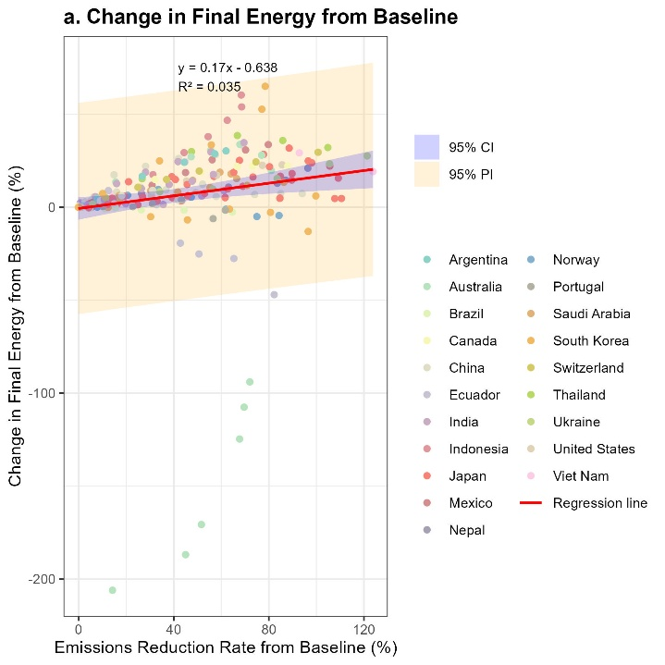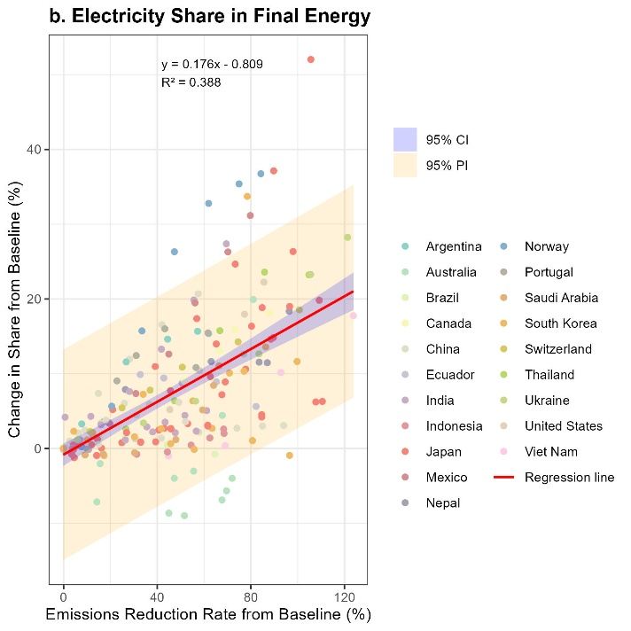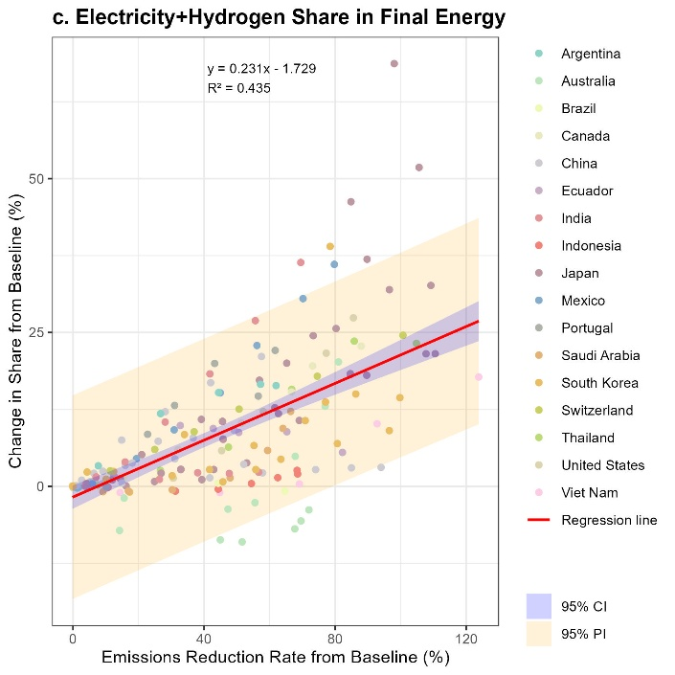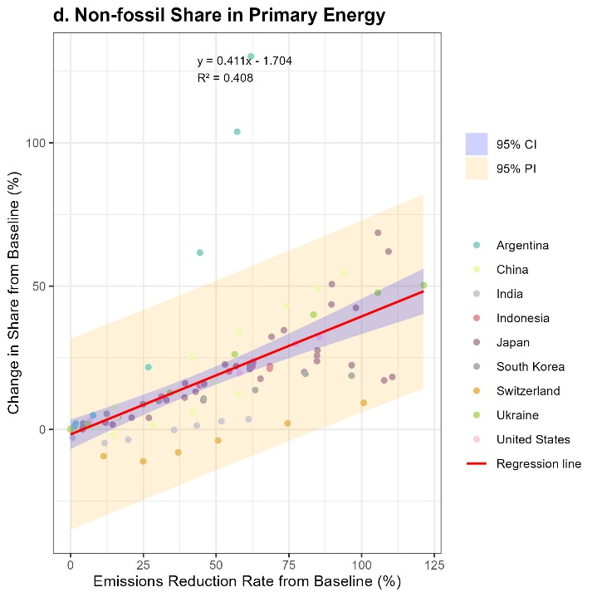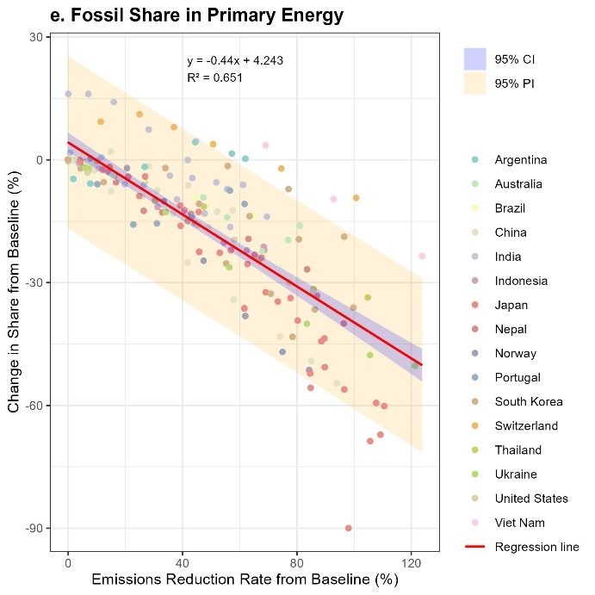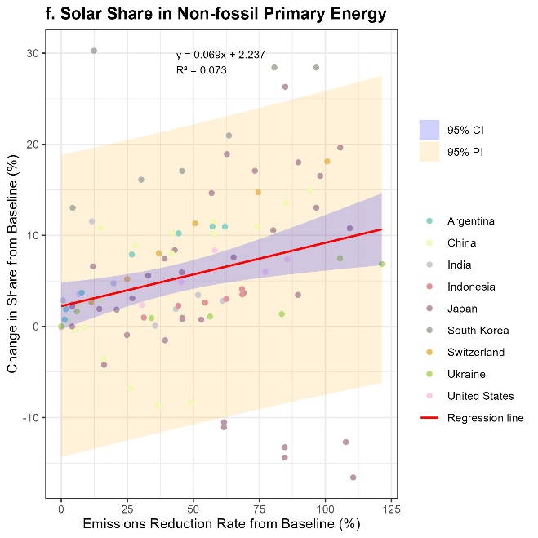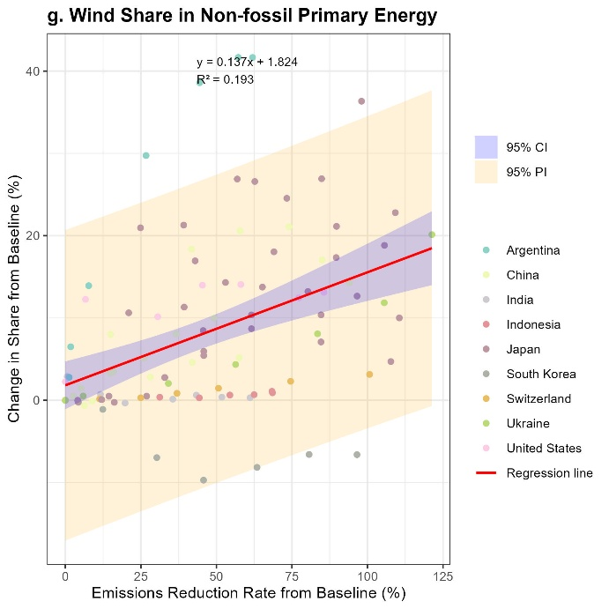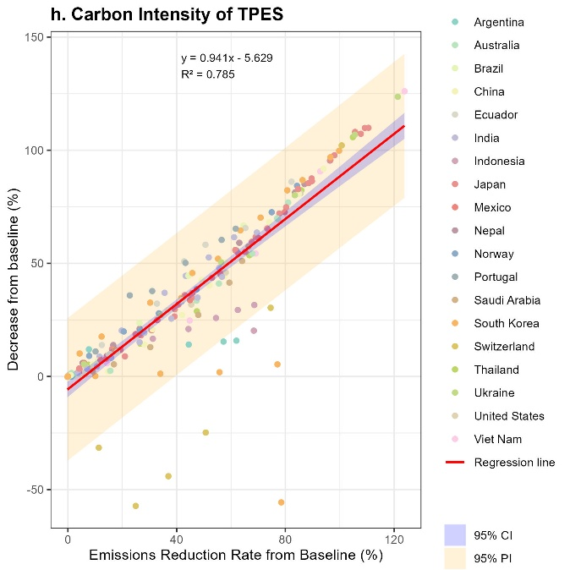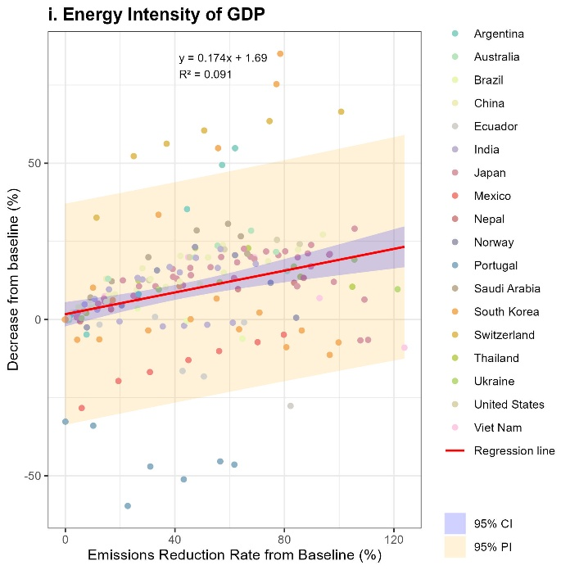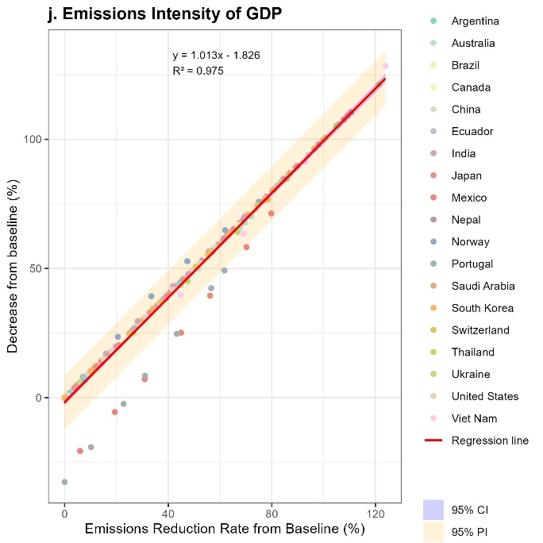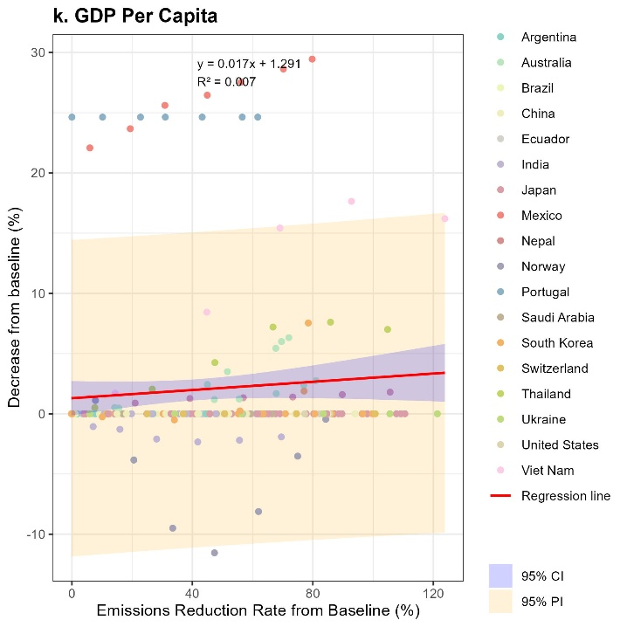

Cumulative carbon emissions in net-zero scenario and effort sharing budgets by taking Emissions|CO2
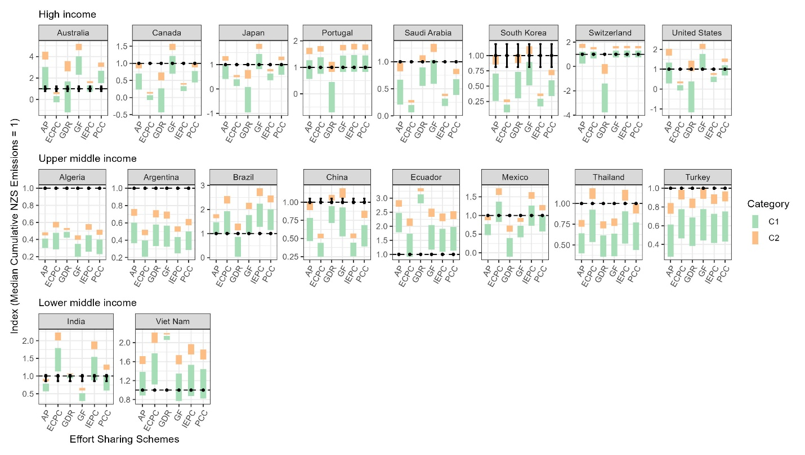

Emissions coverage by taking Emissions|CO2
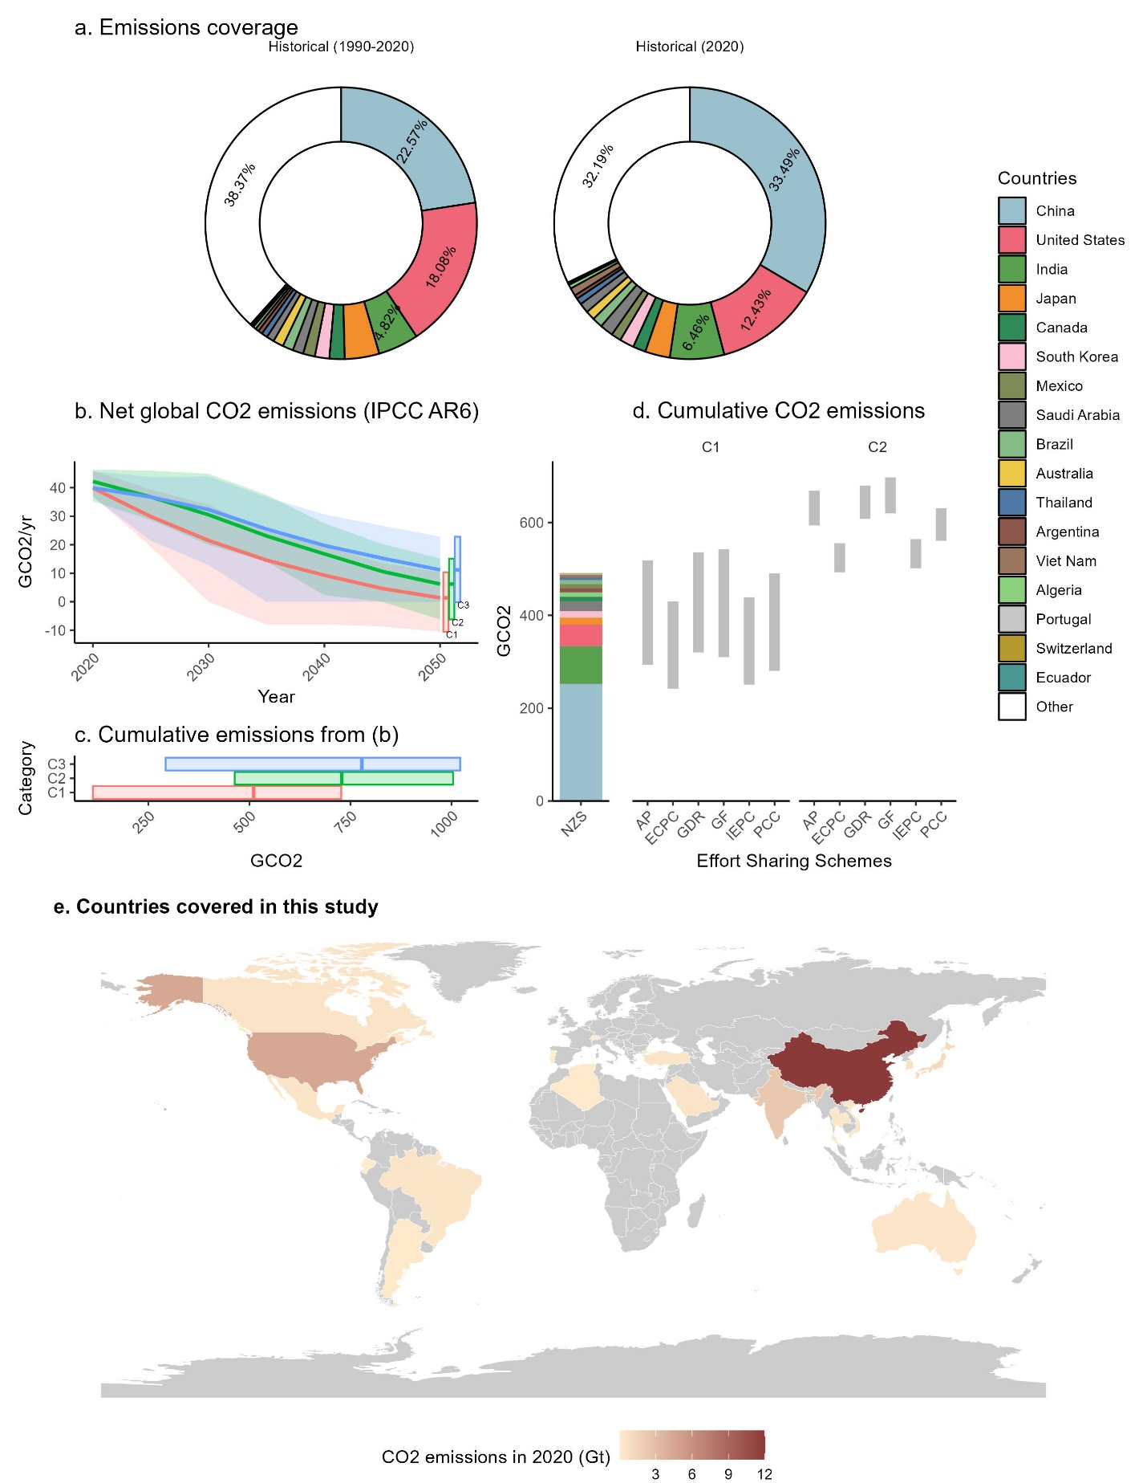

Individual countries cumulative emissions vs effort sharing allocation of global emissions

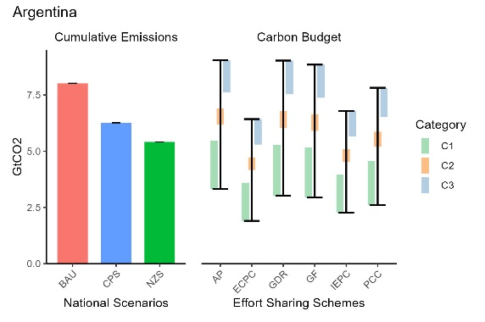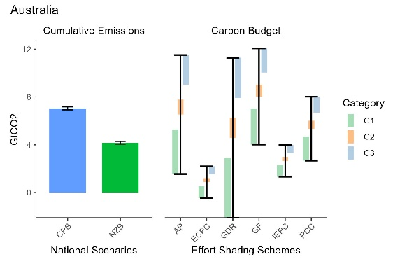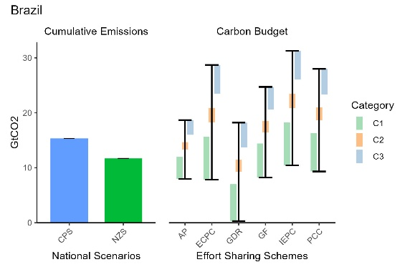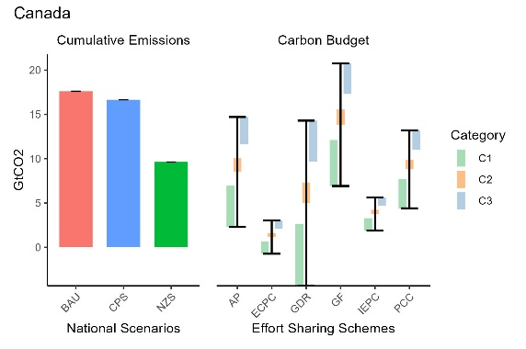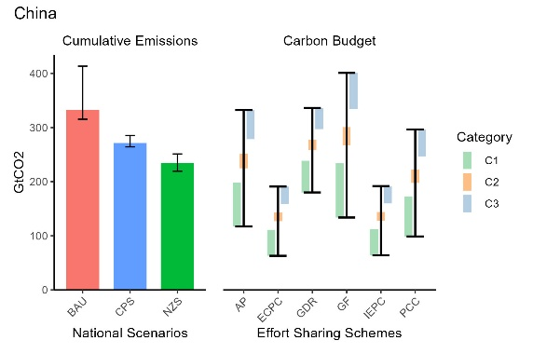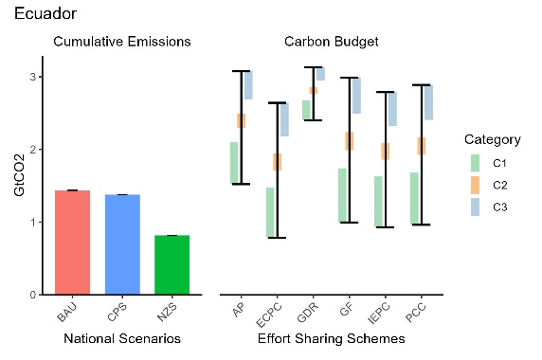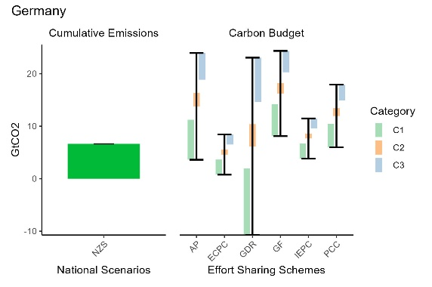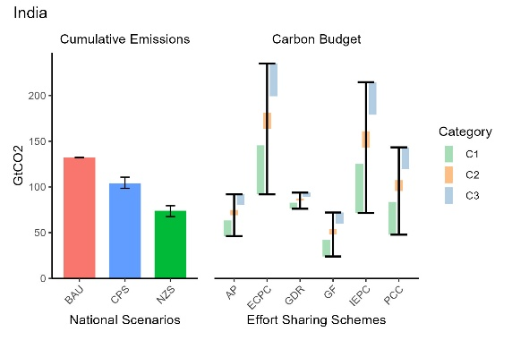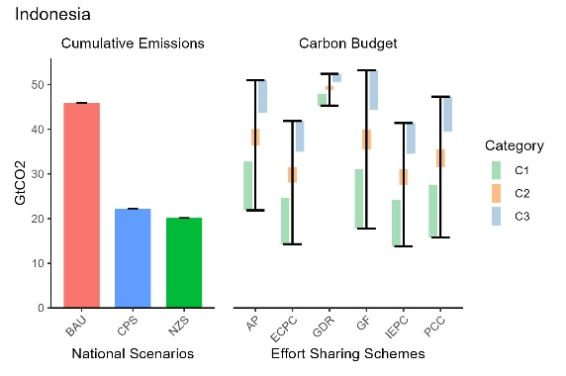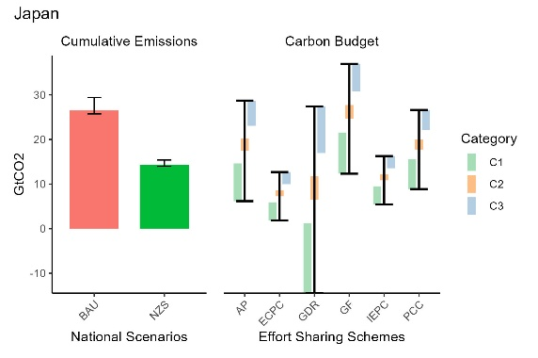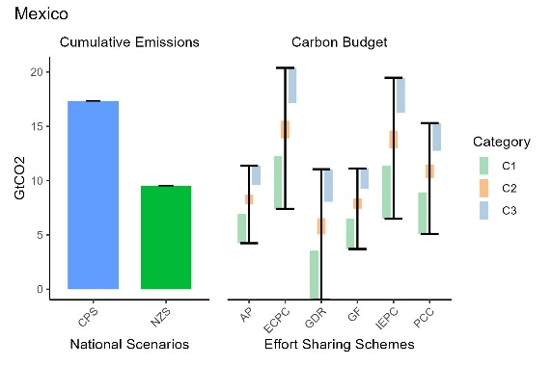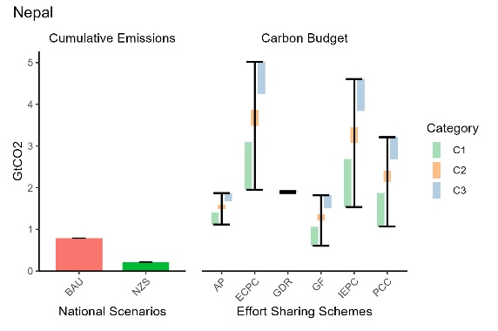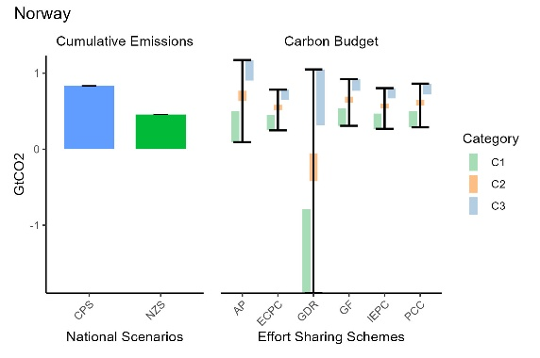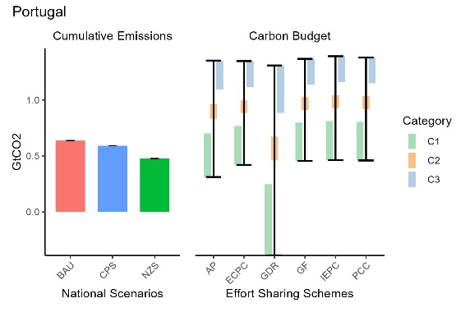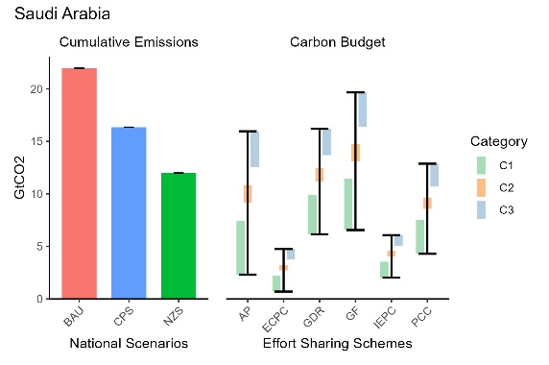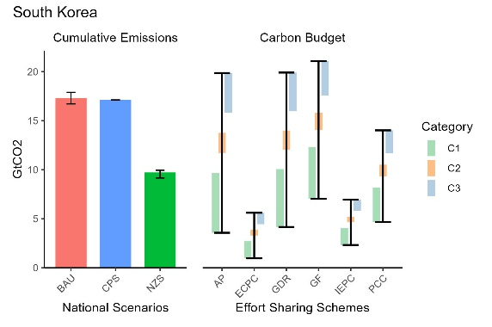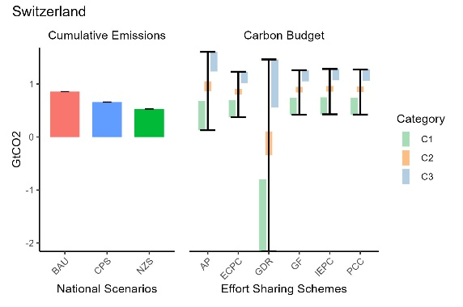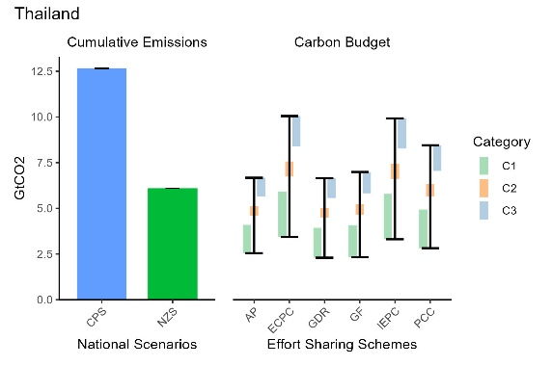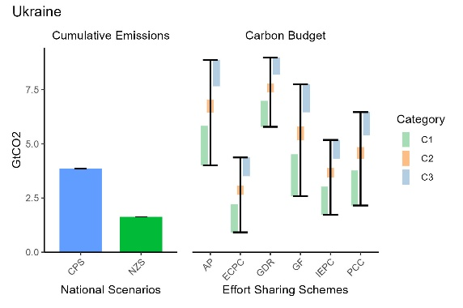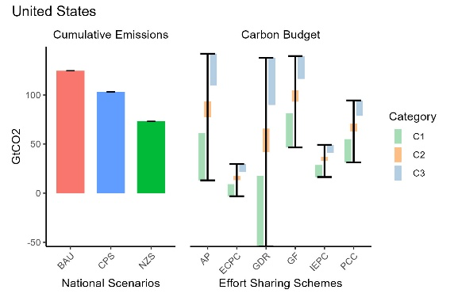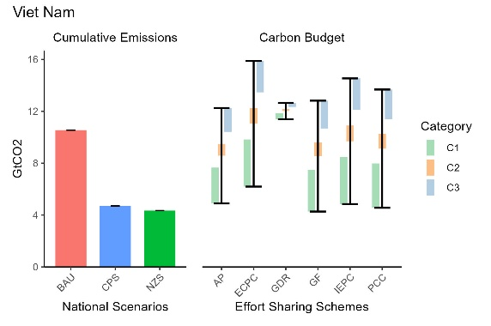

Supplementary Tables

Table 1: Models considered for main figures in the manuscript
SN | Model | Region | Scenario
1 | AIM-Thailand 1 | Thailand | CPS, NZS
2 | AIM/Enduse India 3.3 | India | BAU, CPS, NZS
3 | AIM/Hub-Japan 2.4 | Japan | BAU, NZS
4 | AIM/Hub-Vietnam 2.2 | Viet Nam | BAU, CPS, NZS
5 | AIM/Nepal V1.0 | Nepal | BAU, NZS
6 | AIM/Technology-Japan 2.1 | Japan | BAU, NZS
7 | ASEAN Energy Outlook AEO8 | Indonesia | BAU, CPS, NZS
8 | ATEM v1 | Australia | CPS, NZS
9 | BLUES 2.0 | Brazil | CPS, NZS
10 | China TIMES 2 | China | BAU, CPS, NZS
11 | D-TIMES_3 | Japan | BAU, NZS
12 | DNE21+ V.16_JMIP | Japan | BAU, NZS
13 | ELENA v1 | Ecuador | BAU, CPS, NZS
14 | GCAM KAIST 2.0 | South Korea | CPS, NZS
15 | GCAM-China-v6 | China | BAU, CPS, NZS
16 | GCAM-KSA V1.0 | Saudi Arabia | BAU, CPS, NZS
17 | GCAM-USA-CGS | United States | BAU, CPS, NZS
18 | GRACE Nor_v1.0 | Norway | CPS, NZS
19 | GTEM-C v1 | Australia | CPS, NZS
20 | IEEJ-NE_Japan v2023 | Japan | BAU, NZS
21 | India Energy Policy Simulator 3.1.3 | India | CPS, NZS
22 | KLEM/ENERGYPATHWAYS/RIO-MX 1 | Mexico | CPS, NZS
23 | KLEM/LEAP-ARG 1 | Argentina | BAU, CPS, NZS
24 | MESSAGEix-Canada 1 | Canada | BAU, CPS, NZS
25 | MESSAGEix-KOR 1 | South Korea | BAU, NZS
26 | PECE-LIU 2024_V1.0 | China | BAU, CPS, NZS
27 | PROMETHEUS V2 China | China | CPS, NZS
28 | PROMETHEUS V2 India | India | CPS, NZS
29 | REMod V1.0 | Germany | NZS
30 | Swiss TIMES Energy System Model (STEM) 2 | Switzerland | BAU, CPS, NZS
31 | TIMES-Japan 3.3 | Japan | BAU, NZS
32 | TIMES-Japan 3.4 | Japan | BAU, NZS
33 | TIMES-Portugal 9.3 | Portugal | BAU, CPS, NZS
34 | TIMES-Ukraine v1 | Ukraine | CPS, NZS
35 | UNICON-K-Power 2 | South Korea | BAU, NZS

Table 2: Models considered for supplementary Fig. 1, Fig. 4, Fig. 5
SN | Model | Region | Scenario
1 | AIM-Thailand 1 | Thailand | CPS, NZS
2 | AIM/Enduse India 3.3 | India | BAU, CPS, NZS
3 | AIM/Hub-Japan 2.4 | Japan | BAU, NZS
4 | AIM/Hub-Vietnam 2.2 | Viet Nam | BAU, CPS, NZS
5 | AIM/Technology-Japan 2.1 | Japan | BAU, NZS
6 | ATEM v1 | Australia | CPS, NZS
7 | BLUES 2.0 | Brazil | CPS, NZS
8 | China TIMES 2 | China | BAU, CPS, NZS
9 | D-TIMES_3 | Japan | BAU, NZS
10 | DNE21+ V.16_JMIP | Japan | BAU, NZS
11 | ELENA v1 | Ecuador | BAU, CPS, NZS
12 | GCAM KAIST 2.0 | South Korea | CPS, NZS
13 | GCAM-China-v6 | China | BAU, CPS, NZS
14 | GCAM-KSA V1.0 | Saudi Arabia | BAU, CPS, NZS
15 | GCAM-USA-CGS | United States | BAU, CPS, NZS
16 | GTEM-C v1 | Australia | CPS, NZS
17 | IEEJ-NE_Japan v2023 | Japan | BAU, NZS
18 | IMED_China V1.0 | China | BAU, CPS, NZS
19 | India Energy Policy Simulator 3.1.3 | India | CPS, NZS
20 | KLEM-DZA 2 | Algeria | BAU, CPS, NZS
21 | KLEM/ENERGYPATHWAYS/RIO-MX 1 | Mexico | CPS, NZS
22 | KLEM/LEAP-ARG 1 | Argentina | BAU, CPS, NZS
23 | MESSAGEix-Canada 1 | Canada | BAU, CPS, NZS
24 | MESSAGEix-Turkey 5 | Turkey | BAU, CPS, NZS
25 | PECE-LIU 2024_V1.0 | China | BAU, CPS, NZS
26 | PROMETHEUS V2 China | China | CPS, NZS
27 | PROMETHEUS V2 India | India | CPS, NZS
28 | Swiss TIMES Energy System Model (STEM) 2 | Switzerland | BAU, CPS, NZS
29 | TIMES-Japan 3.3 | Japan | BAU, NZS
30 | TIMES-Japan 3.4 | Japan | BAU, NZS
31 | TIMES-Portugal 9.3 | Portugal | BAU, CPS, NZS
32 | UNICON-K-Power 2 | South Korea | BAU, NZS

