Supplementary Materials for
Long-term metal fume exposure assessment of workers in a shipbuilding factory

Ying-Fang Wang^{1,2}, Yu-Chieh Kuo³, Lin-Chi Wang^{4,5}*

¹ Department of Occupational Safety and Health, Chung Shan Medical University, 110 Sec. 1 Jianguo Road, Taichung City 40201, Taiwan.
² Department of Occupational Medicine, Chung Shan Medical University Hospital, 110 Sec. 1 Jianguo Road, Taichung City 40201, Taiwan.
³Department of Environmental and Occupational Health, College of Medicine, National Cheng Kung University, 138 Sheng-Li Rd, Tainan City 70403, Taiwan.
⁴ Department of Environmental Engineering, Chung Yuan Christian University, 200 Chung Pei Road, Chung Li District, Taoyuan City, 32023, Taiwan
⁵ Center for Environmental Risk Management, Chung Yuan Christian University, 200 Chung Pei Road, Chung Li District, Taoyuan City, 32023, Taiwan

*Corresponding author: Tel: +886-3-265-4913; E-mail: lcwang@cycu.edu.tw

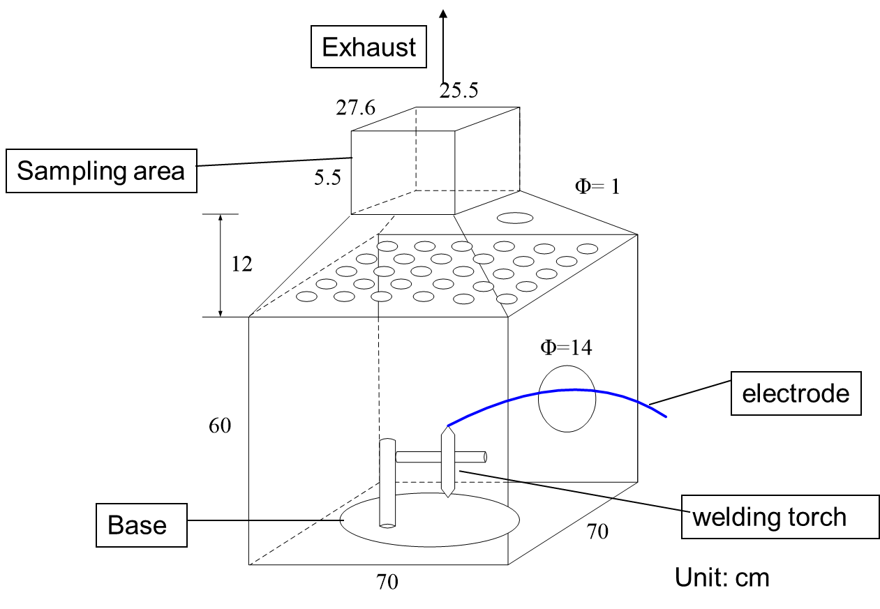
Fig. S1 The welding fume generation and collection chamber

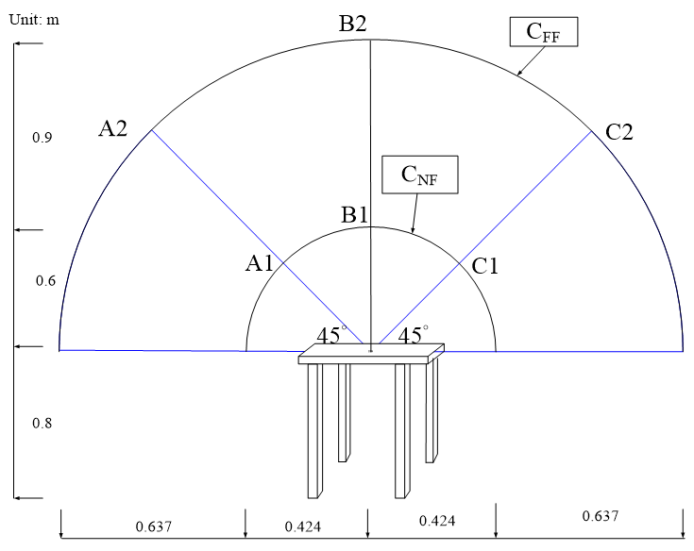

Fig. S2 Schematic of the air samplings at NF and FF regions in welding simulation experiment

Table S1 The air flow rate (β) (m³/min)(SD) between the near and far fields by field measurement from the selected welding processes.
Current (A) |  | FCAW |  |  |  | GMAW
Current (A) |  | KFX71T  (n=3) |  | KFX70T  (n=3) |  | KM56  (n=3) |  | KM58  (n=3)
120 |  | 7.12(1.96) |  | 6.78(1.94) |  | 5.43(1.82) |  | 5.11(1.63)
220 |  | 7.69(1.76) |  | 8.82(2.05) |  | 6.11(1.76) |  | 7.46(1.81)
300 |  | 10.3(1.92) |  | 11.1(2.07) |  | 8.82(1.96) |  | 9.08(2.19)

Table S2 Parameters used in NF-FF model
Parameter | Symbol | Unit | Value | Reference
Room Supply Flow Rate | Q | m³/min | 22.3 | Field measurement
Generation Rate | G | mg/min | Table 1 | Sampling
Near Field Volume | V_{N} | m³ | 0.45 | Field observation
Far Field Volume | V_{F} | m³ | 44.8 | Field observation
Flow Rate between NF and FF regions | β | m³/min | Table S1 | Field measurement

Table S3 The predicted concentrations (C_{p}) obtained by NF-FF models from the selected welding processes (mg/m³). (n=3)
Fume type |  | Current (A) |  |  | FCAW |  |  |  |  |  |  |  | GMAW
 |  |  |  | KFX71T |  |  |  | KFX70T |  |  |  |  |  | KM56 |  |  | KM58
Fume type |  | Current (A) |  | NF |  | FF |  | NF | FF |  |  |  |  | NF | FF |  | NF | FF
Cr |  | 120 |  | 0.003 |  | 0.001 |  | 0.005 | 0.001 |  |  |  |  | 0.002 | 0.001 |  | 0.007 | 0.001
Cr |  | 220 |  | 0.006 |  | 0.002 |  | 0.006 | 0.002 |  |  |  |  | 0.002 | 0.001 |  | 0.005 | 0.001
Cr |  | 300 |  | 0.009 |  | 0.003 |  | 0.011 | 0.004 |  |  |  |  | 0.004 | 0.002 |  | 0.013 | 0.003
Fe |  | 120 |  | 4.41 |  | 0.98 |  | 5.07 | 1.09 |  |  |  |  | 4.42 | 0.79 |  | 5.60 | 0.95
Fe |  | 220 |  | 5.25 |  | 1.24 |  | 5.39 | 1.42 |  |  |  |  | 5.78 | 1.14 |  | 5.91 | 1.37
Fe |  | 300 |  | 9.34 |  | 2.74 |  | 9.29 | 2.87 |  |  |  |  | 9.65 | 2.53 |  | 9.91 | 2.66
Mn |  | 120 |  | 0.332 |  | 0.074 |  | 0.709 | 0.152 |  |  |  |  | 0.416 | 0.075 |  | 0.693 | 0.118
Mn |  | 220 |  | 0.559 |  | 0.132 |  | 0.929 | 0.244 |  |  |  |  | 0.522 | 0.103 |  | 0.582 | 0.135
Mn |  | 300 |  | 1.07 |  | 0.314 |  | 1.19 | 0.367 |  |  |  |  | 1.19 | 0.311 |  | 1.28 | 0.344
Ni |  | 120 |  | 0.003 |  | 0.001 |  | 0.005 | 0.001 |  |  |  |  | 0.006 | 0.001 |  | 0.007 | 0.001
Ni |  | 220 |  | 0.008 |  | 0.002 |  | 0.012 | 0.003 |  |  |  |  | 0.008 | 0.002 |  | 0.008 | 0.002
Ni |  | 300 |  | 0.013 |  | 0.004 |  | 0.014 | 0.004 |  |  |  |  | 0.009 | 0.002 |  | 0.013 | 0.004
Pb |  | 120 |  | 0.003 |  | 0.001 |  | 0.005 | 0.001 |  |  |  |  | 0.004 | 0.001 |  | 0.005 | 0.001
Pb |  | 220 |  | 0.007 |  | 0.002 |  | 0.004 | 0.001 |  |  |  |  | 0.006 | 0.001 |  | 0.005 | 0.001
Pb |  | 300 |  | 0.012 |  | 0.004 |  | 0.013 | 0.004 |  |  |  |  | 0.009 | 0.002 |  | 0.012 | 0.003

Table S4 The simple linear regression model of predicted concentrations (Cp) and their corresponding measured concentrations (Cm).
 |  | NF |  |  |  | FF
 |  | Predicted model |  | R² |  | Predicted model |  | R²
Cr |  | C_{m}=1.29C_{p}+0.001 |  | 0.85 |  | C_{m}=2.36C_{p}-0.0002 |  | 0.87
Fe |  | C_{m}=3.42C_{p}+3.81 |  | 0.81 |  | C_{m}=4.82C_{p}+3.95 |  | 0.85
Mn |  | C_{m}=0.77C_{p}+0.13 |  | 0.83 |  | C_{m}=1.46C_{p}+0.05 |  | 0.82
Ni |  | C_{m}=2.11C_{p}-0.001 |  | 0.94 |  | C_{m}=2.28C_{p}-0.0001 |  | 0.94
Pb |  | C_{m}=1.06C_{p}-0.001 |  | 0.82 |  | C_{m}=1.56C_{p}+0.0004 |  | 0.91

