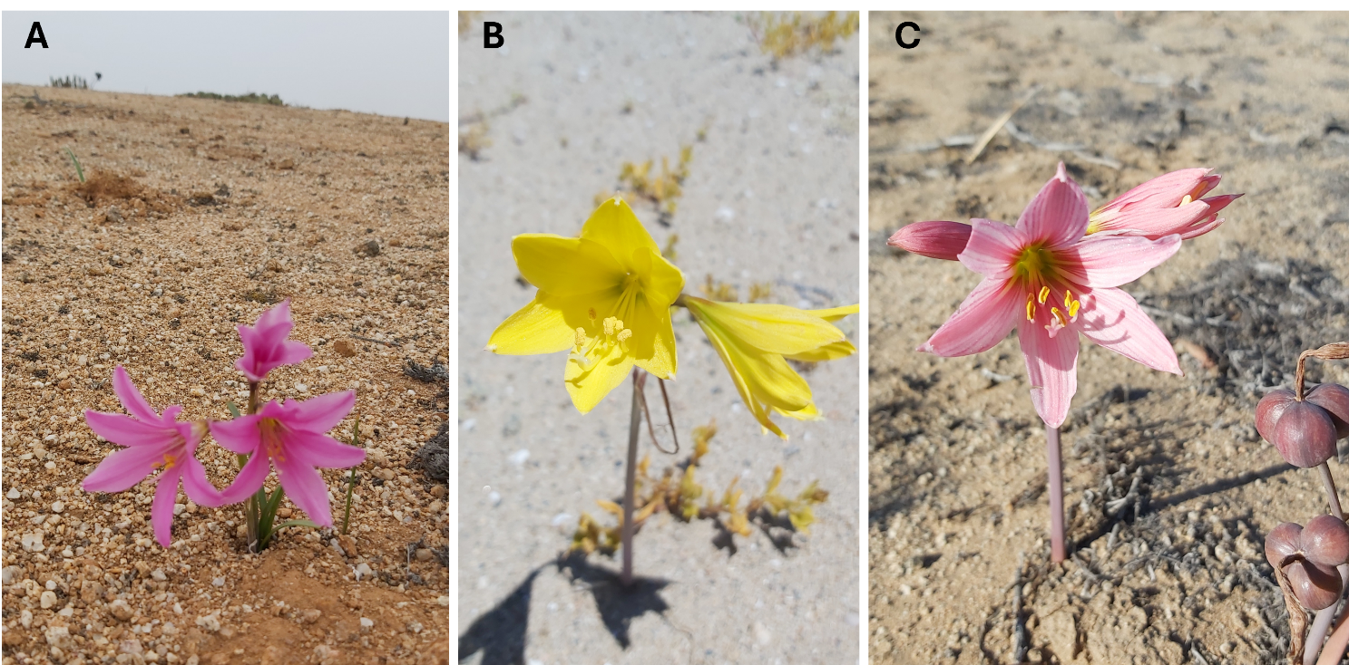
Figure S1. Representative flowering individuals of three geophytic species from the Atacama Desert. (A) Paposoa laeta from Pan de Azúcar National Park (Chañaral), (B) Zephyranthes bagnoldii from Pampa Caracoles (Caldera), and (C) Zephyranthes sarae from Freirina, Chile.

