Table I. Patient Demographics and Clinical Characteristics Before and After Propensity Score Matching.
Values are presented as median (range) or n (%).
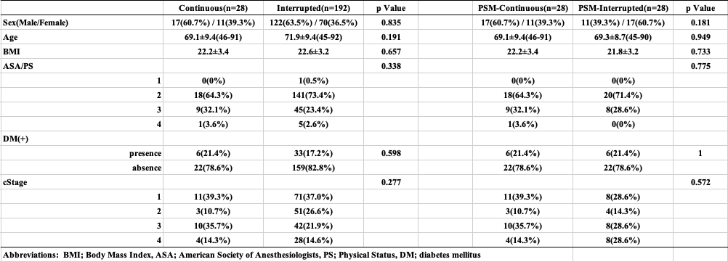

Table II. Intraoperative and Postoperative Outcomes in the Propensity Score-Matched Groups.
Values are presented as median (range). p-values were calculated using the Mann-Whitney U test for continuous variables, and Fisher’s exact test or the chi-squared test for categorical variables.
