Supplementary Information
Electrified synthesis of small-diameter single-walled carbon nanotubes via plasma-catalytic pyrolysis of methane
Jafar Fathi^{a,b,c*}, Alan Mašláni^{b}, Michal Hlína^{b}, Dawid Janas^{d}, Alena Michalcová^{e}, David Sedmidubskýª, Ondřej Jankovský^{a*}
ª University of Chemistry and Technology, Department of Inorganic Chemistry, Technická 5, 166 28, Prague 6, Czech Republic
^{b} Institute of Plasma Physics of the Czech Academy of Sciences, U Slovanky 2525/1a, 182 00, Prague 8, Czech Republic
^{c} Czech University of Life Sciences Prague, Department of Environmental Geosciences, Kamýcká 129, Suchdol 165 00, Prague, Czech Republic
^{d} Silesian University of Technology, Faculty of Chemistry, B. Krzywoustego 4, 44-100, Gliwice, Poland
^{e} University of Chemistry and Technology, Department of Metals and Corrosion Engineering, Technická 5, 166 28, Prague 6, Czech Republic
* Corresponding author: fathi@ipp.cas.cz (J. Fathi) +420 266 052 037

History of SWCNTs synthesis evaluation
The first synthesis of SWCNTs was reported by Iijima and Ichihashi in 1993, who produced them in the gas phase using the arc discharge method. This technique involves the use of graphite electrodes, generating SWCNTs through vaporization and subsequent condensation in an inert atmosphere [1]. Following this, alternative synthesis methods were developed, such as laser ablation, in which a high-energy laser evaporates graphite in an inert gas environment [2]. While these methods can produce high-yield and high-purity SWCNTs, they do come with disadvantages, including high energy consumption and production of large quantities of amorphous carbon and the necessity for extensive post-synthesis purification, which complicates scalability and cost-effectiveness [3], [4], [5].
An alternative method is chemical vapor deposition (CVD), which employs catalysts (e.g., metal nanoparticles or thin films) to facilitate the growth of SWCNTs from carbon precursors at elevated temperatures. CVD has established itself as a leading method for the synthesis of SWCNTs, providing the versatility and scalability necessary for industrial applications [6]. The first evidence of the effect of transition metals (e.g. Fe, Ni, Co) on the decomposition of gaseous carbon-containing molecules and the subsequent precipitation of solid carbon at 873 K was reported by Radushkevich et al. in 1952. In their pioneering work, they demonstrated that carbon monoxide (CO) decomposes on the surfaces of transition metals, leading to the formation of solid carbon. The resulting carbon structures were described as wisp-like and elongated carbon particles with hollow channels, that we now recognize as carbon nanotubes (CNTs) [7]. This phenomenon is explained by the Carbide-Cycle Mechanism, which also contributes to carbon erosion on the surfaces of iron-group metals. The mechanism is inactive on smooth or polished metal surfaces but becomes prominent at sites with microstructural defects, which act as nucleation points for carbon precipitation. The Carbide-Cycle Mechanism proceeds through three distinct stages: (1) decomposition of carbon-containing molecules and dissolution of carbon atoms into the metal, (2) diffusion of carbon through the metal particle, and (3) formation and growth of carbon structures on the opposite side of the metal particle. A key aspect of this mechanism is the transient formation of unstable metal carbide phases, which are characteristic of transition metals such as Fe, Co, and Ni. These carbides decompose, releasing solid carbon and regenerating the metal catalyst, thereby enabling the continuous formation of carbon nanostructures. Understanding this mechanism is crucial for elucidating the role of transition metals in the synthesis of CNTs and other carbon allotropes from gaseous precursors [8]. The growth of SWCNTs facilitated by the surface of molten transition metal nanoparticles is commonly described by the Vapor-Liquid-Solid (VLS) process [9]. Experimental studies have shown that the melting point of iron decreases when exposed to a methane atmosphere, indicating the formation of a eutectic compound with carbon, such as iron carbide (Fe₃C). This behavior provides strong evidence for the involvement of carbide phases in the CNT growth process. Notably, even after the synthesis of SWCNTs on iron nanoparticles, the formation of Fe₃C is still observed, suggesting its persistent role in the catalytic cycle and carbon precipitation dynamics [10]. During the VLS process, the diameter of the molten monometallic nanoparticles used as catalysts determines the diameter of the SWCNTs formed [11], In contrast, SWCNTs grown from solid-state catalysts, typically transition metal alloys with high melting points, such as Co₇W₆ via the Vapor-Solid-Solid (VSS) process, exhibit particle size independence. This means that the resulting SWCNTs maintain a consistent diameter regardless of the size of the catalyst nanoparticles. Such behavior highlights fundamental differences in growth dynamics between VLS and VSS processes and underscores the unique catalytic properties of solid alloy systems in CNT synthesis [12]. The CVD technique can be classified into three main methods: High-Pressure CVD (HiPco), Substrate-Supported Catalyst CVD (SCCVD), and Floating Catalyst CVD (FCCVD) [13]. These approaches represent the primary strategies through which CVD technology has been developed and commercialized to produce single-walled carbon nanotubes (SWCNTs) with a balance of cost-effectiveness and quality.
In the HiPco process, iron pentacarbonyl (Fe(CO)₅) is used as the catalyst precursor, while carbon monoxide (CO) serves as both carbon source and carrier gas. Under high-temperature conditions (1000–1100 °C), Fe(CO)₅ decomposes due to thermal interaction with the CO gas, forming iron nanoparticles in situ. These nanoparticles act as active catalytic sites for the Boudouard reaction, which leads to the precipitation of solid carbon. The deposited carbon then nucleates and grows into SWCNTs on the surface of the iron nanoparticles [14]. This process is currently employed by companies such as NanoIntegris, which utilize HiPco technology for the mass production of high-purity SWCNTs, particularly for applications in electronics, sensors, and advanced materials [15], [16].
Furthermore, the SCCVD for SWCNTs production method relies on cobalt-based catalysts supported on solid substrates. Timesnano company, a spin-off of the Chinese Academy of Sciences (CAS), has successfully scaled up the mass production of SWCNTs using the SCCVD technique. Their process employs cobalt as the catalyst and methane as the carbon precursor, enabling efficient and consistent SWCNT synthesis [17]. Another highly successful approach is the CoMoCAT® method, recognized for its ability to produce SWCNTs with a narrow-chirality distribution. This technique utilizes a silica-supported catalyst system composed of cobalt and molybdenum (CoMo). In the CoMoCAT process, SWCNTs are synthesized at temperatures ranging from 700 to 950 °C under a pure carbon monoxide (CO) flow [18]. The synergistic interaction between Co and Mo is critical to the catalyst’s performance, with the Mo:Co atomic ratio playing a key role in determining selectivity and activity. The catalyst exhibits high selectivity for SWCNT growth only when an adequate amount of molybdenum is present [19].
Finally, the FCCVD is a scalable method for synthesis of SWCNTs by introducing both catalyst precursors and carbon sources into a high-temperature reactor. Common catalysts are metallocenes and carbonyls [20] where they decompose to form floating metal nanoparticles that initiate SWCNT growth, with Fe yielding the highest production efficiency compared to Ni or Co [21]. This process is often promoted with sulfur-containing additives to control particle size and chirality. Catalyst feeding is typically achieved by aerosolized injections. Carbon precursors range from aromatic hydrocarbons, alcohols, and light hydrocarbons [13]. Aromatics offer high yield but risk amorphous carbon deposition, while alcohol provides cleaner growth but lower rates. At the same time, light hydrocarbons balance cost and purity [22]. Temperature range for SWCNTs growth starts from 600 °C and go above 1000 °C [8], [23], [24]. Adding water to process has been observed mitigate amorphous carbon formation by etching it [25]. FCCVD allows for continuous production and direct assembly of SWCNTs macrostructures (films, fibers, sponges), but challenges remain as controlling chirality, diameter uniformity, and length [24]. the catalyst structure is of utmost importance. Recent innovations, such as induction thermal plasma or hot-wire generators, enable the formation of metal nanoparticles within a narrow size range (e.g. 1-3 nm) and provide advanced control over SWCNT properties, facilitating the synthesis of sub-nanometer diameter SWCNTs [26], [27]. In particular, the catalyst nanoparticle growth from metal bulk source by plasma arc discharge in methane atmosphere was found notably effective in this regard [28], [29], [30]. Consequently, low-cost, large-scale, and high-purity SWCNT production has been introduced by OCSiAl under the commercial name TUBALL [31]. In their process, Fe nanoparticles are generated via a plasma arc, where an Fe molten pool is formed through arc discharge [32]. These nanoparticles subsequently react with a carbon source gas to grow SWCNTs. The company reports an annual production capacity exceeding 60 tons of SWCNTs at a cost of approximately $2,000 per kilogram which is the lowest price for such high-quality material [31].

Methane pyrolysis
Concomitantly, with the growing demand for greenhouse gas (GHG) emission-free fuels, hydrogen has emerged as a credible candidate. One promising method for producing hydrogen at a competitive cost compared to conventional technologies is methane pyrolysis, a process that yields hydrogen and solid carbon. For every kilogram of hydrogen produced, approximately three kilograms of solid carbon are generated. Rather than releasing this carbon into the atmosphere, it can be repurposed as a valuable material to support technological and industrial advancement.
Various technologies exist for methane pyrolysis, among which plasma pyrolysis stands out due to its potential to utilize renewable electricity to drive the endothermic methane cracking reaction. Plasma serves as a powerful tool to convert electrical energy into extremely high-temperature thermal energy, which can be harnessed in the pyrolysis process. This energy is stored chemically within hydrogen molecules, making them suitable for use as fuel.
From a cost-benefit perspective, the profitability of the process largely depends on the quality of the carbon produced. SWCNTs are among the most valuable carbon products that can be targeted. However, their synthesis during pyrolysis typically requires a catalyst, which can increase the overall cost. To maximize economic viability, selecting a low-cost catalyst is essential. Iron (III) oxide (Fe₂O₃) is one of the most affordable options and can be used to influence carbon structure during the process, but it is rarely used in this context.

Supplementary Figures

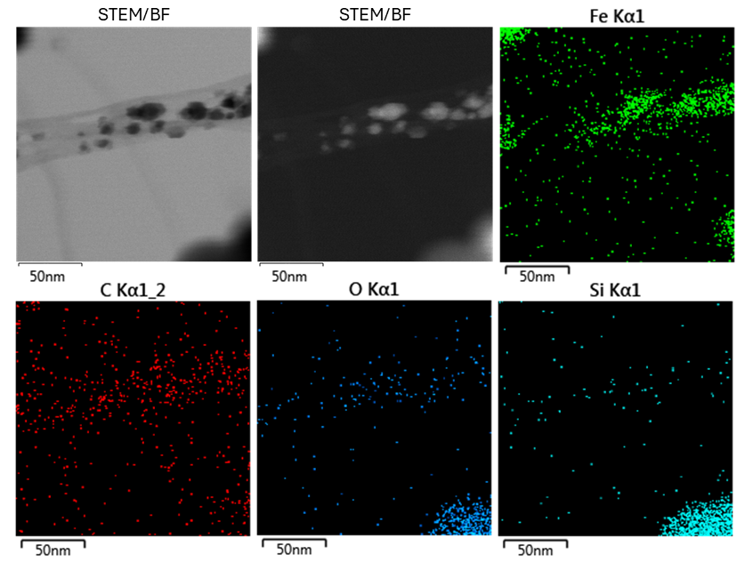
Figure S1 STEM images and EDS elemental maps for fibers and nanoparticles

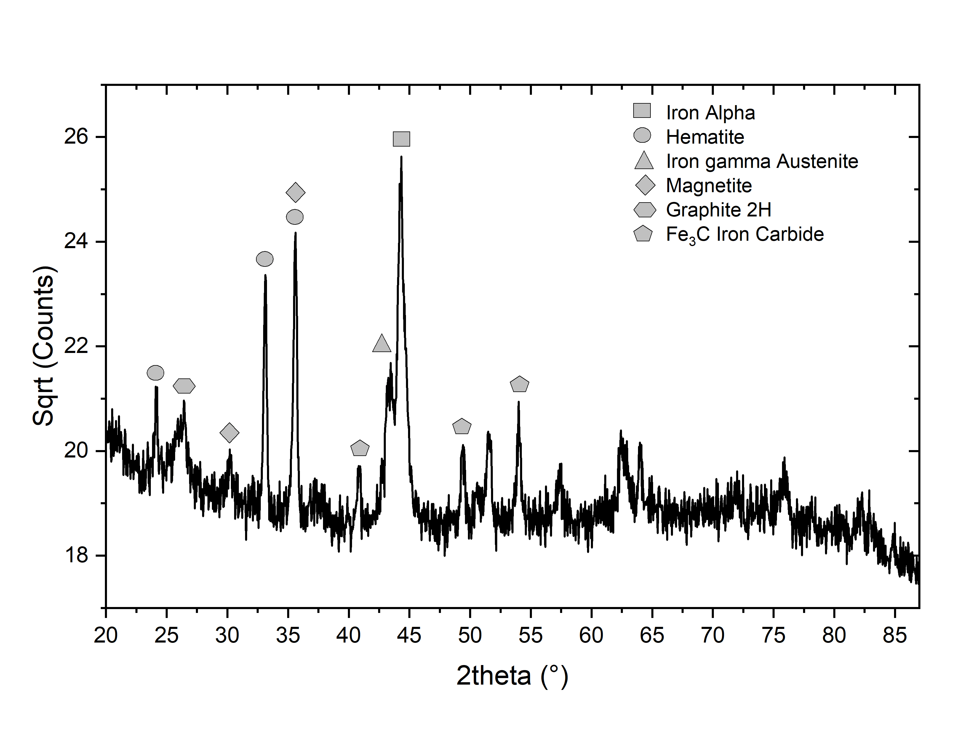
Figure S2 XRD analysis of the as-produced SWCNT, which confirms the existing phases of Fe in the sample

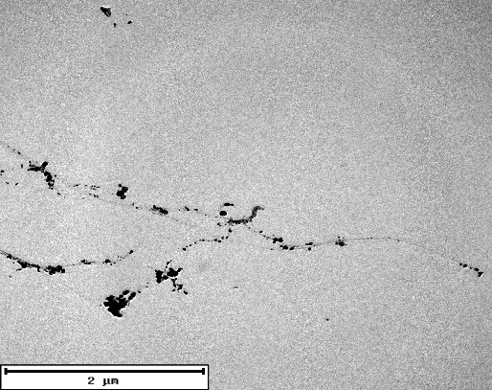
Figure S3 The original four TEM micrographs are combined.
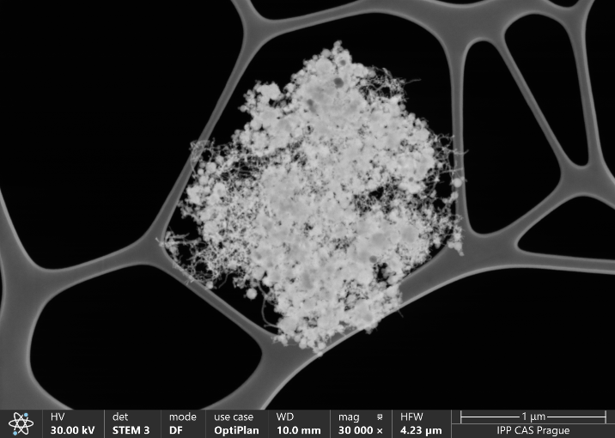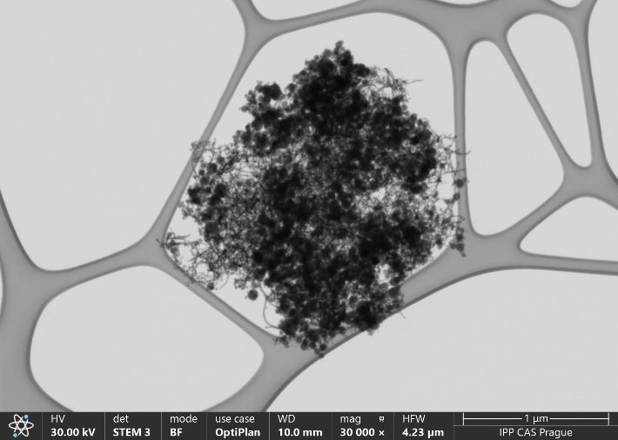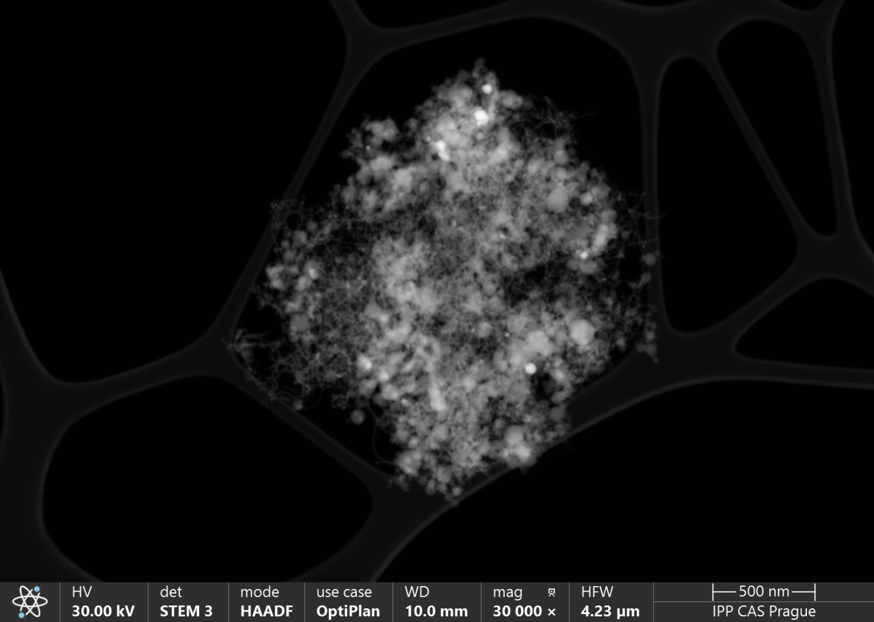
Figure S4 STEM images of as-produced SWCNTs in DF, BF, and HAADF modes

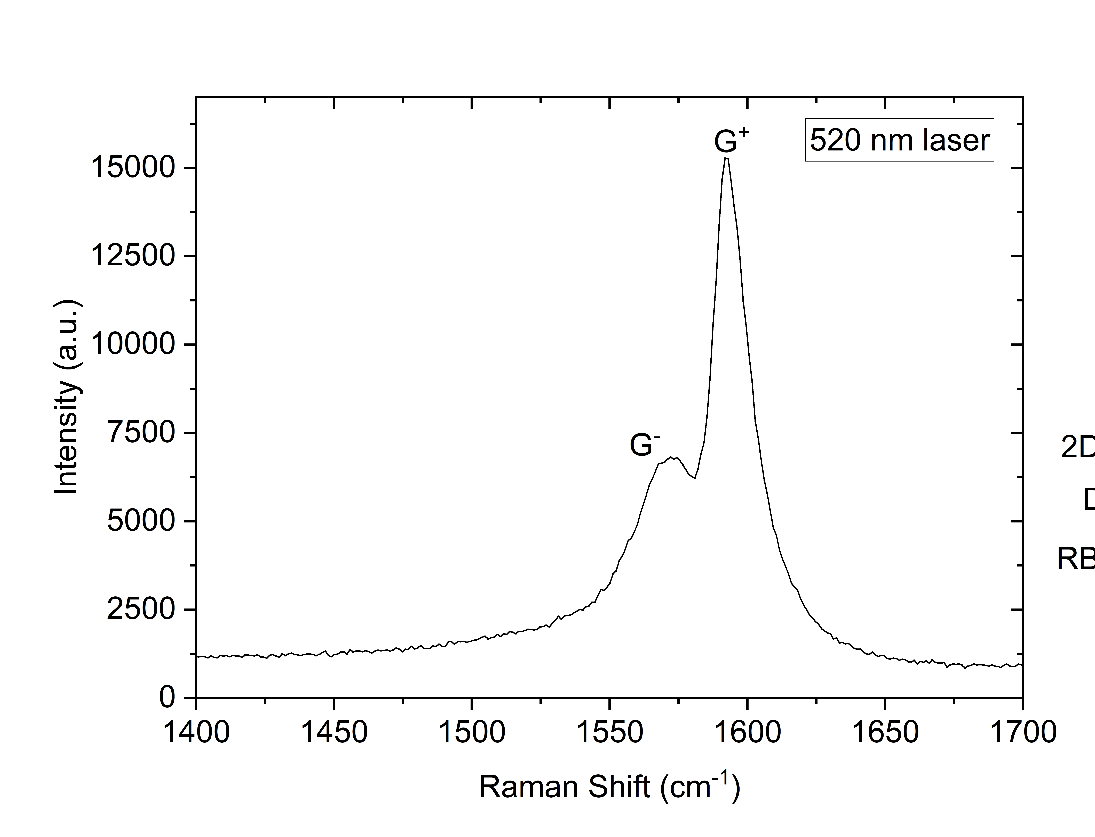
a)
b)

Figure S5 (a) RBM Raman spectrum deconvolution and (b) G peak splitting

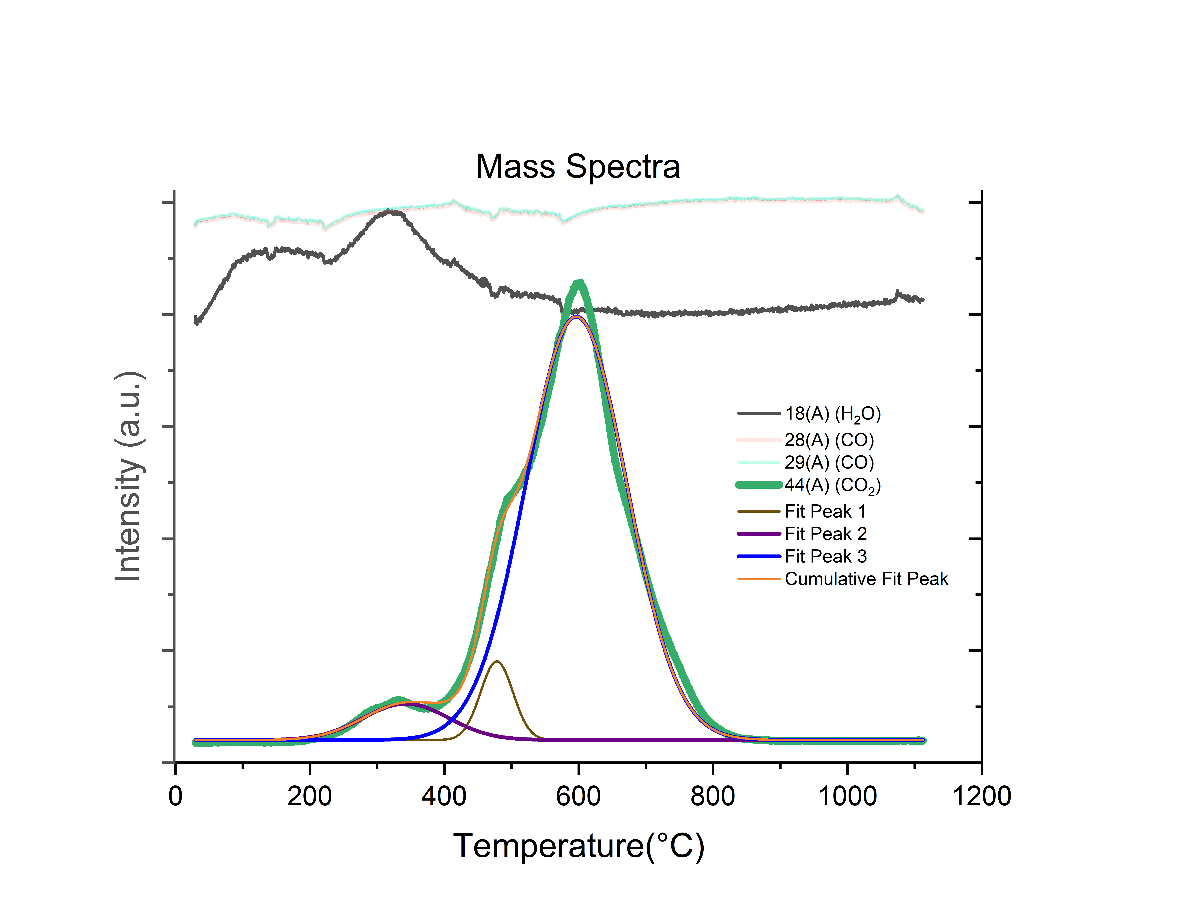
Figure S6 Mass spectra of m/z 18,28,29, and 44 which correspond to H₂O, CO, and CO₂ spectra, respectively
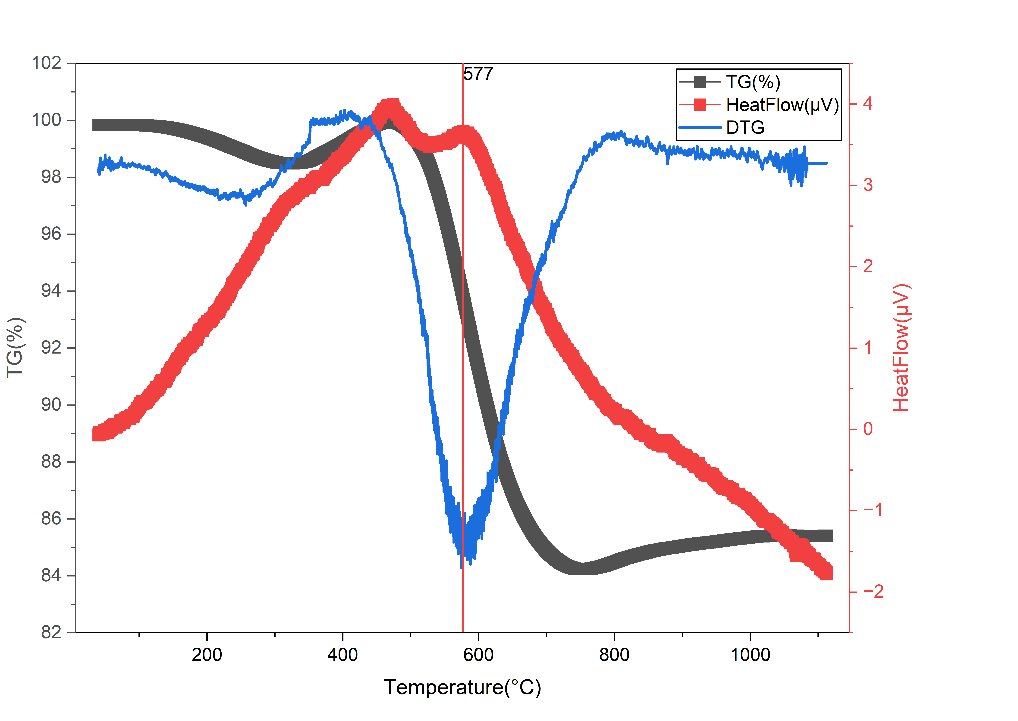
Figure S7 DTG interpretation of TGA from STA

Supplementary References
[1] S. Iijima and T. Ichihashi, ‘Single-shell carbon nanotubes of 1-nm diameter’, Nature, vol. 363, pp. 603–605, 1993, doi: 10.1038/363603a0.
[2] J. Chrzanowska et al., ‘Synthesis of carbon nanotubes by the laser ablation method: Effect of laser wavelength’, Phys Status Solidi B Basic Res, vol. 252, no. 8, pp. 1860–1867, Aug. 2015, doi: 10.1002/pssb.201451614.
[3] X. Fang, A. Shashurin, G. Teel, and M. Keidar, ‘Determining synthesis region of the single wall carbon nanotubes in arc plasma volume’, Carbon N Y, vol. 107, pp. 273–280, Oct. 2016, doi: 10.1016/j.carbon.2016.05.061.
[4] C. Hu et al., ‘Preparation of single-walled carbon nanotubes from fullerene waste soot’, ACS Sustain Chem Eng, vol. 2, no. 1, pp. 14–18, 2014, doi: 10.1021/sc4003278.
[5] P. R. L. Lefebvre, J., Ding, J., Li, Z., Finnie, P., Lopinski, G. P., & Malenfant, ‘High-Purity Semiconducting Single-Walled Carbon Nanotubes: A Key Enabling Material in Emerging Electronics’, Acc Chem Res, vol. 50, no. 10, pp. 2479–2486, 2017, doi: https://doi.org/10.1021/acs.accounts.7b00234.
[6] Q. Zhang, J. Huang, M. Zhao, W. Qian, and F. Wei, ‘Carbon Nanotube Mass Production : Principles and Processes’, pp. 864–889, 2011, doi: 10.1002/cssc.201100177.
[7] L. V. and L. V. M. , Zh. Fiz. Khim. , 1952, vol. 26, pp. 88–95 Radushkevich, ‘Radushkevich LV, Lukyanovich VM. O strukture ugleroda,obrazujucegosja pri termiceskom razlozenii okisi ugleroda na zeleznom kontakte. Zurn Fisic Chim 1952’, Zh. Fiz. Khim., vol. 26, pp. 88–95, 1952.
[8] R. A. Buyanov, I. V. Mishakov, and A. A. Vedyagin, ‘Carbon erosion of hardware made of iron subgroup metals and their alloys’, Doklady Physical Chemistry, vol. 448, no. 1, pp. 11–13, 2013, doi: 10.1134/S0012501613010041.
[9] E. F. Kukovitsky, S. G. L’vov, and N. A. Sainov, ‘VLS-growth of carbon nanotubes from the vapor’, 2000. [Online]. Available: www.elsevier.nlrlocatercplett
[10] Y. Homma, Y. Kobayashi, and T. Ogino, ‘Role of Transition Metal Catalysts in Single-Walled Carbon Nanotube Growth in Chemical Vapor Deposition’, pp. 12161–12164, 2003.
[11] F. Yang et al., ‘Growth modes of single-walled carbon nanotubes on catalysts’, 2022. [Online]. Available: https://www.science.org
[12] X. Zhao, S. Sun, F. Yang, and Y. Li, ‘Atomic-Scale Evidence of Catalyst Evolution for the Structure-Controlled Growth of Single-Walled Carbon Nanotubes’, Acc Chem Res, vol. 55, no. 23, pp. 3334–3344, Dec. 2022, doi: 10.1021/acs.accounts.2c00592.
[13] P. X. Hou, F. Zhang, L. Zhang, C. Liu, and H. M. Cheng, ‘Synthesis of Carbon Nanotubes by Floating Catalyst Chemical Vapor Deposition and Their Applications’, Adv Funct Mater, vol. 32, no. 11, pp. 1–20, 2022, doi: 10.1002/adfm.202108541.
[14] M. J. Bronikowski, P. A. Willis, D. T. Colbert, K. A. Smith, and R. E. Smalley, ‘Gas-phase production of carbon single-walled nanotubes from carbon monoxide via the HiPco process: A parametric study’, Journal of Vacuum Science & Technology A: Vacuum, Surfaces, and Films, vol. 19, no. 4, pp. 1800–1805, Jul. 2001, doi: 10.1116/1.1380721.
[15] V. S. Gangoli, M. A. Godwin, G. Reddy, R. K. Bradley, and A. R. Barron, ‘in 2019’, C (Basel), no. Cvd, p. 2019, 2019, doi: 10.3390/c5040065.
[16] D. E. Johnston, M. F. Islam, A. G. Yodh, and A. T. Johnson, ‘Electronic devices based on purified carbon nanotubes grown by high-pressure decomposition of carbon monoxide’, Nat Mater, vol. 4, no. 8, pp. 589–592, 2005, doi: 10.1038/nmat1427.
[17] P. Ananthasubramanian, R. Sahay, and N. Raghavan, ‘Enhancement of the mechanical properties in ultra-low weight SWCNT sandwiched PDMS composites using a novel stacked architecture’, Sci Rep, vol. 14, no. 1, Dec. 2024, doi: 10.1038/s41598-024-54631-7.
[18] D. E. Resasco, W. E. Alvarez, F. Pompeo, L. Balzano, J. E. Herrera, and A. Borgna, ‘A scalable process for production of single-walled carbon nanotubes (SWNTs) by catalytic disproportionation of CO on a solid catalyst’, 2002.
[19] W. E. Alvarez, B. Kitiyanan, A. Borgna, and D. E. Resasco, ‘Synergism of Co and Mo in the catalytic production of single-wall carbon nanotubes by decomposition of CO’, 2001.
[20] A. Moisala, A. G. Nasibulin, D. P. Brown, H. Jiang, L. Khriachtchev, and E. I. Kauppinen, ‘Single-walled carbon nanotube synthesis using ferrocene and iron pentacarbonyl in a laminar flow reactor’, Chem Eng Sci, vol. 61, no. 13, pp. 4393–4402, Jul. 2006, doi: 10.1016/j.ces.2006.02.020.
[21] S. Ahmad et al., ‘Systematic investigation of the catalyst composition effects on single-walled carbon nanotubes synthesis in floating-catalyst CVD’, Carbon N Y, vol. 149, pp. 318–327, Aug. 2019, doi: 10.1016/J.CARBON.2019.04.026.
[22] L. Song et al., ‘Large-scale synthesis of rings of bundled single-walled carbon nanotubes by floating chemical vapor deposition’, Jul. 18, 2006. doi: 10.1002/adma.200502372.
[23] O. Yu, L. Daoyong, C. Weiran, S. Shaohua, and C. Li, ‘A temperature window for the synthesis of single-walled carbon nanotubes by catalytic chemical vapor deposition of CH 4 over Mo 2-Fe 10/MgO catalyst’, Nanoscale Res Lett, vol. 4, no. 6, pp. 574–577, 2009, doi: 10.1007/s11671-009-9284-z.
[24] L. Wang et al., ‘A comprehensive review of FCCVD for carbon nanotubes growth’, Mar. 01, 2025, Springer. doi: 10.1007/s10853-025-10732-w.
[25] J. Geng, M. Motta, V. Engels, J. Luo, and B. F. G. Johnson, ‘Temperature threshold and water role in CVD growth of single-walled carbon nanotubes’, Front Mater, vol. 3, Feb. 2016, doi: 10.3389/fmats.2016.00004.
[26] A. G. Nasibulin, A. Moisala, D. P. Brown, H. Jiang, and E. I. Kauppinen, ‘A novel aerosol method for single walled carbon nanotube synthesis’, Chem Phys Lett, vol. 402, no. 1–3, pp. 227–232, 2005, doi: 10.1016/j.cplett.2004.12.040.
[27] K. S. Kim et al., ‘Synthesis of single-walled carbon nanotubes by induction thermal plasma’, Nano Res, vol. 2, no. 10, pp. 800–817, 2009, doi: 10.1007/s12274-009-9085-9.
[28] S. Musikhin, V. A. Nemchinsky, H. Gu, B. E. Koel, and Y. Raitses, ‘In situ studies of a molten metal anode ablation in a nearly atmospheric pressure DC arc’, J Phys D Appl Phys, Oct. 2025, doi: 10.1088/1361-6463/ae159a.
[29] V. Nemchinsky, S. Musikhin, and Y. Raitses, ‘Simulation of metal nanoparticles growth in methane atmosphere of arc discharge: comparison to experiment’, J Phys D Appl Phys, vol. 58, no. 8, Feb. 2025, doi: 10.1088/1361-6463/ad9ebd.
[30] S. Musikhin, V. Nemchinsky, and Y. Raitses, ‘Growth of metal nanoparticles in hydrocarbon atmosphere of arc discharge’.
[31] M. R. Predtechenskiy et al., ‘New perspectives in SWCNT applications: Tuball SWCNTs. Part 1. Tuball by itself—All you need to know about it’, Jul. 01, 2022, Elsevier Ltd. doi: 10.1016/j.cartre.2022.100175.
[32] ‘Plasma-chemical reactor OCSiAl US6846467’.

Supplementary Abbreviation
Plasma-Catalytic Pyrolysis (PCP)
water stabilized plasma Hybrid (WSP-H)
single-walled carbon nanotubes (SWCNTs)
Carbon Nanotubes (CNTs)
chemical vapor deposition (CVD)
Vapor-Liquid-Solid (VLS)
Vapor-Solid-Solid (VSS)
High-Pressure CVD (HiPco)
Substrate-Supported Catalyst CVD (SCCVD)
Floating Catalyst CVD (FCCVD)
greenhouse gas (GHG)
hybrid water/Argon stabilized plasma (WSP®H 2000)
Transmission Electron Microscopy (TEM)
Energy-Dispersive X-ray Spectroscopy (EDS)
Electron Energy Loss Spectroscopy (EELS)
Energy-Filtered Transmission Electron Microscopy (EFTEM)
Scanning Transmission Electron Microscopy (STEM)
Selected Area Electron Diffraction (SAED)
High-Resolution Transmission Electron Microscopy (HRTEM)
Laser Diffraction (LD)
Scanning Transmission Electron Microscopy (STEM)
Radial Breathing Mode (RBM)
Photoluminescence excitation–emission maps (PLE)
Volatile Organic Compounds (VOCs)
Derivative Thermogravimetry (DTG)
Steam Reforming (SR)
Water-Gas Shift Reaction (WGSR)

