Supplement 1. Self-assessment Questionnaire
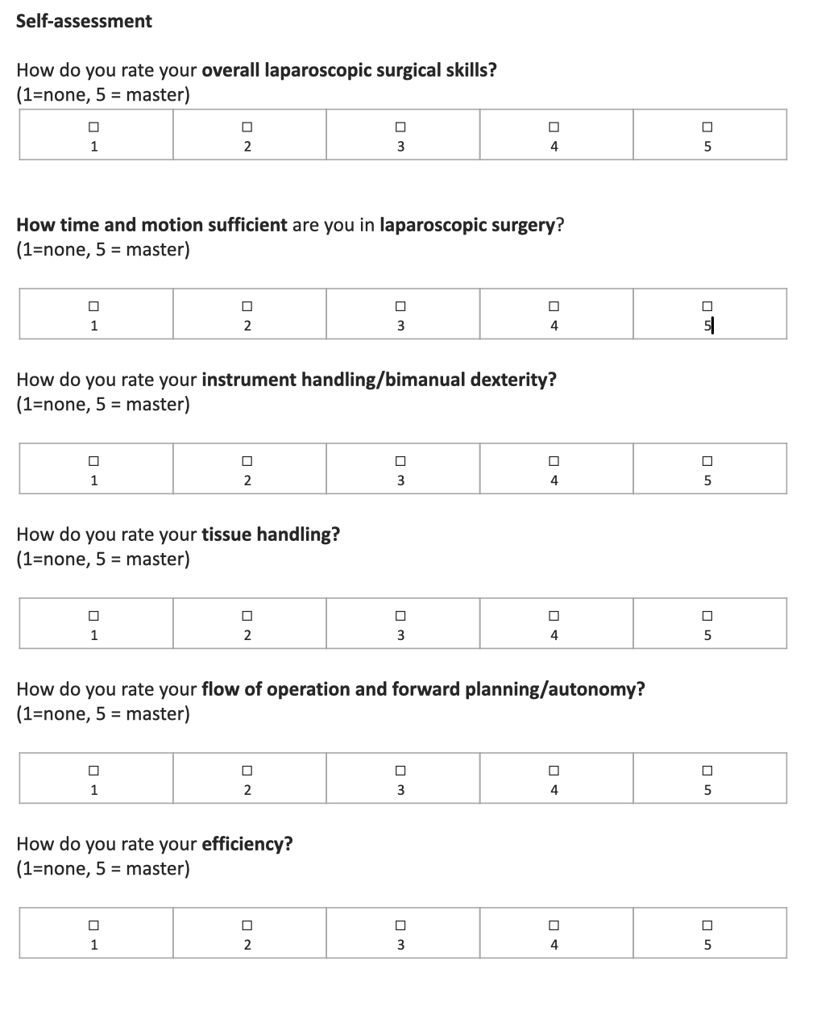

Supplement 2. Sample Size Determination for Interrater Reliability Analyses
The power analysis was based on the method described by Walter et al. employing a two-way random effects intraclass correlation coefficient (ICC) model. This model is appropriate for assessing agreement among multiple raters when both raters and subjects are considered random samples from a larger population.
To evaluate agreement among six raters (five surgeons and the AI system), we aimed to detect a true ICC (ρ₁) of 0.80 against a minimally acceptable ICC (ρ₀) of 0.60, with a significance level (α) of 0.05 and statistical power of 80% (β = 0.20). Using the standard formula:
N ≈ [(Z₁₋α + Z₁₋β)² × (k – 1) × (1 – ρ₁)²] / [(k × ρ₁ + k – 1) × (ρ₁ – ρ₀)²]
where k = 6 raters, Z₁₋α = 1.96, and Z₁₋β = 0.84, the calculated minimum sample size was approximately 20 videos (see table: sample size determination parameters).
To enhance precision and allow for secondary pairwise comparisons (specifically AI vs. consensus human panel), we extended our analysis to 50 out of the 82 available video recordings. These additional comparisons included evaluations of the GOALS scoring system. For these analyses, we assumed a true ICC of 0.85 and a minimally acceptable ICC of 0.70 for GOALS. This expanded dataset provided greater than 80% power for all reliability estimations.
These calculations ensured that our study was adequately powered to detect meaningful levels of agreement, while also supporting the robustness of both primary and secondary statistical comparisons.
Sample size determination parameters

Comparison | ICC* | ICC ** | Number of Raters (k) | Power | Alpha | Calculated N | Final N
All Raters  (AI + 5 Experts) | 0.80 | 0.60 | 6 | 80% | 0.05 | ~20 | 50
AI vs. Expert (GOALS) | 0.85 | 0.70 | 2 | 80% | 0.05 | <20 | 50

*expected ρ₁, **minimum ρ₀

Supplement 3: Intraclass Correlation Coefficients (ICCs) Among Expert Raters Using Intraclass Correlation Coefficient (ICC[2,k])
Domain | ICC | 95% CI (ICC) | F(df1, df2) | p-value
Depth Perception | 0.906 | [0.857, 0.942] | 10.63 (49,196) | < .001
Bimanual Dexterity | 0.944 | [0.915, 0.965] | 17.83 (49,196) | < .001
Efficiency | 0.916 | [0.873, 0.948] | 11.92 (49,196) | < .001
Tissue Handling | 0.913 | [0.868, 0.946] | 11.52 (49,196) | < .001
Autonomy | 0.933 | [0.898, 0.958] | 14.89 (49,196) | < .001
GOALS Total | 0.965 | [0.947, 0.978] | 28.51 (49,196) | < .001
ICC is based on a two-way random effects model with consistency definition.

