Supplementary Table S1: CTCAE v5.0 Grade ≥3 Criteria Used for Toxicity Adjudication
Hepatic Toxicity
Toxicity type | Grade 1 | Grade 2 | Grade 3 (primary endpoint) | Grade 4 | Grade 5
ALT or AST elevation | > ULN–3× ULN (> 40–120 U/L) | > 3–5× ULN (> 120–200 U/L) | > 5–20× ULN (> 200–800 U/L) | > 20× ULN (> 800 U/L) | Death
Total bilirubin elevation | > ULN–1.5× ULN (> 1.2–1.8 mg/dL) | > 1.5–3× ULN (> 1.8–3.6 mg/dL) | > 3× ULN (> 3.6 mg/dL) | Life-threatening hepatic failure | Death
ALP elevation | > ULN–2.5× ULN (> 130–325 U/L) | > 2.5–5× ULN (> 325–650 U/L) | > 5–20× ULN (> 650–2600 U/L) | > 20× ULN (> 2600 U/L) | Death
Renal / Metabolic Toxicity
Toxicity type | Grade 1 | Grade 2 | Grade 3 (primary endpoint) | Grade 4 | Grade 5
Creatinine elevation | ≥ 0.3 mg/dL increase but ≤ 1.5× baseline | > 1.5–3× baseline (≈ 1.4–1.9 mg/dL if baseline normal) | > 3× baseline or ≥ 4.0 mg/dL absolute | Life-threatening; dialysis indicated | Death
Hypomagnesemia | LLN–1.5 mg/dL (1.8–1.5 mg/dL) | 1.2–<1.5 mg/dL | < 1.2 mg/dL or symptomatic requiring IV replacement | Life-threatening arrhythmia, seizure, etc. | Death
Hypokalemia | 3.0–<3.5 mmol/L | 2.5–<3.0 mmol/L | < 2.5 mmol/L or symptomatic (e.g., arrhythmia) | Life-threatening consequences | Death
Hematologic Toxicity
Toxicity type | Grade 1 | Grade 2 | Grade 3 (primary endpoint) | Grade 4 | Grade 5
Neutropenia (ANC) | 1500–< LLN (1500–< 1800/µL) | 1000–<1500/µL | 500–<1000/µL | < 500/µL (life-threatening infection risk) | Death
Thrombocytopenia (platelets) | 75–< LLN (75–<100 × 10⁹/L) | 50–<75 × 10⁹/L | 25–<50 × 10⁹/L | < 25 × 10⁹/L | Death
Anemia (hemoglobin) | ≥ 10–< LLN (≥ 10–< 12 g/dL) | ≥ 8–<10 g/dL | ≥ 6.5–<8 g/dL | < 6.5 g/dL | Death

Supplementary Table S2: Baseline Characteristics by HER2 Status
Characteristic | HER2-Positive (n=74) | HER2-Negative (n=126) | P-value
Age, years (mean ± SD) | 46.2 ± 11.8 | 48.1 ± 12.5 | 0.49
BMI, kg/m² (mean ± SD) | 27.3 ± 4.2 | 26.9 ± 4.5 | 0.68
Stage Distribution |  |  | 0.008
Stage I, n (%) | 8 (10.8%) | 8 (6.3%)
Stage II, n (%) | 20 (27%) | 52 (41.3%)
Stage III, n (%) | 38 (51.4%) | 58 (46%)
Stage IV, n (%) | 8 (10.8%) | 8 (6.3%)
Stage III/IV Combined, n (%) | 46 (62.2%) | 66 (52.4%)
Histological Grade |  |  | 0.021
Grade I, n (%) | 2 (4%) | 14 (16%)
Grade II, n (%) | 32 (43%) | 68 (53%)
Grade III, n (%) | 40 (54%) | 44 (30%)
Hormone Receptor Status
ER-positive, n (%) | 32 (44%) | 84 (66%) | 0.005
ER-negative, n (%) | 42 (57%) | 42 (29%)
PR-positive, n (%) | 26 (35%) | 70 (55%) | 0.025
PR-negative, n (%) | 48 (65%) | 56 (45%)
Molecular Features
BRCA-mutated, n (%) | 5 (16%) | 11 (21%) | 0.67
BRCA wild-type, n (%) | 26 (84%) | 42 (79%)
BRCA not tested, n (%) | 43 (58%) | 73 (58%)
Baseline Laboratory Values
Baseline LDH >300 U/L, n (%) | 38 (52%) | 26 (25%) | 0.009
Baseline LDH ≤300 U/L, n (%) | 36 (48%) | 100 (75%)
Baseline Mg <1.7 mg/dL, n (%) | 26 (30%) | 24 (16%) | 0.13
Baseline Mg ≥1.7 mg/dL, n (%) | 48 (70%) | 122 (84%)
Treatment Received
Received Trastuzumab (TCHP or P-TRAS), n (%) | 38 (51.4%) | 0 (0%) | N/A
No Trastuzumab, n (%) | 36 (49%) | 126 (100%) | N/A
- Financial/Insurance constraints, n (%) | 10 (19% of HER2+) | — | —
- Baseline cardiac dysfunction (LVEF <50%), n (%) | 4 (7% of HER2+) | — | —
- Treatment pre-trastuzumab availability, n (%) | 2 (4% of HER2+) | — | —
Surgery Type
Mastectomy, n (%) | 39 (52.7%) | 67 (53.2%) | 0.69
Lumpectomy, n (%) | 31 (41.9%) | 53 (42.1%)
No surgery/Neoadjuvant only, n (%) | 4 (5.4%) | 6 (4.8%)

Supplementary Table S3: Dose Modifications by Risk Group and Organ System
Risk Group | n | Full Dose (%) | Reduced Dose (%) | Delays | Any Mod
Low-risk (0-1) | 118 | 106 (89.8%) | 8 (6.8%) | 2 cycles (1.7%) | 12 (10.2%)
Intermediate (2) | 40 | 32 (80.0%) | 4 (10.0%) | 2 (5.0%) | 8 (20.0%)
High-risk (≥3) | 42 | 22 (52.4%) | 12 (28.6%) | 4 (9.5%) | 20 (47.6%)
These findings demonstrate that the LDH–magnesium–HER2 score, applied at baseline, can stratify patients into distinct groups with markedly different probabilities of completing full-intensity therapy. This supports its potential utility in guiding a risk-adapted treatment strategy: identifying high-risk patients for closer monitoring and preemptive supportive care to mitigate toxicity, while affirming the safety of standard dosing and monitoring for low-risk patients.

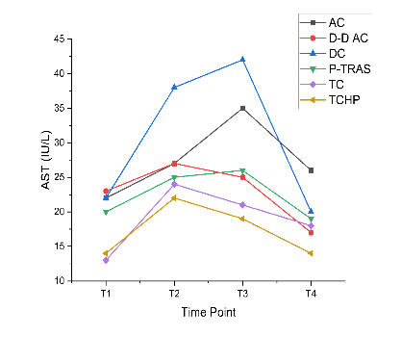
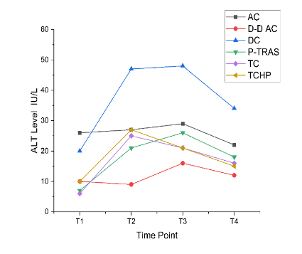
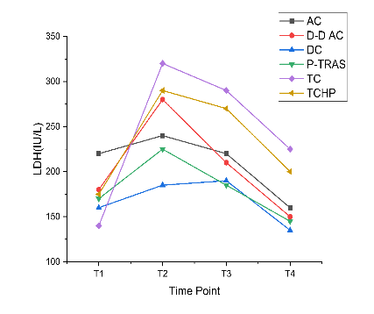
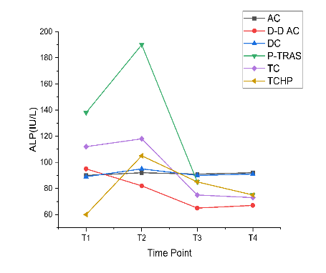
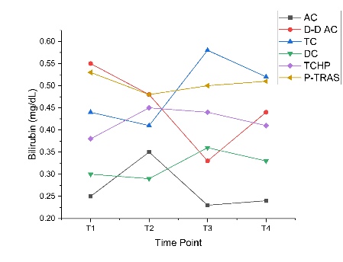

Supplementary Figure 1. Liver and tissue injury over time across chemotherapy regimens. Longitudinal trajectories for ALT, AST, ALP, and total bilirubin at four timepoints (T1 baseline; T2 mid-therapy; T3 end-of-therapy; T4 ~30-day follow-up) in AC, DDAC, DC, P-TRAS, TC, and TCHP. Curves show mean ± SE. ALT/AST peaked by T3 with partial normalization at T4; bilirubin stayed within reference limits, supporting a predominantly hepatocellular (not cholestatic) pattern. Repeated-measures models used Greenhouse–Geisser correction with Bonferroni-adjusted contrasts.
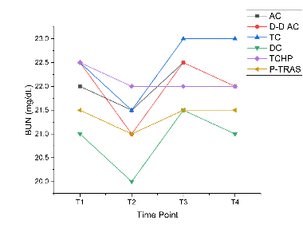
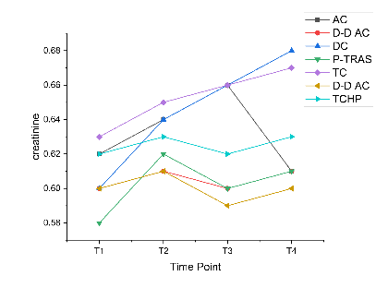
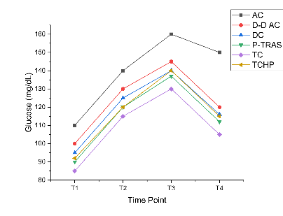

Supplementary Figure 2. Renal function and key metabolic parameter. Serum creatinine, BUN, and glucose at T1–T4 across regimens (mean ± SE). Creatinine rose modestly and persisted in platinum-containing regimens (DC, TC) through T4, while other regimens were flat or recovered; BUN fluctuated within physiologic range. Glucose peaked at T3 and declined at T4, with AC showing the highest values and least decline (160→150 mg/dL).

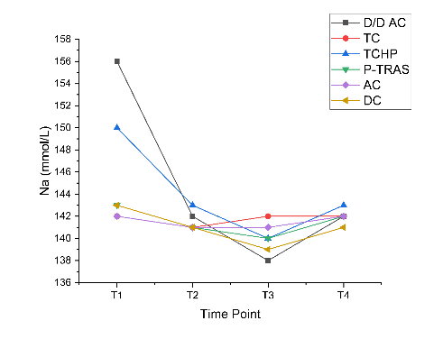
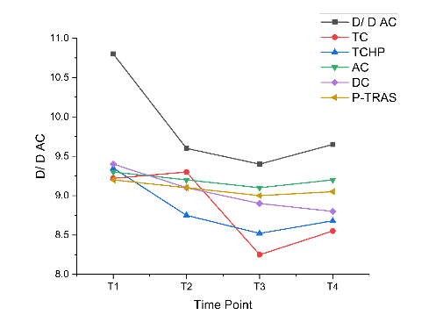
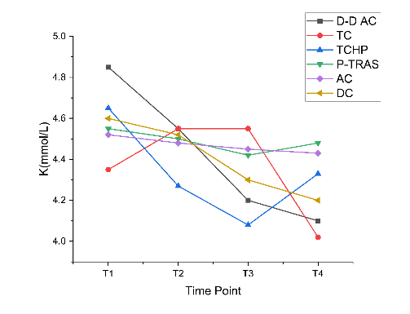
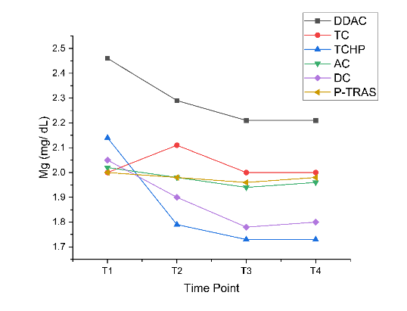
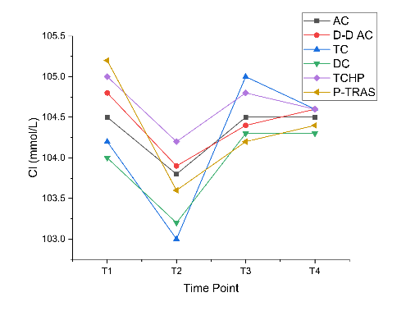

Supplementary Figure 3. Key electrolyte dynamics over time. Sodium, potassium, chloride, and magnesium at T1–T4 (mean ± SE). Potassium and sodium remained within reference ranges with small regimen-specific drifts; chloride paralleled sodium with minor T2 dips; Total calcium (mg/dL) at T1–T4 (mean ± SE). All regimens showed small T1→T3 dips with partial rebound at T4; no protocol exhibited persistent hypocalcemia; magnesium declined most in carboplatin-containing TCHP and remained low at T4, consistent with platinum-related renal Mg wasting.
Supplementary File: TRIPOD Checklist for Prediction Model Development
Item | Section | Checklist Item | Page
1 | Title | Identify study as development of prediction model | 1
2 | Abstract | Summary of objectives, methods, results, conclusions | 1
3a | Background | Medical context and rationale for developing model | 2
3b | Objectives | Study objectives including predictors and outcome | 2
4a | Source of data | Describe data sources (prospective/retrospective) | 3
4b | Participants | Eligibility criteria, treatment, setting | 3
5a | Outcome | Clearly define outcome (CTCAE grade ≥3 toxicity) | 3-4
5b | Outcome timing | Time of outcome assessment (T1–T4) | 3
6a | Predictors | Define all predictors (LDH, Mg, HER2) | 4
6b | Predictor assessment | How and when predictors assessed (baseline) | 4
7a | Sample size | Explain how sample size arrived at | 4
7b | Sample size | Number of events per variable (14.7 EPV) | 4
8 | Missing data | How missing data handled (exclusion criteria) | 3
10a | Statistical methods | Describe statistical analysis (logistic regression) | 4
10b | Model building | Predictor selection method (backward stepwise) | 4
10d | Validation | Internal validation method (bootstrap 1,000) | 4
13a | Participants | Flow of participants through study | 5
13b | Characteristics | Participant characteristics (Supplementary Table 1) | 5
14a | Model development | Number of participants (200) and events (44) | 5
15a | Model specification | Present full model equation | 4
16 | Performance | Report discrimination (AUC) and calibration (H-L) | 5-6
18 | Limitations | Discuss limitations (single-center, etc.) | 7
19a | Interpretation | Interpret results for clinical use | 7
19b | Implications | Discuss implications for clinical practice | 7
21 | Funding | Report funding sources (none) | 8

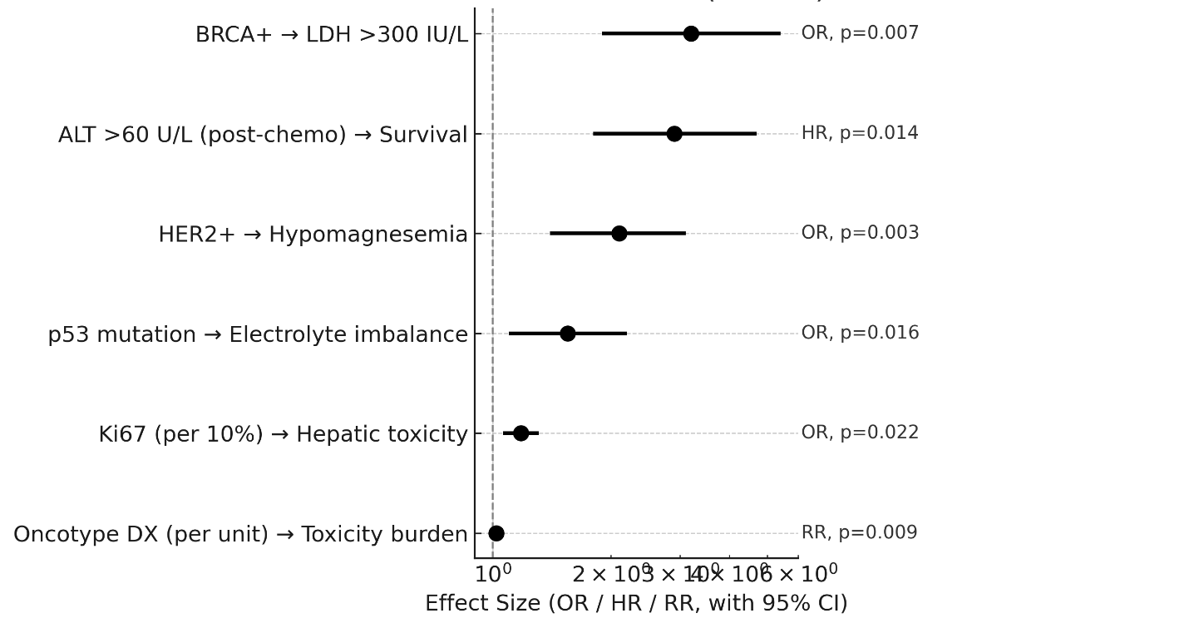
Figure S4: MOLECULAR MARKER CORRELATIONS

