Supplementary Information for

Impacts of extreme flooding conditions on cuttlefish early development and behaviour
Joana Martins*, João Saldanha da Gama, Carlos Gonçalves, Melanie Court, Rui Rosa*

*Corresponding authors: Joana Martins, e-mail: joanamfmar@gmail.com
Rui Rosa, e-mail: rrosa@fc.ul.pt

This PDF file includes:
Table S1, S2 and S3
Figure S1 and S2

Tables

Table S1. Values of seawater parameters monitored daily in each tank during acclimation and exposure to lower salinities, presented as mean ± standard deviation.

Parameters | Salinity 7 | Salinity 17 | Salinity 24 | Salinity 28 | Salinity 35 (control) | Acclimation
Salinity | 7.25 ± 0.43 | 17.33 ± 0.47 | 24.50 ± 0.50 | 27.50 ± 0.50 | 34.86 ± 0.35 | 34.70 ± 2.07
Temperature (ºC) | 17.67 ± 0.63 | 17.33 ± 0.83 | 17.21 ± 0.74 | 17.16 ± 0.50 | 17.74 ± 1.23 | 17.41 ± 1.50
O2 (%) | 97.74 ± 0.46 | 98.03 ± 0.31 | 98.15 ± 0.20 | 97.81 ± 0.74 | 98.04 ± 0.48 | 97.28 ± 0.58
O2 (mg L-1) | 7.55 ± 0.12 | 7.56 ± 0.16 | 7.65 ± 0.11 | 7.63 ± 0.11 | 7.57 ± 0.19 | 7.15 ± 0.23
pH | 8.051 ± 0.03 | 7.964 ± 0.06 | 7.962 ± 0.06 | 7.933 ± 0.04 | 8.027 ± 0.06 | 8.070 ± 0.06

Table S2. Post-hoc multiple comparisons results. Effects of salinity treatments (24, 28 and 35) on hatchling success and camouflage ability of Sepia officinalis.

Pairwise comparisons | SE | z-ratio | p-value
Mortality
35 - 28 | 1.879 | 3.609 | 0.0009
35 - 24 | 1.100 | 2.210 | 0.0695
28 - 24 | 0.229 | -1.395 | 0.3435
Mantle length
35 - 28 | 0.0134 | 5.280 | < .0001
35 - 24 | 0.013 | 7.287 | < .0001
28 - 24 | 0.0134 | 1.807 | 0.1701
Latency to camouflage
35 - 28 | 0.149 | -2.154 | 0.0792
35 - 24 | 0.110 | -3.296 | 0.0028
28 - 24 | 0.195 | -1.682 | 0.2123
Minimum pixel value
35 - 28 | 1.38 | 2.997 | 0.0093
35 - 24 | 1.82 | 2.750 | 0.0188
28 - 24 | 1.91 | 0.462 | 0.8893
Pixel intensity integrated density
35 - 28 | 0.00397 | -5.932 | < .0001
35 - 24 | 0.0564 | -5.460 | < .0001
28 - 24 | 0.0722 | -2.171 | 0.0763
Camouflaged hatchlings
35 - 28 | 0.403 | -0.167 | 0.9847
35 - 24 | 3.770 | 5.354 | < .0001
28 - 24 | 4.30 | 5.209 | < .0001

Table S3. Mantle length (cm), means, standard deviation (SD), minimum (Min) and maximum (Max) values for Sepia officinalis hatchlings under salinity treatments (24, 28 and 35).

Treatment | N | Mean | SD | Range
 |  |  |  | Min | Max
35 | 70 | 0.7321 | 0.086 | 0.5401 | 0.8982
28 | 61 | 0.6615 | 0.058 | 0.4978 | 0.8342
24 | 68 | 0.6374 | 0.080 | 0.4716 | 0.8405

Figures

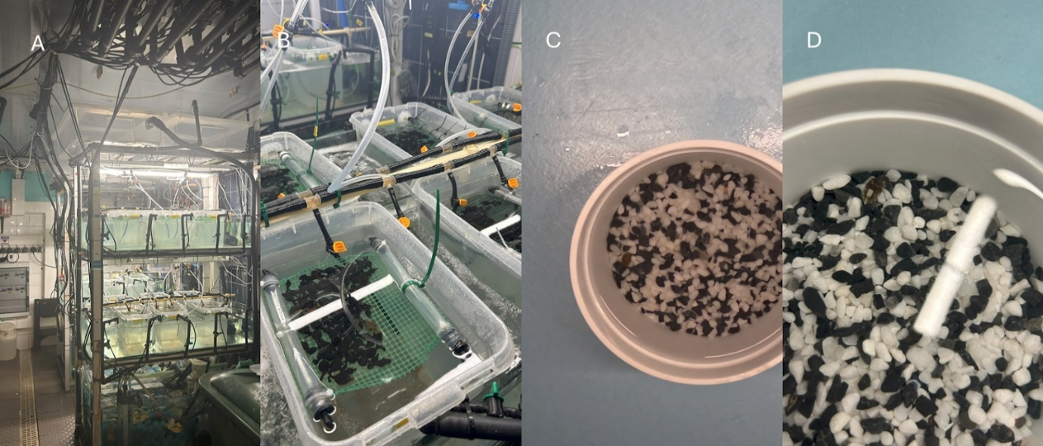

Figure S1. Aquaria systems, with two water baths and a sump each (A) and Sepia officinalis eggs on little rafts within the tanks (B). Cuttlefish camouflaged with the dark uniform (C) and disruptive patterns (D) in the camouflage arena with 50% black and 50% white gravel mixture.

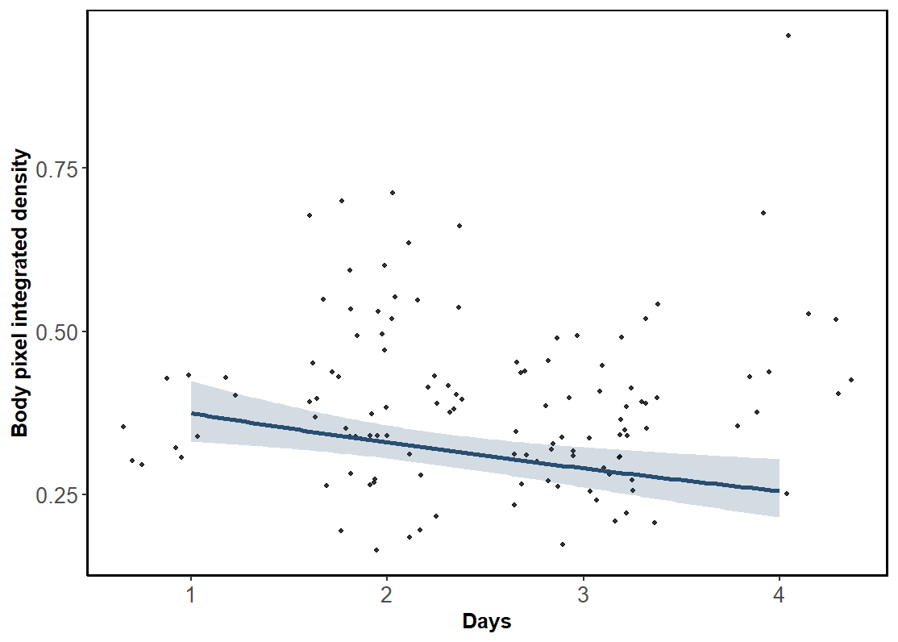

Figure S2. Pixel integrated density in body patterning of Sepia officinalis over time under restored salinity conditions. The blue line represents the predicted trend from the fitted model and the 95% confidence interval on the predictions is illustrated in the shaded area. Black points represent observed individual data.

