Supporting Information Document
Influence of Mass Transport Near Parallel Band Pumping Electrodes and Walls on the Fate of Chemical Species in a Sample Plug Introduced onto a Redox Magnetohydrodynamics Microfluidics Chip

Shirin Hesan (shesan@uark.edu) Department of Chemistry and Biochemistry, University of Arkansas, Fayetteville, United States
Jörg König (joerg.koenig@tu-ilmenau.de) Institute of Thermodynamics and Fluid Mechanics,Technische Universität Ilmenau, D-98684, Ilmenau, Germany
Foysal Z. Khan (foysalzahid@gmail.com) Department of Chemistry and Biochemistry, University of Arkansas, Fayetteville, United States
Christian Cierpka* (christian.cierpka@tu-ilmenau.de) Institute of Thermodynamics and Fluid Mechanics and Institute of Micro- and Nanotechnologies, Technische Universität Ilmenau, D-98684, Ilmenau, Germany
Ingrid Fritsch* (ifritsch@uark.edu) Department of Chemistry and Biochemistry, University of Arkansas, Fayetteville, United States

*Co-corresponding authors.

Supporting Information
Supporting information provides details about experimental conditions, including chemicals and materials, electrochemical instrumentation, chip preparation and electrode modification, formation of the R-MHD microfluidic chamber, microscope and APTV setup, APTV measurement procedures, velocity data processing and analysis, figure illustrating experimental pumping configurations and microscopy image of PEDOT-modified end electrode E2. Also provided is supplemental information about computer simulations, including a mesh study, figure of velocity color map for APTV at end of electrode E2 compared to simulation map across entire chamber including the end of paired pumping electrode E1, comparison of component velocities at end of electrode E2 when flow direction is reversed, and concentration color maps at ½ and ¾ the height for study #2 at 50 s.

Table of Contents
Supporting Information 2
Experimental Details 4
Chemicals and Materials 4
Electrochemical Instrumentation 4
Chip Design, Preparation and Electrode Modification 5
Formation of the Microfluidics Chamber and Microscope Setup 6
Flow Field Analysis 8
References 8
Figures 9
Figure S1. Mesh study. 9
Figure S2. Experimental setup for µ-APTV studies 10
Figure S3. Photo of chip with PEDOT-modified electrodes, E1-E2 pumping configuration, and APTV particle images at the PEDOT-modified electrode end of E2 11
Figure S4. Comparison of experimental and simulated cross-sectional velocity fields in the y–z plane at the ends of pumping electrodes 12
Figure S5. Comparison of simulated component velocities at end of electrode E2 when flow direction is reversed 13
Figure S6. Concentration color maps at ½ and ¾ the height for study #2 at 50 s 14

Experimental Details

Chemicals and Materials
Propylene carbonate (PC, anhydrous 99.7%), 3, 4-ethylenedioxythiophene (EDOT), and tetrabutylammonium hexafluorophosphate (TBAPF₆) were purchased from Sigma-Aldrich (St. Louis, MO). Sodium chloride was obtained from ORG Laboratory Chemistry GmbH (Bunde, Germany). Pre-cleaned micro cover glasses (24 mm × 30 mm) were received from VWR International, LLC (West Chester, PA). Polystyrene microbeads (excitation/emission: 540/607 nm) were acquired from Microparticles GmbH (Berlin, Germany). A nickel-coated NdFeB permanent magnet with a magnetic flux density of 0.37 T (3.5 cm diameter and 1.27 cm height, grade N40) was attained from Amazing Magnets (Irvine, CA). Edge connectors (solder contact, 20/40 position, and 0.05 in. pitch) were acquired from Sullins Electronics Corp. (San Marcos, CA). Sylgard184 silicon elastomer base, Sylgard 184 silicon elastomer curing agent, and OS-30 solvent for polydimethylsiloxane (PDMS) fabrication were purchased from Ellsworth Adhesives, Milwaukee, WI. Glycerol (>99.5 %) was obtained from Sigma Aldrich (Burlington, MA).

Electrochemical Instrumentation
A model 760B galvanostat/potentiostat from CH Instruments, Inc. (Austin, TX) was used for electrochemical deposition of PEDOT by CV and characterization by CV and chronoamperometry (CA) in a “three-electrode” setup using a Ag/AgCl (saturated KCl) [1]. A PalmSens4 potentiostat/galvanostat (Houten, Netherlands) was used for the MHD experiments in the microfluidic device by the chronopotentiometry (CP) technique in a “two-electrode” configuration consisting of one PEDOT-modified band on the chip serving as the working electrode and an adjacent coplanar, PEDOT-modified band as a combined counter/quasi-reference electrode. The sign for current follows IUPAC convention, where anodic current is positive and cathodic current is negative.

Chip Design, Preparation and Electrode Modification
The chip consists of four, individually-addressable, parallel band electrodes made of gold, each ~100 nm thick with nominal dimensions of 650 μm width and 15 mm length, and the gap between the outer electrode pair (E1 and E2) is 3.2 mm and that between the inner pair (E2 and E3) is 4.7 mm. Other smaller, patterned gold features in the gaps between the band electrodes are also present on the chip, but were not used in the studies herein. The photolithography procedure used to fabricate the chips with patterned electrodes was similar to that reported previously [2].
The gold electrodes were coated with PEDOT via electrochemical deposition in a procedure described earlier [1] by cycling at 0.005 V/s from -0.455 to 1.4 V vs Ag/AgCl reference (saturated KCl) and back for 12 cycles in the monomer solution containing 0.010 M EDOT and 0.100 M TBAPF₆ in propylene carbonate. The PEDOT-modified electrodes were then stabilized by cycling at 0.05 V/s at least five times in monomer-free electrolyte solution in propylene carbonate and stored in 50 mL capped polypropylene centrifuge tubes filled with DI water when not in use. This procedure produces well-adhered polymer films of 28 ± 3 μm in thickness (appears black on top of the gold electrodes in Figure S2(c)). The actual horizontal distance between the modified electrodes is narrower than the nominal gap between bare gold electrodes due to the presence of the thick PEDOT layer.

Formation of the Microfluidics Chamber and Microscope Setup
Figure S2 shows a photograph of the actual R-MHD/APTV coupled setup. An inverted epifluorescence microscope (AxioObserver 7, Zeiss) (Figure S2 (a)) was used for the experimental flow characterization. A PDMS gasket (429 µm-thick with rectangular opening 3.0 cm × 1.7 cm) was positioned over the electrode chip to define the chamber and so that the PEDOT-modified electrodes were exposed to the solution (Figure S2 (c)). The solution used in the experiments was an electrolyte of 0.1 M sodium chloride in which glycerol was added to about 20 wt%, yielding a density of about 1.05 g/cm³. In that way, the density of the particles used for flow measurements matched that of the electrolyte, avoiding sedimentation. To the electrolyte was added the tracer particle solution in an 800:1 volume ratio, respectively, then about 500 µL of this combined solution was pipetted into the rectangular opening of the gasket using a micropipette, followed by sealing with a thin glass coverslip so that it was overflowing and being careful to avoid trapping bubbles. The resulting assembly was gently squeezed together to make a sealed system. This chip-gasket-coverslip assembly was flipped upside down and placed onto a 3D-printed chip holder (Figure S2 (b)) which had already been pre-set on the microscope stage. The whole assembly was arranged in a way that the coverslip would face the microscope objective (LD Plan-Neofluar, 20x/0.4, Zeiss). A permanent NdFeB magnet (35 mm diameter and 12.7 mm in thickness, Amazing magnets LLC) was placed onto the backside of the chip and clipped into place (Figure S2 (d)) to provide a magnetic field perpendicular to the chip.
A 525 nm green, high-power LED light source (SOLIS-525C, Thorlabs) was used for the excitation of the fluorescently labeled polystyrene particles (ex/em: 540/607 nm, MicroParticles GmbH) with a diameter of 5 μm and a density of about 1.05 g/cm³. The fluorescence signal emitted from the particles was observed through the microscope objective and captured by a monochrome camera (Imager sCMOS, LaVision GmbH) operating in single-frame mode.
Astigmatic particle images in the solution were obtained by placing a cylindrical lens (focal length of 200 mm) between the tube lens and the sCMOS camera. The pulse width of the LED and frame rate of the camera were adjusted prior to each measurement in order to obtain particle images with high contrast, suitable for particle tracking at each individual parameter setting, e.g. current density applied. With the optical setup, the measurement volume of the APTV amounted to approximately (wx x wy x wz) = (680 x 1050 x 80) μm in size. APTV interrogation of the fluid velocity was performed between the activated, PEDOT-modified parallel band electrodes by traversing through the region of interest with a step width of 500 μm in the y-direction and of about 40 μm in the z-direction to to obtain velocity profiles in the horizontal plane and in the z-. As the Reynolds number is low, a fully-developed laminar flow is expected within a very short starting time (< 1 s). However, the charge capacity of the PEDOT-film limited the pumping duration to 30 s for the highest applied current of 400 μA. Therefore, the PEDOT had to be recharged after each measurement by applying a reversed current of the same magnitude and duration, which resulted in an opposite directional fluid flow, due to having a constant magnetic field direction throughout the whole experimental campaign. During this time, velocity measurements were conducted as well, allowing to check for differences between both current directions that should ideally not occur. Additionally, the total number of measurements can be increased by taking a reversal of the fluid flow into account. For all measurements, the in-situ calibration approach was used to obtain physical coordinates of the particles [3]. The same procedures for the APTV measurements and data processing were followed for the measurements at the end of electrode E2, near wall b, as illustrated in Figure S3.

Flow Field Analysis
APTV detects position at subsequent times and allows for the tracking of individual particles. The three components of velocity of these individual particles that are randomly distributed within the measurement volume can be determined by a nearest neighbor approach [4]. All randomly distributed particle velocity vectors (for both directions (±) of electrical currents) were ensemble-averaged and interpolated onto a rectangular grid using Gaussian-weighted interpolation based on the vector distance from the grid nodes. The size of the bins was varied (such as, Δy x Δz = 500 x 10, 500 x 20 and 200 x 20 μm²) and the overlap between neighboring bins yielded a velocity grid spacing in spanwise direction (y and z). Spatial resolution in the streamwise direction was given by the size of the measurement volume in x-direction (approximately 800 µm).

References
1. Khan, F.Z. and I. Fritsch, Chip-Scale Electrodeposition and Analysis of Poly(3,4-ethylenedioxythiophene) (PEDOT) Films for Enhanced and Sustained Microfluidics Using DC-Redox-Magnetohydrodynamics. J. Electrochem. Soc., 2019. 166(13): p. H615-H627.
2. Sahore, V. and I. Fritsch, Flat flow profiles achieved with microfluidics generated by redox-magnetohydrodynamics. Anal. Chem., 2013. 85(24): p. 11809-11816.
3. Cierpka, C., M. Rossi, R. Segura, and C. Kähler, On the calibration of astigmatism particle tracking velocimetry for microflows. Measurement Science and Technology, 2010. 22(1): p. 015401.
4. Cierpka, C., B. Lütke, and C.J. Kähler, Higher order multi-frame particle tracking velocimetry. Experiments in Fluids, 2013. 54(5): p. 1533.

Figures
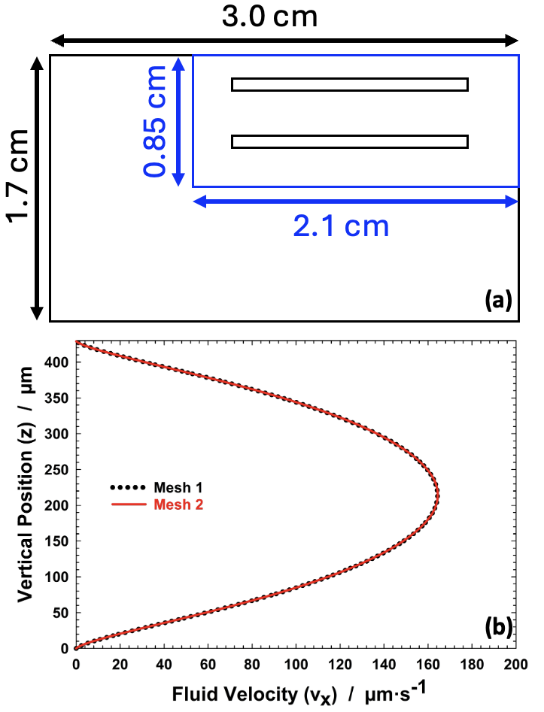
Figure S1. (a) Schematic of the computational meshing strategy used for the R-MHD microfluidic gasket opening (3.0 cm × 1.7 cm), including a locally refined inner meshing sub-domain (2.1 cm × 0.85 cm) surrounding the activated electrode region, where the largest MHD body force occurs. (b) Simulated x-directed velocity profile of the x-component (vₓ) along the chamber height (in z) comparing Mesh 1 and Mesh 2.

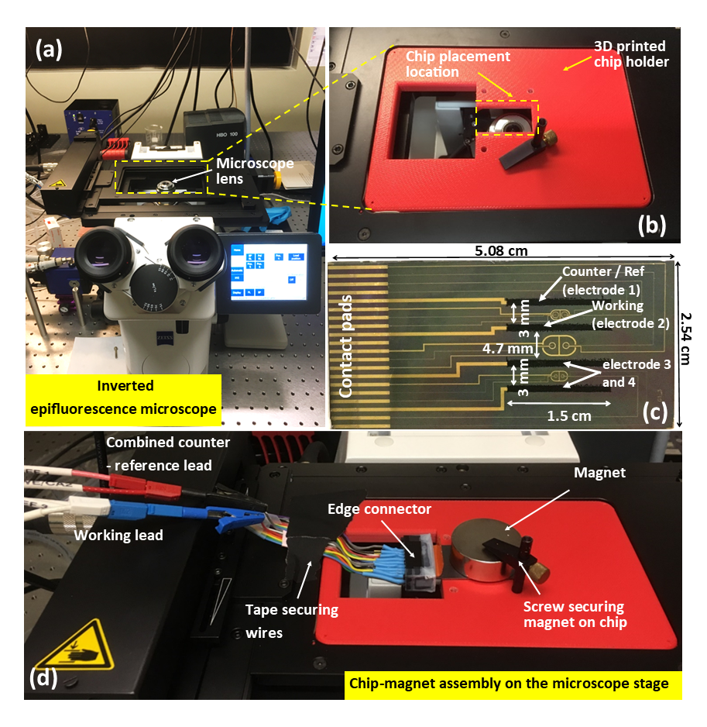
Figure S2. Experimental setup for µ-APTV studies. (a) The inverted epifluorescence microscope consisting of the microscope stage positioned over the microscope lens. (b) The 3D printed chip holder consisting of an opening the same size as the chip and with a small lip to keep the chip in place. (c) The chip with electrodeposited PEDOT films on the four band electrodes; electrodes E1 and E2 served as the combined and counter-reference and working electrodes, respectively, for the experimental studies reported herein. (d) The assembled chip, PDMS gasket, solution, coverslip and edge connector assembly is inserted facing down on the “chip placement location”, and the permanent magnet is placed on the backside of the chip and secured in place with a hold-down clamp and screw. Working and counter-reference leads from the galvanostat are attached via the edge connector wires and the wires are taped on the stage to ensure minimal movement.

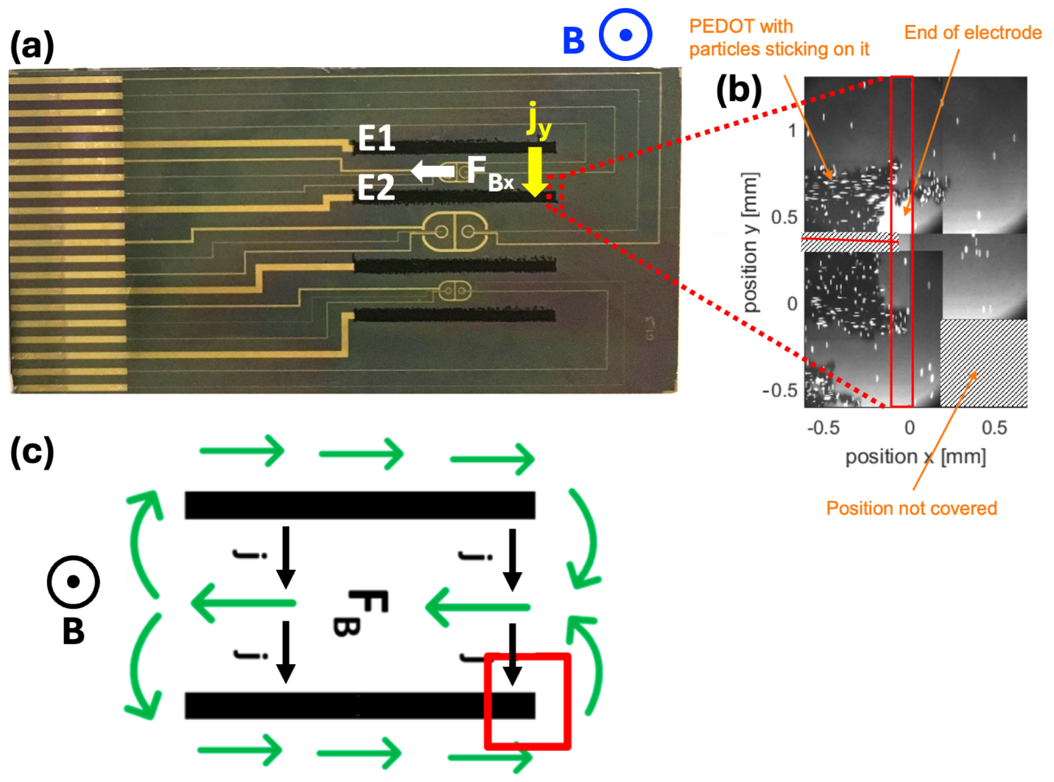
Figure S3. (a) Image of the R-MHD chip with PEDOT-modified electrodes highlighting electrodes E1 and E2. The red dashed box indicates the region of electrode E2 where end-electrode APTV measurements were performed. (b) Representative APTV particle images at the PEDOT-modified electrode end, shown at different positions in the xy-plane. The dark regions are PEDOT, some of which appears to have come off of the extreme end of the electrode. (c) Schematic illustration (not to-scale) of the general MHD-driven flow pattern in the x-y plane expected for the E1-E2 pumping configuration for a given set of B and j vectors; green arrows indicate the direction of circulation, and the red box highlights the APTV measurement region for the end-electrode studies.

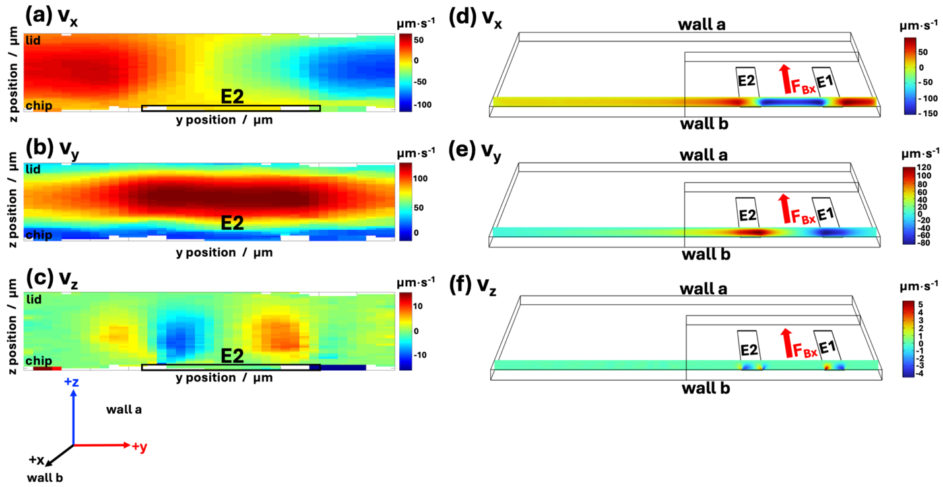
Figure S4. Color maps of cross-sectional velocity fields in the y–z plane at the ends of pumping electrodes from the perspective of facing wall a, in the -x direction of the coordinate system. (a-c) Experimentally measured v_{x}, v_{y}, and v_{z} components obtained by APTV averaged over ±75 µm from the end of electrode E2. (d-f) Corresponding simulated v_{x}, v_{y}, and v_{z} components extracted in the y-z slice location in the x position at end of electrode E2. The slice in (d-f) is across the entire device geometry and shows velocity components at the ends for both pumping electrodes E1 and E2. We provide evidence in Figure S5 that in the simulations, the direction of pumping when electrodes E1 and E2 are activated does not change the absolute magnitudes of the velocity components located at the end of E2. (The visible internal boundary in the simulated panels (d-f) corresponds to the refined inner meshing sub-domain used to improve the resolution in the region of largest F_{B} (see Figure S1(a)).)

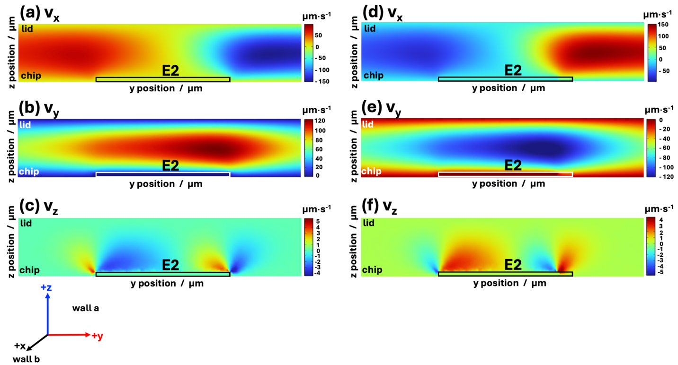

Figure S5. Comparison of color maps for simulations of cross-sectional velocity fields for components v_{x}, v_{y}, and v_{z} in the y–z plane at the end of pumping electrode E2 and from the perspective of facing wall a in the -x direction of the coordinate system. Two different directions of pumping show that the magnitude of the velocity components in this location is the same regardless of whether the fluid is being pumped (a-c) toward wall a or (d-f) toward wall b.

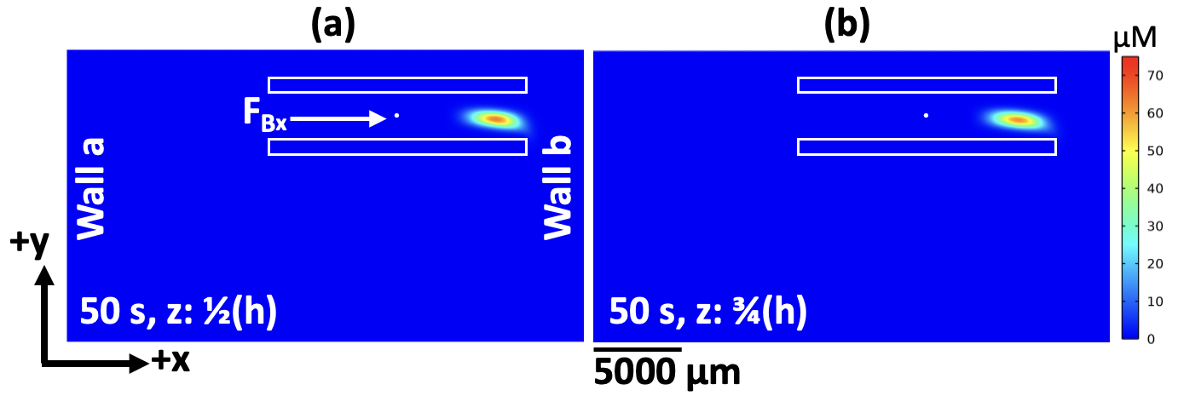
Figure S6. Simulated concentration color map of the sample plug at t = 50 s for study #2, shown in the x–y plane at two chamber heights: (a) z = h/2 (214.5 µm) and (b) z = 3h/4 (321.75 µm). The sample plug is initially centered at (x = 0, y = 0) and pumped toward wall b (+x direction).

