Table 1. Pore formation methods in/on nanofibers [1].
Method explanation | Porosity formation method
jet partially fast freezing by fast evaporating of very volatile solvent or collecting nanofibers in the liquid bath | Phase separation between polymer and solvent
Vapor phase separation (usually, with electrospinning in high humidity, the water molecules in the air works as nonsolvent) and liquid phase separation | Phase separation between polymer and nonsolvent
Jet with triple-phase separation due to difference between volatility of solvent and nonsolvent (by changing ratios of this system) and pores form by changing relative rates of solvent/nonsolvent, controlling phase separation dynamic | Phase separation of the liquid section in polymer, nonsolvent, and solvent system
Phase separation between polymer and nonsolvent due to residual solvent in nanofiber by receiving nanofibers to nonsolvent bath and pore formation due to miscibility between solvent and nonsolvent | Collecting the nanofibers in a nonsolvent bath
Washing small molecules (like salt), block copolymers, polymers from nanofibers, or calcinating (the best way because pores formation by solvent evaporating is time-consuming and sometimes is impossible to remove one phase) | Selective removal of one phase of nanofiber
Controlling porosity by adjusting the ratio of two phases in nanofibers | Thermal degradation of one phase

Table 2 shows the average diameters of the nano webs.
Sample code | FESEM image | Higher resolution
PA/PVA
PA/noPVA
PA and PA/no PVA | 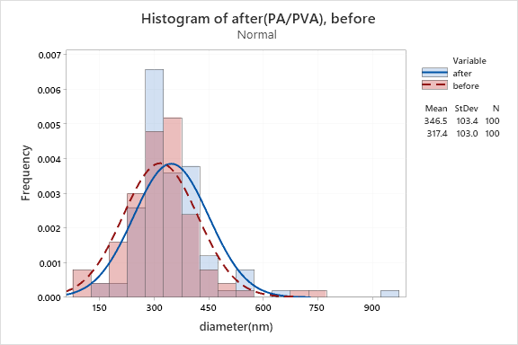

Table 3. Porosity and pore size of the nano webs.
Sample code | Porosity from BET (m²/g) | Average pore size from BET (nm) | Diameter (nm)
PA6/PVA | 2.358 | 17.22 | 317.4±103.4
PA6/no PVA | 0.933 | 17.29 | 346.5±103

Table 4. Showing adsorption, and deadsorption curves.
Sample code | Adsorption and deadsorption curve
PA/PVA | 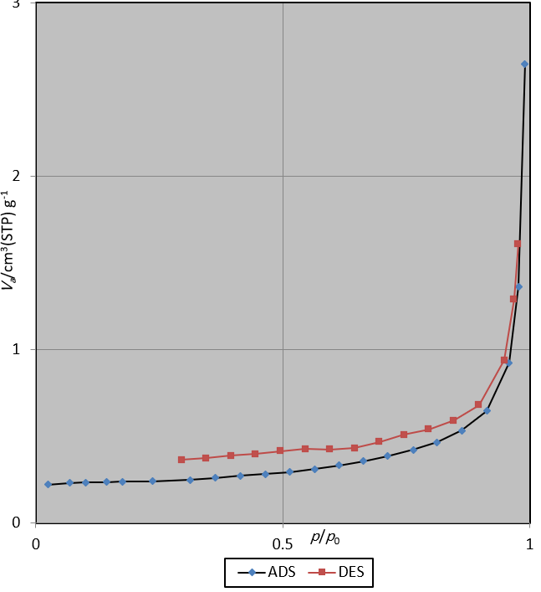
PA/no PVA | 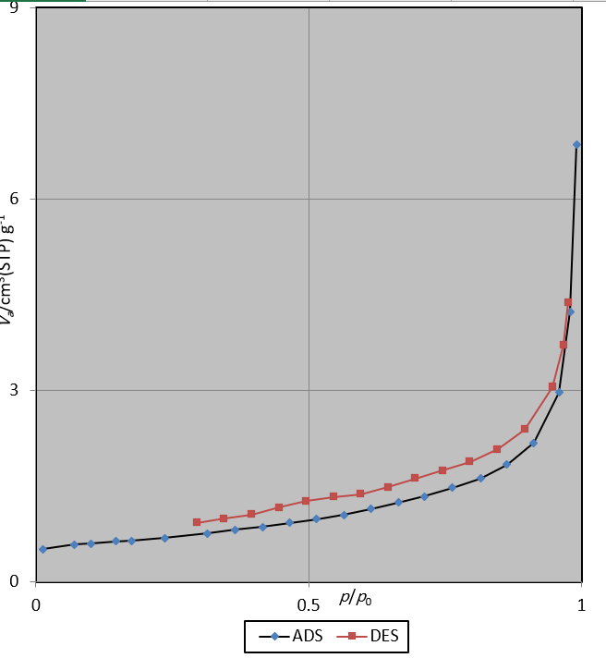

Table5. Surface roughness and pore volume measurements.
sample | Surface roughness curve | Pore volume distribution
PA/PVA
PA/noPVA

Table 6. Orientation measurements.
sample | Radon curve | Orientation (degree)
PA/PVA |  | 88
PA/no PVA |  | 89

