Supplementary information for:
Identification of Gene Conversion Events in Horse IGHV Suggests Preferential Hotspots for Diversification

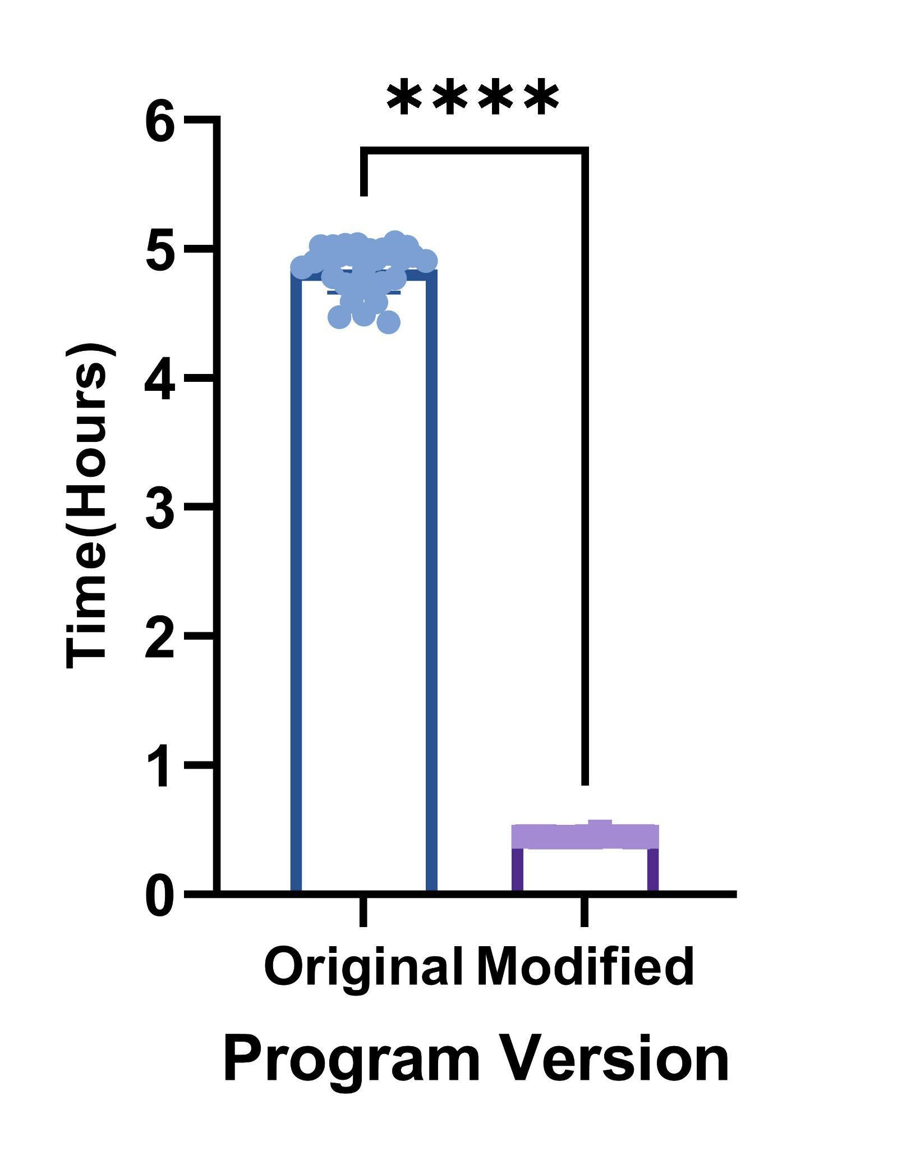
Supplementary Figure 1: BrepConvert processing time before and after implementation of pBLAT for gene conversion identification. Execution time was measured by randomly selecting 1,000 sequences from the annotated antibody repertoire of eight horses and repeating the process 30 times using either the original software (blue) or the optimized version (purple). Statistical significance was assessed using the Mann–Whitney test. ****p < 0.0001.

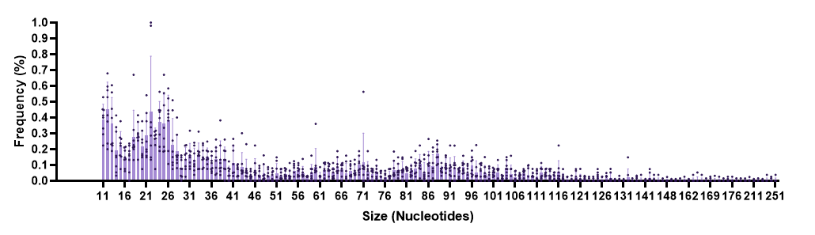
Supplementary Figure 2: Percentage of the size in nucleotides of gene conversion events in horse IGHV higher than 10 nucleotides.

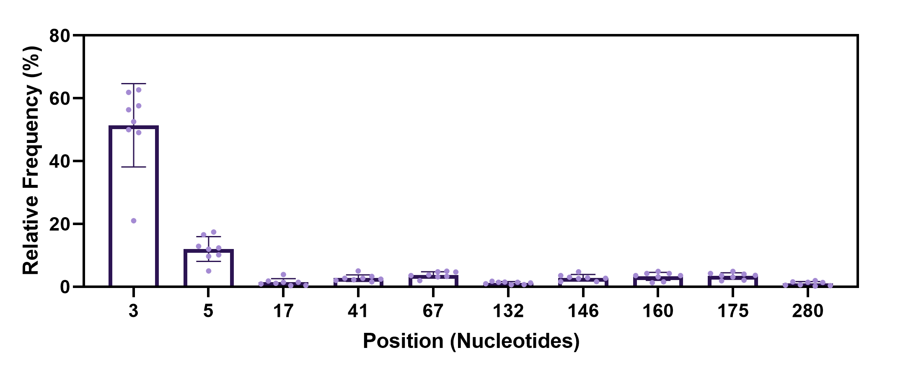
Supplementary Figure 3: Nearest AID Motif Position. This figure shows the position of the nearest AID motif from the observed gene conversion events. The highest observed values correspond to positions with the greatest number of gene conversion events in our dataset.

Supplementary Table 1: Summary of Motif and Event Distances
Description | Range
Distance to AID Motif | 0-35
Position of AID Motif | 3-310
Size of gene conversion Event | 3-251
Distance between Repertoire and Pseudogene | 0-49
Source: This table summarizes the distances and sizes related to the AID motif and gene conversion events

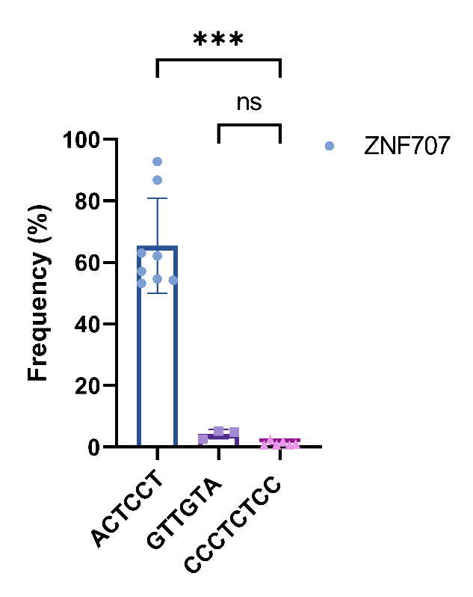
Supplementary Figure 4: Identification of motifs downstream of gene conversion events. Motifs identified within a 10-nucleotide region downstream (3′) of the gene conversion sites. Statistical significance was assessed using the Kruskal–Wallis test. Significance was determined using a Kruskal-Wallis test. ****p = 0.0008. ns p = 0.7001.

Supplementary Table 2: Equine Functional IGHV Gene Sequences
Sequence ID | Gene Name | Nucleotide Sequence
NW 001876796 | IGHV1-41*01 | gaggtccagctggtgcagtctggggct...gaggtgaggaagccaggggcatccgtgaag gtctcctgcaaggcttctggagacagcttc............acttattactctatgagc tgggtgcgacaggcccctggacaagggctcgactggatgggagggatcttgcctata... ...gttgatgatacaagctacacgcagaagttccag...ggcagagtcaccatgactgca gacaag...tccacgagcacagtctacatggagctgagcagtctgacatcc gaggacacggccgtgtattactgtgcaaaaga
IMGT000040 | IGHV1-41*02 | ................................................................................................... .................................................................................... gttgatgat-  acaagctacacgcagaagttccag...ggcagagtcaccatgactgcagacaag...tcca cgagcacagtctacatggagctgagcagtctgacatccgaggacacggccgtgtattactgtgcaacaga
IMGT000040 | IGHV1-41D*01 | ................................................................................................  .......................................................................................gttgat-  gatacaagcta cacgcagaagttccag...ggcagagtcaccatgactgcagacaag...tc cacgagcacagtctacatggagctgagcagtctgacatccgaggacacggccgtgt attactgtgcaacaga
IMGT000040 | IGHV1-41N*01 | ..............................................................................................  .........................................................................................gttgat-  gatacaagctacacgcaga agttccag...ggcagagtcaccatgactgcagacaag...tcc acgagcacagtctacatggagctgagcagtctgacatccgaggacacg gccgtgtattactgtgcaacaga
IMGT000040 | IGHV1-5*01 | gaggtccagctggtgcagtctggggct...gaggtgaagaagccaggggcatccgtgaag gtctcctgcaaggcttctggagacagcttc............acttattactctatgagc tgggtgcgacaggcccctggacaagggcttgagtggacgggatatatctatcctgaa... ...tatgatgctatgggctacccgcagaagttccag...ggcagagtcaccatgactgcg gacaag...tccacgagcacagtctacatggagctgagcagtctggcatctgaggacaca gccgtgtattactgtgcaacaga
IMGT000040 | IGHV1-70*01 | gaggtccagctaatacagtcggggcca...gagttgaagaagcctgggtcatcagtgaag atctcctgcaaggcttctggatacaccttc............actgaatatgctatgcac tgggtgcgacaggccaatggaaaagggattgaatggatgggatctatcagtcctcat... ...gatgatgatacgagctacgcaccgaagttccaa...ggcagagtcaccatcaccgtg gacaag...tccacgagcacagtctacatggagctgagcagtctgacatctgaggacacg gccatgtattactgtgcgaaaga
NW 001876796 | IGHV1-70*02 | gagggtcagctggaacagtcggggccg...gagttgaagaagcctgggtcatcagtgaag atctcctgcaaggcttctggatacaccttc............agtagctatgctgtgcac tgggtgcgacaggccaatggaaaagggattgagtggatgggatctatctatgctgaa... ...tatgatgatacaagctacgcaccgaagttccag...ggcagagtcaccatgactgcg gacaag...tccacgagcacagtctacatggagctgagcagtctgacatctgaggacatg gccgtgtattactgtgcaacaga
NW 019646341 | IGHV1-70*03 | gagggtcagctggaacagtcggggccg...gagttgaagaagcctgggtcatcagtgaag atctcctgcaaggcttctggatacaccttc............agtagctatmctgtgcac tgggtgcgacaggccaatggaaaagggattgagtggatgggatctatctatgctgaa... ...tatgatgatacaagctacgcaccgaagttccag...ggcagagtcaccatgactgcg gacaag...tccacgagcacagtctacatggagctgagcagtctgacatctgaggacacg gccgtgtattactgtgcaacaga
IMGT000040 | IGHV2-63*01 | cagatcagcctgcaggagtctggtcct...gggctgctgaagcccacccagacccttacg ctgacctgctccttctctgggttctcactgact......acttctgatattggtgttggt tggatgcgtcaaccccctgggaaggcactggagtggctcacctatgtttggtggact... ......gatgaaaagcattacaacccatctctgaag...agccggctcacaatctccaag gacacc...tccaaaaaccaggtgatgctgacaatgaccagtttggaccctccagacaca gccacatattactgtgtaaagaggg
IMGT000040 | IGHV3-78*01 | gaggtgcagctggtggagtctggggga...ggcctggtgaagcctggggggtctctgaga ctctcctgtgcagcctctggattcaccttc............agcagctatgctatgagc tgggtccgccaggctccaggaaagggcctgcagtgggtcgcaggtattaacagtgat... ...ggtggtagcacacactacgccgactccgtgaag...ggccgattcaccatctccaga gacaac...gccaagaacacggtgtgtctgcaaatgaacagcctgagagacgaggacacg gccgtgtattactgtgcgaagga
IMGT000040 | IGHV4-11*01 | caggtgcaactgaaggagtcaggacct...ggcctggtgaagccctcgcagaccctgtcc ctcacctgccctgtctctagattcccttta............accaaccatcatgtacac tggacccaccaggctccaggaaaagggctggagtggcttggtgattcaaggagtggt... ......gaaagcacatactacaacttaactctgaag...tcccaactcagcatccccagt gatact...tccaaaagccaaatttatttaacgctgaacaggctgagaggcgatgacatg gccatgtactactgtgccagaga
IMGT000040 | IGHV4-17*01 | caggtgaagctgcaggagtcgggccca...ggactggtgaagccctcacagaccctctcc ctcacctgctctgtgtctggagtctccatcaca......agcagtggtgactggtggagc tggatccgccagcccccagggaaggggctggaatggatggggtacataagttatagt... ......ggtagcgcttactacaccacatccctcaag...agccgactctccatctccaga gacacg...tccaaggaccagttctccctgcagctgagctccgtgaccgccgaggacacg gccgtttattactgtgcaaggaag
NW 001876796 | IGHV4-17*02 | caggtgaagctgcaggagtcgggccca...ggactggtgaagccctcacagaccctctcc ctcacctgctctgtgtctggagtctccatcaca......agcagtggtgactggtggagc tggatccgccagcccccagggaaggggctggaatggatggggtacataagttatagt... ......ggtagcgcttactacaccacatccctcaag...agccgactctccatctccaga gacacg...tccaaggaccagttctccctgcagctgagctccgtgaccacagaggacacg gccgtttattactgtgcaagtga
IMGT000040 | IGHV4-21*01 | caggtgcaactgaaggagtcaggacct...ggcctggtgaagccctcgcagaccctctcc ctcacctgcactgtctctggattatctttg............agcagttatggtgtgggc tgggtccgccaggctccaggaaaagggctggaatttgttggtggtatagctagtagt... ......ggaagtgcaaactacaacccagccctgaag...tcccgagccagcatcaccaag gacacc...tcaaagagccaagtttatctgacgctgaacagcctgacaagcgaggacacg gccgtctattactgtgcaggagg
IMGT000040 | IGHV4-22*01 | caggtgcaactgaaggagtcaggacct...ggcctggtgaagccctcgcagaccctgtcc ctcacctgcactgtctctggattctctttg............agcagttacggtgtaggc tgggtctgccaggctccaggaaaagggctggaatatgttggtgttatagctagtagt... ......ggaagtgcaaactacaacccagccctgaag...tcccgagccagcatcaccaag gacacc...tcaaagagccaagtttatctgacgctgaacagcctgacaggcgaggacacg gccgtctattactgtgcgaga
IMGT000040 | IGHV4-29*01 | caggtgcaactgaaggagtcaggacct...ggcctggtgaagccctcgcagaccctctcc ctcacctgcactgtctctggattatctttg............agcagttatgctgtaggc tgggtccmccaggctccaggaaaagggctggaatatgttggtgctatatatggtagt... ......gcaagtgcaaactacaacccagccctgaag...tcccgagccagcatcaccaag gacacc...tcaaagagccaagtttatctgacgctgaacagcctgacaggcgaggacacg gccgtctattactgtgcgaga
NW 001876796 | IGHV4-29*02 | caggtgcaactgaaggagtcaggacct...ggcctggtgaagccctcgcagaccctgtcc ctcacctgcactgtctctggattatctttg............agcagttatgctgtaggc tgggtccgccaggctccaggaaaagggctggaatatgttggtgctatatatggtagt... ......gcaagtgcaaactacaacccagccctgaag...tcccgagccagcatcaccaag gacacc...tcaaagagccaagtttatctgacgctgaacagcctgacaggcgaggacacg gccgtctattactgtgcgaga
IMGT000040 | IGHV4-37*01 | caggtgcagctgaaggagtcgggccca...ggacaggtgaagccctcacagaccctctcc ctcacctgcactgtcactggaggctccatcaca......agcaggtattatggctggagc tggatccgccagaccccagggaaggggctggagtacattgggagcatagcttatagt... ......ggtagcacttactacagcccatccttcaag...agccgcgcctccatctccaga gacacg...tccaagaaccagttctccctgcagctgagctccgtgaccaccgaggacacg gccgtttattactgtgcaagtga
NW 001872990 | IGHV4-37*02 | caggtgcagctgaagaagtcgggccca...ggacaggtgaagccctcacagaccctctcc ctcacctgcactgtcactggaggctccatcaca......agcaggtattatggctggagc tggatccgccagaccccagggaaggggctggagtacattgggagcatagcttatagt... ......ggtagcacttactacagcccatccttcaag...agccgcgcctccatctccaga gacacg...tccaagaaccagttctccctgcagctgagctccgtgaccacagaggacacg gccgtttattactgtgcaagtga
IMGT000040 | IGHV4-37D*01 | caggtgcagctgaagaagtcgggccca...ggacaggtgaagccctcacagaccctctcc ctcacctgcactgtcactggaggctccatcaca......agcaggtattatggctggagc tggatccgccagaccccagggaaggggctggagtacattgggagcatagcttatagt... ......ggtagcacttactacagcccatccttcaag...agccgcgcctccatctccaga gacacg...tccaagaaccagttctccctgcagctgagctccgtgaccaccgaggacacg gccgtttattactgtgcaagtga
IMGT000040 | IGHV4-37N*01 | caggtgcagctgaaggagtcgggccca...ggacaggtgaagccctcacagaccctctcc ctcacctgcactgtcactggaggctccatcaca......agcaggtattatggctggagc tggatccgccagaccccagggaaggggctggagtacattgggagcatcacttatagt... ......ggtagcacttactacagcccatccttcaag...agccgcgcctccatctccaga gacacg...tccaagaaccagttctccctgcagctgagctccgtgaccacagaggacacg gccgtttattactgtgcaagtga
IMGT000040 | IGHV4-55*01 | caggtgcagctgcaggagtcgggccca...ggactggtgaagccctcacagaccctctcc ctcacctgcactgtcactggttactccatcacc.........agtggttactactggagc tggatccgtcagcccccaggaaagaggctggagtggatgggctccatatattatagt... ......ggtagcacttactacagcccatccctcaag...agccgcatcaccatctccaca gacacg...tcccagaaccagtcctccctgcagctgagctccgtgaccaccaaggacaca gctgtgtattactgtgccagaga
IMGT000040 | IGHV4-59*01 | caggtgcagctgcaggagtcaggacca...ggccagacgaatccctcacagaccctgtcc ctcacatgcactgtcactggttactccatcacc.........agtggttatggctggaac tggatccgccagccaccaaacaaagggctggagtggatggggagcataagctatagt... ......ggtagaactaactacagcccatccctcagg...agccgcatcaccatctccaga gacact...tccaagaaccagttcttgctgcagctgagctcagtaaccactgaggacacg gccgtgtattactgtgcgacaga
IMGT000040 | IGHV4-65*01 | caggtgcagctgcaggagtcgggccca...ggactggtgcagccctcacagaccctgtcc ctcacctgcactgtcactggaggctccatcaca......agcagctattctagctggagc tggttacgccagcctccagggaaggggctggagtacatggggtacatatattatgat... ......ggtagaacttactacaatccttccttcaag...agccgcacctccatctccaga gacacc...tccaagaaccagttctccctgcagctgagctccgtgaccaccgaggacgcg gccgtgtattactgtgcaagaga
NW 001876796 | IGHV4-65*02 | caggtgcagctgcaggagtcggmccca...ggactggtgcagccctcacagaccctgtcc ctcacctgcactgtcactggaggctccatcaca......agcagctattctagctggagc tggttacgccagcctccagggaaggggctggagtacatggggtacatatattatgat... ......ggtagaacttactacaatccttccttcaag...agccgcacctccatctccaga gacacc...tccaggaaccagttctccctgcagctgagctccgtgaccaccgaggacgcg gccgtgtattactgtgcaagaga
IMGT000040 | IGHV4-75*01 | caggtgaagctgcagagttggggccca...gaacttgtgaagccctcgcagacaatctcc ctcacttgtgctgtctatggatcctccttcaca......agcagtgattatggttggagc tggactcgccagcccctaaggaaggggctggagtggatgggacttgtaagctatagt... ......ggtagcacttactacagcccatccctcaag...agccgcatctccatctccaga gacacg...tccaagaaccagttctccctgcagctgagctccgtgaccaccgaggacacg gccgtgtattactgtgcaagagtgaaagttagatattatgatgca
IMGT000040 | IGHV4-82*01 | caggtgcaactgaaggagtcaggacct...ggcctggtgaagccctcgcagaccctctcc ctcacctgcactgtctctggattctctttg............agcagttatgctgtaggc tgggtccgccaggctccaggaaaagggctggaatatgttggtgctatatatggtagt... ......gcaagtgcaaactacaacccagccctgaag...tcccgagccagcatcaccaag gacacc...tccaagagccaagtttatctgacgctgaacagcctgacaggcgaggacacg gccgtctattactgtgcgaaaga
NW 001876796 | IGHV4S1*01 | caggtgcaactgaaggagtcgggacct...ggcctggtgaagccctcgcagaccctgtcc ctcacctgcactgtctctggattatctttg............agcagtaatgctgtaggc tgggtccgccaggctccaggaaaagggctggagtgggttggtgttatatatggtagt... ......gaaagtacatactacaacccagccctgaag...tcccgagccagcatcaccaag gacacc...tcaaagagccaagtttatctgacgctgaacagcctgacaggcgaagacacg gccgtctattactgtgcaggatg
IMGT000040 | IGHV9-66*01 | gaggaccctctcgtgcaatggggaggt...ggagtggtggtctcctcacagacactcagc ctcacctgtgccgcctacaaacgcaaagtt............tcagaatattccctgtgg tggattcgccttctcccagggaaggggttggagtgcgtaggtgtgatctgggctaag... ......ggggacactcagtgcagcccccacctgcag...tctcgagtcagcatctccagg gacgcc...accaagaaccaagtgttcttacagctgagcagtgtgatgcctgaggattca ggcgtgtattactgtgctcaaga

Supplementary Table 3: Equine IGHV Pseudogene Sequences
Sequence ID | Gene Name | Nucleotide Sequence
IMGT000040 | IGHV3-58*01 | gaggtgcagctggtggagtctggggga............................................. gcctctggattcaactcc............agtatctccttggtgtactggatgcaccagg atgcagggaagggactgcgctgggttggatgaattaataacggt......ggaagtagcact aactgtgctggctctgtggag...ggctggttcaccatctcgagagacaac...agcaaga acaccctatttctccaaatgagcaacctgagagccaaggacacggctgtatattgct gtgcaggaga
IMGT000040 | IGHV3-69*01 | gaggtgcagctggtggagtccggggga...ggcttggtgcaacctgggtggtctctgaga gtctcatgtgcagcctctggattcatctgt............agcagctactggatggac tgggtctgccaggttccagggaaggtgctggactgggttggttgaattaatacagat... ...ggatgcagcatttactatgctgactttgtgaag...tgctgattcaccatctccaga gacaat...gacaagaacatgctgtatttgtaaatgaacagactgagcaccaagggtatg gctgtgtattaccgtgcaagacg
NW 001876796 | IGHV3-69*02 | gaggtgcagctggtggagtccggggga...ggcttggtgcaacctgggtggtctctgaga gtctcatgtgcagcctctggattcatctgt............agcagctactggatggac tgggtctgccaggttccagggaaggtgctggactgggttggttgaattagtacagat... ...ggatgcagcatttactatgctgactttgtgaag...tgctgattcaccatctccaga gacaat...gacaagaacatgctgtatttgtaaatgaacagcctgagcaccaagggtatg gctgtgtattaccgtgcaagaca
IMGT000040 | IGHV3-9*01 | gaggtgcagctggtggagtctggggga...ggcctggtgaagcctggggggtctctgaga ctctcctgtgcagcctctggattcactttt............gatgactatgccctgcac tgggttagacaggctccaggaaaaggacttgagtgggtgtcattcattagctggagt... ...ggtggtagcacacactacgctgactccgtgaag...ggccgattcaccatctccaga gacaac...gccaagaacacgctctatctgcaaatgaacagcctgagagacgaggacacg gccgtgtattattgtgcaaaaga
IMGT000040 | IGHV4-10*01 | caggtgctggtgtaggagtcaggccca...ggacacgtgaagccctcagagacacgctcc ctctcctggtctgtctctacattctccatcaca......aactgcagttactgctgggac tgaatccaccagcccctaggaaacggactggattggatagcgtgttttggttctgta... ......ggcagcacggtatataacctgcatctccaa...agatgactctccctctccaga gacaca...tccaagaaccagttctctctgcagctgagctccgtgaaggctgagcacacg gccctgtattactgtgcaagaga
IMGT000040 | IGHV4-20*01 | ccaggtgtggatcaggagtctgctcca...ggactggtgcagccctcacagacacacacc ctcacttgtgctgcctctggaatctccatcaca......accaggagataatgttgggac tggaccctcatgcctccagggaaggggctggagtggatgggagatataccttatcat... ......gggaacacagactgtaaaacgtcgctaaag...agccgcacctctgtctccaga gacatg...accaagaagcagttttccctgaagctgagctccgtgaccactgaggacaaa gctgtgagttactgtgcaagatg
NW 001876796 | IGHV4-20*02 | ccaggtgtggatcaggagtctggtcca...ggactggtgcagccctcacagacacacacc ctcacttgtgctgcctctggaatctccatcaca......accaggagataatgttgggac tggaccctcatgcctccagggaaggggctggagtggatgggagatataccttatcat... ......gggaacacagactgtaaaacgtcgctaaag...agccgcacctctgtctccaga gacatg...accaagaagcagttttccctgaagctgagctccgtgaccactgaggacaaa gctgtgagttactgtgcaagatg
IMGT000040 | IGHV4-20D*01 | ccaggtgtggatcaggagtctgctcca...ggactggtgcagccctcacagacacacacc ctcacttgtgctgcctctggaatctccatcaca......accaggagataatgttgggac tggaccctcatgcctccagggaaggggctggagtggatgggagatataccttatcat... ......gggaacacagactgtaaaacgtcgctaaag...agccgcacctctgtctccaga gacatg...accaagaagcagttttccctgaagctgagctccgtgaccactgaggacaaa gctgtgagttactgtgcaagatg
IMGT000040 | IGHV4-20N*01 | ccaggtgtggatcaggagtctgctcca...ggactggtgcagccctcacagacacacacc ctcacttgtgctgcctctggaatctccatcaca......accaggagataatgttgggac tggaccctcatgcctccagggaaggggctggagtggatgggagatataccttatcat... ......gggaacacagactgtaaaacgtcgctaaag...agccgcacctctgtctccaga gacatg...accaagaagcagatttccctgaagctgagctccgtgaccactgaggacaaa gctgtgagttactgtgcaagatg
IMGT000040 | IGHV4-35*01 | cagtcaaagtgccaggagtcagcccca...gggcaggtgaagccctcagagaccacgtcc tcagcctgcattctctctggtaactttgtcacc.........agtgatgaatcctggtgc tgggtccaccagcctccagggaaggggctggaatggcttgggcatggtcactatagggca tcatcatggaacacagactacaacccatgcatcaag...gaccgcatctccatcactgct gacatcacttccaagaaatagttttccctgcagctgagctttgtggtggctgaggacaca gtgatgtatctctgcacaaga
NW 001876796 | IGHV4-35*02 | cagtcaaagtgtcaggagtcagcccca...gggcagatgaagccctcagagaccacgtcc tcagcctgcattctctctggtaactttgtcacc.........agtgatgaatcctggtgc tgggtccaccagcctccagggaaggggctggaatggcttgggcatggtcactatagggca tcatcatggaacacagactacaacccatgcatcaag...gaccgcatctccatcactgct gacatcacttccaagaaatagttttccctgcagctgagctttgtggtggctgaggacaca gtgatgtatctctgcacaaga
IMGT000040 | IGHV4-35D*01 | cagtcaaagtgccaggagtcagcccca...gggcaggtgaagccctcagagaccacgtcc tcagcctgcattctctctggtaactttgtcacc.........agtgatgaatcctggtgc tgggtccaccagcctccagggaaggggctggaatggcttgggcatggtcactatagggca tcatcatggaacacagactacaacccatgcatcaag...gaccgcatctccatcactgct gacatcacttccaagaaatagttttccctgcagctgagctttgtggtggctgaggacaca gtgatgtatctctgcacaaga
IMGT000040 | IGHV4-38*01 | caggtgcagctggaagagctgggccca...ggactggtgaagcccgtgatgaccatcgcc ctcacctgtgctgtctctggtttctgcatcaca......gccatctgtggctggtgcagc tgagttttccagagcccggggaaggggttggaaaggacgagatgcatctgtgatggt... ......ggtagcacaacttataacccaacacgcaaa...agctggagctctgtccccaga gacatg...tccaagaaccagttctccctgccgctgagctctctgatcaggaaggacaca gctgtgtgttactgcgcaacatg
IMGT000040 | IGHV4-38N*01 | caggtgcagctggaagagctgggccca...ggactggtgaagcccgtgatmaccatcgcc ctcacctgtgctgtctctggtttctgcatcaca......gccatctgtggctggtgcagc tgagttttccagagcccggggaaggggttggaaaggatgagatgcatctgtgatggt... ......ggtagcacaacttataacccaacacgcaaa...agctggagctctgtccccaga gacatg...tccaagaaccagttctccctgccgctgagctctctgatcaggaaggacaca gctgtgtgttactgcgcaacatg
IMGT000040 | IGHV4-52*01 | caggtgcagctgcaggagtcgggccca...ggactggtgcagccctcacagaccctgtcc ctcacctccactgtctatggattctccatcaca......accagctgatactgatggaac tggatccacgagaccccagagaaggggctgctgtggattgggcagaaatgttataat... ......gggaacactaactacagcccatccctcaaa...agctgcaactacatctgcaga gatatg...atcaagaaccagttctccctgcaattgagccatttgaccactaaagacacg atcatgtattacaggggaaggga
IMGT000040 | IGHV4-53*01 | caggtgaagctgcaggaataggggtca...gacctggtgaagccctcgcagaccctctcc ctcacttgtgctgtctctggattctccatcaca......acagactattactcctggatg tggatccgccagcccccaggaaaaagcctggagtacatggggcacatacattctaat... ......gggaacacagattacaaaccttcctttgag...agccacatctccatctccata gataca...tccaagaaccagttctccctgcagctgaactcgatgactgccgaggacaca gctgtgtattactgtgccaga
IMGT000040 | IGHV4-57*01 | caggtgcagctgcagaagttgagccca...ggattggtgaagacctcacagaccatctca ttcaactgtcctgtctatggattctccatcacc.........agtggttatgaatggatg aggatttgtcagtccccagggaagggctttgagtagatgaggtacataaatgctgct... ......ggtagcacagcatacaatccatccctcaag...agctgcatctttatctcgaga aactca...tccaagaacaagttctccctgaagctgagctccatgactgttaaggagaga gccacgtattactattcaaga
IMGT000040 | IGHV4-68*01 | caggtgcagctgcaagggtcattccca...ggtctagtgaagccatgacagaccatgtca ctcacctgtgctgtctgtggattccccatcatc.........agtggttatgaatgcatg tggatccagcagcccccagggcagggcttggagtggatgtggtacataaatgctgat... ......ggttgcacagcatatgacccatcccacgag...agctgcatctccatctccaga gacaag...tcccagaaacagttctccctgcagttgagctccaggaccactgtggacatg gccatctattactgtgcaagaga
NW 001876796 | IGHV4-68*02 | caggtgcagctgcaagggtcattccca...ggtctagtgaagccatgacagaccatgtca ctcacctgtgctgtctgtggattccccatcatc.........agtggttatgaatgcatg tggatccagcagcccccagggcagggcttggagtggatgtggtacataaatgctgat... ......ggttgcacagcatatgacccatcccgcgag...agctgcatctccatctccaga gacaag...tcccagaaacagttctccctgcagttgagctccaggaccactgtggacatg gccatctattactgtgcaagaga
IMGT000040 | IGHV4-72*01 | caggtgcagctgcaacagtcagatcca...ggactggtgaagccctttcagaccctctca ctcaccagtgctgtctgtggattgtccatcaca......accatcaatcaatggtggaac tgaatctggcagcgcccacgaaaggggctggagtggaatgggaagatcagctacgat... ......ggttgcacaaagtttaacccatccctcaat...ggccacacctctatctccaga gtcaca...tccaagggatcattctccctgcagctgagctctgtgactgctgaggacatg gctgtgtattactgctccagagg
IMGT000040 | IGHV7-34*01 | aaggtccagctggtgcagtctggggct...gaggtgaagaagcctggggaatccgtgaag gtttcctgcaaggcttctggatacaccttc............actgaatatgctatgaac tgggtgtgacagacccctggaaaaggactcaagtggatgggatggattaacacaaat... ...actgggaagcccacgtatgcctccggcttctca...gaacgatttgtcttctccatg gacgcc...tctgtcagcacggcctatctacagatcagcagcctgaagtctgaggacaca gccacatattactgtgcaagact
NW 001876796 | IGHV7-34*02 | aaggtccagctggtgcagtctggggct...gaggtgaagaagcctggggaatccgtgaag gtttcctgcaaggcttctggatacaccttc............actgaatatgctatgaac tgggtgtgacagacccctggaaaaggactcaagtggatgggatggattaacacaaat... ...actgggaagcccacgtatgcctccggcttctca...gaacgatttgtcttctccatg gacgcc...tctgtcagcacggcctatctacagatcagcagcctgaagtctgaggacaca gacacatattactgtgcaagact
IMGT000040 | IGHV7-34D*01 | aaggtccagctggtgcagtctggggct...gaggtgaagaagcctggggaatccgtgaag gtttcctgcaaggcttctggatacaccttc............actgaatatgctatgaac tgggtgtgacagacccctggaaaaggactcaagtggatgggatggattaacacaaat... ...actgggaagcccacgtatgcctccggcttctca...gaacgatttgtcttctccatg gacgcc...tctgtcagcacggcctatctacagatcagcagcctgaagtctgaggacaca gccacatattactgtgcaagact

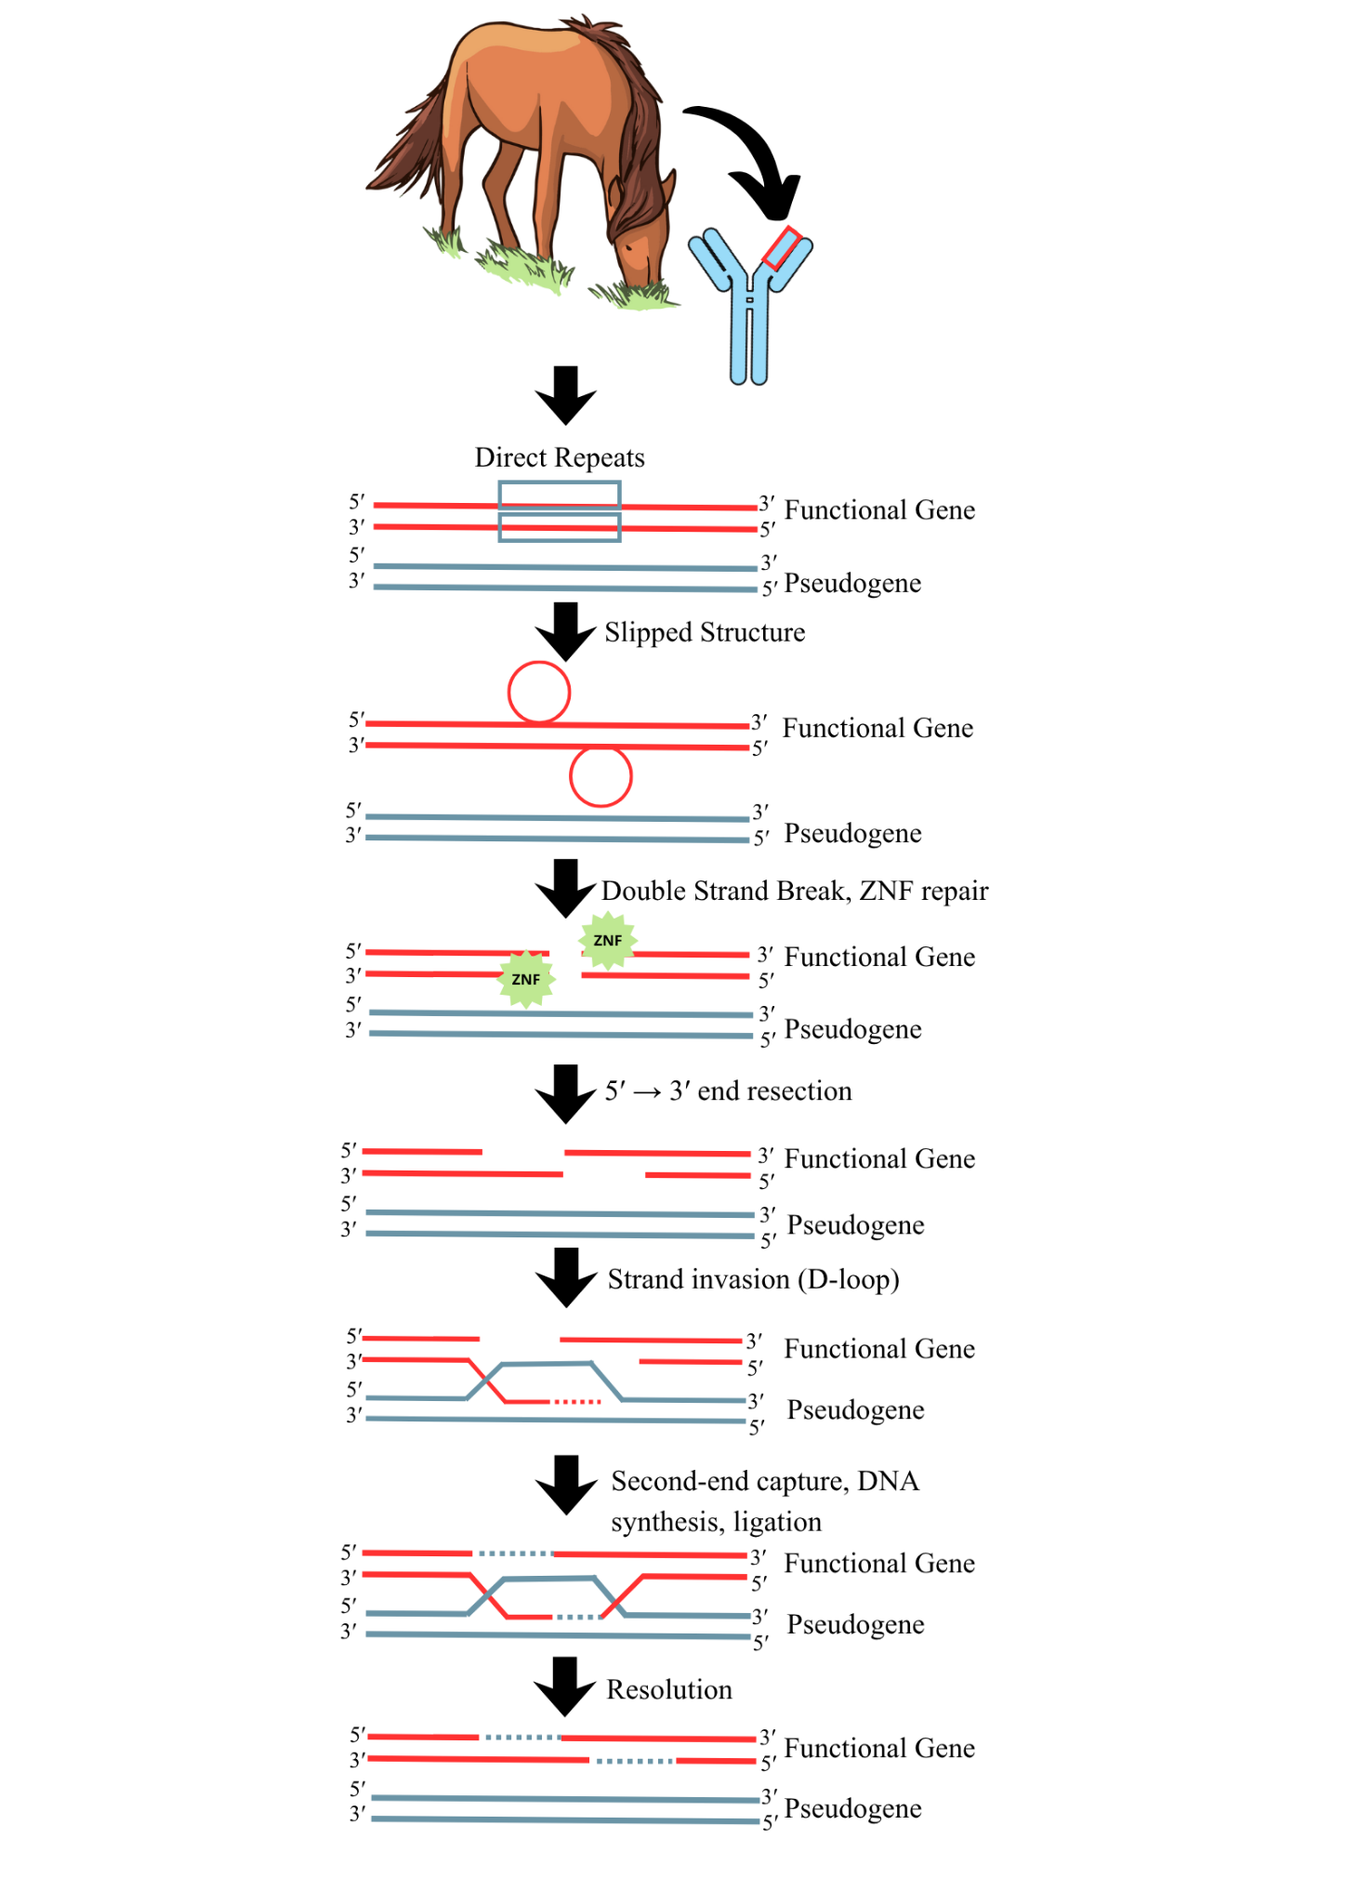
Supplementary Figure 5: Suggested mechanism for gene conversion events in the horse IGHV region. Directed repeats may be a preferential region for the formation of slipped structures, which can lead to double-strand breaks. These breaks can be repaired by zinc finger (ZNF) proteins, resulting in 5' to 3' end resection, strand invasion and the formation of a displacement loop (D-loop), leading to homologous recombination repair and gene conversion events.

