Table1. Meta-Analytic Regression of Simulated Effect Sizes as a Function of Prompt Framing, Model Identity Alignment, and Model Quantity.
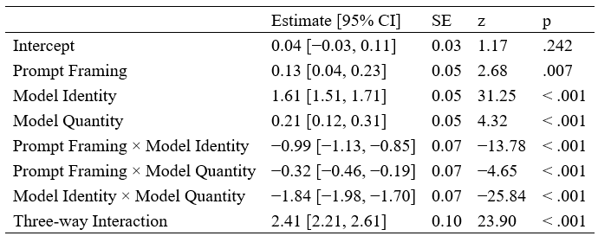
Note. Predictors represent contrasts between simulation configurations. Reference levels were participant-level prompt framing, general-purpose model identity, and multiple-model configuration. Positive coefficients indicate larger simulated effect sizes relative to these reference levels. Confidence intervals are 95%, and p values are two-tailed.

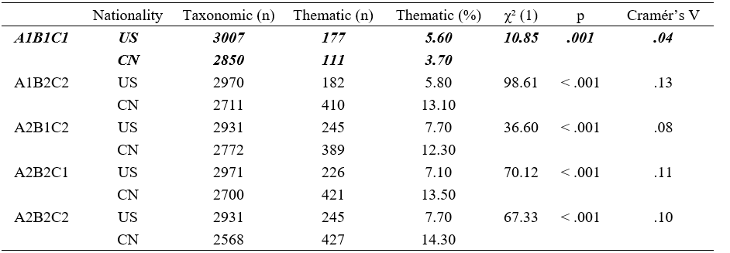
Table2. Taxonomic and Thematic Reasoning in LLM-Generated Explanations by Condition and Nationality.

Note. Frequencies and proportions of taxonomic and thematic explanations produced by large language models (LLMs) when simulating U.S. (US) and Chinese (CN) participants across five experimental conditions. Conditions reflect combinations of Prompt Framing (A1 = participant-level; A2 = distributional), Model Identity (B1 = general-purpose model; B2 = culturally aligned models), and Model Quantity (C1 = single model; C2 = multiple models). Chi-square tests compare reasoning-type distributions between US and CN simulations within each condition; effect size is reported as Cramér’s V. Analyses exclude explanations classified as unclear. The bolded condition indicates a reversal in the expected direction, with simulated U.S. participants producing more thematic explanations than simulated Chinese participants.

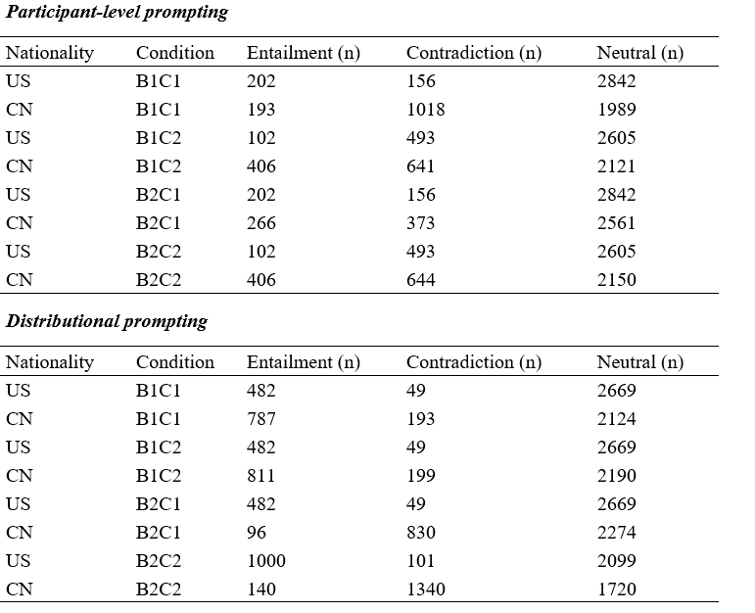
Table 3. Logical Consistency of LLM Explanations.
Note. Explanations were classified using Natural Language Inference as entailing, contradicting, or neutral with respect to the selected option. Entailment (n) indicates explanations that logically support the selected answer; Contradiction (n) indicates explanations that logically conflict with the selected answer; Neutral (n) indicates explanations that are logically consistent but do not provide sufficient information to support or contradict the selected answer. No human benchmark was available for evaluating logical or ethical coherence.

