Supplementary Information

Supplementary material 1: Prompt engineering

Participant-level Prompt:
US:
"""
In this game, you will see a series of target items, **32 target items in total**, each followed by two **choices**. Your task is to **select one choice** that is most closely related to the target item.
### Task Start ###
# These are the instructions for your task:
# You are tasked with solving a triads relationship problem based on your personal background. For each trial, a target item is followed by two options.
## What You Need to Do:
1. Review the **32 target-choice pairs** carefully.
2. Choose the option that you feel is most closely related to the **target item**.
3. Provide your responses in a **table format** with three columns:
- **Column 1:** Target item
- **Column 2:** Choices (both options)
- **Column 3:** Your chosen option
### Task ###
# Trial:
# - Target: A
# - Option 1: B
# - Option 2: C
# Answer: C

# Explanation

### Task End ###

### Task Start ###
"""
CN:
"""
在这个游戏中，你将看到一系列目标项目，总共有**32个目标项目**，每个目标项目后面都有两个**选项**。你的任务是从中**选择一个选项**，该选项与目标项目最相关。
### 任务开始 ###
# 以下是你的任务说明：
# 你的任务是代入给你设定好的背景并且根据你的个人背景解决一个三项关系问题。对于每个试验，一个目标项目后面会跟随两个选项。
## 你需要做的是：
1. 仔细阅读**32个目标-选项对**。
2. 选择你认为与**目标项目**最相关的选项。
3. 用**表格格式**提供你的回答，表格包含三列：
- **第一列:** 目标项目
- **第二列:** 选项（包括两个选项）
- **第三列:** 你选择的选项
### 任务 ###
# 试验：
# - 目标: 目标项目
# - 选项 1: 选项一
# - 选项 2: 选项二
# 答案: 选项二

# 解释

### 任务结束 ###

### 任务开始 ###
"""

Distributional Prompt:
US:
"""
## Task Overview ##
In this game, each participant will see a series of **target items**, **a total of 32 target items**—each target item is followed by two **options**. Their task is to **choose the option most closely related to the target item** and provide an explanation for their choice.

### What to Do ###
1. For each participant:
- Collect **demographic information** of the participant, including **age**, **gender**, **overseas experience**, **Resimobi**, **Native language**, **whether they are monolingual**, **subjective social status evaluation**, **whether they are attending college**, **highest educational attainment**, **whether they study STEM subjects**, **place of birth**, **current residence**, **where they grew up**, **ethnicity**. These should align with the eligibility criteria for participants to be collected.
- Collect their answers to the **32 target-option pairs**.
- Output the **demographic information** and **answers to the 32 target-option pairs** together.

2. **Demographic information** of the participant should include the following:
- **Participant ID**: Identifier for the participant (e.g., P1 for Participant 1, P2 for Participant 2).
- **Age**: Age of the participant must be an integer.
- **Gender**: Gender of the participant ("Male", "Female", "Non-binary", "Decline to answer").
- **Overseas Experience**: Number of overseas experiences the participant has had ("had no experiences overseas," "had one experience overseas," "had two experiensces oversea," "had three to five experiences overseas," "had six or more experiences overseas").
- **Resimobi**: Resimobi refers to the number of places the participant has lived in since the age of five, must be an integer.
- **first language**: participant's first language is english or not("English" or "Not English").
- **Monolingual**: The participant is monolingual or speaks multiple languages ("only speaks English" or "speaks multiple languages").
- **subjectiveses**: The participant's self evaluation of their social status, scored must be an integer and between 1 and 9.
- **current in college**: Whether the participant is currently attending college ("is currently in college" or "is not currently in college").
- **selfeducation**: The participant's highest level of education ("High school graduate/GED," "Some high school," "8th grade/junior high or less," "Two-year college degree/vocational school," "Four-/Five-year college Bachelor's degree", "At least some graduate school", "One or more years of college, no degree").
- **STEM or not**: Whether the participant has studied or is currently studying STEM subjects for not ("studied or is currently studying STEM subjects" or "did not study or is not currently studying STEM subjects").
- **country of birth**: The participant's country of birth ("was born in the U.S." or "was not born in the U.S.").
- **current in**: The participant's currently living country ("is currently living in the U.S." or "is currently not living in the U.S.").
- **state grew up**: Which state the participant grew up("Alabama", "Alaska", "Arizona", "Arkansas", "California", "Colorado", "Connecticut", "Florida", "Georgia", "Hawaii", "Idaho", "Illinois", "Indiana", "Iowa", "Kansas", "Kentucky", "Louisiana", "Maine", "Maryland", "Massachusetts", "Michigan", "Missouri", "Montana", "Nebraska", "Nevada", "New Hampshire", "New Jersey", "New York", "North Carolina", "Ohio", "Oklahoma", "Oregon", "Pennsylvania", "Rhode Island", "South Carolina", "Tennessee", "Texas", "Utah", "Virginia", "Washington", "West Virginia", "Wisconsin", "Wyoming", ""Delaware", "Minnesota", "Mississippi", "New Mexico", "North Dakota", "South Dakota", "Vermont")
- **Ethnicity**: The participant's self-identified ethnicity ("White," "Black or African American", "Asian", "Hispanic or Latino", "multiracial", "Other").

3. **Answers to the 32 target-option pairs** should include the following:
- **Participant ID**: Identifier for the participant, which should match the Participant ID in the **demographic information**.
- **Target Item**: The target item for each row.
- **Options**: The two options provided for the target item.
- **Participant's Choice and Explanation**: The participant's choice and their explanation for the choice.

4. After completing one participant's responses (**ensure all 32 target-option pairs are collected before moving to the next participant**), record the next participant's responses sequentially and store all data in the same format.

---

### Example Task ###
| Target | Options | Participant's Choice and Explanation |
|---------|-----------------|---------------------------------------|
| Lemon | Grape, Pear | Pear is more similar in terms of being a fruit like a lemon. |

---

### Example Output ###
| Participant ID | Target | Options | Participant's Choice and Explanation |
|----------------|----------|-----------------|---------------------------------------------------------|
| P1 | Lemon | Grape, Pear | Chose Pear because both lemon and pear are fruits, while grape is a type of berry. |

Repeat this process until the responses to **all 32 target-option pairs** have been collected for all participants.

---

### Task End ###

### Task Start ###
"""
CN:
"""
## Task Overview ##
In this game, each participant will see a series of **target items**, **a total of 32 target items**—each target item is followed by two **options**. Their task is to **choose the option most closely related to the target item** and provide an explanation for their choice.

### What to Do ###
1. For each participant:
- Collect **demographic information** of the participant, including **age**, **gender**, **overseas experience**, **Resimobi**, **Native language**, **whether they are monolingual**, **subjective social status evaluation**, **whether they are attending college**, **highest educational attainment**, **whether they study STEM subjects**, **place of birth**, **current residence**, **where they grew up**, **ethnicity**. These should align with the eligibility criteria for participants to be collected.
- Collect their answers to the **32 target-option pairs**.
- Output the **demographic information** and **answers to the 32 target-option pairs** together.

2. **Demographic information** of the participant should include the following:
- **Participant ID**: Identifier for the participant (e.g., P1 for Participant 1, P2 for Participant 2).
- **Age**: Age of the participant, must be an integer.
- **Gender**: Gender of the participant ("Male", "Female", "Non-binary", "Decline to answer").
- **Overseas Experience**: Number of overseas experiences the participant has had ("had no experiences oversea," "had one experience oversea," "had two experiences oversea," "had three to five experiences oversea," "had six or more experiences oversea").
- **Resimobi**: Resimobi refers to the number of places the participant has lived in since the age of five, must be an integer.
- **first language**: participant's first language is english or not("English" or "Not English").
- **Monolingual**: The participant is monolingual or speaks multiple languages ("only speaks English" or "speaks multiple languages").
- **subjectiveses**: The participant's self evaluation of their social status, scored must be an integer and between 1 and 9.
- **current in college**: Whether the participant is currently attending college ("is currently in college" or "is not currently in college").
- **selfeducation**: The participant's highest level of education ("High school graduate/GED," "Some high school," "8th grade/junior high or less," "Two-year college degree/vocational school," "Four-/Five-year college Bachelor's degree", "At least some graduate school", "One or more years of college, no degree").
- **STEM or not**: Whether the participant has studied or is currently studying STEM subjects for not ("studied or is currently studying STEM subjects" or "did not study or is not currently studying STEM subjects").
- **country of birth**: The participant's country of birth ("was born in the U.S." or "was not born in the U.S.").
- **current in**: The participant's currently living country ("is currently living in the U.S." or "is currently not living in the U.S.").
- **state grew up**: Which state the participant grew up("Alabama", "Alaska", "Arizona", "Arkansas", "California", "Colorado", "Connecticut", "Florida", "Georgia", "Hawaii", "Idaho", "Illinois", "Indiana", "Iowa", "Kansas", "Kentucky", "Louisiana", "Maine", "Maryland", "Massachusetts", "Michigan", "Missouri", "Montana", "Nebraska", "Nevada", "New Hampshire", "New Jersey", "New York", "North Carolina", "Ohio", "Oklahoma", "Oregon", "Pennsylvania", "Rhode Island", "South Carolina", "Tennessee", "Texas", "Utah", "Virginia", "Washington", "West Virginia", "Wisconsin", "Wyoming", ""Delaware", "Minnesota", "Mississippi", "New Mexico", "North Dakota", "South Dakota", "Vermont")
- **Ethnicity**: The participant's self-identified ethnicity ("White," "Black or African American", "Asian", "Hispanic or Latino", "multiracial", "Other").

3. **Answers to the 32 target-option pairs** should include the following:
- **Participant ID**: Identifier for the participant, which should match the Participant ID in the **demographic information**.
- **Target Item**: The target item for each row.
- **Options**: The two options provided for the target item.
- **Participant's Choice and Explanation**: The participant's choice and their explanation for the choice.

4. After completing one participant's responses (**ensure all 32 target-option pairs are collected before moving to the next participant**), record the next participant's responses sequentially and store all data in the same format.

---

### Example Task ###
| Target | Options | Participant's Choice and Explanation |
|---------|-----------------|---------------------------------------|
| Lemon | Grape, Pear | Pear is more similar in terms of being a fruit like a lemon. |

---

### Example Output ###
| Participant ID | Target | Options | Participant's Choice and Explanation |
|----------------|----------|-----------------|---------------------------------------------------------|
| P1 | Lemon | Grape, Pear | Chose Pear because both lemon and pear are fruits, while grape is a type of berry. |

Repeat this process until the responses to **all 32 target-option pairs** have been collected for all participants.

---

### Task End ###

### Task Start ###
"""

Supplementary material 2: Response Diversity Analysis
To assess whether LLM-generated explanations exhibit diversity comparable to human responses, we examined the variability of explanations across repeated trials and experimental conditions. Diversity was evaluated at the level of reasoning structure, rather than lexical variation, capturing whether models converged on a limited set of dominant rationales or generated heterogeneous explanatory patterns. We therefore treat reasoning diversity as a necessary, though not sufficient, condition for using LLM outputs as proxies for human behaviour.
Similarity matrices (left panels) visualise pairwise semantic similarity among explanations across trials, with lighter colours indicating greater similarity, whereas semantic drift overlays (right panels) depict temporal fluctuations in explanation trajectories, reflecting changes in underlying reasoning patterns over the course of generation.
Together, these analyses characterise LLM-generated explanations as structured outputs, focusing on their internal organisation and variability across responses. For clarity, we present results from the first simulation run as representative; patterns were highly similar across repeated runs.
Participant-level prompt:
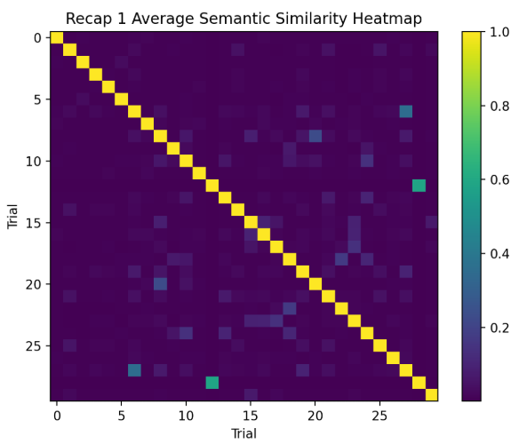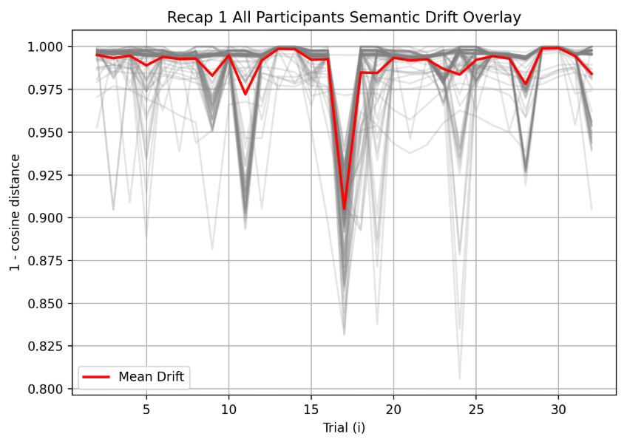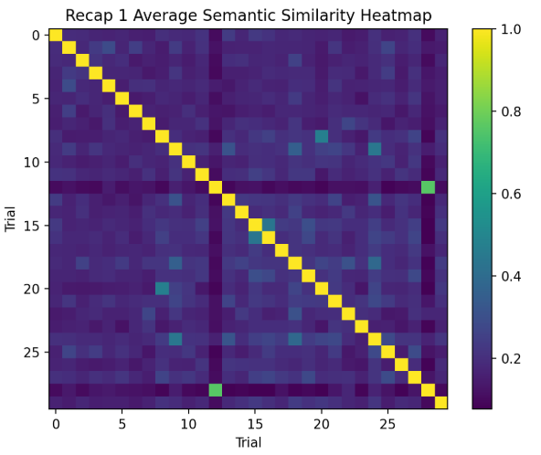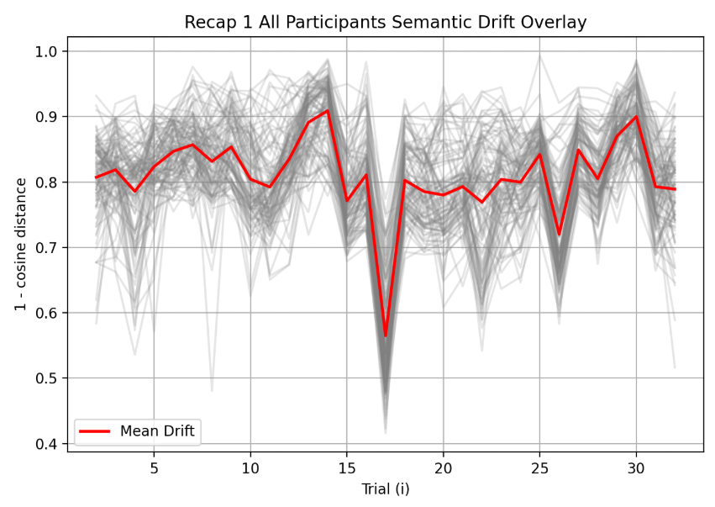
A1_B1_C1_CN A1_B1_C1_US
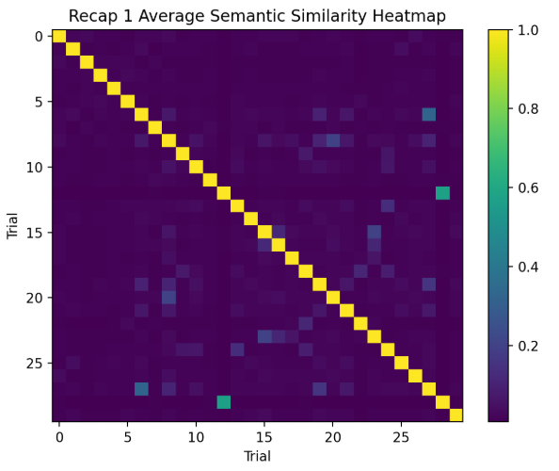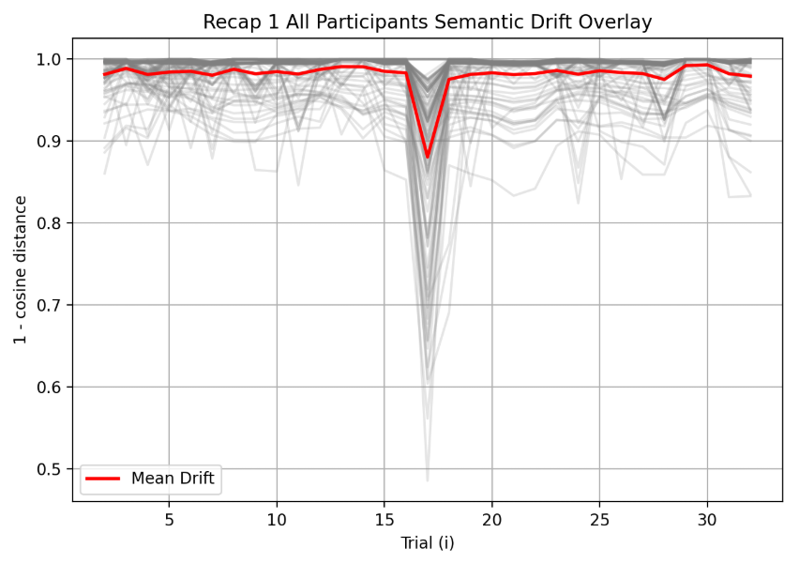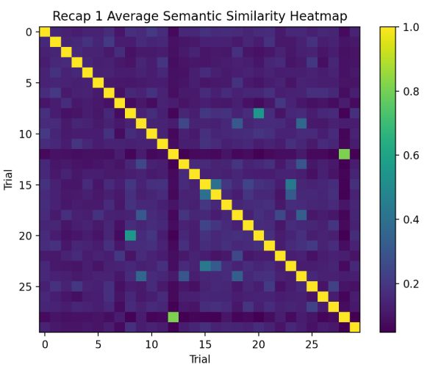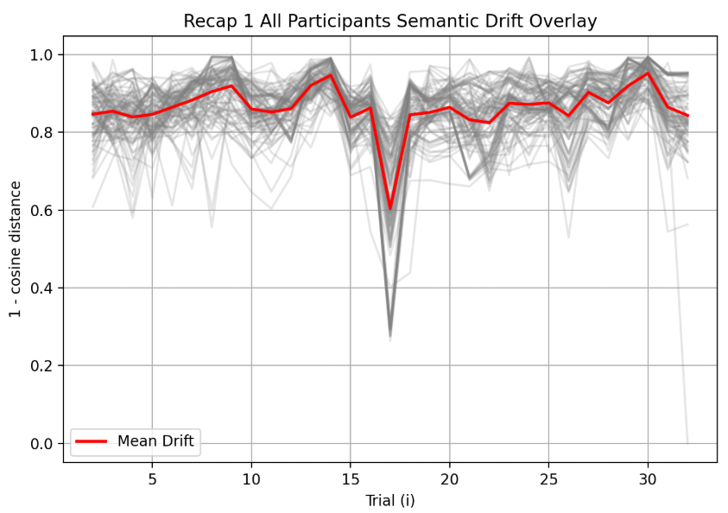
A1_B1_C2_CN A1_B1_C2_US
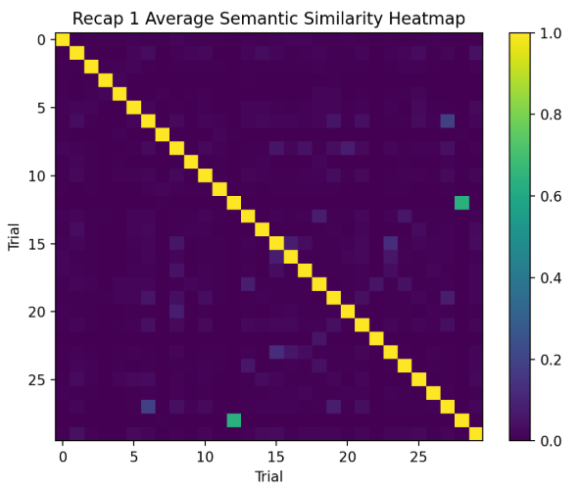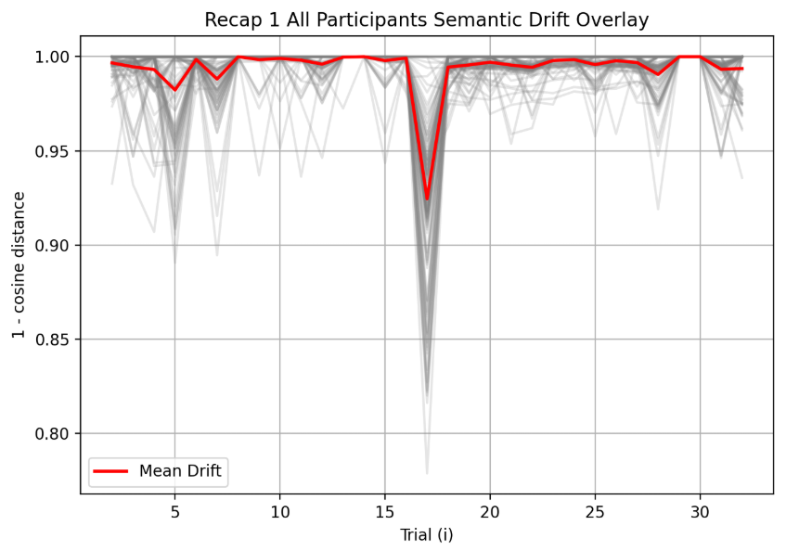
A1_B2_C1_CN A1_B2_C1_US
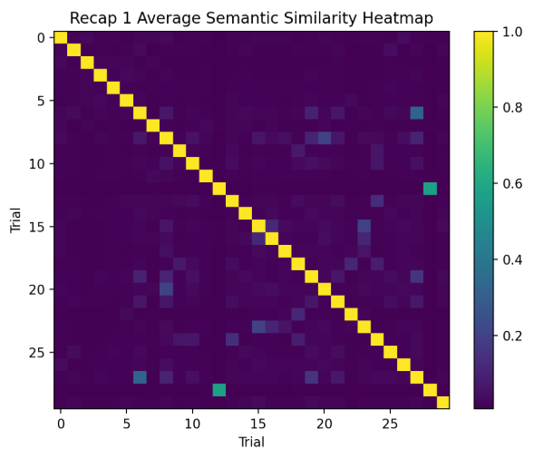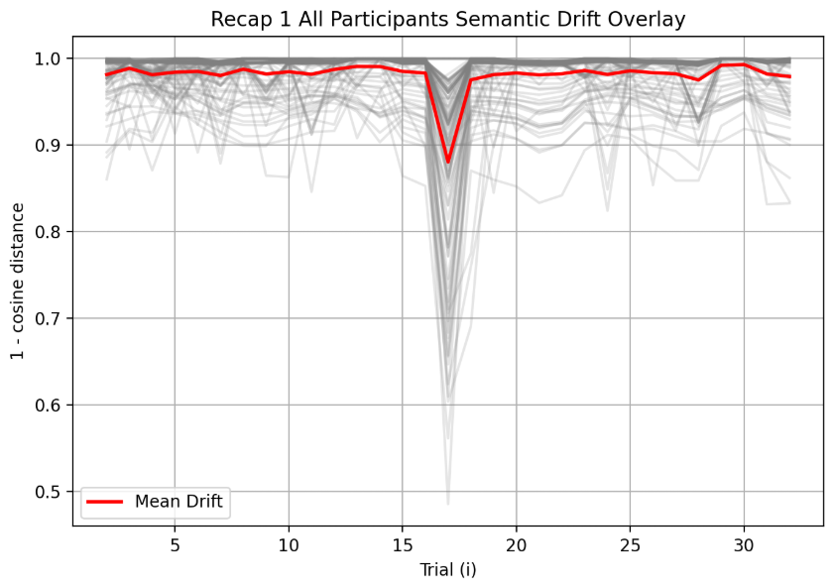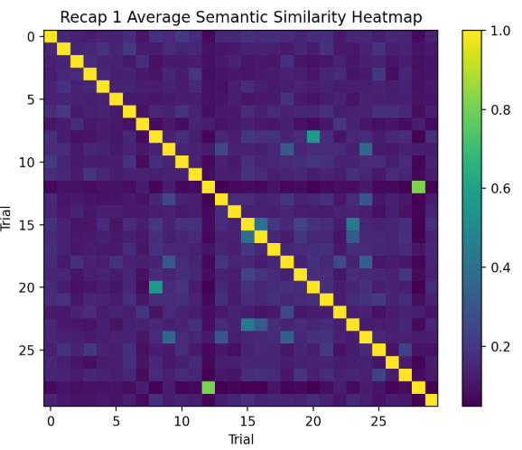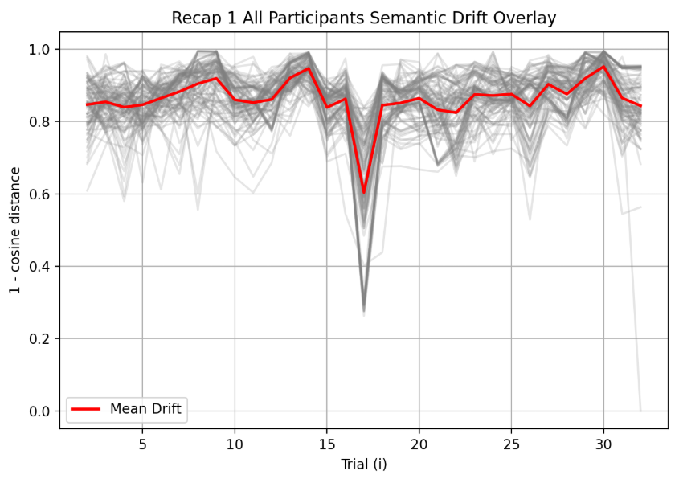
A1_B2_C2_CN A1_B2_C2_US
Distributional prompt:
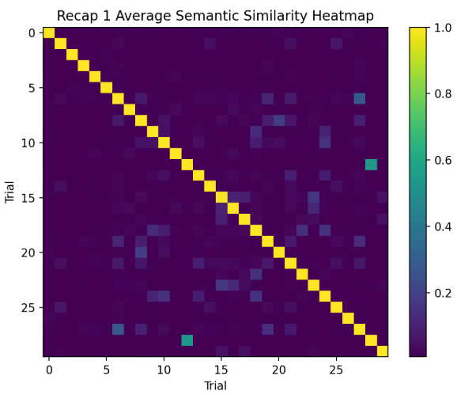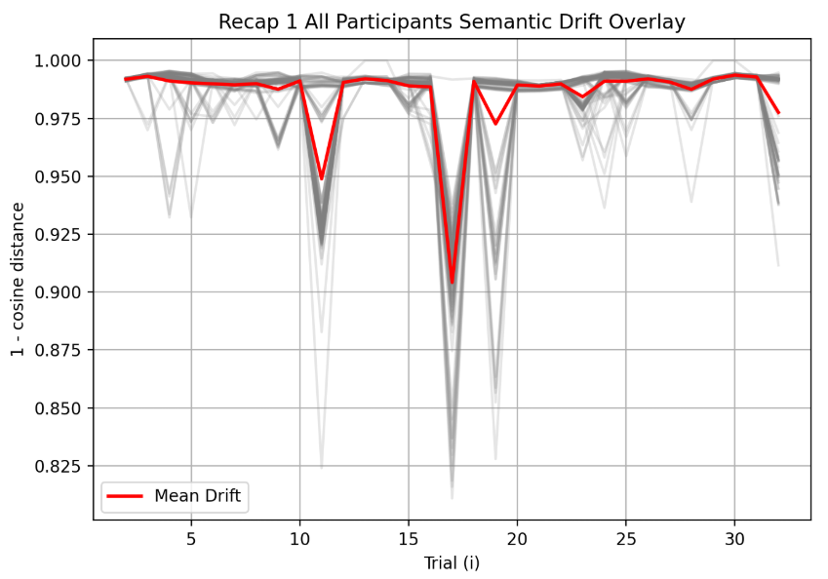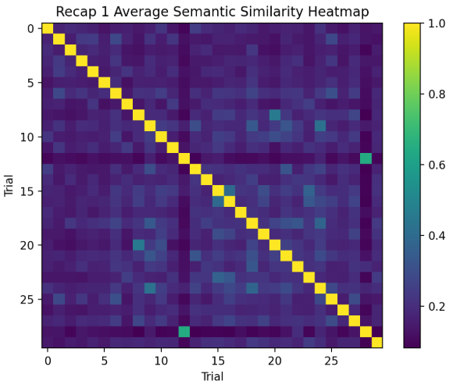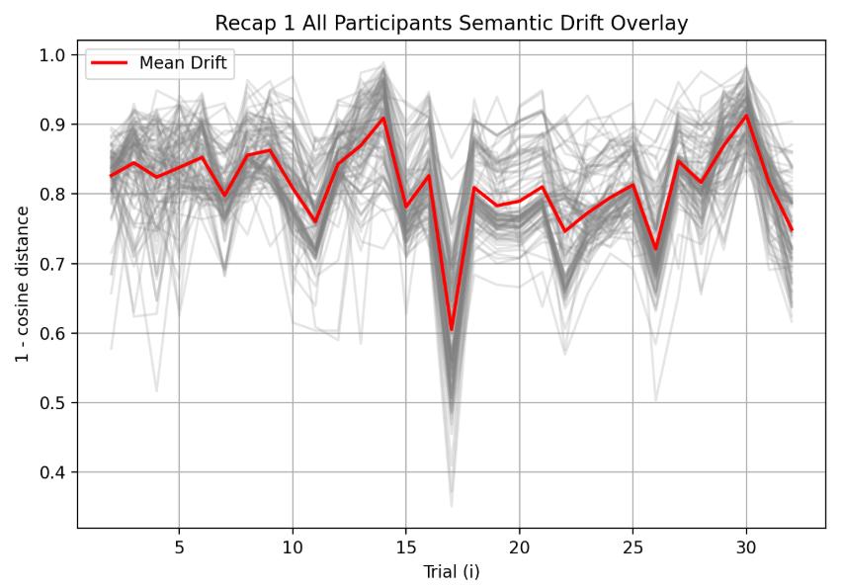
A2_B1_C1_CN A2_B1_C1_US
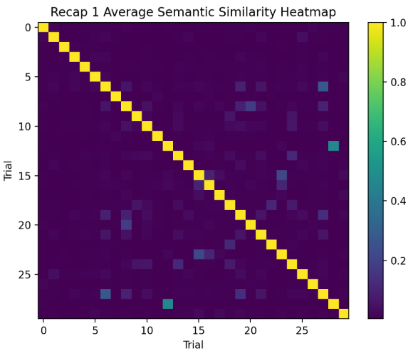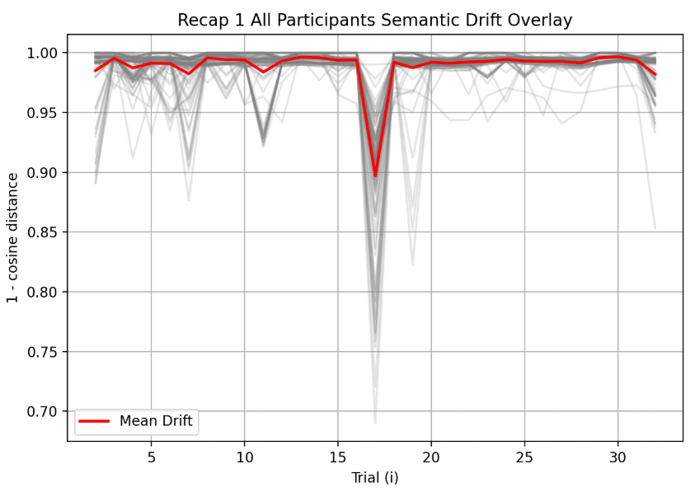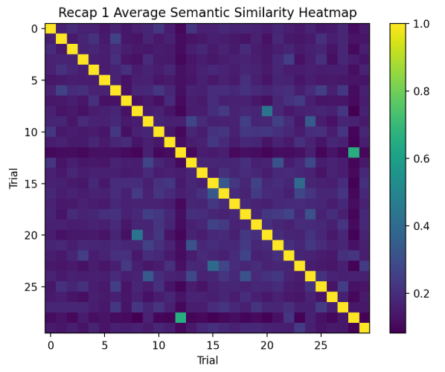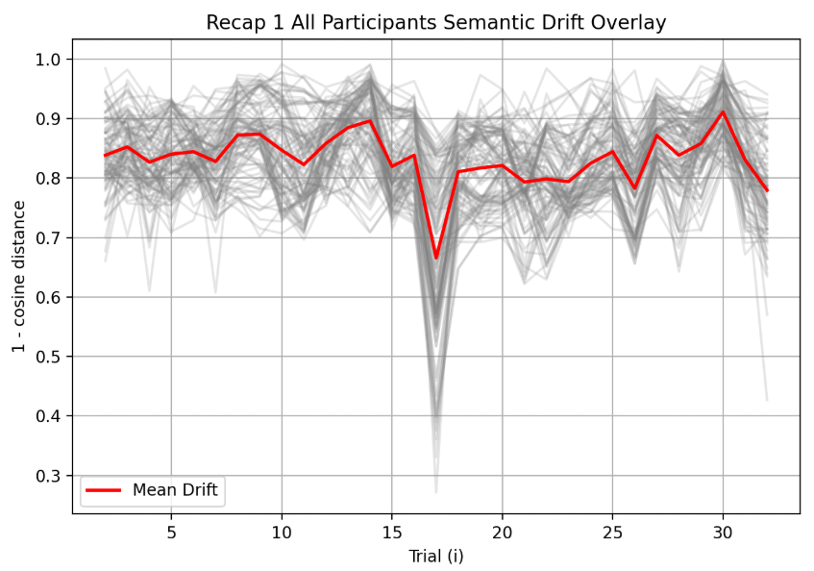
A2_B1_C2_CN A2_B1_C2_US
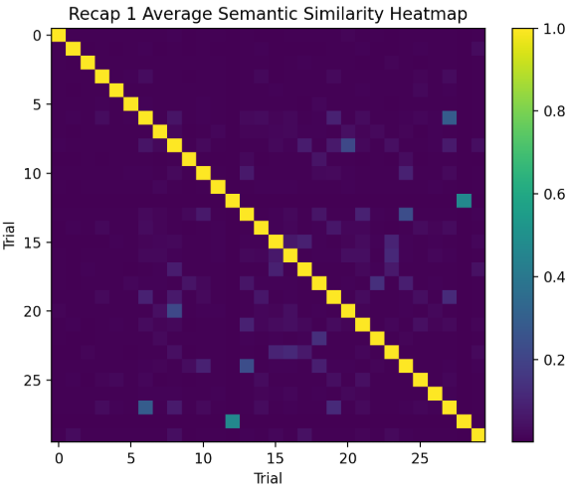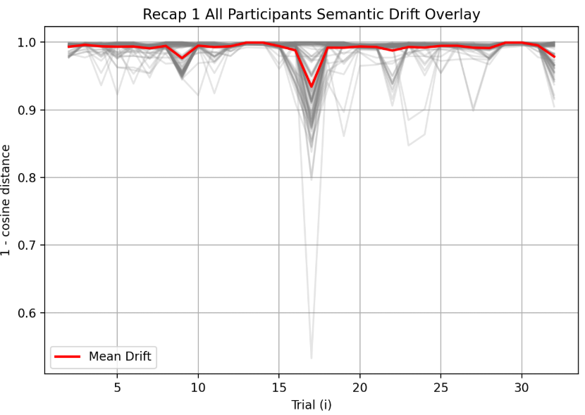
A2_B2_C1_CN A2_B2_C1_US
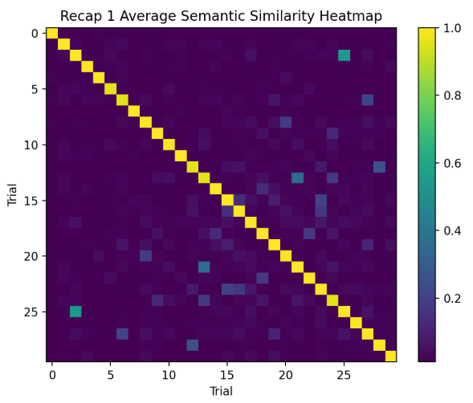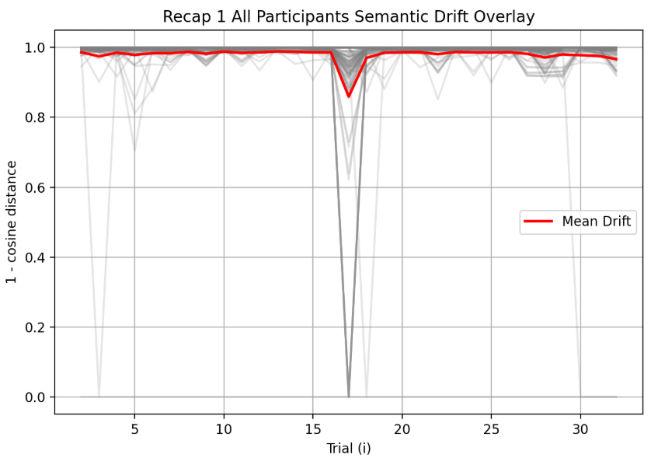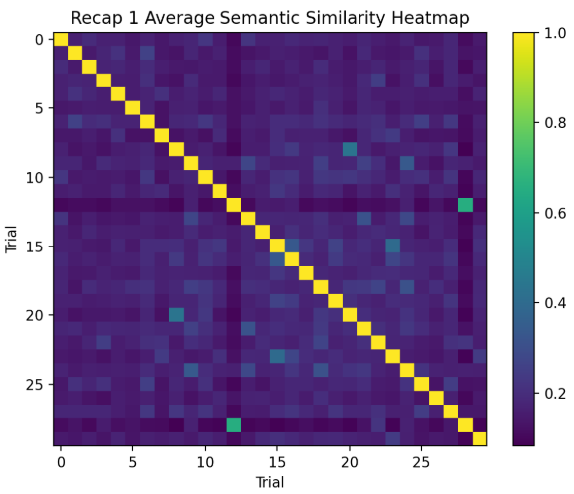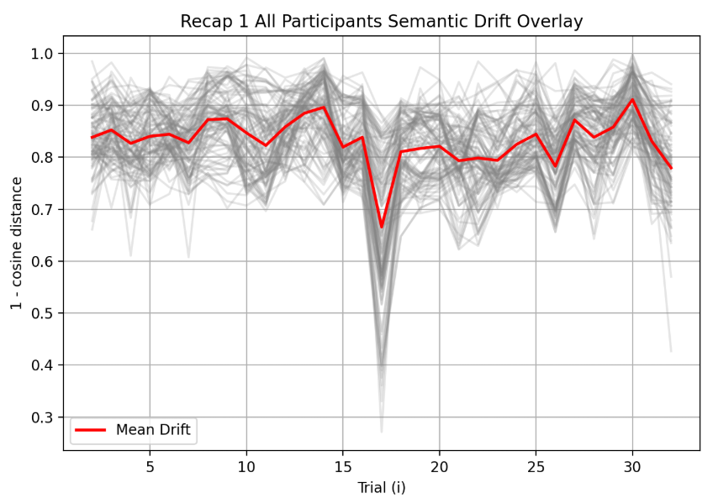
A2_B2_C2_CN A2_B2_C2_US

