Table S1. Number of progenies assigned to the plus trees by maternity analysis
Plus tree | Hongcheon | Hwaseong | Plus tree | Hongcheon | Hwaseong
CB01 | - | 3 | GB23 | 2 | -
CB03 | 1 | - | GB24 | 1 | 1
CB06 | 1 | - | GB25 | 5 | 1
CN04 | 1 | - | GB26 | - | 2
CN05 | 6 | 1 | GB27 | 3 | 5
CN08 | - | 1 | GB28 | - | 1
CN09 | 6 | 4 | GB29 | 2 | -
CN10 | 2 | 1 | GB31 | 2 | -
CN13 | 1 | - | GG01 | 2 | 1
CN14 | 3 | 3 | JB01 | 3 | 4
CN15 | 2 | 3 | JB03 | 3 | 1
CN16 | 2 | 1 | JB05 | 2 | -
CN18 | - | 1 | JB07 | - | 2
CN19 | 1 | 2 | JB08 | 3 | 2
GB04 | 1 | - | JB09 | 2 | 2
GB05 | 1 | - | JB10 | 1 | 3
GB07 | - | 3 | JB11 | 1 | -
GB09 | 2 | - | JB12 | 1 | 1
GB10 | - | 2 | JB13 | 1 | 1
GB11 | 1 | - | JB14 | 3 | -
GB12 | 1 | 5 | JB15 | 1 | -
GB13 | 1 | 2 | JJ01 | 1 | -
GB14 | - | 1 | JN01 | 3 | 4
GB15 | - | 1 | JN03 | 1 | 1
GB16 | 1 | - | JN04 | 5 | 1
GB18 | - | 2 | JPOR-1 | 1 | -
GB19 | - | 1 | JPR-1 | 3 | 1
GB21 | 2 | 1 | JPR-10 | 2 | -
JPR-12 | 3 | 2 | KW28 | 2 | 3
JPR-3 | 2 | 1 | KW29 | 2 | 2
JPR-4 | 6 | 2 | KW30 | 2 | -
JPR-5 | - | 2 | KW31 | 1 | -
JPR-8 | 1 | 4 | KW33 | - | 1
JPR-9 | 2 | - | KW34 | 4 | 2
KW01 | - | 1 | KW35 | 1 | 2
KW02 | 5 | 2 | KW38 | 1 | 1
KW03 | 4 | 2 | KW40 | 1 | 1
KW04 | 1 | 1 | KW42 | 3 | 1
KW06 | 1 | 1 | KW43 | 2 | 1
KW07-1 | 3 | 2 | KW44 | 1 | -
KW07-2 | 3 | 4 | KW47 | - | 1
KW08 | 4 | 3 | KW48 | 1 | 1
KW09 | 3 | 2 | KW51 | 1 | -
KW10 | 3 | 2 | KW52 | 2 | 1
KW11 | - | 1 | KW54 | 1 | -
KW12 | 1 | - | KW55 | 1 | 2
KW13 | 2 | 2 | KW56 | 4 | -
KW15 | 1 | 1 | KW57 | 1 | 3
KW16 | - | 1 | KW58 | 2 | -
KW19 | 3 | 2 | KW59 | 1 | 2
KW20 | 1 | - | NO01 | - | 1
KW21 | 1 | - | NO02 | 1 | 2
KW22 | 1 | 1 | NO03 | 2 | -
KW23 | 1 | - | NO04 | - | 3
KW24 | 3 | 3 | NO05 | 2 | 1
KW26 | 1 | 1 | NO06 | 3 | -

Table S2. Comparison of the predicted breeding value (PBV) and its rank of individual based on Animal model and Animal+AR1⊗AR1 model
Tree | Animal + AR1⊗AR1 model |  | Animal model |  | DBH | Rank
ID | PBV | Rank | PBV | Rank | DBH | (DBH)
hc1335 | 5.655 | 1 | 2.06E-05 | 7 | 28.1 | 7
hc1427 | 4.846 | 2 | 2.44E-05 | 2 | 27.5 | 9
hc1429 | 4.466 | 3 | 2.24E-05 | 5 | 29 | 3
hc1410 | 4.252 | 4 | 2.24E-05 | 4 | 29 | 4
hc1515 | 4.236 | 5 | 2.12E-05 | 6 | 28.5 | 6
hc1436 | 3.971 | 6 | 1.50E-05 | 21 | 24.6 | 25
hc1520 | 3.9 | 7 | 1.99E-05 | 9 | 25.8 | 17
hc1453 | 3.799 | 8 | 1.17E-05 | 25 | 23 | 29
hc1437 | 3.795 | 9 | 1.51E-05 | 20 | 25 | 23
hc1450 | 3.784 | 10 | 6.05E-06 | 51 | 22.5 | 34
hc1485 | 3.621 | 11 | 2.77E-05 | 1 | 29.7 | 1
hc1478 | 3.266 | 12 | 1.71E-05 | 17 | 26.3 | 16
hc1562 | 3.229 | 13 | 1.92E-05 | 14 | 27.4 | 13
hc1406 | 3.186 | 14 | 2.04E-05 | 8 | 28 | 8
hc1477 | 3.082 | 15 | 1.04E-05 | 32 | 25.4 | 20
hc1559 | 3.068 | 16 | 1.93E-05 | 12 | 25.4 | 21
hc1593 | 2.949 | 17 | 1.67E-05 | 18 | 27.5 | 10
hc1563 | 2.847 | 18 | 8.90E-06 | 38 | 21.9 | 42
hc1585 | 2.778 | 19 | 2.28E-05 | 3 | 29.6 | 2
hc1430 | 2.743 | 20 | 8.10E-06 | 42 | 23.5 | 26
hc1497 | 2.698 | 21 | 1.82E-05 | 16 | 27 | 14
hc1339 | 2.688 | 22 | 1.28E-05 | 24 | 23.5 | 27
hc1618 | 2.65 | 23 | 8.90E-06 | 37 | 21.5 | 43
hc1552 | 2.604 | 24 | 8.90E-06 | 36 | 20.5 | 52
hc1612 | 2.563 | 25 | 6.08E-06 | 50 | 20.8 | 49
hc1536 | 2.531 | 26 | 3.89E-06 | 65 | 19.7 | 61
hc1463 | 2.442 | 27 | 6.11E-06 | 48 | 19 | 67
hc1423 | 2.39 | 28 | 1.90E-05 | 15 | 25.2 | 22
hc1537 | 2.208 | 29 | 7.55E-06 | 43 | 20.6 | 51
hc1538 | 2.171 | 30 | 1.10E-05 | 28 | 18.5 | 74
hc1428 | 2.157 | 31 | 1.33E-05 | 22 | 26.5 | 15
hc1551 | 2.088 | 32 | 7.28E-06 | 44 | 21.4 | 44
hc1404 | 2.086 | 33 | 1.93E-05 | 13 | 28.7 | 5
hc1475 | 2.083 | 34 | 4.88E-06 | 56 | 22 | 37
hc1484 | 1.898 | 35 | 1.94E-05 | 10 | 27.5 | 11
hc1489 | 1.833 | 36 | 1.56E-05 | 19 | 25 | 24
hc1603 | 1.802 | 37 | 5.08E-06 | 54 | 20.3 | 56
hc1547 | 1.645 | 38 | 4.56E-06 | 59 | 19 | 68
hc1584 | 1.636 | 39 | 1.94E-05 | 11 | 27.5 | 12
hc1420 | 1.627 | 40 | 1.15E-05 | 26 | 23.5 | 28
hc1344 | 1.605 | 41 | 1.49E-06 | 78 | 18.5 | 75
hc1569 | 1.6 | 42 | 5.58E-06 | 53 | 21 | 45
hc1322 | 1.596 | 43 | 9.10E-06 | 35 | 23 | 30
hc1528 | 1.555 | 44 | 4.96E-06 | 55 | 19 | 69
hc1505 | 1.531 | 45 | 7.08E-06 | 46 | 22 | 38
hc1530 | 1.52 | 46 | 7.20E-06 | 45 | 20.5 | 53
hc1327 | 1.507 | 47 | 1.10E-05 | 27 | 18.5 | 76
hc1621 | 1.48 | 48 | 1.05E-05 | 30 | 23 | 31
hc1474 | 1.465 | 49 | 4.81E-06 | 57 | 18.9 | 71
hc1544 | 1.458 | 50 | 4.09E-06 | 62 | 19.8 | 59
hc1351 | 1.423 | 51 | 3.09E-06 | 69 | 19.3 | 66
hc1575 | 1.217 | 52 | 1.47E-06 | 79 | 20 | 58
hc1332 | 1.169 | 53 | 2.71E-06 | 70 | 20.3 | 57
hc1422 | 1.085 | 54 | 8.47E-06 | 39 | 22 | 39
hc1524 | 1.026 | 55 | 4.53E-06 | 60 | 22.2 | 36
hc1508 | 1.017 | 56 | 1.05E-05 | 29 | 22.7 | 33
hc1517 | 0.938 | 57 | -1.17E-06 | 95 | 18 | 80
hc1432 | 0.93 | 58 | 2.09E-06 | 74 | 18.8 | 72
hc1440 | 0.897 | 59 | 4.70E-07 | 85 | 18.8 | 73
hc1519 | 0.875 | 60 | 8.27E-06 | 40 | 18 | 81
hc1545 | 0.789 | 61 | 3.16E-06 | 67 | 19.7 | 62
hc1589 | 0.782 | 62 | 6.48E-06 | 47 | 21 | 46
hc1578 | 0.764 | 63 | 8.15E-06 | 41 | 20.4 | 54
hc1346 | 0.748 | 64 | -3.09E-06 | 106 | 16.2 | 101
hc1405 | 0.628 | 65 | 1.04E-05 | 31 | 25.5 | 18
hc1609 | 0.57 | 66 | 3.51E-06 | 66 | 17.2 | 90
hc1411 | 0.548 | 67 | -4.29E-06 | 113 | 15.6 | 113
hc1557 | 0.468 | 68 | 1.99E-06 | 77 | 22.5 | 35
hc1402 | 0.446 | 69 | 1.32E-05 | 23 | 25.5 | 19
hc1617 | 0.392 | 70 | 1.50E-07 | 86 | 19.5 | 63
hc1529 | 0.292 | 71 | 5.00E-07 | 83 | 18 | 82
hc1512 | 0.284 | 72 | 4.41E-06 | 61 | 20.4 | 55
hc1501 | 0.279 | 73 | 2.24E-06 | 73 | 22 | 40
hc1433 | 0.278 | 74 | 2.07E-06 | 75 | 23 | 32
hc1535 | 0.201 | 75 | -3.00E-08 | 88 | 16.3 | 100
hc1407 | 0.179 | 76 | -2.90E-06 | 105 | 17.3 | 88
hc1610 | 0.134 | 77 | 2.26E-06 | 72 | 17.2 | 91
hc1604 | 0.125 | 78 | 1.02E-06 | 81 | 17 | 92
hc1549 | 0.117 | 79 | 4.68E-06 | 58 | 14.3 | 134
hc1566 | 0.042 | 80 | -1.45E-06 | 96 | 19.4 | 65
hc1447 | 0.013 | 81 | 1.24E-06 | 80 | 16 | 102
hc1444 | 0.01 | 82 | 3.14E-06 | 68 | 16.7 | 96
hc1342 | 0.005 | 83 | -3.49E-06 | 109 | 16 | 103
hc1456 | -0.066 | 84 | -6.58E-06 | 126 | 15 | 119
hc1500 | -0.081 | 85 | 9.57E-06 | 34 | 21 | 47
hc1469 | -0.106 | 86 | -7.41E-06 | 130 | 13.5 | 145
hc1325 | -0.107 | 87 | -9.80E-07 | 92 | 17.7 | 85
hc1352 | -0.215 | 88 | -7.56E-06 | 135 | 17.6 | 87
hc1550 | -0.253 | 89 | 1.00E-07 | 87 | 17.8 | 84
hc1425 | -0.254 | 90 | 6.08E-06 | 49 | 20.8 | 50
hc1608 | -0.265 | 91 | -7.33E-06 | 128 | 16.7 | 97
hc1615 | -0.311 | 92 | -2.87E-06 | 104 | 17 | 93
hc1521 | -0.312 | 93 | -3.25E-06 | 107 | 19 | 70
hc1504 | -0.323 | 94 | -1.10E-06 | 93 | 18.5 | 77
hc1452 | -0.333 | 95 | -5.49E-06 | 117 | 15 | 120
hc1498 | -0.357 | 96 | 1.02E-05 | 33 | 22 | 41
hc1553 | -0.376 | 97 | -2.50E-06 | 101 | 16.5 | 98
hc1426 | -0.38 | 98 | 5.83E-06 | 52 | 18.2 | 79
hc1525 | -0.401 | 99 | -1.65E-06 | 98 | 14.7 | 125
hc1449 | -0.409 | 100 | -8.08E-06 | 138 | 16.5 | 99
hc1417 | -0.426 | 101 | -1.29E-05 | 169 | 13 | 150
hc1340 | -0.428 | 102 | -2.17E-06 | 100 | 16 | 104
hc1572 | -0.436 | 103 | -1.50E-06 | 97 | 17 | 94
hc1577 | -0.454 | 104 | -9.00E-07 | 91 | 17.3 | 89
hc1341 | -0.462 | 105 | -4.09E-06 | 112 | 15.7 | 111
hc1473 | -0.474 | 106 | 1.99E-06 | 76 | 18 | 83
hc1602 | -0.516 | 107 | -6.34E-06 | 124 | 14.5 | 127
hc1466 | -0.55 | 108 | -5.49E-06 | 116 | 13 | 151
hc1522 | -0.6 | 109 | -6.56E-06 | 125 | 14.4 | 132
hc1413 | -0.618 | 110 | -1.44E-05 | 180 | 12 | 162
hc1568 | -0.628 | 111 | -8.00E-08 | 89 | 18.4 | 78
hc1614 | -0.64 | 112 | -5.51E-06 | 119 | 13.9 | 139
hc1443 | -0.668 | 113 | -3.52E-06 | 111 | 16 | 105
hc1348 | -0.698 | 114 | -7.38E-06 | 129 | 13.8 | 141
hc1345 | -0.72 | 115 | -1.92E-06 | 99 | 14.4 | 133
hc1461 | -0.731 | 116 | -1.07E-05 | 155 | 13.2 | 149
hc1539 | -0.755 | 117 | -1.10E-05 | 158 | 15.3 | 118
hc1611 | -0.772 | 118 | -7.68E-06 | 136 | 13.9 | 140
hc1451 | -0.782 | 119 | -7.56E-06 | 134 | 15.4 | 117
hc1401 | -0.785 | 120 | 3.96E-06 | 63 | 21 | 48
hc1558 | -0.848 | 121 | 3.89E-06 | 64 | 16.9 | 95
hc1448 | -0.865 | 122 | -8.75E-06 | 143 | 14.5 | 128
hc1534 | -0.909 | 123 | -5.76E-06 | 120 | 14.5 | 129
hc1479 | -0.93 | 124 | -1.50E-07 | 90 | 15.7 | 112
hc1439 | -0.943 | 125 | -6.31E-06 | 123 | 15.9 | 110
hc1324 | -0.95 | 126 | -2.87E-06 | 103 | 15 | 121
hc1480 | -0.959 | 127 | -3.49E-06 | 110 | 16 | 106
hc1506 | -0.959 | 128 | -1.13E-06 | 94 | 17.7 | 86
hc1527 | -0.99 | 129 | -2.72E-06 | 102 | 14.5 | 130
hc1531 | -1.014 | 130 | -7.28E-06 | 127 | 15.5 | 114
hc1414 | -1.146 | 131 | -1.06E-05 | 154 | 11 | 179
hc1468 | -1.163 | 132 | -3.39E-06 | 108 | 10.2 | 188
hc1526 | -1.193 | 133 | -8.20E-06 | 139 | 13 | 152
hc1472 | -1.209 | 134 | -7.73E-06 | 137 | 14 | 135
hc1445 | -1.37 | 135 | -1.03E-05 | 152 | 12.6 | 156
hc1462 | -1.469 | 136 | -9.33E-06 | 146 | 13 | 153
hc1470 | -1.493 | 137 | -8.31E-06 | 140 | 12.9 | 154
hc1616 | -1.501 | 138 | -1.19E-05 | 162 | 14.7 | 126
hc1548 | -1.511 | 139 | -1.27E-05 | 167 | 11.4 | 174
hc1412 | -1.52 | 140 | -1.14E-05 | 159 | 12.5 | 157
hc1619 | -1.552 | 141 | -5.96E-06 | 122 | 14.5 | 131
hc1460 | -1.555 | 142 | -1.29E-05 | 170 | 13.3 | 148
hc1408 | -1.585 | 143 | 5.00E-07 | 84 | 19.5 | 64
hc1613 | -1.605 | 144 | -1.25E-05 | 164 | 11.5 | 173
hc1465 | -1.642 | 145 | -1.35E-05 | 172 | 11 | 180
hc1546 | -1.66 | 146 | -7.48E-06 | 132 | 14 | 136
hc1435 | -1.703 | 147 | -7.53E-06 | 133 | 13.5 | 146
hc1415 | -1.704 | 148 | -1.25E-05 | 165 | 10.8 | 185
hc1446 | -1.71 | 149 | 2.42E-06 | 71 | 16 | 107
hc1565 | -1.739 | 150 | -8.33E-06 | 141 | 11.7 | 170
hc1421 | -1.8 | 151 | 7.20E-07 | 82 | 19.8 | 60
hc1458 | -1.808 | 152 | -1.49E-05 | 182 | 12.7 | 155
hc1416 | -1.811 | 153 | -1.55E-05 | 183 | 11.3 | 176
hc1467 | -1.878 | 154 | -1.40E-05 | 174 | 11.8 | 168
hc1471 | -1.915 | 155 | -9.05E-06 | 144 | 12.4 | 161
hc1564 | -1.936 | 156 | -1.59E-05 | 184 | 12.5 | 158
hc1418 | -2.006 | 157 | -1.31E-05 | 171 | 11.2 | 177
hc1574 | -2.025 | 158 | -7.48E-06 | 131 | 14 | 137
hc1573 | -2.036 | 159 | -9.90E-06 | 148 | 15 | 122
hc1556 | -2.246 | 160 | -1.24E-05 | 163 | 11 | 181
hc1532 | -2.252 | 161 | -1.48E-05 | 181 | 10.5 | 186
hc1567 | -2.263 | 162 | -1.10E-05 | 157 | 11.7 | 171
hc1343 | -2.265 | 163 | -9.93E-06 | 149 | 11.9 | 166
hc1507 | -2.401 | 164 | -9.95E-06 | 151 | 16 | 108
hc1518 | -2.419 | 165 | -1.07E-05 | 156 | 15.5 | 115
hc1434 | -2.451 | 166 | -4.74E-06 | 114 | 16 | 109
hc1523 | -2.489 | 167 | -5.86E-06 | 121 | 15 | 123
hc1419 | -2.495 | 168 | -8.38E-06 | 142 | 13.8 | 142
hc1570 | -2.532 | 169 | -1.15E-05 | 160 | 13.5 | 147
hc1605 | -2.541 | 170 | -1.41E-05 | 176 | 13.7 | 143
hc1441 | -2.544 | 171 | -1.37E-05 | 173 | 12.5 | 159
hc1326 | -2.565 | 172 | -1.19E-05 | 161 | 11.8 | 169
hc1347 | -2.675 | 173 | -1.41E-05 | 175 | 11.1 | 178
hc1555 | -2.675 | 174 | -1.59E-05 | 185 | 11 | 182
hc1350 | -2.981 | 175 | -1.29E-05 | 168 | 11.9 | 167
hc1560 | -3.039 | 176 | -9.50E-06 | 147 | 14 | 138
hc1576 | -3.092 | 177 | -9.25E-06 | 145 | 11.4 | 175
hc1579 | -3.106 | 178 | -5.16E-06 | 115 | 15 | 124
hc1349 | -3.16 | 179 | -1.42E-05 | 177 | 11.7 | 172
hc1464 | -3.399 | 180 | -1.63E-05 | 186 | 11 | 183
hc1438 | -3.515 | 181 | -1.26E-05 | 166 | 12 | 163
hc1514 | -3.557 | 182 | -9.95E-06 | 150 | 13.7 | 144
hc1533 | -3.631 | 183 | -1.68E-05 | 187 | 10.4 | 187
hc1409 | -3.714 | 184 | -5.49E-06 | 118 | 15.5 | 116
hc1476 | -3.737 | 185 | -1.05E-05 | 153 | 12.5 | 160
hc1509 | -3.812 | 186 | -1.43E-05 | 179 | 12 | 164
hc1442 | -4.125 | 187 | -1.81E-05 | 188 | 11 | 184
hc1516 | -5.937 | 188 | -1.43E-05 | 178 | 12 | 165

Table S3. Predicted breeding values (PBV) of Larix kaempferi trees assigned as mother trees
Mother tree | PBV | Mother tree | PBV | Mother tree | PBV | Mother tree | PBV
KW02 | 3.065 | KW22 | 0.813 | JPR-10 | -0.057 | KW48 | -0.830
JB10 | 2.827 | KW35 | 0.803 | KW51 | -0.127 | KW13 | -0.985
NO05 | 2.630 | KW40 | 0.740 | KW59 | -0.127 | GB04 | -1.003
NO03 | 2.495 | CN19 | 0.729 | KW21 | -0.167 | KW44 | -1.012
GB25 | 2.267 | KW04 | 0.711 | GB16 | -0.188 | JB03 | -1.043
CN13 | 2.233 | KW08 | 0.653 | JPR-1 | -0.193 | JPR-12 | -1.075
KW26 | 2.126 | KW52 | 0.639 | KW20 | -0.218 | KW42 | -1.113
KW29 | 1.943 | KW24 | 0.587 | KW03 | -0.224 | GB31 | -1.120
GB09 | 1.797 | KW57 | 0.543 | JPOR-1 | -0.227 | JN03 | -1.283
JJ01 | 1.633 | JPR-4 | 0.531 | GB24 | -0.231 | JB09 | -1.494
JB15 | 1.615 | GB05 | 0.465 | CN10 | -0.262 | KW58 | -1.618
CN04 | 1.593 | KW10 | 0.464 | JB13 | -0.386 | GG01 | -1.719
KW43 | 1.381 | JPR-3 | 0.427 | JB05 | -0.418 | GB21 | -1.742
KW30 | 1.307 | JB11 | 0.391 | KW19 | -0.436 | KW07-2 | -1.788
KW23 | 1.281 | GB11 | 0.374 | KW55 | -0.479 | KW07-1 | -1.792
KW06 | 1.266 | JB14 | 0.290 | JB01 | -0.538 | JN04 | -1.853
CN14 | 1.152 | GB12 | 0.274 | KW28 | -0.638 | GB13 | -1.869
CN09 | 1.105 | GB29 | 0.258 | KW54 | -0.685 | CN05 | -2.022
NO02 | 1.044 | NO06 | 0.251 | KW34 | -0.705 | JN01 | -2.169
KW09 | 1.003 | JPR-8 | 0.146 | GB27 | -0.723 | KW56 | -2.304
KW12 | 0.949 | CN16 | 0.135 | JB12 | -0.755 | CN15 | -2.638
CB06 | 0.901 | CB03 | 0.002 | KW38 | -0.802 | JB08 | -2.868
KW31 | 0.818 | JPR-9 | -0.009 | KW15 | -0.821 | GB23 | -3.900

Table S4. Environmental conditions of the individual trees examined in the L. kaempferi plantation
Environmental conditions |  | Unit | Mean | Standard error
Topography | Elevation | m | 390.10 | 1.13
Topography | Aspect¹⁾ | - | 0.90 | 0.05
Topography | Slope | degree | 30.77 | 0.33
Solar radiation |  | MJ/cm²/day | 3762.4 | 9.9
Wetness |  | - | 3.51 | 0.09
Soil | Sand | % | 69.74 | 0.05
Soil | Silt | % | 21.79 | 0.03
Soil | Clay | % | 8.47 | 0.05
Soil | pH | - | 5.43 | 0.00
Soil | Organic matter | % | 8.53 | 0.05
Soil | Total N | % | 0.36 | 0.00
Soil | Available P | mg/kg | 65.61 | 0.19
Soil | Cation  exchange capacity | cmol/kg | 13.56 | 0.01
Soil | K⁺ | cmol/kg | 0.35 | 0.00
Soil | Na⁺ | cmol/kg | 0.05 | 0.00
Soil | Ca²⁺ | cmol/kg | 3.33 | 0.00
Soil | Mg²⁺ | cmol/kg | 0.47 | 0.00
Soil | Electrical Conductivity | dS/m | 0.22 | 0.00

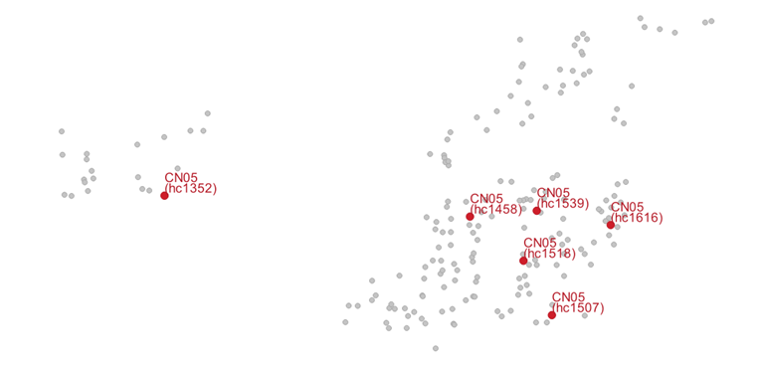
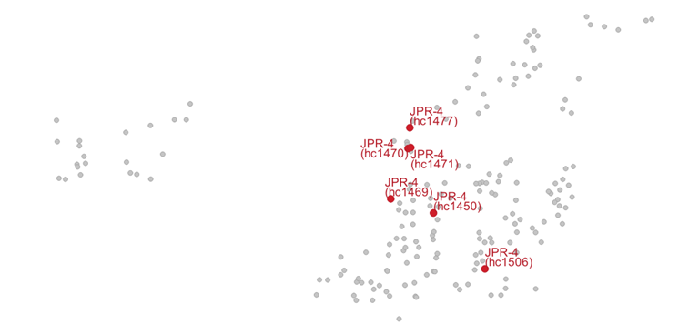
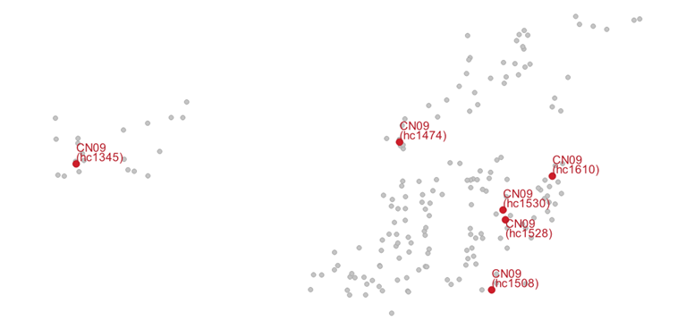
Fig S1. Locations of the progenies of mother trees with six assigned progenies

(a)
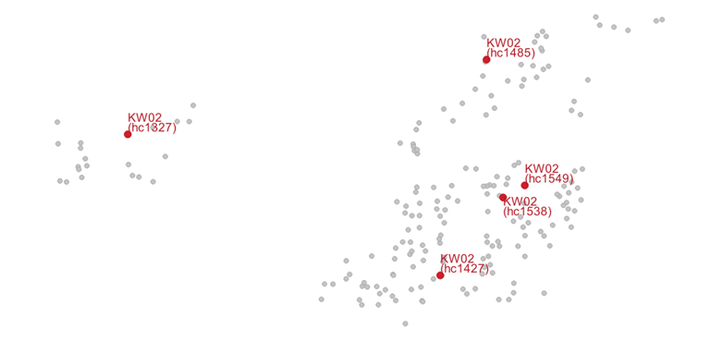
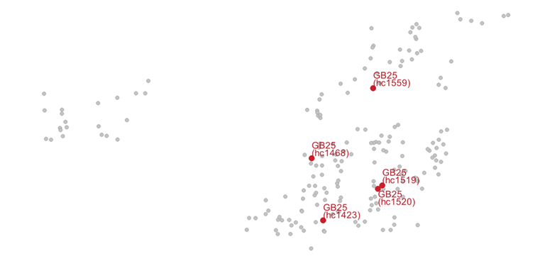
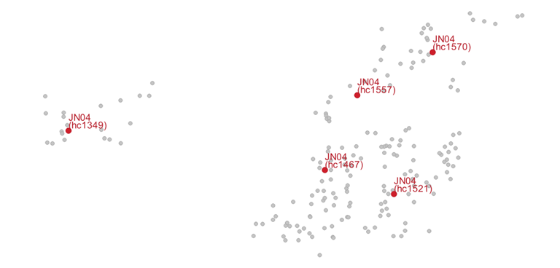
(b)
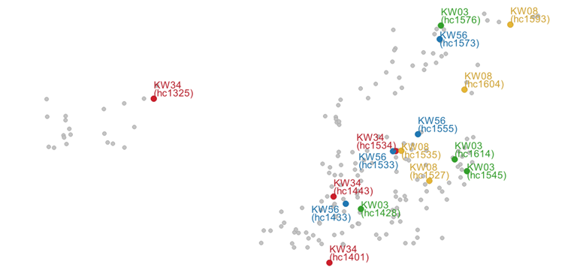
Fig S2. Locations of the progenies of mother trees with (a) five assigned progenies, and
(b) four assigned progenies
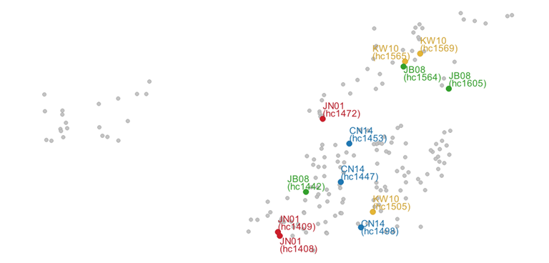
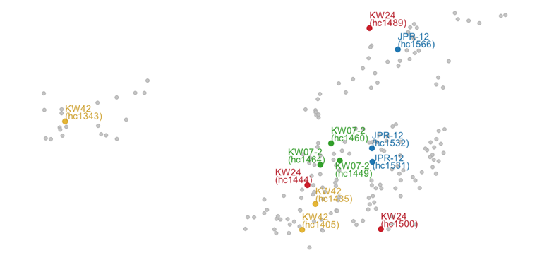
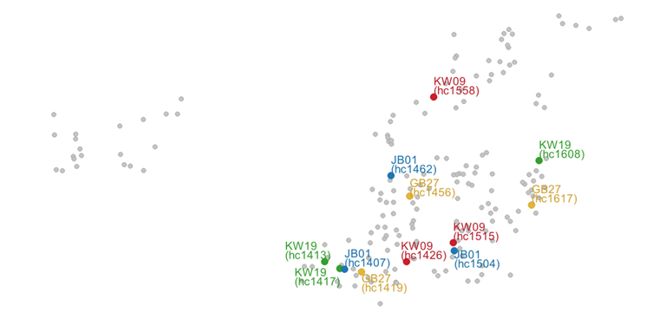
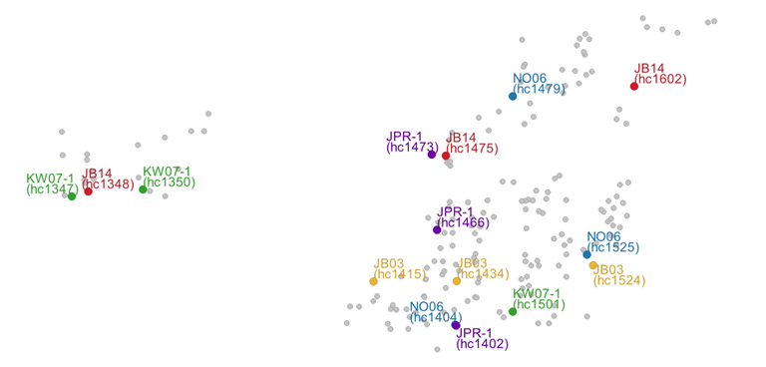
Fig S3. Locations of the progenies of mother trees with three assigned progenies
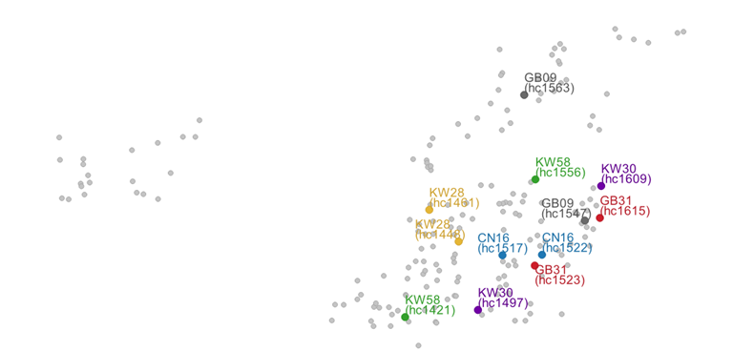
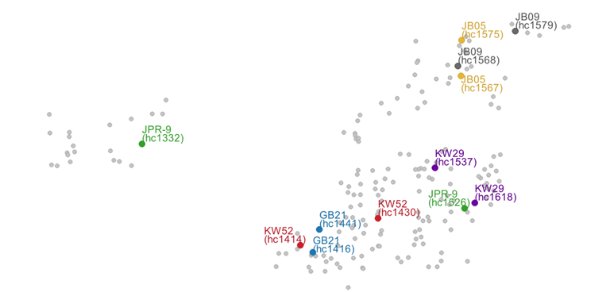
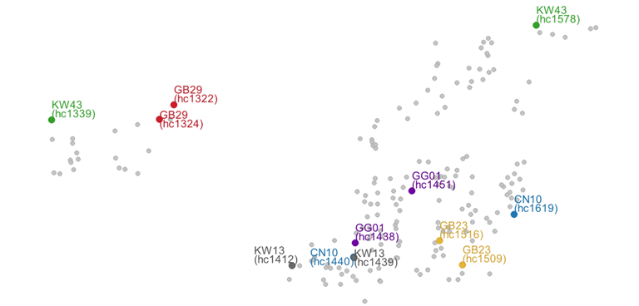
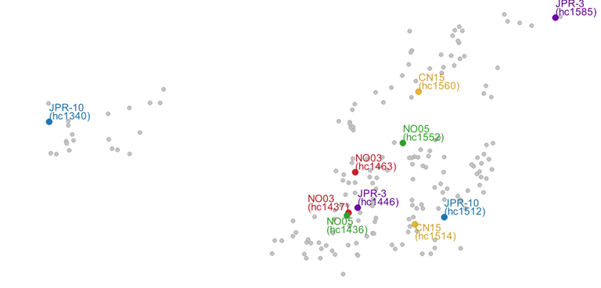
Fig S4. Locations of the progenies of mother trees with two assigned progenies
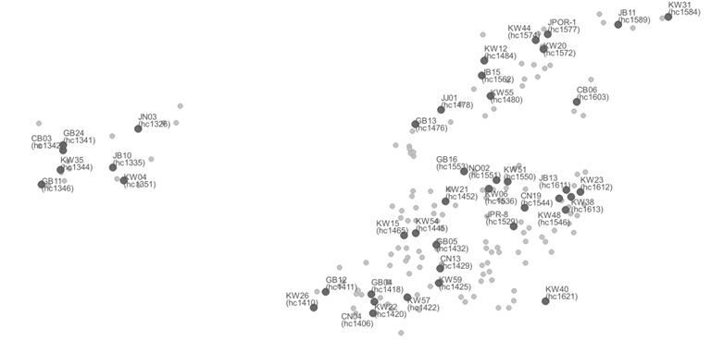
Fig S5. Location of the progenies of mother trees with one assigned progeny
(a)  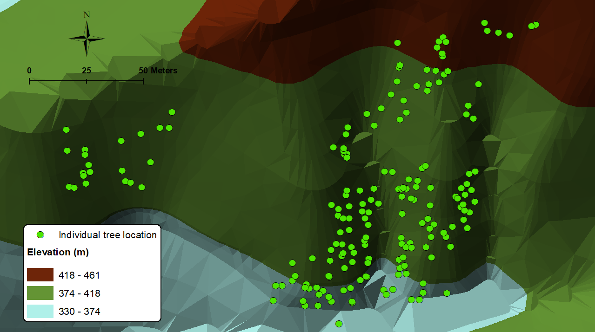 | (b)  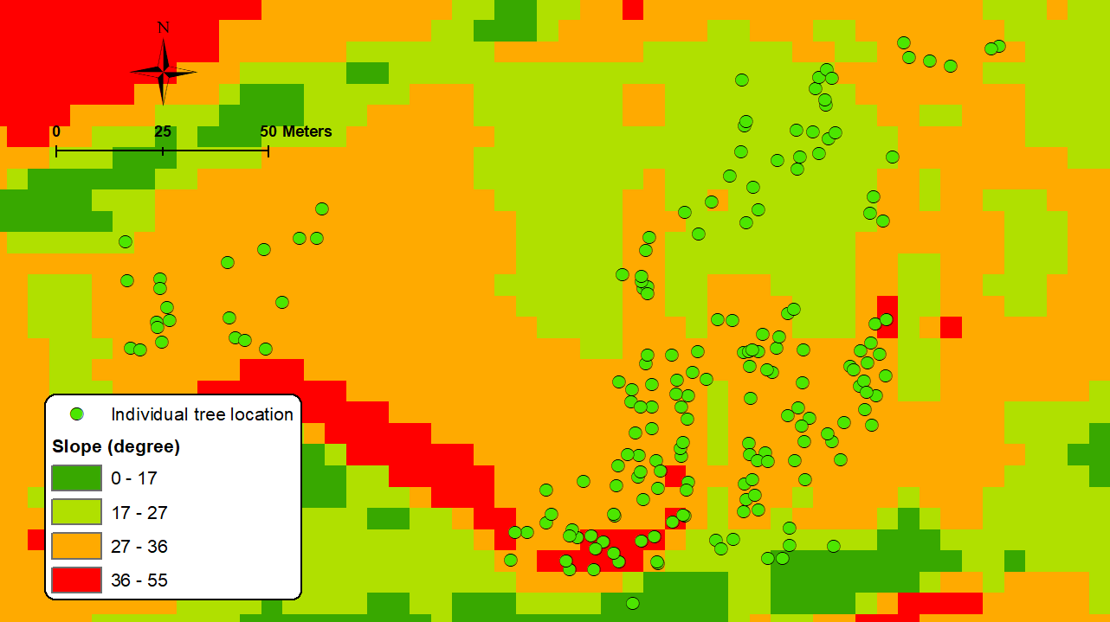 | (c)  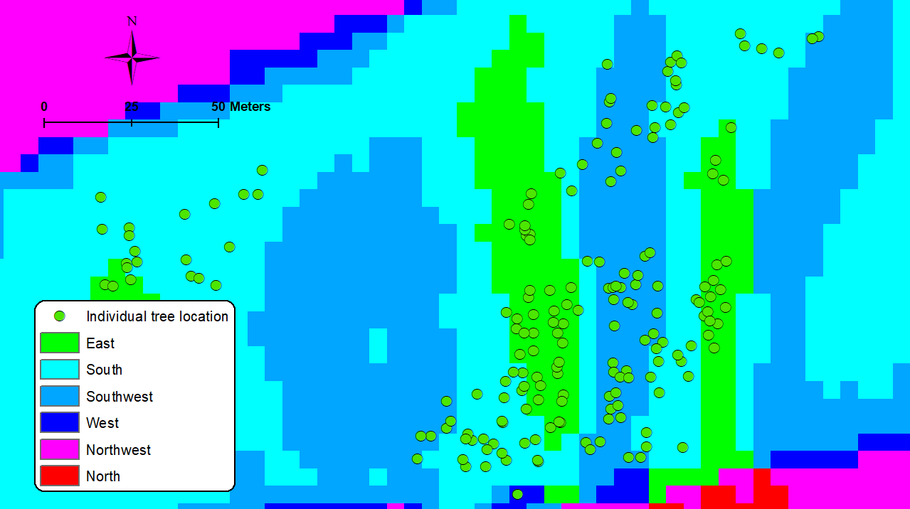 | (d)  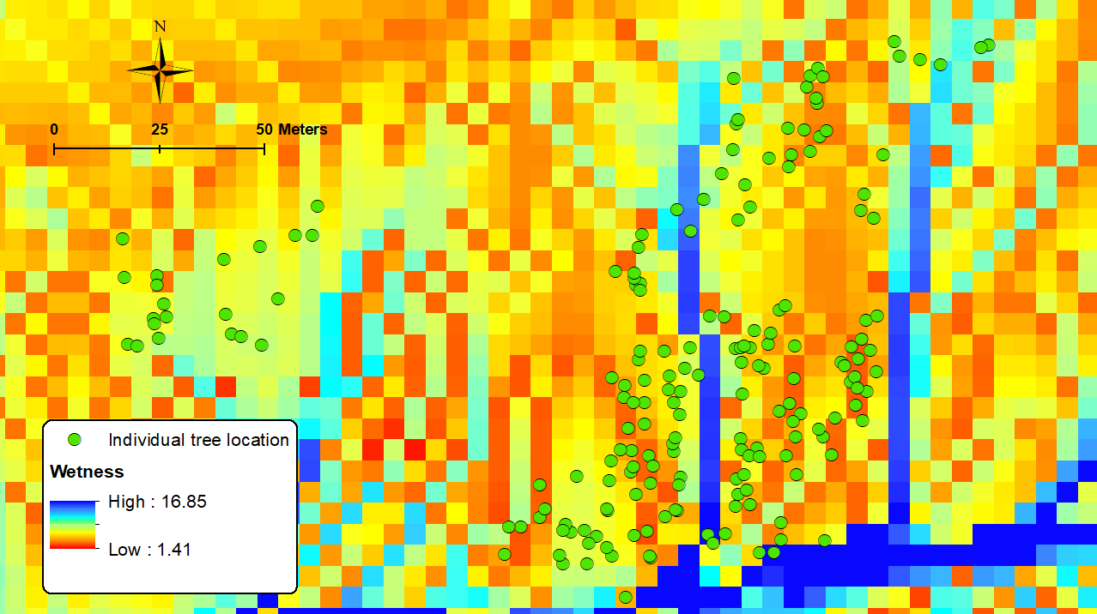
(e)  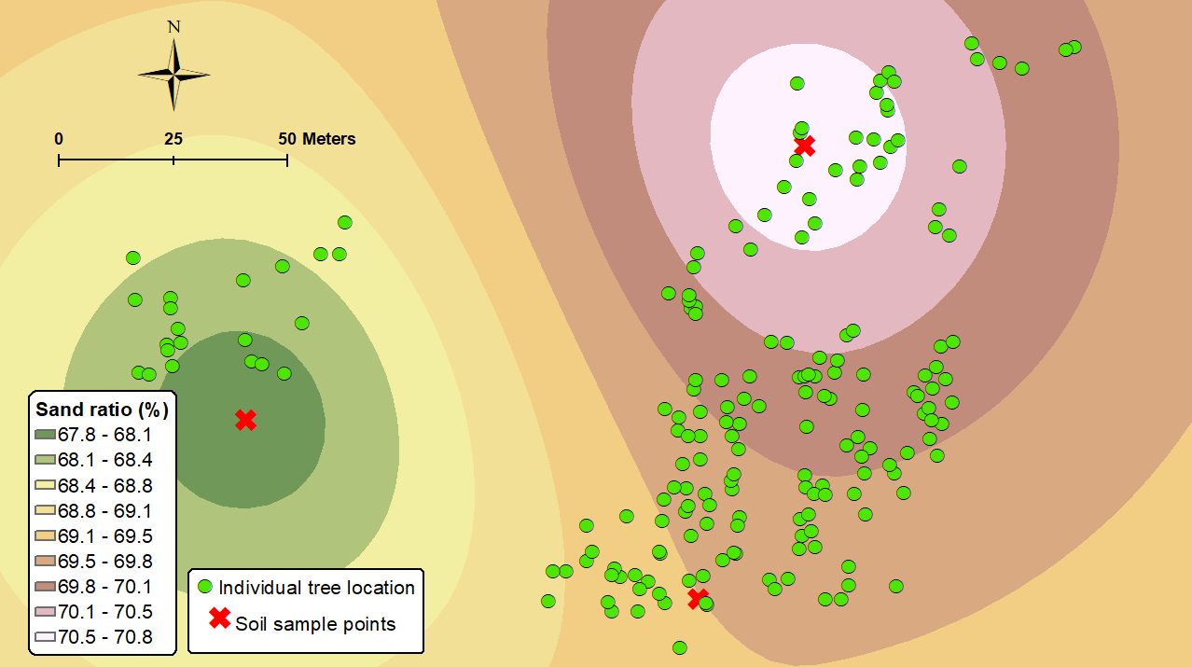 | (f)  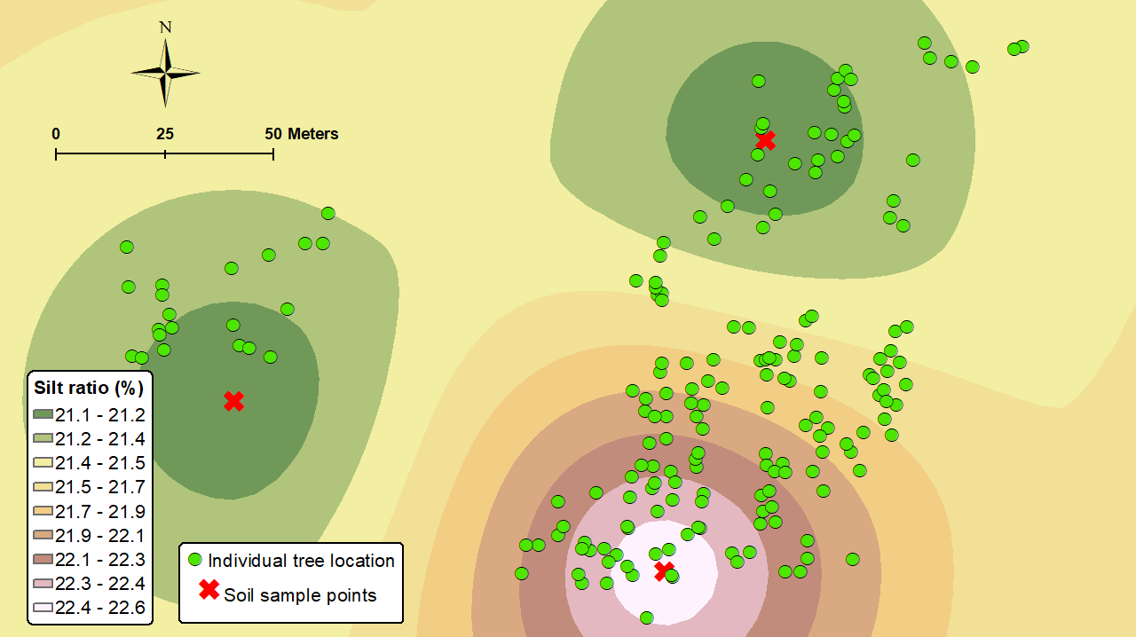 | (g)  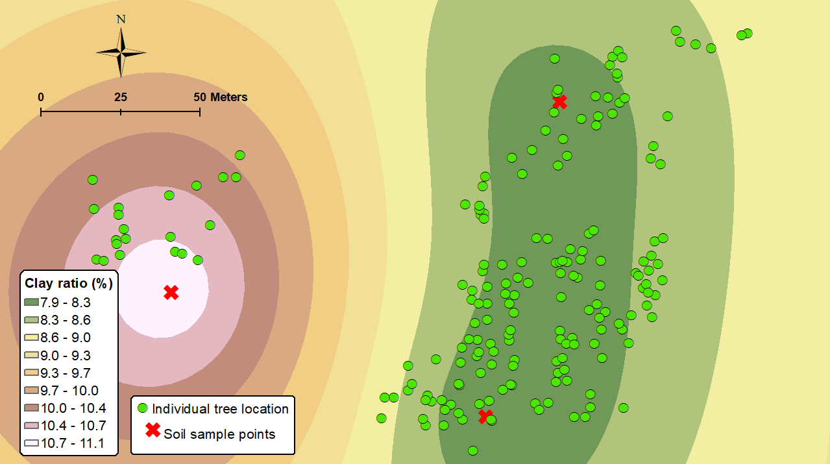 | (h)  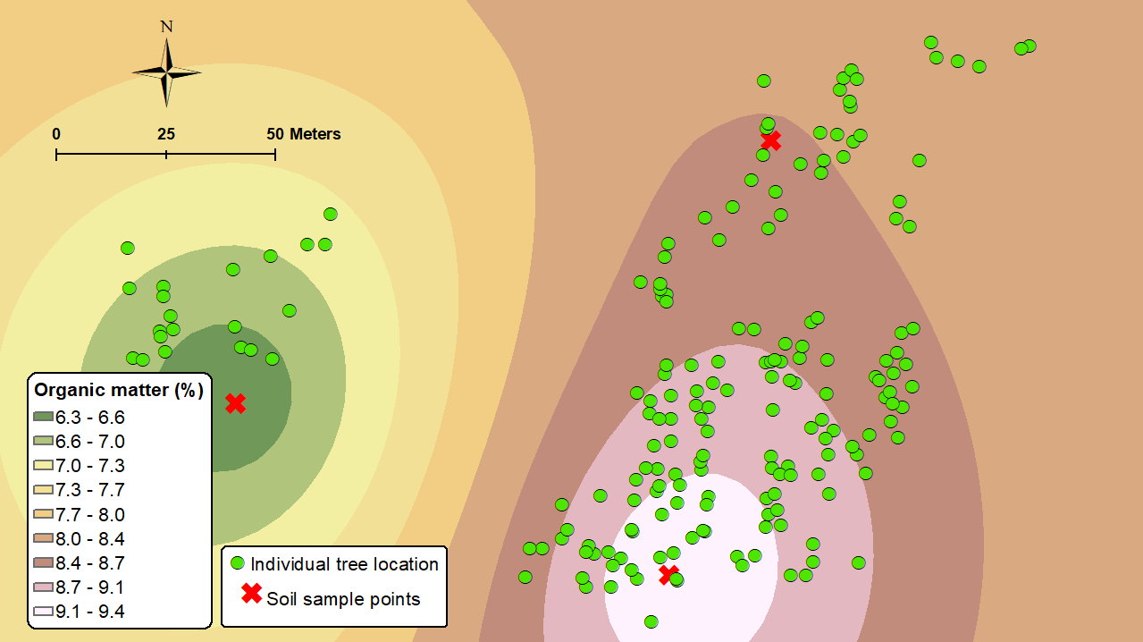
(i)  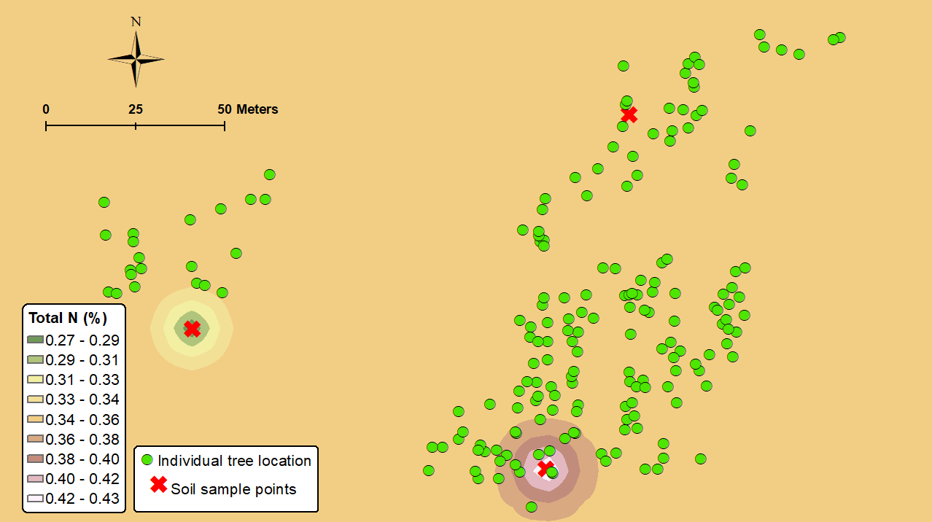 | (j) 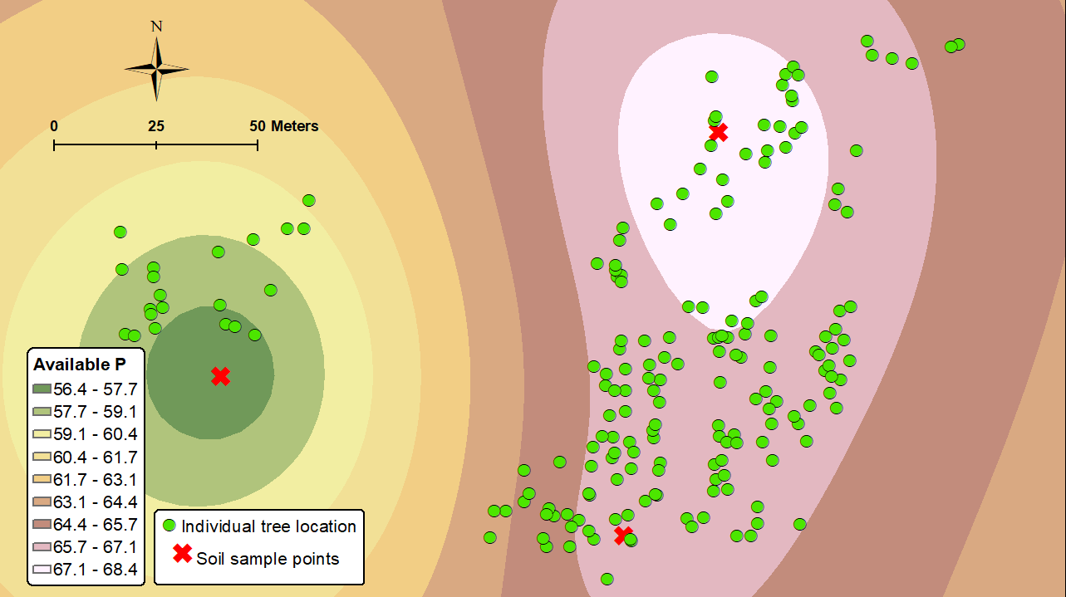 | (k)  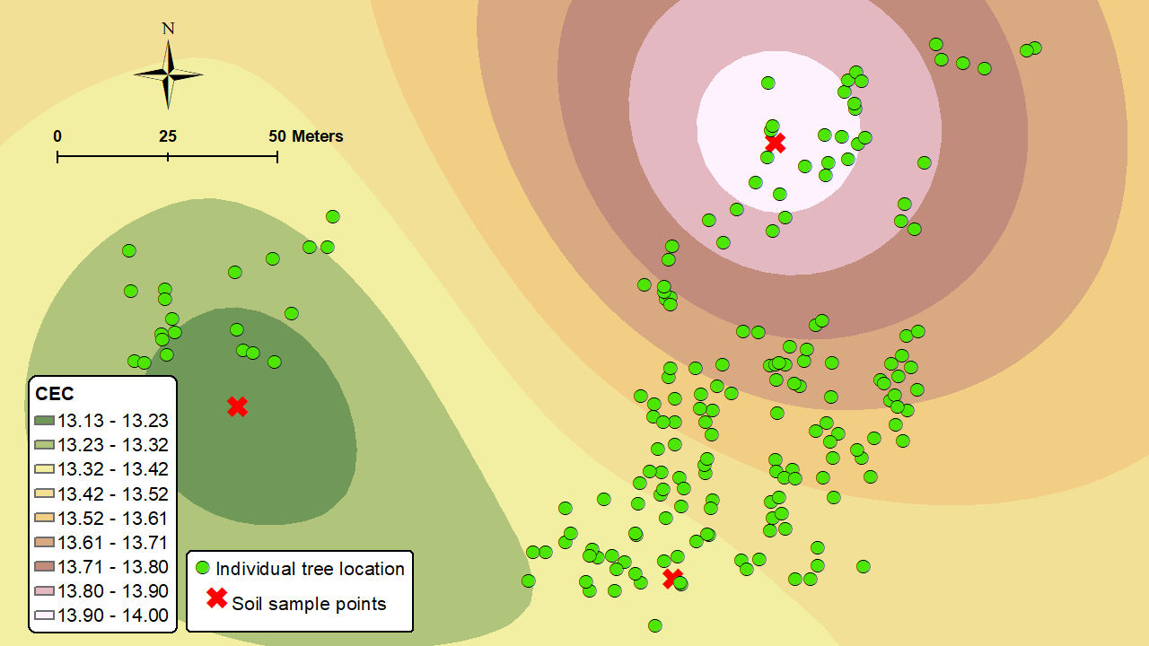 | (l)  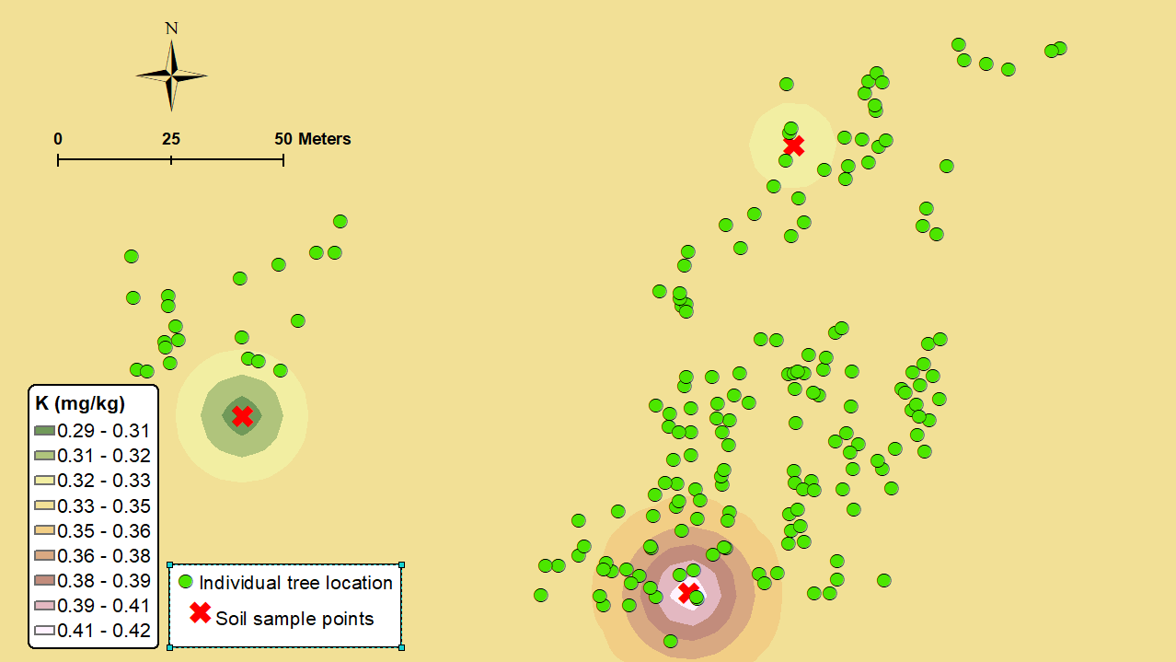
(m)  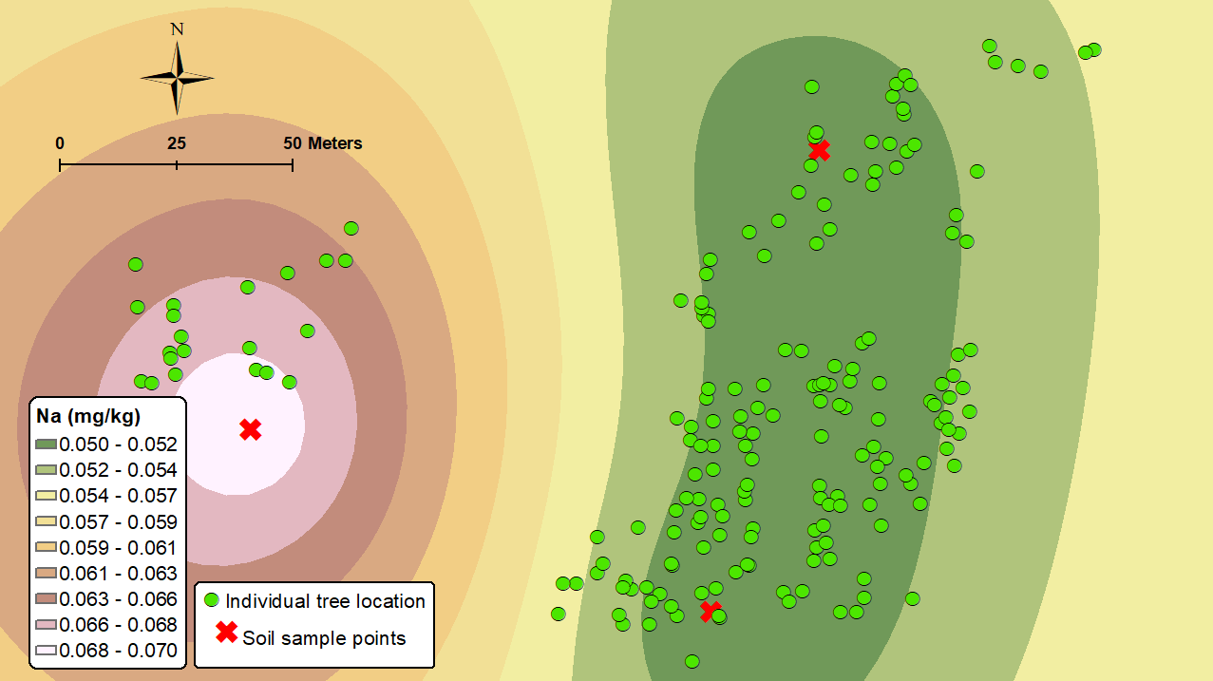 | (n)  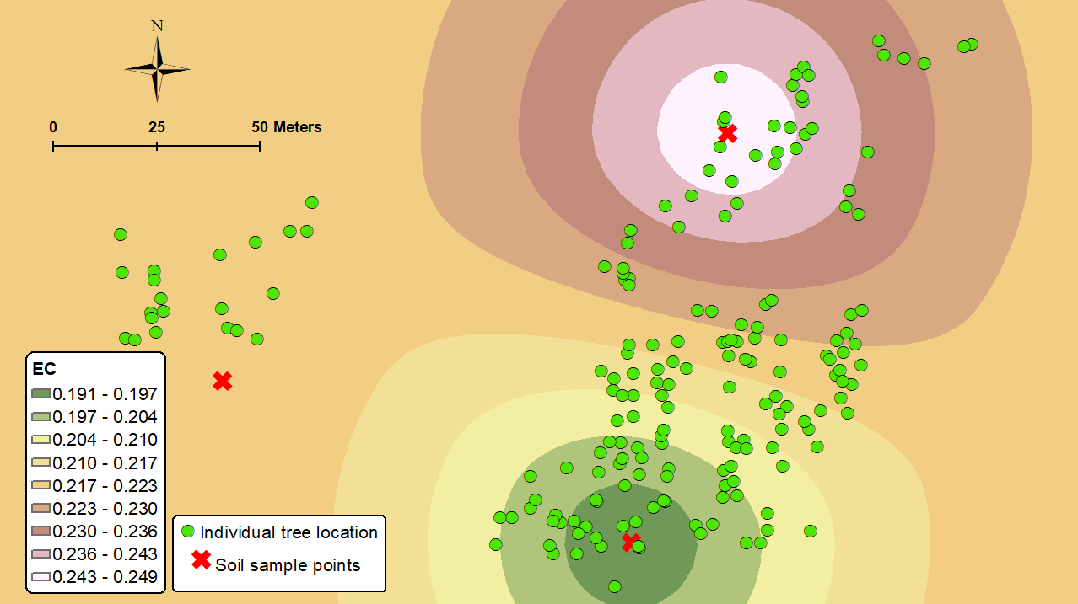
Fig S6. Changes in the environmental factors by the individual trees in the study site (a) elevation (m), (b) slope, (c) aspect, (d) wetness, (e) sand ratio (%), (f) silt ratio (%), (g) clay (%), (h) organic matter (%), (i) Total N (%), (j) available P (mg/kg), (k) cation exchange capacity, (l) K⁺ (cmol/kg), (m) Na⁺ (cmol/kg), (n) electrical conductivity (dS/m) (red marks: three points of soil sampling)

